*भारतीय मानक*

**मृदा परीक्षण के लिए संहनन रैमर**

**विशिष्टि**

*(पहला पुनरीक्षण)*

*Indian Standard*

**COMPACTION RAMMERS FOR SOIL TESTING SPECIFICATION**

(*First Revision*)

(ICS 93.020; 13.080.20)



Soil and Foundation Engineering Sectional Committee, CED 43

**FOREWORD**

This Indian Standard (First Revision) was adopted by the Bureau of Indian Standards, after the draft finalized by the Soil and Foundation Engineering Sectional Committee had been approved by the Civil Engineering Division Council.

There are a series of standards on methods of testing of soils. It has been recognized that reliable and inter-comparable test results can be obtained only with the standard testing equipment capable of giving the desired level of accuracy. With this objective, a series of specifications covering the requirements of equipment used for testing soils have been published to encourage their development and manufacturing in the country.

The equipment covered in this standard is used for determination of water content-dry density relation of soil in accordance with IS 2720 (Part 7) : 1980 ‘Methods of test for soils: Part 7 Determination of water content-dry density relation using light compaction (*second revision*)’ and IS 2720 (Part 8) : 1983 ‘Methods of test for soils: Part 8 Determination of water content-dry density relation using heavy compaction (*second revision*)’.

This standard was first published in 1980. The present revision has been taken up with a view to incorporate the modifications found necessary as a result of experience gained in the use of this standard. Also, in this revision, the standard has been brought into latest style and format of Indian Standards, and references to Indian Standards, wherever applicable have been updated. The other major modifications incorporated in this revision of the standard are given below:

1. Mechanical compaction rammers, both light and heavy, have been included along with necessary modifications in the clause for manual compaction rammers.
2. Correct Indian Standard for forging quality mild steel has been referred.
3. Marking clause has been updated to also indicate manual or mechanical type of compaction rammer.
4. BIS certification marking clause has been modified to align with the revised *Bureau of Indian Standards Act, 2016*.

This standard contributes to the Sustainable Development Goal 9 - Industry, Innovation and Infrastructure: Build resilient infrastructure, promote inclusive and sustainable industrialization and foster innovation.

The composition of the Committee responsible for formulation of the standard is given in Annex A.

For the purpose of deciding whether a particular requirement of this standard is complied with, the final value, observed or calculated, expressing the result of a test or analysis, shall be rounded off in accordance with IS 2 : 2022 ‘Rules for rounding off numerical values (*second* *revision*)’. The number of significant places retained in the rounded off value should be the same as that of the specified value in this standard.

***Indian Standard***

**COMPACTION RAMMERS FOR SOIL TESTING ― SPECIFICATION**

(*First Revision*)

**1 SCOPE**

This standard covers the requirements for compaction rammers, both for light and heavy compaction, used for determination of the water content-dry density relation of soils.

**2 REFERENCES**

The following standards contain provisions, which through reference in this text, constitute provisions of this standard. At the time of publication, the editions indicated are valid. All standards are subject to revision, and parties to agreement based on this standard are encouraged to investigate the possibility of applying the most recent editions of the standards indicated below:

|  |  |
| --- | --- |
| *lS No.* | *Title* |
| IS 1239 (Part 1) : 2004 | Steel tubes, tubulars and other wrought steel fittings ― Specification: Part 1 Steel tubes (*sixth revision*) |
| IS 1875 : 1992 | Carbon steel billets, blooms, slabs and bars for forgings ― Specification (*fifth revision*) |
| IS 2102 (Part 1) : 1993 | General tolerances: Part 1 Tolerances for linear and angular dimensions without individual tolerance indications (*third revision*) |
| IS 4170 : 1967 | Specification for brass rods for general engineering purposes |
| IS 5382 : 2018 | Rubber seals ― Joint rings for water supply, drainage and sewerage pipelines ― Specification for materials (*second revision*) |

**3 MATERIALS**

The materials of construction for the different components of the compaction rammer of both light and heavy type shall be as given in Table 1.

**Table 1 Materials of Construction for Different Components of**

**Compaction Rammer (Light and Heavy)**

(*Clause* 3)

|  |  |  |  |  |
| --- | --- | --- | --- | --- |
| Sl  No. | Part | Material | Specific Requirements,  if any | Conforming to  Indian Standards |
| (1) | (2) | (3) | (4) | (5) |
| i) | Rammer foot | Mild steel or brass | Smooth finish and chrome plated | IS 1875  IS 4170 |
| ii) | Shaft | Mild steel | - | IS 1875 |
| iii) | Handle knob | Mild steel | - | IS 1875 |
| iv) | Guide pipe | Mild steel drawn pipe | - | IS 1239 (Part 1) |
| v) | Washer | Gasket rubber vulcanized | - | Vulcanized rubber  IS 5382 |

**4 DIMENSIONS**

Dimensions with tolerances of different components of compaction rammer shall be as detailed in Fig. 1 to Fig. 4. Except where tolerances are specifically mentioned against the dimensions, all dimensions shall be taken as nominal dimensions and tolerances as given in IS 2102 (Part 1) shall apply thereon.

**5 MANUAL COMPACTION RAMMER, LIGHT**

The light compaction rammer shall be as shown in Fig. 1 to Fig. 3. The mass of the moving parts of the rammer shall be 2.6 kg ± 25 g. The length of the guide pipe shall be such that it gives a fall of 310 ± 4 mm. The free end of the rammer foot shall be squared with the sides and shall be finished smooth. Provision shall also be made to secure this to the shaft with a pin to prevent it from unscrewing during usage. It shall be chrome plated. It shall be provided with air vents at both ends as shown in Fig. 3 and a suitable guide for the shaft of the rammer shall be screwed on to the pipe at the top end. The washer shall be as shown in Fig. 2 and shall be minimum 1.5 mm thick.

**6 MANUAL COMPACTION** **RAMMER, HEAVY**

The heavy compaction rammer shall be as shown in Fig. 1, Fig. 2 and Fig. 4. The mass of the moving parts of the rammer shall be 4.9 kg ± 50 g. The length of the guide pipe shall be such that it gives a fall of 450 ± 4 mm. The free end of the rammer foot shall be squared with the sides and shall be finished smooth. Provision shall also be made to secure it to the shaft with a pin to prevent it from unscrewing during usage. It shall be chrome plated. The washer shall be as shown in Fig. 4 and shall be of minimum 1.5 mm thick.

**7 MECHANICAL COMPACTION RAMMER, LIGHT**

The mechanical rammer shall be as shown in Fig. 5 to Fig. 6. The mass of moving parts of the rammer shall be 2.6 kg ± 25 g. The rammer shall operate mechanically by power operated machine. The design of rammer shall be such that it gives a fall of 310 ± 4 mm from the surface of the specimen and provide uniform and complete coverage of specimen surface irrespective of mould size 100 mm or 150 mm. The machine shall be equipped with a resettable blow counter device. Provision shall be made to stop the machine on completion of set number of blows. The machine shall be equipped with a mechanical means to support the rammer when not in use.

**8 MECHANICAL COMPACTION RAMMER, HEAVY**

The mechanical rammer shall be as shown in Fig. 7 to Fig. 8. The mass of moving parts of the rammer shall be 4.9 kg ± 50 g. The rammer shall operate mechanically by power operated machine. The design of rammer shall be such that it gives a fall of 450 ± 4 mm from the surface of the specimen and shall provide uniform and complete coverage of specimen surface irrespective of mould size 100 mm or 150 mm. The machine shall be equipped with a resettable blow counter device. Provision shall be made to stop the machine on completion of set numbers of blows. The machine shall be equipped with a mechanical means to support the rammer when not in use.

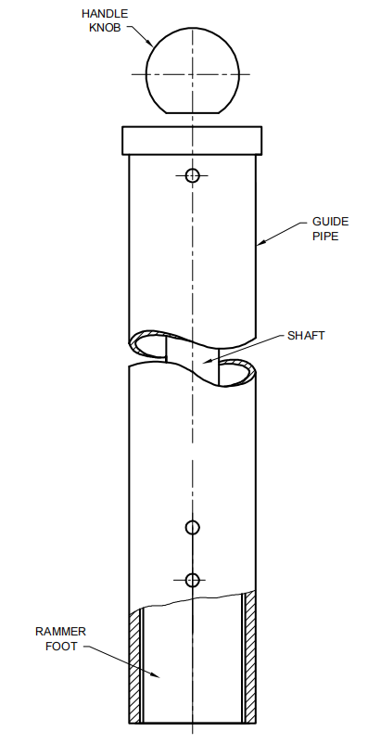

All dimensions in millimetres.

FIG. 1 ASSEMBLY OF MANUAL COMPACTION RAMMER

All dimensions in millimetres.

FIG. 2 DETAILS OF LIGHT MANUAL COMPACTION RAMMER FOOT, SHAFT AND KNOB

All dimensions in millimetres.

For light compaction rammer, L = 361 $±$ 4 mm

For heavy compaction rammer, L = 581 $±$ 4 mm

FIG. 3 DETAILS OF GUIDE PIPE

All dimensions in millimetres.

FIG. 4 DETAILS OF HEAVY MANUAL COMPACTION RAMMER FOOT, SHAFT AND KNOB

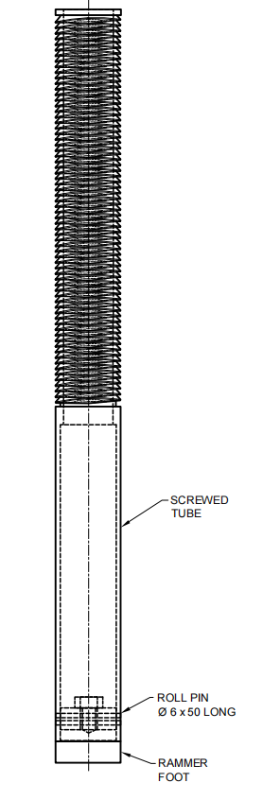

All dimensions in millimetres.

FIG. 5 ASSEMBLY OF LIGHT MECHANICAL RAMMER

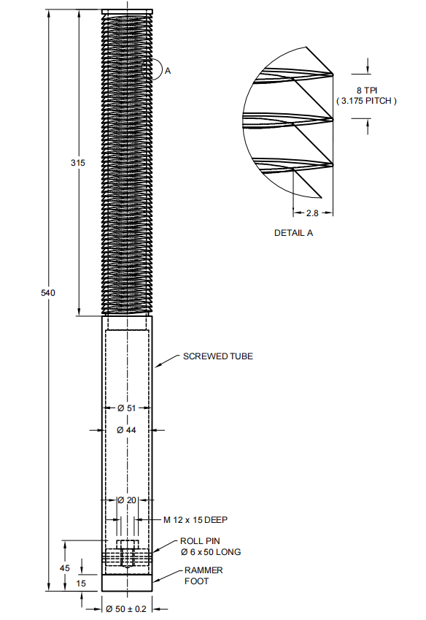

All dimensions in millimetres.

FIG. 6 DETAILS OF LIGHT MECHANICAL RAMMER FOOT AND SCREWED TUBE

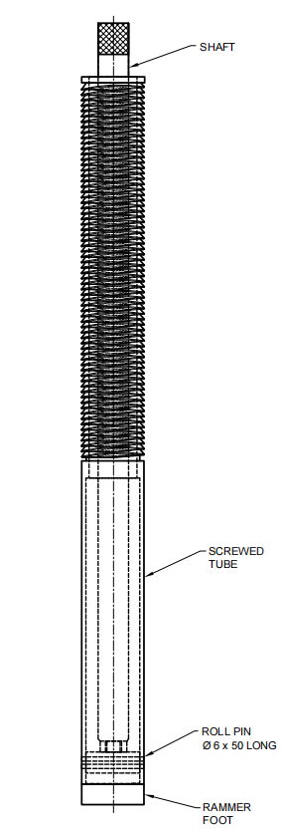

All dimensions in millimetres.

FIG. 7 ASSEMBLY OF HEAVY MECHANICAL RAMMER

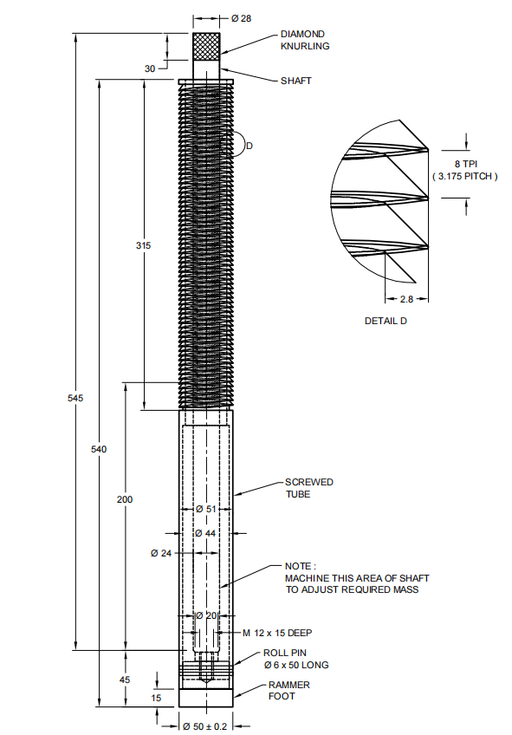

All dimensions in millimetres.

FIG. 8 DETAILS OF HEAVY MECHANICAL RAMMER FOOT AND

SCREWED TUBE AND SHAFT

**9 MARKING**

**9.1** The following information shall be clearly and indelibly marked on each component of the apparatus in such a way that it does not interfere with the performance of the apparatus:

1. Name of manufacturer or his registered trade-mark or both;
2. Type of rammer (that is light or heavy);
3. Whether the rammer is manual or mechanical;
4. Whether the rammer foot is of mild steel or brass; and
5. Date of manufacture.

**9.2** **BIS Certification Marking**

The product conforming to the requirements of this standard may be certified as per the conformity assessment schemes under the provisions of the *Bureau of Indian Standards Act*, 2016 and the Rules and Regulations framed there under, and the product may be marked with the Standard Mark

**ANNEX A**

(*Foreword*)

**COMMITTEE COMPOSITION**

Soil and Foundation Engineering Sectional Committee, CED 43

| *Organization* | *Representative(s)* |
| --- | --- |
|
| In Personal Capacity, *473, Vinayak Apartments, BHEL Housing Society, Plot No. C-58/19, Sector 62, Noida, Uttar Pradesh* - *201301* | Shri C. Pushpakaran **(*Chairperson*)** |
| AFCONS Infrastructure Limited, Mumbai | Dr Sunil Basarkar  Dr Lakshmana Rao Mantri (*Alternate-I*)  Shri Budhmal Jain (*Alternate-II*) |
| AIMIL Limited, New Delhi | Shri Rohitash Barua  Smt Aarti Bhargava (*Alternate-I*)  Shri Anil Singh (*Alternate-II*) |
| Bharat Heavy Electricals Ltd, New Delhi | Shri T. M. S. Rao  Shri Vikram S. (*Young Professional*) |
| CEM Engineers and Consultants Pvt Ltd, Bhubaneswar | Shri Ashok Basa  Shri Dilip Basa (*Alternate*) |
| Cengrs Geotechnica Pvt Ltd, Noida | Shri Sanjay Gupta  Shri Ravi Sundaram (*Alternate*)  Shri Sorabh Gupta (*Young Professional*) |
| Central Board of Irrigation and Power, New Delhi | Director |
| Central Electricity Authority,  New Delhi | Shri Baleshwar Thakur  Shri Deepak Singh Raghuvansi (*Alternate*) |
| Central Public Works Department,  New Delhi | Shri Nagendra Prasad  Shri Amrendra Kumar Jalan (*Alternate*) |
| Central Soil and Materials  Research Station, New Delhi | Dr Manish Gupta  Ms Swapna Varma (*Alternate*) |
| CSIR-Central Building Research  Institute, Roorkee | Shri Manojit Samanta  Dr S. Ganesh Kumar (*Alternate*)  Shri Kaushik Pandit (*Young Professional*) |
| CSIR-Central Road Research  Institute, New Delhi | Dr Kanwar Singh  Dr P. S. Prasad (*Alternate*) |
| CSIR-Structural Engineering  Research Centre, Chennai | Dr P. Kamatchi  Smt R Sreekala (*Alternate*)  Dr A. Thirumalaiselvi (*Young Professional*) |
| D-CAD Technologies,  New Delhi | Dr K. G. Bhatia |
| Delhi Development Authority,  New Delhi | Shri Arun Kumar  Shri Harindar Pal (*Alternate*) |
| Delhi Technological University,  New Delhi | Prof. Ashok Kumar Gupta |
| Engineers India Limited,  New Delhi | Shri V. K. Panwar  Shri Sampat Raj (Alternate-I)  Shri Anil Banoth (*Young Professional*) |
| Geodynamics Ltd, Vadodara | Dr Ravikiran Vaidya  Shri Sujan Kulkarni (*Alternate*) |
| Geological Survey of India,  Kolkata | Dr Timir Baran Ghosal  Shri Prashant Tukaram Ilamkar (*Alternate*) |
| Ground Engineering Limited,  New Delhi | Shri Ashok Kumar Jain  Shri Neeraj Kumar Jain (*Alternate*) |
| Hindustan Construction Company  Limited, Mumbai | **Representative** |
| Indian Geotechnical Society,  New Delhi | Prof H. N. Ramesh  Dr Anil Joseph (*Alternate*)  Prof D. Neelima Satyam (*Alternate-II*) |
| Indian Institute of Science,  Bengaluru | Prof Jyant Kumar  Prof G. Madhavi Latha (*Alternate*) |
| Indian Institute of Technology  Delhi, New Delhi | Dr G. V. Ramana  Dr J. T. Shahu (Alternate-I)  Dr Prashanth Vangla (*Young Professional*) |
| Indian Institute of Technology  Kanpur, Kanpur | Prof Priyanka Ghosh |
| Indian Institute of Technology  Madras, Chennai | Prof Subhadeep Banerjee  Prof Ramesh K Kandasami (*Alternate*) |
| Indian Institute of Technology  Bombay, Mumbai | Prof Deepankar Choudhury  Prof Dasaka Murty (*Alternate*) |
| Indian Institute of Technology  Roorkee, Roorkee | Dr Mahendra Singh  Dr Vishwas A. Sawant (*Alternate*) |
| Indian Road Congress, New Delhi | Secretary General  Director (T) (*Alternate*) |
| Indian Society of Earthquake  Technology, Roorkee | Prof B. K. Maheswari  Prof Vasant A. Matsagar (*Alternate*) |
| ITD Cementation India Ltd, Kolkata | Shri Manish Kumar  Shri Aminul Islam (*Alternate*) |
| Jadhavpur University, Kolkata | Prof Sibapriya Mukherjee  Prof Ramendu Bikas Sahu (*Alternate*) |
| Keller Ground Engineering Pvt Ltd, Chennai | Shri V. V. S. Ramadas  Shri Madan Kumar Annam (*Alternate*) |
| [L&T GeoStructure Private Limited, Chennai](javascript:;) | Shri M. Kumaran  Shri A. Vetriselvan (*Alternate*) |
| Military Engineer Services,  Engineer-in-Chief's Branch,  Integrated HQ of MoD (Army),  New Delhi | Shri Manoj Bapna  Shri Ajay Kumar Sinha (*Alternate*) |
| MECON Limited, Ranchi | Shri Shankar Ray  Shri Ayush Srivastava (*Alternate*) |
| Ministry of Ports, Shipping and  Waterways, New Delhi | Shri H. N. Aswath  Shri Anil Pruthi (*Alternate*) |
| Mumbai Port Trust, Mumbai | Dy Chief Engineer (Design)  Superintending Engineer (Design) (*Alternate*) |
| Nagadi Consultants Pvt Limited,  New Delhi | Dr V. V. S. Rao  Shri N. Santosh Rao (*Alternate*) |
| National Capital Region Transport  Corporation, New Delhi | Shri Jitender Kumar |
| National High Speed Rail  Corporation Ltd, Mumbai | **Representative** |
| National Institute of Disaster  Management, New Delhi | Dr Chandan Ghosh  Dr Amir Ali Khan (*Alternate*) |
| NTPC Limited, Noida | Shri Mohit Jhalani |
| Power Grid Corporation of India  Limited, Gurugram | **Representative** |
| Research Designs and Standards  Organization (Ministry of  Railways), Lucknow | Shri Sameer Singh  Shri S. K. Ojha (*Alternate*) |
| RITES Limited, Gurugram | Shri Koshy Vaidyan  Shri Sumeet Mahajan (*Alternate*) |
| Safe Enterprises, Mumbai | Shri Vikram Singh Rao  Shri Suryaveer Singh Rao (*Alternate*) |
| STUP Consultants Pvt Ltd, Mumbai | Shri Anirban Sengupta  Shri Yogesh Waingankar (*Alternate*) |
| Tata Consulting Engineers Limited, Mumbai | Shri Sanjeev Gupta  Shri B. N. Nagaraj (*Alternate*) |
| Telangana State Research  Laboratories, Hyderabad | Shri A. G. Manoj Kumar  Shri Ashirwadam Jakkula (*Alternate-I*)  Smt M. Manjula (*Alternate-II*) |
| The Pressure Piling Co (I) Pvt  Limited, Mumbai | Shri V. C. Deshpande  Shri Pushkar V. Deshpande (*Alternate*) |
| Unique Geocivil Services Pvt Ltd,  Surat | Shri Nehal H. Desai  Shri Hitesh H. Desai (*Alternate-I*)  Shri Dhruval D. Shah (*Alternate-II*) |
| In Personal Capacity, *1-B, Villakkupattam Palace, First Floor, 48, New Avadi Road, Kilpauk, Chennai 600010* | Dr V. Balakumar |
| BIS Directorate General | Shri Dwaipayan Bhadra, Scientist ‘E’/ Director and Head (Civil Engineering) [Representing Director General (*Ex-officio*)] |
| *Member Secretary*  Shri Dheeraj Damachya  Scientist ‘B’ / Assistant Director  (Civil Engineering), BIS | |