भारतीय मानक

मृदा में जल की मात्रा के शीघ्र निर्धारण हेतु
तेज आद्रता मीटर — विशिष्टि

(पहला पुनरीक्षण )

Indian Standard

Rapid Moisture Meter for Rapid Determination of Water Content of Soil Specification — Specification

(First Revision)

(ICS 93.020; 13.080.20)

© BIS 2024
भारतीय मानक ब्यूरो
BUREAU OF INDIAN STANDARDS
मानक भवन, 9, बहादुरशाह ज़फर मार्ग, नई दिल्ली — 110002
MANAK BHAVAN, 9, BAHADUR SHAH ZAFAR MARG NEW DELHI-110002
www.bis.gov.in www.standardsbis.in


September 2024
Price Group XX

Soil and Foundation Engineering Sectional Committee, CED 43

FOREWORD

This Indian Standard (First Revision) was adopted by the Bureau of Indian Standards, after the draft finalized by the Soil and Foundation Engineering Sectional Committee had been approved by the Civil Engineering Division Council.

There are a series of standards on methods of testing of soils. It has been recognized that reliable and inter-comparable test results can be obtained only with the standard testing equipment capable of giving that desired level of accuracy. With this objective, a series of specifications covering the requirements of equipment used for testing soils have been published to encourage their development and manufacturing in the country.

The equipment covered in this standard is used as a part of the assembly for the equipment used for the determination of water content from the gas pressure developed by the reaction of calcium carbide with the free water of the soil covered in IS 2720 (Part 2) : 1973 ‘Methods of test for soils: Part 2 determination of water content (second revision)’.

This standard was first published in 1988. The present revision has been taken up with a view to incorporate the modifications found necessary as a result of experience gained in the use of this standard. Also, in this revision, the standard has been brought into latest style and format of Indian Standards, and references to Indian Standards, wherever applicable have been updated. The other major modifications incorporated in this revision of the standard are given below:

- Scope has been modified to explicitly specify the two ranges of rapid moisture meter covered in the standard.
- Reference for specification of calcium carbide has been given.
- Requirements of weighing balance for measuring specimen weight and calcium carbide measuring device to be supplied with rapid moisture meter have been included.
- BIS certification marking clause has been modified to align with the revised Bureau of Indian Standards Act, 2016.

The results of water content of the soil determined using the Rapid Moisture Meter, specifications for which have been covered in this standard, are directly influenced by and dependent on the grade, quality, purity and freshness of the Calcium Carbide used and are therefore, prone to inaccuracy. Hence, the results obtained using the Rapid Moisture Meter should be used only as indicative values of water content of the soil till confirmation is obtained by carrying out water content determination as per Section 1 of IS 2720 (Part 2) : 1973 ‘Methods of test for soils: Part 2 determination of water content (second revision)’.

This standard contributes to the Sustainable Development Goal 9 - Industry, Innovation and Infrastructure: Build resilient infrastructure, promote inclusive and sustainable industrialization and foster innovation.

The composition of the Committee responsible for formulation of the standard is given in Annex A.

For the purpose of deciding whether a particular requirement of this standard is complied with, the final value, observed or calculated, expressing the result of a test or analysis, shall be rounded off in accordance with IS 2 : 2022 ‘Rules for rounding off numerical values (second revision)’. The number of significant places retained in the rounded off value should be the same as that of the specified value in this standard.

Draft Indian Standard

RAPID MOISTURE METER FOR RAPID DETERMINATION
OF WATER CONTENT FOR SOIL ― SPECIFICATION

(First Revision)

1 SCOPE

1.1 This standard covers the moisture meter used for rapid determination of water content from the gas pressure developed by the reaction of calcium carbide with the free water of the soil.

1.2 The standard covers following ranges of percentage of water content (wet weight basis)determined using rapid moisture meter:

a) 0-25 percent; and
b) 0-50 percent.

2 REFERENCES

The following standards contain provisions, which through reference in this text, constitute provisions of this standard. At the time of publication, the editions indicated are valid. All standards are subject to revision, and parties to agreement based on this standard are encouraged to investigate the possibility of applying the most recent editions of the standards indicated below:

IS No. | Title
IS 318 : 1981 | Specification for leaded tin bronze ingots and castings (second revision)
IS 513 (Part 1) : 2016 | Cold reduced carbon steel sheet and strip: Part 1 Cold forming and drawing purpose (sixth revision)
IS 617 : 2024 | Aluminium and aluminium alloys ingots for remelting and castings for general engineering purposes – specification (fourth revision)
IS 1040 : 2024 | Calcium carbide, technical – specification (fourth revision)
IS 2102 (Part 1) : 1993 | General tolerances: Part 1 tolerances for linear and angular dimensions without individual tolerance indications (third revision)
IS 3624 : 1987 | Specification for pressure and vacuum gauges (second revision)
IS 4398 : 1994 | Carbon ― Chromium steel for the manufacture of balls, rollers and bearing races ― Specification (second revision)
IS 6603 : 2024 | Stainless steel semi-finished products, bars, wire rods and bright bars – specification (second revision)
IS 17891 | Fluid power systems O-rings
(Part 1) : 2023 | Inside diameters cross-sections tolerances and designation codes
(Part 2) : 1984 | Housing dimensions for general applications

3 DIMENSIONS

Dimensions of the equipment and different component of the equipment shall be as detailed in Fig. 1 to 5. Except where tolerances are specifically mentioned against the dimensions, all dimensions shall be taken as nominal dimensions and tolerances thereon shall be as given in IS 2102 (Part 1) for medium class.

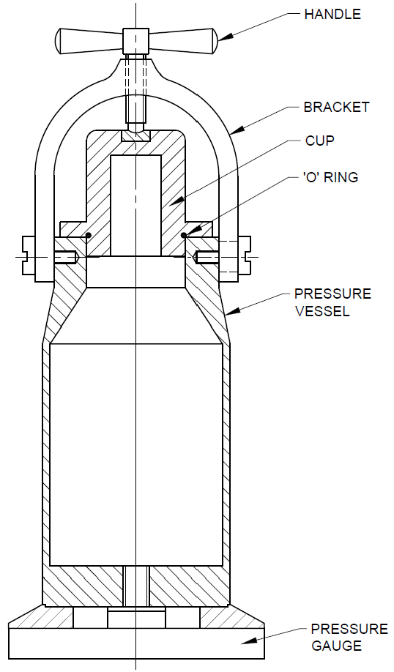
All dimensions in millimetres.

FIG. 1 ASSEMBLY

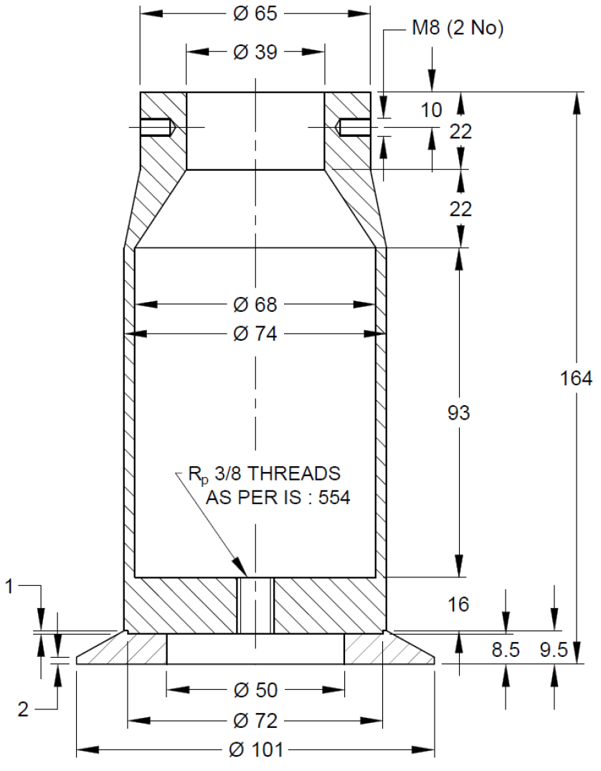
All dimensions in millimetres.

FIG. 2 PRESSURE VESSEL

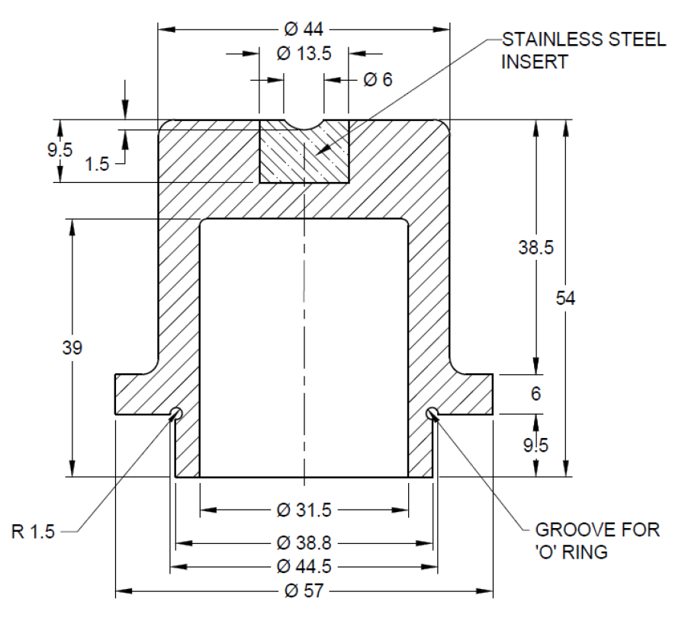
All dimensions in millimetres.

FIG. 3 CUP

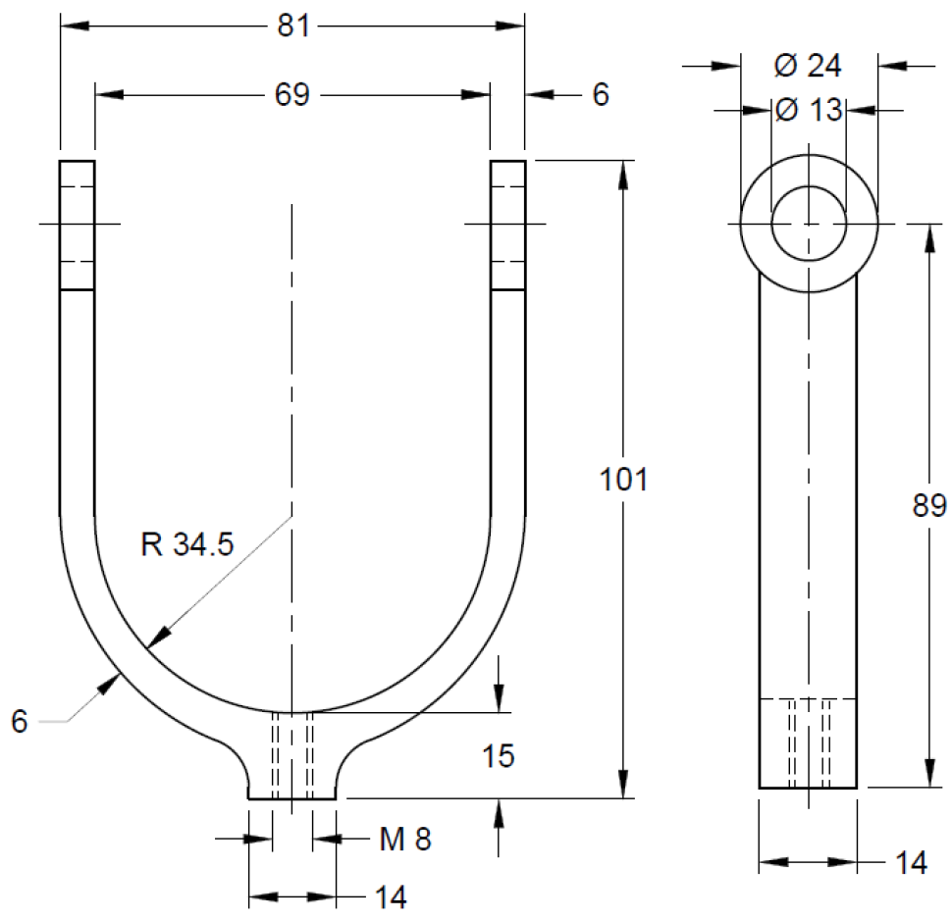

All dimensions in millimetres.

FIG. 4 BRACKET

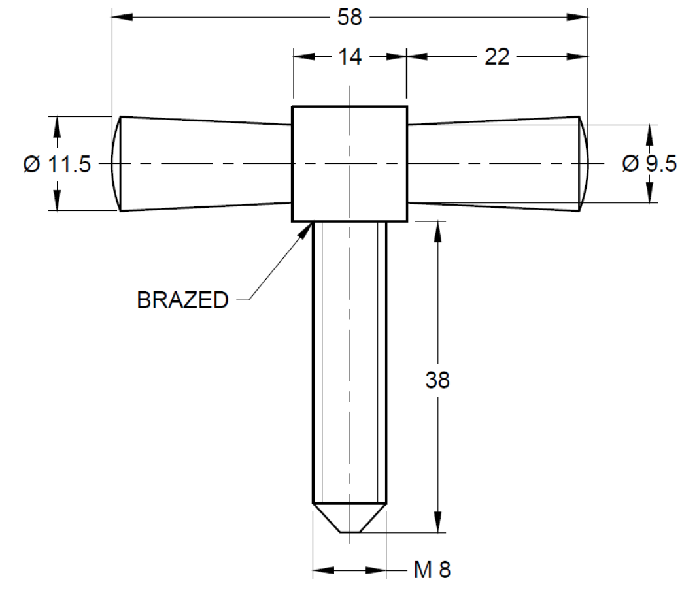
All dimensions in millimetres.

FIG. 5 HANDLE

4 MATERIAL

4.1 The materials of construction of various component of the equipment shall be as given in Table 1.

Table 1 Materials of Construction of Component of
Rapid Moisture Meter
(Clause 4)

Sl No. | Component Part | Material | Special Requirement, if any | Conforming to Indian Standard
(1) | (2) | (3) | (4) | (5)
i) | Pressure vessel | Aluminium alloy | Shall be machined  smooth from  inside | IS 617
ii) | Cup  - Body  - Inset | Aluminium alloy  Stainless steel | Shall be machined  smooth from  inside  Shall be machined  smooth from  inside | IS 617  IS 6603
iii) | Bracket | Copper alloy | Nickel/Chrome  Plated | IS 318
iv) | Handle | Mild steel | Nickel/Chrome  Plated | IS 513 (Part 1)
v) | ‘O’ Ring | Synthetic rubber |  | IS 17891 (Parts 1 and 2)
vi) | Balls | Steel | Nickel/Chrome  Plated | IS 4398
vii) | Pressure gauge | Conforming to requirements for industrial concentric scale gauge Class IA  covered in IS 3624

4.2 Calcium carbide to be used shall be as per IS 1040. Suitable grade of calcium carbide as per IS 1040 shall be provided by the manufacturer.

5 CONSTRUCTION

5.1 The mating parts of the pressure vessel and the cup shall be machined properly to ensure a proper and leak-proof seating when assembled with ‘O’ ring fitted in its position.

5.2 Pressure Gauge

A pressure gauge shall be fitted as shown in Fig. 1 to the pressure vessel. The dial of the pressure gauge shall be calibrated in percentage of water content either in the range of 0 - 25 percent or 0 - 50 percent for two different ranges of the moisture meters on the basis of dry soil. The minimum divisions on the dial shall be 1 percent.

5.3 Steel Balls

Three steel balls of about 12.5 mm diameter and one steel ball of 25 mm diameter shall be provided with the moisture meter.

5.4 Weighing Balance

A weighing balance of capacity 10 g and least count of 0.01 g shall be provided with the rapid moisture meter for weighing the sample.

5.5 Calcium Carbide Measuring Device

Suitable calcium carbide measuring device (scoop) shall be provided as per the range of the rapid moisture meter.

6 MARKING

6.1 The following information shall be clearly and indelibly marked on each equipment:

a) Name of the manufacturer or his registered trade-mark or both;
b) Range of rapid moisture meter on wet weight basis;
c) Type of material
d) Grade of Calcium Carbide to be used; and
e) Date of manufacture.

6.2 BIS Certification Marking

The product conforming to the requirements of this standard may be certified as per the conformity assessment schemes under the provisions of the Bureau of Indian Standards Act, 2016 and the Rules and Regulations framed thereunder, and the product may be marked with the Standard Mark.

ANNEX A
(Foreword)
COMMITTEE COMPOSITION

Soil and Foundation Engineering Sectional Committee, CED 43

Organization | Representative(s)
In Personal Capacity, 473, Vinayak Apartments, BHEL Housing Society, Plot No. C-58/19, Sector 62, Noida, Uttar Pradesh - 201301 | Shri C. Pushpakaran (Chairperson)
AFCONS Infrastructure Limited, Mumbai | Dr Sunil Basarkar  Dr Lakshmana Rao Mantri (Alternate-I)  Shri Budhmal Jain (Alternate-II)
AIMIL Limited, New Delhi | Shri Rohitash Barua  Smt Aarti Bhargava (Alternate-I)  Shri Anil Singh (Alternate-II)
Bharat Heavy Electricals Ltd, New Delhi | Shri T. M. S. Rao  Shri Vikram S. (Young Professional)
CEM Engineers and Consultants Pvt Ltd, Bhubaneswar | Shri Ashok Basa  Shri Dilip Basa (Alternate)
Cengrs Geotechnica Pvt Ltd, Noida | Shri Sanjay Gupta  Shri Ravi Sundaram (Alternate)  Shri Sorabh Gupta (Young Professional)
Central Board of Irrigation and Power, New Delhi | Director
Central Electricity Authority,  New Delhi | Shri Baleshwar Thakur  Shri Deepak Singh Raghuvansi (Alternate)
Central Public Works Department,  New Delhi | Shri Nagendra Prasad  Shri Amrendra Kumar Jalan (Alternate)
Central Soil and Materials  Research Station, New Delhi | Dr Manish Gupta  Ms Swapna Varma (Alternate)
CSIR-Central Building Research  Institute, Roorkee | Shri Manojit Samanta  Dr S. Ganesh Kumar (Alternate)  Shri Kaushik Pandit (Young Professional)
CSIR-Central Road Research  Institute, New Delhi | Dr Kanwar Singh  Dr P. S. Prasad (Alternate)
CSIR-Structural Engineering  Research Centre, Chennai | Dr P. Kamatchi  Smt R Sreekala (Alternate)  Dr A. Thirumalaiselvi (Young Professional)
D-CAD Technologies,  New Delhi | Dr K. G. Bhatia
Delhi Development Authority,  New Delhi | Shri Arun Kumar  Shri Harindar Pal (Alternate)
Delhi Technological University,  New Delhi | Prof. Ashok Kumar Gupta
Engineers India Limited,  New Delhi | Shri V. K. Panwar  Shri Sampat Raj (Alternate-I)  Shri Anil Banoth (Young Professional)
Geodynamics Ltd, Vadodara | Dr Ravikiran Vaidya  Shri Sujan Kulkarni (Alternate)
Geological Survey of India,  Kolkata | Dr Timir Baran Ghosal  Shri Prashant Tukaram Ilamkar (Alternate)
Ground Engineering Limited,  New Delhi | Shri Ashok Kumar Jain  Shri Neeraj Kumar Jain (Alternate)
Hindustan Construction Company  Limited, Mumbai | Representative
Indian Geotechnical Society,  New Delhi | Prof H. N. Ramesh  Dr Anil Joseph (Alternate)  Prof D. Neelima Satyam (Alternate-II)
Indian Institute of Science,  Bengaluru | Prof Jyant Kumar  Prof G. Madhavi Latha (Alternate)
Indian Institute of Technology  Delhi, New Delhi | Dr G. V. Ramana  Dr J. T. Shahu (Alternate-I)  Dr Prashanth Vangla (Young Professional)
Indian Institute of Technology  Kanpur, Kanpur | Prof Priyanka Ghosh
Indian Institute of Technology  Madras, Chennai | Prof Subhadeep Banerjee  Prof Ramesh K Kandasami (Alternate)
Indian Institute of Technology  Bombay, Mumbai | Prof Deepankar Choudhury  Prof Dasaka Murty (Alternate)
Indian Institute of Technology  Roorkee, Roorkee | Dr Mahendra Singh  Dr Vishwas A. Sawant (Alternate)
Indian Road Congress, New Delhi | Secretary General  Director (T) (Alternate)
Indian Society of Earthquake  Technology, Roorkee | Prof B. K. Maheswari  Prof Vasant A. Matsagar (Alternate)
ITD Cementation India Ltd, Kolkata | Shri Manish Kumar  Shri Aminul Islam (Alternate)
Jadhavpur University, Kolkata | Prof Sibapriya Mukherjee  Prof Ramendu Bikas Sahu (Alternate)
Keller Ground Engineering Pvt Ltd, Chennai | Shri V. V. S. Ramadas  Shri Madan Kumar Annam (Alternate)
L&T GeoStructure Private Limited, Chennai | Shri M. Kumaran  Shri A. Vetriselvan (Alternate)
Military Engineer Services,  Engineer-in-Chief's Branch,  Integrated HQ of MoD (Army),  New Delhi | Shri Manoj Bapna  Shri Ajay Kumar Sinha (Alternate)
MECON Limited, Ranchi | Shri Shankar Ray  Shri Ayush Srivastava (Alternate)
Ministry of Ports, Shipping and  Waterways, New Delhi | Shri H. N. Aswath  Shri Anil Pruthi (Alternate)
Mumbai Port Trust, Mumbai | Dy Chief Engineer (Design)  Superintending Engineer (Design) (Alternate)
Nagadi Consultants Pvt Limited,  New Delhi | Dr V. V. S. Rao  Shri N. Santosh Rao (Alternate)
National Capital Region Transport  Corporation, New Delhi | Shri Jitender Kumar
National High Speed Rail  Corporation Ltd, Mumbai | Representative
National Institute of Disaster  Management, New Delhi | Dr Chandan Ghosh  Dr Amir Ali Khan (Alternate)
NTPC Limited, Noida | Shri Mohit Jhalani
Power Grid Corporation of India  Limited, Gurugram | Representative
Research Designs and Standards  Organization (Ministry of  Railways), Lucknow | Shri Sameer Singh  Shri S. K. Ojha (Alternate)
RITES Limited, Gurugram | Shri Koshy Vaidyan  Shri Sumeet Mahajan (Alternate)
Safe Enterprises, Mumbai | Shri Vikram Singh Rao  Shri Suryaveer Singh Rao (Alternate)
STUP Consultants Pvt Ltd, Mumbai | Shri Anirban Sengupta  Shri Yogesh Waingankar (Alternate)
Tata Consulting Engineers Limited, Mumbai | Shri Sanjeev Gupta  Shri B. N. Nagaraj (Alternate)
Telangana State Research  Laboratories, Hyderabad | Shri A. G. Manoj Kumar  Shri Ashirwadam Jakkula (Alternate-I)  Smt M. Manjula (Alternate-II)
The Pressure Piling Co (I) Pvt  Limited, Mumbai | Shri V. C. Deshpande  Shri Pushkar V. Deshpande (Alternate)
Unique Geocivil Services Pvt Ltd,  Surat | Shri Nehal H. Desai  Shri Hitesh H. Desai (Alternate-I)  Shri Dhruval D. Shah (Alternate-II)
In Personal Capacity, 1-B, Villakkupattam Palace, First Floor, 48, New Avadi Road, Kilpauk, Chennai 600010 | Dr V. Balakumar
BIS Directorate General | Shri Dwaipayan Bhadra, Scientist ‘E’/ Director and Head (Civil Engineering) [Representing Director General (Ex-officio)]
Member Secretary

Shri Dheeraj Damachya
Scientist ‘B’ / Assistant Director
(Civil Engineering), BIS

