भारतीय मानक

मृदा की पारगम्यता के निर्धारण के लिए सांचा एसेम्बली विशिष्टि

(पहला पुनरीक्षण)

Indian Standard

Mould Assembly for Determination of Permeability of Soils — Specification

(First Revision)

(ICS 93.020; 13.080.20)

© BIS 2024
भारतीय मानक ब्यूरो
BUREAU OF INDIAN STANDARDS
मानक भवन, 9, बहादुरशाह ज़फर मार्ग, नई दिल्ली — 110002
MANAK BHAVAN, 9, BAHADUR SHAH ZAFAR MARG NEW DELHI-110002
www.bis.gov.in www.standardsbis.in


September 2024
Price Group XX

Soil and Foundation Engineering Sectional Committee, CED 43

FOREWORD

This Indian Standard (First Revision) was adopted by the Bureau of Indian Standards, after the draft finalized by the Soil and Foundation Engineering Sectional Committee had been approved by the Civil Engineering Division Council.

There are a series of standards on methods of testing of soils. It has been recognized that reliable and inter-comparable test results can be obtained only with the standard testing equipment capable of giving the desired level of accuracy. With this objective, a series of specifications covering the requirements of equipment used for testing soils have been published to encourage their development and manufacturing in the country.

The equipment covered in this standard is used for determination of coefficient of permeability of soils in accordance with IS 2720 (Part 17) : 1986 ‘Methods of test for soils: Part 17 Laboratory determination of permeability (first revision)’.

This standard was first published in 1985. The present revision has been taken up with a view to incorporate the modifications found necessary as a result of experience gained in the use of this standard. Also, in this revision, the standard has been brought into latest style and format of Indian Standards, and references to Indian Standards, wherever applicable have been updated. The other major modifications incorporated in this revision of the standard are given below:

- Requirements for washers and 'O'-ring have been included.
- The figure of permeability cell assembly has been modified to indicate the placement of washer and O-ring.
- BIS certification marking clause has been modified to align with the revised Bureau of Indian Standards Act, 2016.

This standard contributes to the Sustainable Development Goal 9 - Industry, Innovation and Infrastructure: Build resilient infrastructure, promote inclusive and sustainable industrialization and foster innovation.

The composition of the Committee responsible for formulation of the standard is given in Annex A.

For the purpose of deciding whether a particular requirement of this standard is complied with, the final value, observed or calculated, expressing the result of a test or analysis, shall be rounded off in accordance with IS 2 : 2022 ‘Rules for rounding off numerical values (second revision)’. The number of significant places retained in the rounded off value should be the same as that of the specified value in this standard.
Indian Standard
MOULD ASSEMBLY FOR DETERMINATION OF
PERMEABILITY OF SOILS ― SPECIFICATION

(First Revision)

1 SCOPE

This standard covers the details of mould, drainage base, drainage cap, extension collar, metal ring and rod used as the mould assembly for laboratory determination of the coefficient of permeability of soils.

2 REFERENCES

The following standards contain provisions, which through reference in this text, constitute provisions of this standard. At the time of publication, the editions indicated are valid. All standards are subject to revision, and parties to agreement based on this standard are encouraged to investigate the possibility of applying the most recent editions of the standards indicated below:

IS No. | Title
IS 292 : 1983 | Specification for leaded brass ingots and casting (second revision)
IS 318 : 1981 | Specification for leaded tin bronze ingots and casting (second revision)
IS 2102 (Part 1) : 1993 | General tolerances: Part 1 tolerances for linear and angular dimensions without individual tolerance indications (third revision)
IS 4367 : 1991 | Alloy steel forgings for general industrial use ― Specification (first revision)
IS 17891 | Fluid power systems O-rings
(Part 1) : 2023 | Inside diameters cross-sections tolerances and designation codes
(Part 2) : 2023 | Housing dimensions for general applications

3 DIMENSIONS

Dimensions with tolerances of different components of the equipment shall be as given in Fig. 1 to 6. Except where tolerances are specifically mentioned against the dimensions, all dimensions shall be taken as nominal dimensions and tolerances as given in IS 2102 (Part 1) of medium class shall apply.

4 MATERIALS

The materials of construction for the various component parts of the mould assembly shall be as given in Table 1.

Table 1 Materials of Construction for Different Equipment Parts
(Clause 4)

Sl No. | Equipment | Material | Special Requirements | Relevant Indian Standard
(1) | (2) | (3) | (4) | (5)
i) | Mould | Brass/  Gun metal | - | IS 292  IS 318
ii) | Drainage base | Brass/  Gun metal | - | IS 292  IS 318
iii) | Drainage cap | Brass/  Gun metal | - | IS 292  IS 318
iv) | Metal ring | Brass/  Gun metal | - | IS 292  IS 318
v) | Tie rod and fly nut | Mild steel | Nickel/chrome plated | IS 4367
vi) | Extension collar | Brass/  Gun metal | - | IS 292  IS 318
vii) | Washer | Vulcanized rubber gasket |  | IS 11149  IS 3400 various parts
viii) | ‘O’-ring | Synthetic rubber |  | IS 17891 (Parts 1 and 2)

5 CONSTRUCTION

The mould, drainage base and cap, metal ring, tie rod, extension collar shall be constructed as per details given in Fig. 1 to 7. The complete assembly shall be leak proof and tested for an internal hydraulic pressure of 100 kPa.

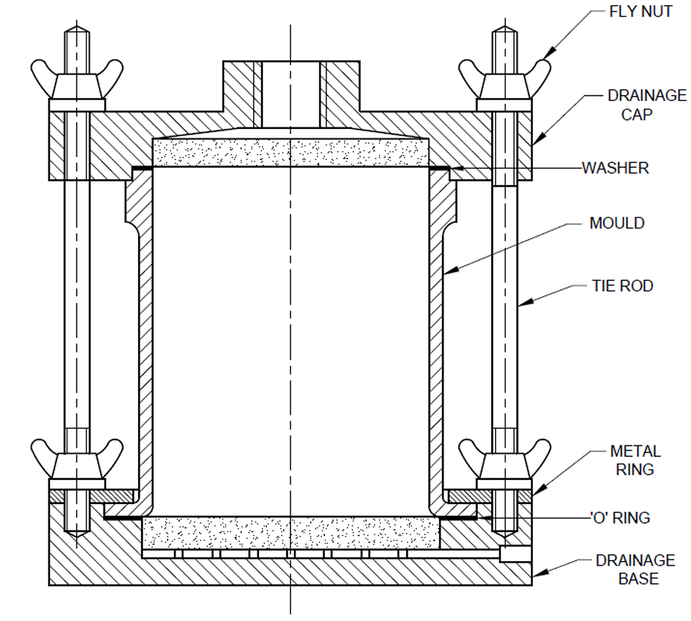

Washer to be mentioned at the upper portion and O-ring to be mentioned
below at the lower end

FIG. 1 PERMEABILITY CELL ASSEMBLY

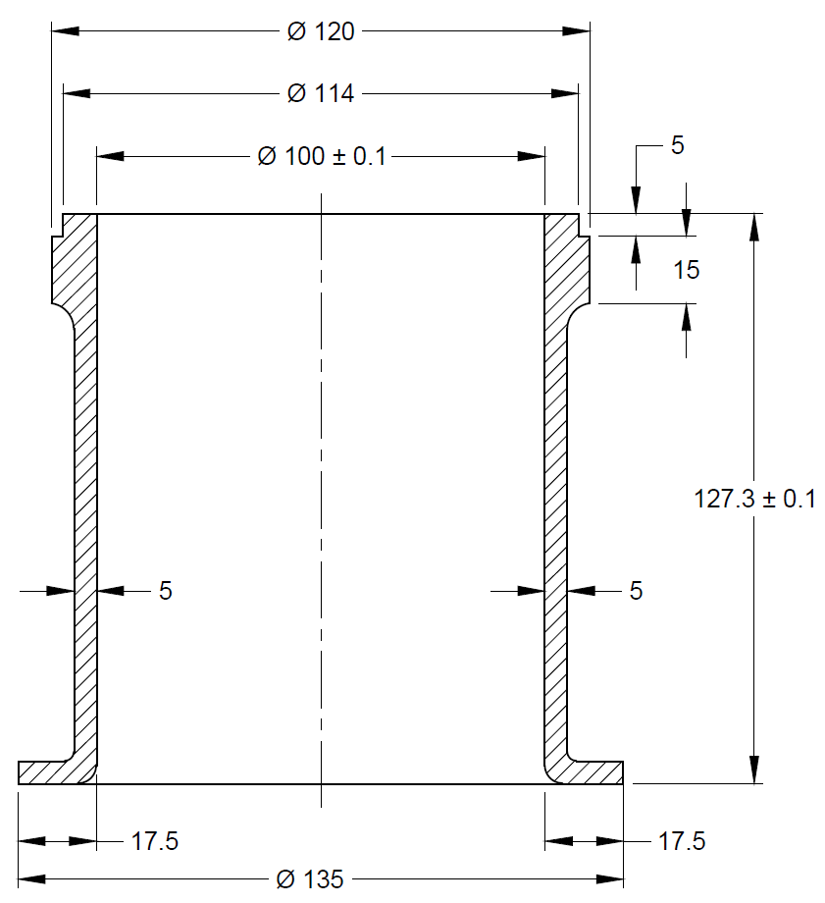
All dimensions in millimetres

FIG. 2 MOULD

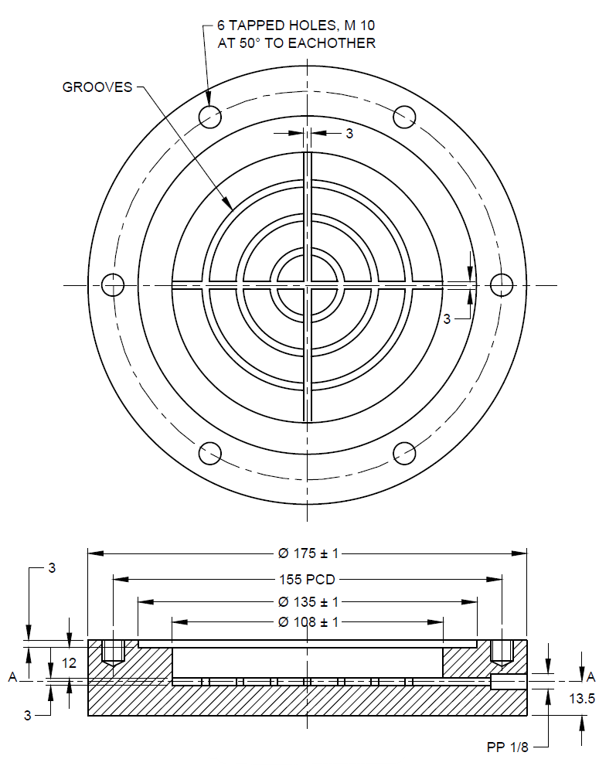
All dimensions in millimetres

FIG. 3 DRAINAGE BASE

NOTE — Line A-A shown in Fig 3 is the line from which the water level shall be measured. This line is at a height of 13.5 mm from the bottom.

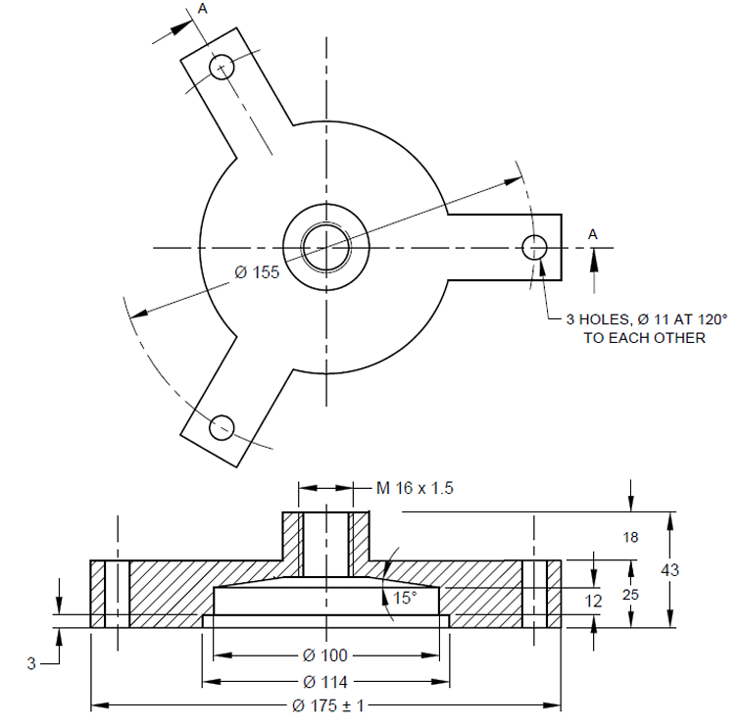
All dimensions in millimetres.

FIG. 4 DRAINAGE CAP

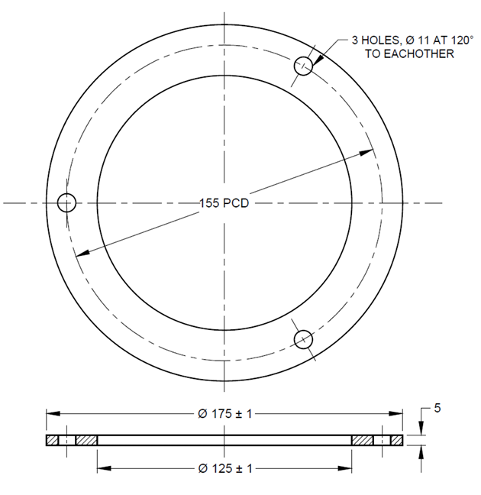
All dimensions in millimetres.

FIG. 5 METAL RING

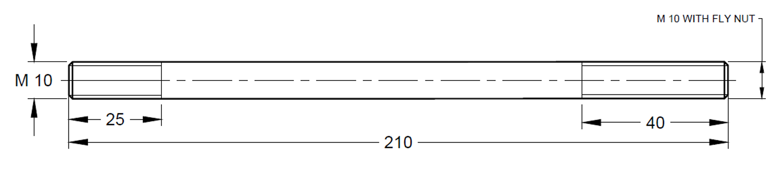
All dimensions in millimetres.

FIG. 6 TIE ROD

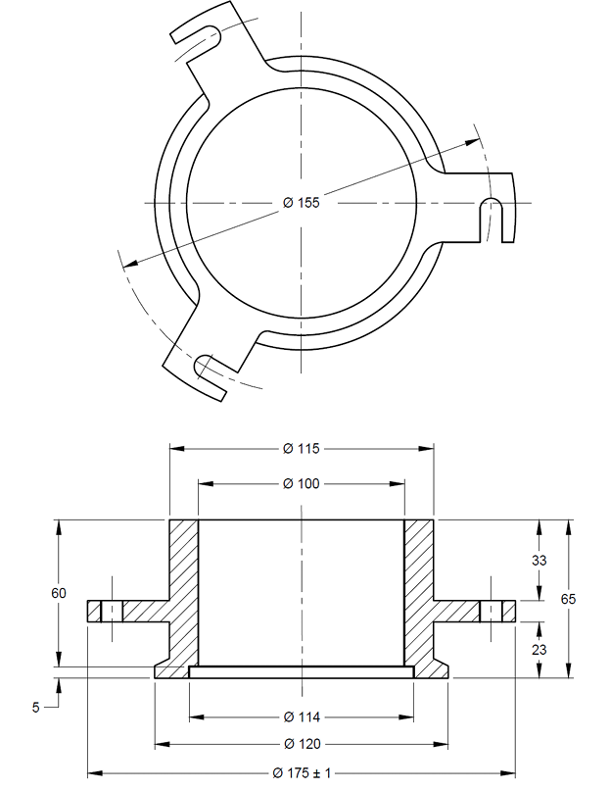
All dimensions in millimetres.

FIG. 7 EXTENSION COLLAR

6 MARKING

6.1 The following information shall be clearly and indelibly marked on each equipment:

a) Name of the manufacturer or his registered trade-mark or both;
b) Type of material; and
c) Date of manufacture.

6.2 BIS Certification Marking

The product conforming to the requirements of this standard may be certified as per the conformity assessment schemes under the provisions of the Bureau of Indian Standards Act, 2016 and the Rules and Regulations framed thereunder, and the product may be marked with the Standard Mark.

ANNEX A
(Foreword)
COMMITTEE COMPOSITION

Soil and Foundation Engineering Sectional Committee, CED 43

Organization | Representative(s)
In Personal Capacity, 473, Vinayak Apartments, BHEL Housing Society, Plot No. C-58/19, Sector 62, Noida, Uttar Pradesh - 201301 | Shri C. Pushpakaran (Chairperson)
AFCONS Infrastructure Limited, Mumbai | Dr Sunil Basarkar  Dr Lakshmana Rao Mantri (Alternate-I)  Shri Budhmal Jain (Alternate-II)
AIMIL Limited, New Delhi | Shri Rohitash Barua  Smt Aarti Bhargava (Alternate-I)  Shri Anil Singh (Alternate-II)
Bharat Heavy Electricals Ltd, New Delhi | Shri T. M. S. Rao  Shri Vikram S. (Young Professional)
CEM Engineers and Consultants Pvt Ltd, Bhubaneswar | Shri Ashok Basa  Shri Dilip Basa (Alternate)
Cengrs Geotechnica Pvt Ltd, Noida | Shri Sanjay Gupta  Shri Ravi Sundaram (Alternate)  Shri Sorabh Gupta (Young Professional)
Central Board of Irrigation and Power, New Delhi | Director
Central Electricity Authority,  New Delhi | Shri Baleshwar Thakur  Shri Deepak Singh Raghuvansi (Alternate)
Central Public Works Department,  New Delhi | Shri Nagendra Prasad  Shri Amrendra Kumar Jalan (Alternate)
Central Soil and Materials  Research Station, New Delhi | Dr Manish Gupta  Ms Swapna Varma (Alternate)
CSIR-Central Building Research  Institute, Roorkee | Shri Manojit Samanta  Dr S. Ganesh Kumar (Alternate)  Shri Kaushik Pandit (Young Professional)
CSIR-Central Road Research  Institute, New Delhi | Dr Kanwar Singh  Dr P. S. Prasad (Alternate)
CSIR-Structural Engineering  Research Centre, Chennai | Dr P. Kamatchi  Smt R Sreekala (Alternate)  Dr A. Thirumalaiselvi (Young Professional)
D-CAD Technologies,  New Delhi | Dr K. G. Bhatia
Delhi Development Authority,  New Delhi | Shri Arun Kumar  Shri Harindar Pal (Alternate)
Delhi Technological University,  New Delhi | Prof. Ashok Kumar Gupta
Engineers India Limited,  New Delhi | Shri V. K. Panwar  Shri Sampat Raj (Alternate-I)  Shri Anil Banoth (Young Professional)
Geodynamics Ltd, Vadodara | Dr Ravikiran Vaidya  Shri Sujan Kulkarni (Alternate)
Geological Survey of India,  Kolkata | Dr Timir Baran Ghosal  Shri Prashant Tukaram Ilamkar (Alternate)
Ground Engineering Limited,  New Delhi | Shri Ashok Kumar Jain  Shri Neeraj Kumar Jain (Alternate)
Hindustan Construction Company  Limited, Mumbai | Representative
Indian Geotechnical Society,  New Delhi | Prof H. N. Ramesh  Dr Anil Joseph (Alternate)  Prof D. Neelima Satyam (Alternate-II)
Indian Institute of Science,  Bengaluru | Prof Jyant Kumar  Prof G. Madhavi Latha (Alternate)
Indian Institute of Technology  Delhi, New Delhi | Dr G. V. Ramana  Dr J. T. Shahu (Alternate-I)  Dr Prashanth Vangla (Young Professional)
Indian Institute of Technology  Kanpur, Kanpur | Prof Priyanka Ghosh
Indian Institute of Technology  Madras, Chennai | Prof Subhadeep Banerjee  Prof Ramesh K Kandasami (Alternate)
Indian Institute of Technology  Bombay, Mumbai | Prof Deepankar Choudhury  Prof Dasaka Murty (Alternate)
Indian Institute of Technology  Roorkee, Roorkee | Dr Mahendra Singh  Dr Vishwas A. Sawant (Alternate)
Indian Road Congress, New Delhi | Secretary General  Director (T) (Alternate)
Indian Society of Earthquake  Technology, Roorkee | Prof B. K. Maheswari  Prof Vasant A. Matsagar (Alternate)
ITD Cementation India Ltd, Kolkata | Shri Manish Kumar  Shri Aminul Islam (Alternate)
Jadhavpur University, Kolkata | Prof Sibapriya Mukherjee  Prof Ramendu Bikas Sahu (Alternate)
Keller Ground Engineering Pvt Ltd, Chennai | Shri V. V. S. Ramadas  Shri Madan Kumar Annam (Alternate)
L&T GeoStructure Private Limited, Chennai | Shri M. Kumaran  Shri A. Vetriselvan (Alternate)
Military Engineer Services,  Engineer-in-Chief's Branch,  Integrated HQ of MoD (Army),  New Delhi | Shri Manoj Bapna  Shri Ajay Kumar Sinha (Alternate)
MECON Limited, Ranchi | Shri Shankar Ray  Shri Ayush Srivastava (Alternate)
Ministry of Ports, Shipping and  Waterways, New Delhi | Shri H. N. Aswath  Shri Anil Pruthi (Alternate)
Mumbai Port Trust, Mumbai | Dy Chief Engineer (Design)  Superintending Engineer (Design) (Alternate)
Nagadi Consultants Pvt Limited,  New Delhi | Dr V. V. S. Rao  Shri N. Santosh Rao (Alternate)
National Capital Region Transport  Corporation, New Delhi | Shri Jitender Kumar
National High Speed Rail  Corporation Ltd, Mumbai | Representative
National Institute of Disaster  Management, New Delhi | Dr Chandan Ghosh  Dr Amir Ali Khan (Alternate)
NTPC Limited, Noida | Shri Mohit Jhalani
Power Grid Corporation of India  Limited, Gurugram | Representative
Research Designs and Standards  Organization (Ministry of  Railways), Lucknow | Shri Sameer Singh  Shri S. K. Ojha (Alternate)
RITES Limited, Gurugram | Shri Koshy Vaidyan  Shri Sumeet Mahajan (Alternate)
Safe Enterprises, Mumbai | Shri Vikram Singh Rao  Shri Suryaveer Singh Rao (Alternate)
STUP Consultants Pvt Ltd, Mumbai | Shri Anirban Sengupta  Shri Yogesh Waingankar (Alternate)
Tata Consulting Engineers Limited, Mumbai | Shri Sanjeev Gupta  Shri B. N. Nagaraj (Alternate)
Telangana State Research  Laboratories, Hyderabad | Shri A. G. Manoj Kumar  Shri Ashirwadam Jakkula (Alternate-I)  Smt M. Manjula (Alternate-II)
The Pressure Piling Co (I) Pvt  Limited, Mumbai | Shri V. C. Deshpande  Shri Pushkar V. Deshpande (Alternate)
Unique Geocivil Services Pvt Ltd,  Surat | Shri Nehal H. Desai  Shri Hitesh H. Desai (Alternate-I)  Shri Dhruval D. Shah (Alternate-II)
In Personal Capacity, 1-B, Villakkupattam Palace, First Floor, 48, New Avadi Road, Kilpauk, Chennai 600010 | Dr V. Balakumar
BIS Directorate General | Shri Dwaipayan Bhadra, Scientist ‘E’/ Director and Head (Civil Engineering) [Representing Director General (Ex-officio)]
Member Secretary

Shri Dheeraj Damachya
Scientist ‘B’ / Assistant Director
(Civil Engineering), BIS

