**IS 4967 : XXXX**

***भारतीय मानक***

***Indian Standard***

(*Superseding IS 4967 : 1968*)

***बांध परियोजनाओं का भूकंप यंत्रीकरण***

*(* पहला पुनरीक्षण )

**Earthquake Instrumentation of Dam Projects**

( *First Revision )*

ICS 91.120.25

© BIS 2024

भारतीय मानक ब्यूरो

BUREAU OF INDIAN STANDARDS

मानक भवन, 9 बहादुर शाह ज़फर मार्ग, नई दिल्ली - 110002

MANAK BHAVAN, 9 BAHADUR SHAH ZAFAR MARG

NEW DELHI - 110002

[www.bis.gov.in](http://www.bis.org.in) [www.standardsbis.in](http://www.standardsbis.in)

**September 2024 Price Group X**

Earthquake Engineering Sectional Committee, CED 39

FOREWORD

This Indian Standard (First Revision) was adopted by the Bureau of Indian Standards, after the draft finalized by the Earthquake Engineering Sectional Committee had been approved by the Civil Engineering Division Council.

Earthquake instrumentation required for near real-time monitoring of dam projects will help in the earthquake safety assessment of the dams through the characterization of:

1. Earthquake sources around the dam projects before and after the construction of the structures,
2. Earthquake ground motion, structural responses of the structures, and verification of design parameters by the structural response measured during earthquake ground shaking, and
3. Reservoir induced seismicity.

This standard contains general provisions on earthquake instrumentation applicable to dams.

This standard was first published in 1968. This revisionis based on significant experience gained over the last five decades in earthquake instrumentation and monitoring of shaking of the ground and built structures during an earthquake. In 2022, the Committee decided to revise the provisions to keep abreast with rapid developments in instrumentation and extensive research carried out in earthquake-resistant design of proposed large projects and earthquake safety assessment of existing large projects.

In this revision, the following changes have been included:

1. The scope has been expanded to include instrumentation to capture strong earthquake shaking of:
   1. the ground at and adjoining the dam sites, and
   2. the buildings and critical structures associated with dams.
2. Guidance is provided on parameters of earthquake shaking to be captured, and on the selection of type, detailed specifications, location, and number of instruments.
3. Emphasis is laid on database management and processing protocols.
4. The provisions on dam projects have been extended to include:
5. Measurements needed,
6. Sensors to be used,
7. Digital Data System required,
8. Installation procedure to be adopted,
9. Maintenance to be complied with, and
10. Processing and dissemination of data to be agreed upon.

In the preparation of this standard, effort has been made to coordinate with standards and practices prevailing in different countries in addition to relating it to the practices in the field in this country.

The composition of the Committee responsible for the formulation of this standard is given in Annex A.

For the purpose of deciding whether a particular requirement of this standard is complied with, the final value, observed or estimated, expressing the result of a test or analysis, shall be rounded off in accordance with IS 2 : 2022 `Rules for rounding off numerical values (*second revision*)'. The number of significant places retained in the rounded-off value should be the same as that of the specified value in this standard.

*Indian Standard*

**EARTHQUAKE INSTRUMENTATION OF DAM PROJECTS**

(*First Revision*)

**1 SCOPE**

**1.1** This standard deals primarily with recommendations for instrumentation required for near real-time monitoring of dams and the associated built structures that are part of existing dam projects towards realistic earthquake responseestimation of structures, earthquake hazard monitoring and defining earthquake design criteria for structures to be built in future in that region*.*

**1.2** This standard provides guidelines in:

1. choosing the type, specifications, number, and location of instruments to be placed adjoining and on a dam to:
   1. determine sources (namely magnitude, hypocentral location, and source mechanism) of earthquakes in the geological neighbourhood of existing dams;
   2. capture earthquake ground motions and structural response of the dam; and
   3. study the possibility of the reservoirs triggering earthquakes;
2. identifying the method of installation of instruments, requirements of data acquisition, methods of data processing, protocols for data archiving of the earthquake shaking at and adjoining the dam site, earthquake responses of the dam, and schedules for maintenance of the instruments; and
3. tuning the analytical models to match the measured dynamic characteristics of the dams, which are used in the earthquake analysis as part of the processes of structural design and structural assessment phases.

**1.3** The provisions of this standard may be adopted in dam projects, after suitably customizing to meet the needs of such projects. In such cases, the requirements specified by this standard shall be taken as at least the minimum that should be met with.

**2 REFERENCES**

The standards listed below contain provisions, which, through reference in this text, constitute provisions of this standard. At the time of publication, the editions indicated were valid. All standards are subject to revision, and parties to agreements based on this standard are encouraged to investigate the possibility of applying the most recent editions of the standards indicated below:

|  |  |
| --- | --- |
| *IS No.* | *Title* |
| CED39 (22343) | Criteria for earthquake resistant design of structures Part 1 General provisions (*seventh revision* of IS 1893) (*under preparation*) |
| CED39 (25407) | Earthquake Resistant Design and Detailing of Structures Code of Practice Part 1 General Provisions (*second revision of* IS 13920) (*under preparation*) |

**3 TERMINOLOGY**

For this standard, the definitions given below shall be applicable.

**3.1 Accelerometers** —Strong-motion sensors are accelerometers designed to measure the large amplitude high-frequency seismic waves typical to large magnitude local earthquakes. These seismic waves result in the strong ground motion felt during a large earthquake.

**3.2 Broadband Velocity Seismometer** — Three component sensors capable of sensing ground motions over a wide range of frequencies, hence the term 'broadband'. Modern, feedback electronics lead to the housing of three-component broadband sensors in a single case, and are portable and can be deployed at short notice to record weak motions from micro, regional, and teleseismic earthquakes, as well as ambient noise.

**3.3 Data Acquisition System (DAS)** — Signal conditioners consisting of pre-amplifiers, analog to digital (*A/D*) converters, time signal receivers, on-site data storage units, telemetry interface, and state of health information to both local and remoter users.

**3.4 Global Positioning System (GPS)** — An all-weather system that uses radio signals from a minimum of four satellites to determine its own world-wide terrestrial location using passive receivers.

**3.5 Metadata** — Information about station location, recording instrument characteristics and data quality.

**3.6 Seismograph** — An instrument comprising a sensor and recording device to record ground motions during the earthquake.

**3.7 Strong Ground Motion** — Large amplitude ground motion arising from near earthquakes or large magnitude farther earthquakes.

**3.8 Time Series Data** — Continuous seismological information varying with time at a seismological station like seismograms are velocity records and accelerograms are strong motion acceleration records.

**3.9** **Weak Ground Motion** — Small amplitude ground motion arising from distant earthquakes or small magnitude near earthquakes.

**4 ABBREVIATIONS**

Unless otherwise stated, the abbreviations specified below shall be used.

|  |  |
| --- | --- |
| *Abbreviation Used* | *Description* |
| (1) | (2) |
| DAS | Data Acquisition System |
| RMS | Root Mean Square |
| GPS | Global Positioning System |
| PGA | Peak Ground Acceleration |
| PGV | Peak Ground Velocity |
| PGD | Peak Ground Displacement |
| CRS | Central Receiving Station |
| OEM | Original Equipment Manufacturer |
| SEED  RH  STA  LTA VSAT | Standard for the Exchange of Earthquake Data  Relative Humidity  Short Term Average  Long Term Average  Very Small Aperture terminal |

**5 PRINCIPLES OF EARTHQUAKE MONITORING**

Earthquake monitoring of a dam requires placing of appropriate type and number of instruments of required sensitivity and range which are placed at the appropriate locations for capturing the free-field earthquake ground shaking and response of the dam. This effort to instrument all dams is humongous. Hence, the instrumentation shall be undertaken in a phased manner, with priority for dams in earthquake zones VI, V, and IV.

**5.1 Instrument Location**

Earthquake monitoring of dams requires placing sensors in the free-field earth adjoining the dam and on the dam structure itself. The locations of these instruments should be at the locations of dominant response of the dam.

**5.2 Measurements**

**5.2.1** Two sets of motions shall be measured, namely:

* + 1. Shaking of the ground at and adjoining the dam site, and
    2. Shaking of the dam.

**5.2.2** The following information shall be determined from the above measurements:

1. Earthquake source parameters, namely hypocentral location (latitude, longitude, and focal depth), time of occurrence of the earthquake, focal mechanism (strike-slip, normal, and thrust), and magnitude of the earthquake;
2. Velocity and acceleration of the ground at and adjoining the dam, and of the dam at different locations along the three cartesian directions; and
3. Response spectra of the motions recorded along with natural frequencies, mode shapes and damping of the dam.

**5.3 Instrument Type**

The selection of instruments shall depend on the measurements to be made and information to be extracted. Table 1gives the instruments to be used for different parameters. The range of instruments is indicated in Table 1 are suggestive; more specific determination of the range of instruments needs to be undertaken depending on the severity of earthquake hazard and the height of the dam.

**5.4 Database Management**

The data collected from the instruments at a dam site shall be archived, processed, conclusions drawn, and disseminated to the concerned stakeholders. When doing so, the earthquake parameters specified in **5.2** shall be provided in a standard format.

**Table 1 Instruments needed to measure Different Parameters**

(*Clause* 5.3)

|  |  |  |  |
| --- | --- | --- | --- |
| **Sl No.** | **Measurement** | **Instrument Type** | **Suggestive Instrument Range** |
| (1) | (2) | (3) | (4) |
| **Shaking of the ground** | | | |
| i) Adjoining the dam site | | | |
|  | 1) Velocity of the ground, m/s | Broadband seismometer | ± 2 |
| ii) At the Dam Site | | | |
|  | 1) Acceleration (g), m/s2 | Strong Motion Accelerograph | ± 2 |
|  | 2) Displacement, m | Global Positioning System Device | ± 2 |
| **Shaking of the Dam** | | | |
| i) Acceleration (g), m/s2 | | Strong Motion Accelerograph | ± 2 |
| ii) Velocity, m/s | | Seismometer | ± 2 |

**5.5 Processing Protocols**

The internationally acceptable global protocols shall be adopted for measurement, archiving, processing, and dissemination of data. A summary of the protocols required are presented in Table 2.

**Table 2 Protocols Required for Processing Ground Motions**

(*Clause* 5.5)

|  |  |  |
| --- | --- | --- |
| **Sl No.** | **Requirement** | **Protocol** |
| (1) | (2) | (3) |
| i) | Data acquisition | Standard protocol by global agencies |
| ii) | Data archiving | Standard protocol by:   1. National Center for Seismology, Ministry of Earth Sciences, Government of India, and 2. Global Agencies |
| iii) | Data processing | Standard protocol by global agencies except that ground motions shall not be corrected to remove the near-fault residual displacement (that is*,* slip) |
| iv) | Data dissemination | National Center for Seismology, Ministry of Earth Sciences, Government of India |

**6 INSTRUMENTATION OF DAMS**

The provisions given hereunder shall be applicable to all types of dams, embankments, and appurtenant structures.

**6.1 Measurements Needed**

The main reasons for seismic monitoring of dams are:

1. Precisely defining the seismicity of the region, that is, the exact location of earthquake epicenters and their depths,
2. Defining magnitude, frequency characteristics and source mechanism,
3. Providing data on the dynamic behaviour of the dam body for the purpose of objective evaluation of its functioning immediately after the occurrence of earthquake, and
4. Verifying design parameters by the actual behaviour of the dam body during strong ground shaking.

**6.1.1** *Free Field Motion*

At least three accelerographs need to be installed at different locations (such as at the bottom of the canyon and others at the top of the canyon) to discriminate the ground motion variation due to the geo-morphological conditions.

**6.1.2** *Abutment Motion*

Strong motion data of the abutment structures with the canyon shall provide information about relative motion, if any, between abutments and dam structure during an earthquake.

**6.1.3** *Dam Responses*

When capturing the dam response, the modal characteristics of the vibration of the dam become an important criterion. The fundamental mode and the higher modes of vibration of the dam structure are obtained through processing of the strong motion accelerogram data.

**6.2 Sensors**

Earthquake instruments shall be classified into two categories, namely broadband velocity seismometers and strong motion accelerographs. The data from these sensors are recorded onto a Digital Acquisition System.

1. *Velocity Meter —* The broadband velocity seismometer is a tri-axial, force-balanced, broadband velocity transducer with electronic feedback and axial accuracy better than 1°.
2. *Accelerometer —* An accelerometer is an electromechanical tri-axial device, which records accelerations along the three cartesian directions.
3. *Displacement Meter —* A displacement meter is a global positioning system, the tri-axial device that records displacements along the three cartesian directions.

**6.2.1** *Specifications*

1. *Broadband Seismographs* — Broadband velocity seismometer and data acquisition system are an integral part of the system to record ground motion velocity with time. The instruments of the present generation are digital systems with the sensors working on the principle of force feedback system. The minimum specifications of the sensors required to be deployed shall be as specified hereunder.

The sensor shall have the following capabilities:

* 1. *Tri-axial Measurement* — It should measure vertical, north-south, and east-west motions.
  2. *Type* — It should be a force-balanced broadband velocity transducer with electronic feedback and axial accuracy better than 1°, for surface fault deployment.
  3. *Frequency Response*: It should have a flat response (within +/- 3 dB) to ground velocity in the range of 120 sec to 50 Hz.
  4. *Dynamic Range* — It should be 135 dB or more;
  5. *Full-scale Output voltage —* It should be ± 20V;
  6. *Damping —* It should be 0.7 times of critical damping;
  7. *Output Sensitivity* — It should be 1,500 V/(m/s) or more;
  8. *Linearity* — It should be less than ± 1 percent of full-scale
  9. *Mass Centering —* It should have an option to perform the mass centering through a motorized method either, by an external command given locally or remotely. The temperature range for which no centering is required shall not exceed ± 20°C.
  10. *Frequency Response Curve* — It should have a frequency response curve of the unit along with information regarding the transfer function including poles, zeros, and normalization factor provided by the manufacturer (for each sensor as per the serial number) shall be over the range of 120 sec to 50 Hz;
  11. *Noise* — It should have a noise response below the USGS New Low Noise Model in the frequency range of 120 sec to 50 Hz. Test reports of the sensor noise over the full pass band should be provided by the manufacturer;
  12. *Levelling* — Bubble level indicator should be provided for leveling the transducer;
  13. *Orientation —* Suitable marks should be provided to indicate the direction of the relative orientation of the transducer;
  14. *Mass Locking —* Automatic or manual mass locking and safety mechanism should be provided to be activated during transportation;
  15. *Enclosure* — The sensor should be placed in a shock and water-resistant enclosure; and
  16. *Humidity* — It should be functional up to 100 percent RH.
  17. *Power* — It should have an input power range 9V-18V DC.
  18. *Power Consumption —* It should have 1.5 watts or less at 12V DC.
  19. *Generator constant* — It should 1,200 Volts/(m/s) or more.
  20. *Others* — It should have:

1. A reverse voltage protection and over-voltage protection with built-in lightning protection.
2. An airtight thermal insulation cover from OEM shall be provided.
3. A rugged field carry case for a seismometer from OEM shall be provided.
4. Detailed user manual, data sheets and calibration data templates.
5. The test reports of the quoted model of the seismometer from internationally recognized standard test laboratories (like USGS Albuquerque seismological laboratory or IRIS) along with technical bid documents.
6. *Strong Motion Accelerographs* — These are triaxial, orthogonally oriented, force-balanced transducers (one vertical and two horizontal) along with the data acquisition system in a single sealed unit.

The sensor shall have the following capabilities:

* 1. *Full-Scale Range* — It should be user-selectable through the software, and of the ranges ± 4g, ± 2g, and ± 1g;
  2. *Frequency response —* Flat (within ± 3 dB) to ground acceleration in the range of 0 Hz to 200 Hz;
  3. *Dynamic Range* — It should be 150 dB or more at 3 Hz to 30 Hz;
  4. *Full-scale Output voltage —* It should be ± 2.5 V;
  5. *Linearity* — It should be less than 1 000 μg/g2;
  6. *Hysteresis* — It should be less than 0.1 percent of full scale;
  7. *Cross-axis sensitivity —* Less than 0.5 percent of full scale;
  8. *Orientation —* A suitable mark shall be placed to indicate the direction of relative orientation of the transducer;
  9. *Calibration Facility* — It should be accessible for calibration from a 24-bit Data Acquisition System (DAS) locally or remotely from the central recording station through DAS;
  10. *Recording Mode —* It should have continuous and triggered capabilities;
  11. *Triggering —* The DAS should be capable of recording the acceleration data in the STA/LTA ratio trigger, threshold trigger, and time window options;
  12. *Trigger Selection —* It should permit independent selection for each channel;
  13. *Threshold Trigger —* It should be user-selectable from 0.01 percent to 100 percent of the full scale;
  14. *Pre-event Recording Length —* It should be user-selectable for up to 30 s or more; and
  15. *Post-event Length —* It should be user-selectable for up to 90 sec or more.
  16. Detailed user manual, data sheets, and calibration data sheet of the accelerometer should be provided.

**6.2.2** *Location and Number*

Strong motion accelerographs should be installed at least at the base of the dam in a recess provided in the foundation gallery and at the top of the dam; if intermediate galleries are present. The location shall be such that the background noise created due to the vibration originating from the appurtenant works of the dam is avoided. The instruments located in the foundation gallery are meant for observing the input ground motion in the event of major earthquake. The instruments located at the top of the dam (and at intermediate heights) are expected to provide information about the response of the dam to the earthquake. A general representation of location of different sensors is given at Fig. 1.

The minimum number and comprehensiveness of the broadband seismographs required for monitoring the local earthquake activity, based on dam height, are given as below:

a) *H* < 30 m : 1 Tri-axial broadband seismograph

b) 30 m < *H* < 60 m : 3 Tri-axial broadband seismographs

c) 60 m < *H* <100 m : 5 Tri-axial broadband seismographs in a radius of 50 km

d) *H* > 100 m : To be decided by the Competent Authority

In regions where large magnitude earthquakes occurred in the past, the GPS instruments (for recording the displacements in the near field) shall be co-located with broadband seismographs and strong motion accelerographs.

1. *Concrete Dams —* A maximum of twelve accelerographs are proposed for installation, the layout of which shall be:

1) Crest : 4

2) Abutment : 2

3) Toe : 2

4) Heel : 2

5) At half the distance between crest and toe : 1

6) At half the distance between crest and Heel : 1

A typical arrangement of seismographs in concrete gravity and arch dams is represented in Figs. 2, 3 and 4.

1. *Earth Dams and Embankments —* At least a minimum of five accelerographs shall be installed, the layout of which shall be:

1) At the crest : 1

2) Abutments : 2

3) At the toe : 1

4) Half way between the toe and the crest : 1

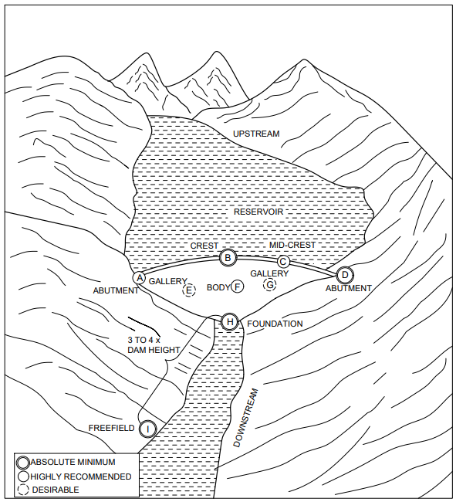

Fig. 1 Dam Seismic Instrumentation

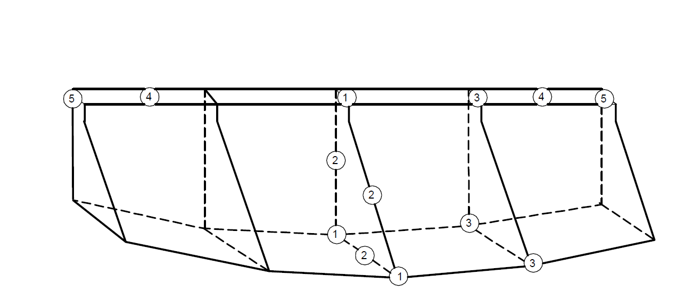

Fig. 2 Scheme of Strong Motion Accelerographs

for Gravity Dams

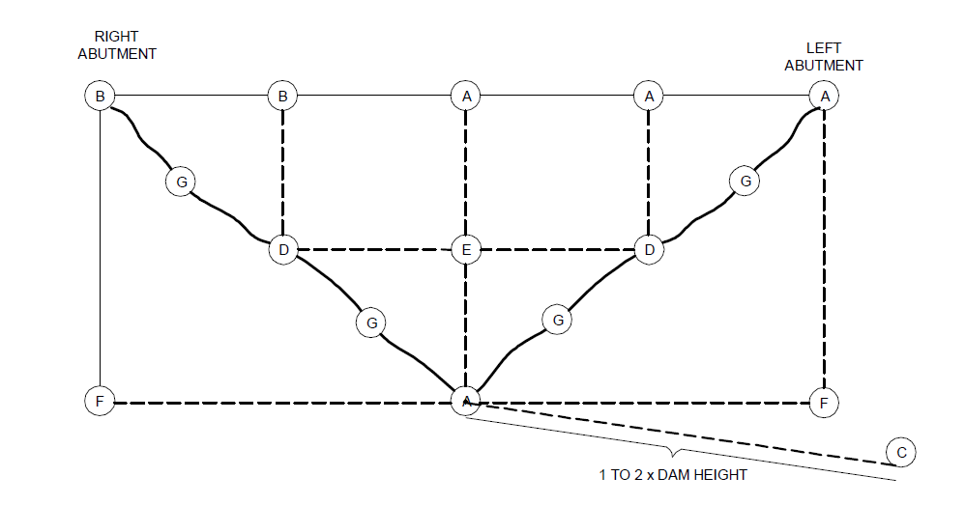

Fig. 3 Downstream View of Scheme of Strong Motion

Accelerographs for Arch Dams

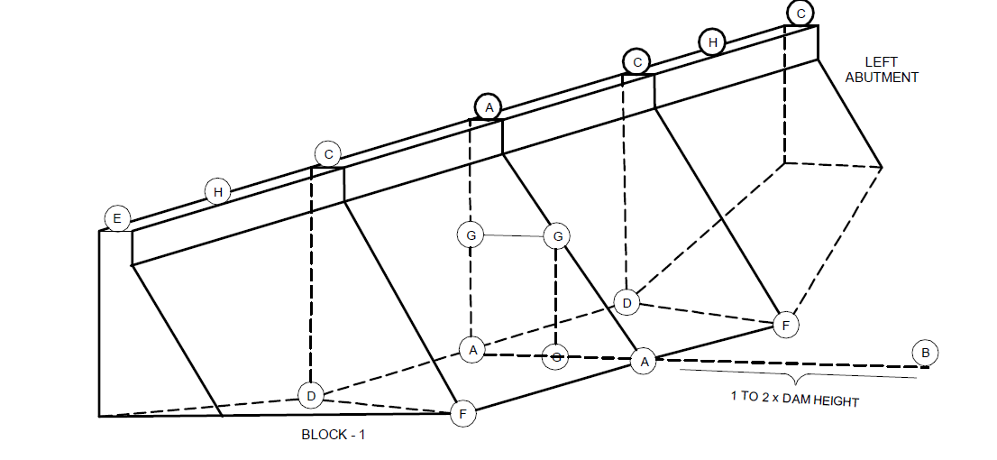

Fig. 4 Scheme of Strong Motion Accelerographs

for Gravity Dams

**6.3 Digital Data System**

The preamplifiers shall be capable of adjusting the analog output of the sensor, match impedance and adjusting gain level on the input to the A/D converter. These digitizers shall be power efficient and designed for rugged, harsh environments.

**6.3.1** *Resolution*

The salient specifications are:

|  |  |  |
| --- | --- | --- |
| 1. Number of Channels | : | 3 |
| 1. Digitizers | : | 3 independent 24-bit digitizers, 1 per channel |
| 1. Dynamic Range | : | ≥ 135 dB @ 100 samples per second |
| 1. Input Full-Scale Range | : | Sensor output with full scale at ± 20V (40 Vpp) |
| 1. Common Mode Rejection Ratio | : | > 70 dB |
| 1. Channel to Channel Skew | : | Zero (simultaneous sampling of all the channels) |

**6.3.2** *Noise Level —* The overall system noise shall not be more than 2-3 counts of 24-bit system on a Root Mean Squared basis in the frequency range of 120 sec to 50 Hz.

**6.3.3** *Sensor Controller —* The sensor controller shall have the facility to calibrate, mass position monitoring, and mass centering on command of the broadband seismometer.

a) *Resolution*

A status indicator (in-built or external) for indicating the power, data acquisition and GPS status shall be provided. The DAS shall be capable of:

* 1. Recording on the local storage media as well as support real-time data telemetry to a central site through VSAT telemetry network simultaneously; and
  2. Retrieving the old data in the storage media from Central Recording Station manually through VSAT network.

b) *GPS Receiver Clock*

It shall have the following capabilities:

1) Timing accuracy of ±10 μ s or better when GPS is locked;

2) Free running accuracy 0.1ppm over a wide range of temperature;

3) Record of GPS status information;

4) DAS-GPS cable length of at least 20 meters with end connectors; and

5) Rust proof GPS mounting rod and accessories.

c) *Power Requirements*

The following shall be the features:

* 1. Supply voltage 9-18V DC;
  2. Power consumption < 1.5 watts, 12V DC for recording 3 channels at 100 samples per second, and continuous mode data acquisition;
  3. Supply power isolated from the signal ground;
  4. Reverse voltage protection;
  5. Low battery voltage protection;
  6. DAS power cable of at least 3 m length;
  7. Resumption of data acquisition automatically when power is restored after disruption;
  8. Operating Temperature - 20°C to 60°C;
  9. Humidity resistance up to 100 percent RH;
  10. DAS and GPS units enclosed in weather and shock resistant sealed enclosures with lightning protection; and
  11. Detailed user manual and data sheet shall be provided.

d) *Sampling —* The sampling rate shall be:

* 1. User selectable up to 1 000 samples per second/channel in different data streams (at least 2 or more);
  2. Simultaneous recording at different sampling rates in different streams (at least 2 or more), both in continuous and trigger modes; and
  3. Trigger parameters should be user selectable.

**6.3.4** *Recording System*

The data recording and storage system shall have the following features:

* + 1. RAM of 8 MB or more;
    2. User removable recording media of capacity 32 GB or more;
    3. Hot-swappable recording media;
    4. Standard seismic data recording format compatible with Windows and Linux platforms with proven compression technique;
    5. Capability to record on the stand-alone mode on a local storage media as well as support real-time data telemetry to a central site through VSAT telemetry network simultaneously; and
    6. Internet or VSAT-based recording with:

1. *Communication Ports*

i) USB and/or serial port for ethernet connectivity to a local terminal for parameter setting and data downloading; and

ii) Ethernet port (10/100 Base - T) supporting TCP/IP Protocol.

1. *DAS Firmware Features*

i) Web browsing support/ communication over TCP/ IP;

ii) Support off-the-shelf communication equipment;

iii) Extensive error correction;

iv) Status indicator (in-built or external) for indicating the power, data acquisition, and GPS status should be provided; and

v) DAS with the facility to retrieve old data manually from the storage media of the Central Recording Station through the VSAT network.

1. Connectivity to central monitoring station with built-in modem support for full duplex communication between the digitizer and terminal field station, and Central Receiving Station (CRS) Triggered or continuous data transmission.

**6.4 Installation**

The earthquake instruments shall be installed to record free field ground motion, abutment motion and dam response.

**6.4.1** *Free Field Motion*

The instruments shall be located near both abutments at the toe of the dam. But, the need to install instruments at suitable distances beyond any significant influence of the dam on the recorded ground motion shall be determined by an expert group constituted by the Competent Authority. Ambient noise survey shall be carried out for ascertaining the back ground noise due to spillway discharge or hydro power stations for establishing the seismological locations.

**6.4.2** *Abutment Motion*

The instruments shall be located at the downstream toe and at the abutments as close to the dam as possible. They shall be placed on concrete piers firmly secured to the underlying rock or surface material, which is protected by an earthquake resistant enclosure. But, finding suitable locations at the toe may be difficult owing to water conditions, and at the abutments owing to restricted access due to topographic conditions.

**6.4.3** *Dam Response*

One or two instruments shall be installed on the crest of both earth and concrete dams. The locations shall be:

* + 1. Where maximum deformation is expected to be strong motion during earthquake shaking; and
    2. At about one-third of the crest length from an abutment.

**6.5 Maintenance**

The instruments shall be maintained every six months to capture the state of health of the dam for its continuous operation.

**ANNEX A**

(*Foreword*)

**COMMITTEE COMPOSITION**

Earthquake Engineering Sectional Committee, CED 39

| *Organization* | *Representative(s)* |
| --- | --- |
| Indian Institute of Technology Madras, Chennai | Prof C. V. R. Murty **(*Chairperson*)** |
| Atomic Energy Regulatory Board, Mumbai | Dr A. D. Roshan |
| B & S Engineering Consultants, Noida | Shri Alok Bhowmick  Shri Sanjay Kumar Jain (*Alternate*) |
| Bharat Heavy Electricals Limited, New Delhi | Shri Sushil K. Mahato  Shri Amit Kumar (*Alternate* I)  Shri Ravi Kumar Ponna (*Alternate* II) |
| Central Public Works Department, New Delhi | Shri Dinesh Kumar Ujjainia |
| Creative Design Consultants Pvt Ltd, Ghaziabad | Shri Aman Deep  Shri Barjinder (*Alternate*) |
| CSIR–Central Building Research Institute, Roorkee | Dr Navjeev Saxena  Dr Ajay Chourasia (*Alternate*) |
| CSIR–National Geophysical Research Institute, Hyderabad | Dr Prantik Mandal  Dr Sandeep Kumar Gupta (*Alternate*) |  |  |
| CSIR–Structural Engineering Research Centre, Chennai | Dr R. Sreekala  Dr K. Satish Kumar (*Alternate*) |
| DDF Consultants Pvt Ltd, New Delhi | Dr Pratima R. Bose  Shri Sadanand Ojha (*Alternate*) |
| Engineers India Limited, New Delhi | Dr G. G. Srinivas Achary  Dr Sudip Paul (*Alternate*) |
| Geological Survey of India, Kolkata | Shri L. H. Moirangcha  Shri Snehasis Bhattacharya (*Alternate*) |
| Indian Association of Structural Engineers, New Delhi | Shri Manoj K. Mittal  Shri Rajiv Ahuja (*Alternate*) |
| Indian Concrete Institute, Chennai | Dr K. P. Jaya  Dr Debashish Bandopadhyay (*Alternate*) |
| Indian Institute of Technology Bombay, Mumbai | Prof Ravi Sinha  Dr Alok Goyal (*Alternate*) |
| Indian Institute of Technology Bhubaneswar, Bhubaneswar | Dr Suresh Ranjan Dash |
| Indian Institute of Technology Delhi, New Delhi | Prof Dipti Ranjan Sahoo  Dr Vasant Matsagar (*Alternate*) |
| Indian Institute of Technology Gandhinagar, Gandhinagar | Prof Amit Prashant  Dr Manish Kumar (*Alternate*) |
| Indian Institute of Technology Kanpur | Prof Durgesh C. Rai |
| Indian Institute of Technology Madras, Chennai | Prof A. Meher Prasad  Dr Rupen Goswami (*Alternate*) |
| Indian Institute of Technology Roorkee, Roorkee | Prof Yogendra Singh  Dr Manish Shrikhande (*Alternate* I)  Dr B. K. Maheshwari (*Alternate* II) |
| Indian Society of Earthquake Technology, Roorkee | President  Vice President (*Alternate*) |
| International Institute of Information Technology, Hyderabad | Dr Pradeep Kumar Ramancharla |
| Malviya National Institute of Technology Jaipur | Dr S. D. Bharti  Dr M. K. Shrimali (*Alternate*) |
| National Centre for Seismology, Ministry of Earth Sciences, New Delhi | Dr O. P. Mishra  Dr H. S. Mandal (*Alternate*) |
| National Institute of Technology Goa, Goa | Dr O. R. Jaiswal |
| NTPC Ltd, New Delhi | Shri Praveen Khandelwal  Shri Saurabh Gupta (*Alternate*) |
| Research Design and Standards Organization, Lucknow | Shri Mohit Verma  Shri Manish Kumar (*Alternate* I)  Shri Sandeep Singh (*Alternate* II) |
| Tandon Consultants Pvt Limited, New Delhi | Prof Mahesh Tandon  Shri Vinay K. Gupta (*Alternate*) |
| Tata Consulting Engineers, Mumbai | Shri Arjun C. R. |
| R. S. Mandrekar & Associates | Dr. Jaswant N. Arlekar |
| Vakil-Mehta-Sheth Consulting Engineers, Mumbai | Ms Alpa R. Sheth  Shri R. D. Chaudhari (*Alternate*) |
| In Personal Capacity *(200 N.S.C. Bose Road South Enclave, Flat 301 Kolkata)* | Dr Indrajit Choudhary |
| In Personal Capacity *(Row House 4, Sun City Housing Society, Vadgaon Budruk)* | Dr I. D. Gupta |
| In Personal Capacity (*36*,*Old Sneh Nagar, Wardha Road, Nagpur*) | Shri L. K. Jain |
| In Personal Capacity (*H-102, VVIP Addresses, Rajnagar Extn,* *Ghaziabad*) | Dr A. K. Mittal |
| In Personal Capacity *(174/2 F, Solanipuram, Roorkee)* | Dr S. K. Thakkar |
| BIS Directorate General | Shri Dwaipayan Bhadra., Scientist ‘E’/Director and Head (Civil Engineering) [Representing Director General (*Ex-officio*) |

*Member Secretary*

Shri Jitendra Kumar Chaudhary

Scientist ‘B’/Assistant Director

(Civil Engineering), BIS

Composition of the Working Group, CED 39/WG 56

|  |  |
| --- | --- |
| *Organization* | *Representative(s)* |
| In Personal Capacity (*16-9-831/7/1 Sarojini Nagar Colony, Old malakpet, Hyderabad*) | Dr D. Srinagesh (**Convenor**) |
| Indian Institute of Technology Kanpur, Kanpur | Dr Durgesh C. Rai |
| Indian Institute of Technology Madras, Chennai | Dr S. T. G. Raghukanth |
| Malaviya National Institute of Technology Jaipur, Jaipur | Dr S. D. Bharti |
| In Personal Capacity (*Row House 4, Sun City Housing Society, Vadgaon Budruk*) | Dr I. D. Gupta |
| In Personal Capacity (*Flat no. 1507, Tower 5 Purvanchal Royal Park Sector 137, Noida*) | Dr Ashok Kumar Mathur |

**\*\*\*\*\*\*\*\***