भारतीय मानक
IS 4963 : 2024
Indian Standard

बुजुर्ग और विकलांग व्यक्तियों के लिए निर्मित वातावरण में
अभिगम्यता के लिए अपेक्षायें

(दूसरा पुनरीक्षण )

Requirement for accessibility in built environment for
older adults and persons with disabilities

(Second Revision)

(ICS No. 91.060.01)

© BIS 2024

भारतीय मानक ब्यूरो
BUREAU OF INDIAN STANDARDS
मानक भवन, 9, बहादुरशाह ज़फर मार्ग, नई दिल्ली — 110002
MANAK BHAVAN, 9, BAHADUR SHAH ZAFAR MARG NEW DELHI-110002
www.bis.gov.in www.standardsbis.in

March 2024
Price Group XX

Functional Requirements in Buildings Sectional Committee, CED 12
FOREWORD
This Indian Standard was adopted by the Bureau of Indian Standards, after the draft finalized by the Functional Requirements in Buildings Sectional Committee had been approved by the Civil Engineering Division Council.
This standard covers the requirements for accessibility in built environment to ensure a barrier-free environment for elders and persons with disabilities. The goal of barrier free deign is to provide an environment that supports the independent functioning of individuals so that they can participate without assistance, in everyday activities. It has been intended to progressively update these provisions and make the same more effective and elaborate based on experience gained with the implementation of this standard.
Through this standard, it is intended to make all buildings and facilities used by the public accessible to, and usable by all people including those living with disabilities and may include those with inability to walk or difficulty in walking, reliance on walking/mobility aids, blindness and visual impairments, speech and hearing impairments, in-coordination of motor movements, limitations of reaching and manipulation, lack of stamina, difficulty in interpretation and reacting to sensory information and extremes in physical sizes. This standard supplements the general requirements for accessibility and reflects greater concern for safety of life and limb of every resident irrespective of their age, gender or abilities.
This standard was originally published in 1968. In its first revision undertaken in 1987, the standard was revised to align it with ISO publication: ‘Needs of disabled people in buildings – Design guidelines’. In this revision, the provisions on accessibility have been aligned with those given in Annex B of Part 3 of the National Building Code of India 2016. In addition, the following important changes have been incorporated in this revision:
- Gender neutrality has been incorporated in the various provisions including for toilets and definition for the gender neutral/gender inclusive toilets has been added.
- A clause for reach range for children of various ages has been added.
- Lift size has been revised and detailed figures of control panel have been added. Lux levels in lifts have also been revised taking reference from ISO 21542.
- New provisions have been added for residential washrooms and family washrooms for children with ambulatory disabilities covering special requirements for children in washrooms for handrails and grab bars for Indian squat pans.
- Requirements in changing places toilets for people with profound and multiple disabilities have been added to provide a solution for people who require high level of assistance.
- Signage for accessible left handed and right handed toilets have been added.
- Requirements for emergency alarm system for outside assistance in accessible toilets have been added.
- Clauses for Neighbourhood play spaces, community facilities, educational and research buildings, and residential spaces have been added.
- New clauses for accessible transport stations and supporting infrastructure for rail transport, road transport, air transport and water transport have been added.
In this revision, opportunity has been taken to further mainstream the issue of barrier free environment by covering the requirements at greater length. The concept of universal design has also been included herein that promotes the usability of built environment by all without discrimination. It is worthwhile to note that Govt. of India has enacted The Rights of Persons with Disabilities Act 2016, which has more specific provisions in Chapter VIII - Duties and Responsibilities of Appropriate Governments (Section 39 to 48) that deal with formulation of rules for persons with disabilities laying down the standards of accessibility for different domains, time limits for making existing infrastructure and premises accessible and also time limits for accessibility of services by service providers among other things.
National policy for persons with disabilities also emphasizes the role of barrier-free environment as one that enables people with disabilities to move about safely and freely, and use the facilities within the built environment. Therefore, to the maximum extent possible, buildings/places/transportation systems for public use should be made barrier free. India has also signed and ratified the UN Convention on Rights of Persons with Disabilities that casts an obligation on the member states in its Article 9 'Accessibility', to enable persons with disabilities to live independently and participate fully in all aspects of life.
In this revision of the standard, assistance has also been derived from the following publications:
ISO 21542 : 2021 | Building construction — Accessibility and usability of the built environment
BS 8300-2: 2018 | Design for an accessible and inclusive built environment Part 2: Buildings — Code of practice
This standard contributes to the UN Sustainable Development Goal 10: ‘Reduced inequalities’ particularly its target to empower and promote the social, economic and political inclusion of all and Goal 11: ‘Sustainable cities and communities’, particularly its target to provide access to safe, affordable, accessible and sustainable transport systems for all.
The composition of the Committee responsible for the formulation of this standard is given in Annex A.
For the purpose of deciding whether a particular requirement of this standard is complied with the final value, observed or calculated, expressing the result of a test or analysis shall be rounded off in accordance with IS 2 :2022 ‘Rules for rounding off numerical values (second revision)’. The number of significant places retained in the rounded off value should be the same as that of the specified value in this standard.

Indian Standard
REQUIREMENTS FOR ACCESSIBILITY IN BUILT ENVIRONMENT FOR OLDER ADULTS AND PERSONS WITH DISABILITIES
(Second Revision)
1 SCOPE
This standard deals with the requirements of barrier free access to, movement within and around buildings, by the elderly persons and persons with disabilities who may have non-ambulatory disabilities, ambulatory disabilities, sight disabilities, hearing disabilities, disabilities due to incoordination, ageing, allergies, heart and lung diseases, epilepsy, haemophilia, incontinence, enterostomy, etc.
These requirements apply to all buildings and facilities open to and used by the public. These shall also apply to all forms of public housing by the government/civic bodies or private developers. It does not apply to individual private residences. For extent of application of requirements covered under this standard to different building occupancy types, reference shall be made to 5.
The reference to the accessibility needs of persons with disabilities, made in this standard shall also mean a reference to such needs of the elderly persons, children, women and persons of short stature / dwarfism in so far as the concerned provision is applicable to the type of disabilities that may be associated therewith.
2 REFERENCES
The following standards contain provisions, which through reference in this text, constitute provisions of this standard. At the time of publication, the editions indicated are valid. All standards are subject to revision and parties to agreement based on this standard are encouraged to investigate the possibility of applying the most recent editions of the standards indicated below:
IS No. | Title
IS 3646 (Part 1): 1992 | Code of practice for interior illumination: Part 1 general requirements and recommendations for working interiors (First Revision)
IS 4838 : 1990 | Anthropometric dimensions for school children age group 5 - 17 years (Second Revision)
IS 6571 : 1991 | Rehabilitation equipment — wheelchairs, non-folding, adult size, institutional model — Specification (First Revision)
IS 7454 : 1991 | Rehabilitation equipment — wheelchairs, folding, adult size — Specification (First Revision)
IS 8086 : 1991 | Rehabilitation equipment — wheelchairs, folding, junior size — Specification (First Revision)
IS 10976 : 1993/  ISO 6440 : 1985 | Wheelchairs — nomenclature, terms and definitions (First Revision)
IS 15330 : 2020 | Requirements of Lifts for Persons with Disabilities (First Revision)
3 TERMINOLOGY
For the purpose of this standard, the following definitions shall apply.
3.1 Ability — Identifiable human attribute, including but not exclusively, to walk, to speak, to hear, to see, to feel by touch, to taste, to understand, and to recognize.
3.2 Access Aisle — An accessible pedestrian space between elements, such as parking spaces, seating and desks, that provides clearances appropriate for use of the elements.
3.3 Accessible Site, Building, Facility or Portions — A site, building, facility, or portions thereof that complies with the requirements given in this standard to which people, regardless of their disability, age or gender are able to gain access to, in to them, to use them and exit from them with dignity.
NOTE ― Accessibility includes ease of independent approach, entry, evacuation and/or use of a building and its services and facilities, by all of the building's potential users with an assurance of individual health, safety and welfare during the course of those activities.
3.4 Accessible Route — A continuous unobstructed path connecting all accessible elements and spaces in a building or facility that may be negotiated by a person with disability using a wheelchair and that is also safe for and usable by persons with other disabilities. Interior accessible routes may include corridors, ramps, elevators, lifts, and clear floor space at fixtures. Exterior accessible routes may include parking, access aisles, kerb ramps, walkways, pathways, footpaths/sidewalks, and ramps.
3.5 Accessible Signage — Any visual way finding system incorporates architecture, landscape design, lighting, landmarks, and orientation points. Signage is one key element of an effective way finding system and should be accessible to all users including people with disabilities.
3.6 Accessible Toilet — A compartment having the basic requirements of minimum clear spaces, water-closet, washbasin and other essential washroom accessories as required by people with non-ambulatory disabilities. There are also toilets for ambulant disabled which provide accessibility for convenient use by persons with ambulatory disabilities.
3.7 Ageing — Those manifestations of the ageing processes that significantly reduce mobility, flexibility, coordination, and perceptiveness but are not accounted for in disability categories mentioned elsewhere in this standard.
3.8 Area of Rescue Assistance — Building space directly adjoining, and visible from, a main vertical evacuation route, robustly and reliably protected from heat, smoke and flame during and after a fire, where people can temporarily wait with confidence for further information, instructions, and/or rescue assistance, without obstructing or interfering with the evacuation travel of other building users
NOTE — ‘Robust’ means structurally hardened and resistant to mechanical damage during the fire and for a period of time afterwards, that is, the cooling phase.
3.9 Assistive Product/Device — Product/device especially produced or generally available, for preventing, compensating for, monitoring, relieving or neutralizing impairments, activity limitations and participation restrictions.
3.10 Assisted Evacuation — Strategy that exists during which a designated person or persons provide assistance, during an emergency, to another person to leave a building or a specific part of the built environment and to reach a final place of safety.
3.11 Automatic Door — A door equipped with a power operated mechanism and controls that open and close the door automatically upon receipt of a momentary signal. The switch that begins the automatic cycle may be photoelectrical device, floor mat, sensing device, or manual switch mounted on or near the door itself.
3.12 Circulation Path — An exterior or interior way of passage from one place to another for pedestrians, including walkways, pathways, hallways, courtyards, stairways and stair landings.
3.13 Circulation Space — Unobstructed space necessary for access to, into and within; and egress from any part of the built environment.
3.14 Clear — Unobstructed or so as to be out of the way of or away from.
3.15 Colour Contrast — The difference in colour that makes an object (or its representation in an image or display) distinguishable. It is determined by the difference in the colour of the object and other objects within the same field of view. Distinguishing one form/object from another by hue is the most basic and easily understood contrast.
NOTE ― The basic guidelines for making effective colour choices are based on the hue value of the colours. The most commonly used methods of achieving colour contrast incorporate either harmonizing or contrasting colour combinations. Contrast of hue is what relates most directly to the colour wheel combinations. The further away from each other two colours are, the higher the contrast. This means that the complementary colour combination has the highest contrast, while the analogous combination has the lowest.
3.16 Disability — An umbrella term for impairments, activity limitations, and participation restrictions, denoting the negative aspects of the interaction between an individual (with a health condition) and that individual’s contextual factors (environmental and personal factors). Disability is neither simply a biological nor a social phenomenon but arises from the relationship between health condition and context.
3.17 Grab Bars — A bar used to give a steadying or stabilizing assistance to a person engaged in a particular function.
3.18 Handrails — A rail used in circulation areas such as corridors, passageways, ramps and stairways to assist in continuous movement.
3.19 Hue — Attribute of visual sensation which has given rise to colour names, such as, blue, green, yellow, red and purple.
NOTE — People with normal colour vision report that hues follow a natural sequence based on their similarity to one another. With most colour deficits, the ability to discriminate between colours on the basis of hue is diminished.
3.20 Impairment — Limitation in body function or structure such as a significant deviation or loss which can be temporary due, for example to injury, or permanent, slight or severe and can fluctuate over time, in particular, deterioration due to ageing.
NOTE ― Body function can be a physiological or psychological function of a body system. Body structure refers to an anatomic part of the body such as organs, limbs and their components.
3.21 Incoordination — Lack of coordination especially of muscular movements resulting from loss of voluntary control.
3.22 International Symbol of Accessibility — The symbol consisting of a square overlaid with a stylized image of a person using a wheelchair (see 34.2.16 and Fig. 104).
NOTE ― The symbol is often provided where access has been improved, particularly for wheelchair users and other mobility impaired persons. The symbol denotes a barrier free environment, to help older people, parents with prams and travellers with luggage besides persons with disabilities. The wheelchair symbol is always facing to the right.
3.23 Kerb — A side barrier to a trafficable surface or the edge where a raised sidewalk/footpath, road median, or road shoulder meets an unraised street or other roadway.
3.24 Kerb Ramp — A short ramp cutting through a kerb or built up to it.
3.24 Knurled Surface — Roughened area, often in a crisscross pattern; used on grab bars to improve grasp and to prevent slipping.
3.25 Landing — A platform or part of a floor structure at the end of a flight of stairs or a ramp or at the entrance to a lift car.
3.26 Light Reflectance Value (LRV) — The total quantity of visible light reflected by a surface at all wavelengths and directions when illuminated by a light source.
3.27 Manoeuvring Zone — The minimum three dimensional space within which it is feasible to complete a manoeuvre needed to gain access to a specific facility, component or fitting, in particular while using a wheelchair or a walking aid.
3.28 Ramp — The construction, in the form of an inclined plane that is steeper than or equal to 1:20 (5 percent) from the horizontal, together with any intermediate landing, that makes it possible to pass from one level to another (see 11.2).
3.29 Operable Parts — A part of a piece of equipment or appliance used to insert or withdraw objects, or to activate, deactivate, or adjust the equipment or appliance (for example coin slot, push button, handle, etc).
3.30 Persons with Disabilities — A person with any physical, mental, intellectual or sensory impairment which in interaction with various barriers may hinder full and effective participation in society on an equal basis with others.
3.31 Public Buildings — Government or private building, used or accessed by the public at large, including a building used for educational or vocational purposes, workplace, commercial activities, public utilities, religious, cultural, leisure or recreational activities, medical or health services, law enforcement agencies, reformatories or judicial foras, railway stations or platforms, roadways bus stands or terminus, airports or waterways.
3.32 Public Facilities and Services — Includes all forms of delivery of services to the public at large, including housing, educational and vocational trainings, employment and career advancement, shopping or marketing, religious, cultural, leisure or recreational, medical, health and rehabilitation, banking, finance and insurance, communication, postal and information, access to justice, public utilities, transportation.
3.33 Space — A definable area (for example toilet room, hall, assembly area, entrance, storage, room alcove, courtyard, or lobby).
3.34 Tactile — That relating to perception using the sense of touch.
NOTE ― It relates to information and interpretations derived from the sense of touch. This involves sensory transfer through physical contact of the hands or feet with other surfaces, as well as sensory transfers received by contact with non-physical elements such as pressure, wind and temperature.
3.35 Tactile Ground Surface Indicators (TGSI)/ Tactile Walking Surface Indicators (TWSI) — Indicators profiled paving surface with visual contrast criteria to enable a person with impaired sight using a long cane, underfoot or visual identification to detect a specific route (guiding pattern) or the presence of a hazard (attention pattern).
NOTE ―These indicators which provide a distinctive surface pattern of strips and truncated domes or cones (small domes or cones that have had their tops cut off or truncated) are used to guide/alert persons with vision impairments of their approach to facilities, streets and hazardous drop-offs. People who are blind or visually impaired are alerted of impending danger from vehicle impact or a grade change.
3.36 Tactile Guiding Blocks — Tiles of size 300 mm x 300 mm that incorporate flat topped bars 5 mm (±0.5 mm) high, 20 mm wide and spaced 50 mm from the centre of one bar to the centre of the next, and are easily detectable underfoot by persons with visual impairments. They are used externally to guide people with visual impairments along the circulation path. They may also be used internally in large busy areas such as railway stations and airports.
3.37 Tactile Warning Blocks — Tiles of size 300 mm x 300 mm that incorporate rows of 5 mm (±0.5 mm) high flat topped blister like domes that are easily detectable underfoot by persons with visual impairments, recognized as a sign of approaching hazards. These are placed along the approach path to unavoidable obstacles and hazards to warn persons with visual impairments of the approaching danger or level change.
3.38 Tactile Signs — Tactile signage incorporates raised text or symbols to enable touch reading by people who are blind, and touch enhancement of visual perception for people who are vision impaired.
3.39 Threshold — a constructive element of the floor that serves to finish when there is a notable change in material or level. Typically, it is a sill of the door.
3.40 Unobstructed Width — Free unobstructed space necessary for passage through a doorway, along a passageway, or other route element (for example stairway).
3.41 Unobstructed Width, Door — Available width for passage through a door opening, clear of all obstructions, measured when the door is opened 90°, or when a sliding or folding door is opened to its fullest extent.
3.42 Unisex / Gender Inclusive / Gender Neutral Accessible Toilet — Accessible toilets that can be used by a person of any sex.
NOTE ― Unisex accessible toilets allow the greatest flexibility for people who require assistance. Unisex or gender-inclusive accessible toilet allows Persons with Disabilities to be assisted by carers of the same or opposite gender.
3.43 Universal Design — The design of products and environments to be usable by all people, to the greatest extent possible, without the need for adaptation or specialized design.
3.44 Upstand — Upstands at the side of ramps are used to prevent wheelchair users from falling over the edge of the ramp but also provide detection for people who are blind or have low vision who are using a cane.
3.45 Visual Contrast — Visual perception between one element of a building and another. This can be produced by a difference in light reflectance value (LRV) or luminance, also called luminance contrast.
NOTE ― Light reflectance value is measured on a scale of 0 to 100 where 0 equals black meaning total light absorption and 100 equals white meaning total light reflection.
A simple formula for visual contrast is given below for guidance:
$$\text{Visual contrast} \text{=} \frac{{\text{B}}_{\text{1}} \text{-}{ \text{B}}_{\text{2}}}{{\text{B}}_{\text{1}}}\text{×100, in percent}$$
where
B₁ = LRV of the lighter area; and
B₂ = LRV of the darker area
In most circumstances, a difference in these values of 30 percent is considered adequate. However, research suggests that signs are more legible for the visually impaired when characters contrast with their background by at least 70 percent.
3.46 Walks (Walkways) — A predetermined prepared surface, exterior pathway leading to or from a building or facility, or from one exterior area to another, placed on the existing ground level and not deviating from the level of the existing ground immediately adjacent.
3.47 Way Finding/ Signage — Descriptive of a system whereby appropriate information is provided to assist a person to pass through the built environment towards a specific destination.
NOTE ― Way finding includes orienting oneself, knowing one's destination, following the best route, recognizing one's destination and finding one's way back out. People who are blind or who have a vision impairment benefit from tactile information to facilitate way finding.
3.48 Wheelchair User — A person who relies on a wheelchair for mobility.
3.49 Water-Closet Compartment/ Toilet Cubicle — A compartment having a water-closet with grab bars installed to assist persons with physical disabilities/mobility impairments.
3.50 White Cane — A long rod-like device used by blind or visually impaired travellers to give them information about the environment they are travelling through.
4 GENERAL DESIGN CONSIDERATIONS
4.1 These requirements relate to the principal human abilities that should be considered when designing, constructing and managing the built environment. Some of these abilities are described in 6 which gives an overview of concerned design considerations that should be taken into account.
4.2 Design Aspects According to Human Abilities
Understanding of the human abilities or limitation thereof as described below, and design aspects according to the same, when fully implemented, are expected to benefit all people.
    - Non-ambulatory disabilities — Impairments that, regardless of cause or manifestation, for all practical purposes, make an individual a wheelchair user for his mobility. The requirement of non-ambulatory disabilities relates primarily to the design of buildings, so as to meet their independent mobility needs while sitting in the wheelchair with or without assistance, minimum widths and heights, level changes and signage, etc.
    - Ambulatory disabilities — Impairments that cause individuals to walk with difficulty or insecurity of balance. Such persons are able to walk on level, either with or without personal assistance, and may depend on prostheses (artificial limbs), orthoses (calipers), sticks, crutches or walking aids or may negotiate suitably graded steps provided that convenient handrails are available. For example, elders using walking sticks, ladies in advance stage of pregnancy, temporary disabilities, such as, fracture, individuals using braces or crutches, amputees, persons having arthritis, those with spasticity and those with pulmonary and cardiac ills, etc, may be ambulatory disabled.
    - Sight disabilities — Total blindness or impairments affecting sight to the extent that the individual may have to use his other sensory organs such as sense of touch and hearing, use assistive devices for orientation in the environment, such as white cane. Accordingly, building design needs to take in to account means, such as, tactile, Braille and audio-visual, and colour contrasting signage.
    - Hearing disabilities — Deafness or hearing impairment may affect an individual’s verbal communication or ability to hear warning signals in the environment. The buildings need to be designed to provide more visual signage, induction loops for hearing enhancement, emergency audio-visual sirens, etc.
    - Disabilities due to incoordination — In coordination of motor movements due to cerebral palsy, spinal injury or peripheral nerve injury.
    - People with allergies — People with allergies may be sensitive to dust, mildew, pollen, animal hair, formalin, turpentine, etc. Some are sensitive to contact with substances and materials such as nickel, chromium and rubber.
    - People with heart and lung diseases — People with heart and lung diseases may only be able to walk short distances and may be unable to climb stairs. The requirements of these people are similar to those with impaired mobility.
    - People with epilepsy, haemophilia, etc —The requirements of those with epilepsy, haemophilia, etc, are related primarily to the design of buildings and the need to minimize the risk of injury caused by falling or encountering obstacles.
- People with incontinence, enterostomy operations, etc — The requirements of people with incontinence, enterostomy operations, etc, (colostomies, ileostomies and urostomies) are mainly related to bathroom provision. In certain circumstances, for example in public water-closet compartments, it may be desirable to provide a special sink for emptying urine bags.
- People with hidden impairments — Impairments related to strength, stamina, dexterity and allergy and
- People with diversities in age and stature (including frail persons).
4.3 Key Accessibility Issues
Entering, using and evacuating buildings should be safe and easy for individuals, families and groups which include persons with disabilities. The main considerations are as follows:
- Pedestrian access into site;
- Designated vehicular parking near the main entrance;
- Accessible path to the entrance;
- Appropriate external lighting;
- Accessible external furniture (seats, bins, etc);
- Accessible information at the entrance to the site;
- Suitable drop-off point near main entrance;
- Reduced travelling distances;
- Level entrances and exits;
- Simple and logical layouts;
- Unobstructed level circulation;
- Easy access to information desks, lifts and toilet compartments for disabled persons;
- Intuitive, obvious and accessible means of egress;
- Spacious lifts;
- Safe stairs that are easy to use, and facilitate safe assisted evacuation/ rescue in emergencies;
- Slip-resistant walking surfaces;
- Wide door openings and easy door operation, sufficient space around doors that makes it possible to open and close them when seated in a wheelchair;
- Adequate manoeuvring space;
- Adequate height, location and easy operation of controls and switches;
- Good lighting;
- Good visual contrast of walls, floors, doors and signage;
- Good signage;
- Important information communicated via two senses or more (tactile, audible and visual);
- Good acoustics;
- Hearing enhancement systems; and
- Management and maintenance of the built environment.
The key accessibility issues are highlighted in Table 1.

Table 1 Key Accessibility Issues
(Clause 4.3)
Sl No. | Key Accessibility Issues | Example
(1) | (2) | (3)
 | Equitable approach to a building, for example designated parking, clear pedestrian routes separate from vehicles and cyclists, no steps or obstacles, short distances from parking and public transport, good signage, good lighting and good contrast. | 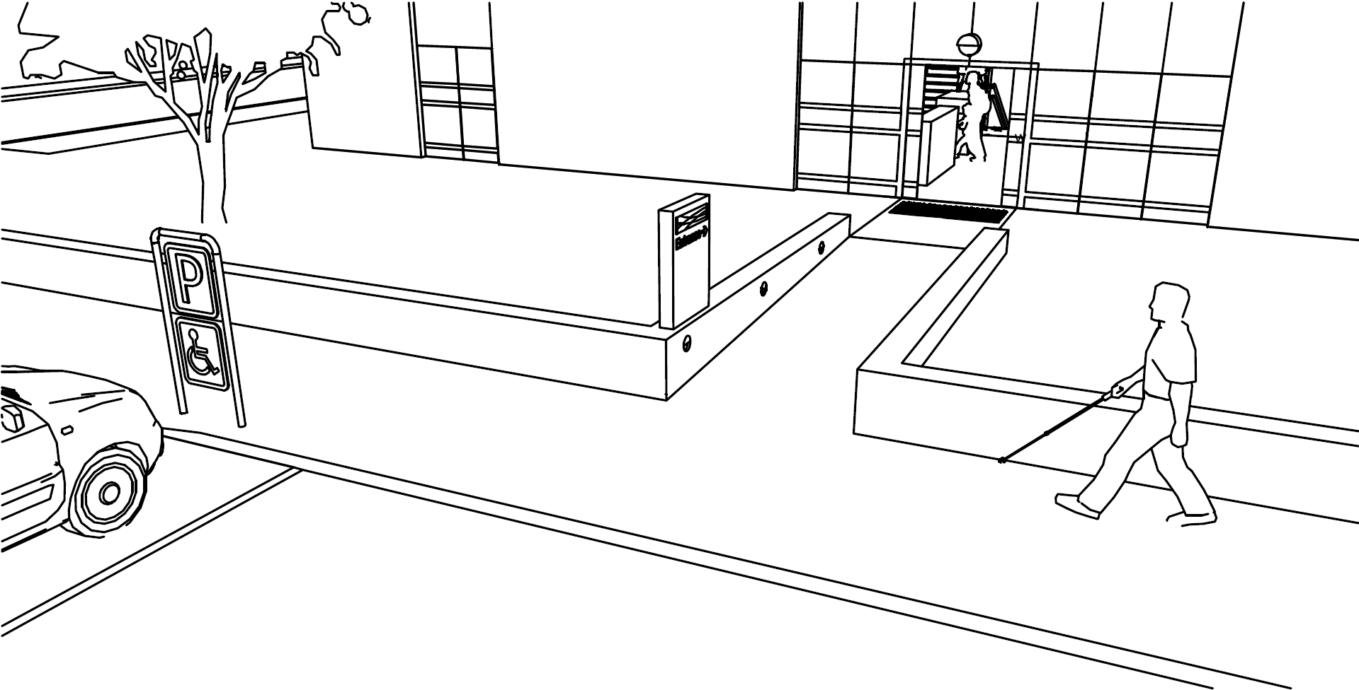
 | Equitable entry via the same entrances, for example easy to locate main entrances, no steps or obstacles, wide openings, adequate manoeuvring space in front of the door, low operating forces, good signage, good lighting and good visual contrast. | 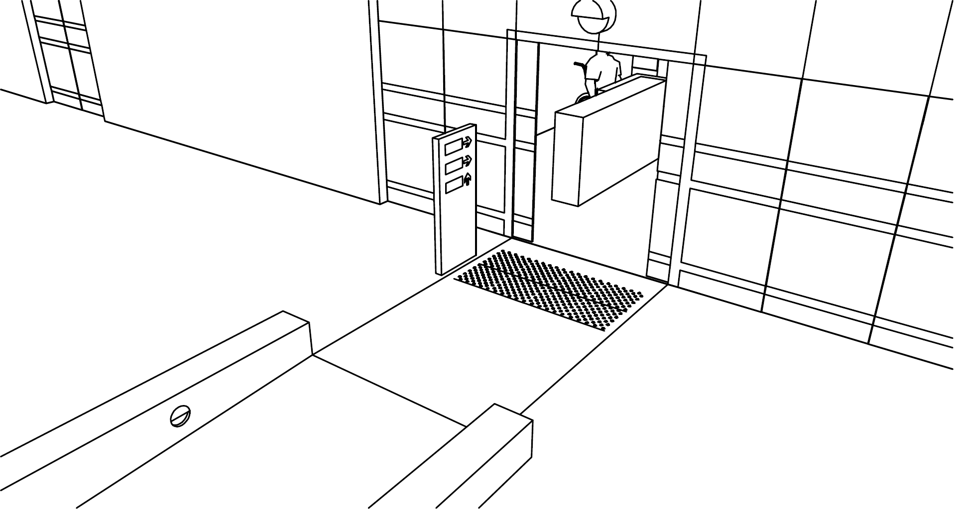
 | Equitable use of the same paths in horizontal circulation, for example no steps or obstacles, adequate manoeuvring space, wide door openings, easy to operate doors, resting places, clear layout, good signage, good lighting and good visual contrast . | 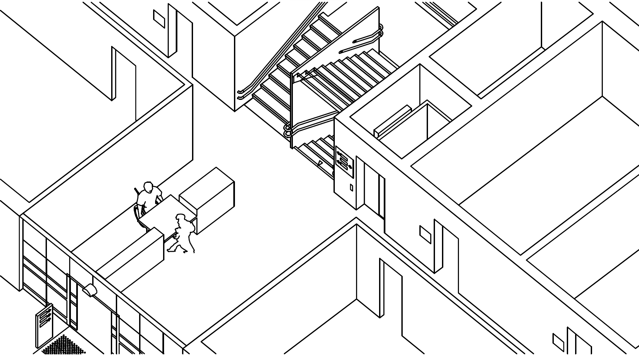
 | Equitable access to the same paths in vertical circulation, for example safe stairs, spacious lifts with easy operation, good signage, good lighting and good visual contrast. | 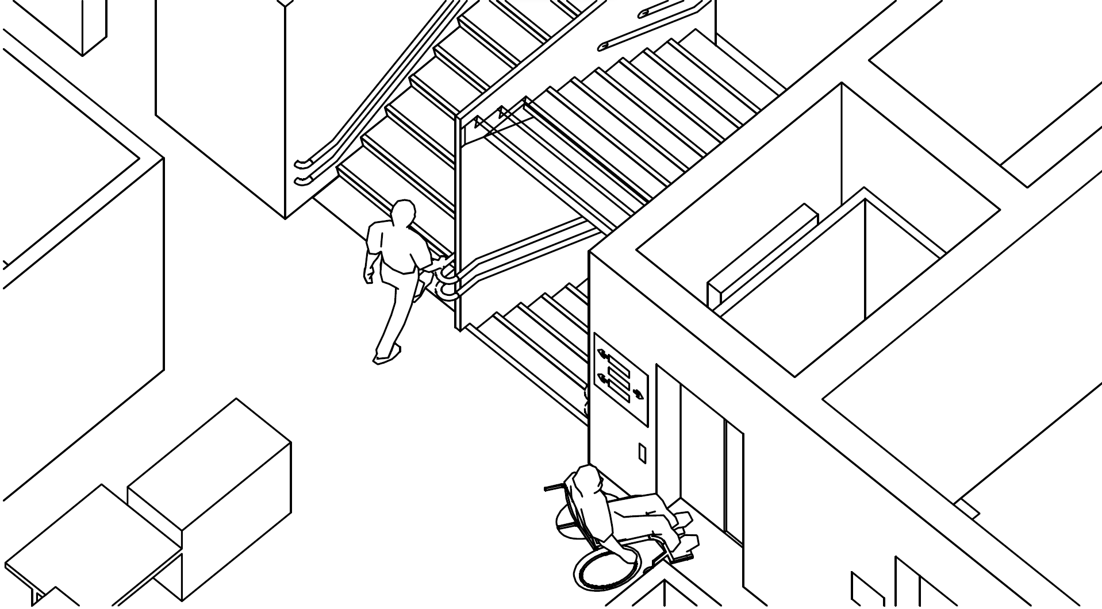
 | Equitable use of the same rooms, for example ample circulation space and different seating possibilities, good acoustics and hearing enhancement systems, good lighting and good visual contrast. | 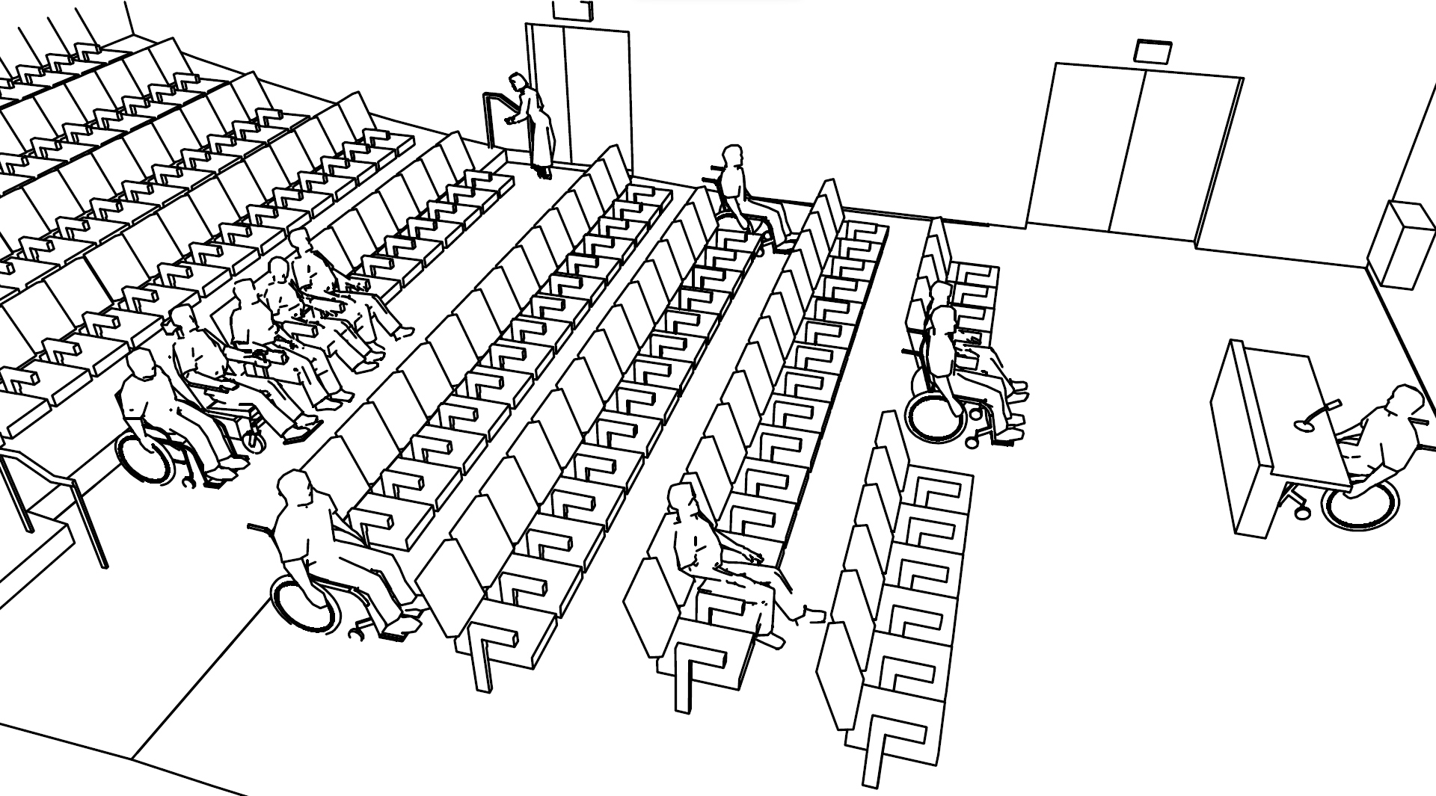
 | Equitable use of the same equipment and facilities, for example easy to understand and operate, adequate manoeuvring space and operating height, information via two senses. | 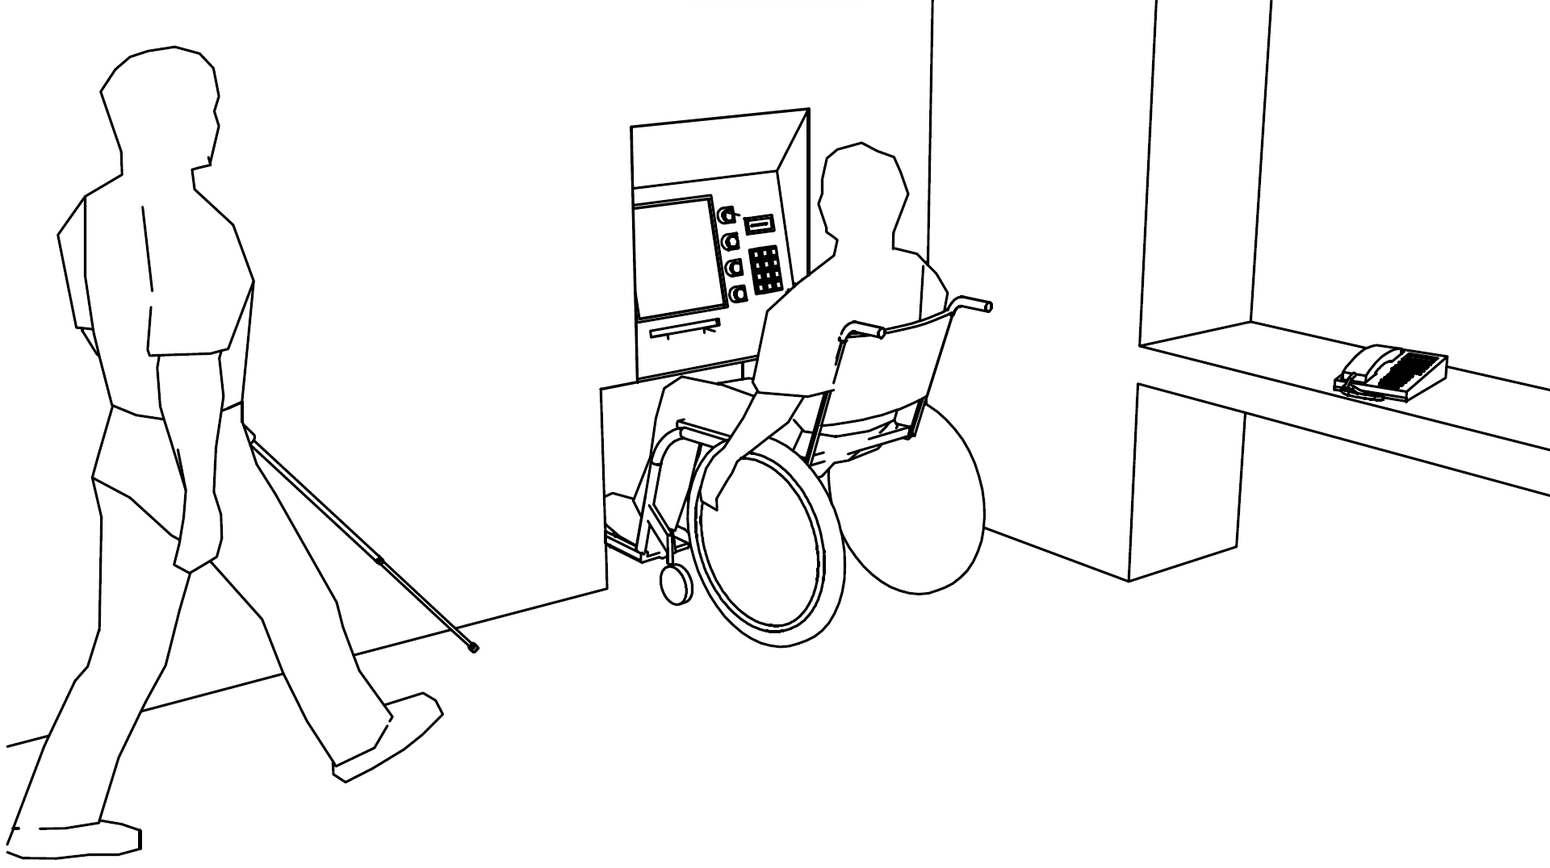
 | Equitable use of toilet and sanitary facilities, for example good signage, adequate manoeuvring space, good transfer options, well-placed equipment, easy operation. | 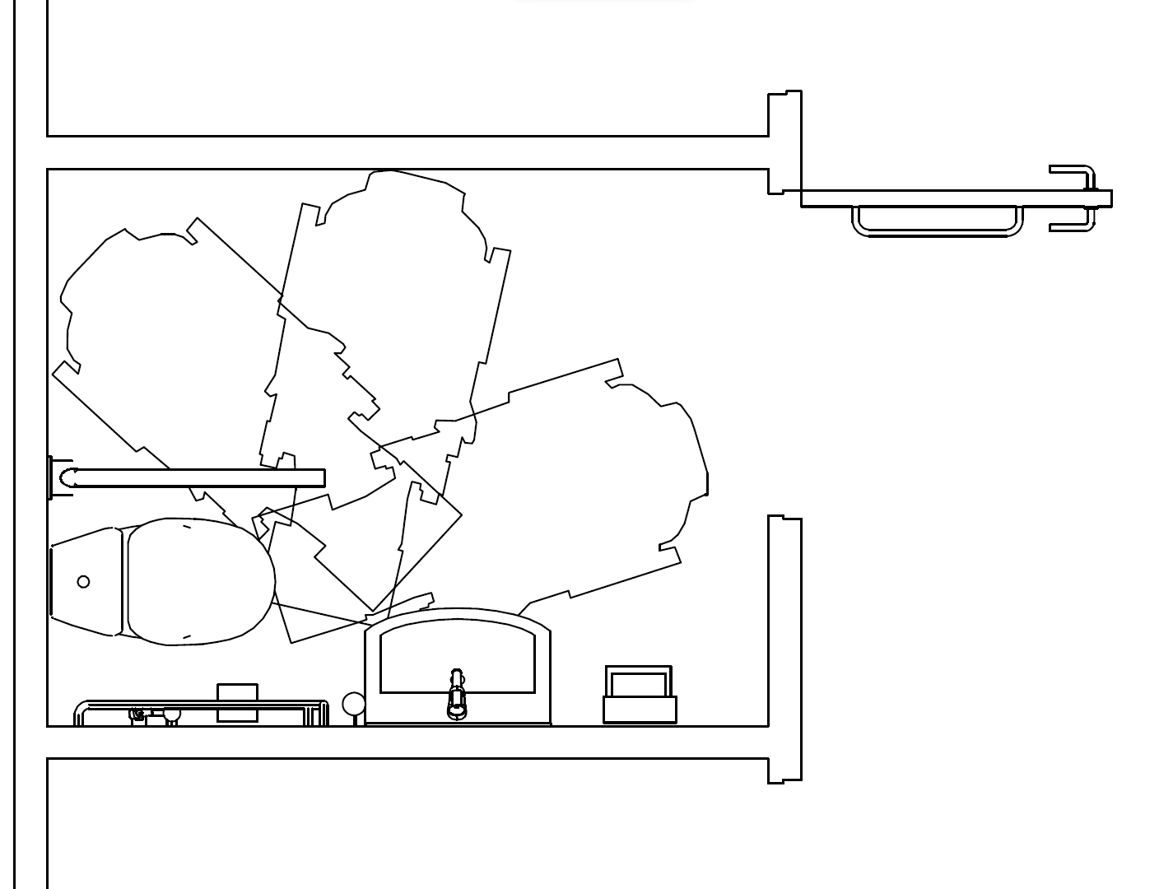
 | Equitable means of egress, concepts for emergency planning, for example no steps or obstacles, fire protected lifts, good signage, good lighting, good visual contrast, good fire safety, protection and evacuation, accessible means of egress. | 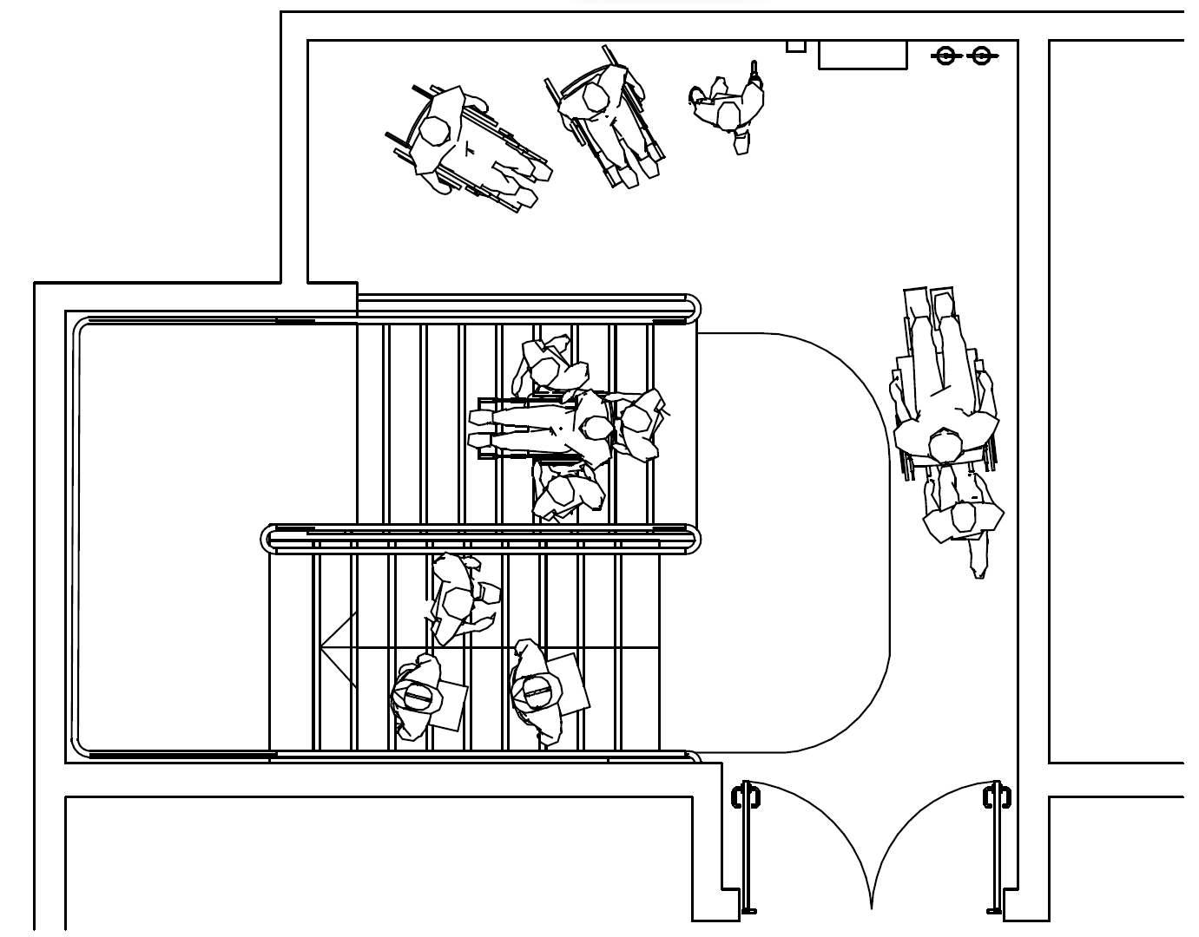
 | Important information via two senses or more, for example visual, audible and tactile. | 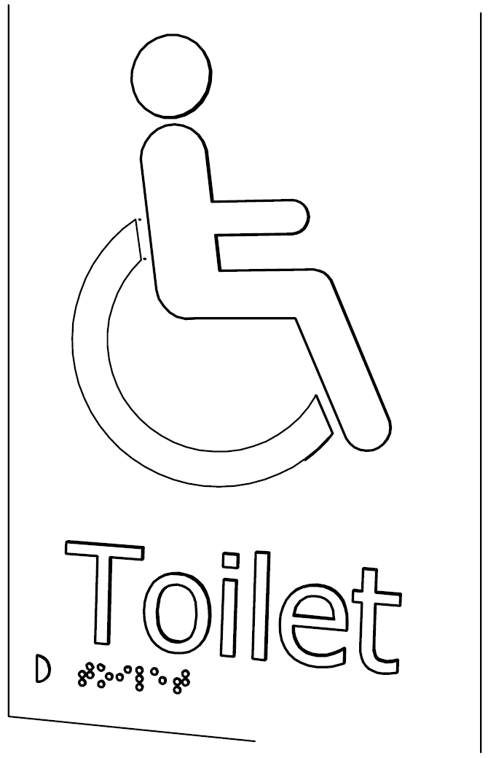
4.3.1 Various key accessibility issues shall be taken into account for ensuring accessibility in built environment in accordance with the provisions given in 6 to 30 in regard to anthropometrics and specific requirements on site planning and development, designated accessible parking space, approach to the buildings, access at entrance and within the buildings, controls and operating mechanisms, seating spaces, other facilities, level changes, toilet and sanitary facilities, emergency evacuation in buildings, signages, etc. For other accessibility aspects in buildings, relevant parts of NBC may be referred.
5 TYPES OF ACCESSIBLE BUILT ENVIRONMENTS
Various accessibility requirements for persons with disabilities and the elderly shall be applied to different building occupancies in accordance with Table 2, unless mentioned otherwise specifically in 6 to 30. In addition, all building occupancy types shall comply with the following:
  - At least one entrance preferably the main entrance per building shall be accessible. All efforts should be made to make as many/all entrances accessible.
  - All common areas open to public and staff and all facilities provided in a building for public use, such as, waiting areas, seating spaces, coffee shops, display areas, merchandising departments, service areas, ticket counters and refreshment stands shall be accessible to all persons with disabilities. These shall also include facilities like, lobby toilets, lifts, saloons, bars, restaurants, eateries, clubs, swimming pool, parking, fitness centres/gymnasiums, religious facilities, sports facilities/parks and recreation areas, etc, within an occupancy.
  - In all buildings, accessible toilet and sanitary room(s) shall be provided in accordance with 14. Such facility shall be provided in each toilet group in a building.
Table 2 Minimum Accessibility Provisions in Different Building Occupancies
(Clause 5)
Sl. No. | Category | Type of Built Environment within the category | Applicability
 | Residential | Public housing including low income housing and housing developed by private developers | - All common and communal areas, such as, approach, entrances/exits, lifts, stairs, lobbies, clubs, religious facilities, parking, sports facilities/parks and recreation areas, etc, and associated sanitary and other facilities therein.  - 5 percent houses shall meet accessibility requirements, preferably on ground floor.  - In all other 95 percent houses, minimum universal design features, such as, minimum clear door widths of: main entrance, rooms, kitchen and that of at least one toilet and sanitary room in each house. Such toilet and sanitary room in the house shall be the one having access from the living/drawing room and their size shall comply with those given in 14 to allow the occupants to adapt to their needs to facilitate ageing-in-place and disabled friendly environment.  NOTE ― The provisions given in (c) are minimum prescriptions with the objective to progressively move towards universal design of the buildings and the built environment, to be usable by all people, to the greatest extent possible irrespective of their age, situation, abilities, gender or any other diversity.
 | Hotels/ Hospitality Centres | Hotels, dormitories, lodging and rooming houses, such as inns, clubs, motels and guest houses | Minimum five percent of the total rooms including their toilet room, shower room, balcony, etc, shall be accessible and preferably be provided on the ground floor for ease of evacuation in case of an emergency.  All other rooms shall have universal design features (without specific adaptations like handrails/grab bars, etc). This would include minimum clear door widths of 900 mm of all entrances including those of sanitary rooms and balcony areas; and minimum passage width of 1 200 mm in the rooms and required turning radius.  In accommodations having more than one toilet/sanitary room, one such facility shall be accessible.  In case of accessible accommodations, a choice of right or left hand transfer to the toilet and shower shall be provided.
 | Educational Buildings | Schools, colleges, classrooms, libraries, assembly points, halls, staff rooms, laboratories, playgrounds | - All teaching/administrative and common areas frequented by staff/students.  - In libraries all open book stacks. At least one enclosed room in library for those with hearing and vision impairments who may need assistance while reading.  - In laboratories, equipment and facilities.
 | Hospitals/ Health Facilities | Hospitals/ clinics/ diagnostic centres/ pharmacy, etc | All public areas to be accessible, including OPDs, IPDs, wards, toilets, changing rooms, sample collection rooms, x-ray rooms, patient examination rooms, medical distribution rooms/centres.
 | Assembly Buildings | Stadia, theatres, lecture halls, spectator seating in sports complexes and all other type of assembly halls with fix seating, by whatever name called. | To all common areas/facilities open to public and staff. Number of designated seating areas to be as per 17.3.
 | Public Transit Buildings | Bus terminus, airports, railway/ metro stations, organized inter-change points/ transit junctions, taxi stands | All public areas used by passengers and staff including but not limited to drop off areas, parking, boarding/transfer areas, waiting areas/lounges, custom areas, baggage halls, booking halls, inquiry offices, ticket counters, shops, banks, etc.
 | Heritage Buildings/ Sites | All heritage sites/buildings protected by concerned authorities and open to public, interpretation centres, ancillary services/ facilities | - Reasonable access to all public areas without affecting the historical character of the building.  - Reasonable access to trekking points/ view points.  - Alternative solutions and innovative methods that do not conflict with conservation/preservation requirements should be explored.
 | Public Toilets |  | To be provided in accordance with 14.15.
 | Cafeterias and restaurants |  | To be provided in accordance with 20.
 | Sports complexes |  | - Sports halls, administration and common areas.  - At least one changing room and shower room to be provided at every place where such facility is provided.  - Spectators seating areas for wheelchair users as per assembly buildings above.
 | Mercantile Buildings | Shops, malls, large multi-storey department stores and super markets, etc | At least one trial room for each group of such facility. Where only one is provided, it shall be accessible.
6 ANTHROPOMETRICS
Adequate space should be allocated for persons using mobility devices, for example wheelchairs, crutches and walkers, white cane etc., as well as those walking with the assistance of others. The dimensions prescribed in 6.1 to 6.4 may be used for guidance while designing facilities and equipment to be used by persons with disabilities.
6.1 Mobility Devices and Space Allowance
6.1.1 Wheelchair
The basic elements of wheelchairs (manual, electric and others) and terms and definitions for these elements are defined in IS 10976. Basic elements of a wheelchair (folding, adult size) are shown in Fig. 1. Wheelchair shall conform to the requirements given below and those mentioned in IS 6571, IS 7454 and IS 8086.
6.1.1.1 Some of the dimensions of a standard wheelchair are extremely important and helps to arrive at requirements for space allowance, reach range, etc., of a wheelchair user. Electric wheelchair may be of a large dimension, much heavier and do not have the same manoeuvrability/capability as manual wheelchairs.
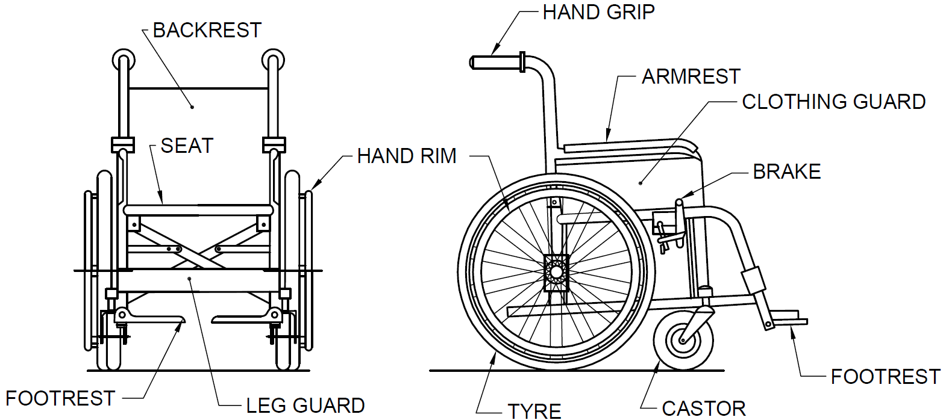
Fig. 1 Nomenclature of Basic Elements of Wheelchair
6.1.1.2 An example of manual adult wheelchair are as follows (see Fig. 1):
- Overall length | : 1 000 mm – 1 100 mm
- Overall width, open | : 650 mm – 720 mm
- Overall width, folded | : 300 mm – 330 mm
- Overall height | : 910 mm – 950 mm
- Seat height from floor at the front | : 480 mm –510 mm
- Distance between seat and footrest | : 400 mm – 450 mm
- Arm rest height from seat | : 220 mm – 230 mm
- Seat depth | : 420 mm – 440 mm
- Clearance of footrest from floor | : 90 mm – 200 mm
- Clearance of frame from floor | : 90 mm, Min
- Wheelchair footrest | : 350 mm (deep)
- Wheelchair castor width | : 12 mm
- Weight of the wheelchair (basic model) | : 25 kg, Max
The following form important considerations in deciding various space requirements to ensure functionality for wheelchair users:
- Arm rest height from floor | : 760 mm
- Lap height | : 675 mm
NOTE — The dimensions given above are from the point of view of better understanding and appreciation of various needs emanating therefrom. However, considering various aspects including diversity of population, stature, age, gender, etc, the dimensions and ranges thereof, as may be applicable, have been prescribed in these provisions given hereinafter.
6.1.1.3 A wheelchair has a footplate and leg rest attached in front of the seat. The footplate extends about 350 mm in front of the knee. The footplate may prevent wheelchair users from getting close enough to an object/site. Hence, at least 350 mm deep and 700 mm high space under a counter, stand, etc, shall be provided (see Fig. 2).
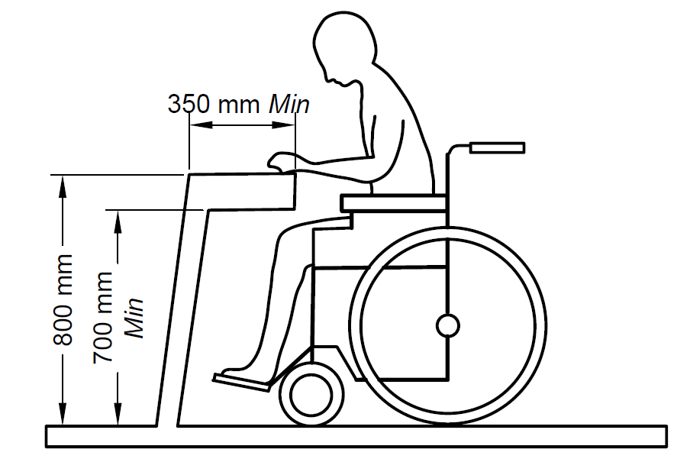
Fig. 2 Necessary Space under Counter or Stand for Ease of Wheelchair Users
6.1.1.4 Clear floor space for wheelchair user
The minimum clear floor or ground area required for accommodating a single, stationary wheelchair and occupant is 900 mm x 1 200 mm (see Fig. 3). Where transfer from the wheelchair is involved, the clear space should preferably be 900 mm x 1 350 mm.
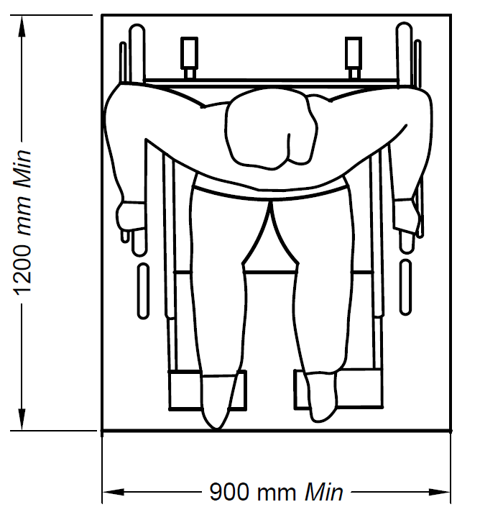
Fig. 3 Clear Floor Space
6.1.1.5 Circulation dimensions
The minimum clear floor area for a wheelchair to turn is 1 500 mm, whereas area for turning comfortably is 1 800 mm and it is ideal to provide 2 000 mm (see Fig. 4).
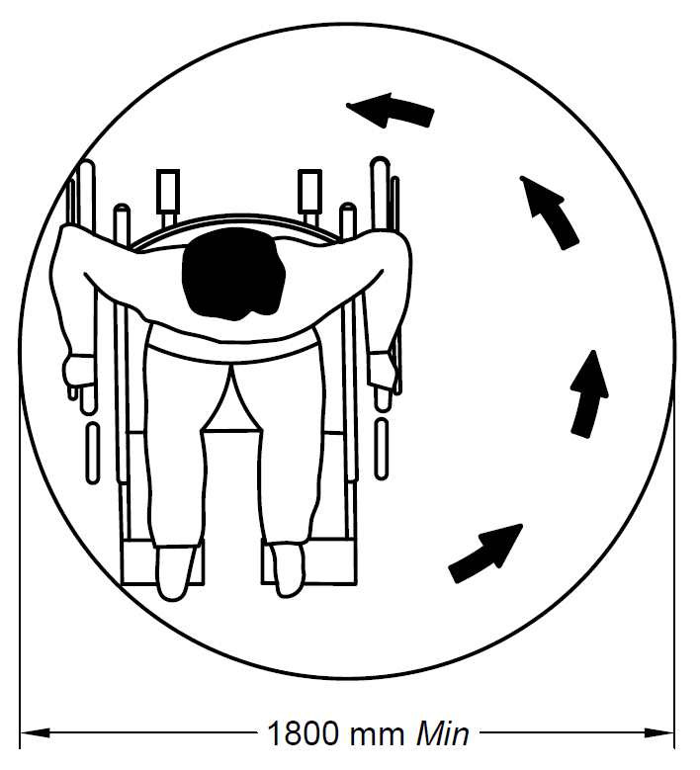
Fig. 4 Preferred Comfortable Turning Radius
6.1.2 Space Allowance for Crutch Users
Although people who use walking aids can manoeuvre through door openings of 900 mm clear width, they need wider passageways for comfortable gaits as shown in Fig. 5.
Crutch tips, often extend down out at a wide angle, and are hazardous in narrow passageways where they might not be seen by other pedestrians.
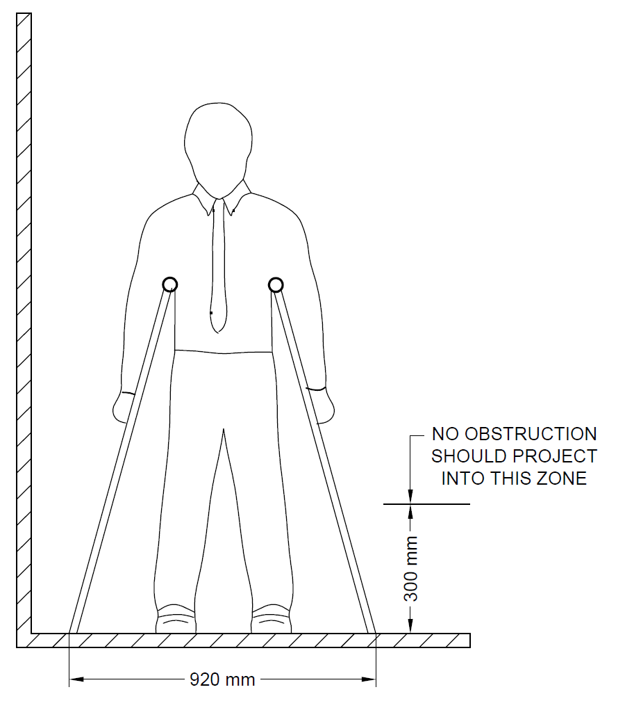
Fig. 5 Passageway Required for People who uses Walking Aids
6.1.3 Space Allowance for White Cane Users
Following shall be ensured for white cane users:
- Protruding objects, such as directional signs, tree branches, wires, guy ropes, public telephone booths, benches and ornamental fixtures shall be installed with consideration of the range of the white cane of a person with vision impairment.
- A barrier to warn blind or visually impaired person shall be provided under stairways or escalators so that they don’t accidently enter in to them.
- Walkways, halls, corridors, passageways, aisles, or other circulations spaces shall have clear headroom to minimize the risk of accidents.
- Adequate space allowance should be made considering that the radial range of white cane is a band of 900 mm wide (see Fig. 6).
- Any obstacle above 300 mm cannot be detected by the white cane. If there are projections above this height, then the same has to be treated in accordance with 7.6.2.
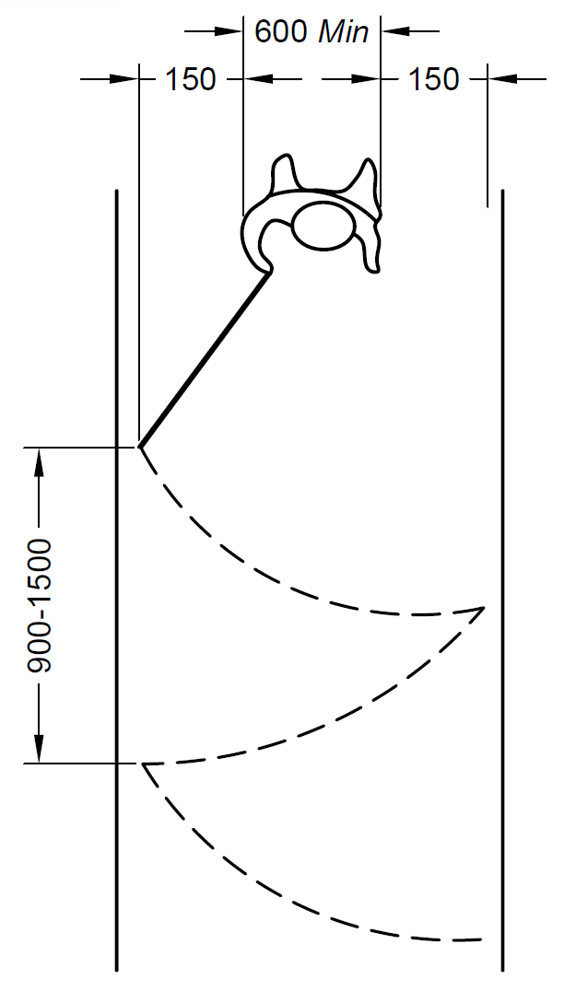
All dimensions in millimetres
Fig. 6 Space Allowance (Radial Range) by People Using White Canes
6.2 Reach Range
A wheelchair user’s movement pivots around its shoulders (see Fig. 7). The reach range (forward and side; with or without obstruction) of a wheelchair user, as given in 6.2.1 to 6.2.3 shall be taken in to consideration.
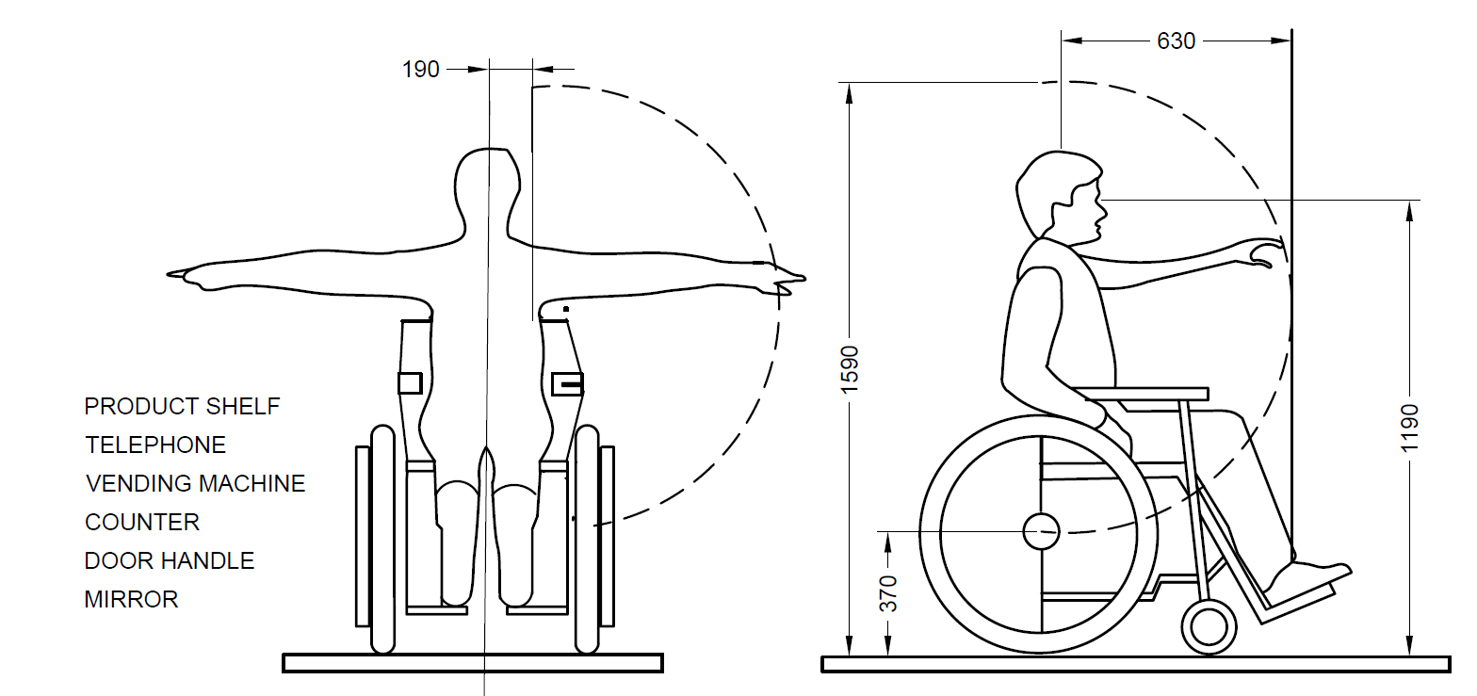
All dimensions in millimetres
Fig. 7 Range of Reach of Wheelchair User
6.2.1 Forward Reach
The maximum forward reach without obstruction is 1200 mm from the floor and the minimum forward reach without obstruction is 400 mm from the floor as shown in Fig. 8.
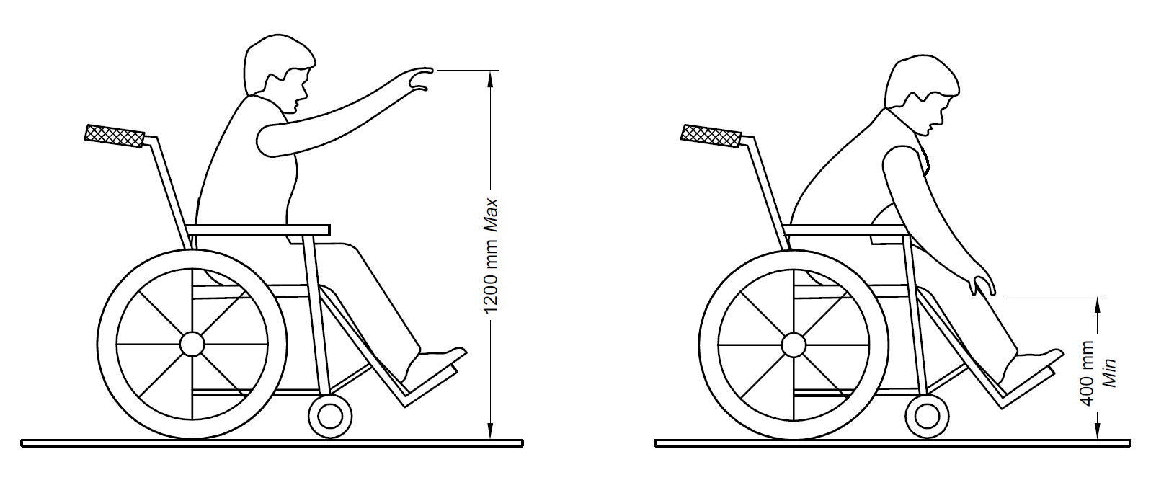
Fig. 8 Forward Reach Without Obstruction
The maximum forward reach over an obstruction is 1 000 mm from the floor as shown in Fig. 9, which also indicates the touch reach and grasp reach.
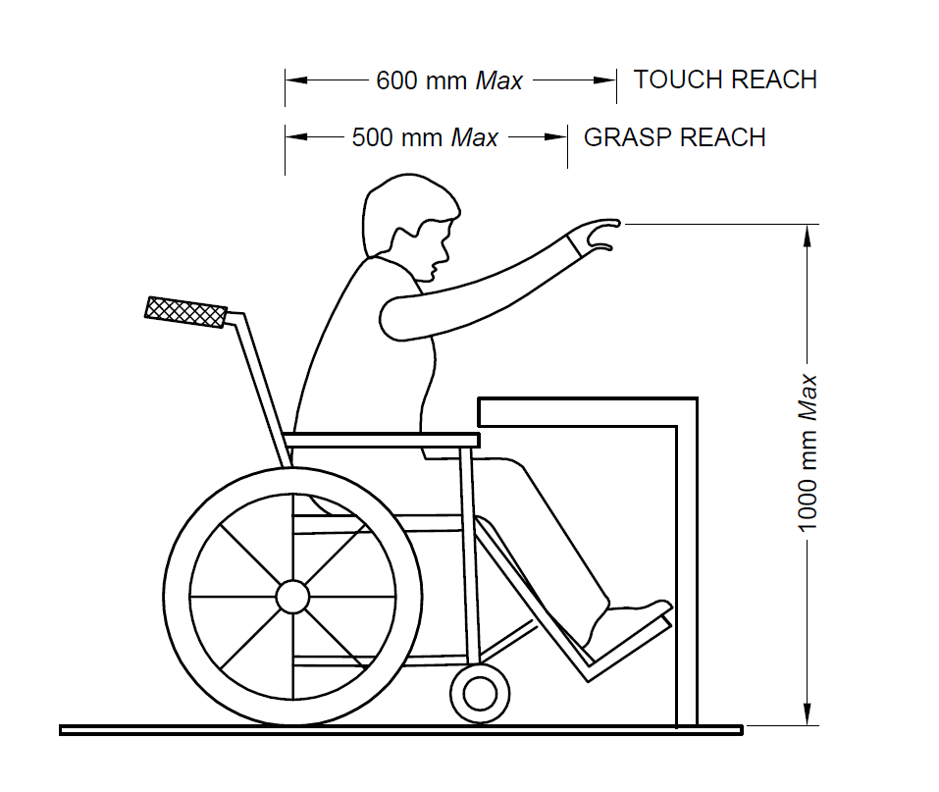
Fig. 9 Forward Reach Over Obstruction
6.2.2 Side Reach
The maximum side reach without obstruction is 1 300 mm from the floor and the minimum side reach is 250 mm as shown in Fig.10.
The maximum side reach over an obstruction of size 860 mm high x 500 mm deep is 1 200 mm from the floor as shown in Fig. 11, which also indicates the touch reach and grasp reach.
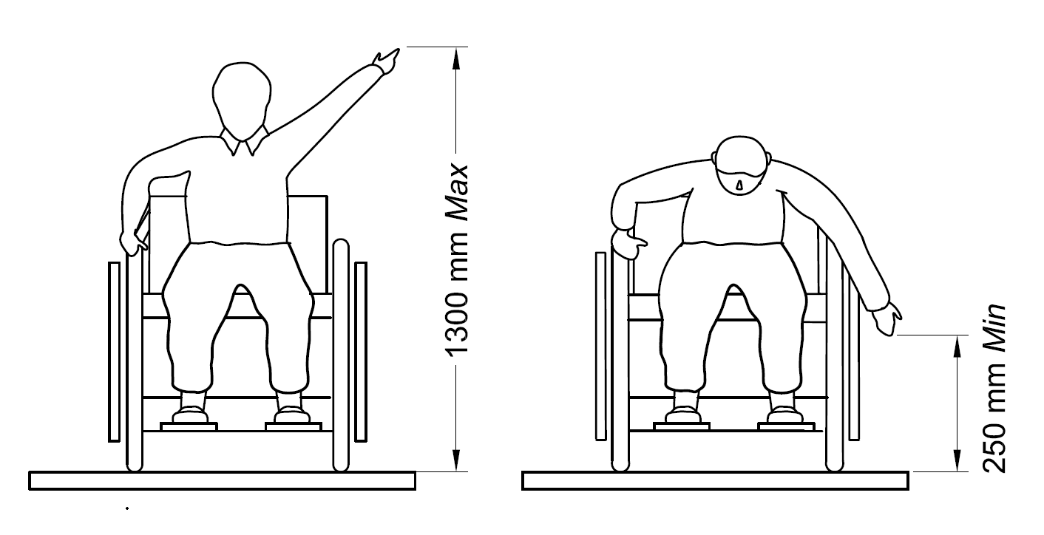
Fig. 10 Side Reach Without Obstruction
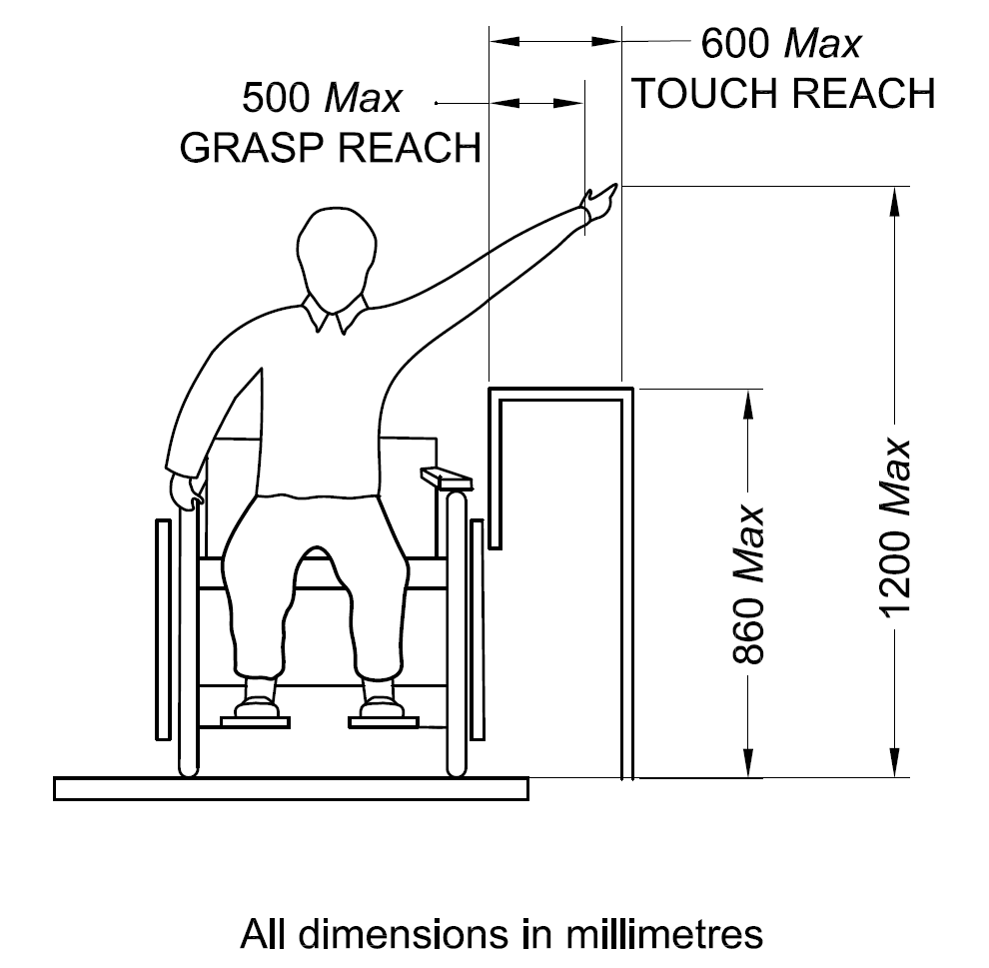
All dimensions in millimetres
Fig. 11 Side Reach Over Obstruction
6.2.3 A Reach Range for children of various ages:
Forward or side reach | Ages 3 and 4 | Ages 5 to 8 | Ages 9 to 12
High (Max) | 915 mm (36 inch) | 1015 mm (40 inch) | 1120 mm (44 inch)
Low (Min) | 510 mm (20 inch) | 455 mm (18 inch) | 405 mm (16 inch)
For other requirements, reference shall be made to IS 4838.
6.2.4 Common Reach Zone
As part of the common reach zone, the comfortable reach zone when seated on a wheelchair is between 900 mm and 1 200 mm and the maximum reach zone is between 1 200 mm and 1 400 mm (see Fig. 12).
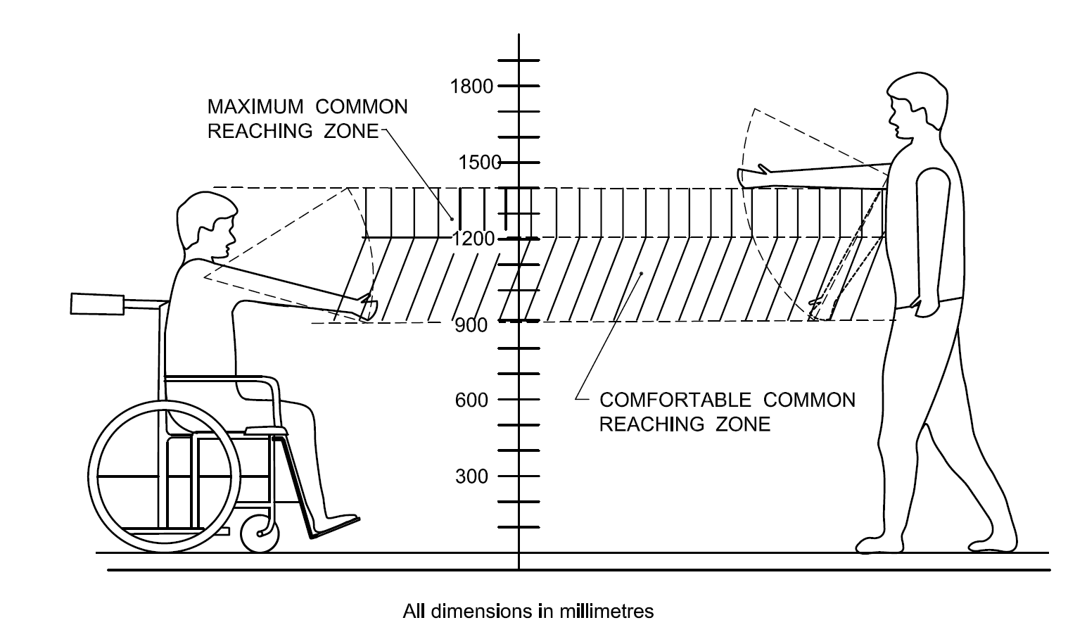
All dimensions in millimetres
Fig. 12 Common Reaching Zone
6.3 Vision Zone
Different fields of vision are given in Fig. 13. All signage should be designed based on these dimensions.
Map and information panels along pathways shall be placed at a height between 900 mm and 1 800 mm (see Fig. 14). The smallest letter shall not be less than 15 mm.
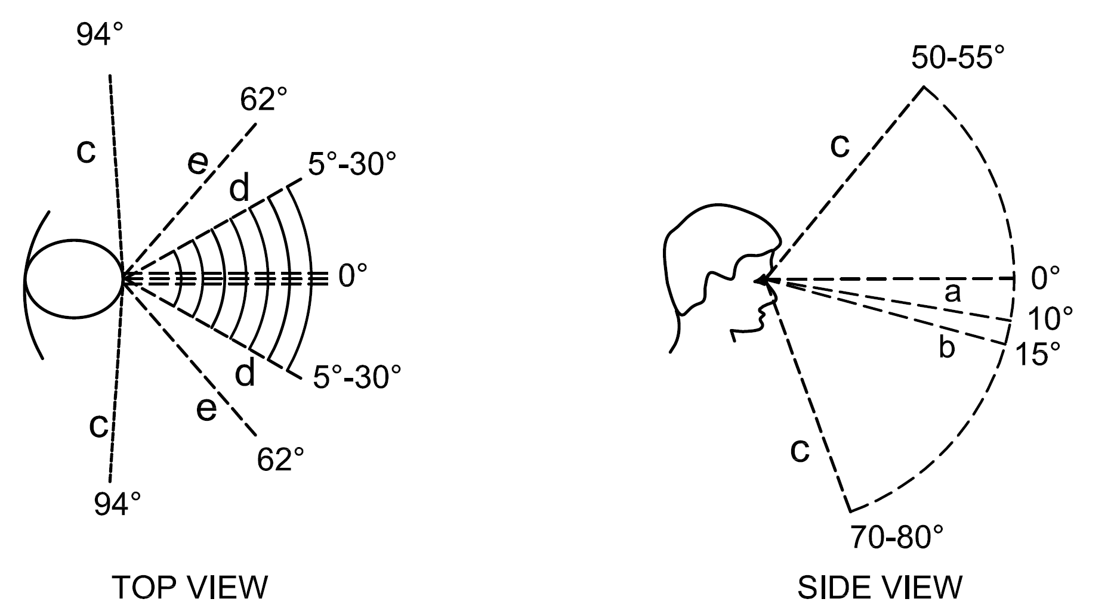
Key
a – Normal optical axis, standing person
b – Normal optical axis, sitting person
c – Limit of field of vision
d – Normal angle of vision
e – Maximum angle of vision
Fig. 13 Field of Vision
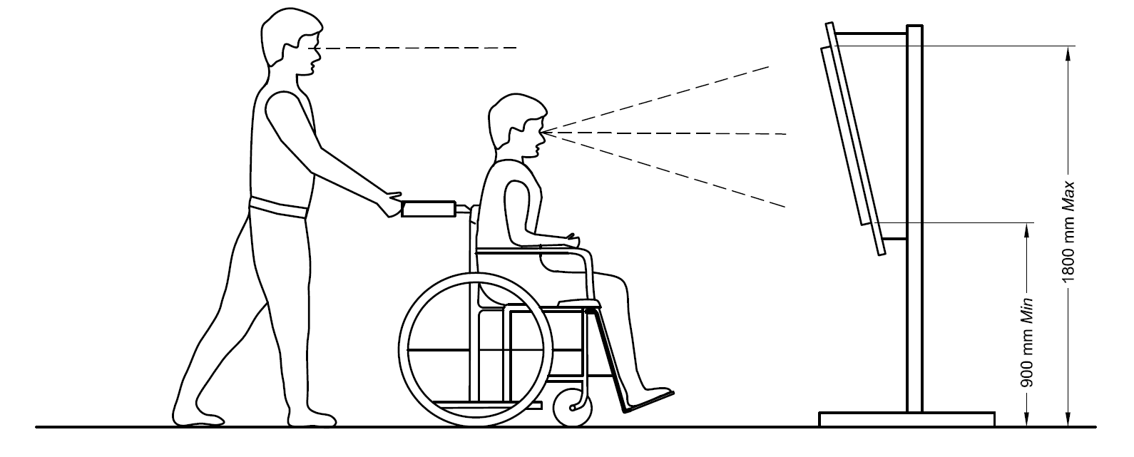
Fig. 14 Vision Zone
6.4 Heights and Widths
6.4.1 Wheelchair Users
The average height of a person seated on a wheelchair is less than 1 200 mm.
6.4.2 Standing Person
The average height of a standing person is less than 2 000 mm.
6.4.3 Height of Controls
- Height of controls from floor level | : 400 mm - 1 200 mm
- Height for switches (power) | : 400 mm - 500 mm
- Height for switches (lights) | : 800 mm - 1 200 mm
- Height of door handles | : 800 mm - 1 100 mm
- Opening controls for windows | : 800 mm - 1 100 mm
- Space required under the counter | : 350 mm deep for wheelchair footrest
6.4.4 Entrance/Exit Door
- Minimum width of entrance/exit | : 900 mm Door (see Fig. 32)
- Minimum front approach doorways | : 600 mm space (see Fig. 33 and Fig. 34)
- Minimum latch side approach | : 1 250 mm doorways space (see Fig. 33)
7 SITE PLANNING AND DEVELOPMENT
7.1 General
Site development is the most effective means to resolve the problems created by topography, definitive architectural designs or concepts, water table, existing streets, and typical problems, singularly or collectively, so that ingress and egress to buildings by persons with disabilities can be facilitated while preserving the desired design and effect of the architecture. Each building and its site shall be planned and designed as an integral unit from the very beginning of the design process. Equipment and materials causing allergic reactions shall as far as possible be avoided in dwellings and buildings.
The provisions of accessibility in outdoor built environment covered herein pertain to the immediate outdoor environment of a building or of a building complex. However, these may be considered by the Authorities and concerned parties for suitably applying the same at township/city level.
7.2 Walkways and Pathways
7.2.1 General
Walkways and pathways (used here interchangeably) shall meet the following general requirements:
- Walkways shall be smooth, non-slippery, hard and have levelled surface suitable for walking and wheeling. Irregular surfaces as cobble stones, coarsely exposed aggregate concrete, bricks, etc, often cause bumpy rides and shall be avoided.
- Minimum walkway width shall be provided as per 7.2.2. The width of footpath should be normally designed for a pedestrian Level of Service (LOS) B, thereby providing wide pedestrian facilities for safe, pleasant and comfortable walking. Under resource constraint, LOS C may be adopted for deciding the width of footpath mentioned in Table 3. The width of footpaths depends upon the expected pedestrian traffic and may be fixed with the help of the following norms subject to not being less than 1.8 m.
- The walkway shall not have a gradient exceeding 1:20. If the slope or any part of a walkway on an accessible route to a building exceeds 1:20, it shall be designed and constructed as a ramp in accordance with 11.2.
- Where pathway meets the road, a kerb shall be provided, which shall be designed in accordance with 8.3.
- The cross-fall gradient across an accessible route shall not exceed 1:50 (20 mm/m), except when associated with a dropped kerb.
- The requirements for drainage of pathways shall be as per 7.2.5.
- When walkways exceed 60 m in length, it is desirable to provide rest area adjacent to the walk at convenient intervals of 30 m in the form of benches/resting seats. For comfort, seat height shall be between 450 mm and 500 mm, and the seating shall have a back rest and arm rests at 700 mm height. One side of seating may be without arm rest to address the transfer needs of persons with disabilities. A colour contrast should be provided around the seating area for ease of identification by persons with low vision.
- Texture changes in walkways adjacent to seating shall be provided for persons with vision impairment by means of warning blocks (see 7.5).
- Gratings and manholes should be avoided in walks.
- Walks or driveways shall have a non-slip surface. Care shall be taken to ensure that adjacent surface materials do not display different slip resistance characteristics, particularly at the edges of changes of level or gradients.
- Such walks shall be of a continuing common surface not interrupted by steps or abrupt changes in level.
- Wherever walks cross other walks, driveways, or parking lots, they shall blend to a common level.
p) Obstacles, such as objects or signs mounted on walls, columns or free-standing supports along the walking path shall be avoided. These shall however be regulated in accordance with 7.6.1. Bollards along or on the walking pathway shall also be regulated in accordance with 7.6.1. Any protruding object projecting into a walkway shall be treated in accordance with 7.6.2.
Table 3 Capacity of Footpath and Design
[Clause 7.2.1 (b)]
Sl No | Width of Footpath | Design Flow in Number of Persons Per hour
 |  | In Both Direction |  | All in One Direction
 | m | LOS B | LOS C | LOS B | LOS C
(1) | (2) | (3) | (4) | (5) | (6)
i) | 1.8 | 1350 | 1890 | 2025 | 2835
ii) | 2.0 | 1800 | 2520 | 2700 | 3780
iii) | 2.5 | 2250 | 3150 | 3375 | 4725
iv) | 3.0 | 2700 | 3780 | 4050 | 5670
v) | 3.5 | 3150 | 4410 | 4725 | 6615
7.2.2 Width of the Walkway/Pathway
7.2.2.1 The unobstructed width of the pathway shall be,
- not less than 1 800 mm for two-way traffic (see key 1 of Fig. 15); which may be reduced to a minimum of 1 500 mm, provided that a passing and turning space of at least 1 800 mm x 2 000 mm should be provided for every 25 m (see keys 2 and 5 of Fig. 15); and
- not less than 1 200 mm for one-way traffic (see key 3 of Fig. 15); which may be reduced to a minimum of 1 000 mm, provided that a passing and turning space of at least 1 800 mm x 2 000 mm should be provided for every 25 m (see keys 4 and 5 of Fig. 15)
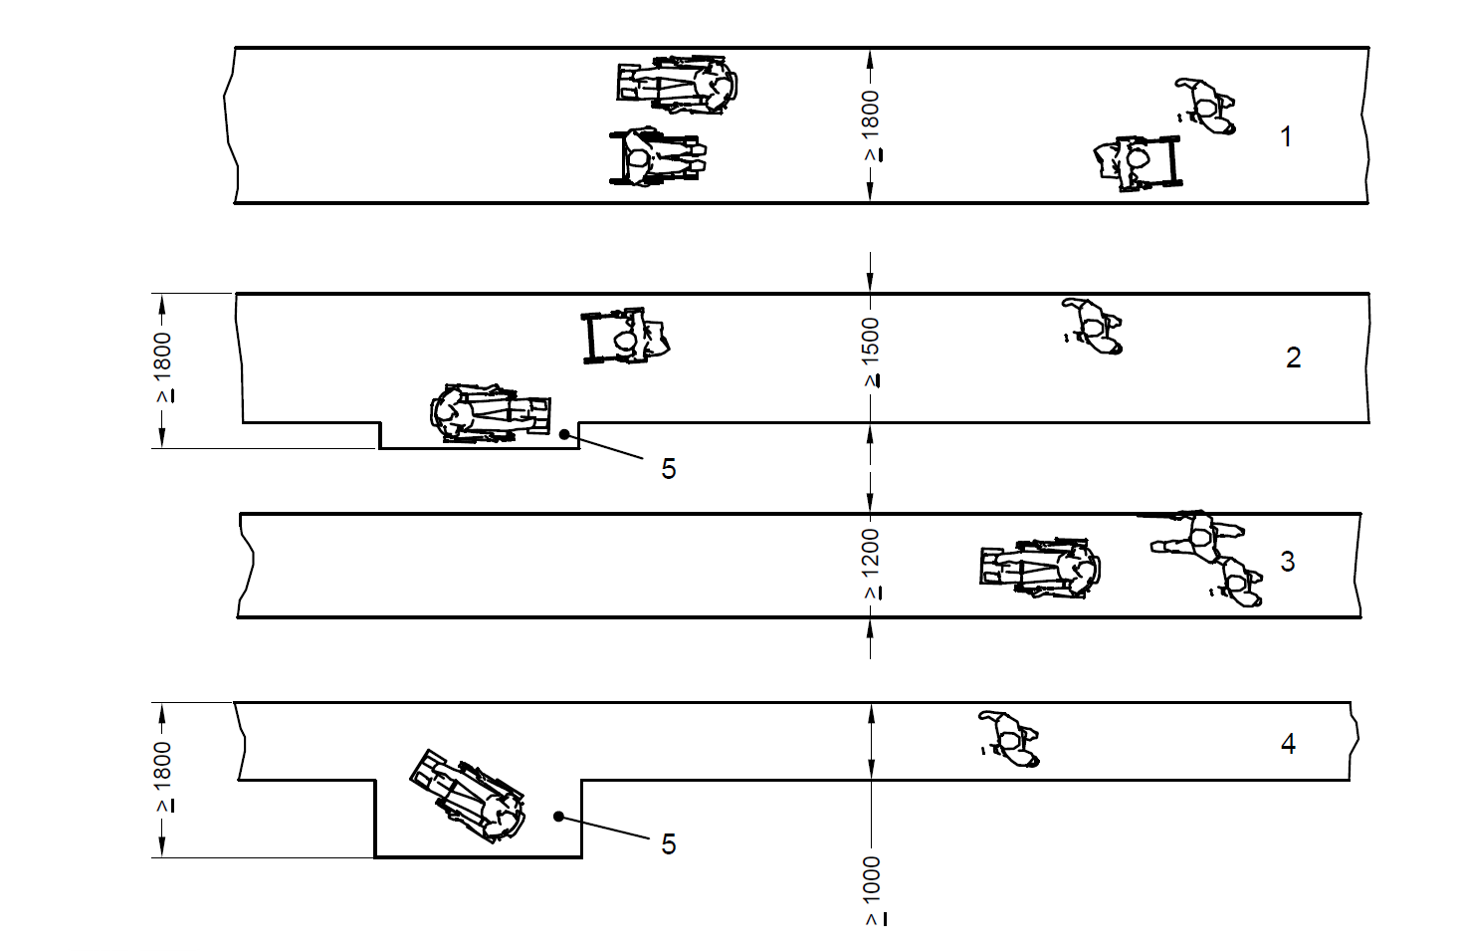
Key
1 AND 2 FOR TWO WAY TRAFFIC
3 AND 4 FOR ONE WAY TRAFFIC
5 PASSING AND TURNING SPACE EVERY 25 m (ONLY ACCEPTABLE FOR WHEELCHAIR USERS UNDER EXCEPTIONAL CIRCUMSTANCES)
All dimensions in millimetres
Fig. 15 Different Surface Widths of the Path Depending on Traffic
The width of footpath shall be in accordance with 7.2.1 (b).
7.2.2.2 Passing space for wheelchair users
A path whose surface width is less than 1 800 mm (see 7.2.2.1) and whose overall length is more than 50 m, shall be provided with a passing place or places. Passing places should be a maximum of 25 m apart. This does not apply to a landing forming part of a sloped path, a ramp, steps or a stair.
Passing place for two people using wheelchairs shall be a minimum width of 1 800 mm for a minimum length of 2 000 mm (see examples in Fig. 16).
NOTE — Passage widening can be associated with intersections, turns and doorways so as to appear as integrated design features or enhancements.
7.2.2.3 For wheelchair manoeuvrability at turnings, minimum turning radius required shall be in accordance with 10.2.3 and 10.2.4.
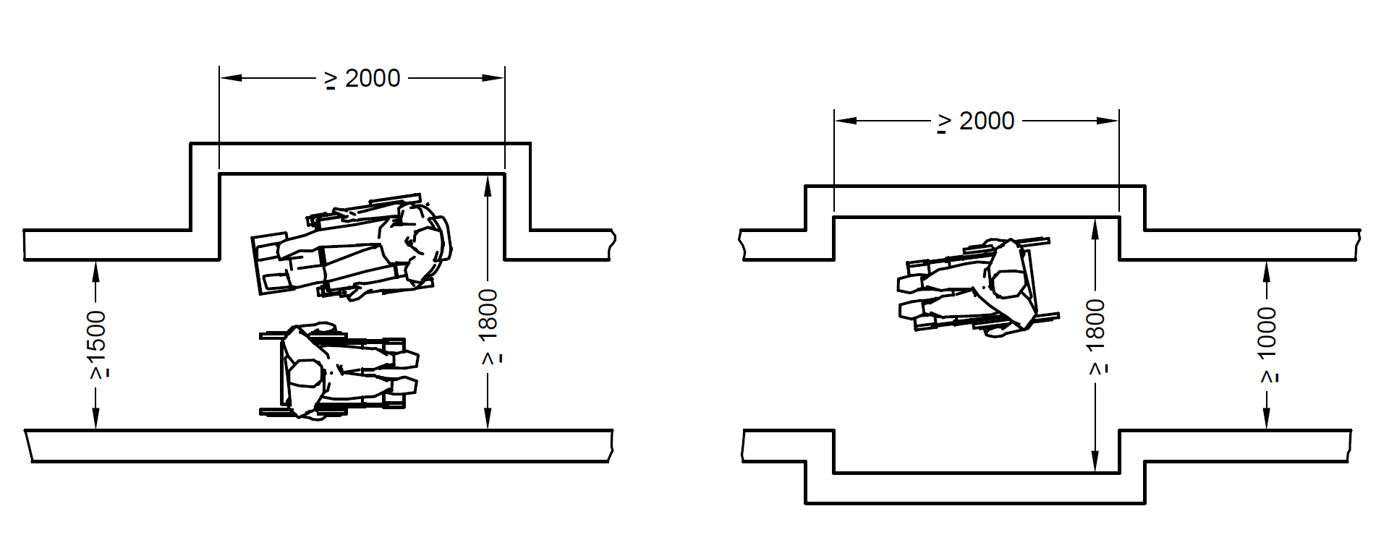
All dimensions in millimetres
Fig. 16 Examples for Passing Places for Wheelchair Users
7.2.3 Stepped Path and Stair
For ambulant people, a stepped path can provide a safer and more assuring means of access than a sloped path or a ramp. Wherever the rise of a ramp exceeds 300 mm, an additional flight of steps shall also be provided. An isolated single step is not acceptable. Where required on a continuous accessible path of travel, tactile warning indicators shall be located at both the top and bottom of stairways. The surface width of a stepped path and stair shall be not less than 1 200 mm and it shall meet the other requirements of 11.3.
7.2.4 Support and Guidance by a Handrail on Paths
Support and guidance by a handrail shall be provided on stepped paths. A handrail shall be provided on each side of a flight of steps consisting of two or more risers and each riser shall be not more than 150 mm high. A handrail shall be provided on both sides of a channel that can subdivide a flight of steps. For requirements of handrails, reference shall be made to 10.5.2.
7.2.5 Drainage of Path/Access Routes
The cross-fall of a level or sloped path, a stepped path, a ramp, or a landing, that is provided to permit drainage of surface water, shall be in accordance with 7.2.1(e). The top, bottom and landings of steps and ramps shall be properly drained in order to avoid water flowing down steps and ramps.
A dished channel should not be constructed within the boundaries of a path or ramp. Dished channels shall have a maximum width of 150 mm and a maximum drop into gulley of 5 mm.
A drainage grating that is within the boundaries of a path or a ramp shall be set flush with the surface (see 7.4).
7.2.6 Guarding along Paths and Ramps
Providing protection at the side of the path protects people who use wheelchairs and ambulant people from injuring themselves as the result of a fall. Examples of protection against falling are shown in Fig. 17.
- If a level or sloped path is bounded on one or both sides by terrain that slopes downwards by up to 30° from the horizontal, a firm and level margin of at least 600 mm shall be provided at the relevant side or sides. The level margin shall have different texture.
- If a sloped path or ramp is bounded on one or both sides by terrain that slopes downwards by more than 30°, an upstand of minimum height of 150 mm shall be provided at the relevant side or sides. Upstands shall have a minimum difference in LRV of 30 points in relation to the ramp.
- If a path, or a sloping path, stepped path, ramp, terrace or other unfenced platform rises more than 600 mm above the adjacent ground, it shall be provided with guarding. If the adjacent ground is firm and level with the path for 600 mm, no guard is needed.
Guarding shall be designed to discourage a user, particularly a child, from climbing on it.
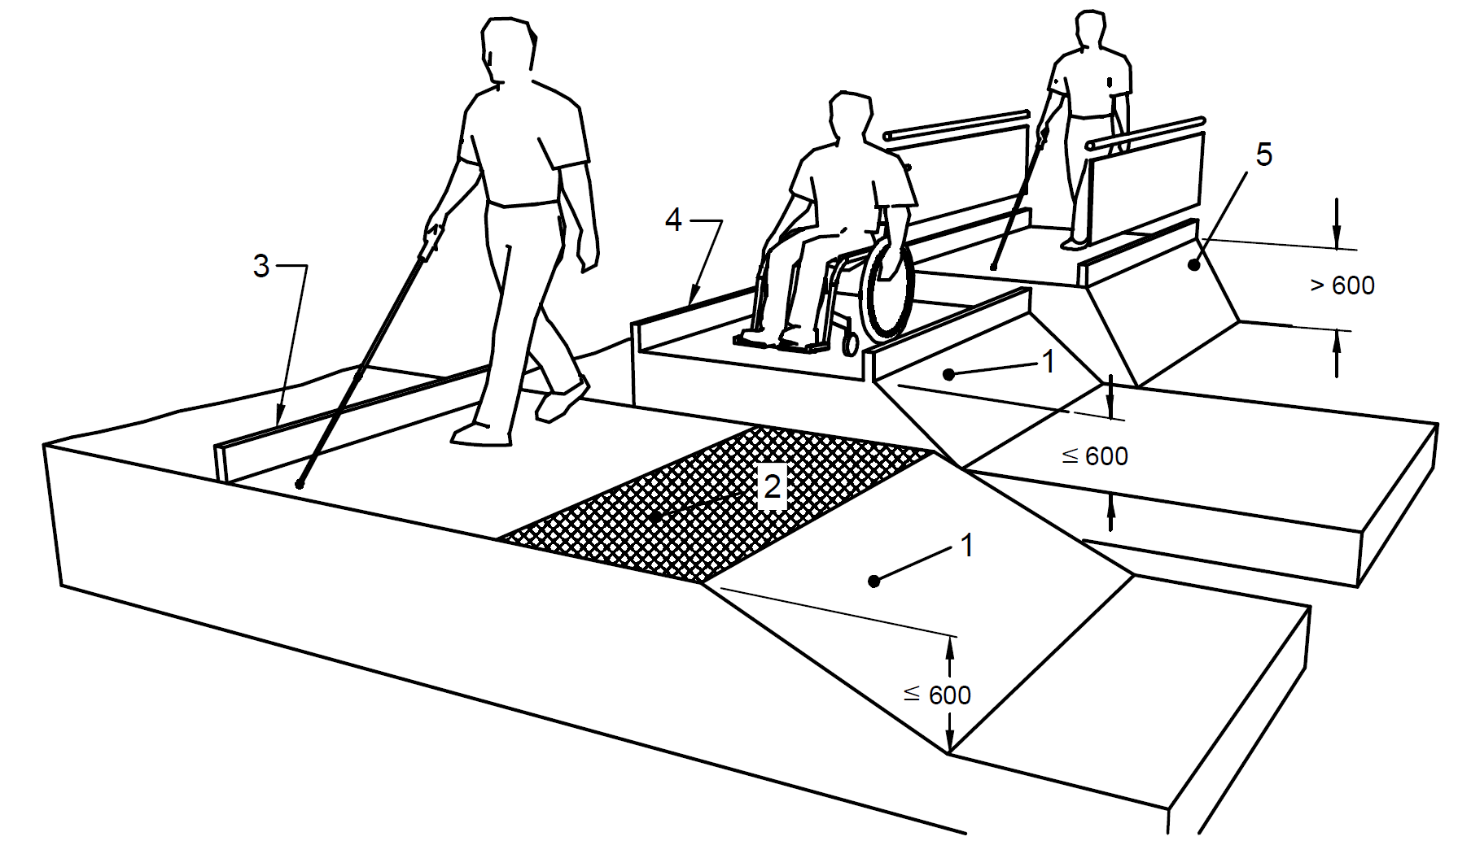
Key
- Downward slope less than 30°
- Level margin minimum 600 mm wide
- Upstand where the difference in level is 600 mm or less
- Upstand with a minimum difference in LRV of 30 points in relation to the path or ramp
- Upstand with guarding where the difference in level is greater than 600 mm
All dimensions in millimetres
Fig. 17 Examples of Protection Against Falling
7.3 Kerb Ramp/Dropped Kerb
7.3.1 General
It is a ramp built on a footpath or pavement to accommodate the change in level towards vehicular areas to allow easy and continuous access. Kerb ramps shall be provided at pedestrian crossings and at each end of the footpath of a private street or access road.
Kerb ramps shall be provided where the vertical rise is less than 150 mm. They shall meet the following requirements:
- They shall have a slip-resistant surface.
- They shall avoid raised traction strips in order to reduce the hazard to everyone.
- They shall be designed not to allow water accumulating on the walking surface.
- Handrails may not be provided with kerb ramps.
- They shall not project into the road surface.
- They shall be so located and also protected to prevent obstruction by parked vehicles.
- They shall be free from any obstruction such as signposts, traffic lights, etc.
- They shall not encroach into a roadway, as it is dangerous for users and obstructive for vehicles.
- They shall be so located to enable users to have an unobstructed view of traffic approaching from any direction.
- They shall be provided with adequate visual and tactile warning.
m) TGSI (warning type) shall be provided to notify the presence of traffic and shall have a minimum luminous contrast of 70 percent with the adjoining surfaces for the elderly and persons with visual impairment.
Typical kerb ramp requirements and kerb extension at street intersections are shown in Fig. 29 and Fig. 30.
7.3.2 Gradient
The gradient of a kerb ramp shall not be steeper than 1:12.
7.3.3 Width
The kerb ramp shall not be less than 1 200 mm in width. It shall provide a clearance of at least 900 mm at the back of the kerb ramp on the footpath (see Fig. 18). The minimum width of footpath shall be extrapolated from the below table at the location of kerb ramp, however, it shall not be less than 1 800 mm.
Kerb height | Minimum Footpath width
≤ 75 mm | 1800 mm
150 mm | 2 700 mm

7.3.4 Flared Sides
Kerb ramps shall have flared sides where pedestrians are likely to walk across them as shown in Fig. 18 and the gradient of the flared side shall not be steeper than 1:10.
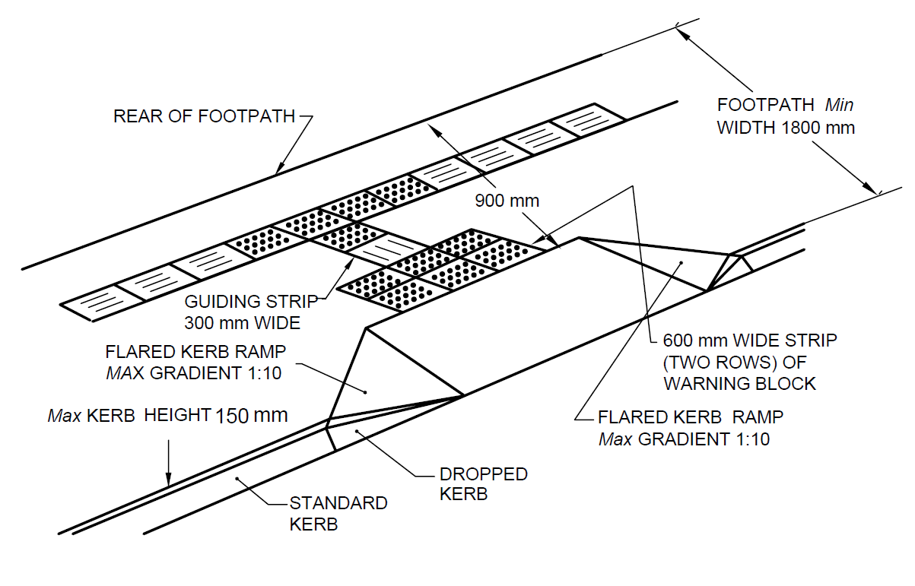
Fig. 18 Kerb Extension at Street Intersection
7.4 Levels, Grooves, Gratings and Manholes
7.4.1 Passing over Different Levels and Grooves
Vertical level changes up to 6 mm may not need edge treatment. Changes in level between 6 mm and 12 mm shall be levelled off with a slope no greater than 1:2. The edge shall be rounded off or bevelled.
7.4.2 Gratings and Manholes
Gratings and manholes should be avoided on walkways/pathways. If unavoidable, gratings shall have spaces not greater than 12 mm wide in one direction to prevent a wheelchair from getting its casters caught in a drainage ditch or grating cover. Also, the grating bars shall be perpendicular to the travel path in such a way that its longer dimension is perpendicular to the dominant direction of movement. Grating shall be flushed with finished ground level and shall be treated with a non-slip finish (see Fig. 19).
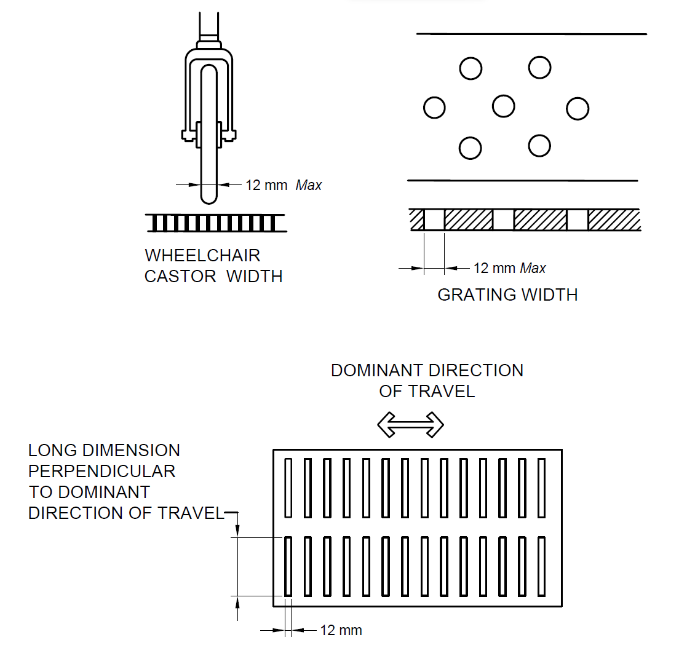
Fig. 19 Installation of Grating
7.5 Tactile Ground Surface Indicators (TGSI) ― Tactile Guiding and Warning Blocks
Tactile ground surface indicators or tactile guiding and warning tiles/blocks aid blind and vision impaired pedestrians negotiate the built environment, and shall be of the dimensions as given in Fig. 20.
NOTE ― Alternatively, other internationally accepted tactile pattern may be accepted by the Authority.
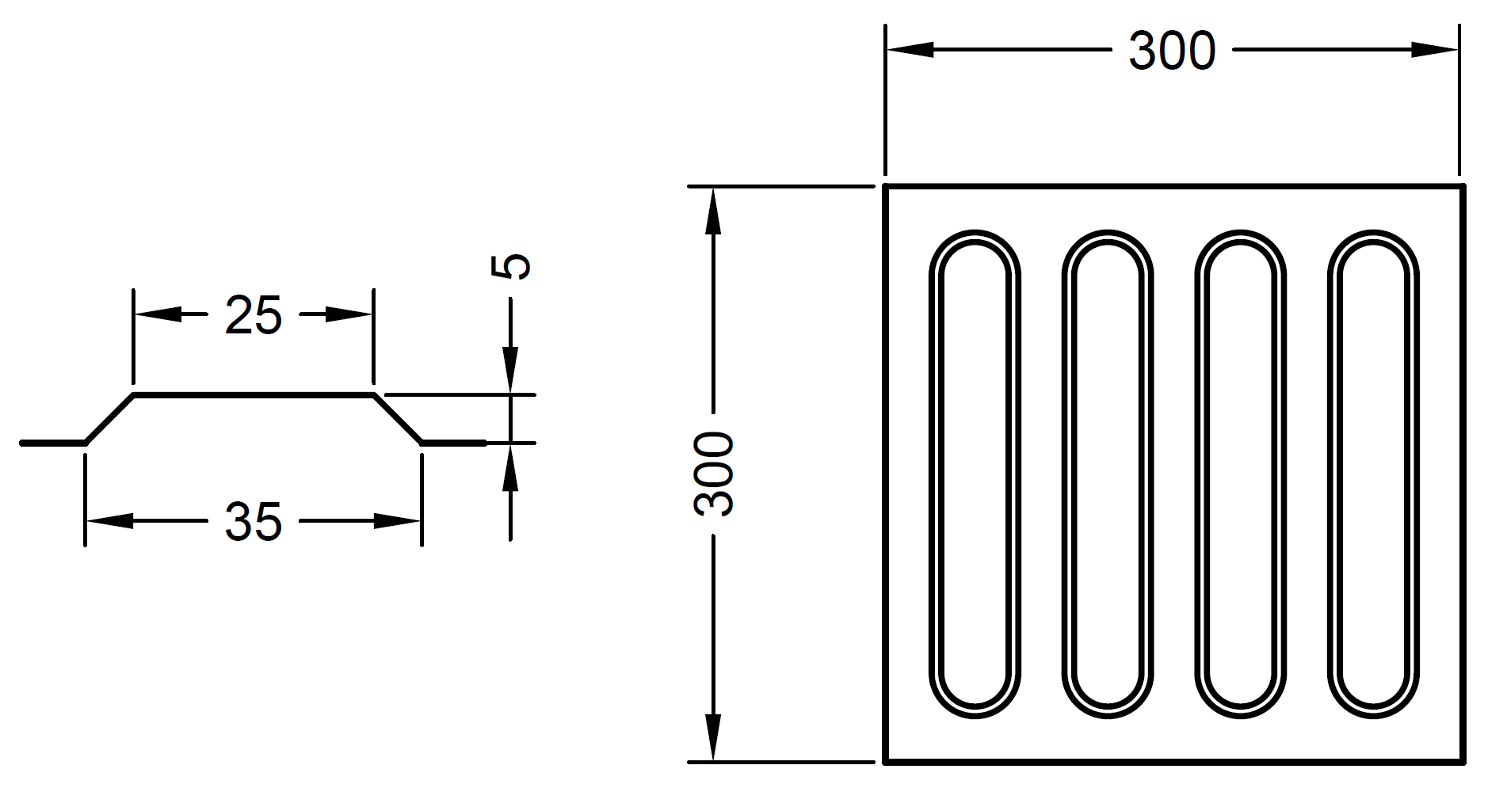
20A Guiding Blocks
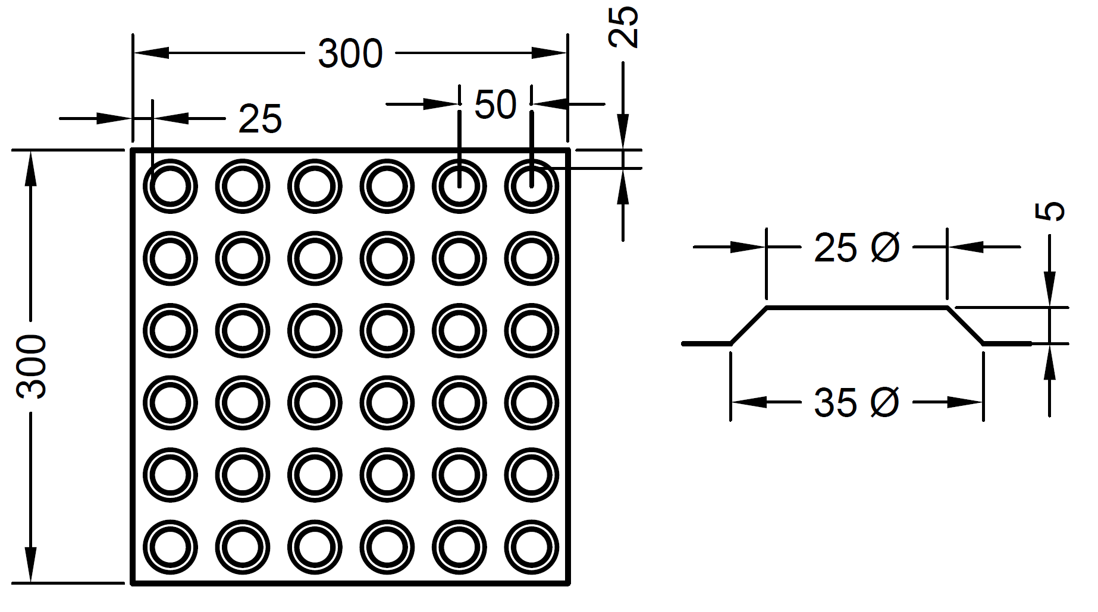
20B Warning Blocks
All dimensions in millimetres
Fig. 20 Guiding Blocks and Warning Blocks
7.5.1 Tactile guiding blocks indicate a correct path/route to follow for a person with visual impairment. It is recommended to install one/two rows of tactile guiding blocks along the entire length of the proposed accessible route. Care shall be taken to ensure that there are no obstacles, such as trees, poles or uneven surfaces, along the route traversed by the guiding blocks. Also, there shall be clear headroom of at least 2 100 mm height above the tactile guiding blocks, free of protruding objects such as overhanging tree branches and signage, along the entire length of the walk.
7.5.2 Tactile warning blocks indicate an approaching potential hazard or a change in direction of the walkway, and serve as a warning of the approaching danger to persons with visual impairments, preparing them to tread cautiously and expect obstacles along the travel path, traffic intersections, doorways, etc. They are used to screen off obstacles, drop-offs or other hazards, to discourage movement in an incorrect direction, and to warn of a corner or junction. Two rows of tactile warning tiles shall be installed across the entire width of the designated accessible pathway, before intersections, building entrances, level changes, obstacles such as trees, and each time the walkway changes direction. Warning blocks shall be placed 300 mm from the beginning and end of the ramps and stairs, at landings and entrance to any door.
7.5.3 Places to Install TGSI (see Fig. and Fig. 22)
TGSI shall be installed in following places:
- In open space to orient persons with vision impairment;
- In front of an area where traffic is present;
- In front of an entrance/exit to and from a ramp, staircase or multi-level crossing facility;
- Entrances/exits at public transport terminals or boarding areas;
- Sidewalk/footpath section of an approach road to a building; and
- From a public facility to the nearest public transport station.
TGSI shall not be installed at the following places:
- On the ramp surface, stairs or any inclined surface;
- Shall not extend into areas where vehicular movement is expected. Access routes must be protected from vehicular movement;
- Internal corridors narrower than 1 800 mm, except at decision points; and
- Inside sanitary facilities.

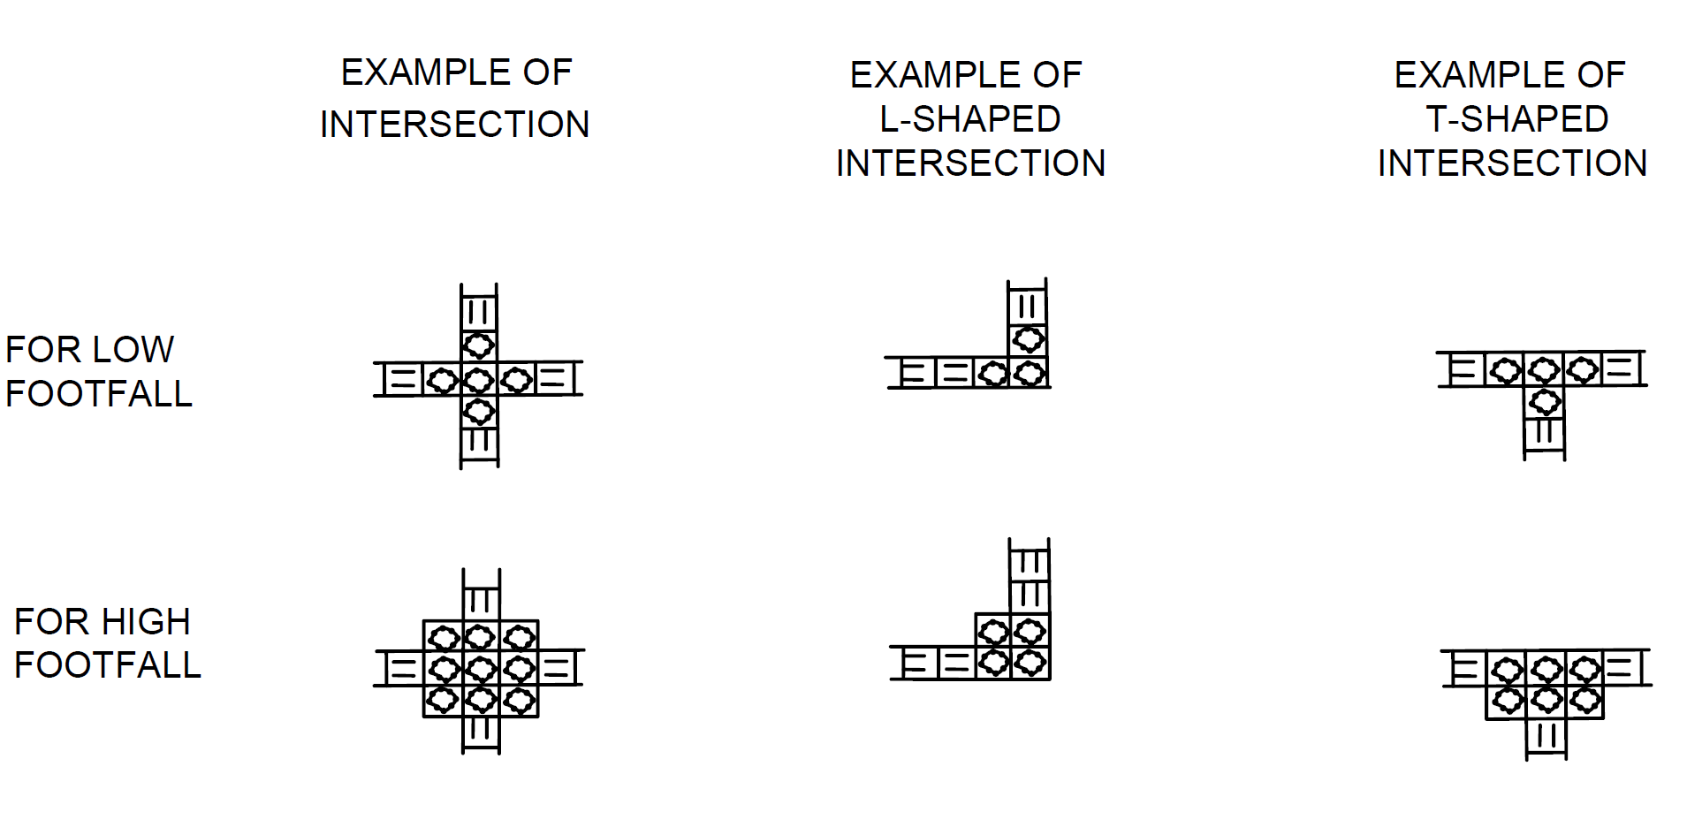
21A Arrangement of Guiding Blocks for Persons with Visual Impairment
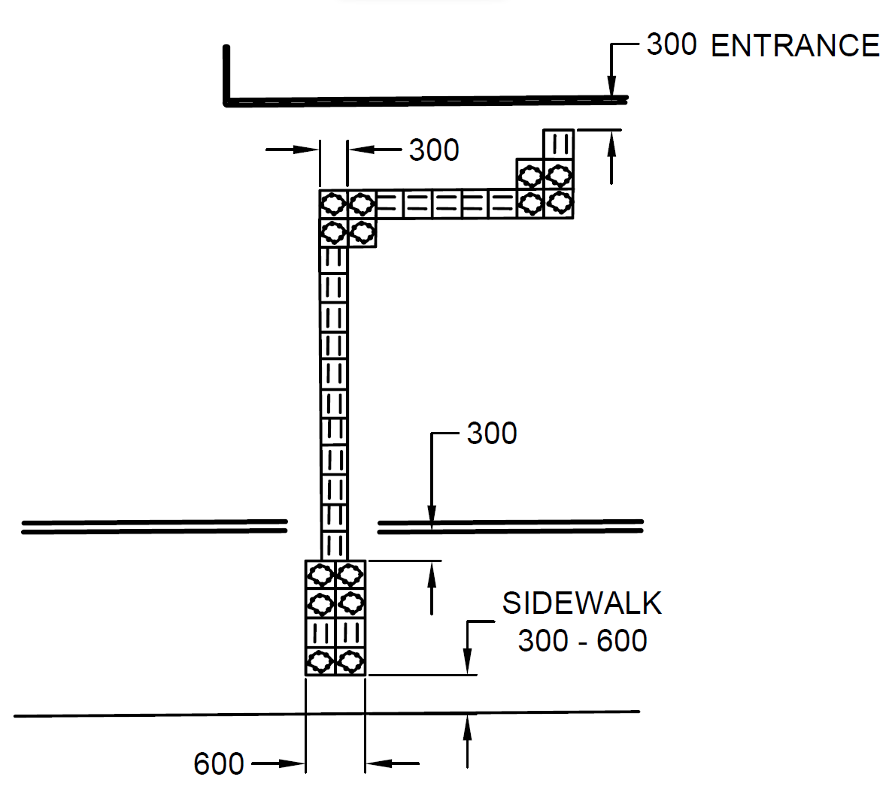
21B Guiding Path and Approaching Sidewalk to the Building
Fig. 21 Installation of TGSI
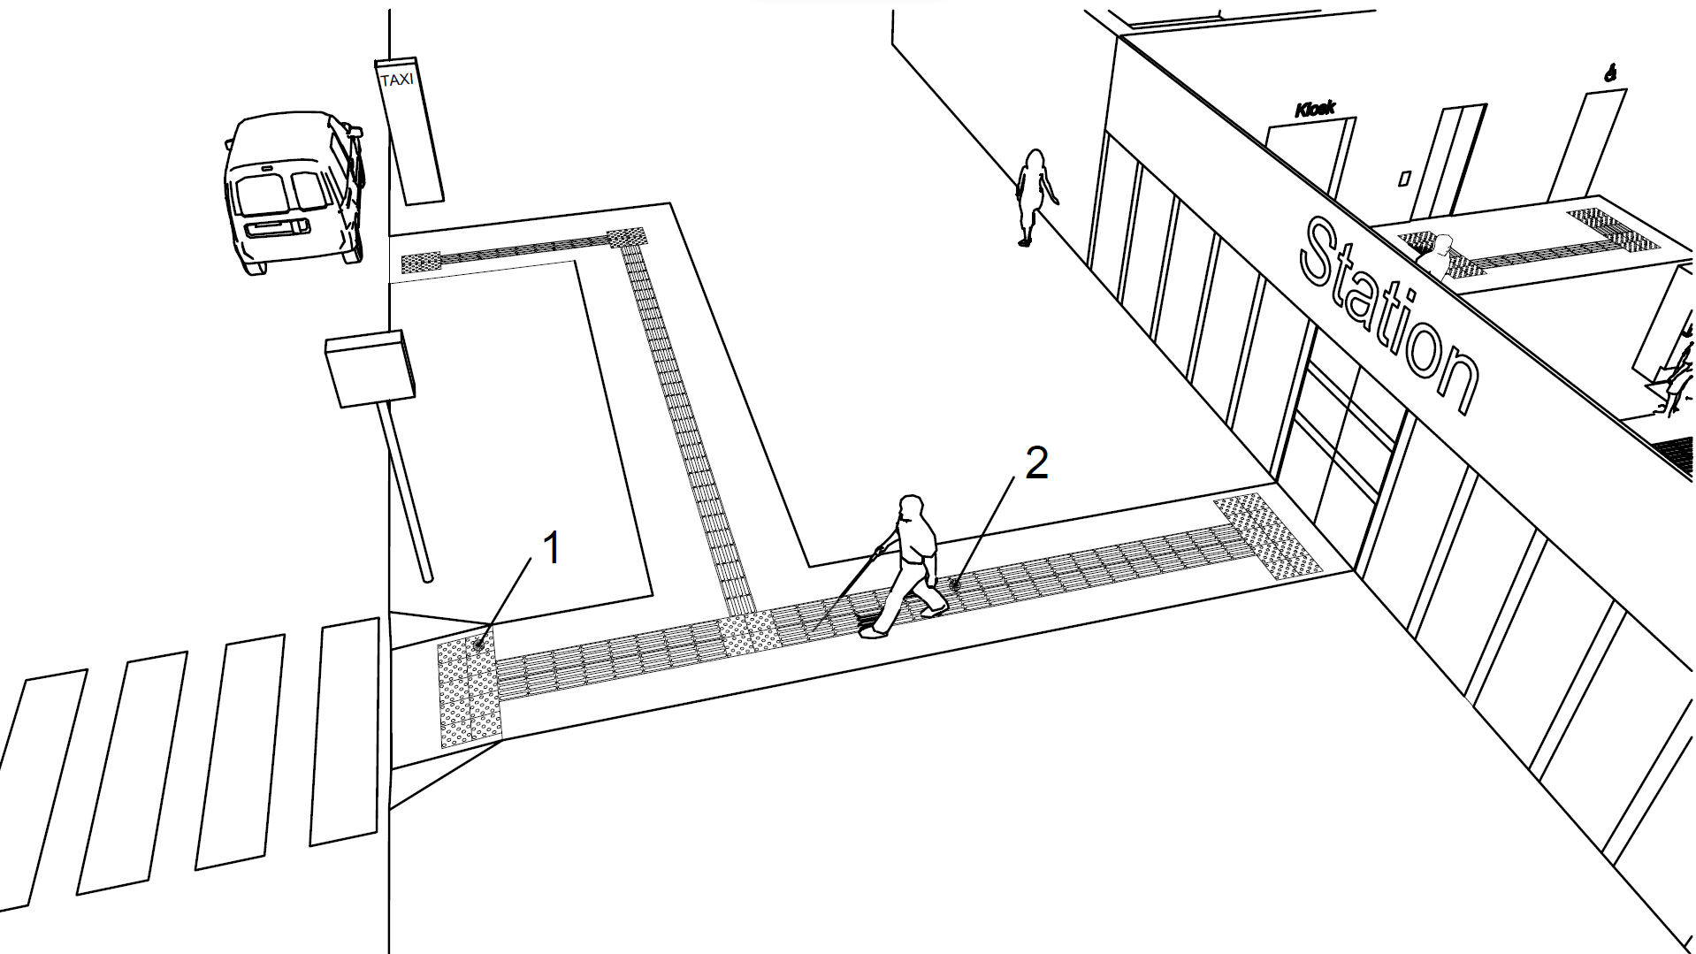
Key
- Tactile ground surface indicator as attention pattern for decision points or hazards
- Tactile ground surface indicator as guiding pattern
Fig. 22 Example of Tactile Ground Surface Indicators Used in Open Areas
7.6 Barriers and Hazard
7.6.1 Obstacles, such as objects or signs mounted on walls, columns or free- standing supports along the walking path shall be avoided. Unavoidable free standing posts or columns within access routes on pathways shall leave at least unobstructed walking width of 1 000 mm and be clearly marked with visual indicators. Visual indicators at least 75 mm in height with a minimum visual contrast of 30 points difference in the LRV value of the colours to the background shall be placed; one at a height between 800 mm and 1 000 mm above floor level, and the other between 1 400 mm and 1 600 mm above floor level.
Bollards, short vertical posts generally arranged in a line to guide traffic and protect from vehicle intrusions, shall have a maximum height of 1000 mm. Bollards, where installed within the access route shall have a minimum clear spacing between them of 1000 mm so as to provide clear passage width for movement of wheelchairs.
7.6.2 Protruding Objects
Unavoidable protruding objects shall not reduce the minimum clear width of an accessible route or manoeuvring space. Protruding objects in the access route shall contrast visually with the background environment.
Objects with a height lower than 1 000 mm can create a hazard for blind or partially sighted people. Permanent equipment that cannot be located outside the boundaries of a path shall be,
- designed to be easily seen with a minimum difference in LRVs of 30 points to the background;
- shielded to protect against impact; and
- accompanied by a feature that warns of the presence of a potential hazard and is detectable for a person using a white cane or stick (see Fig. 23).
The headroom along a path shall be maintained at a height of not less than 2 100 mm above the surface of the path.
Any objects projecting more than 100 mm between 300 mm and 2 100 mm above ground level into an access route shall be clearly visible and detectable with a cane (see Fig. 23).
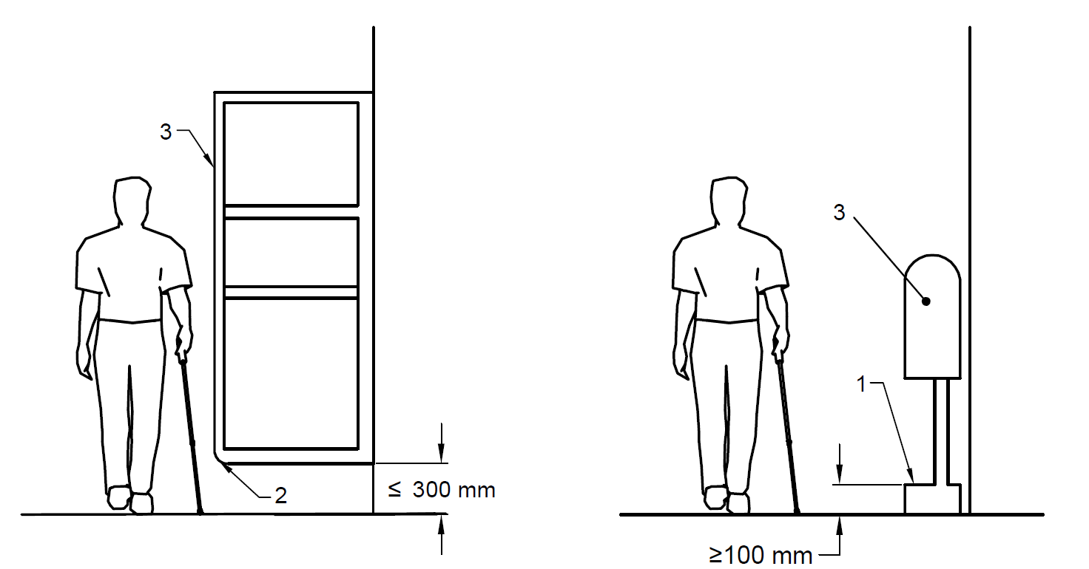
Key
1 Base plinth detectable with cane if a projecting object is more than 100 mm above floor level
2 Winged protection between 300 mm and 1000 mm above floor level, contrasting visually with the background and detectable with a cane
3 Difference in light reflectance value to background – minimum 30 points
Fig. 23 Solitary Obstacles
When a projecting obstacle exists, a protective guard shall be provided at ground level, under the projecting object, such as, a kerb or fixed element at a height of 100 mm – 300 mm as cane detection. Cane detection shall not be set back more than 100 mm from the face of the projecting object. Wing walls, side partitions, alcoves or recesses are solutions for projecting elements where free space under the object is needed. Winged protection shall extend continuously between 300 mm and 1 000 mm above the floor and shall contrast visually with the background.
7.6.3 Headroom
Where headroom is less than 2 100 mm from the finished floor level, a warning guardrail or other suitable barrier shall be provided for detection, having its leading edge at or below 680 mm above the finished floor level, such as to enable easy detection with a white cane (see Fig. 24).
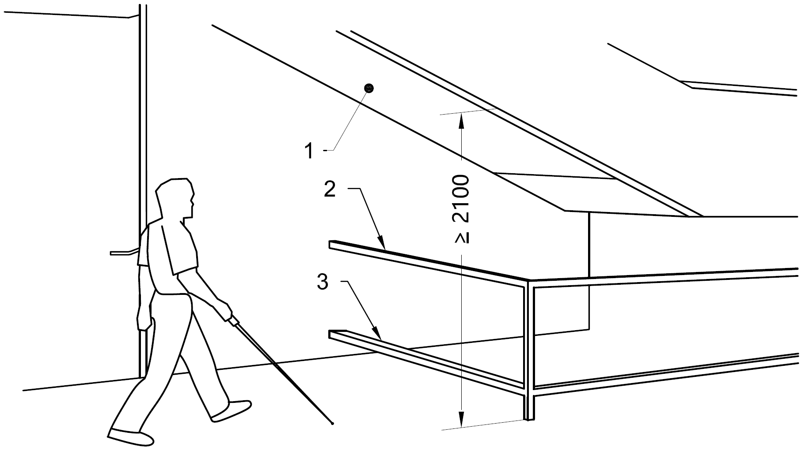
Key
- Minimum 2 100 mm height
- Guardrail against impact, at a height 680 – 700 mm above floor
- Guardrail detectable with cane, at a maximum height 300 mm above floor
All dimensions in millimetres.
Fig. 24 Warning Guardrail in case of Insufficient Headroom
7.6.4 Identification
Appropriate identification of specific facilities within a building used by the public is particularly essential to the persons with visual impairments. Raised letters or numbers shall be used to identify rooms or offices. Such identification shall be placed on the wall, to the left of the door, preferably at a height of 1 500 mm from the floor and comply with the requirements given in 34.
7.6.5 Warning Signals
Following requirements with respect to warning signals near barriers shall be complied with:
- Audible warning signals shall be accompanied by simultaneous visual signals for the benefit of those with hearing disabilities.
- Visual signals shall be accompanied by simultaneous audible signals for the benefit of the blind and visually impaired people. To assist blind people, lettering and symbols on signs should be raised for tactile reading.
- Information based on colour codes only should be avoided; colour blind people may find them difficult to understand.
- Signs should be designed, located and illuminated as per 34.
7.6.6 Hazards
7.6.6.1 Where hazards on the direct line of pedestrian travel such as stairs, escalators and moving walks or ramps with a slope of more than 1:16 cannot be avoided, tactile warning indicators and visual markings shall be provided. Every effort shall be exercised to obviate hazards to persons with disabilities.
7.6.6.2 Access panels in walls or manholes in walks, may be extremely hazardous, particularly when in use/open, and shall be avoided. When manholes or access panels are open and in use, or when an open excavation exists on a site, particularly when it is in proximity of normal pedestrian traffic, barricades shall be placed on all open sides, and warning devices shall be installed.
7.7 Lighting for Walkways
Lighting for walkways shall be as given below:
- Lighting should illuminate the walkway; lighting fixtures not exceeding a height of 4 m from ground level should be provided.
- Lighting shall be provided every 20 m to 30m, focusing light not on the car lanes, but on the walkways.
- A white light source, for example high-pressure sodium, is preferable in city and town centres for the aesthetic effect and for better colour definition, which benefits those with poor sight.
- White lighting at average 35 to 40 lux is recommended to ensure colour contrast of tactile blocks and to ensure visibility at night to persons with low vision.
- Light pole may preferably be located within the tree-planting zone.
- Lower level light poles are preferred to avoid shadow where there are high trees.
8 DESIGNATED ACCESSIBLE PARKING SPACE
8.1 Location of Parking
The designated accessible parking spaces that serve a building shall be located as near as possible to the main entrance, and the distance from the accessible parking space to the main entrance shall not be more than 30 m. In case the access is through lift, the parking shall be located within 30 m of the lift lobby. Kerb ramp from parking space to an adjacent higher pedestrian path shall be provided in accordance with 8.6.
Where indoor parking is provided, a suitable passenger lift or separated pedestrian ramp shall be installed to provide access from the parked vehicle to the principal entrance of the building or buildings served by the car parking.
8.2 Number of Designated Accessible Parking Spaces
The following minimum requirements concerning the number of parking places shall apply:
- A minimum of one accessible designated parking space shall be provided in every parking area;
- For up to 10 parking spaces, one designated accessible parking space shall be provided;
- For up to 25 parking spaces, two designated accessible parking space shall be provided;
- For up to 50 parking spaces, three designated accessible parking spaces shall be provided;
- For up to 100 parking spaces, four designated accessible parking spaces shall be provided;
- For up to 200 parking spaces, six designated accessible parking spaces shall be provided; and
- For over 200 parking spaces, six designated accessible parking spaces for 200 parking spaces and one for each additional 100 parking spaces shall be provided.
In specialized facilities such as health care facilities, shopping areas and recreational facilities, a greater number of designated accessible parking spaces should be considered.
8.3 Signage for Parking
Signage for designated accessible parking spaces shall meet the following requirements:
- International symbol of accessibility shall be displayed at approaches and entrances to car parking to indicate the provision of accessible parking lot for persons with disabilities within the vicinity.
- Directional signs consisting of arrows combined with the international symbol of accessibility shall be placed along the route leading to the accessible parking lot (see Fig. 25).
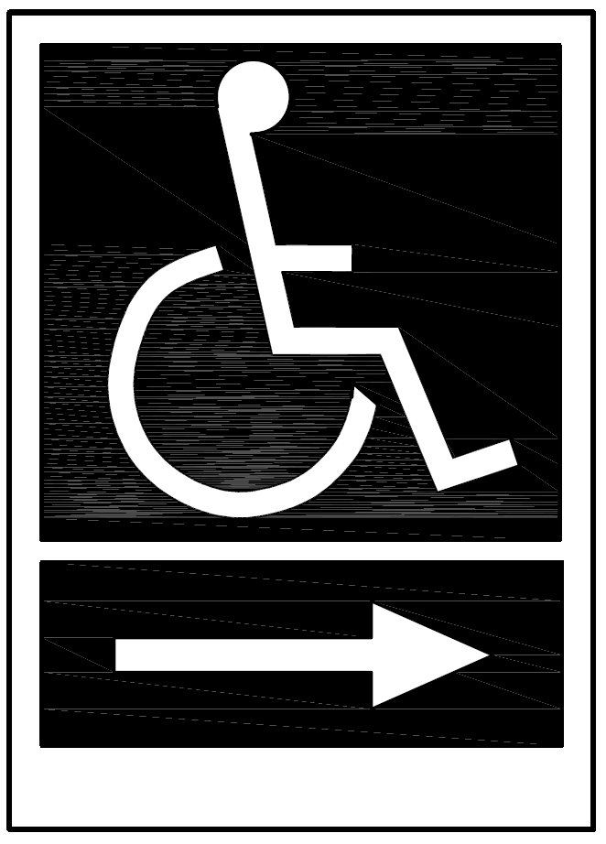
Fig. 25 Directional Signage Leading to Designated Accessible Parking Spaces
- Directional signs shall also be displayed to direct persons with disabilities to the accessible parking lot at points where there is a change of direction, or where the location of the accessible parking lot is not obvious or is distant from the approach viewpoints.
- Accessible parking lot shall be identifiable by the International Symbol of Accessibility placed vertically. The signs shall not be obscured by a vehicle parked in the designated lot.
- A vertical sign shall be provided, and to make it easily visible, the sign shall be at a minimum height of 2 100 mm. This height is to ensure that the sign does not get hidden behind large vehicles in the parking (see Fig. 26).
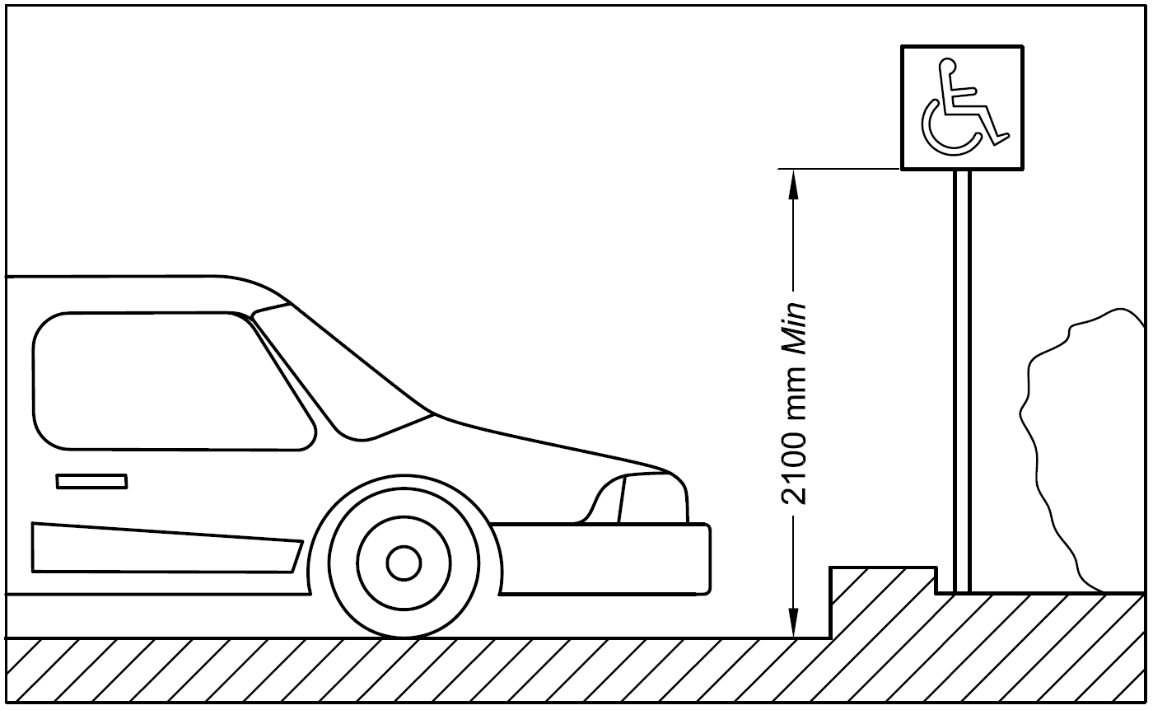
Fig. 26 Vertical Sign at Designated Accessible Parking Spaces
- International symbol of accessibility shall be clearly marked/painted on the floor surface of the designated accessible parking lot for drivers/riders with disabilities only. The symbol painted on the designated lot shall comply the following:
  - A square with dimensions of at least 1 000 mm but not exceeding 1 500 mm in length;
  - Located at the centre of the parking lot; and
  - Colour of the symbol shall be in contrasting colour scheme of blue and white (see 34.2.16 and Fig. 104).
8.4 Car Park Entrance and Parking Controls
The car park entrance shall have a height clearance of at least 2 600 mm.
If payment machine is provided, it shall provide all control at the height between 800 mm and 1 000 mm (see 12).
Access to the machine shall be level along an accessible route and easy to operate. The machine shall be located so that it does not create a hazard or barrier for persons with disabilities.
8.5 Accessible Car Parking Space Dimensions and Surface Requirements
The accessible car parking space shall meet the following requirements:
- The minimum width of the parking space for a car shall be 3 900 mm and the minimum length shall be 5 400 mm. This minimum width includes the transfer area beside the car with a minimum of 1 500 mm.
- Two accessible parking spaces with one shared transfer area are widely used and shall have a minimum width of 6 300 mm (see Fig. 27).
- It shall have a firm, level surface without aeration slabs.
- Wherever possible, it shall be sheltered.
- The transfer zones, both on the side and the rear should have yellow or white cross-hatch road markings (see also Fig. 27).
- The designated accessible parking spaces shall be located on a gradient not greater than 1:50, throughout its length and its width.
- The accessible route of 1 200 mm width shall be provided for wheelchair users to pass behind vehicle that may be backing out (see Fig. 28).
- Parking space along the footpath/sidewalk― For road side parking of an accessible van, the minimum dimensions shall be 9 000 mm x 2 400 mm with a kerb to access the nearest footpath/sidewalk (see Fig. 29).
- Van parking with auxiliary movable ramps ―The size and design of accessible vehicles may vary as some are fitted with ramps or hoists at the side or at the rear. The minimum width of the accessible parking space for a van shall have at least the same dimensions as for car parking spaces (see Fig. 26). Transfer areas between spaces may be shared.
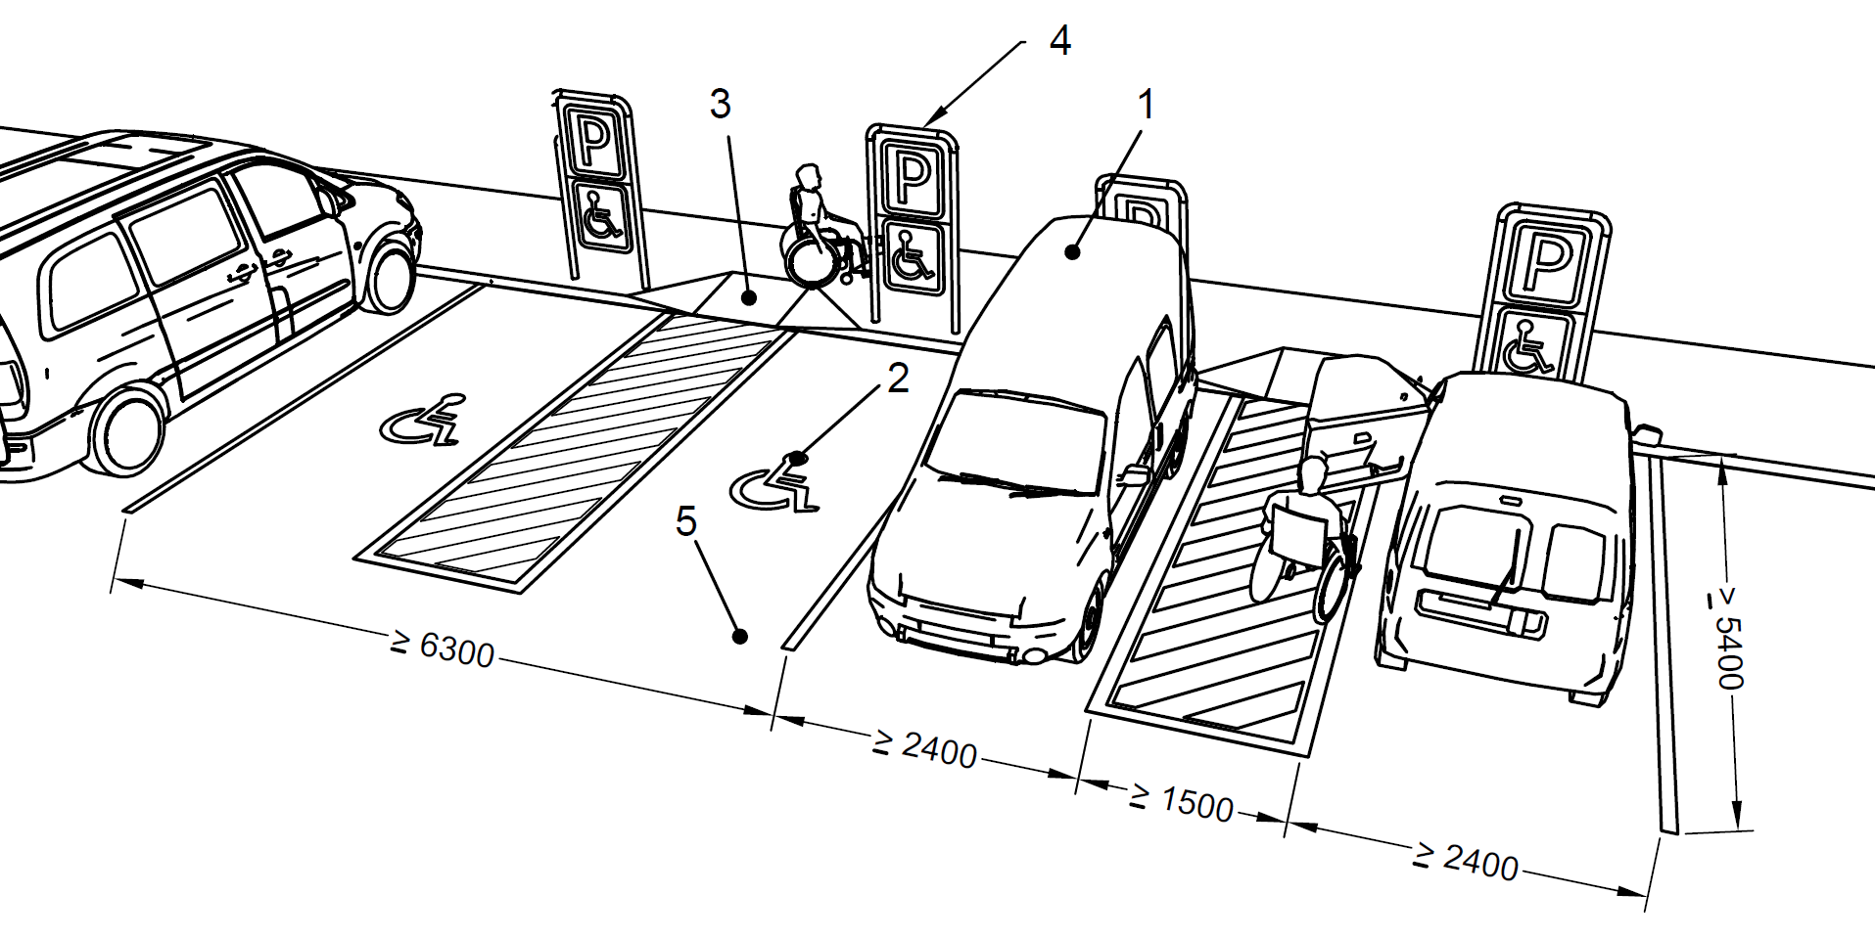
Key
- Minimum unobstructed height for vans 2600 mm
- Symbol of accessibility
- Kerb ramp
- Signage, including symbol of accessibility
- Firm ground
All dimensions in millimetres
Fig. 27 Accessible Parking Spaces Accessible Parking Spaces with One Shared Transfer Area
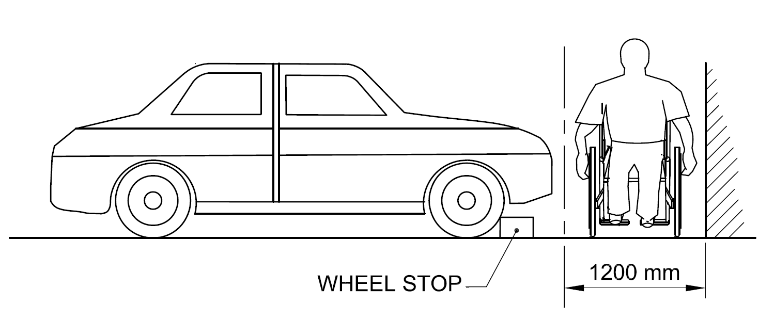
Fig. 28 Accessible Route Width for Wheelchair Users to Pass Behind a Vehicle
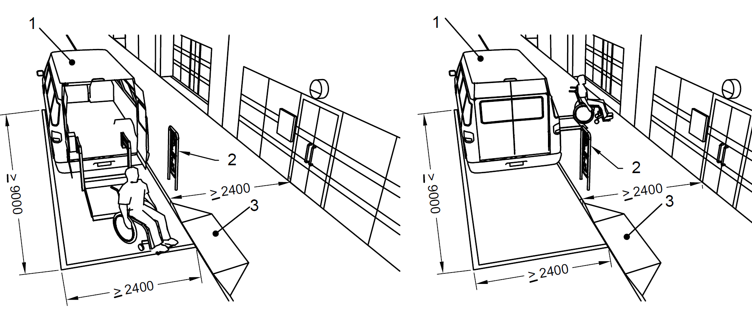
Key
- Minimum unobstructed height 2 600 mm
- Signage, including symbol of access
- Kerb ramp
All dimensions in millimetres
Fig. 29 Parking Space Along a Footpath/Sidewalk
For multi-purpose vehicles with hoists or lifts, more space is needed; at least an additional 2 400 mm area beside the van and/or at the rear of the van may be required. The dedicated parking space in this case shall be 4 800 mm wide and 9 000 mm long (see Fig. 27 and Fig. 29 for different types of designated parking spaces).
As an alternative, a parking space of 2 400 mm wide x 9 000 mm in length along a footpath may be used, provided the footpath is at least 2 400 mm wide as shown in Fig.28.
8.6 Kerb Ramp from Parking Space to an Adjacent Higher Pedestrian Path
The kerb ramp should be located in close proximity to the designated accessible parking area connecting the accessible path of travel to the main entrance. The kerb ramp width should be a minimum of 1 000 mm. The gradient of the kerb ramp should consider the requirements in 7.3. Kerb ramps shall have a slip-resistant surface. The accessible path to the kerb ramp can be marked with hatching painted on the road surface to prevent people from parking in this area (see Fig. 27).
9 APPROACHES TO THE BUILDING
The entry to the building shall be facilitated by the following:
- Space should be provided for passenger drop-off points for taxis, public transport and also for large vehicles such as vans, etc, as near as possible to the main accessible entrance. Vehicle drop-off areas should be a minimum of 9 000 mm in length, have a minimum width of 3 600 mm and be served by a kerb ramp.
- At least one accessible route leading to an accessible entrance of the building shall be provided from the alighting and boarding point of taxi stands and car park lots (see 8) for people with disabilities.
- If there is a difference in level between the carriageway and the footpath, a kerb ramp conforming to 7.3 shall be provided to facilitate the setting-down of people close to the main entrance of a building. This benefits people who need to transfer to and from a wheelchair and others.
- An appropriate tactile ground surface indicator (TGSI) should be provided to lead vision impaired persons to the main entrance where no other clues indicate the path to the building.
- Building shall have all accessible entrance doors complying with 10.3.
- The accessible entrance, if different from the main entrance, shall be located adjacent to the main entrance and not at the rear of the building. The accessible entrance shall be clearly signed and easy to locate.
- Symbol shall be displayed at all other non-accessible entrances to direct persons with disabilities to the accessible entrance.
10 ACCESS AT ENTRANCE AND WITHIN THE BUILDING
10.1 General Requirements
- Access to the building entrance shall be in accordance with 9.
- A clear, firm and level landing of at least 1 800 mm x 1 800 mm shall be provided on either side of the entrance door.
- The clear width of the accessible entrance door shall not be less than 900 mm and the width of the corridors or passageways leading to and from such access door shall not be less than 1 200 mm.
- In multi-storey buildings, the accessible entrance shall have an accessible route leading to the lifts.
- Internal floor surfaces shall be of materials that do not impede the movement of wheelchairs. If mat is provided it shall be in level with the floor finish.
- Persons with visual impairments find it easier to locate doors if there is a texture difference in the floor around the doorway from the rest of the flooring. It is generally good practice to recess foot mats in the floor on either side of the door but care shall be taken to ensure that the top end of the mats are flush with the rest of the flooring.
- In addition to the tactile pavers (TGSI) leading to the main entrances, beepers may be put at all main entrances to enable people with visual impairments to locate them.
- Tactile layout plan of the building should be provided at the entrance for people with visual impairments.
- Glazed entrance doors shall have manifestations on the glass as per 10.3.13.
NOTE: The clear width does not include any protrusions like door panels, door handles, door frames or jambs etc.
10.2 Internal Corridors and Accessible Routes
10.2.1 General
The main horizontal circulation design shall be level on each floor in order to ensure that the building is accessible to all people. Horizontal circulation shall be without steps. Where differences in level cannot be avoided, ramps or lifts shall be provided in accordance with 11.
Buildings should be designed, constructed and managed so that the internal layout is accessible and easily understood. All aspects of horizontal circulation, including corridors, should be designed to facilitate ease of movement for all people.
In order to avoid a tripping hazard (especially during a fire evacuation), where a raised threshold is necessary at a door opening, its maximum height shall be 12 mm, and those exceeding 5 mm shall be bevelled, and shall have a minimum difference in LRV of 30 points compared to the floor.
Routes should preferably intersect at right angles to each other and be easy to follow. To facilitate people with visual impairments, routes should have detectable cues and different visual contrast from the surroundings. For orientation and wayfinding in very complex buildings and across large areas, guidance may be provided by tactile ground surface indicators and visual, audible and tactile information, including egress and evacuation.
NOTE ― Handrails can provide support for people with impaired mobility, guidance for people who are blind or have impaired vision, and can also support Braille information or tactile information.
10.2.2 Internal Passages
Intensity in use of the corridor shall be a criterion when establishing the minimum width and length of the corridor (see Fig. 30). The minimum unobstructed width of corridors shall be 1 500 mm, with a preference for a width of 1 800 mm.
Where less than 1 800 mm wide, a corridor shall be provided with passing places, 1 800 mm wide and at least 1 800 mm in length at reasonable intervals. These dimensions shall be exclusive of handrails and any other projections, for example portable fire extinguishers, notice boards, etc. Adequate circulation space, where a doorway exists, shall be provided (see 10.3).
Changes of direction within a corridor shall have a turning circle with a diameter of 1 500 mm or more, clear of any obstructions (see Fig. 31). The minimum clear height of corridors shall be 2 100 mm.
Hanging objects on walls should be avoided, except when they comply with the minimum unobstructed width shall remain 900 mm.
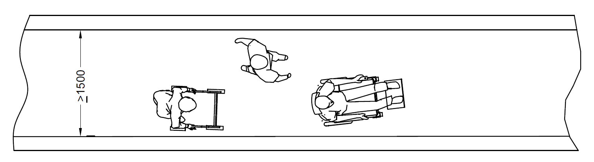
30A Minimum Unobstructed Width of Corridor
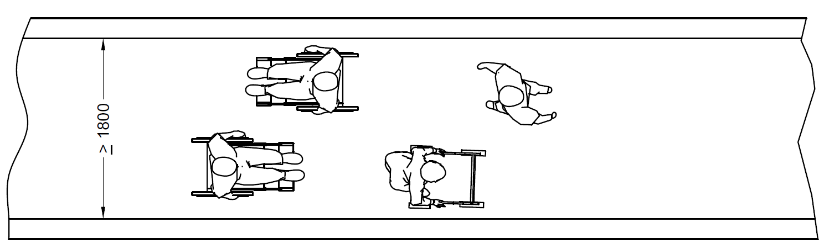
30B Preferred Corridor Width
All dimensions in millimetres
Fig. 30 Different Corridor Widths Determined by the Intensity of Use
10.2.3 Turning Space for 90° Turn of a Wheelchair in Corridors
The manoeuvring zone required for a wheelchair to make a 90° turn shall be designed according to Fig. 31.
It shall have no gradient, and it shall not be less than 1 500 mm wide and 1 500 mm long in the direction of travel.

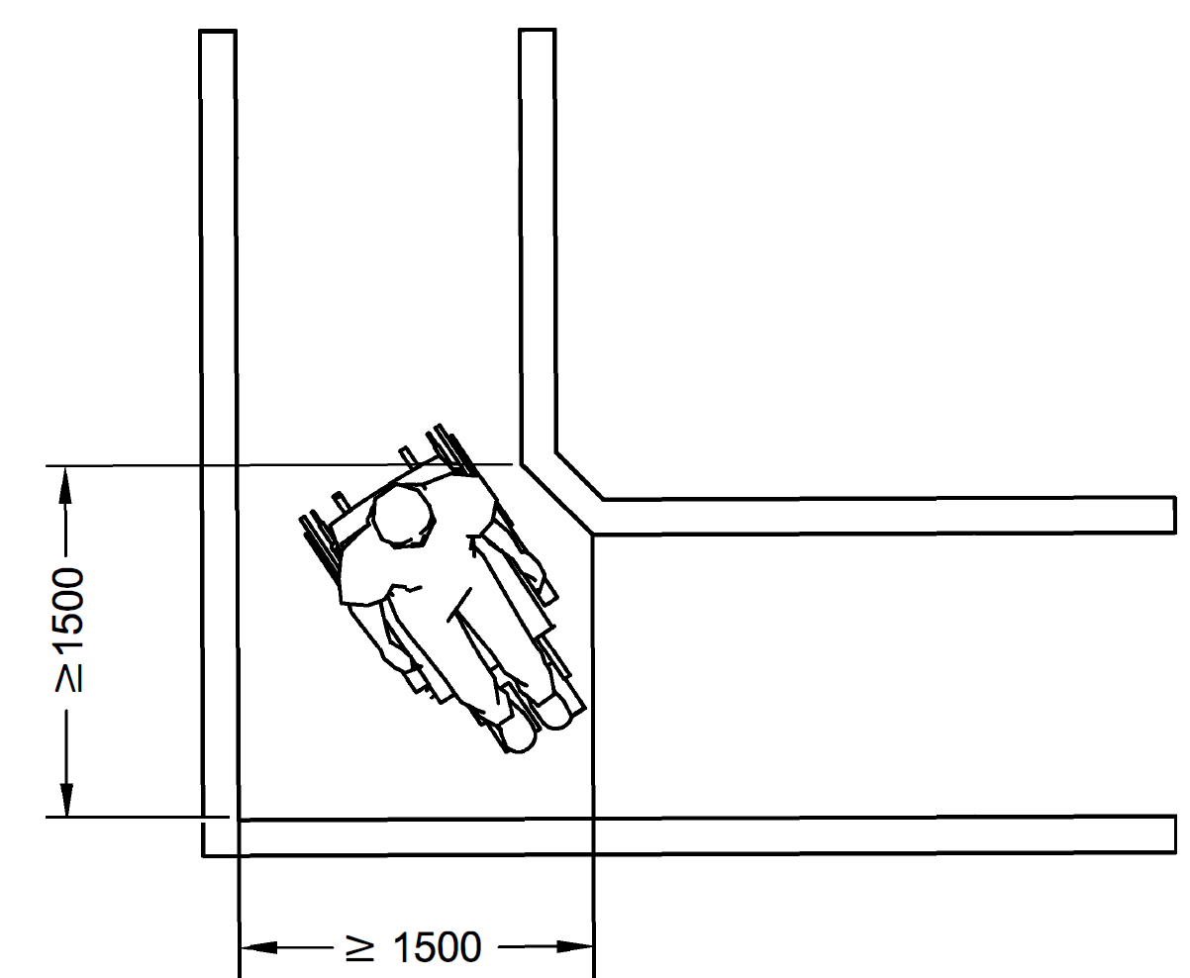

All Dimensions in millimetres
Fig. 31 Space Required for 90º Turn
10.2.4 Circulation Space for 180° Wheelchair Turn
The space required for a wheelchair to make a 180° turn shall be not less than 2 000 mm in the direction of travel and not less than 1 800 mm wide. For landing dimensions, see 11.2.6.
10.2.5 Resting Benches/Seats
In long paths of travel resting areas shall be provided at frequent intervals not exceeding 30 m complying with 7.2.1 (g).
10.2.6 Protruding Object
Obstacles, projections or other protrusions shall be avoided in corridors, passageways or aisles. Long paths of travel shall be avoided and resting areas shall be provided at frequent intervals not exceeding 30 m. For provision of unavoidable obstacles and protruding objects and protection therefrom, requirements given in 7.6 shall be followed.
10.2.7 Floors in Corridors
10.2.7.1 Floor surface shall be clean, stable, firm, level and slip-resistant and glare resistant, preferably of matt finish and shall not have any projections, drops, or unexpected variation in level that may impede the easy access by persons with disabilities. Following requirements shall also be complied with:
        - Complex patterns shall be avoided.
        - Floor patterns that could be mistaken for steps, for examples stripes, shall not be used for floors in corridors.
        - Floors shall be levelled. If this is unavoidable, the slope of floors shall be no greater than 1:20. If greater slope is adopted, floor shall be designed as ramp.
10.2.7.2 For people with low vision, lines of brightly coloured fluorescent tape may be placed on the floor surface to assist mobility in poor lighted areas.
10.2.7.3 Carpeting should be avoided in circulation areas/accessible routes. In case, Where, carpets are used in circulations areas, they shall,
        - not be deeper than 12 mm;
        - shall be securely fixed;
        - have firm cushion, pad or backing; and
        - exposed edges of carpets be fastened to floor surface and trimmed along the entire length of the exposed edge.
10.2.7.4 Wherever cables/wires/pipes etc. are required at floor level they shall be securely accommodated in cable raceways recessed into the floor.”
10.2.8 Lighting in Corridors and Manoeuvring Zone
Lighting in the corridor and manoeuvring zone shall be even, diffused and without glare, reflections or shadows. Minimum illumination level at the corridor and manoeuvring zone shall be 100 lux.
10.2.9 Doors Leading into Corridors
Doors shall conform to 10.3 and shall not open outwards from rooms directly into a frequently used corridor, with the exception of doors to accessible toilets and service ducts. Where a door opens into an infrequently used corridor such as emergency exit, the corridor width shall allow a clear space of 900 mm within the corridor when the door is open. Such doors shall be located clear of any sloping floor surfaces in the corridor. Any door that opens towards a frequently used corridor should be located in a recess at least as deep as the width of the door leaf.
10.3 Door
10.3.1 General
The doors shall meet the following general requirements:
- Doorways shall be levelled.
- Doorways shall be easy for people with vision impairment to locate and identify.
- Wherever revolving doors or turnstiles are installed, they shall be supplemented with an alternate side-hung (swing type) door with 900 mm minimum clear opening width.
- Bathroom (toilets/washroom) doors should swing out/should be two way opening type so that the person inside does not fall against the door and block it. In case there is not much space available, consideration should be given to the use of sliding or folding doors, which are easier to operate and require less wheelchair manoeuvring space.
- Door should not be too heavy to operate and shall not require a force of more than 22 N to operate.
- Automatic doors shall have a push button system to open them.
- All external doors shall have warning blocks installed 300 m before the entrances for aid of visually impaired users.
- The leading edge of any door that is likely to be held open, especially those which are opening into corridors or circulation areas, shall contrast visually with the remaining surfaces of the door and its surroundings on its both sides by a 25 mm wide high-contrast manifestation, to help identification by visually impaired people. The architrave/door frame shall also contrast visually with the wall surfaces surrounding the doorway.
- Low-hanging door closers that remain within the opening of a doorway, when the door is open or that protrude hazardously into regular corridors or traffic ways when the door is closed, shall be avoided.
- All glazed doors shall have a highly visible contrasting frame with manifestations in a contrasting colour complying with the requirements given in 10.3.13. Colour should contrast with the background visible through the door, whether on the inside looking out or on the outside looking in.
- Tactile warning should be provided at approach to automatic doors complying with 7.5.
- Automatic doors, where provided should have guard rails, power floor mats, push or kick plate, horizontal or vertical sensing device and the doors should remain fully open until area is cleared by user. Sliding automatic doors are safer than swinging automatic doors.
- Doors which remain ajar are extremely hazardous for vision impaired people. Doors are best fully open or completely closed; therefore, where appropriate, automatic door closure devices should be considered.
- Entrance shall be well illuminated with even lighting between entrance and reception area.
- Door hardware shall comply with the requirements in 10.3.6.
10.3.2 Clear Width
10.3.2.1 The minimum clear opening of doorways shall be 900 mm, measured between the face of the door and the face of the door stop with the door open at 90° as illustrated in Fig. 32.
10.3.2.2 In case, the door has two independently operated door leaves, at least one active leaf shall comply with 10.3.2.1.
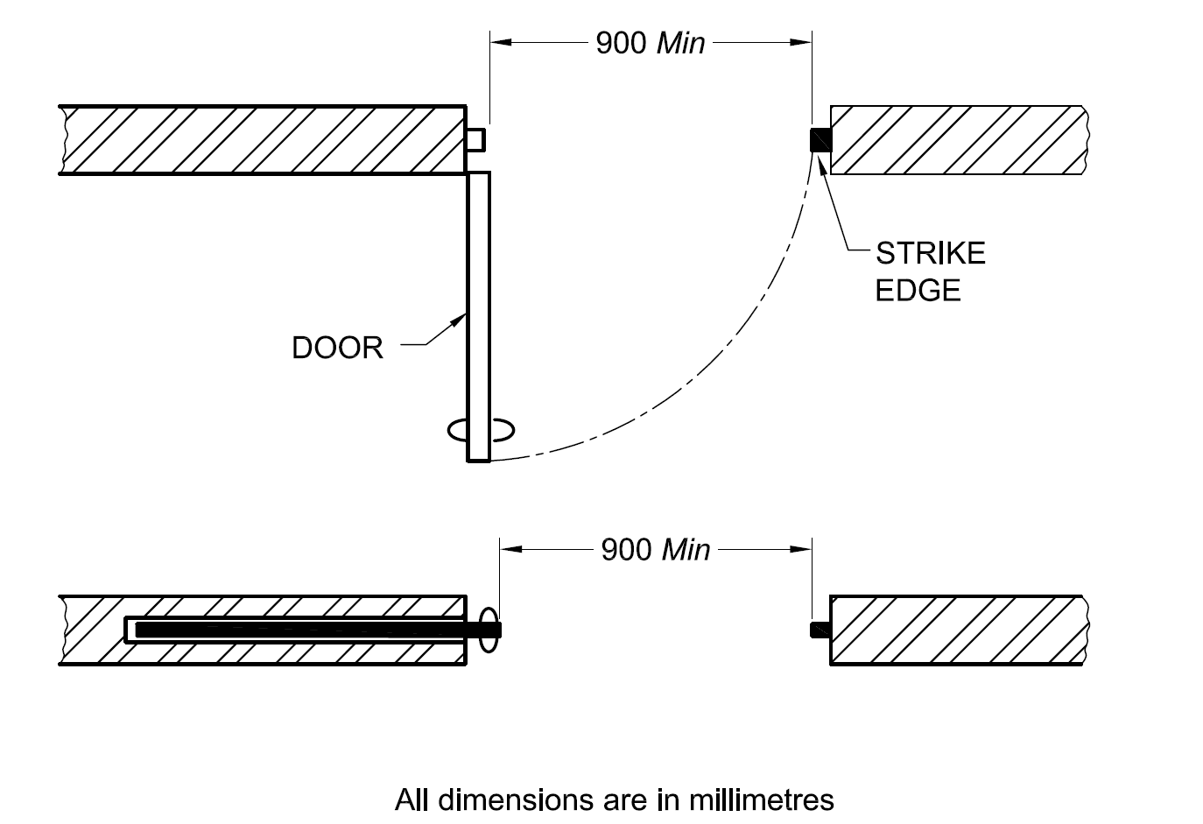
All dimensions in millimetres
Fig. 32 Minimum Clear Opening of Doorways
10.3.3 Thresholds
There shall be no thresholds (doorsills). If thresholds are unavoidable, they shall not exceed 12 mm and those exceeding 5 mm shall be bevelled and contrast visually with the adjacent floor. A minimum difference in LRV of 30 points compared to the floor shall be provided.
10.3.4 Manoeuvring Space at Doors
To enable wheelchair users to approach doors, manoeuvring space as given below shall be provided. In narrow spaces, sliding doors may be preferable. A minimum distance of 600 mm shall be provided beyond the leading edge of door to enable a wheelchair user to manoeuvre and to reach the handle. Wheelchair manoeuvring spaces shall be free of any obstructions and be provided on the side of the door handle in the following manner (see also Figs. 33 and 34):
- On the pull side, a minimum space of 600 mm;
- On the push side, a minimum space of 300 mm; and
- For two-way swing door, a minimum space of 300 mm.
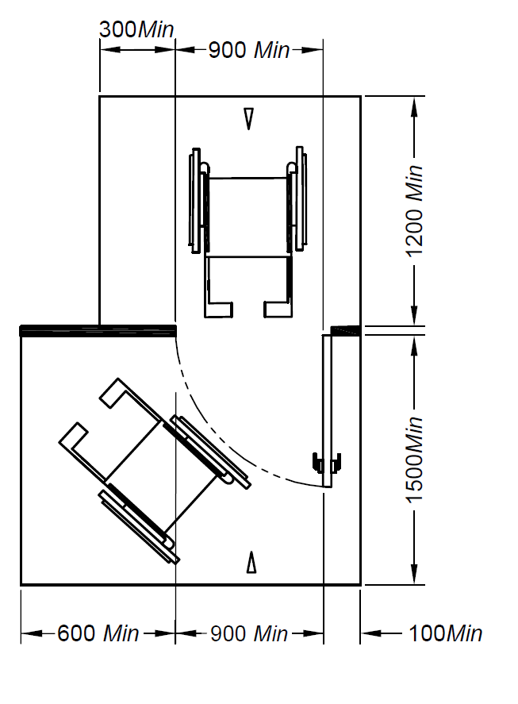 | 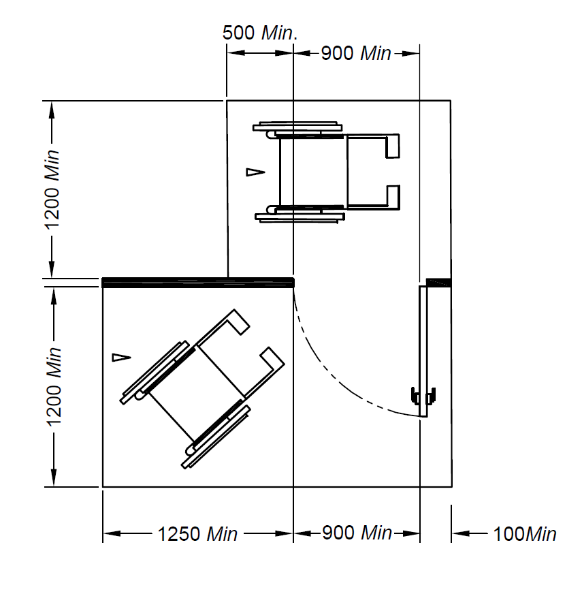
33 A Front Approach | 33 B Latch Side Approach
All dimensions in millimetres
Fig.33 Manoeuvring Space Needed by Wheelchair Users to Approach Doors
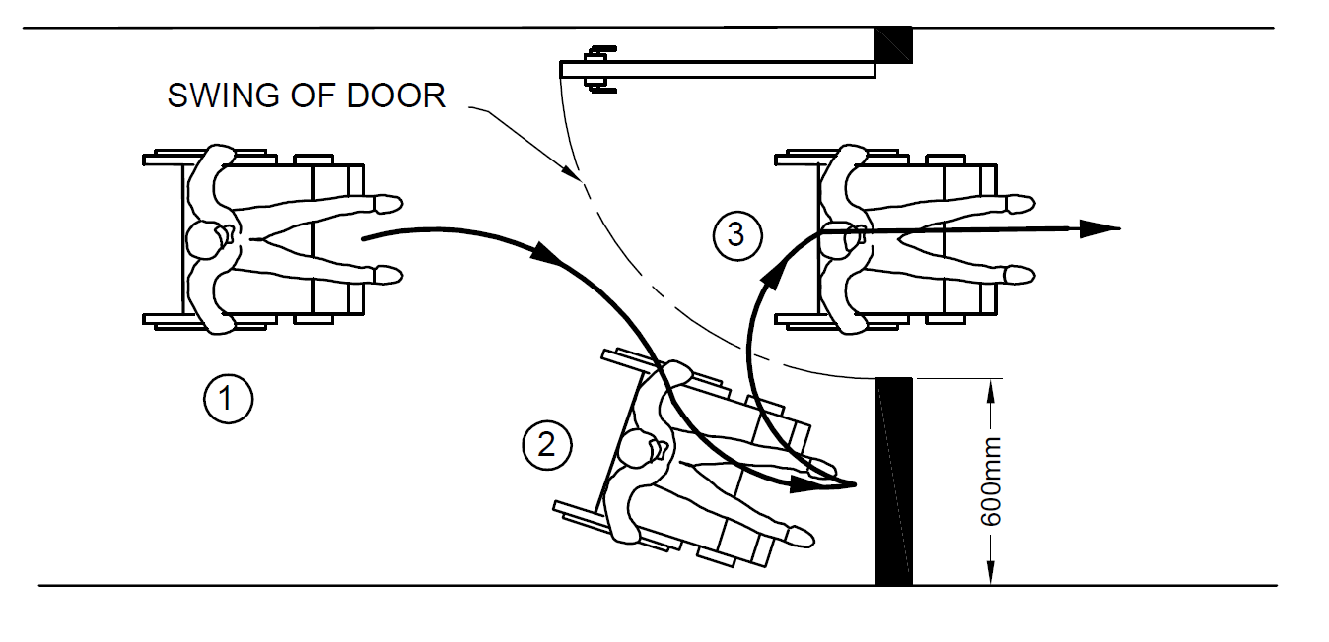
Fig. 34 Position Taken by a Wheelchair User when Negotiating
Door in Passageway
10.3.5 Two Doors in Series
The minimum space between two hinged or pivoted doors in series, shall be 1 500 mm plus the width of the door swinging into that space, as shown in Fig. 35.
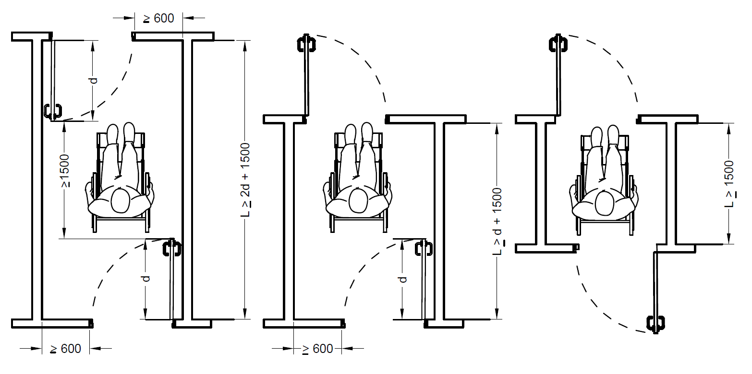
All dimensions in millimetres
Fig.35 Space Between Two Hinged or Pivoted Doors in a Series
10.3.6 Door Hardware
Operable devices such as handles, pulls, latches and locks shall meet the following requirements:
- They shall be operable by one hand.
- They shall not require fine finger control, tight grasping, pinching or twisting to operate.
- They shall be mounted at a height of 850 mm to 1 100 mm from the floor (see Fig. 36).
- For easy identification by persons with visual impairment, all door furniture shall contrast visually with the surface of the door;
- The location and design of latch and push/pull handles shall be consistent throughout a building.
- To facilitate the closing of a door by wheelchair users (for example a water- closet compartment, that does not have a self-closing mechanism), the door shall have a horizontal handle, provided on the closing face of the door, approximately 760 mm from the floor.
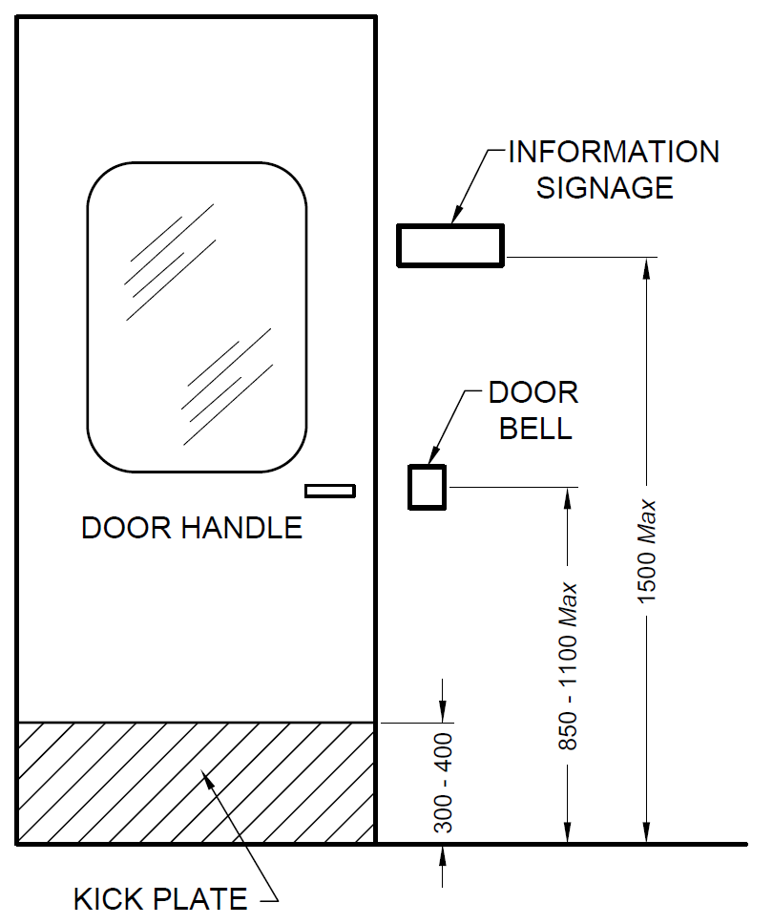
All dimensions in millimetres
Fig.36 Door Hardware Location
10.3.7 Door Handles
The door handles shall conform to 12. The following are recommended for door handles:
- Push-pull mechanisms that require no grasping;
- Lever handles to be preferred on latched doors;
- It is safer to use D-shaped handles as they reduce the risk of catching on clothing, or injuring from the exposed lever end; and
- Doorknob is not recommended, as it does not provide adequate grip for persons with impaired hand functions.
10.3.8 Sliding/Folding Doors
Operating hardware should be exposed and usable from both the sides when the door is fully open.
10.3.9 Door Closure
The sweep period of the door should be adjusted, so that from an open position of 90°, the door does not take less than 3 s to move to a semi-closed position.
10.3.10 Vision Panel
All two-way swing doors or doors in general circulation areas shall be provided with vision panels giving a visibility from a height of 800 mm to 1 500 mm (see Fig. 37). This will enable both the wheelchair user and the ambulatory disabled to be noticed by a person on the opposite side in order to prevent him/her from being accidentally struck by the door.
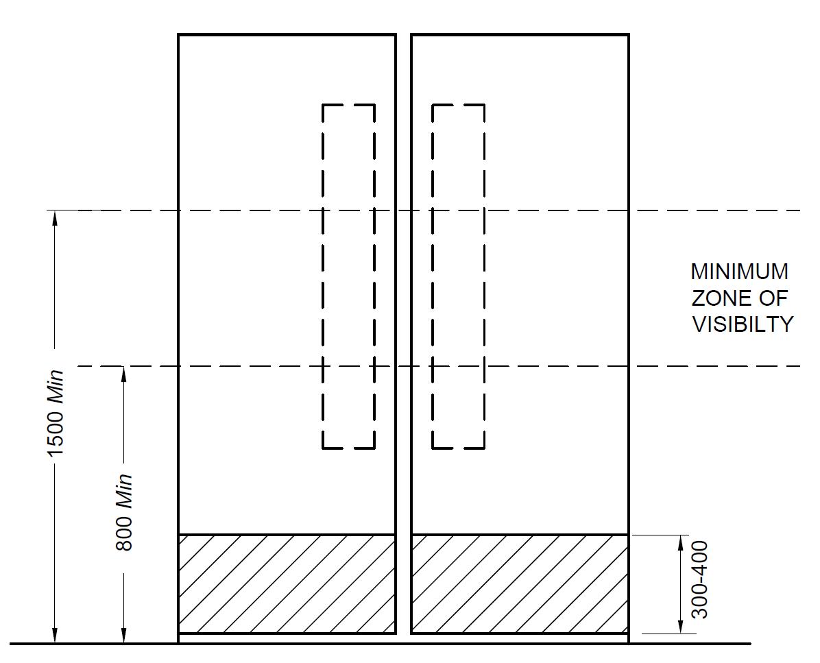
All dimensions in millimetres
Fig. 37 Vision Panel
10.3.11 Kick-Plate
Kick-plates of not less than 300-400 mm height are recommended for doors in high- use in order to protect the push side of doors from damage (see Fig. 36 and Fig. 37).
10.3.12 Door Identification
To help people with impaired sight to see doors, the door and frame should be in a colour which contrasts with the adjoining wall. The door shall not be of a highly polished/reflective material such as stainless steel.
10.3.13 Glass Doors
The presence of a glass door shall be made apparent, with permanent uninterrupted visual manifestation at two levels (hand and eye level), within 800 mm to 1 000 mm from the floor and within 1 400 mm to 1 600 mm from the floor, contrasting visually with the immediate background with a difference in LRV of 30 points seen through the glass in all light conditions (see Fig. 38). The width of the manifestation shall be minimum 75 mm. The edges of a glass door shall also be apparent when the door is open. An additional visual manifestation placed at a height of 100 mm to 300 mm is recommended (see Fig. 38). Visual manifestation consisting of two separate colours with a minimum difference in LRV of 60 points are recommended to enable lighting conditions and backgrounds to be taken into account.
If a glass door is adjacent to, or is incorporated within, a fully glazed wall, the door and wall shall be clearly differentiated from one another, with the door more prominent. To achieve this, the door may be framed on both sides and also on the top by an opaque high-contrast strip at least 25 mm wide.
Glass that is silvered or highly reflective should be avoided and any free-standing edges of glazed screens should have a strip contrasting visually with the surroundings against which they are seen.
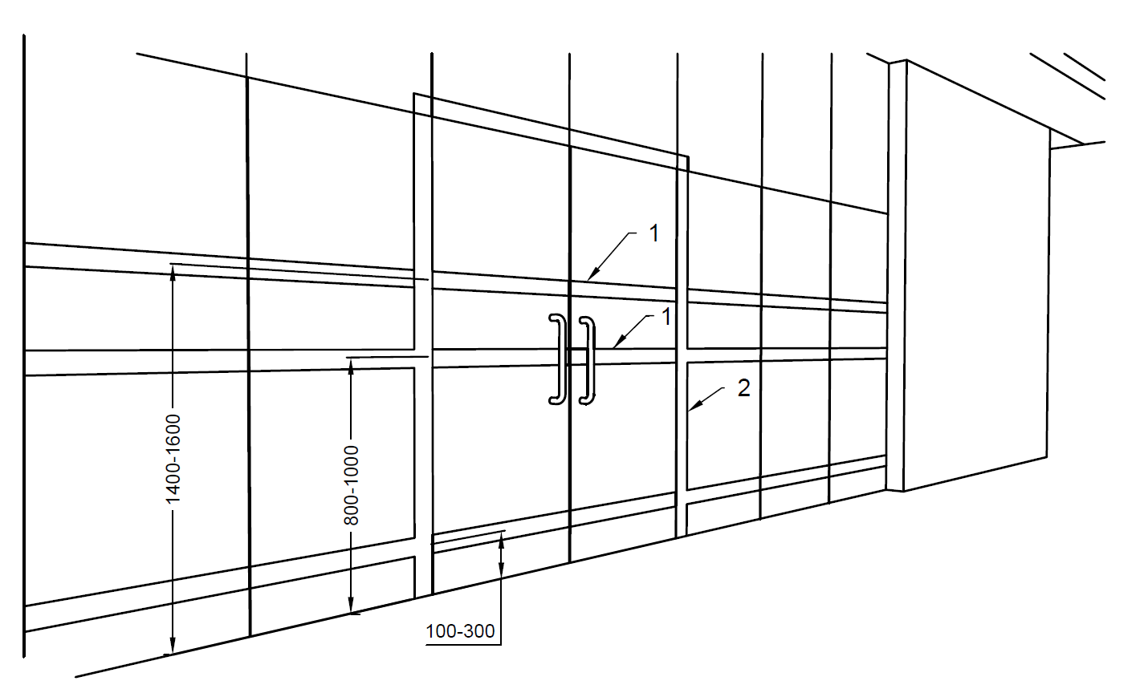
Key
- Visual marking (manifestations), minimum width 75 mm, two separate colours with a minimum difference in LRV of 30 points
- Visual marking on door frame, minimum width 50 mm
All dimensions in millimetres
Fig. 38 Permanent Manifestation on Glass Door
10.4 Windows
The windows shall meet the following general requirements (see Fig. 39):
- Windows shall have handles/controls in accordance with 12 and 10.3.7.
- They shall provide an unobstructed viewing zone for wheelchair users between 600 mm and 1 400 mm.
- Curtain or venetian blind controls/ropes shall be at 800-1 000 mm height from the finished floor level for wheelchair users/short stature persons.
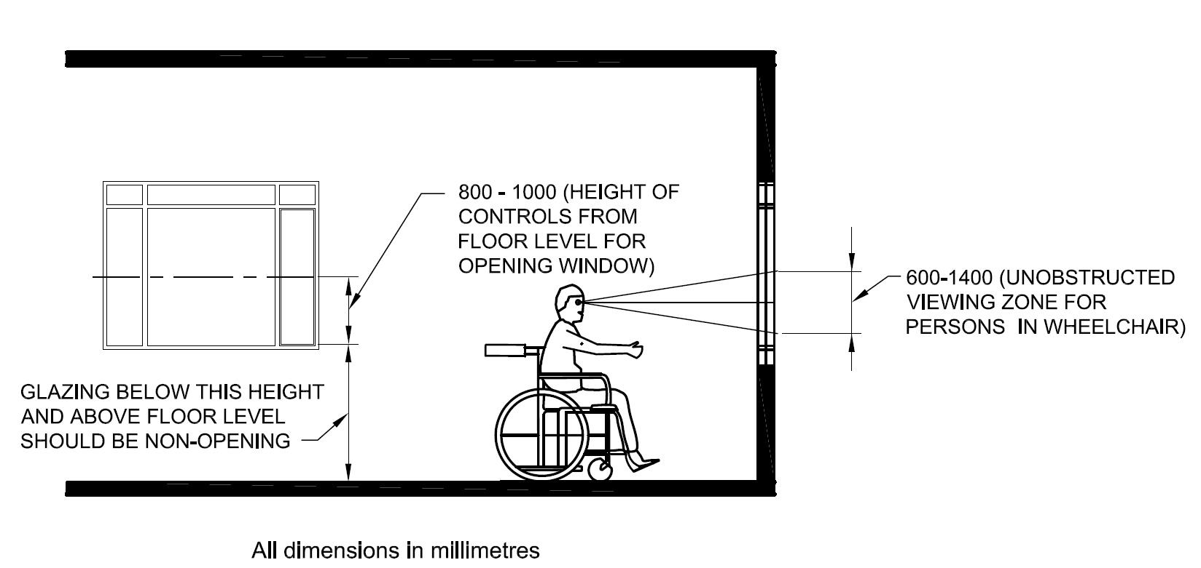
All dimensions in millimetres
Fig. 39 Requirements for Windows
10.5 Handrails and Grab Bars
10.5.1 General
Handrails and grab bars are extremely important features and shall be designed to be easy to grasp and to provide a firm and comfortable grip and shall be non-slippery so that the hand can slide along the rail without obstruction. Many persons with disabilities rely upon handrails/grab bars to maintain balance or to prevent serious falls. Handrails are used as a locational and mobility aid by persons with visual impairments and as a support for persons with mobility impairments. The handrail/grab bars shall be securely fixed to bear the design loads. To aid identification, the colour of the handrail/grab bar shall contrast with the wall behind.
10.5.2 Specific Requirements for Handrail
10.5.2.1 Handrails shall (see also Fig. 40),
        - be securely fixed and rigid; the fastenings and the materials shall be able to withstand a minimum point load, both vertical and horizontal of 1.7 kN;
        - be slip-resistant with round ends;
        - have a circular section of 32 to 45 mm in diameter;
        - be free of any sharp or abrasive elements;
        - have a clear space of 50 mm to 65 mm from the wall;
        - have continuous gripping surfaces, without interruptions or obstructions that may break a hand hold;
        - contrast with the wall behind;
        - external handrails shall be made of materials with low heat conductivity to prevent discomfort or burns, and
        - shall be provided with Braille/tactile markings at the beginning and at the end to give information to people with visual impairment
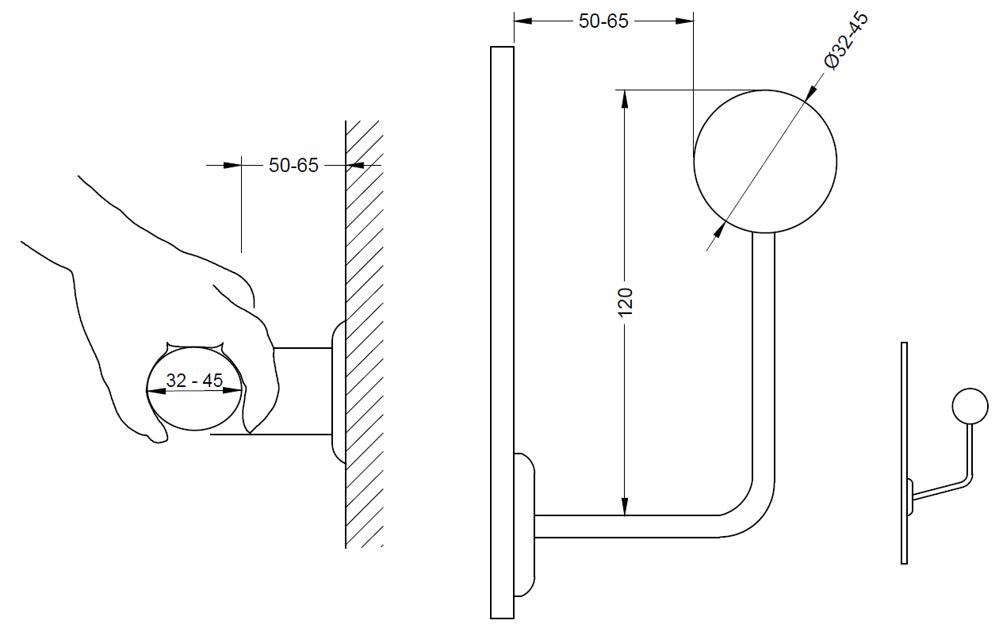
All dimensions in millimetres
Fig. 40 Requirements for Handrails
10.5.2.2 For stepped path, stairs and ramps, handrails shall meet the following requirements (see Figs. 41, 42 and 43):
        - They shall be provided on both the sides;
        - They shall be continuous throughout the full length of a flight of stairs, a ramp, stepped path and intermediate landings, except where they intercept with a doorway or path of travel;
        - They shall extend at least 300 mm beyond the first and last nosing. A handrail shall not project into a transverse circulation path unless it is continuous and intended to form part of the guidance along that path. The end of the horizontal extension should be turned towards the wall on the closed side of the ramp or stairs, or return to the stem or be turned down and terminate at the floor or ground level.
        - They shall have a minimum clear space of 50 mm from the walls; and
        - The height to the top of a handrail shall be between 850 mm and 950 mm above the surface of a ramp, the pitch line of a stair, and the surface of a landing.
        - A second additional handrail, with a lower profile than the first one, shall be provided. For the second additional lower handrail, the cross-section shall be a rounded profile with a diameter not less than 25 mm or greater than 32 mm in any dimension; in the case of ramps, the profile of lower handrails may be greater depending on the users of the building.
        - The height to the top of the second handrail should be between 650 mm and 750 mm above the surface of a ramp, the pitch line of a stair, and the surface of a landing. There shall be sufficient distance between the two handrails (say, 200 mm).
        - In case the handrail is enclosed in a recess, the recess shall extend at least 450 mm above the top of the rail.
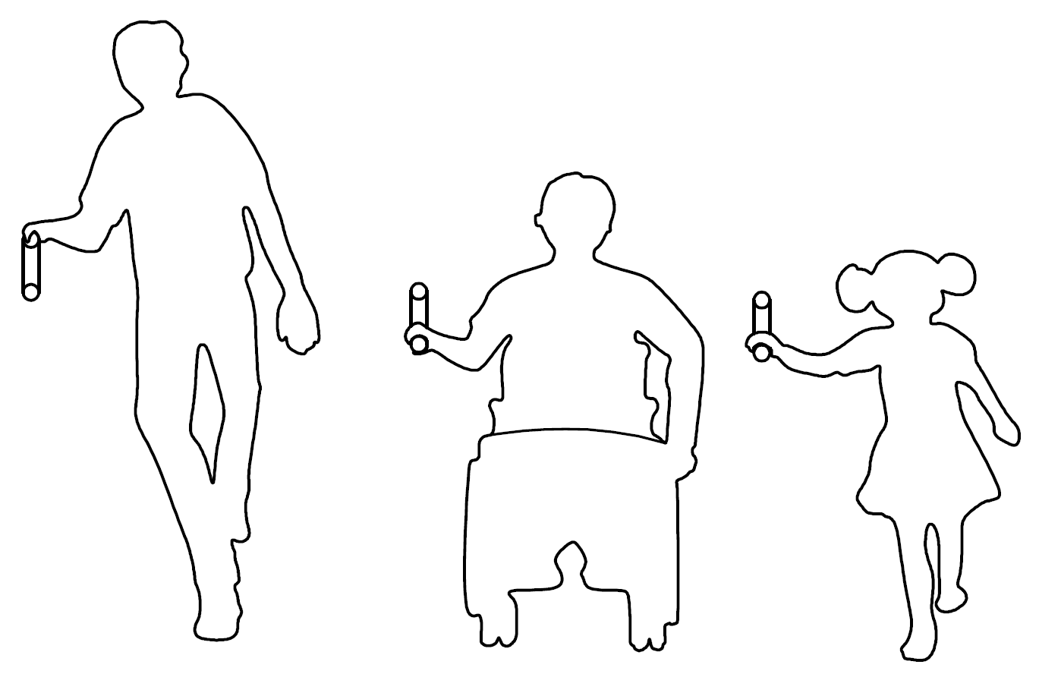
Fig. 41 Handrails at Two Levels to help Children and People with Short Stature
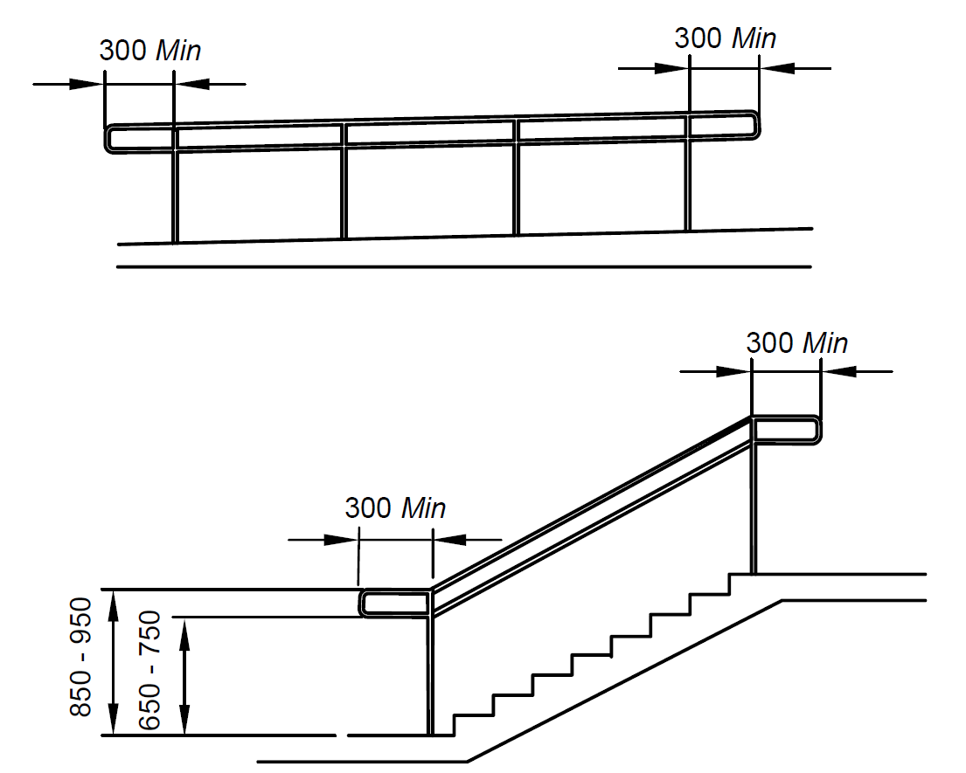
All dimensions in millimetres
Fig. 42 Handrails for Steps and Stairs
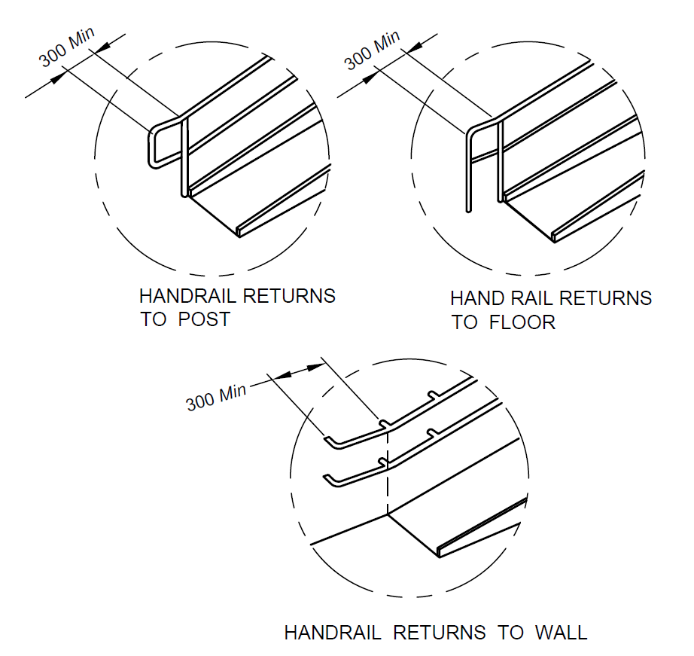
All dimensions in millimetres
Fig. 43 Typical Handrail Extensions
10.5.3 Grab Bars
Grab bars shall,
- be securely fixed and rigid;
- be slip-resistant with round ends;
- Preferably have knurled surfaces;
- have a circular section of 32-45 mm in diameter;
- be free of any sharp or abrasive elements;
- have a minimum clear space of 50 mm to 65 mm from the wall;
- be installed at a height of 700 mm to 900 mm;
- be able to bear a weight of 1.7 kN; and
j) contrast with the wall/surface behind.
11 LEVEL CHANGES
11.1 General
Vertical circulation and level changes shall be designed, constructed and managed so that they can easily be understood and used by all people. Vertical circulation includes the provision of ramps, stairs and lifts, as well as escalators, moving walks and lifting platforms.
11.2 Ramps
A ramp is a sloping pathway leading from one level to another. Ramps of an appropriate design shall be provided at all changes in level other than those served by an accessible lift or accessible lifting mechanism accommodating the specific requirements of persons with disabilities.
11.2.1 General
Ramps allow persons with reduced mobility to move from one level to another. However, many ambulant persons with disabilities negotiate steps more easily and safely. Hence it is preferable to provide accessibility by both steps and ramps.
Ramps shall meet the following general requirements:
      - Wherever the rise of a ramp exceeds 300 mm, an additional flight of steps shall also be provided as described in 11.3, shall be provided for ambulant persons. An isolated single step is not acceptable, hence a ramp is preferred to a single step.
      - Where there is a large change in elevation that requires multiple ramps and landing combination, other solutions such as lifts should be considered.
      - Ramps should not ideally connect straight to doors as wheelchair users need a levelled platform at the end of the ramp to manoeuvre and negotiate opening the door.
      - A curved ramp is not a preferred design solution. Similarly, a cross fall may put a wheelchair user at risk and may adversely affect steering, particularly on manually propelled chair.
      - Shiny, polished surface materials that cause glare shall not be used for ramps.
      - Single row of tactile warning blocks (TGSI) shall be placed as per 7.5 at the beginning and end of each ramp. This shall be placed 300 mm before the beginning and end of each ramp run to indicate the level change to visually impaired persons.
11.2.2 Gradient
The gradient shall be constant between landings. The minimum specifications for ramp gradients addressing different level differences are given in Table 4 (see also Fig. 44).
Table 4 Requirements for Ramp
(Clause11.2.2)
Sl No. | Level Difference | Maximum Gradient of Ramp | Ramp Width  mm | Handrail on Both Sides | Other Requirements
(1) | (2) | (3) | (4) | (5) | (6)
 | 150 mm to 300 mm | 1:12 | 1 200 | √ | -
 | 301 mm to 750 mm | 1:12 | 1 500 | √ | Landings after every 5 m of ramp run
 | 751 mm to 3 000mm | 1:15 | 1 800 | √ | Landings after every 9 m of ramp run
 | More than 3 000 mm | 1:20 | 1 800 | √ | Landings after every 9 m of ramp run
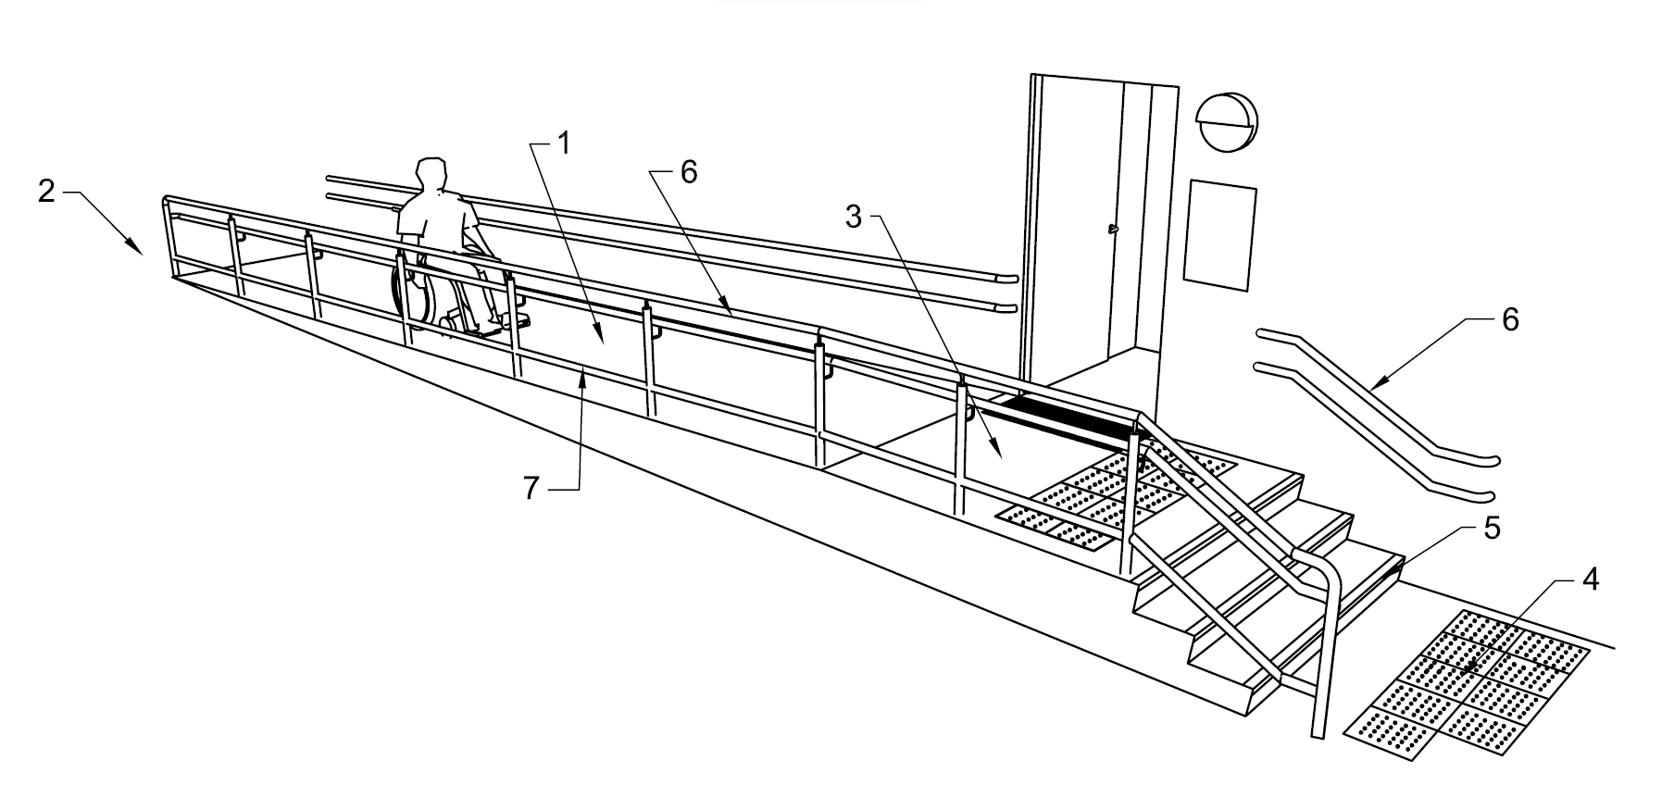
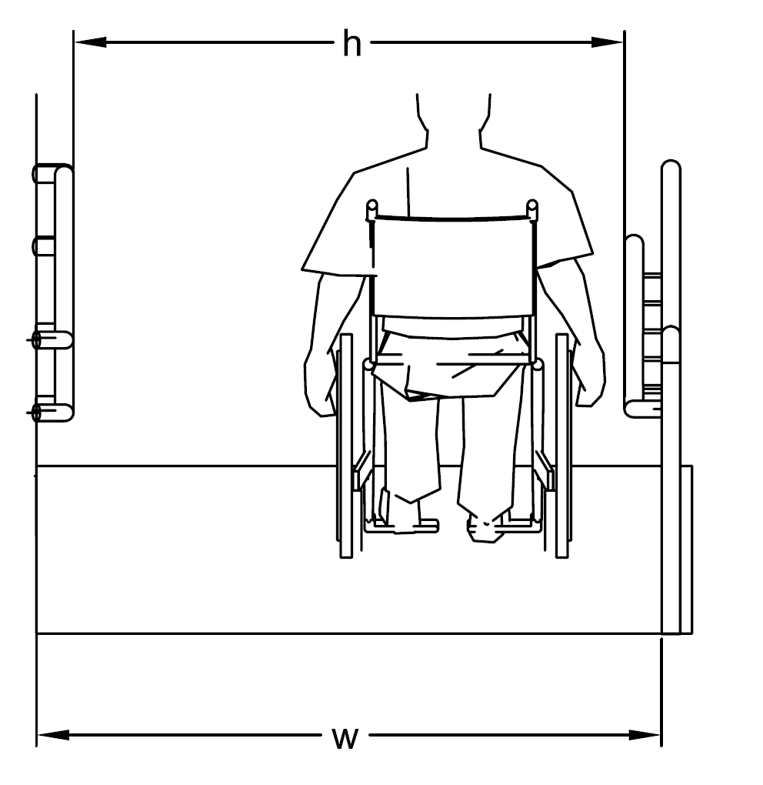
Key
- Ramp surface (see table 10 for maximum slope and length)
- Horizontal landing
- Horizontal landing
- Tactile ground surface indicator in front of stairs complementary stairs with markings
- Handrails on both sides of ramp and stairs
- Upstand, Min 150 mm
h Width between handrails
w Width of ramp surface
Fig. 44 Examples of Ramp with Slope 1:20 and Horizontal Landings at Beginning and End
11.2.3 Width
The minimum clear width of a ramp (exclusive of handrails) shall be 1 200 mm and shall increase correspondingly as the level difference addressed by the ramp increases as per Table 3.
11.2.4 Surface
Ramps and landing surfaces shall be non-glary, smooth, level, even and slip resistant even when wet. Outdoor ramps and their surface shall be designed to prevent water from accumulating on the walking surfaces. The surface finish shall be hard and suitable for the volume of traffic that the ramp is likely to experience.
11.2.5 Internal ramps should, if possible, be avoided. Where required, internal ramps shall be designed in accordance with the following additional criteria:
      - No series of ramps should rise more than 2 000 mm in total. If this is the case, an alternative should be provided, for example a lift.
      - An internal ramp should have the lowest practical gradient. In order to avoid trips and falls during a fire evacuation, a gradient of 1:15 should be the maximum permissible gradient within a building.
      - The minimum illumination at the top and bottom of the ramp should be 200 lux and 150 lux in between the bottom and top.
11.2.6 Landings
An end landing shall be provided at the bottom and the top of a sloped path, a stepped path, or a ramp and also where the run changes direction. The area of the end landing may be a part of the continuing path (see Fig. 45). The length of an end landing and an intermediate landing shall be not less than 1 500 mm. Where the ramp run changes direction, the minimum landing dimensions shall be 1500 mm x 1500 mm. The area of a landing shall be clear of any obstruction including the path of swing of a door or a gate.
Landings shall also be provided at regular intervals of not more than 9 000 mm of every horizontal run. It shall conform to other provisions of this standard if served by a doorway. If the end landing follows or precedes a turn for a pathway or an entrance, the minimum dimension of the landing shall be minimum 1 500 mm x 1 500 mm.
The width of ramp and consequently the dimension of landing in the direction perpendicular to the direction of ramp shall also be governed by the provisions of Table 3.
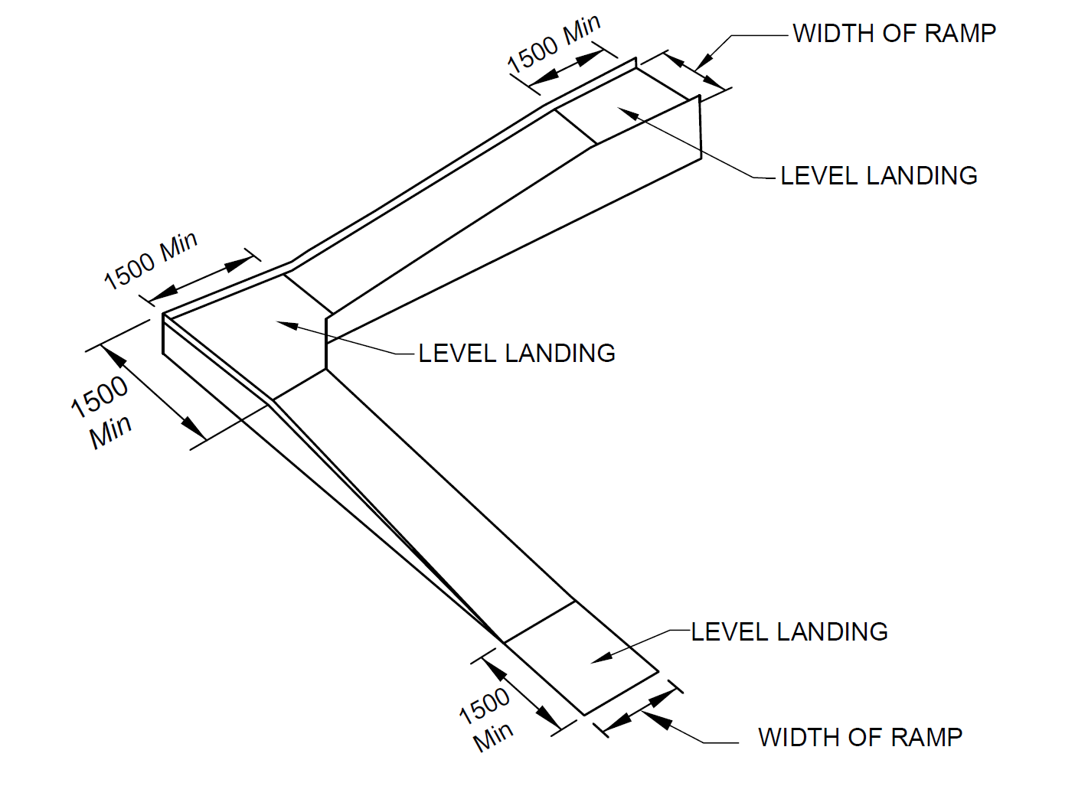
All dimensions in millimetres
Fig. 45 Landing Details for Ramps
11.2.7 Handrails for Ramps
A ramp run with a vertical rise greater than 150 mm shall have handrails that are on both the sides and comply with 10.5.2.
11.2.8 Edge Protection/Guarding Along Ramps
Ramps and landings not adjacent to a wall should have an edge protection in form of a 75 mm kerb. Guarding along ramps in pathway shall also meet the requirements in 7.2.6.
11.3 Stairs
11.3.1 General
Steps and staircases are intended as an alternative to lift access in buildings and shall be of adequate design to allow all persons, with or without a disability, to travel safely and independently.
Stairs shall not be the only means of moving between floors. They shall be supplemented by lifts (see 11.4) and/or ramps (see 11.2). Staircases shall comply with the following general requirements:
- The materials selected for the surface finish of the stairs shall be firm and slip resistant, especially if surfaces are likely to become wet due to location or use, or if spillage occurs. Slippery surfaces like granite, glazed tiles shall be avoided.
- Shiny, polished surface materials that cause glare shall not be used for stairs or ramps.
- Risers, treads, maximum number of risers per flight and minimum width of stairs shall be in accordance with the following (see also Part 4 'Fire and Life Safety' of the National Building Code of India 2016):
- Minimum clear width – The following minimum width shall be provided for staircases for respective occupancies (see Part 4 'Fire and Life Safety' of the National Building Code of India 2016 for classification of buildings based on occupancy):
 | Residential (A-2)  NOTE — For row housing with 2 storeys, the minimum width shall be 0.75 m. | : 1.00 m
 | Residential (A-1, A-3 and A-4) | : 1.25 m
 | Residential hotel (A-5 and A-6) | : 1.50 m
 | Assembly  NOTE — The width of stairs may be accepted to be 1.50 m in case of assembly occupancy having less than 150 persons. | : 2.00 m
 | Educational | : 1.50 m
 | Institutional | : 2.00 m
 | All other occupancies | : 1.50 m
- Minimum tread – The minimum width of tread without nosing shall be 300 mm. However, for one or two family dwelling, it may be reduced to not less than 250 mm.
- Maximum riser – The maximum height of riser shall be 150 mm. However, for one or two family dwelling, it may be increased to not more than 190 mm. The number of risers shall be limited to 12 per flight.
- Minimum Headroom – The minimum headroom in a passage under the landing of a staircase shall be 2.2 m. The minimum clear head-room in any staircase shall be 2.2 m.
- Exit requirement – All aspects of exit requirements for corridors, doors, staircases, ramps, etc, in respect of widths, travel distance shall be as per Part 4 'Fire and Life Safety' of the National Building Code of India 2016.
- The riser of a step shall not be open.
- The stairs landing shall be minimum 1 500 mm deep (see also 11.2.6). In case of one or two family dwelling units, it may be reduced to 1 200 mm.
- Steps shall be of a consistent height and depth throughout the staircase.
- Projecting nosing and open stairs shall not be provided to minimize the risk of stumbling.
- Spiral stairs shall be avoided.
- Stairs shall have handrails comply with the requirements given in 10.5.2.
11.3.2 Tactile Warning Blocks (TGSI) for Stairs
Tactile ground surface indicators (warning type) shall be installed 300 mm before the beginning and 300 mm after the end of each flight of steps to aid people with visual impairments. It shall be in accordance with 7.5.
Tactile warning strips shall also be provided at landings. For landings leading to a floor or those enclosed by wall, railing or balustrade, tactile warning strips of 300 mm in width shall be provided; for those leading to an open space or the entrance/exit of a building, the tactile warning strips shall be 600 mm in width. In this case, Braille and tactile information signs shall be provided on the adjacent wall to indicate the presence of an opening. For a staircase with intermediate steps between two flights, the provision of tactile warning strips shall follow the same arrangement.
11.3.3 Avoidance of Projection in the Stairs
No appliances, fixtures or fittings shall project beyond 90 mm from the surface of any wall in a staircase below a level of 2 000 mm, measured above the treads of the staircase. If such a projection is unavoidable, the same shall also be extended downwards to the level of the treads. However, in no case the width of the staircase shall be less than that prescribed in11.3.1 (c).
11.3.4 Colour Contrasting and Illumination
There shall be colour contrast between landings, and the steps. Step edges shall contrast in colour to the risers and the treads. Contrast colour bands 50 mm wide shall be provided on edge of the tread. Illumination level of minimum 150 lux shall be maintained on the stairs.
11.3.5 Soffit
Soffit of the stairs shall be cordoned off either by building a wall in front of it or by putting handrails to guide persons around the space. It shall comply with the requirements given in 7.6.3 related to headroom in circulations spaces (see also Fig. 24).
11.4 Lifts
11.4.1 General
Lifts play a crucial role in enhancing the accessibility and connect between various floor levels. It is therefore relevant to understand the wide ranging needs of persons with disabilities, elderly and others, while planning and designing a lift system for a particular building complex. There can be several variants of lifts in terms of design, finishes and technologies. However, few foundational aspects as following shall be complied.
All buildings more than the ground floor shall also be accessible by way of either a ramp or where space is limited, by at least one lift accessible to transport persons with disabilities at all usable levels. Such lifts shall meet the following general requirements:
- Lift shall be located on accessible routes.
- Accessible landings at lift entrance shall be provided on each eligible floors.
- Lifts shall be marked with the international symbol of accessibility.
- Directional signs indicating the location of an accessible lift shall be provided at a location that is clearly visible from the accessible building entrance. The directional signs shall incorporate a representation of the international symbol of accessibility (see Fig. 46).
- A sign indicating the number of the floor arrived shall be provided on each lift landing on the wall opposite the lift in big fonts with good colour contrast.
- It is recommended to install a floor directory of the main facilities and services available on the lift landing, along with an accessible emergency egress route that clearly indicates the location of the nearest refuge area for persons with disabilities.
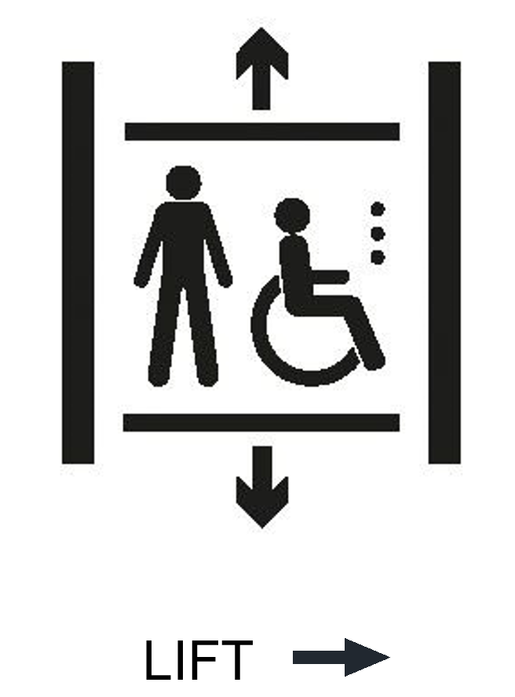
Fig. 46 Way Finding Signage for Lift Location
11.4.2 Lift Size
The minimum size of the lift shall be 1900 mm wide x 1900 deep mm for all new establishments. This would enhance vertical mobility for all including those using powered wheelchairs.
In case where the space is not available, the lift size shall be a minimum of 1 500 mm wide by 1 500 mm deep. In all public buildings, a 13-passenger lift shall be installed which allows easy manoeuvrability for wheelchair users, baby strollers and other wheeling devices (see Fig. 47).
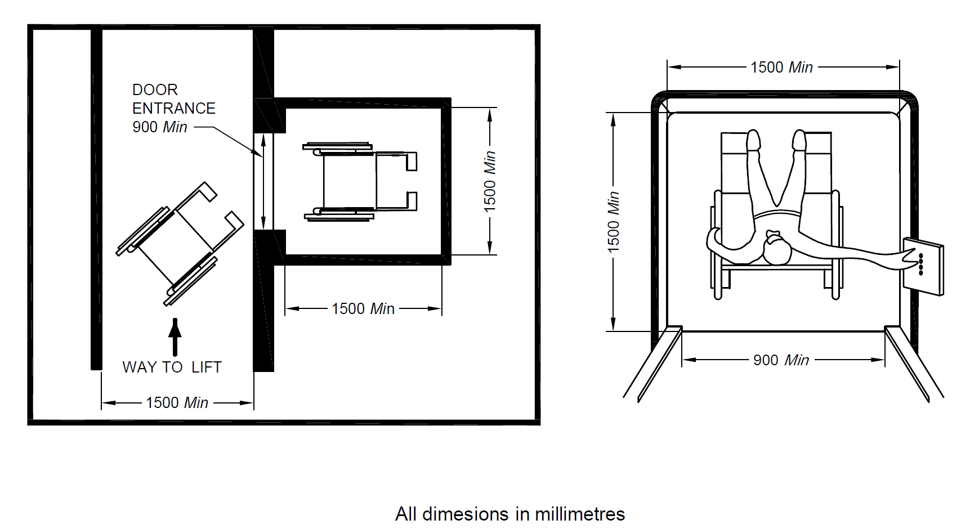
All dimensions in millimetres
Fig. 47 Lift Size
11.4.3 Lift Door
The clear opening of entrance to the lift car shall be at least 900 mm. The doors shall be constructed as automatic horizontal sliding doors. The lift door shall be contrasting in colour from the adjoining wall. There shall be no difference in level between the lift door and the floor surface at each level. The gap between the lift door and building floor shall not be more than 12 mm.
A non-contact sensor device shall be provided in the door opening to detect an entering or exiting passenger or an assistive device and prevent the risk of the passenger or assistive device from being hit by the leading door panel(s). The sensor device shall cover at least 2/3 of the door height measured from a distance of 25 mm above the door sill. Time of closing of an automatic door shall be more than 5 s and the closing speed shall not exceed 0.25 m/s. The door opening time shall be adjustable to suit the conditions where the lift is installed. A mechanism to increase this time shall be installed to be customized by a user with mobility impairments (for example by means of a button outside the car to call the lift to the floor for it to arrive with extended door opening time, and a button marked with a wheelchair symbol inside the car with the same purpose). Under normal operation the levelling accuracy of the lift car shall be ±12 mm.
11.4.2 Call Button
The call button located outside the lift shall have a clear floor space of at least 900 mm x 1 200 mm with no obstruction placed to prevent a wheelchair user from reaching the call button and shall be installed at a height between 800 mm and 1 000 mm (see Fig. 48).
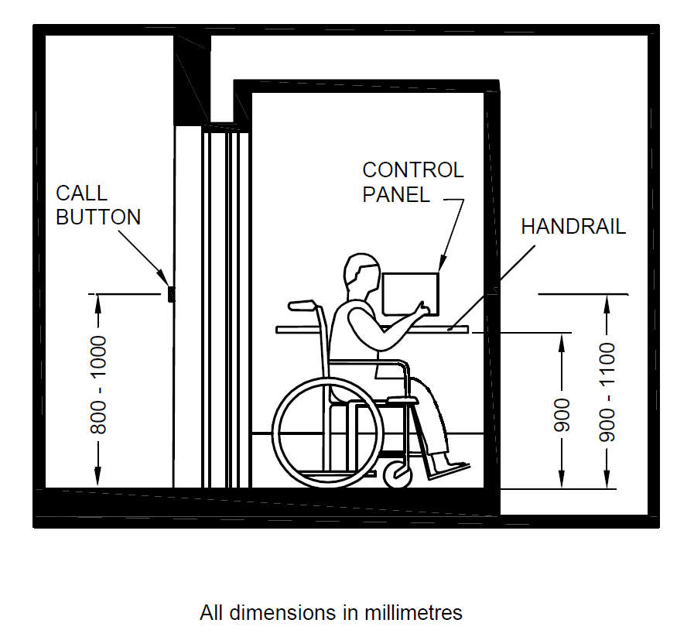
All dimensions in millimetres
Fig.48 Placement of Lift Accessories
11.4.5 Control Panel
Touch control panels shall not be permitted in lifts as they are not accessible to visually impaired persons. The control panel inside the lift shall meet the following requirements (see Fig. 48):
      - Buttons for each function, such as floor selection, alarm, door opening, shall be detectable and identifiable by vision and by touch.
      - It shall be placed at a height of between 900 mm and 1 100 mm from the floor level.
      - The control buttons may be placed either horizontally or vertically within this space.
      - It shall have buttons with Braille/raised letters and in sharp contrast from the background to aid people with visual impairments.
      - An example for a horizontal arrangement of the car controls with large square buttons is given in Fig. 49 and an example for a vertical arrangement of the car controls is given in Fig. 50 below.
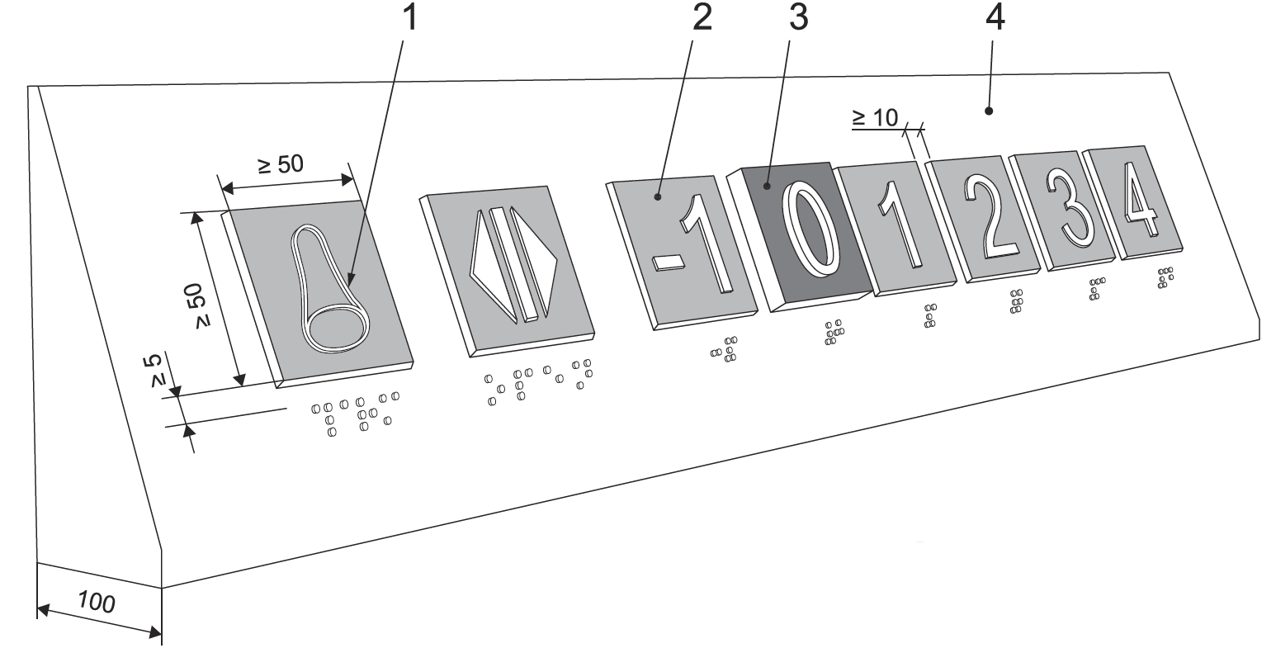
Key
- alarm bell as tactile symbol in yellow colour
- square 50 mm × 50 mm push button with visual contrast to the panel and the raised tactile character/symbol
- ground floor button with higher rise and different colour
- inclined surface
All dimensions in millimetres
Fig. 49 Example of a Horizontal Arrangement of a Single Row of Square Push Buttons with Tactile Characters on and Braille Under the Buttons
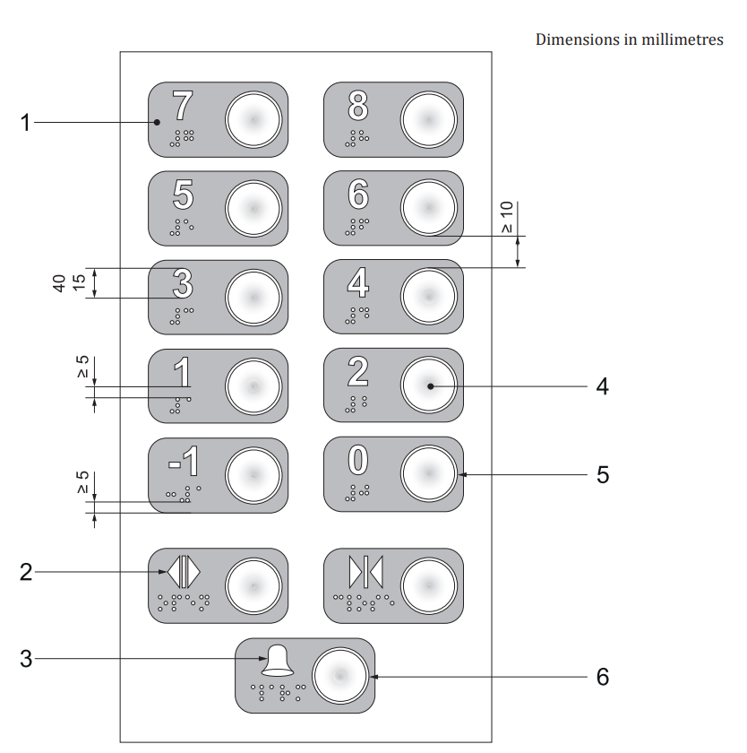
Key
- visual contrast to the face plate
- tactile symbols with visual contrast to the background
- alarm bell as tactile symbol in yellow colour
- round push button with visual contrast between the button and the background
- ring around the button that provides operating feedback (i.e. lights up when pushed)
- yellow ring around the button
All dimensions are in millimetres
Fig. 50 Example of a Vertical Arrangement of Round Push Buttons with Tactile and Braille Symbols on the Left Side of the Buttons
11.4.6 Handrails
Handrails shall comply with 10.5.2 and shall be placed at a height of 900 mm from the floor level. These shall be fixed on both sides and at the rear of the lift.
11.4.7 Audio and Visual Indicators
The lift shall have a voice announcement system along with a visual display to indicate the floor level and also the information that the door of the cage is open or closed for entrance or exit. The announcement system shall be clearly audible, that is, the announcement shall be of the order of 50 dB.
11.4.8 Tactile, braille sign at side walls outside the lift
A visual sign indicating the number of the floor should be provided on each lift landing on the wall opposite the lift. The size of the sign will correspond to the distance from the lift car so as to be clearly seen and identified.
Addition of floor number in raised tactile and braille information on the lift door jamb/lift frame on both sides, readable by visually impaired people from the lift lobby side on each floor can help them identify the floor. For buildings with more than one lift, each lift shall have an accessible sign which shall be clearly seen and identified.
A floor directory of the main facilities and services should also be made available on the lift landing, along with an accessible emergency egress route that clearly indicates the location of nearest refuge areas for persons with disabilities.
11.4.9 Other Requirements
In addition to the requirements given in 11.4.1 to 11.4.7, following requirements shall also be complied with:
- Internal walls shall have a non-reflective matte finish in a colour and tone contrasting with the floor.
- The floor of the lift car shall be rigid and have a non-reflective matte finish and shall be slip resistant having similar frictional qualities to the floor of the lift landing to decrease the risk of stumbling.
NOTE — A lift floor with a high LVR reassures blind and partially sighted people that they are not stepping in to an open lift shaft.
- The provision of a mirror on the wall of the lift car opposite the lift door is a positive aid to navigation for wheelchair users. It allows the wheelchair user to see if anyone is behind them and also to see the floor indicator panel. The mirror should not extend below 900 mm from the lift floor to avoid confusing people with impaired sight.
- Internal car lighting should provide minimum level of illumination of 100 lux at floor level, uniformly distributed, and avoiding the spotlights and the controls in the lift car shall ensure an illumination level of 200 lux.
- Emergency warning ― The car shall have an alarm device (two-way communication system) permanently connected to a manned security point according to the following:
        - The device shall ensure voice communication in both directions with an organization in charge of passenger rescue or with the person in charge of the safety of the building.
        - The operating force for alarm button shall be minimum 2.5 N and maximum 5 N.
        - The device shall provide visual and audible information feedback for passengers confirming that, the alarm has been sent, using a yellow enlightened bell-shaped symbol; and the alarm has been received, voice communication established, using the green enlightened symbol consisting of two heads.
For other requirements, reference shall be made to IS 15330.
11.4.9 Use of Lifts for Fire Evacuation
A fundamental objective of fire engineering design for egress is that there shall be alternative, safe and intuitive means of egress from the scene of a fire; these routes shall be available to all building users.
NOTE ― Manual handling of wheelchairs occupied by their users in a fire evacuation staircase, even with adequate training for everyone directly and indirectly involved, is hazardous for the person in the wheelchair and for those people giving assistance. The weight of an average unoccupied powered wheelchair, alone, makes manual handling impractical. Evacuation chair devices can allow vertical movement on stairs of people with mobility impairments. Some evacuation chairs require a wheelchair user to transfer out of their own chair into the evacuation chair. This transfer operation requires manual handling (for example handling of one work colleague by others), and there is a risk of injury during the transfer process or if the wheelchair user uses an oxygen tube, or has a catheter or a colostomy bag. The transfer can also infringe the independence and dignity of the individual concerned.
Evacuation of occupants through assisted evacuation by use of fireman’s lift should be planned while evacuation through designated lifts suitably planned and installed for use of occupants for safe evacuation are desirous to be provided.
Such lifts used for evacuation should be easily accessible, clearly identifiable and be suitably protected from the increase of smoke, heat and flame. The controls for the lift shall be located in the areas where users must wait and this area shall be designed to ensure a tenable environment provided during the entire time that the evacuation is taking place.
Such lifts should not be used for evacuation unless built for this purpose and suitably protected by the building design.
The fire evacuation shall comply with the requirements given in Part 4 ‘Fire and Life Safety’ of the National Building Code of India 2016 and lifts for evacuation including fireman’s lift shall comply with the requirements given in Part 8 ‘Building Services’, Section 5 ‘Lifts, Escalators and Moving Walks: 5A ‘Lifts’ of the National Building Code of 2016.
11.5 Escalators and Moving Walks
Escalators and moving walks are very common in public buildings. They can greatly facilitate circulation for all building users in large, extensive and complex modern building types. However, the location of escalators and moving walks should always be considered in relation to the position of adjacent fire protected lift shafts and lobbies, staircases and their associated areas of rescue assistance.
During normal periods of maintenance and servicing, escalators and moving walks will not be operational. In the event of a fire emergency, building users attempting to evacuate usually tend to re-trace their routes of entry, whatever the nature of the hazard and wherever it is located. It should be assumed that the electrical supply to escalators and moving walks is terminated or turned off during such emergencies.
Safety shall be the prime consideration when choosing or installing escalators and moving walks. For important reasons of safety, therefore, inclined moving walks should comply with the requirements for ramps in buildings with respect to slope and length. Additionally, for important reasons of safety, special warning notices and indicators shall be provided at the top and bottom of escalators where step rises reduce suddenly and dramatically when not operational.
Some individuals, in particular older people, might have more than one impairment. Some individuals are not able to use an escalator or moving walk independently and rely on assistance/support being provided by a companion.
Lifts are the preferred method of vertical travel for most people with disabilities and in particular wheelchair users.
Persons with a wheelchair generally cannot use horizontal moving walks. An inclination of up to 6° will exclude a majority of wheelchair users from using a horizontal walkway independently. Hence, alternative, like an accessible battery cart, may be provided to them in appropriate cases. Moving walks shall be free of projecting objects and obstacles up to a height of 2 100 mm. A minimum level of illumination of 100 lux shall be provided on moving walks.
A surface of the escalator that contrasts visually with the approach and the use of audible signals or pre-recorded messages that indicate the start and finish of the escalator help blind and partially sighted people. Such signals or recording are not normally provided by the escalator manufacturer as standard.
Signs should be provided to indicate the location of other facilities, such as lifts, and these facilities should be in close proximity to the escalators and moving walks and be easy to find.
Reference shall also be made to other requirements given in 5.2 of Part 8 ‘Building Services’, Section 5 ‘Lifts, Escalators and Moving Walks: 5B ‘Escalators and Moving Walks’ of the National Building Code of 2016.
11.6 Vertical and Inclined Lifting Platforms
11.6.1 General
Where it is impracticable or impossible to provide an accessible lift or a ramp in an existing building, vertical or inclined lifting platforms should be provided as a reasonable alternative for vertical circulation within the building. These are special passenger elevating devices for persons with disabilities. These may have either vertical or an inclined movement. These shall be able to be used safely, independently and also with an accompanying person. All control devices shall also be accessible and usable for powered wheelchair and walking aids users. If driving, guiding or lifting mechanisms present hazards at the sides of a platform, the mechanisms shall be guarded to protect the users. The guarding shall be smooth, hard and continuous.
11.6.2 Vertical Lifting Platforms (see Fig. 51)
For maximum level changes of 2 500 mm, vertical lifting platforms may be installed. For level changes of more than 1 200 mm, the lift shall be placed in a closed structure with doors at different accessible levels. Vertical lifting platforms may have a variety of openings for entry and exit.
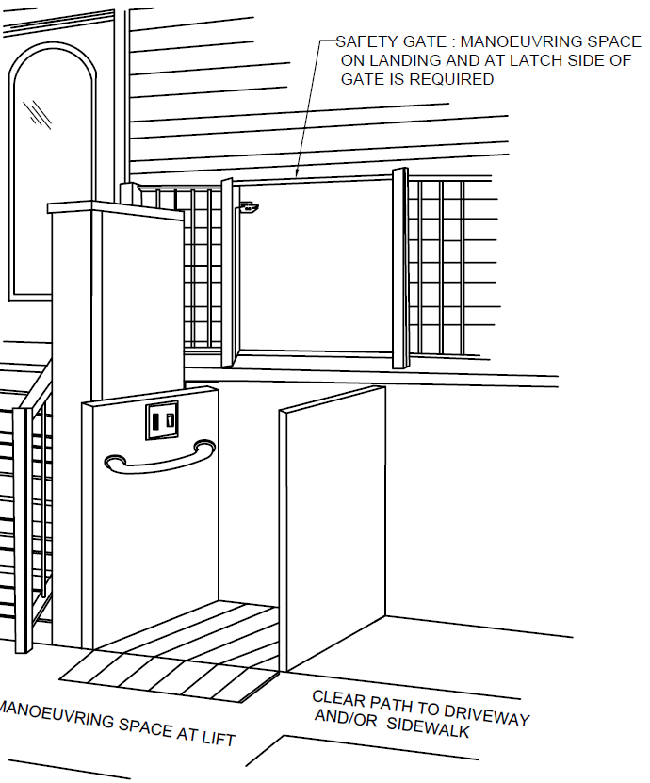
Fig. 51 Vertical Lifting Platforms
11.6.3 Inclined Lifting Platforms (see Fig. 52)
Inclined lifting platforms consist of three elements: a railing, an electric generator and a moving platform. The operating system of the lift may be lateral or suspended. Inclined lifting platforms may be installed along the stair wall as long as they do not obstruct the required width of the exit. The platform may be folded when not in use.
Platform lifts may be installed on all types of stairs including switch back stairs, that is, those with a rotation of 180° and spiral staircases. Inclined lifting platforms are usually used to connect one or more floors or to overcome split levels in existing buildings.
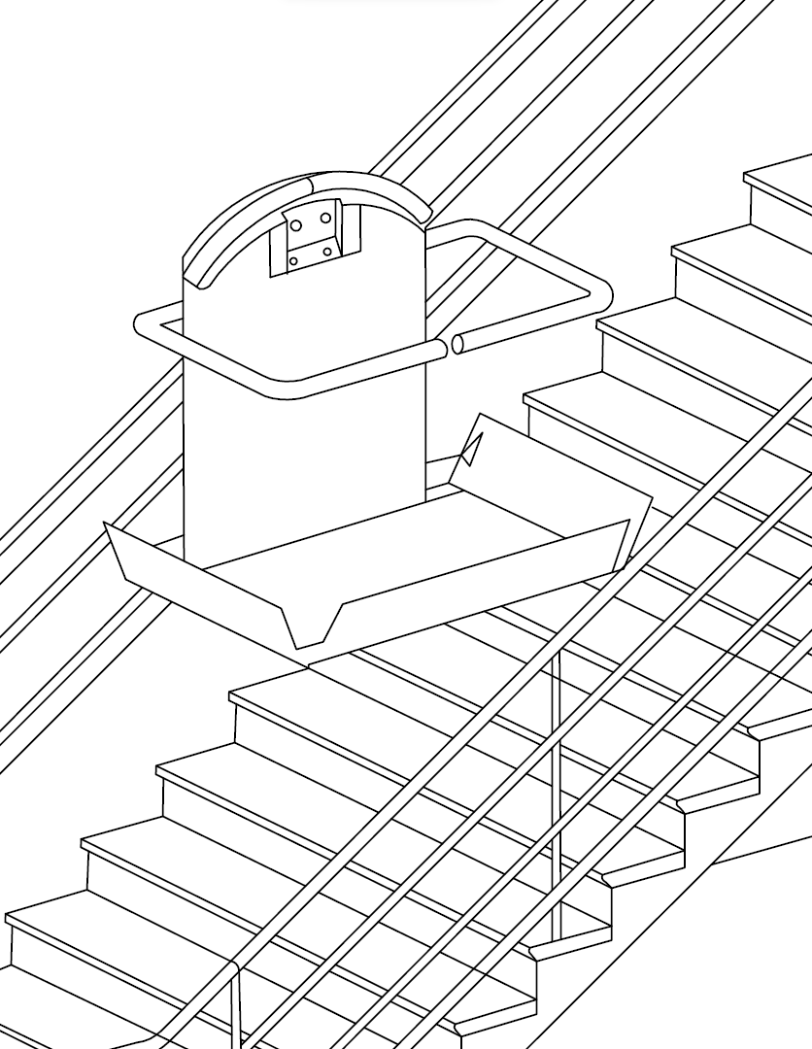
Fig. 52 Inclined Lifting Platforms
11.6.4 Platform Lift Dimensions
The minimum width of the platform lift shall be 1 100 mm and the minimum length shall be 1 400 mm for the use of manual and powered wheelchairs with assistance.
In existing buildings of minor public importance and with few visitors, where sufficient space is not available, other dimensions may be considered, for example 900 mm × 1 250 mm.
12 OPERATING CONTROLS AND DEVICES
12.1 General
The design and construction of operating controls and devices should be such as to enable them to be operated safely and independently by everybody.
Operating controls and devices include, but are not limited to,
- door handles and locks;
- lever, mixer or cross-head taps;
- activation devices;
- window openers and locks; and
- electric outlets and switches.
The operable part of controls shall be located adjacent to the clear floor space. Controls should be easy to use, for example by hands-free operation or by a closed fist or using the elbow. Minimum manual effort should be required, as for opening and closing doors.
All switches and controls should be easy to understand without requiring specialist knowledge.
Sufficient lighting of the control devices and all relevant information should be provided.
Round or oval type door knobs are not suitable for people with mobility impairment, for people of small stature or less strength, and for children.
The use of photoluminescent pictogram signs shall be provided, where appropriate.
12.2 Location, Heights and Distances
Devices, controls (fuse boxes, switches, push-buttons, intercoms, etc), etc, shall be installed at an accessible height for reaching and operating, between 700 mm and 1 300 mm above floor level and shall be located at a minimum of 600 mm with a preference of minimum 700 mm, from any internal corner.
NOTE ― As an exception, electrical wall socket outlets, telephone points and TV sockets can be located at a minimum height of 400 mm above floor level.
Requirements and recommendations on lifts landing controls and car controls shall be as per 11.4.4 and 11.4.5, and reference shall be made to IS 15330.
Control devices placed on a horizontal surface should be placed at a height between 800 mm and 900 mm and within 300 mm from the edge of the surface.
Reading meters should be located between 1 200 mm and 1 400 mm from the floor.
Heights of switches, socket outlets, reading controls and controls on a horizontal surface are illustrated in Fig. 53.
Safety provisions as given in Part 8 ‘Building Services’, Section 2 ‘Electrical and Allied Installations’ of the National Building Code of India 2016 shall be followed.
Door handles should be placed according to Fig. 54. In Fig. 54, the figure on the left shows the height of a handle for pushing or pulling the door, the middle figure shows a vertical door handle, and the figure on the right shows an example of a pull rail that may allow a wheelchair user to close the door behind him, for example in a toilet.
If fire and safety related, all controls should be intuitive and obvious to use. Wherever, fire extinguishers are provided, one fire extinguisher should have a maximum weight of 5 kg or 6 l or even less.
Fire alarm calls should be located between 1 000 mm and 1 100 mm above floor level.
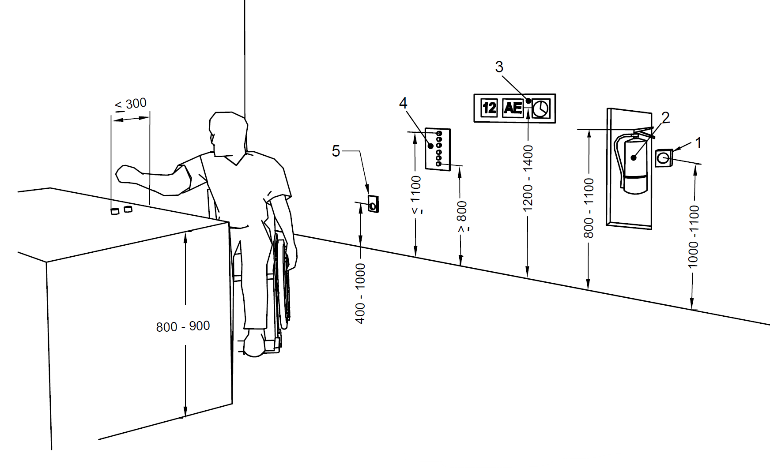
Key
- Fire alarm, call point
- Fire extinguisher
- Meter indicators
- Control devices
- Socket outlets
All dimensions are in millimetres
Fig. 53 Heights of Switches, Socket Outlets, Reading Controls, and Controls on a Horizontal Surface
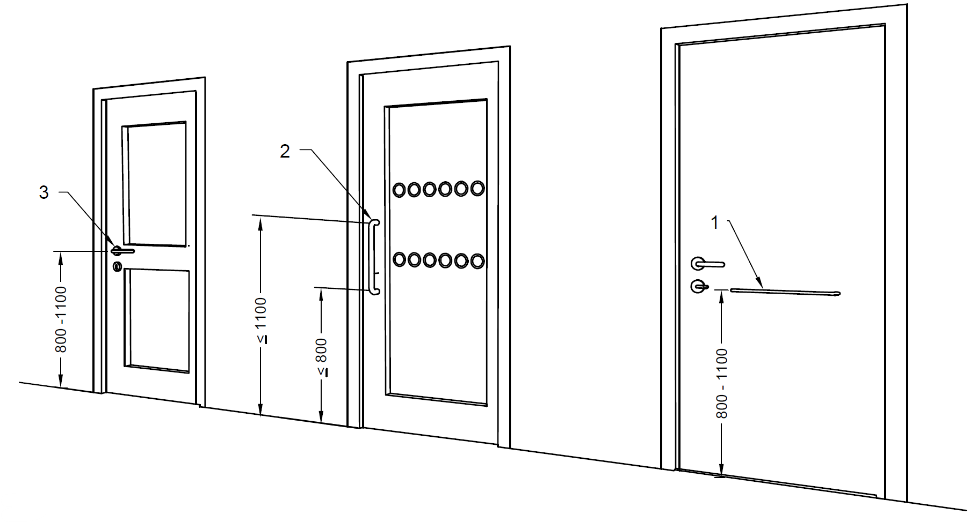
Key
- Horizontal pull bar, toilet room door
- Vertical handle
- Lever type handle
All dimensions are in millimetres
Fig. 54 Door Handle Types and Heights
12.3 Location of Controls from Walls, Corners and Opening Doors
The minimum distance of the centre of switches and devices to control doors or windows, etc, shall be 600 mm from any internal corner or any projecting element (see Fig. 55) and the recommended distance is 700 mm.
Controls for powered door openers to hinged doors should be located so that the doors do not interfere with wheelchairs, canes, mobility aids, etc. Controls for powered door openers to hinged doors should be located at a minimum of 1 000 mm from the swing of the arc of the door so that the door is clear of people in wheelchairs, scooters or other assistive devices (see Fig. 56). The opening time shall be sufficient for a person using wheelchair or assisting devices to pass through the door safely before it closes.
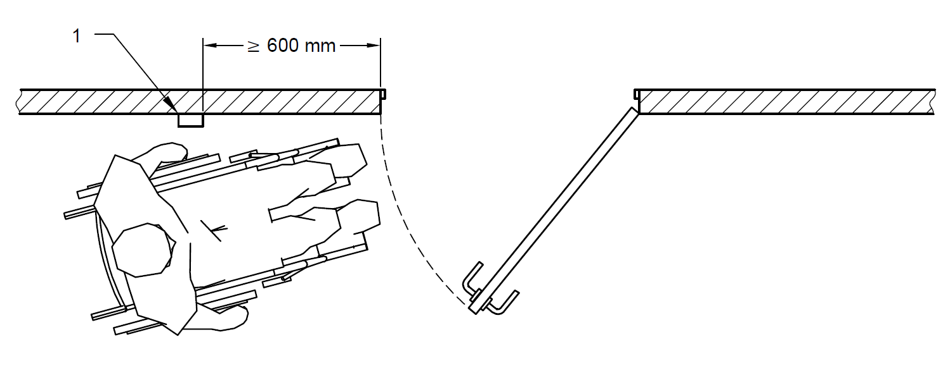
Key
1 Door control, Access Control
Fig. 55 Position of Door and Access Controls
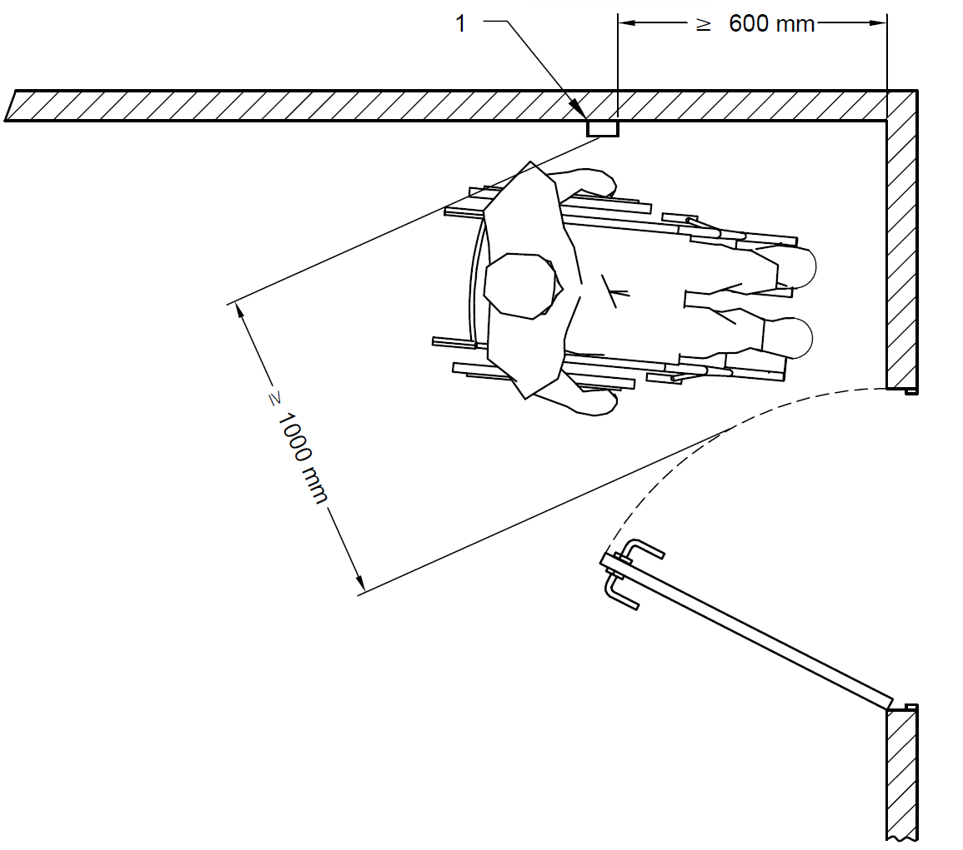
Key
1 Door control, Access Control
Fig. 56 Distance of Controls for Powered Door Openers
12.4 Operation
To help people with diverse abilities, the controls as far as possible shall be operable by one hand and require no tight grasping, pinching or twisting of the wrist.
For persons with reduced dexterity or impaired vision, electrical switches should have large push plates.
Grab bars and door or window handles should be at least 80 mm long. Lever handles should be between 19 mm and 25 mm in diameter; ‘D-Lever’ handles are preferred (see Fig. 57). A vertical door handle for sliding doors should be 32 mm to 45 mm in diameter. The clearance between the bar and the wall should be 45 mm to 65 mm. The back set of a latch/lock should be a minimum of 30 mm. Other door furniture should be 30 mm from the door edge. Suitable clearance should be provided between adjacent fixtures and fittings to prevent accidental operation.
Operating force on control buttons and push plates should be 2.5 N to 5.0 N. Control for drinking water fountains shall be operable with one hand with an operative force of not more than 20 N.
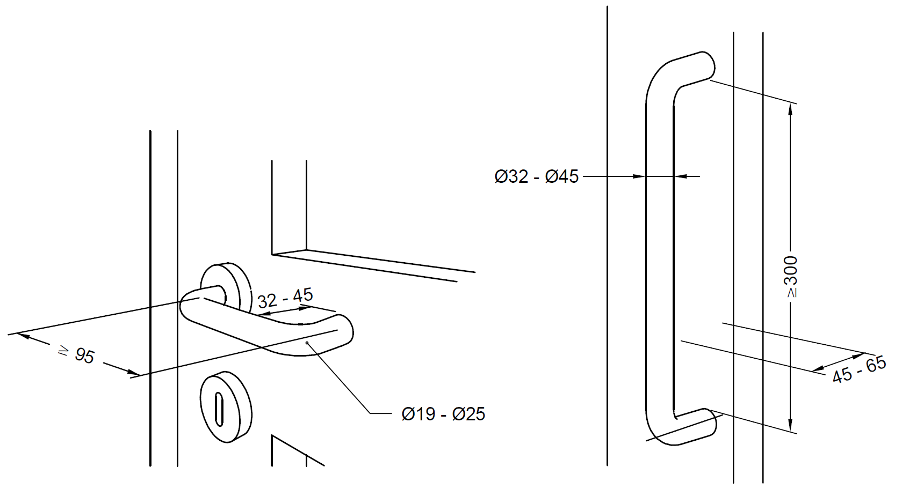
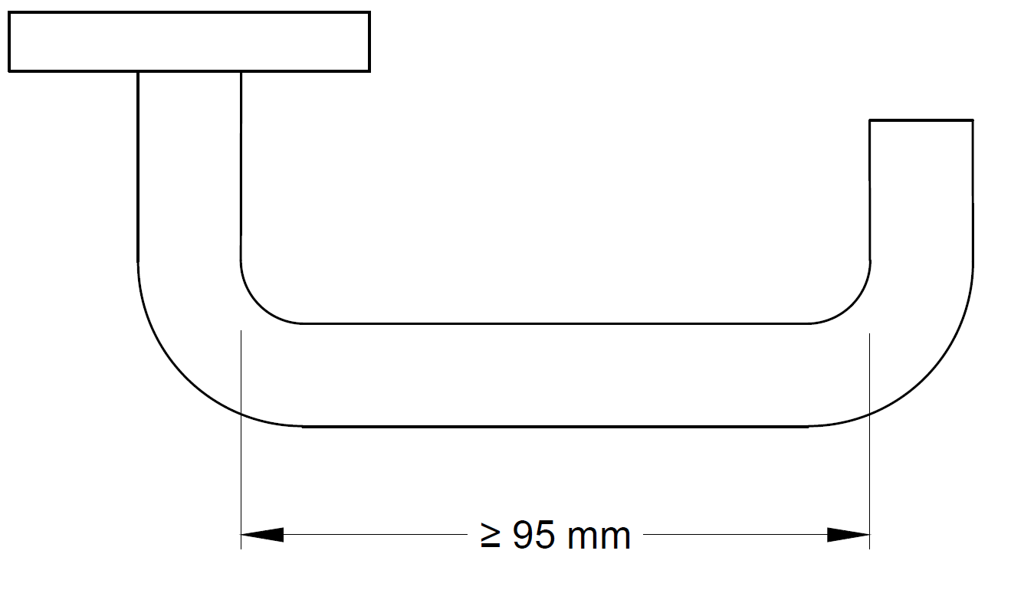
All dimensions in millimetres
Fig. 57 Examples of D-Lever and Vertical Door Handles

12.5 Identification
Buttons and devices should be identified by visual contrast. Information should be in raised tactile and Braille signage. All important controls should have an integral Braille indication.
12.6 Usability
Control devices for different functions should be different. Control devices for similar functions should have a similar design and activation mechanism and be the same for identical functions throughout the facility.
12.7 Telephones
12.7.1 Telephones shall be on a clear accessible route with approach from the front or the side (see Fig. 58). All information should be provided in at least two of visual, oral and tactile forms. The telephone keypad shall have a tactile point on the number five (see also 12.9).
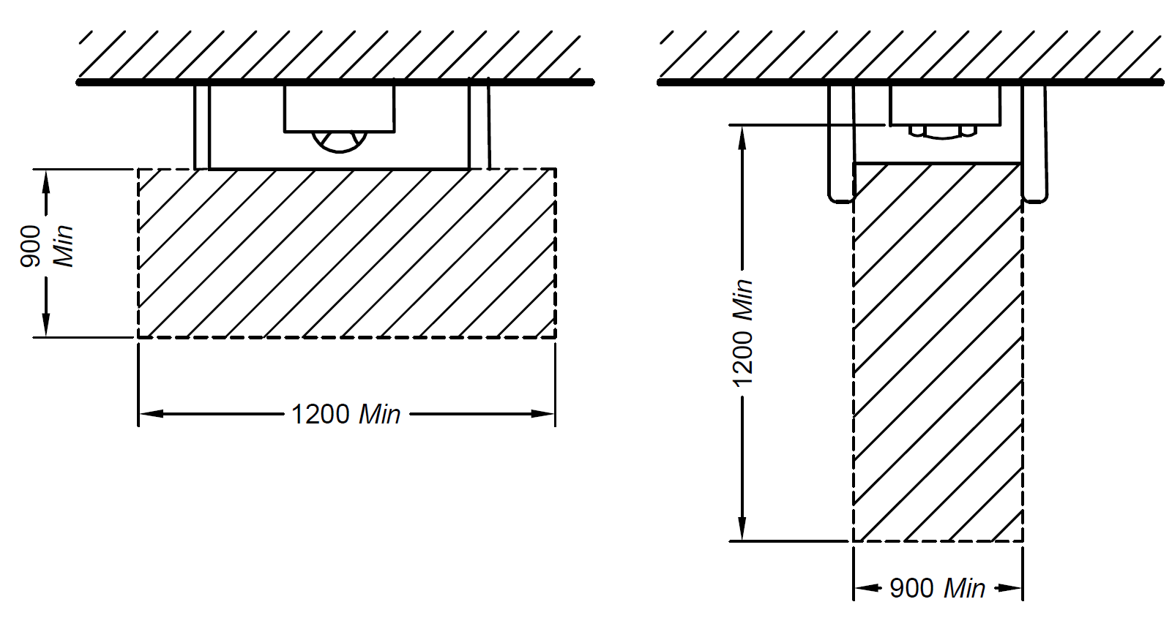
All dimensions in millimetres
Fig. 58 Space Allowance for a Wheelchair User for Using Telephone
12.7.2 Public Telephones
Public telephones shall be located beside the access route and shall be easily detected by people with vision impairments.
Where more than one public telephone are provided, at least one phone shall be accessible.
A clear knee space of minimum 700 mm in height and minimum 600 mm in depth and 900 mm in width shall be provided underneath to accommodate wheelchair user’s knee (see Fig. 59).
Counter tops, where provided, shall be between 750 mm and 800 mm from the floor. The depth of the counter top shall be not less than 480 mm.
Side protection shall be considered according to 7.6.2.
The height of all operable parts of the telephone shall be between 800 mm and 1 100 mm. The minimum length of the telephone cord shall be 900 mm.
The international symbol of accessibility shall be displayed to identify the location of such telephones.
If a public telephone is provided in an enclosed booth, the opening of the booth shall have a clear width of at least 900 mm. The enclosed space shall have clear unobstructed dimensions of at least 900 mm x 1 200 mm, which should not be restricted by fixed seats.
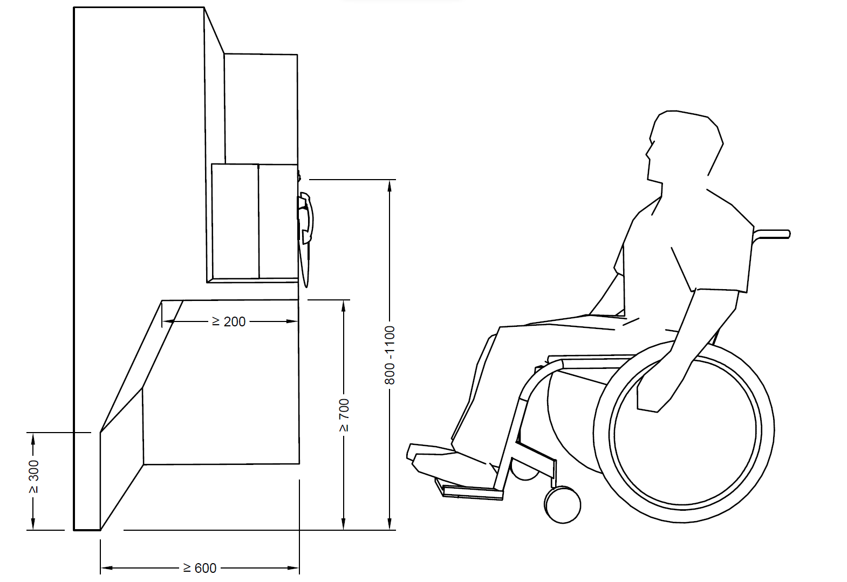
All dimensions in millimetres
Fig. 59 Height of Telephone Controls for Wheelchair Users
12.8 Mailbox/ Dropbox
The mail/drop box slot should be located at the height of maximum 1 200 mm. It should have a clear floor space of 900 mm x 1 200 mm.
12.9 Vending Machine, Card Access, Dispensing Machines and Automatic Teller Machines (ATMs), etc
Machines for dispensing money, tickets or small goods should be accessible and should be located on an accessible level. The approach to dispensers should be clear and unobstructed, at least 900 mm wide. A knee space of minimum 700 mm in height and minimum 600 mm in depth and 900 mm in width should be provided to ease access for wheelchair users (see Fig. 60). The clear area immediately in front of the machine should be at least 1 500 mm x 1 500 mm, to allow a wheelchair user to approach the controls sideways, and to turn around after use and to provide some privacy.
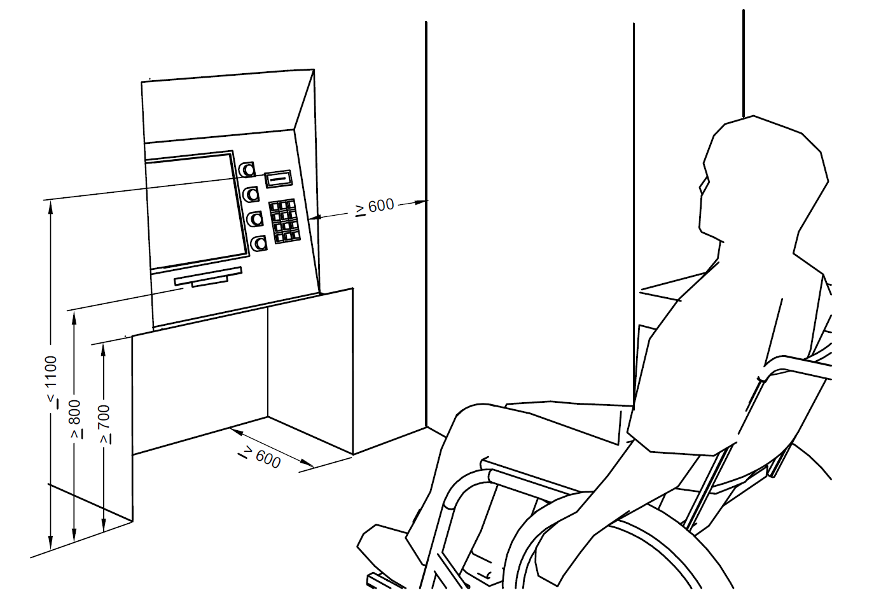
All dimensions in millimetres
Fig. 60 Example of a Vending Machine
Touch screen ticket dispensers at train/bus stations, etc, should not be the only type of ticket dispenser, as they are inaccessible to people with impaired vision. A numeric keypad should also be provided to make it accessible for visually impaired users.
Glare from sun, artificial lighting and street lighting on the screen should be avoided.
The operation of the machine should be easy to understand.
Where card access or coin slot is provided, they shall:
- have a slot located at a height of between 800 mm and 1 000 mm above the floor, preferably between 800 mm and 900 mm,
- with its edge bevelled, and
- colour-contrasted with the surrounding surface;
- include tactile graphic symbols on the surrounding surface that,
- represent the card, and
- identify the orientation of the card/coin insertion; and
- have both audible (beep) and visual (light) signals to indicate that access has been granted.
Where a keypad is provided, it shall,
- be located at a height between 800 mm and 1 000 mm from the floor;
- be colour-contrasted with the background;
- have characters and symbols on key surfaces that are colour-contrasted with the key surfaces;
- where numeric,
- the keys shall be arranged in a 12-key ascending or descending telephone keypad layout,
- the number five key shall be tactilely distinct from the other keys; the raised dot on number five shall be 0.7 ± 0.1 mm high and shall have a base 1.5 mm in diameter, and
- function key surfaces shall have tactile symbols as follows: enter or proceed key: raised circle [o]; clear or correct key: raised left arrow []; cancel key: raised letter x [x]; add value key: raised plus [+] sign; decrease value key: raised minus [-] sign; and
- have both audible (beep) and visual (light) signals to indicate that access has been granted; and
- have the keys readable from both a standing and a seated position.
NOTE — For ATMs and similar facilities, other requirements as laid down by the concerned authorities shall be followed.
12.10 Security Access Systems
Security access systems shall be designed so as to meet the needs of everyone. This includes the requirements for manoeuvring space and for controls which can be reached comfortably. See 12.9 for requirements relating to card access and keypads. Security access systems should be usable by everyone. Biometric systems (for example retinal or palm scanners) cannot accommodate all users. To negotiate the security access systems placed at building entrances, such as, airports, railway stations, metro stations, and shopping malls, relevant rules and regulations laid down by the concerned authorities shall be followed.
NOTE ― The requirements relating to card access and keypads shall be similar to those for ATMs as laid down by the concerned authorities.
12.11 Drinking Water Facility
The drinking water facility (fountains, coolers, taps, etc) shall comply with the following:
- It shall have a clear floor space of at least 900 mm x 1 200 mm as shown in Fig. 61.
- The front edge of the unit shall extend 430 - 480 mm from the wall. It shall have a clear knee space between the bottom of the apron/equipment and floor or ground of at least 900 mm wide, 200 mm deep extending from the front edge of the equipment to back towards the wall, and 700 mm high. It shall have a toe space not less than 900 mm wide, 300 mm high, extending from the back wall to a maximum of 150 mm (see Fig. 61).
- Freestanding or built-in-drinking water units not having a clear space under them shall have a clear floor space of at least 1 200 mm wide x 900 mm in front of the unit a show in Fig. 62.
- Spout heights should be between 800-900 mm, measured from the floor to the spout outlet. The maximum distance of the spout from the front edge of the drinking water facility shall be 125 mm. There shall be water glass provision; a minimum 100 mm space below the spout outlet shall be provided to allow for the insertion of a cup or glass.
- Wall-mounted drinking water provision in an alcove is preferred, because it does not create a hazard for persons with visual impairments. The provision of two drinking facilities at different heights is very convenient for standing adults, people in wheelchairs and children. Where only one is provided, it shall be at a height of 700 mm above floor level.
- Controls shall be centrally positioned at the front of the unit or, if at the side, on both sides, not more than 180 mm from the front and shall comply with 12. Control shall be easily operable with one hand with an operative force as given in 12.
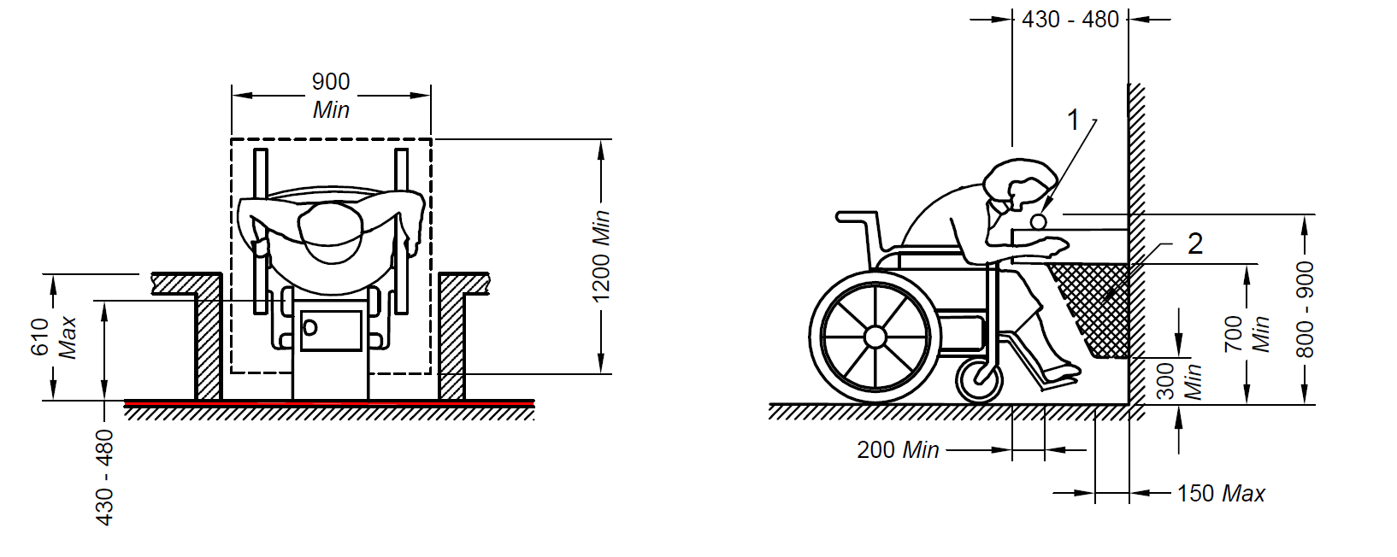
Key
1 Spout
2 Equipment permitted in shaded area
All dimensions in millimetres
Fig. 61 Clear Floor Space and Knee Space Requirement for a Drinking Water Fountain/Facility
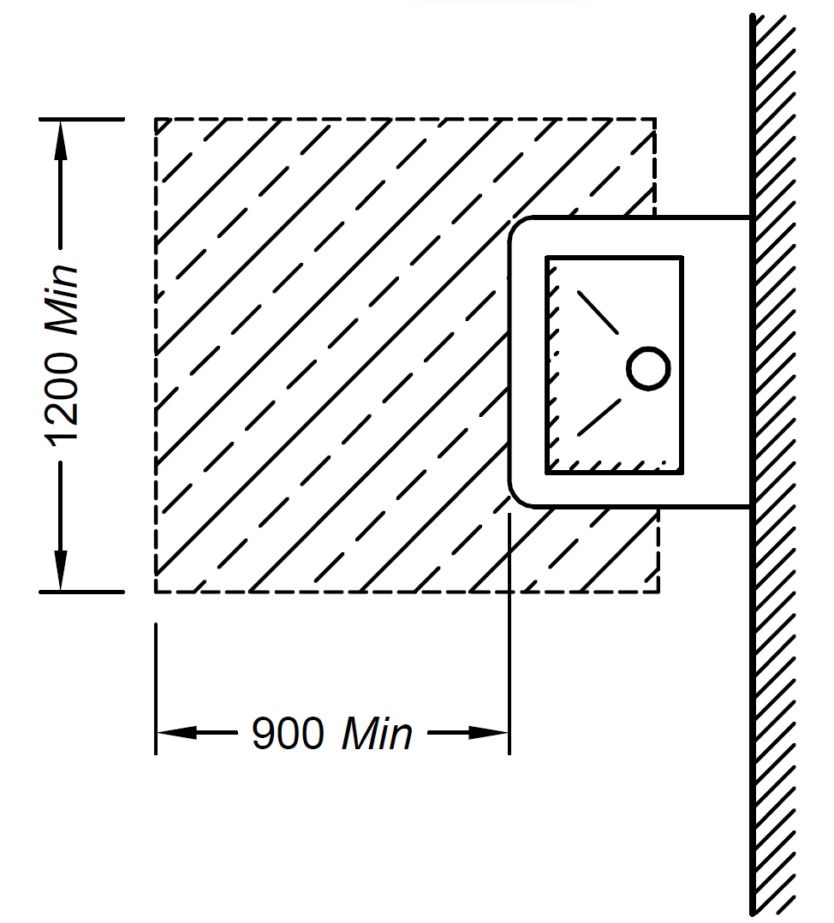
All dimensions in millimetres
Fig. 62 Clear Floor Space for Freestanding or Built-in Drinking Water Unit not Having Clear Space Under the Unit
12.12 Dust Bins
Dust bins should be fully accessible and easy to use for everybody.
13 SEATING SPACES
13.1 General
Seating facilities should be provided in public buildings to provide people with a place to wait and to rest. The location of seats (including reserved areas for wheelchairs) should not disturb the general circulation.
Seating facilities shall have a clear and level floor space of not less than 900 mm x 1 200 mm.
Seats should be designed with armrests to facilitate sitting down and standing up. The seats should also have back rests (see Fig. 63).
13.2 Seating in Waiting Areas
A range of different types of seating should be provided complying with the following (see Fig. 63):
- Seat height 400 mm to 450 mm,
- Back support height 750 mm to 790 mm,
- Seat depth 400 mm to 450 mm,
- Angle of seat to backrest 100° to 105°,
- Armrest height 220 mm to 300 mm above seat,
- Armrest set back from front of seat ≤ 75 mm, and
- A minimum 150 mm set back under the seat for feet when standing up.
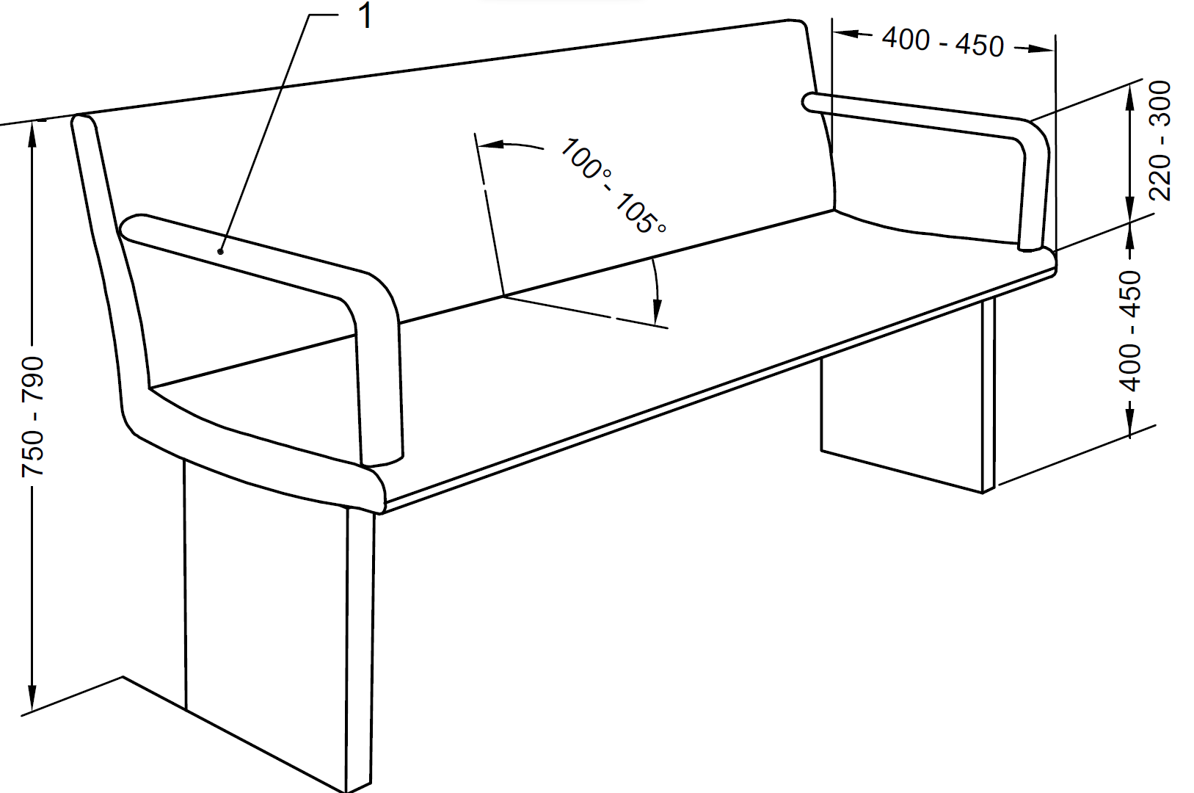
Key
- ARMREST OMITTED ON SOME BENCHES TO ALLOW LATERAL TRANSFER
All dimensions in millimetres
Fig. 63 Example of a Bench with Armrests and Back Support
13.3 Seating at Desks, Tables, etc
To allow a frontal approach with a wheelchair to a table, desk, counter, telephone, etc, an unobstructed space shall be provided with a minimum free height of 700 mm, minimum free depth of 600 mm (see Note) and minimum width of 900 mm to accommodate knees underneath. For footrests, a minimum height of 300 mm is required (see Fig. 64).
NOTE ― This may overlap the clear floor space by a maximum of 480 mm.
If tables with fixed seats are used, there shall be a place for at least one person in a wheelchair at the table.
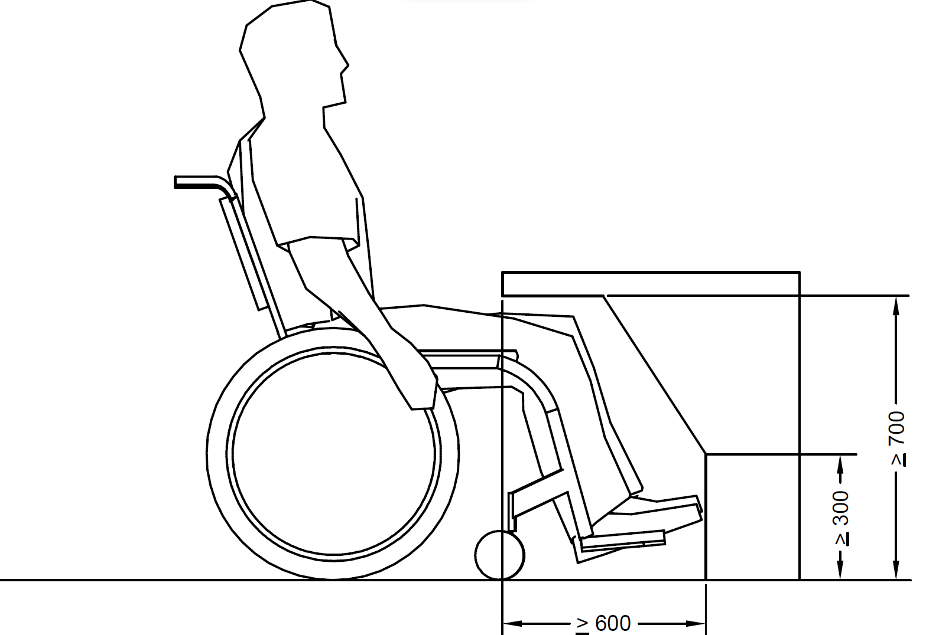
All dimensions in millimetres
Fig. 64 Table and Desk Height for Wheelchair Users
14 TOILET ROOMS AND SANITARY ROOMS
14.1 General
Sanitary facilities shall be designed to accommodate a variety of users. Accessible toilets that can be used by both sexes (unisex or gender neutral accessible toilets) allow the greatest flexibility for people who require assistance hence is the preferred option. Wheelchair accessible unisex toilets should always be provided in addition to wheelchair accessible separate sex toilets. Similarly, a provision of an enlarged cubicle for ambulant disabled people in a separate sex toilet room can also benefit parents with children and people who need an enlarged space (for example those with luggage). The accessible toilet room shall be located as close as possible to the entrance/ reception/waiting area of the building and should be easy to find. It should not be so located that it compromises the privacy of users.
Changing Places (Changing Places) Toilets can be life changing facilities for people with profound and multiple disabilities who are unable to use a standard WC or accessible toilet. Changing Places toilets are designed to meet more complex requirements of the persons with disabilities or senior citizens with “high support needs” in accessing public toilet facilities. Without these vital facilities, carers are forced to change loved ones on the floor compromising dignity or be confined to their own homes denying their equal rights to be a part of and mingle in community.
A unisex wheelchair-accessible facility is intended for independent use. Changing Places (Changing Places) toilets are intended for assisted use and provide the most appropriate solution for people who require high levels of assistance.
A Changing Places (Changing Places) accessible toilet should be provided in addition to the wheelchair accessible toilets and ambulant disabled toilets, in all new builds that fall in the category of:
- assembly, recreation and entertainment buildings with a capacity for 350 people or more;
- a collection of smaller buildings associated with a site used for assembly, recreation or entertainment, such as zoos, theme parks and venues for sport and exhibitions, with a capacity of 2 000 people or more;
- shopping centres/malls or retail parks with a gross floor area of 30 000 m² or more;
- retail premises with a gross floor area of 2 500 m² or more;
- sport and leisure buildings with a gross floor area of 5 000 m² or more; and
- hospitals and primary care centres.
Similar, family washrooms should be provided in assembly, recreation and entertainment buildings and areas like zoos, theme parks and venues for sport and exhibitions, shopping centres, retail premises, malls, etc. which host several families on a regular basis like – shopping malls, cinema theatres, airports, railway stations, etc.
If only one toilet is decided to be provided considering the estimated requirement as per this standard, it shall be Type A unisex accessible toilet (see 14.2 for types of toilets). Where, more than one accessible toilet is provided, different options exist.
Where sanitary facilities are provided, the following shall also apply:
- At least one unisex wheelchair user accessible toilet room of Type A, with central placement of WC, shall be provided, which shall always contain a washbasin.
- One accessible toilet (Type A or Type B) in single sex toilet block (male and female section of toilet block) shall be provided depending on the footfall and space.
- When more than one accessible corner toilet of Type B is planned, a choice of layouts suitable for left hand and right hand transfer shall be provided. In case such toilets are located in similar position on each floor of a multi-storey building, it should allow for right and left hand transfer on alternate floors. In any case, a unisex accessible toilet of Type A shall be provided on the ground floor so as to be able to meet the need for both left and right side transfers.
- In all separate sex toilet/sanitary rooms there shall be provision for one cubicle suitable for use by ambulant disabled as per 14.3 irrespective of the fact that a wheelchair accessible type A or type B toilet has been provided in that toilet block. Where unisex self-contained cubicles or compartments are provided, at least one cubicle suitable for use by people with ambulant disabled should be provided as per 14.3 and identified within each range of facilities / the toilet block.
- Where urinals are provided, there shall be urinals for wheelchair users and ambulant disabled people as per 14.12 and at least one urinal for children at a lower height.
- Where there is requirement for only one toilet or sanitary room in a building, a wheelchair accessible unisex toilet of Type A shall be provided but of a greater width to accommodate a standing height washbasin and a urinal.
- The provision of the accessible toilets shall be such that any wheelchair user/ambulant disabled person doesn’t have to travel more than 30 m on the same floor.
- The design of toilet facilities shall incorporate ease of use for all people and location of fittings should follow a logical sequence.
- Care shall be taken in placing mirrors and lights to avoid confusion and dazzling for visually impaired users.
- Soap dispensers and hand towels or driers shall be placed in a convenient and logical position so that they are easy to locate, identify and use.
- Visual contrast and lighting shall be in accordance with 14.16.
- An emergency assistance alarm according to 14.13, including a reset control, should be provided in all accessible toilets and sanitary rooms.
- If facilities are provided such as buttons or taps which operate by use of sensors, accessible signage shall be provided to explain the same.
- Signage at accessible toilet entrance shall be as per 14.18.
- Tactile signs should be used beside rather than on doors to indicate ‘Ladies’ or ‘Gents’.
- For the benefit of the persons with vision impairments, all general toilets shall have marked on plates with raised alphabets and braille put on the wall next to the door latch, preferably on the left side. An additional signage shall also be provided on the door at 1 500 mm height. See also 29 for other requirements of signage.
- Many persons with visual impairments find it convenient to use the toilets where internal dimensions, accessories and fixtures placement are standardized. A tactile layout of the toilet should be provided on the wall, near the latch side at 900 mm height.
- A distinct audio sound (beeper/clapper) may be installed above the entrance door for the identification of the toilets by persons with visual impairments.
14.2 Wheelchair Accessible Toilet Rooms
14.2.1 This Part gives the characteristics and requirements for the two types of wheelchair accessible toilet rooms, namely, Type A and Type B.
The clear manoeuvring space of the toilet room shall allow frontal, oblique and lateral transfer. Type A toilet with a central placement of WC allows right and left lateral transfer and may be more suitable when assistance is needed. Types B only allow one side transfer.
The clear manoeuvring space at floor level in front of the water-closet and the washbasin in case of Type A toilets shall be 1 800 mm x 1 800 mm, except for Type B where it shall be 1 500 mm x 1 500 mm by using the 300 mm space under the washbasin as part of the total manoeuvring space.
The minimum free clearance beside the water-closet shall be 900 mm, whereas 1 200 mm is preferred for lateral transfer and assistance.
NOTE — Minimum clearance of 900 mm accommodates only 65 percent of the wheelchair users, clearance of 1 200 mm accommodates 90 percent of all wheelchair users especially also those who use powered wheelchairs.
The minimum dimensions for a Type A accessible toilet room are 2 200 mm width and 2 300 mm depth, and the minimum dimensions for a Type B accessible toilet room are 1700 mm width and 2 200 mm depth.
NOTE — In case of existing buildings, as part of exceptional considerations, the measures given above cannot be achieved due to technical reasons, the manoeuvring space at floor level may be reduced, but it should be recognized that such a reduction limits the number of people who can use these toilet rooms.
14.2.2 Type A Toilet Room with Lateral Transfer from Both Side
14.2.2.1 Type A accessible toilet room has the following characteristics (see Fig. 65 and Fig. 66):
- Lateral transfer from both sides,
- Manoeuvring space uninterrupted by washbasin and pan,
- Independent water supply beside water-closet,
- Horizontal grab rails at both sides, and
- Toilet paper dispensers on both folding grab rails.
14.2.2.2 Type A accessible toilet room shall meet the following requirements (see Fig. 65)
- It shall have minimum internal dimensions 2 200 mm x 2 300 mm.
- The layout of the fixtures in the toilet shall be such that there is a clear manoeuvring space that provides a wheelchair turning radius of 1 800 mm in front of the water-closet and washbasin in the accessible toilet unit.
- It shall have all fixtures and utilities arranged in a manner to provide a clear space of 900 mm x 1 350 mm for wheelchair users to access them.
- It shall have clear space of not less than 900 mm wide next to the water closet.
- It shall be equipped with a door complying with 14.5.
- It shall have a water closet complying with 14.6, grab bars complying with 14.7 and washbasin complying with 14.8.
- It shall have essential washroom accessories complying with 14.9.
- It shall have an alarm to seek emergency help, complying with 14.14.
- It shall have the toilet roll dispenser and hand water faucet mounted below the grab bars and at not more than 300 mm from the front edge of the seat and at a height between 50 mm and 200 mm from the top of the water-closet seat.
- Cloth hooks should be set at different heights, 900 mm to 1 100 mm, and additionally at least one hook at 1 400 mm; and projecting not more than 40 mm from the wall.
- Where possible, be equipped with a shelf of dimensions 400 mm x 200 mm fixed at a height of between 900 mm and 1 000 mm from the floor.
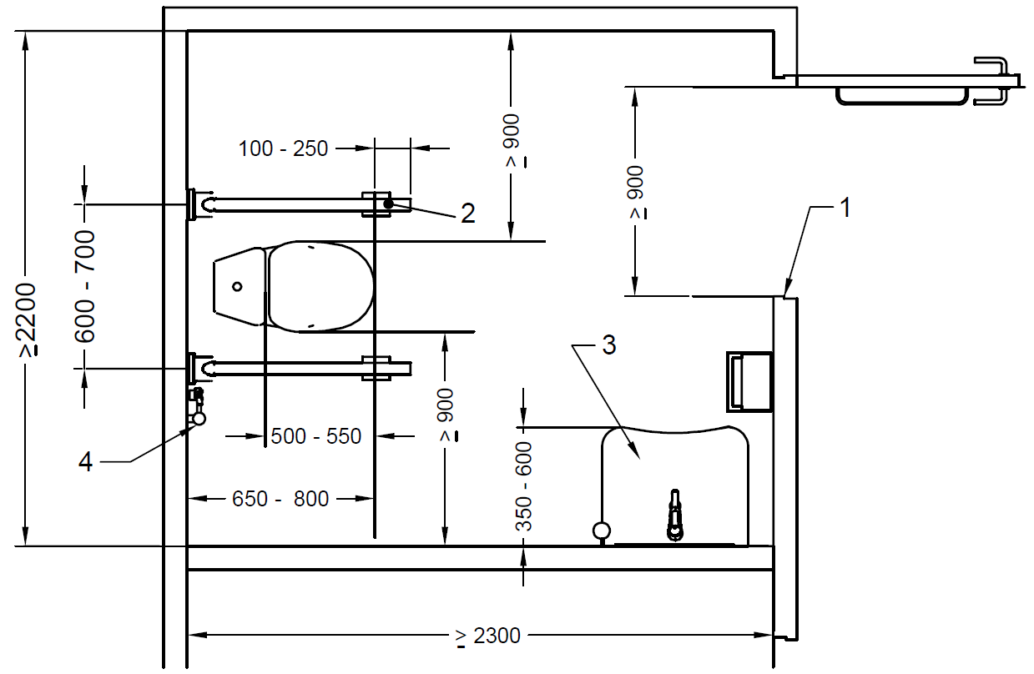
Key
- Minimum 900 mm
- Foldable grab bars, both sides
- Washbasin
- Independent water supply
All dimensions in millimetres
Fig. 65 Example of Type A Toilet Room – Lateral Transfer from Both Sides
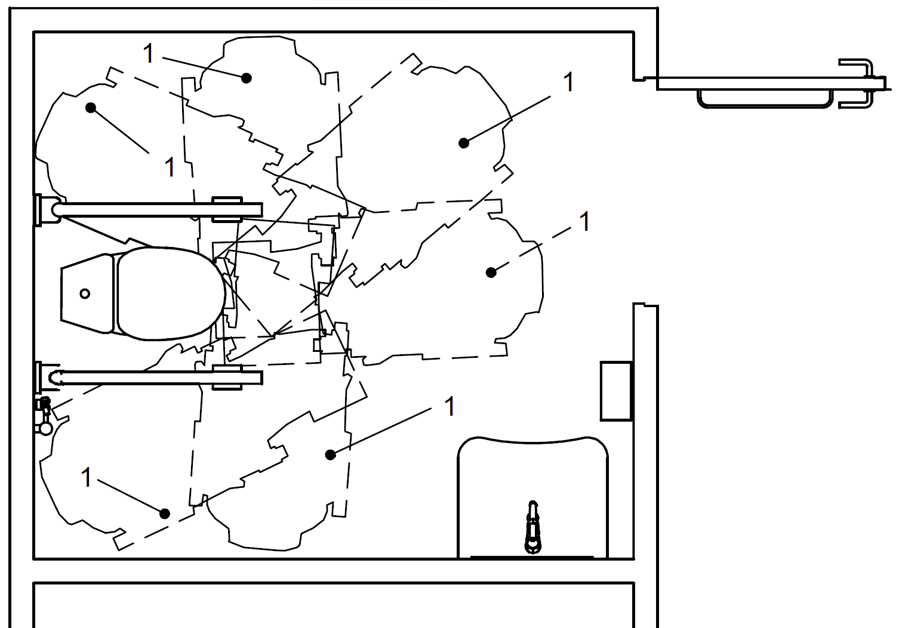
Key
- Possible transfer options
Fig. 66 Type A Toilet Room Transfer Options
14.2.3 Type B Toilet Room with Lateral Transfer from One Side Only
14.2.3.1 Type B toilet has the following characteristics (see Fig. 67 and Fig. 68):
- Lateral transfer only from one side;
- Manoeuvring space reduced by washbasin;
- Independent water supply beside water-closet, with floor drain where necessary;
- Ability to reach small wash hand basin when seated on toilet;
- Horizontal grab rail on wall beside the water-closet;
- Vertical grab rail on wall beside the water-closet for getting up and sitting down (slanted grab bars are not preferred);
- Foldable grab rail; and
- Toilet paper dispenser fixed on the wall beside the water-closet.
14.2.3.2 Type B accessible toilet room shall meet the following requirements (see Fig. 67):
- It shall have minimum internal dimensions of 1 700 mm x 2 200 mm.
- It shall have all fixtures and utilities arranged in a manner to provide a clear space of 900 mm x 1 350 mm for wheelchair users to access them.
- It shall have clear space of not less than 900 mm wide next to the water- closet.
- It shall be equipped with a door complying with 14.4.
- It shall have a water-closet complying with 14.6, grab bars complying with 14.7 and washbasin complying with 14.8.
- It shall have essential washroom accessories complying with 14.8.
- It shall have an alarm to seek emergency help, complying with 14.12.
- It shall have the toilet roll dispenser and hand water faucet mounted below the grab bars and at not more than 300 mm from the front edge of the seat and at a height between 50 mm and 200 mm from the top of the water-closet seat.
- Cloth hooks should be set at different heights, 900 mm to 1 100 mm, and additionally at least one hook at 1 400 mm; and projecting not more than 40 mm from the wall.
- Where possible, toilet room shall be be equipped with a shelf of dimensions 400 mm x 200 mm fixed at a height of between 900 mm and 1 000 mm from the floor.
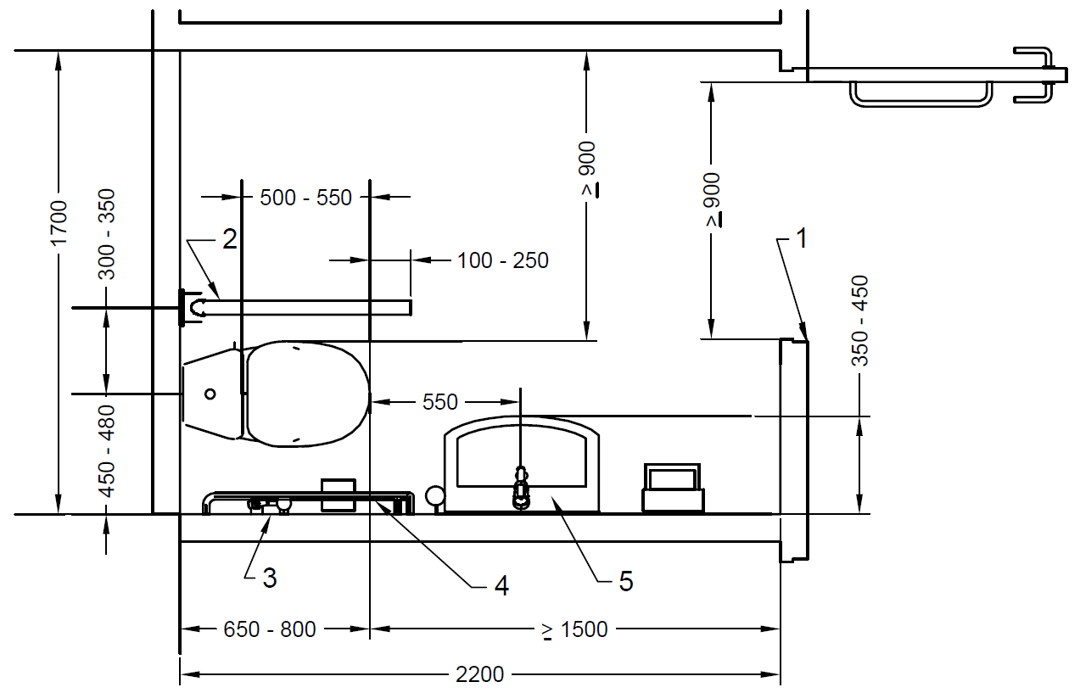
Key
- Minimum 900 mm
- Foldable grab bar
- Independent water supply
- Grab bar on wall
- Washbasin
All dimensions in millimetres
Fig. 67 Example of Type B Corner Toilet Room – Lateral Transfer from One Side Only
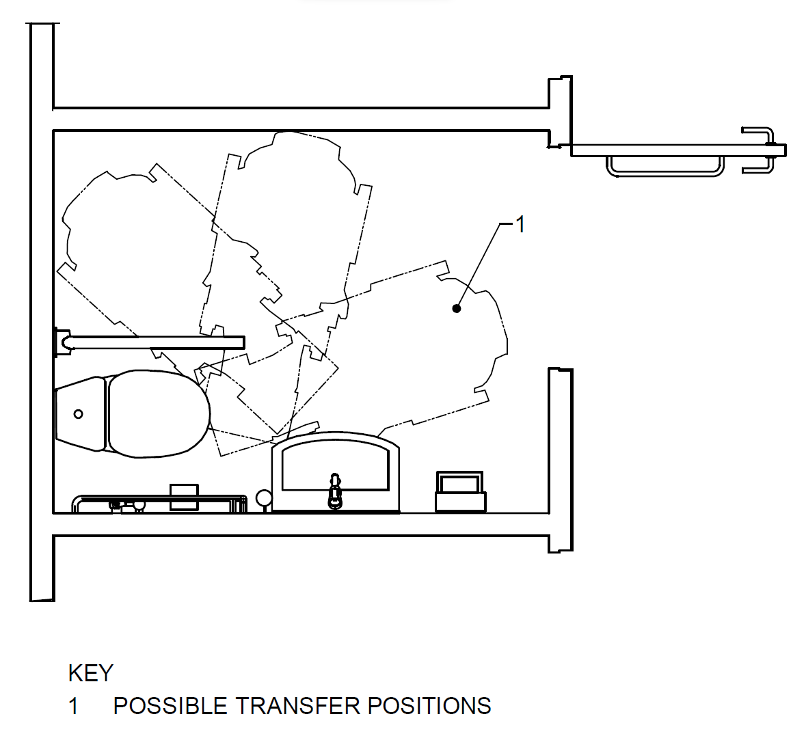
Key
- Possible transfer options
Fig. 68 Type B Toilet Room Transfer Options
14.3 Changing Places (CP) Toilet Room
14.3.1 General
14.3.1.1 A changing places (CP) toilet is a room with a WC, hoist, basin, adult-sized changing bench and optional shower, for use by people with complex and multiple impairments who require the help of up to two assistants. The shall be fitted with a fixed tracked-hoist system so that assistants can fit the user’s slings to the hoist and move the person to the various items in the facility.
14.3.1.2 Any building where the public have access in numbers would benefit from provision of a changing places toilet. Such facilities are particularly important in buildings that might offer the only suitable sanitary accommodation within a locality (e.g. transport interchanges), buildings where visitors might be expected to spend long periods of time (e.g. leisure and sport complexes), or buildings where public services are provided (e.g. those operated by local authorities). Commercial facilities such as large retail and leisure premises would be suitable as they provide longer opening hours and are likely to have a regular cleaning regime. Changing Places toilets require extended space to accommodate disabled people, often with large complex wheelchairs with elevated leg rests, a reclining facility or integral oxygen cylinders, and space to fit slings for use with the hoist. It also requires space for a wheelchair to be parked within the facility when not in use without compromising the safe access and use of the equipment. As changing places toilets are not designed for the use of independent wheelchair users, or to be used as baby changing facilities, it is desirable for facility providers to indicate the location of the nearest unisex accessible toilet and the nearest baby changing facility.
14.3.1.3 A changing places toilet is not suitable for bariatric use, as the turning space and load-bearing capabilities are considerably more onerous. It is necessary to obtain specialist advice for such use. Changing Places toilets should be provided in buildings and complexes such as:
  - major transport termini or interchanges, e.g. large railway stations and airports;
  - motorway services;
  - sport and leisure facilities, including large hotels;
  - cultural centres, e.g. museums, concert halls and art galleries, and faith centres;
  - stadia and large auditoria;
  - large commercial retail premises and shopping centres;
  - key buildings within town centres, e.g. town halls, civic centres and main public libraries;
  - educational establishments;
- health facilities, such as hospitals, health centres and community practices;
- other visitor attractions, such as theme parks, monitored beaches and parks.
Where possible, a changing places toilet shall be located close to other managed facilities in a development. If remote from the reception/management point, the facility shall have controlled access. The changing places toilet shall be in addition to, not instead of, the provision of standard and accessible toilets. A sign shall be provided at the entrance to the changing places toilet indicating the location of the nearest unisex accessible toilet and any baby changing facilities.
Size of the changing places toilet shall be at least 3 m wide and 4 m long, with a ceiling height of 2.4 m. The doorway shall have a minimum effective clear width of 1 000 mm, with a level threshold. Where practicable, recessed single leaf single swing doors shall open out and be fitted with a horizontal pull rail on the interior face of the door. Where they need to open inwards, the door position shall not restrict access.
A turning space of 1 800 mm shall be provided to enable someone to enter safely before the door is closed.
Changing Places facilities shall have a full room cover overhead tracked hoist system (either ceiling or wall mounted). Specialist literature may be referred for guidance.
NOTE – Suggestive specialist literature could be ISO 10535 : 2021 ‘Assistive products — Hoists for the transfer of persons — Requirements and test methods’.
The room structure and the track shall be capable of supporting a safe working load of 200 kg.
All ceiling fittings and fixtures shall be flush, recessed or shallow fittings to allow free movement of the moving rail of the tracked hoist. Manufacturers’ instructions shall be clearly displayed.
NOTE – The use of a mobile hoist might restrict the flexibility and long-term use of the facility. A full room cover system provides greater flexibility by being able to reach all areas of the room. Written instructions on the use of equipment need to be displayed beside each item.
The room shall have a mobile or wall-mounted changing bench, in each case height-adjustable, capable of operating at a safe working load of 200 kg. The covering of the bench shall be suitable for use when a person is showering as well as changing and should be easy to clean/dry.
Large sanitary disposal bins and waste disposal bins should, where practicable, be recessed into the wall to avoid being an obstacle to assistants moving alongside the WC. Sanitary disposal bins shall be large enough to accommodate adult-sized pads. A power-operated, height-adjustable washbasin shall be provided to accommodate use by both wheelchair users and assistants. A WC layout shall be provided, with drop-down support rails either side.
A retractable privacy screen (not ceiling-mounted) shall be provided to allow the disabled person to maintain their dignity when using the WC, as an assistant will always be present.
NOTE – The screen will also benefit assistants who require to use the WC without leaving the disabled person unattended.
Ventilation extract fans should be as quiet as possible in operation as their noise can cause distress to some people and can be a barrier to communication. The changing places toilet shall be heated, as users might be undressed and in the facility for a long period.
The illuminance in the room shall be maintained at 300 lux at changing bench level. Timed lighting shall not be used as, if the lighting switches off, the assistant has to leave the disabled person unattended to re-activate the lighting.
NOTE – It is not appropriate to install ultra-violet light in this type of facility, as it reduces the ability of people who are blind or partially sighted to appreciate visual contrast and might trigger seizures in people with epilepsy.
A changing places toilet shall contain, as a minimum, the fittings and accessories shown in the example layout in Fig. 69. Clear instructions and notices shall be displayed with any weight limits and a reminder, where appropriate, to return the hoist to the charging point.
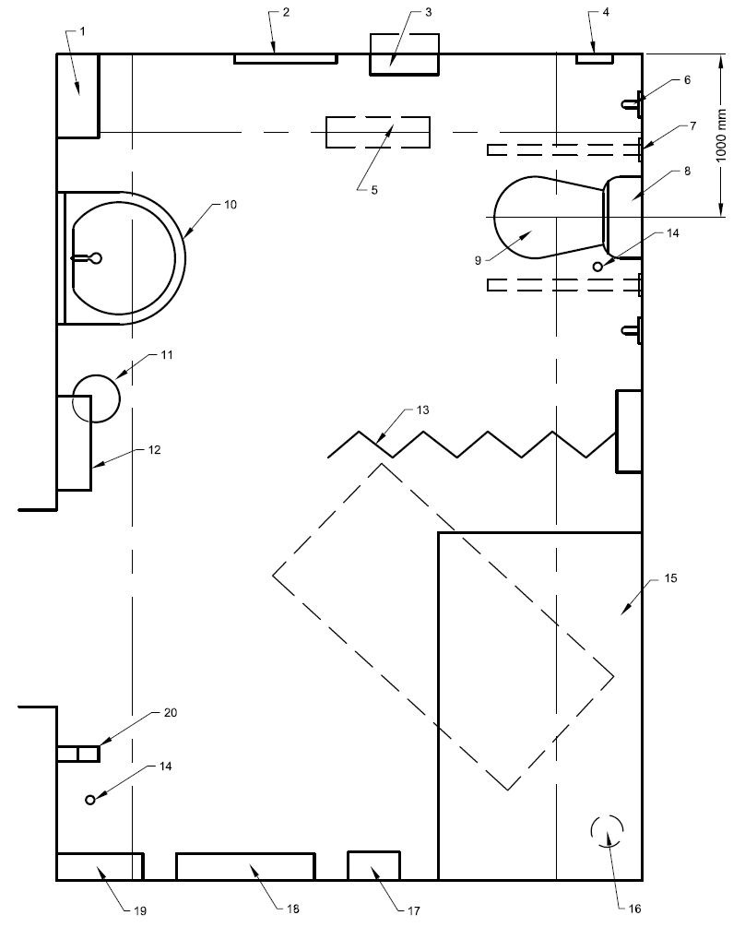

Key
- 1 Paper towel dispenser  - Full length mirror  - Large sanitary disposal bin, if possible recessed into the wall  - Alarm reset button  - Full room cover tracked hoist system  - Vertical grab rail  - Drop-down support rails with toilet paper dispensers  - Flat-topped close-coupled cistern providing a back rest and a colostomy bag changing surface for standing users  - Peninsular WC (see Figure 45 for the location of associated fittings)  - 10 Large power-assisted height-adjustable washbasin | - Waste disposal bin  - Manually-operated low-noise hand dryer (see Note 2 to 18.5.6.1  - Retractable privacy curtain/screen  - Alarm pull cord  - Height-adjustable showering/changing bench, min. 1 800 mm long  - Floor drain  - Optional shower unit with hose long enough to reach the centre of the bench, for personal hygiene purposes  - Wide paper roll dispenser for use on the changing bench  - Sanitary towel dispenser  - Two clothes hooks, one at 1 050 mm and the other at 1 400 mm above the floor
NOTES
1 Provision of a wash/dry type WC can enable greater independence and dignity for users.
2 Provision of a shelf can be beneficial for users where high or low level or reduced flush cisterns are used, a rail with a padded back rest and a separate colostomy bag changing shelf at 950 mm above finished floor level should be provided.
Fig. 69 Fittings and Accessories of a Changing Places Toilet
14.3.2 Accessories and fittings (see Fig. 70 to 73)
14.3.2.1 Ceiling track hoists to safely lift and transfer users from wheelchair to toilet and/or changing table with dignity and comfort. A 3 m x 4 m XY (H) System with manual traverse and powered lifting/ lowering shall be provided along with a 3-amp switched fuse spur at ceiling height.
14.3.2.2 A height adjustable Changing Table to provide a hygienic, safe and comfortable platform for changing continence pads. Height Adjustable Changing Table shall be of 1 800 mm x 700 mm with safety rail. It shall allow for connection to flush-mounted 10-amp spur as per manufacturer’s instructions.
14.3.2.3 A standard Western Commode shall have at least 1 000 mm space on either side from the wall to allow for carers to assist from both sides if necessary. WC shall have a backrest and the seat height shall be 480 mm from floor with toilet paper within reach.
14.3.2.4 Drop down support arms/ pull up grab bars shall be installed 320 mm either side from the centre line of the WC to support transfers as well as while seated. The support arms shall be with visually contrasting colours to the wall and placed at 680 mm height.
14.3.2.5 Privacy screens or curtains can either be wall mounted or mobile and shall be retractable and positioned between the toilet and the rest of the room. These are required to give privacy to the person using the toilet once in position and also allow the assistant to use the facilities in private without vulnerable people leaving the room.
14.3.2.6 An emergency alarm system shall be provided and shall have 2 red pull cords and a reset button. The first pull cord shall be positioned by the toilet and never be tied up out of reach in the event of a fall.
14.3.2.7 A shelf for colostomy bags 100 mm to 150 mm deep and at least 400 mm wide shall be fitted 950 mm above floor level. The shelf shall be positioned where it will not obstruct use of the wall mounted handrails or other equipment, but where it is within reach of a person using the WC.
14.3.2.8 Large paper roll within a dispenser for hygiene purposes shall be positioned on the wall between 800 mm and 1 000 mm above floor level, by the changing table so it can be covered before use. This can also be used for cleaning once the equipment has been used so it’s ready for the next user.
14.3.2.9 A bin for general waste and paper hand towels as well as additional large sanitary or medical waste bins shall be provided to accommodate adult size continence pads. Wherever possible, the waste bin should be recessed into the wall in order to maximise the floor space.
14.3.2.10 A wall mounted paper towel dispenser shall be close to the washbasin with the lower edge positioned 800 mm to 1 000 mm. This will help where hand-dryers are considered too loud or cause discomfort for some users (particularly for those with sensory impairments or dementia).
14.3.2.11 A height adjustable wash basin with safety cut out allows the basin to be lowered to a comfortable working height that can also be raised for users who are able to stand. The height adjustment should be in the range of 580 mm to 1 030 mm above floor level and should ensure at least 700 mm underneath for wheelchair access. Where it’s not possible for an adjustable wash basin to be installed, a standard basin may be fitted (720 - 740mm from floor). In addition, a soap dispenser should be fitted to the wall with the underside positioned 800 mm to 1 000 mm above floor level.
14.3.2.12 Horizontal grab rail shall be provided for outward opening doors, making it easy to close. They can also be fitted to walls where extra assistance and reassurance may be required, such as near the changing table area. All grab rails shall be a contrasting colour to the environment, typically blue or grey, so they are easy to identify for visually impaired users. Vertical grab rails should be 600 mm long and positioned above these to assist those who are able to stand as well as those transferring from the frontal position. Vertical grab rails positioned either side of the basin are also useful for those who are able to stand but require support.
14.3.2.13 A full-length mirror shall be fitted to the wall to allow wheelchair users and assistants to be able to view their whole body. Some manufacturers have extra-large mirrors incorporated into the wash basin which are adjusted with the movement of the basin. These are acceptable mirrors in Changing Places facilities.
14.3.2.14 A minimum of 6 coat hooks shall be fitted to the wall of a Changing Places toilet and shall be within reach of wheelchair users and assistants being positioned approximately 1 050 mm and 1 400 mm above the floor.
14.3.2.15 Optional shower – If a Changing Places toilet is being incorporated in a managed setting such as a leisure centre, a shower can be very useful. Where provided, the shower shall be positioned by the changing table or have a separate fold down seat area and the floor should be unobstructed. Also, the floor shall be waterproof, non-slip and have a gradient no greater than 1:50 to a floor drain.
14.3.2.16 Along with a general waste bin, a separate large sanitary waste bin shall be included in the facility. It should be positioned close to, but not obstructing the WC, and be large enough to accommodate adult size continence pads.
14.3.2.17 A hot-air hand dryer shall be provided on the door side of the washbasin with the lower edge positioned 800 mm to 1 000 mm above the floor level. Hand dryers requiring users to put their hands into a limited space at the top of the dryer shall not be installed. Some ‘ultra-rapid’ hand dryers can be too loud causing discomfort for some users, including those with sensory impairments or people with dementia.
14.3.2.18 The reset button for the emergency alarm system shall be positioned by the door with an alarm indication light above the door.
14.3.2.19 Artificial lighting shall provide an even level of illumination of 300 lux at the height of the changing bench/ table.
14.3.2.20 The door to a Changing Places toilet shall provide easy access into and out of the room, be clearly visible, shall open outwards wherever possible, comprise a single door leaf that is outward opening and easy to operate. The door shall be 1 000 mm wide with a level threshold. Any change in floor finish along the line of the door shall be bridged with a securely fixed low-profile threshold plate. An easy action lever handle at 900 mm height and/or a vertical pull handle with bottom end 700 - 1 000 mm and top end no lower than 1 300 mm above floor level shall be provided with a horizontal rail on the inside face at a height of 900 mm. The door shall have an unobstructed space next to the leading edge of the opening face of the door of at least 300 mm this space is not necessary where an automatic door is installed. Automatic doors should be considered where possible.
14.3.2.21 Door Locks for Privacy and safety – All Changing Places toilet doors require a privacy lock on the inside. Some Changing Places toilets also require a security lock to prevent unauthorised access and to safeguard the facility when not in use. Whether a door is kept locked when not in use will depend on the location of the Changing Places toilet, the proximity of building management staff, and the management policy for that facility. The points below refer to privacy locks only:
- An easy-to-operate privacy lock which incorporates a red/white (occupied/vacant) visual indicator shall be provided.
- Privacy locks shall incorporate a mechanism that allows the door to be opened from the outside in an emergency.
14.3.2.22 Lighting & Décor – It is important to ensure that the décor creates a strong visual contrast between the fittings and their background. A warm, welcoming environment should be created. The facility should be as pleasant as possible as users may spend considerable periods of time there. Artificial lighting shall be provided to achieve an even level of illumination throughout the room. Given the size of the room, it is likely that more than one light fitting will be required. Light fittings controlled by a timer shall be avoided because an assistant may have to move away from the Changing Places user in order to reactivate the light, and this could compromise safety. The use of ultraviolet light, which is used in some public conveniences to deter drug use, shall not be used in Changing Places toilets. Ultraviolet light reduces visual contrast between surfaces and fittings and is also known to induce seizures.
- Matt surfaces shall be used to avoid glare with pale tones for walls and ceilings help to easily identified.
- Fittings such as grab-rails, dispensers pull cords and switches shall also contrast with the walls and surroundings so that they can be easily identified.
- Artificial lighting shall provide an even level of illumination of 300 lux at the height of the changing bench.
- The position of lights shall not create strong contrasts between light and shade or cause glare or reflections and Light fittings shall be shallow or recessed and positioned away from the ceiling track to avoid causing an obstruction to the hoist.
- Light switches shall be a pull cord type positioned 150 mm from the leading edge of the floor. The pull cord shall extend to between 900 mm and 1000 mm above floor level. Although the light pull cord fitting shall contrast in colour with the adjacent wall surface, it shall not be red in colour as it may be mistaken for an emergency assistance pull cord.
14.3.2.23 Changing Places toilets should be heated to maintain a comfortable temperature during winters. The room temperature should take account of the fact that many people using the facilities may be undressed for an extended period, such as while being changed or showered.
- Underfloor heating is recommended wherever it is practical to install, such as in new-build Changing Places toilets or where the room is being substantially renovated.
- If radiators are provided, they shall be carefully positioned so as not to obstruct access to and use of any equipment. They shall have a maximum surface temperature of 43° C. Radiator pipes should also be fully concealed or guarded.
- Convection and fan-type heaters shall be avoided as they can create draughts and cause discomfort. Fan heaters also generate background noise which can impair communications and create an unpleasant environment.
14.3.2.24 Hot water in pipes supplying washbasins and showers shall be at least 60° C in order to avoid the risk of legionella. However, thermostatic valves shall be used to ensure that the water temperature at the point of supply is much lower.
- At the point of supply, water temperature shall not exceed 43° C.
- Water supply pipes shall be concealed or boxed in to avoid the risk of injury.
14.3.2.25 A sling is used in conjunction with the ceiling hoist to enable its user to be transferred between the facilities in a Changing Places toilet. Slings are not expected to be provided within a Changing Places toilet. Slings are assessed to meet individual needs and are intended for personal use only. It is common practice for individuals to have their own slings and to carry them for use outside their home.
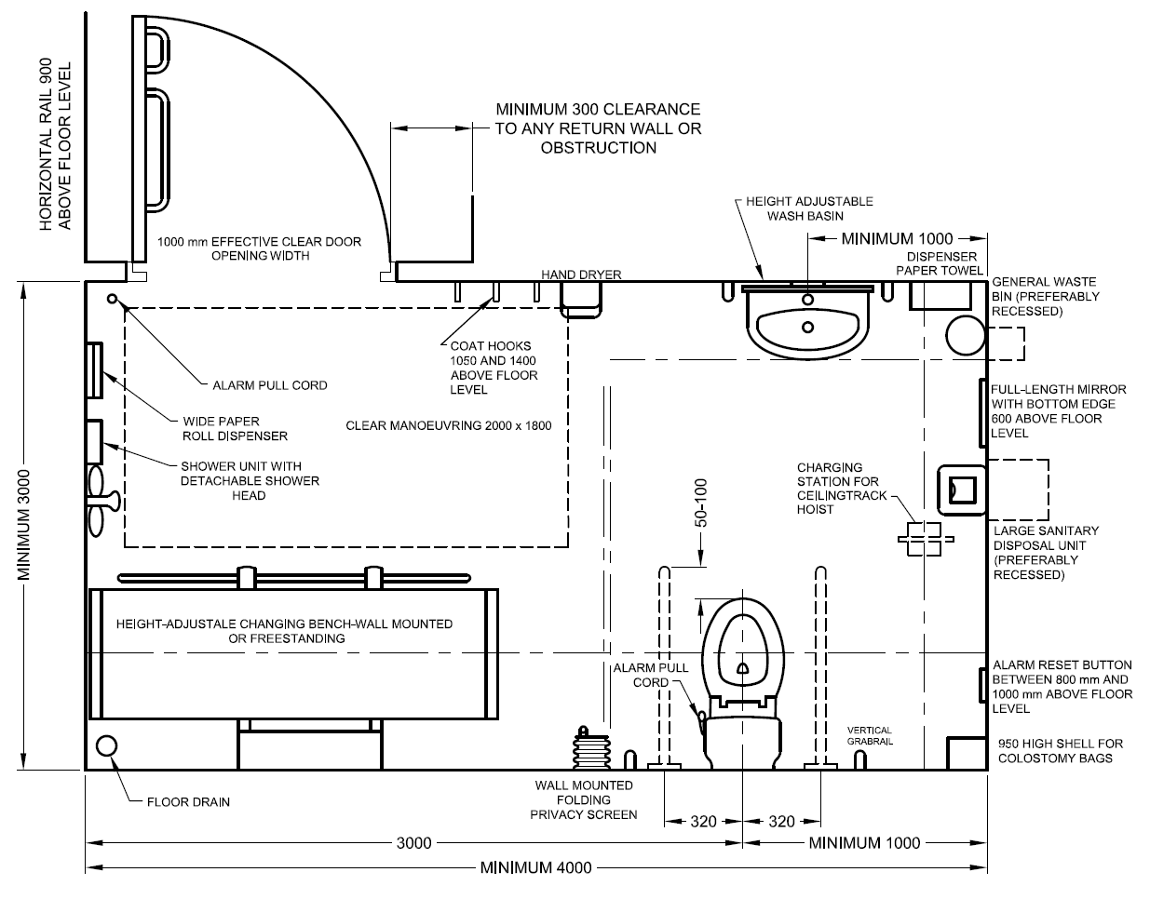
All dimensions are in millimetres
Fig. 70 Changing Places Toilet Room
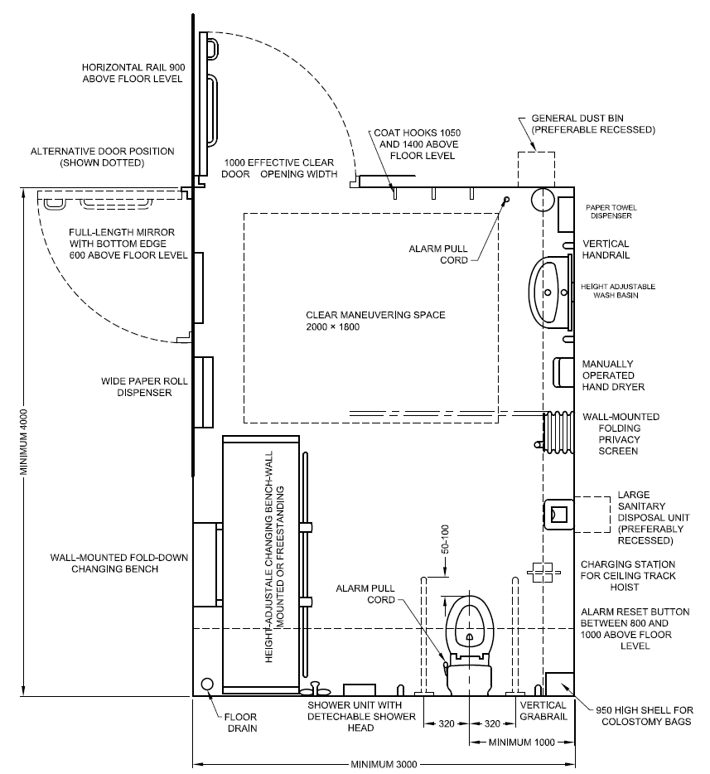
All dimensions are in millimetres
Fig. 71 Alternative Design – Changing Places Toilet Room
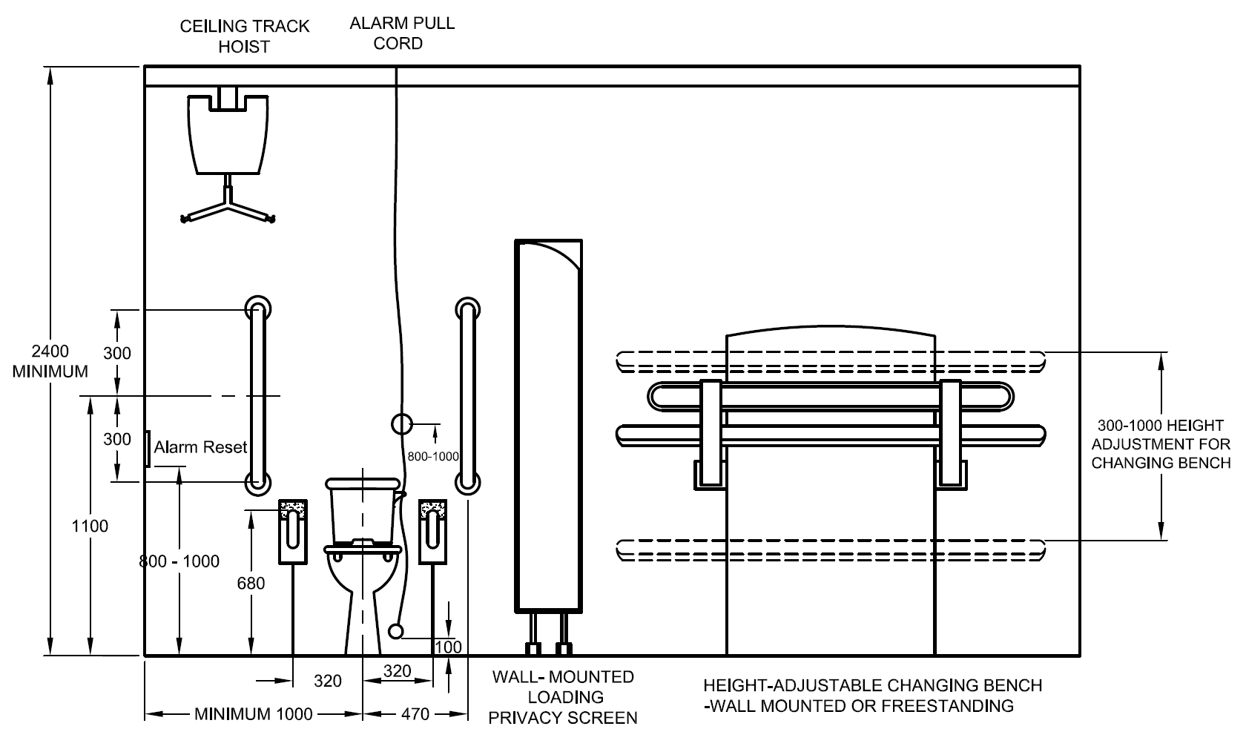
All dimensions are in millimetres
Fig. 72 Recommended Heights for Fittings in changing Places Toilet Room
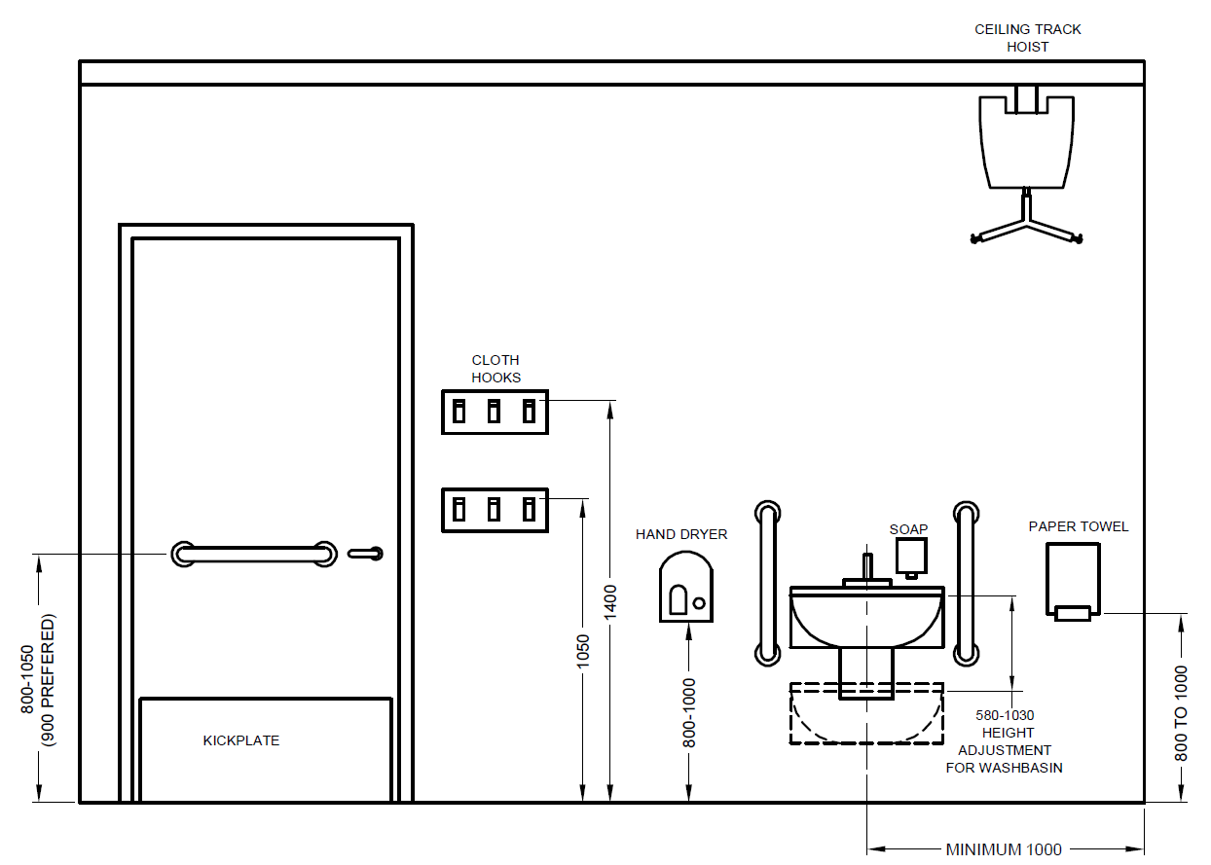
Fig. 73 Recommended Heights in Changing Places Toilet Room
14.4 WC Compartments and Indian squat pans for ambulant disabled people
These compartments meet the needs of ambulant disabled people who require support (see Fig. 74 and Fig. 75). This type of compartment is not for the majority of people who use wheelchairs. When located in a single-sex washroom, hand washing facilities will be available communally. Where this is a standalone facility, hand washing facilities shall be provided either in a space adjacent to the WC compartment or in a compartment suitably enlarged to accommodate a hand wash basin.
Such WC compartments shall meet the following requirements:
- It shall have a clear manoeuvring space of minimum 900 mm x 900 mm in front of the toilet.
- It shall be equipped with a door complying with 14.5 and opening outwards.
- Water-closet shall comply with 14.6.
- Grab bars complying with 14.7, horizontal and vertical shall be provided on both sides of toilet.
- It shall have other toilet accessories and fittings complying with 14.9.
- It shall have independent water supply beside water-closet, preferably a hand held toilet spray and floor drain, where necessary (see 14.10).
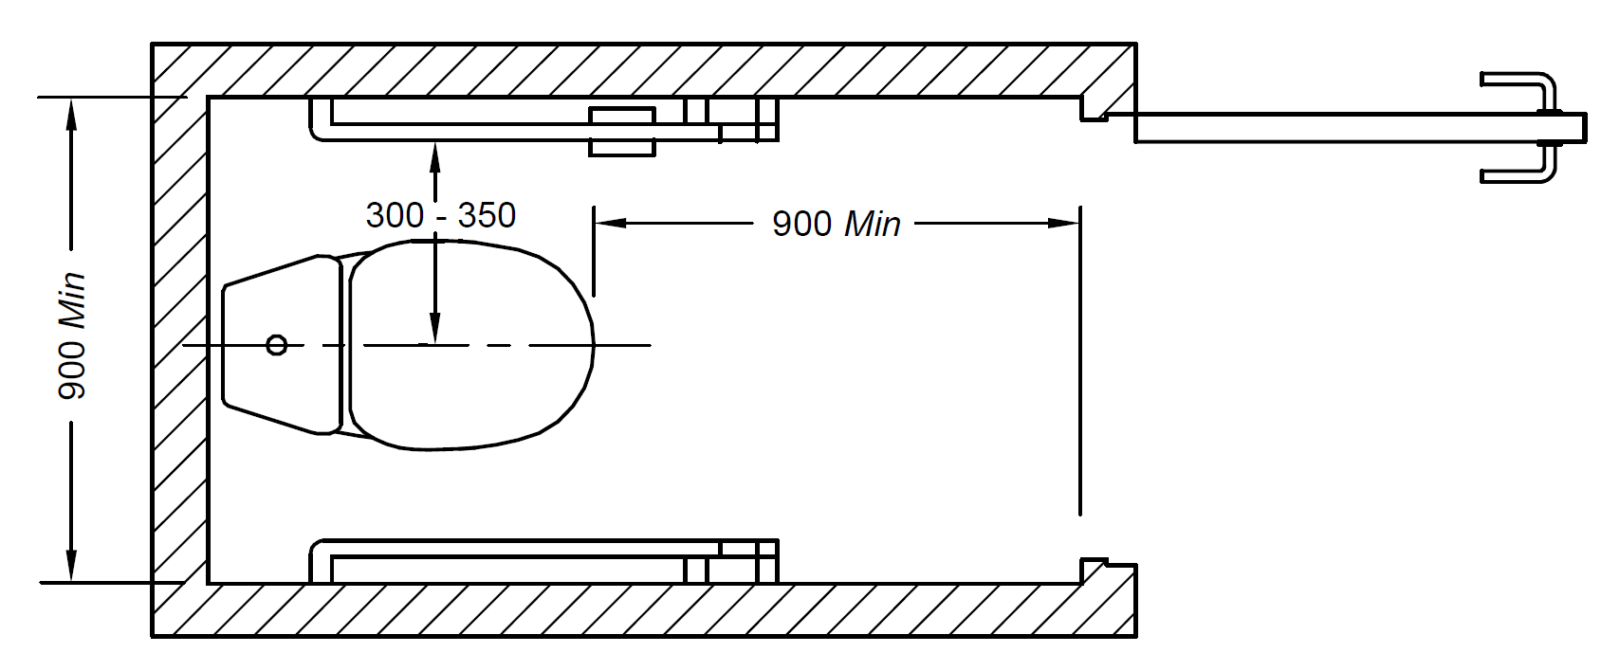
All dimensions in millimetres
Fig. 74 Toilet for Ambulant Disabled with L-Shaped Grab Bar
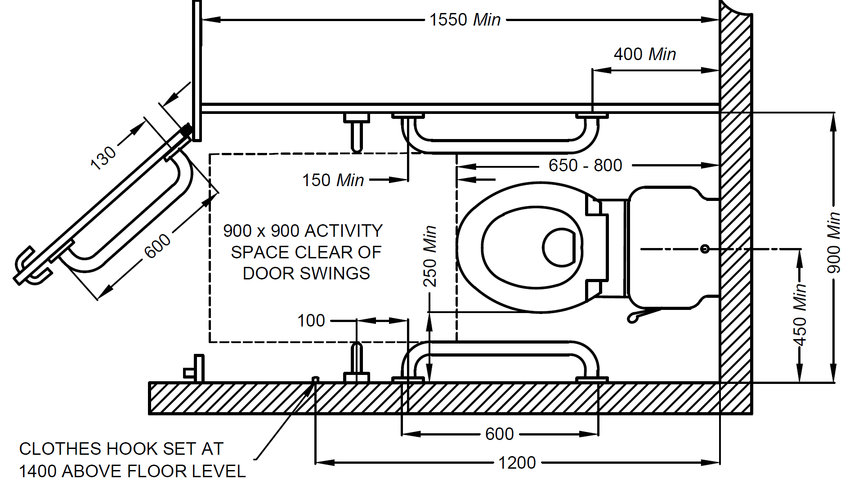
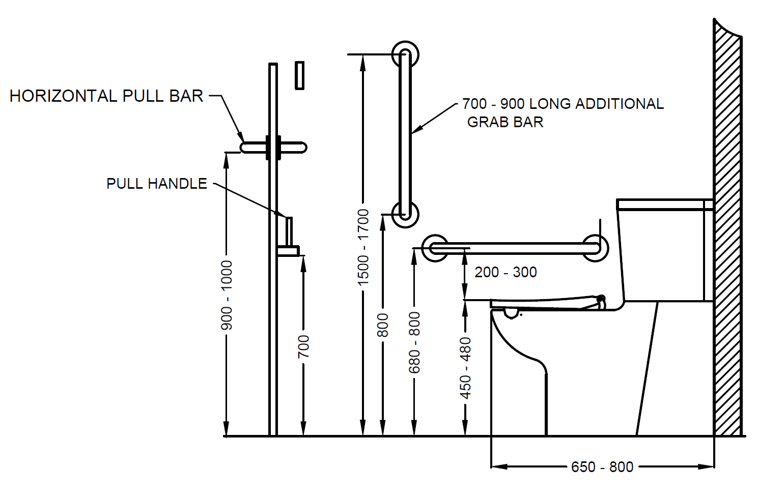
All dimensions in millimetres
Fig. 75 Placement of Fixtures in Toilet for Ambulant Disabled
14.4.1 Family Washrooms
14.4.1.1 Family washrooms are provided in facilities which host several families on a regular basis like shopping malls, cinema theatres, airports, railway stations, etc. Apart from hosting families with younger children, this facility is also very convenient to be used by older family members who require assistance from caregivers, expectant mothers, people recovering from physical injuries who may require assistance from a family member or a caregiver while using washroom facilities. Family washrooms mostly consist of WC, urinal, wash basin facilities for adults and children, diaper changing station, child protection seat, and provision of seat for Nursing mothers (see Fig. 76). A family washroom will benefit a wide range of users, including parents attending to their infants, and young children who need assistance with their toilet activities.
The family washroom shall be equipped with:
- A wash basin with liquid detergent and paper towels.
- A child-sized water closet and wash basin.
- Mirrors.
- A diaper changing station.
- A child protection seat.
- A vending machine for sanitary napkins and diapers.
- Space for baby carriage parking
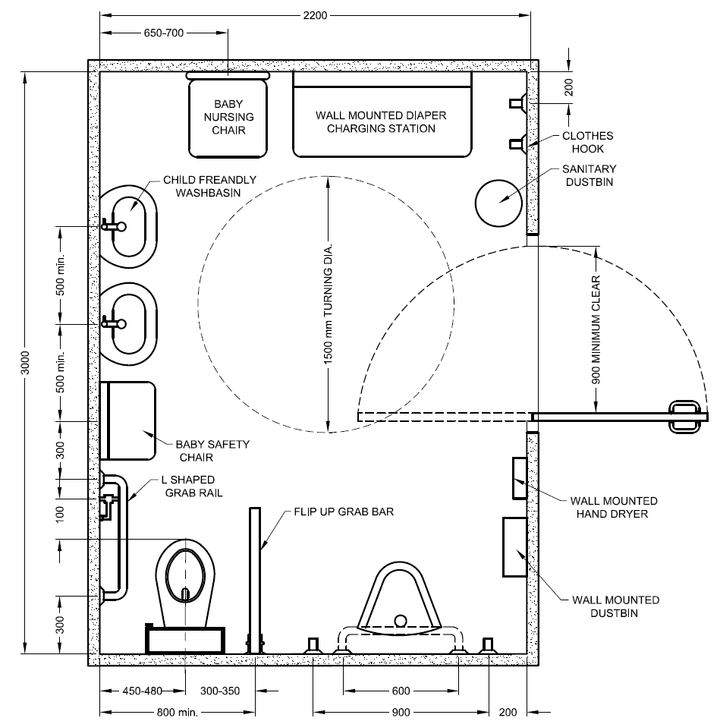
All dimensions in millimetres
Fig. 76 Placement of fixtures in Family Washrooms
14.4.1.2 Additionally, there shall be adequate colour and tonal contrast between the fixtures, walls, and the flooring. This is to enable easy recognition by persons with visual impairments.
14.4.2 Lactation Room/ Baby feeding room
A lactation room is a dedicated enclosed place where mothers can breastfeed their babies or express milk in a private and comfortable environment. A lactation room should provide a quiet environment and shall be equipped with:
- Comfortable seating, preferably armchairs or similar.
- Diaper changing stations.
- Waste containers for the disposal of used diapers.
- Wash basins with liquid detergent and paper towels.
- Dispensers for hot and cold water.
- Vending machines for beverages and diapers.
- Electrical outlets for breast pumps.
- Mirrors
14.4.3 Children Facilities in Washrooms
At least one child-sized water closet should be provided in each of the male and female toilets. The water closet seat shall be at a height of between 250 mm to 350 mm from the finished floor level. The grab bar height for toilets for children shall be between 510 mm and 635 mm. A seat adaptor with a small seat cover suitable for use by young children may be provided for existing buildings under exceptional circumstances. The hanger holding the seat cover shall be mounted at a level that is easily accessible to young children. A portable and stable stool shall also be provided as a stepper for young children who may not be able reach the water closet. Bath liquid dispensers and a flexible hose with water spray head shall be provided in the water closet compartment so that parents or guardians are able to clean their child.
14.4.3.1 Urinals – At least one urinal mounted at a height of about 400 mm from the finished floor level shall be provided in the male toilet for young children.
14.4.3.2 Wash basin – A child-sized wash basin shall be provided to allow young children to wash their hands without assistance. The wash basin shall be equipped with sensor operated taps. The height of the wash basin shall be at about 550 mm from the finished floor level.
14.4.3.3 Child Protection Seat – A child protection seat shall be provided in one of the water closet compartments for both male and female toilets. This will allow parents to seat their baby safely in the washroom with them. A child protection seat shall:
  - be equipped with straps that can be extended over shoulders and between legs to ensure the safety of the baby.
  - be mounted on a solid wall for stability.
  - be able to accommodate a child weighing up to about 20 kg.
  - be mounted with its bottom at least 400 mm above the finished floor for easy reach and with adequate space for parents to manoeuvre around the seated child.
14.4.3.4 Diaper Changing Station – A diaper changing station shall be provided within every family washroom for use by either parent and in every cluster of toilets for both male and female toilets. The sign for diaper changing station shall be indicated as shown in Fig. 77. A diaper changing station shall:
- be stable and equipped with safety straps and barriers lengthwise to ensure the safety of the infants.
- have a concave changing surface to ensure comfort and protection of the child.
- withstand a static weight of about 130 kg.
- be mounted such that the highest edge, or the lip, of the pull-down deck is between 700 mm to 850 mm above the finished floor level when open.
- be provided with clear instructions to facilitate safe use.
- be provided together with dispensers for bed linens and wet wipes for hygiene purposes.

Fig. 77. Diaper Changing Facility
14.4.4 Residential washrooms
The toilets in residential environments like independent houses, multi-storeyed housing, gated communities, affordable housing etc, also need to ensure universal accessibility and adaptability to the life span needs of the diverse residents. At least one washroom in each residence shall ensure complete compliance with universal accessibility features. However, the other washrooms (if any) shall be designed to ensure adaptability to diverse disability types or other functional limitations of its residents. The door shall have a clear width of 900mm (minimum) excluding the door frame and door thickness (see Fig. 78). It is recommended to have lever handles and other door hardware as per 12 and 10.3.7. The floor surfaces shall be non-skid type with a contrasting colour scheme.
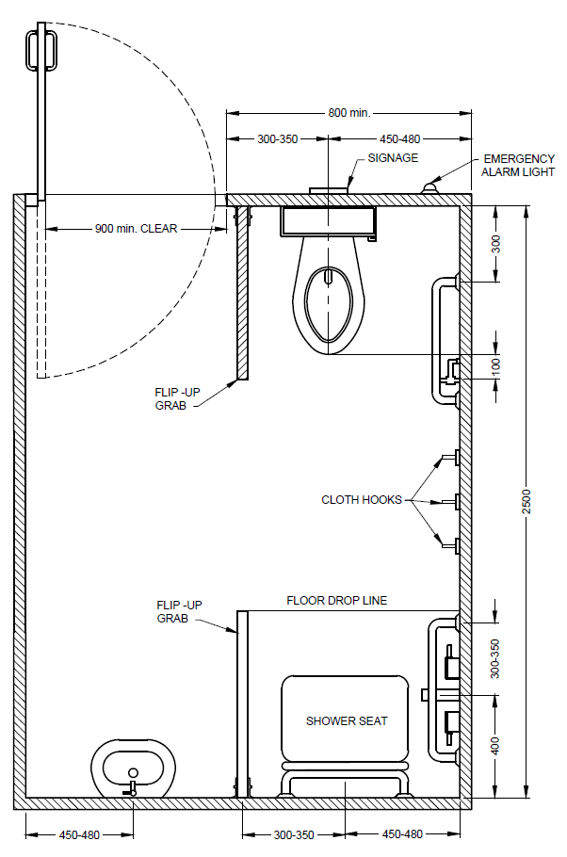 | 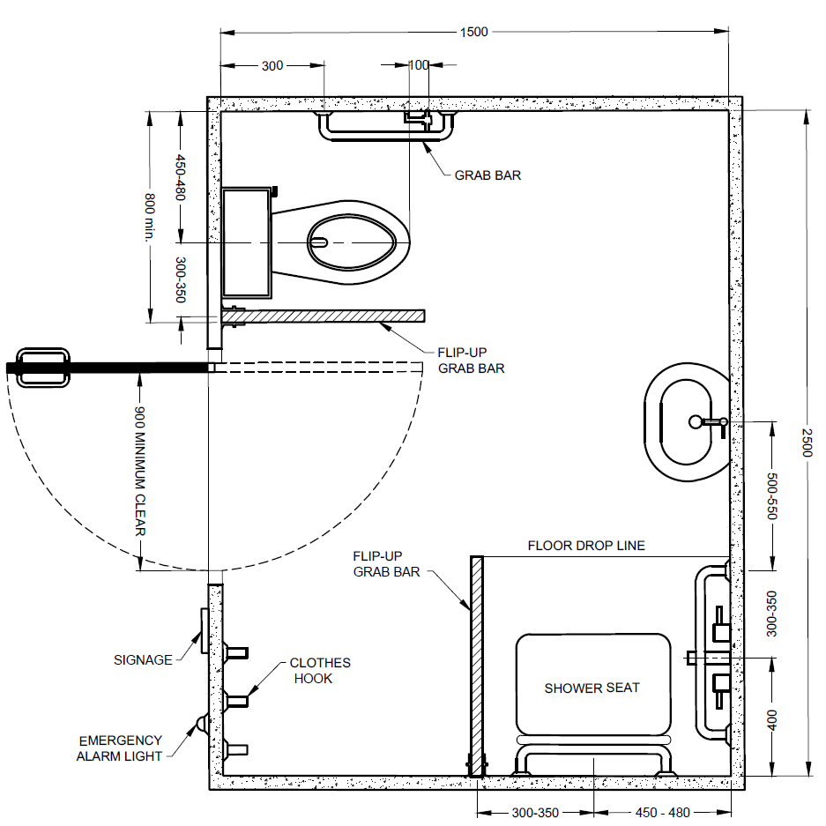
Fig. 78 Two Options of Residential Accessible Washrooms
14.5 Toilet or Sanitary Room Doors
Toilet or sanitary room doors shall comply with 10.3. The toilet door shall either be an outward opening door or two-way opening door or a sliding type and shall provide an unobstructed and clear opening width of at least 900 mm; it shall be easy to open and close. There shall be no openings under or above the door that compromises on privacy. Doors shall be positioned so as not to constitute a hazard.
The toilet door shall be provided with a horizontal pull-bar, at least 600 mm long, on the inside of the door, located so that it is 130 mm from the hinged side of the door and at a height of 900 mm to 1 000 mm. A horizontal pull handle on the inside of the outward opening doors shall be provided at a height of 700 mm above the floor. The door shall be capable of being locked from the inside by a device that is operable by one hand, activated by a force not more than 22 N and which does not require fine finger control, tight grasping, pinching or twisting of the wrist.
14.6 Water-Closet
Water-closet shall comply with the following requirements:
- It shall be so located that the distance between centreline of the water-closet to the adjacent wall in case of corner toilets (Type B) be between 450 mm and 480 mm. The minimum distance of a corner toilet from the edge of the WC seat to the adjacent wall should be 250 mm. In case of Type A toilet, the distance from the edge of the WC seat to the adjacent wall shall be 900 mm, minimum on both sides to allow ease of transfer.
- The top of the water-closet shall be between 450 mm and 480 mm from the floor.
- The minimum distance from the front edge of the water-closet to the rear wall should be between 650 mm and 800 mm.
- There shall be an adequate clear floor space of at least 1 300 mm depth and 900 mm width, both in front and on the transfer side, adjacent to the water-closet.
- There shall be a suitable back support to reduce the chance of imbalance or injury caused by leaning against exposed valves or pipes. The distance from the seat to the backrest should range between 500 mm and 550 mm.
- The water-closet shall preferably be of wall-hung or corbel type as it provides additional space at the toe level.
- Where water cistern is used, the cover shall be securely attached and the flush control shall either be lever type or automatic, and located on the transfer side of the water-closet. The flush control shall not be located more than 1 000 mm from the floor.
- Toilets for children should have a distance from the centre line to the adjacent wall between 305 mm and 380 mm and the water-closet height shall be between 205 mm and 380 mm.
14.7 Grab Bars
Grab bars complying with the following requirements and those given at 10.5.3 shall be provided in toilet or sanitary rooms in accordance with the following requirements.
On both sides of a toilet, a grab bar (whether drop-down or fixed to the wall) shall be provided at a distance between 300 mm and 350 mm from the centre line of the toilet.
On the sides where a lateral transfer is possible, a foldable grab bar (drop-down support bar) shall be provided at a height of 200 mm to 300 mm above the water- closet. The length of the foldable grab bar should overlap the front edge of the water-closet in between 100 mm and 250 mm. The positioning of a foldable grab bar should allow access from a wheelchair when folded up.
Where a wall is beside the toilet, a horizontal grab bar shall be provided at a height of 200 mm to 300 mm above the water-closet, and a vertical grab bar shall exceed from the horizontal grab bar to a height of 1 700 mm above floor level. The grab bar shall extend a distance of minimum 150 mm to the front edge of the water-closet.
Alternatively, one L-shape grab bar, 600 mm long horizontal and 700 mm long vertical shall be mounted on the side wall closest to the water-closet, as illustrated in Fig. 79.
The horizontal grab bar shall be uninterrupted for its full length.
The positioning of accessories such as hand towel, soap, waste bin, etc, should not hamper the use of the grab bar.
The grab bar height for toilets for children should be between 510 mm and 635 mm.
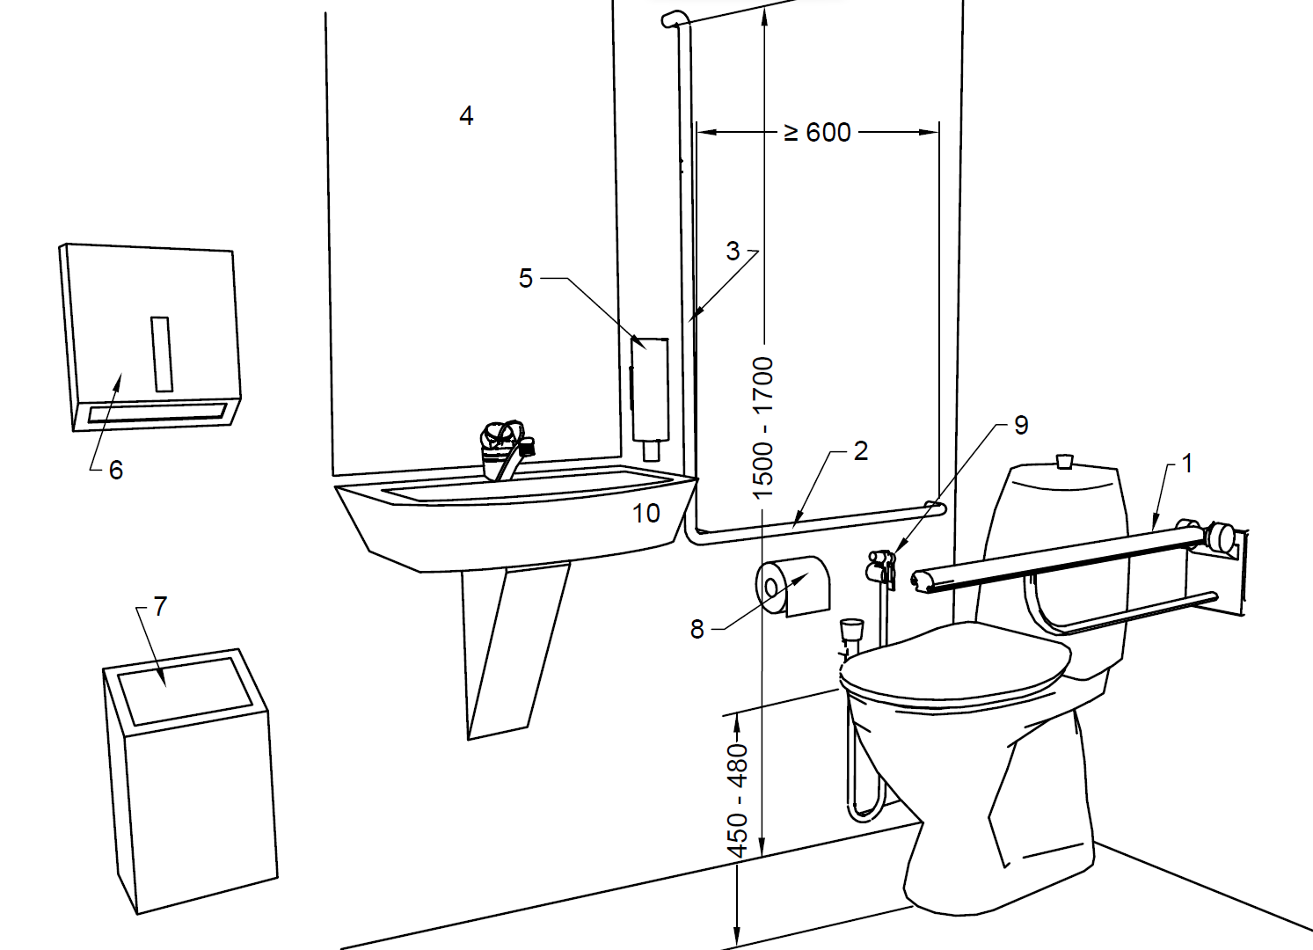
Key
- Drop down support grab bar at seat height plus 200 to 300mm
- Wall mounted horizontal grab bar at seat height plus 200 to 300 mm
- Wall mounted vertical grab bar
- Mirror, top height minimum 900 mm, bottom height maximum 900 mm above floor
- Soap dispenser 800 to 1000 mm above floor
- Towels or dryer 800 to 1100 mm above floor
- Waste bin
- Toilet paper dispenser 600 to 700 mm above floor
- Independent water supply
- Small finger rinse basin 350 mm maximum projection
All dimensions in millimetres
Fig. 79 Positioning of Grab Bars, Water Supply and Other Toilet Accessories in Type B Corner Toilet
14.8 Washbasin
A washbasin complying with following requirements shall be provided within an accessible toilet room (see Fig. 80):
- The positioning of a washbasin should allow access from a wheelchair. It shall provide a minimum clear floor space of 900 mm wide by 1 200 mm deep, of which a maximum of 480 mm in depth may be under the washbasin.
- It shall be mounted such that the minimum distance between the centreline of the fixture and the side wall is 460 mm; and the top edge of the washbasin is between 750 mm and 850 mm from the floor.
- The differences in stature may require lower or higher heights of washbasins and it may be advisable to have an inbuilt flexibility to increase or decrease height.
- The space under the washbasin shall be unobstructed with a knee clearance centred on the washbasin between 680 mm and 700 mm high, and 200 mm deep. In addition, a toe clearance of at least 300 mm high shall be provided (see Fig. 81). The front edge of the washbasin shall be located within a distance of 350 mm to 600 mm from the wall, according to Fig. 81.
- The hot water and drainpipes within the knee space or toe space shall be properly insulated.
- Automatic or lever type faucets/taps shall be provided complying with 14.11.
- In front of the washbasin, space should allow for a frontal or oblique approach by a wheelchair. The reaching distance to the tap control shall be a maximum of 300 mm, according to Fig. 81.
- Edges on washbasins should be rounded.
- The mirror above the washbasin shall be positioned to have the bottom edge at a height of not more than 900 mm above the floor, up to a height of 1 900 mm (see Fig. 80). If a second mirror is provided, the maximum height above the floor should be 600 mm, up to 1 850 mm. The mirror shall be tilted at an angle of 30° for better visibility of wheelchair user. Care shall be taken in placing mirrors and lights to avoid confusion and dazzling for visually impaired users.
- A shelf with minimum dimensions of 200 mm x 400 mm should be provided near the washbasin at a height of 850 mm or combined with the washbasin.
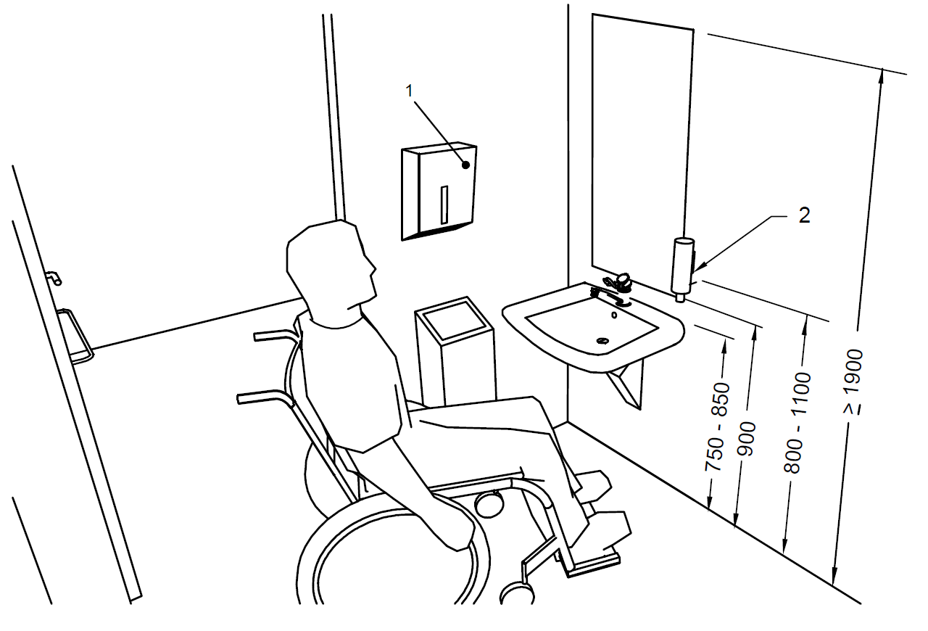
Key
- Paper towels, 800 to 1 100 mm above floor
- Soap dispenser
All dimensions in millimetres
Fig. 80 Placement of Washbasin and Mirror above the Washbasin with Distance of Sanitary Appliances
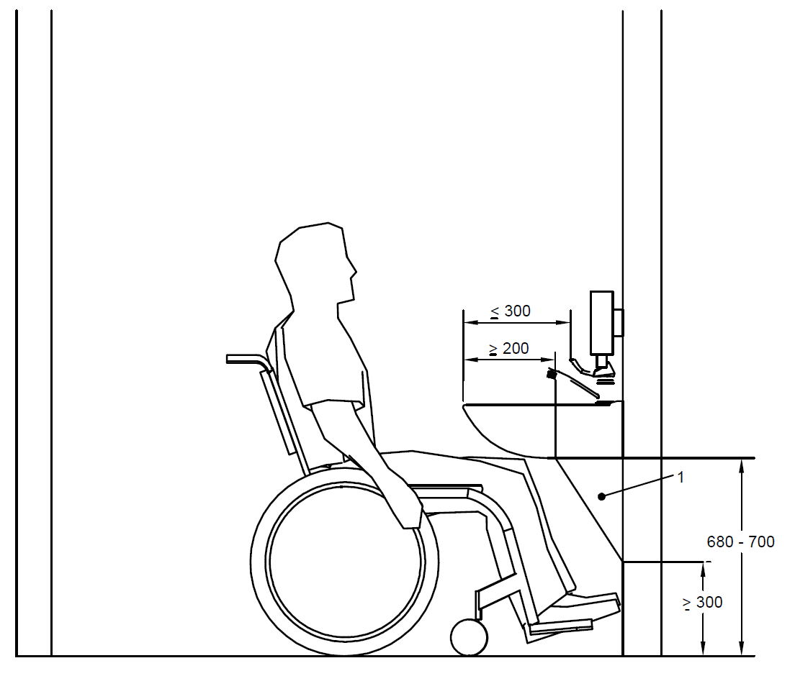
Key
- Concealed piping
All dimensions in millimetres
Fig. 81 Washbasin with Knee/ Toe Clearance
14.9 Other Toilet Accessories and Fittings
All other fittings, for example the water tank, hand dryer, towel, soap dispensers, waste bins, hand-held shower, etc, should be set at a height between 800 mm and1 100 mm from the floor (see Fig. 79). Coat hooks should be set at different heights, 900 mm to1 100 mm, and additionally at least one hook at 1 400 mm. Accessories shall be placed in close proximity to the basin, to avoid a person with wet hands wheeling a chair.
Dispensers for toilet paper shall be reachable from the water-closet, either under the grab bar or on the sidewall of a corner toilet at a height between 600 mm and 700 mm from the floor (see Fig. 79).
Light switches should be fixed inside all accessible toilet cubicles, or the lighting should automatically switch on when someone enters the room. Timed light switches should not be installed or used.
Needle boxes to safely dispose off needles (for example from diabetes patients) should be provided.
If a sanitary bin is supplied, it should be reachable from the water-closet. Sanitary bins with non-touch opening devices are preferred.
Non-touch soap dispensers are preferred.
14.10 Water Supply
An independent water supply (hand-held shower) shall be provided next to the toilet. An alternative such as a combination bidet and rear side pan/built-in bidet can be installed.
14.11 Taps
Taps should be mixer, lever or sensor operated to aid operation, complying with requirements given in 10. The tap controls should be set no more than 300 mm from the front of the washbasin. It is recommended that a thermostat be installed to limit the temperature of the hot water to a maximum of 40 °C in order to prevent scalding. Hot and cold water taps should be identifiable by both colour and tactile markings.
14.12 Urinals
Wheelchair users may be able to pull themselves to a standing position to use a urinal, or they may be able to use a urinal from their wheelchair. Ambulant persons with disabilities, for example crutch users, may need support in front of urinals. Bowl urinals are preferable to slab urinals for the benefit of visually impaired.
When wall hung urinals are fitted in the washroom, it is recommended that at least one of these have its rim set at a height of 380 mm for wheelchair users and at least one has its rim set at a height of 500 mm for standing users/ambulant disabled. When installed, both should be equipped with a vertical grab rail.
The lower urinal position as shown in Fig. 82 is also beneficial to a person of lower stature. Where an accessible urinal is provided, the accessible approach to the same shall be ensured. This wall hung urinal should be set clear above the floor level, without any raised access platform and with a clear floor area in front of the urinal of at least 760 mm wide and 1 220 mm deep to allow forward approach for ambulant disabled and minimum of 900 mm x 1 350 mm for wheelchair users to use the urinals (see Fig. 83). Urinals should contrast visually with the wall to which they are attached.
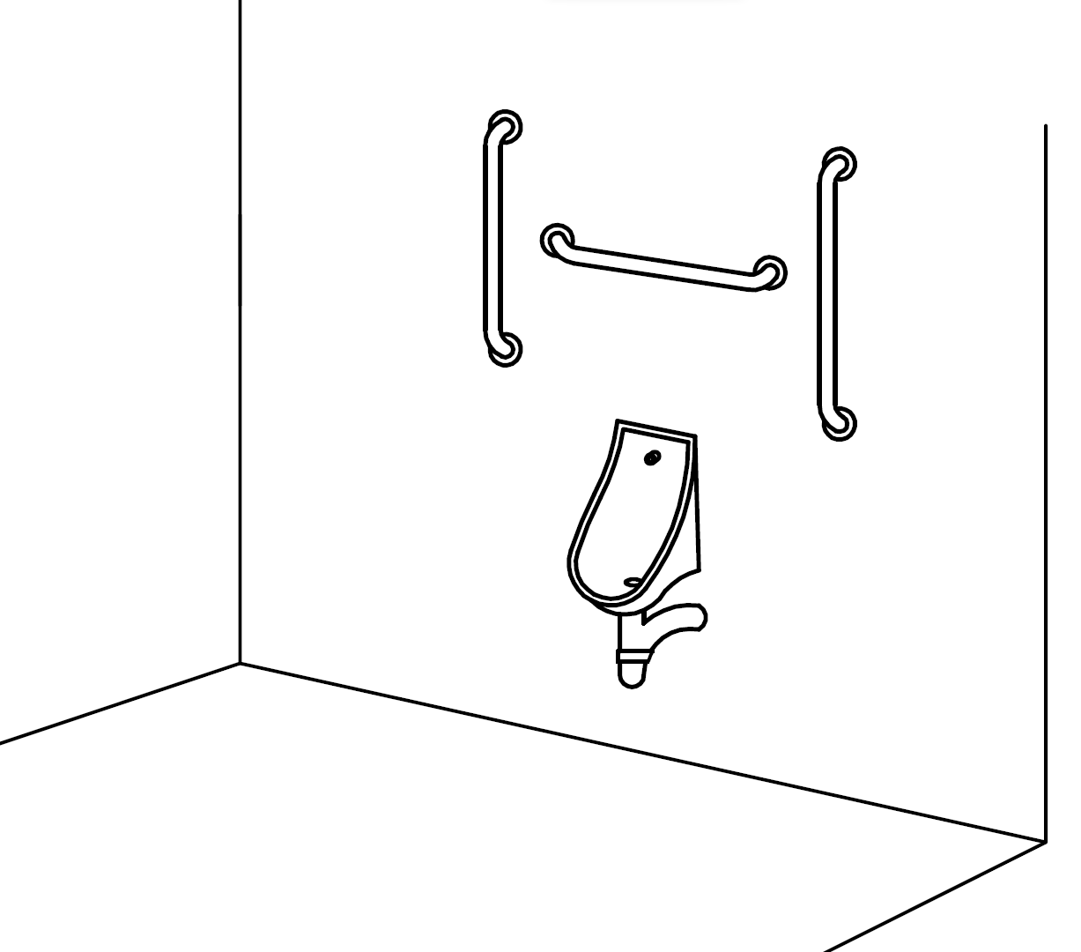
Fig. 82 Urinal for Wheelchair Users
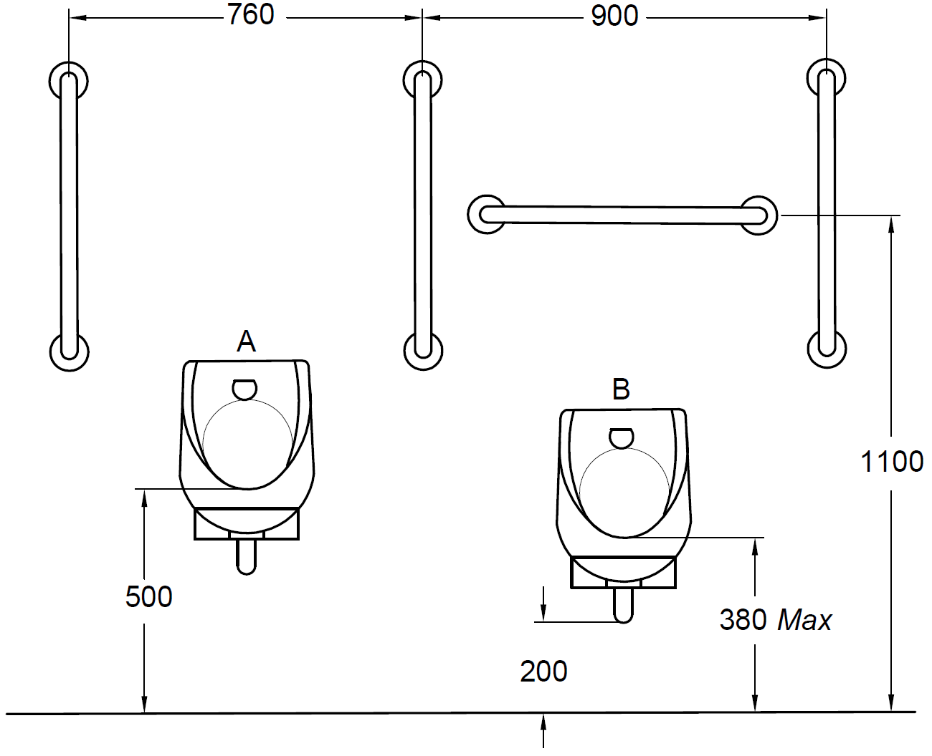
Wall space kept free of pipework to 200 mm above floor unless urinal projects more than the minimum 360 mm from the wall
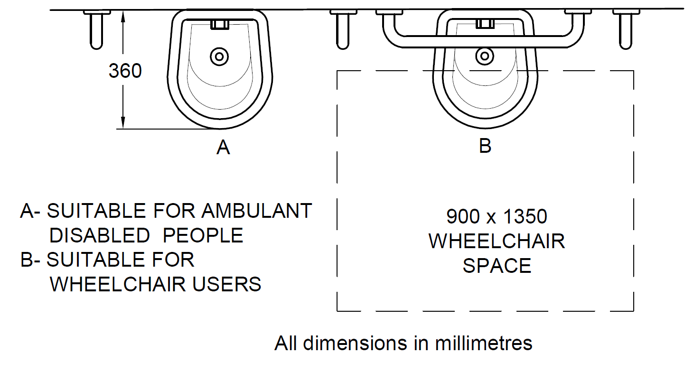
All dimensions in millimetres
Fig. 83 Clear Floor Space and Mounting Heights for Urinals
14.13 Alarm
An assistance alarm, which can be reached from changing or shower seats, from the WC and by a person lying on the floor, shall be provided in all accessible toilets and accessible sanitary rooms. This alarm should be connected to an emergency help point, or where a member of staff can assist.
Visual and audible feedback should be provided to indicate that, when the alarm has been operated, the emergency assistance call has been acknowledged and action has been taken.
It should take the form of a pull cord, coloured red, with two red bangles of 50 mm diameter, one set at a height between 800 mm and 1 100 mm and the other set at 100 mm above floor level.
A reset control shall be provided for use if the alarm is activated by mistake. It shall be reachable from a wheelchair and, where relevant, from the WC, the tip-up seat in a shower or changing facility, or the bed in an accessible bedroom. The reset control shall be easy to operate and located with its bottom edge between 800 mm and 1 100 mm above floor level.
For a corner toilet room, the reset button should be above the fixed horizontal grab rail beside the toilet paper holder.
The marking of the reset control shall be both visible and tactile.
14.14 Emergency Warning Alarm
A visual emergency alarm shall be provided to alert people who are deaf or hard of hearing in the event of an emergency. Emergency alarms and warning systems shall comply to the guidelines for them to be accessible to everyone. The integration of visual and audio features is highly recommended for these systems. Visual emergency alarm can provide alert signals appropriately to persons with hearing impairments including deaf and others with situational conditions. It shall be ensured that emergency alarm systems are well coordinated with emergency support services and provide immediate rescue and support mechanisms to persons in need.
14.14.1 Alarm System in Accessible Sanitary Facilities – An assistance alarm, which can be reached from changing or shower seats, from the WC or an Indian Squat Pan and by a person lying on the floor, shall be provided in all accessible toilets and accessible sanitary rooms. This alarm shall be connected to an emergency help point, or where a member of staff can assist. Visual and audible feedback shall be provided to indicate that, when the alarm has been operated, the emergency assistance call has been acknowledged and action has been taken. It should take the form of a pull cord, coloured red, with two red bangles of 50 mm diameter, one set at a height between 800 mm and 1100 mm and the other set at 100 mm above floor level. A reset control shall be provided for use if the alarm is activated by mistake. It shall be reachable from a wheelchair and, where relevant, from the WC, the tip- up seat in a shower or changing facility. The reset control shall be easy to operate and located with its bottom edge between 800 mm and 1 100 mm above floor level. For a corner toilet room, the reset button should be above the fixed horizontal grab rail beside the toilet paper holder. The marking of the reset control shall be both visible and tactile.
14.15 Shower and Changing Rooms
Showers and changing rooms can be used by people with different disabilities and different supporting aids, for instance, wheelchair users, ambulant disabled people, etc, using their own wheelchairs or special shower chairs.
14.15.1 Shower/Changing Room Size and Space
The shower/change area shall have level entry and have no fixed elements that prevent front and side access.
A self-contained individual shower room or changing room shall have minimum interior dimensions of 2 000 mm x 2 200 mm (see Fig. 84 and Fig. 85). See 14.15.6 for other requirements of individual shower room.
A shower room incorporating a corner accessible toilet room shall have minimum interior dimensions of 2 400 mm x 2 500 mm (see Fig. 86). In such cases, the manoeuvring areas may overlap, as shown in Fig. 86.
The minimum clear floor space or wet showering area should be 900 mm x 1 350 mm, with a transfer area of also 900 mm x 1 350 mm in the shower room (see Fig. 87).
If two or more shower recesses are provided, at least one shall have the seat on the opposite side.
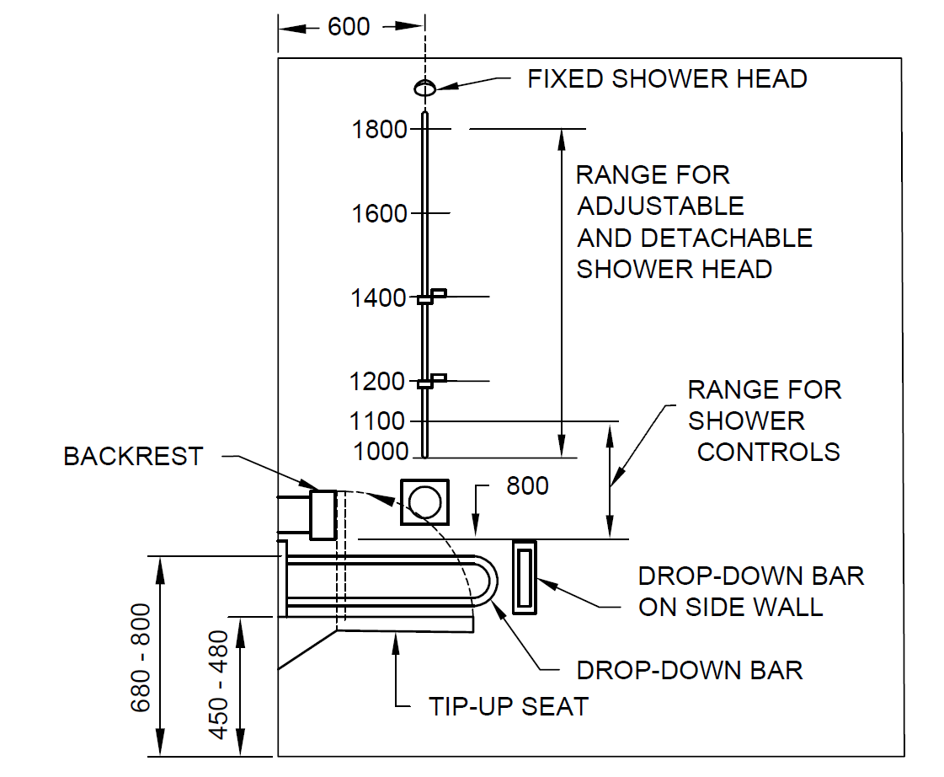
ELEVATION
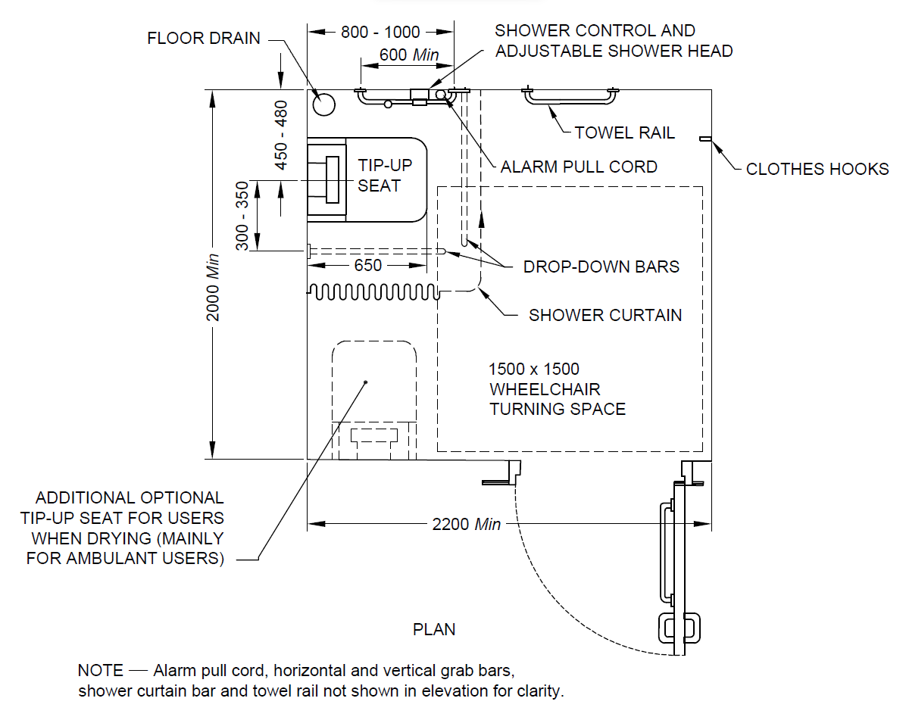
All dimensions in millimetres
Fig. 84 Self-Contained Shower Room for Individual Use
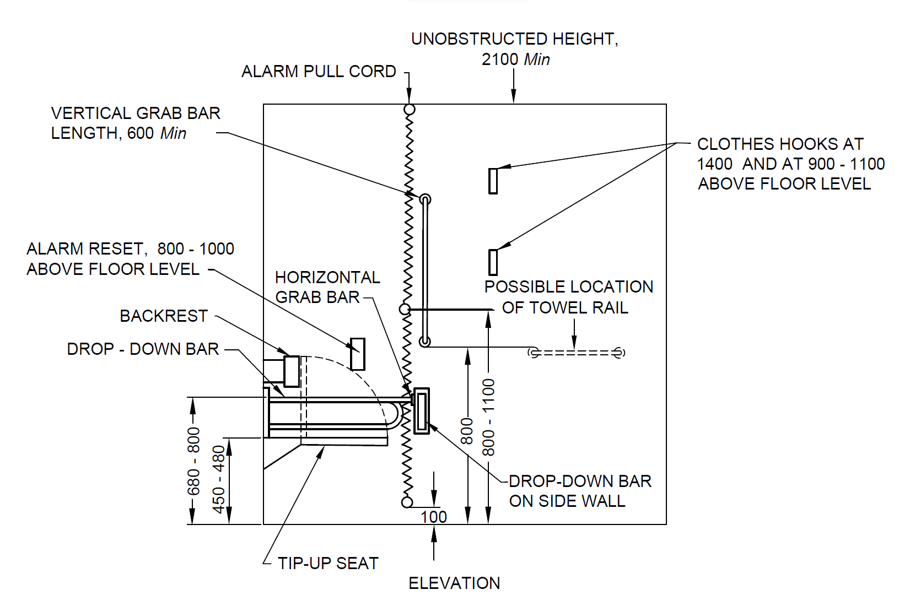
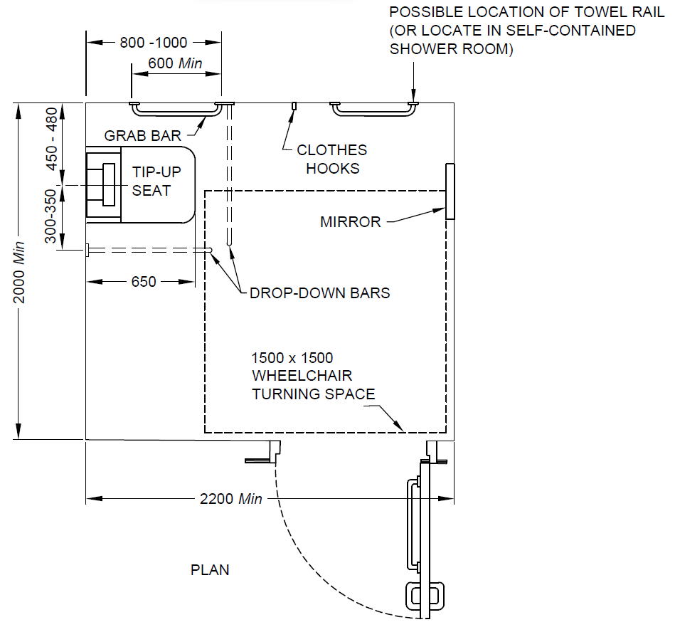
All dimensions in millimetres
Fig. 85 Self-Contained Changing Room for Individual Use
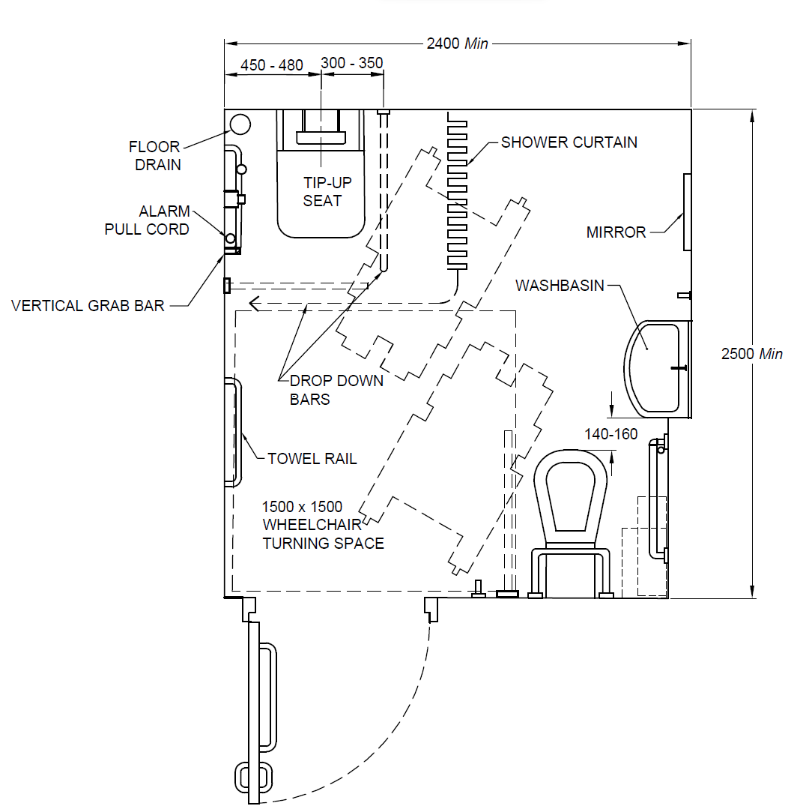
NOTES
1 Layout shown for right hand transfer to shower seat and water closet.
2 The larger washbasin is set back 200 mm to maintain the correct relationship of its leading edge with the water closet.
All dimensions in millimetres
Fig. 86 Shower Room incorporating an Accessible Corner Toilet for Individual Use
14.15.2 Shower Floor and Drainage
The floor in the shower recess shall have a gradient between 1:50 and 1:60 sloping to a floor drain. The area outside the shower recess shall have a gradient between 1:70 and 1:80 draining towards the shower recess.
The floor of the shower shall be slip-resistant even when wet.
The transition into the shower recess shall be level without a step down or a kerb. Where unavoidable the kerb shall not be more than 12 mm high bevelled at a slope of 1:2.
The waste outlet should be centrally located and be a round type outlet, not a channel type, to ensure the stability of the shower chair.
14.15.3 Shower Seat
The shower should be fitted with a wall mounted, easily operable foldable seat that folds in an upward direction. If a foldable seat is provided, its minimum size shall be 450 mm x 450 mm, and, when folded down, have its top surface set between 450 mm and 480 mm above finished floor and spaced a maximum of 45-50 mm from the rear wall.
The shower seat shall be positioned such that the distance between the centre line of the shower seat and the adjacent wall is 450 mm to 480 mm, and the distance between front edge of the shower seat and the rear wall is 650 mm.
Enclosures for the shower cubicle shall not obstruct transfer from wheelchair onto shower seat.
The fastenings for grab bars and the construction of the foldable seat shall be able to withstand a force of 1.1 kN applied at any position and in any direction.
NOTE — Shower wheelchairs are sometimes used instead of shower seats.
The foldable seat shall have the following features:
- Self-draining;
- Slip-resistant and stable;
- Foldable in an upwards direction; when folded, it shall not present a hazard and the grab rail shall be accessible from the foldable seat;
- Rounded front corners (radius 10 mm to 15 mm); and
- Rounded top edges (minimum radius of 2 mm to 3 mm).
The foldable seat should preferably be height adjustable.
14.15.4 Grab Bars
Grab bars in shower shall be set according to 14.7 and Fig. 86. The shower area shall be fitted with at least one vertical grab bar which may hold the flexible shower head.
14.15.5 Stationary, Fittings and Accessories
The length of the flexible (adjustable and detachable) shower hose (telephone shower/ handheld shower), shall be 1 500 mm minimum. The handheld shower head should be provided between 1 000 mm and 1 200 mm above the finished floor. The shower hose fitting should be a minimum 1 300 mm above floor level. Shower controls and folding seat shall be set according to Fig. 87. Controls shall comply with 12.
14.15.6 Individual Shower Room
A clear floor space of at least 1 350 mm x 900 mm shall be provided on the clear side of the foldable seat, to allow access from a wheelchair, in addition to the manoeuvring space of 1 500 mm (see Fig. 84).
The screening of a shower recess shall be either a curtain or a door system that maintains the required circulation and manoeuvring space and does not interfere with the level entry.
A shower head support grab bar shall be fixed on the wall in the position shown in Fig. 87.
A handheld detachable shower head shall be provided with a flexible hose of minimum length 1 200 mm, and it shall be able to reach within 100 mm of the shower floor.
An adjustable shower head holder shall be provided to support the shower head, and shall,
- be installed on the shower head holder support grab bar as shown in Fig. 87;
- allow the graspable portion of the shower head to be positioned at various angles and heights; and
- allow the graspable portion of the shower head to be located at heights between 1 000 mm and 1 800 mm above the finished floor.
The fastenings, materials and construction of the seat shall withstand a force of 1.1 kN applied at any position and in any direction.
Grab bars shall be fixed on the walls in the positions shown in Fig. 87. All other devices, for example taps, soap holder, shall be situated in an accessible range between 900 mm and 1 100 mm.
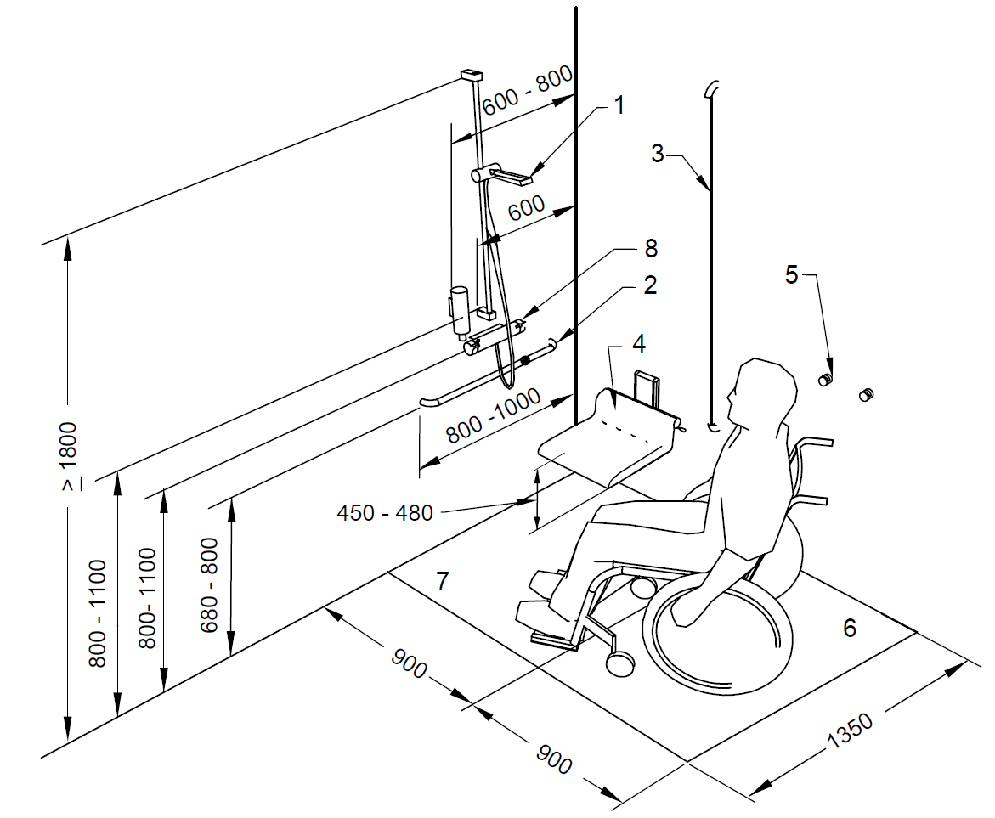
Key
1 Hand - held shower head
2 Horizontal grab bar
3 Vertical grab bar
4 Foldable shower seat
5 Towel hooks
6 Transfer area
7 Wet showering area with gradient 1:50 to 1:60
8 Shower controls
All dimensions in millimetres
Fig. 87 Example of a Shower Place with Grab Rails, Adjustable Shower Head and Folding Seat
14.16 Public Toilets
Public toilets shall also comply with the overall requirements under 14 with respect to the facilities provided therein so as to ensure that the same are accessible. In all public toilets, the following shall be provided:
- Male section shall have one urinal with support grab bars for ambulant disabled and at least one urinal for children at a lower height;
- Both male and female section shall have one WC for ambulant disabled;
- One Type A unisex accessible toilet room with independent entrance; and
- Depending on footfall, one Type B accessible toilet in both male and female toilet groups.
14.16 Contrast and Lighting
Fixtures and fittings in sanitary facilities should visually contrast with the items and surface on which they are positioned. Use of the same colour everywhere, for example white basins and white tiles, etc, shall be avoided and colour and tonal contrast should be used to differentiate elements in the environment.
Light switches should be fixed inside all accessible toilet cubicles, or the light should automatically switch on when someone enters the room. Timed light switches should not be installed or used.
The minimum illumination measured at 800 mm above floor level shall be 200 lux in the area of the washbasin.
14.17 Floor Surface
The floor surface shall be clean, firm, stable, level, slip-resistant and glare-resistant.
14.18 Signage
Signage shall be clearly visible incorporating the international symbol of accessibility and shall comply with the requirements given in 34. Signage for unisex accessible toilet, toilet for ambulant disabled, unisex change rooms or fitting rooms, unisex shower rooms shall be as shown in Fig. 88. Signage for Type B accessible toilet shall also indicate available transfer option, that is, right hand or left hand as shown in Fig. 89.
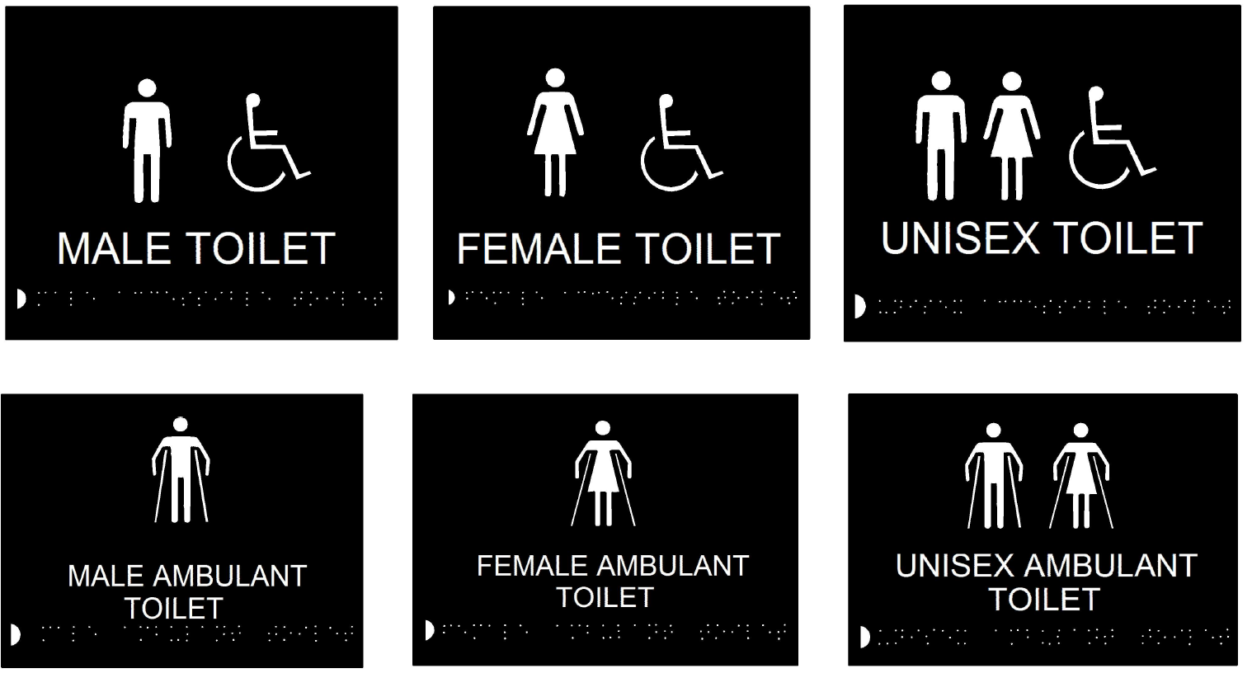
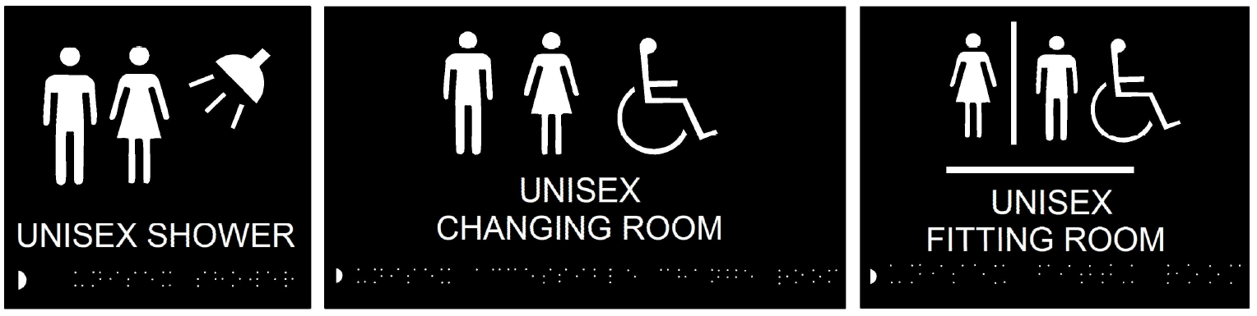
Fig. 88 Signage for Different Sanitary Facilities
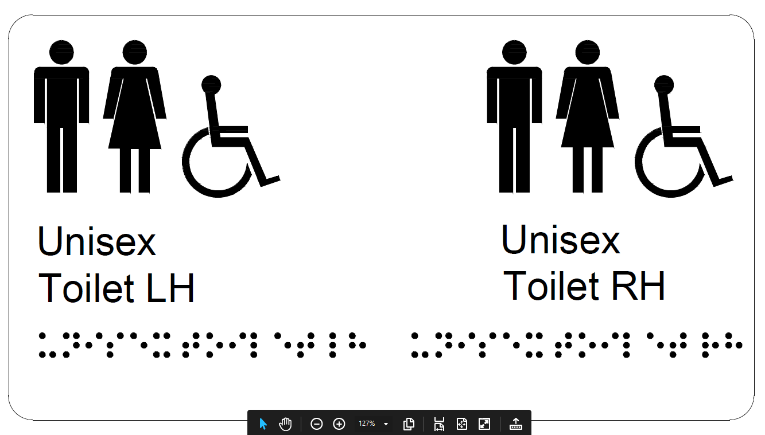
Fig. 89 Signage Indicating Transfer Options (Right Hand or Left Hand) in Unisex Accessible Toilet
15 RECEPTION AREAS, COUNTERS, DESKS AND TICKET OFFICE
15.1 Hearing and Lip-Reading
Reception areas, counters, ticket offices, especially in noisy environments or those equipped with a separating security screen, should have at least one position fitted with a hearing enhancement system (for example induction loop system) to assist hearing-aid users, as described in 31, and be clearly marked with the appropriate signage/symbol.
Positioning of service counters in front of windows where bright sunshine may come should be avoided as it causes the user's face to be in shadow and hence difficult to lip-read. Service counters equipped with a service screen are particularly difficult. Reflections and glare should be avoided.
15.2 Location
Counters and reception desks should be located and clearly identified so that they are easily recognizable from a building entrance. Information reception areas should be positioned near the main entrance. Entrance flooring systems or tactile ground surface indicators can help in locating reception counters for people who have vision impairment. Such products should be designed to minimize trip and slip hazards.
General design requirements for colour and visual contrast should be considered (see 34.3).
15.3 Space to Manoeuvre
Counters, desks and ticket offices should be accessible to wheelchair users on both sides. A clear manoeuvring space at least 1 500 mm x 1 500 mm shall be provided in front of the counter on the receptionist's side and on the visitor's side; 1 800 mm x 1 800 mm is preferred.
15.4 Height
Reception desks where writing is done by the visitor (for example at hotel receptions) should allow frontal approach by wheelchair users with space to provide clearance for wheelchair user's knees. The counter level shall be between 750 mm and 800 mm from the floor. Clear knee space underneath shall be minimum 700 mm (see also Fig. 90). At least a part of the desk should also be at a height suitable as a writing place for standing people, between 950 mm and 1 100 mm (see Fig. 90).
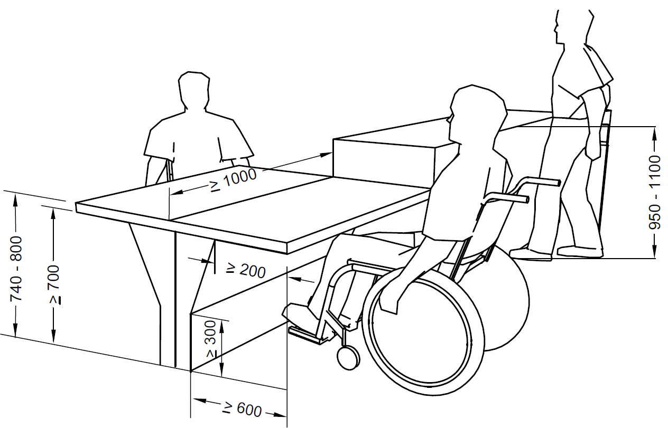
All dimensions in millimetres
Fig. 90 Heights of Counters Suitable for Wheelchair Users and Standing People
15.5 Lighting
To facilitate lip reading, lighting should provide even illumination and shall not cause glare. The reading and writing surfaces at counters, desks and ticket offices shall be illuminated to a level of at least 200 lux in the room, and on the desk in a range of 350 lux to 450 lux without causing any glare. For minimum requirements and recommendations for working in indoor environments, IS 3646 (Part 1) shall be referred.
15.6 Ticket Systems
If a queue number ticket system is used, it shall be suitably designed to be accessible. All control devices shall be located according to 12. All necessary information shall be given in simple wording with sufficient visual contrast and based on the two-sense-principle (see 12, 31, 34.1.2, and 34.3). The ticket machine and the calling system shall provide visual and audible output.
16 CLOAKROOM
Attended cloakrooms are staffed rooms where bags/luggage/other articles can be stored securely. Typically, a ticket or receipt is given to the customer, with a corresponding ticket attached to the garment or item. A cloakroom shall comply with the requirements given for reception/counters (see 15).
17 AUDITORIUMS, CONCERT HALLS, SPORTS ARENAS AND SIMILAR SEATING
17.1 Hearing Enhancement Systems
A hearing enhancement system should be provided. The system should also be provided on the stage/platform (see 31).
17.2 Lighting for Sign Language Interpretation
Adequate provision should be made to facilitate sign language and lip reading. Lighting on the faces and hands of presenters and people signing should be provided at an angle of 45° to 50° from horizontal at ceiling level for people with a hearing impairment to be able to read the presenter's lips and the signer's lips and hands. A suitable contrasting backdrop should be provided, to assist in reading the presenter's lips and hands.
17.3 Designated Seating Areas for Wheelchair Users
At least 1 percent of seats shall be designated as seating areas (see 13 for requirements of seating spaces) for wheelchairs users, with a minimum of two.
For total seats exceeding 51, it is recommended to provide the designated seating areas in the following manner:
- Total seats 51 to 100, minimum three designated seating areas for wheelchair users;
- Total seats 101 to 200, minimum four designated seating areas for wheelchair users; and
- One additional seating area should be provided for every two hundred additional seats or part thereof.
These spaces should be integrated among other seats and allow two wheelchair users to stay together. It is recommended that the armrest on the seats at the end of the row lift up to allow people to transfer from the wheelchair onto a seat. To accommodate groups of wheelchair users, in an auditorium with fixed seats, a minimum of 15 seats shall be foldable or removable to increase the number of designated areas for wheelchair users when necessary.
Some seats should be wider in order to allow larger size people to sit properly.
17.4 Access to Stage and Backstage
Access to the stage and to the backstage area shall be provided. Adequate provision should be made to direct the user to the designated spaces.
17.5 Row and Seat Numbers
The row and seat numbers should be legible to people who have impaired vision. They should be tactile, of adequate size and have enough visual contrast to the background on which they are mounted. The requirements given in 34 should also be considered.
17.6 Accessible Changing Rooms
The minimum number of accessible changing rooms should be provided depending on the type and use of the building and shall have a minimum area of 4 m².
In the event that changing rooms are provided alongside a toilet area, these should comply with the specifications given in 14.15.
A fixed bench should be set at a height of 450 mm to 480 mm above floor level. The bench should be no less than 500 mm wide, 2 000 mm in length, and be provided with a grab bar at a height of 700 mm to 800 mm with a clearance of between 50 mm and 65 mm from the wall.
A clear space of 1 500 mm x 1 500 mm shall be beside the bench.
Coat hooks should be set at different heights, 900 mm to 1 100 mm, and additionally at least one hook at 1 400 mm.
Coat hooks, benches, locker handles, and other furnishings should offer good colour and tonal contrast to their backgrounds. Non-slip floor surfaces should be used, and good lighting as well as matte finished surfaces and furnishings should be provided.
An alarm/call bell/switch may be provided (see 14.13).
18 CONFERENCE ROOMS AND MEETING ROOMS
The requirements for sufficient acoustic provision shall be provided in conference rooms and meeting rooms. Accessible toilet facilities, as per 14 should be as near as possible to such rooms. A sound augmentation system should be provided. Reverberation time for speech, music, etc, should be as per Part 8 ‘Building Services’, Section 4 ‘Acoustics, Sound Insulation and Noise Control’ of the National Building Code of India 2016.
All equipment in conference rooms shall be usable by people chairing or participating in the meeting and shall be at a height between 800 mm and 1 000 mm. See also 12 for requirements of controls and operating devices.
19 VIEWING SPACES IN ASSEMBLY AREAS
19.1 Floor Area
The floor area for a wheelchair viewing space shall be connected to an accessible path of travel and shall meet the following requirements (see Fig. 91):
- It shall be at least 900 mm x 1 400 mm;
- The depth of the row shall be minimum 2 400 mm;
- It shall have clear and level surface;
- It shall have sufficient manoeuvring space;
- Spaces for several wheelchair users shall be provided. They shall be located beside regular seating rows, for the wheelchair user to be able to stay by his/her accompanying person, if relevant; and
- It is recommended that the armrest on the seats at the end of the row (aisle seats) lift up to allow wheelchair users to transfer from the wheelchair onto a seat.
Some seats should be provided with foldable armrests, considering transferences (see 17.3); some other seats should be wider, considering larger size people.
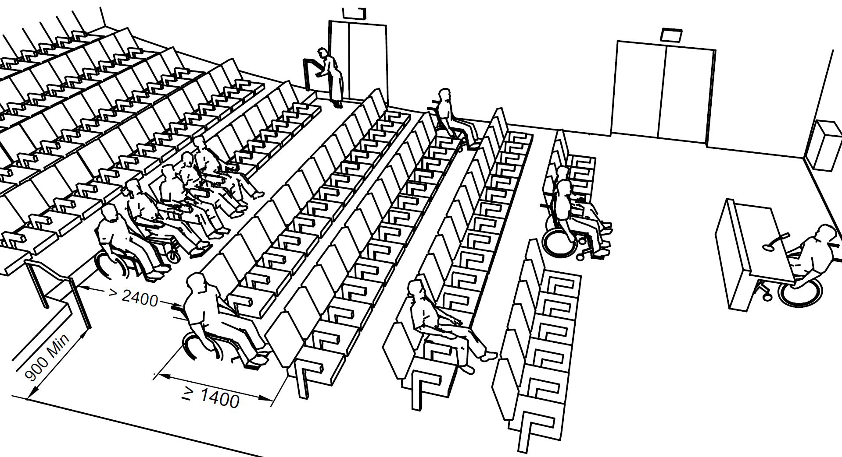
All dimensions in millimetres
Fig. 91 Examples of Viewing Spaces for Wheelchair Users
19.2 Sight Lines
Wheelchair user viewing spaces shall provide viewing spaces that are
- comparable to those for all viewing positions with a minimum unobstructed eye level up to 1 200 mm; and
- not reduced or obstructed by standing members of the audience.
Row and seat number identification signs shall be legible to persons who are visually impaired (see 34).
20 BARS, PUBS, RESTAURANTS, ETC
In restaurants a minimum of 25 percent of the tables shall be usable by wheelchair users according to 13.3. In bars, a minimum of 25 percent of bar counters shall not be more than 800 mm height, and shall have an unobstructed lateral access for wheelchair users.
Sufficient manoeuvring space between tables and the route to the accessible toilet facilities shall be provided. The general design requirements for colour and visual contrast should also be considered, as described in 34.3.
In self service restaurants, tray slides and counters shall be mounted at 800 mm from the floor for wheelchair users. Food shelves shall be mounted at a maximum height of 1 200 mm and aisle space of minimum 900 mm shall be provided. Where stools and high tables are provided, low tables suitable for wheelchair users shall be provided. Cantilevered table or tables with straight legs at each corner are preferable to central pedestals that might restrict wheelchair access.
21 TERRACES, VERANDAS AND BALCONIES
Terraces, Verandas and balconies shall be accessible to all people, including people with mobility impairments.
Parts of these facilities should be covered with a canopy, to give shelter against the weather (sun/rain/snow).
Walking surfaces shall be slip resistant.
22 ACCESSIBLE BEDROOMS IN NON-DOMESTIC BUILDINGS
The access to accessible bedrooms in non-domestic buildings (that is hotels, guesthouses, etc) shall comply with the requirements outlined in this standard and in particular with 9 and 10. The minimum number of accessible bedrooms in non-domestic buildings shall be in accordance with Table 2.
Rooms accessible for wheelchair users shall be designed for two beds. If a single bedroom accessible for wheelchair users is provided, a queen size bed is preferred, 1 500 mm width x 2 000 mm length.
Free space on at least one of the long sides of the bed shall be provided. This space should be 1 500 mm, and shall not be less than 1 200 mm. At the foot of the bed, at least 1 200 mm is required (see Fig.92 and Fig. 93).
Sufficient clear manoeuvring space is needed to gain access to facilities, including the shower.
There should be a bench for luggage at a height between 450 mm and 650 mm.
The minimum height of a bed shall be between 450 mm and 500 mm, when it is compressed under a 90 kg weight.
For communication for people with hearing, vision and cognitive limitations, see 31.
Visual and audible alarm systems shall be accessible to warn people with visual and hearing impairments.
Figures 86 and 87 shall be considered for accessible shower with an accessible toilet.
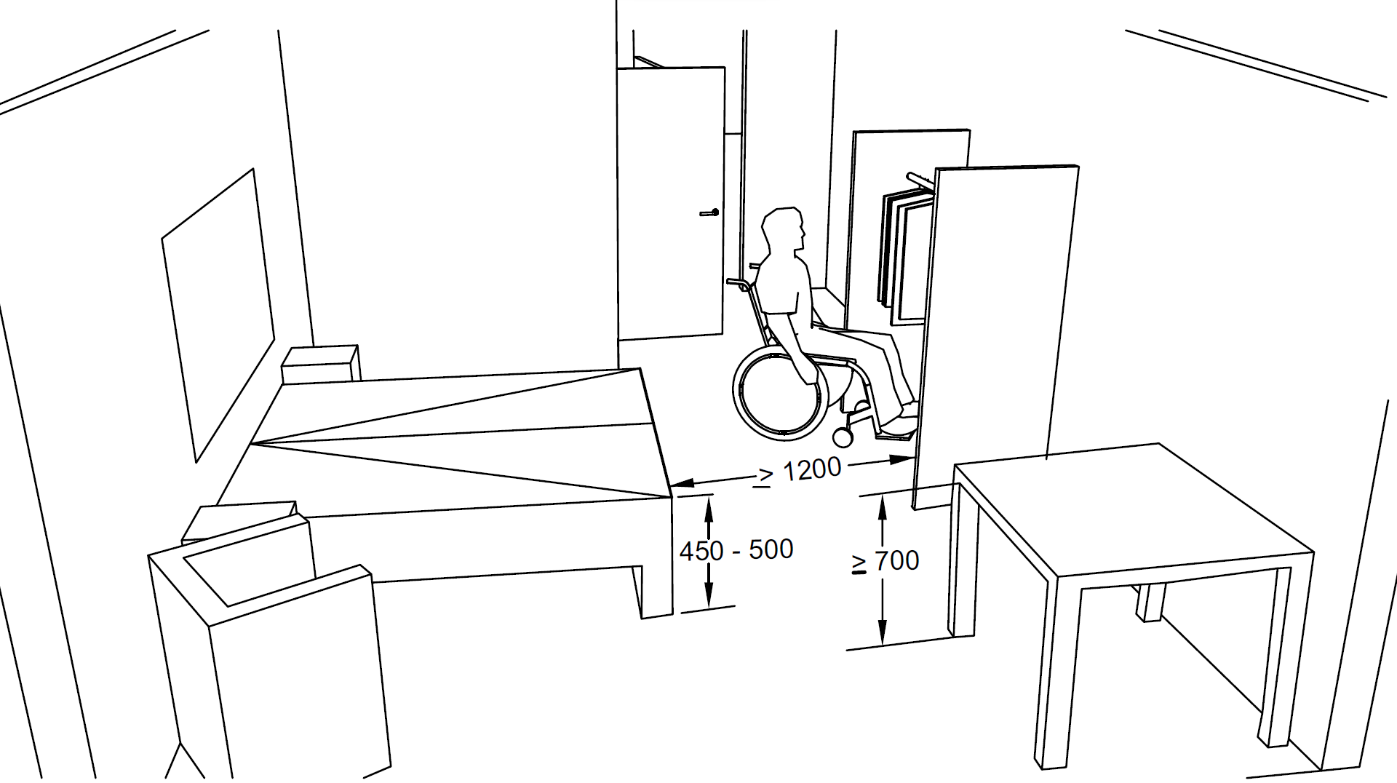
All dimensions in millimetres
Fig. 92 Example of Space Allowances for Accessible Bedroom
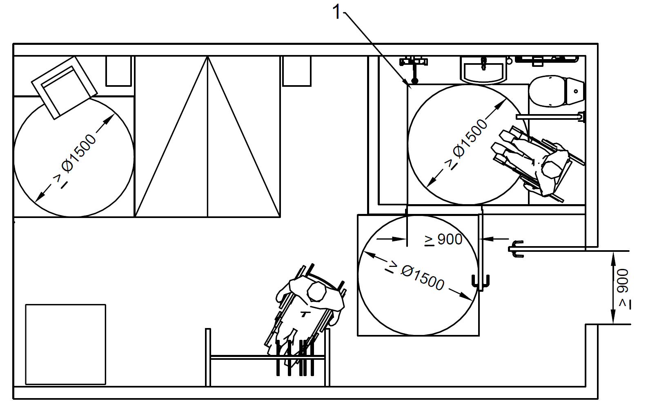
Key
- Shower area
Fig. 93 Example of Space Allowances for Accessible Bedroom and Toilet/Sanitary Room
23 KITCHEN AREAS
Kitchen areas shall take into account general design considerations in respect of manoeuvring space, slip resistant walking surface and accessible height of controls and devices. Wheelchair turning radius of at least 1 500 mm should be provided between the counter and the opposite walls. Floor surface should allow for easy wheelchair manoeuvrability. Essential kitchen appliances (oven, refrigerator, etc) should be usable by persons both standing and sitting in a wheelchair, and a worktop should be located beside all appliances.
The sink taps should be reachable and easy to operate with one hand. The sink should be reachable for a wheelchair user. If a knee recess is provided under a sink, its underside should be insulated. Counter tops should be between 750 mm and 800 mm in height and provide for clear knee space for a wheelchair user. The clear knee space for a wheelchair user is at least 900 mm wide, 480 mm deep and 680 to 700 mm high (see Fig. 94 and Fig. 95). Counter tops/slabs should have rounded edge. All surfaces should be smooth to facilitate sliding of heavy items from one area to another. Slide-out working spaces are useful in providing an over-the lap working surface. For people with ambulatory disabilities, stools (preferably with back and foot rests) should be provided strategically at the main work area.
A section of the shelves should be within reaching distance for a wheelchair user, between 300 mm and 1 100 mm above floor surface.
All controls and operating mechanisms should comply with 12.
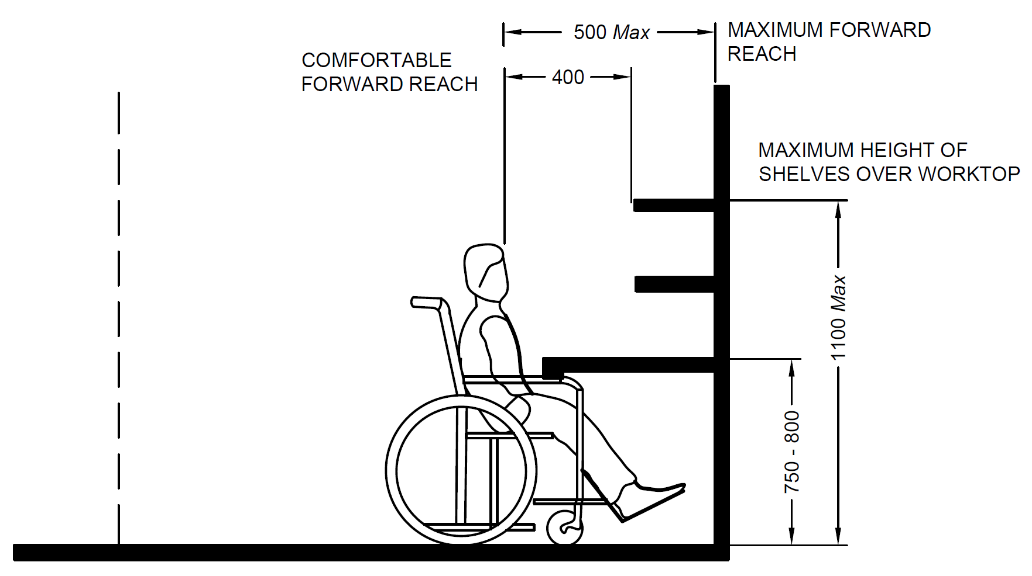
CLEARANCE TO ALLOW PASSAGE OF WHEELCHAIR ARMS UNDER WORKTOP
All dimensions in millimetres
Fig. 94 Requirements for Work Top
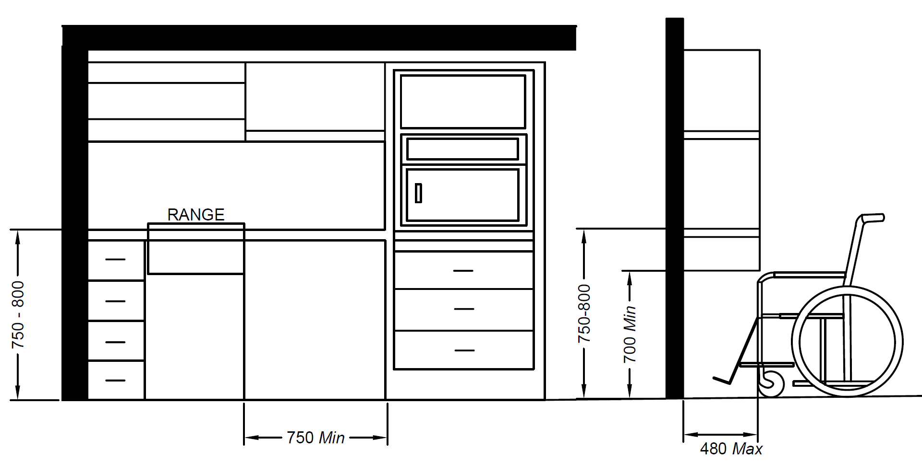
All dimensions in millimetres
Fig. 95 Kitchen Shelves and Cabinets
24 STORAGE AREAS
The minimum manoeuvring space and reachability for wheelchair users should be taken into consideration when designing and constructing a storage area. Part of the shelves should be within reaching distance for a wheelchair user, between 300 mm and 1 100 mm above the floor. If a door is provided, it should open outwards.
25 ACCESSIBLE HOUSING
25.1 Exterior, Entrance and Access within the Building
The site planning and development, approach to the building and access at entrance and within the building shall be in accordance with 7, 9 and 10.
25.2 Interior
25.2.1 Furniture Arrangement
Sufficient manoeuvring space should be made available (at least 1 500 mm turning radius) for wheelchair user or person ambulating with an assistive device such as a walking frame or a white cane. Clear passage should be allowed from one room to the other. Unrestricted access should be provided to electrical outlets, telephones and wall switches. All controls and operating mechanisms shall comply with 13 and a clear floor space for the wheelchair, of at least 900 mm × 1 200 mm should be provided in front of all the utilities and furniture.
25.2.2 Floor Surface
Floor surface shall comply with 10.2.7.
25.2.3 Doors and Windows
Doors and windows shall comply with 10.3 and 10.4, respectively.
25.2.4 Vertical circulation within the house shall be in accordance with 11.
25.3 Bedroom
The bedroom should be planned to provide a 1 500 mm turning in space for wheelchair, at least near all the doors. There should be a clear floor space of at least 900 mm ×1 200 mm in front of all furniture. The bedroom furniture should not have any sharp edges.
The minimum height of a bed shall be between 450 mm and 500 mm, when it is compressed under a 90 kg weight. Stability may be improved by placing the bed against a wall or in corner of the room (except for when the wheelchair user plans to make the bed. The bed should be so positioned so as to provide free space on at least one of the long sides of the bed. This space should be 1 500 mm, and shall not be less than 1 200 mm. At the foot of the bed, at least 1 200 mm is required (see Fig. 96).
A bedside table or cabinet between 450 mm and 900 mm from the floor may be useful to hold a lamp, telephone, necessary medications and a call bell if assistance is needed.
Wall hook installed at a height of 1 100 mm to 1 300 mm may be a useful addition to the closet area.
The closet should have a clear floor space of at least 900 mm × 1 200 mm. It should have the clothes bar at a height of 1 200 mm from the floor. The shelves should be installed at various levels between 300 mm and 1 100 mm from the floor surface (see Fig. 97). The door handle should be conforming to 12.
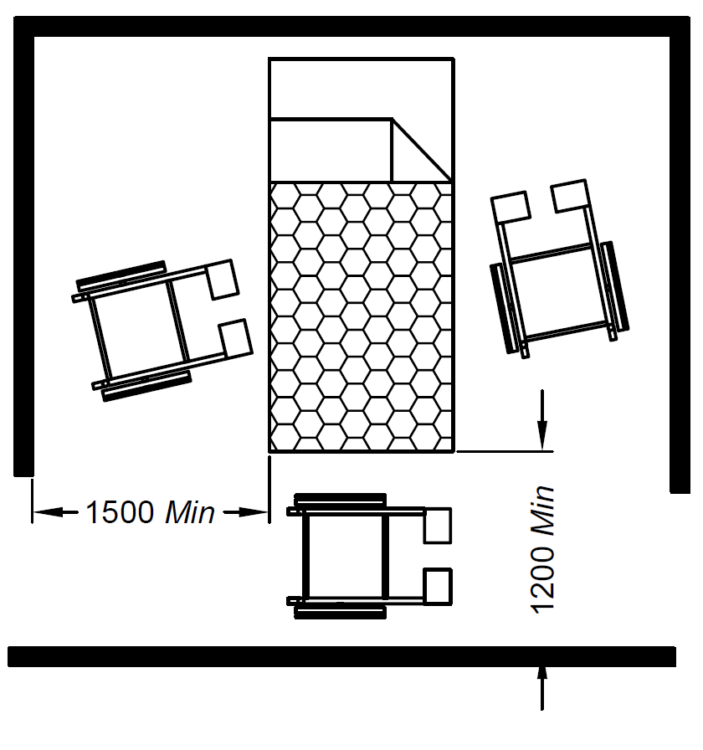
All dimensions in millimetres
Fig. 96 Space around Bed
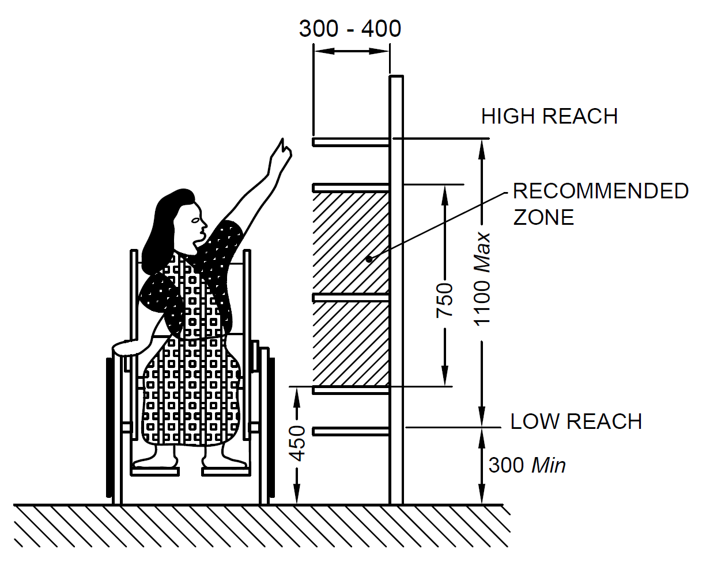
All dimensions in millimetres
Fig. 97 Storage Space
25.4 Living Room
At least 1 500 mm turning in space for wheelchair should be provided near all entry points to the living room. A living-dining combination is preferable to a kitchen-dining combination (except when the wheelchair user does the cooking).
The seating space for a wheelchair user at the dining table should provide a clear knee space. The clear knee space for a wheelchair user is at least 900 mm wide, 480 mm deep and 680 to 700 mm high.
Floor surface should comply with 10.2.7.
There should be a clear floor space for the wheelchair of at least 900 mm × 1200 mm in front of all the fixtures. Chair seat heights should not be less than 500 mm.
Controls and operating mechanisms should comply with 12.

25.5 Toilet or Sanitary Room
Toilet or sanitary room shall comply with 14.
25.6 Kitchen
Kitchen shall comply with 23.
26 NEIGHBOURHOOD PLAY SPACES AND COMMUNITY FACILITIES
Any form of housing community or neighbourhood facilities need to ensure inclusive play and recreational spaces integrating children, elderly and social groups.
Play spaces shall be customized with play furniture, sensory landscapes and access routes to facilitate walking activities, social inclusion and community participation.
Community facilities like clubs, etc. shall also be guided by universal design approach to ensure access through entrance, accessible washrooms and circulation spaces. Any residential society may have persons with disabilities, individuals with high support needs or shall have people going through life stages such as ageing, motherhood, neurodiverse situations, etc. at any given time, which could impact their functional abilities in the short or long run. It is therefore recommended to ensure a sensitive approach while planning and design of residential neighbourhoods keeping in view diverse stakeholders.
27 EDUCATION AND RESEARCH BUILDINGS
All educational institutions shall make universally accessible provisions in their infrastructure and services to render a holistic approach to education. This includes to ensure universal accessibility as an approach in master planning, site planning and built infrastructure detailing both at exterior and interior levels. Specific aspects for accessibility include mobility access to schools or institutions, entrances, circulation spaces (horizontal and vertical), learning spaces like classrooms, lecture theatres, laboratories, multi activity spaces like sports arenas, assembly areas and all others are necessary for access to education in an inclusive manner. Educational environments and typologies include a wide array of knowledge imparting and sharing institutions at all levels like schools (ranging from Primary, Secondary to High Schools), special schools, coaching institutions, higher educational Institutions like colleges, skill development institutions, universities, research organisations and institutions, public institutions of specialised training like defence academies and other multiple sectors. Access to education depends on various aspect ranging from information accessibility, movement to the physical infrastructure and support systems which facilitates accessible learning at various levels and various contexts. Mobility infrastructures shall provide universal accessible features to ensure access to education for all. Accessibility standards for support systems shall ensure that children with disabilities and diverse functional abilities can reach the educational infrastructure. Accessibility in the educational environment shall follow an integrated approach as specified in these guidelines. Institutions shall integrate the built and unbuilt spaces, ensuring the presence of accessible features. Mostly, open spaces are left inaccessible. Built and unbuilt spaces in institutions shall integrate universal accessibility into their character. This implies wider access routes, levels to be made accessible with ramps, provision of shaded seating spaces. The following key recommendations are made towards realizing a universally accessible education environment and infrastructure.
27.1 Master Planning and Site Planning
Universal accessibility must be ensured through master planning, zoning and site planning of educational campuses with a human centric approach. This includes planning for a walkable environment, ensuring seamless access for wheelchairs, baby strollers and other wheeling situations through level crossings, kerb ramps, etc.
Use of sensory landscapes, tactile guiding routes in walkways, multi format signage and other features connecting one zone to another are highly important to retain the inclusive character of an educational environment.
The planning of academic, administrative or multi functional buildings shall adhere to accessibility standards, in particular, the external and internal elements.
27.2 Mobility and Circulation
- Walkability and seamless mobility across the educational spaces shall be ensured through site planning and in building blocks through horizontal and vertical circulation system designs.
- Level crossings, well designed kerbs, guiding systems along with support hand rails, tactile guiding systems and street furniture like resting spaces shall form an integral part of external mobility networks in educational campuses of all scales.
- Sensory landscapes shall be wisely used to provide sensory cues to enhance mobility experience for all, especially for persons with visual impairments.
- Mobility infrastructures shall be complemented by a culture of adopting accessible vehicles such as adaptive motorised and non motorized vehicles.
- Walking routes shall be at least 1 200 mm wide with non slip flooring material and good ambient lighting to maximise contrast between level surfaces. Persons with disabilities, with neurodiverse conditions, the elderly and many others should be able to independently move from one point to the other.
27.3 Formal and Informal Learning Spaces
Learning spaces comprise of enclosed spaces like classrooms, lecture theatres, tutorial rooms, etc. along with semi enclosed ones with landscapes, etc. for independent or collective group learning activities and informal interactions, etc.
Universally accessible learning spaces shall require the presence of accessible entrances and doorways, adaptive seating systems accommodating diverse student needs including those using wheelchairs, height adjustable black / white boards, projection systems and accessible learning technologies and support services.
Stepped lecture halls shall have ramped aisles with a minimum width of 900 mm to making them accessible to persons with non ambulant disabilities. Actual aisle widths shall however be determined based on the capacity and size of the lecture theatre.
Learning spaces shall be guided by universal design features including the principle of flexibility in planning and use to accommodate future technologies in the same space. Transforming some of the existing learning infrastructure into Hybrid Learning spaces shall make them further inclusive. Acoustic treatment and design of classrooms is highly important to include learners with hearing impairments as part of academic activities. Sign language interpretation along with close captioning or subtitles through technological interface shall be further required to address the learning accessibility needs for persons with hearing impairments.
Informal learning spaces like courtyards, corridor edges, landscape spaces etc. require accessibility features like step free spaces, seating with supports and knee clearances, free from physical, sensorial or any other form of barriers, if any.
It shall be ensured that classrooms or informal learning environments be seamlessly accessible at all levels. Therefore, educational campuses shall have well designed ramps as part of circulation spaces as well as interactive zones empowering inclusive mobility culture.
27.4 Laboratory Spaces
Laboratories are the prime spaces for engaging practical learning in controlled environments along with knowledge development through research. Accessibility features in laboratories can make the entire educational experience inclusive while inaccessible laboratories may lead to a form of exclusion.
- Universally accessible laboratories imply access to reach the laboratory, wider doorways to facilitate movement for all, internal layout facilitating wheelchair manoeuvring spaces including adaptive and flexible furniture for safe usage and ergonomic convenience.
- Legibility in laboratory environments with clear surface distinction and colour systems shall be required to ensure visual accessibility especially for persons with low vision and preventing any misinformation leading to any vulnerable situation or accident.
- Emergency or safety signs shall be visible in high contrast and tactile guiding systems for accessible circulation and safety.
- Laboratories with wet systems involving water, chemicals or fluids shall have safety protocols to ensure complete avoidance of accidents and prevention of slips or falls with due to wet floors.
- Laboratory spaces with technical equipment shall have access around the machines and anthropometric adaptability to functionally use the equipment for the same.
27.5 Library and Reading Spaces
The aisle width shall be minimum 900 mm wide to allow a wheelchair user to access the bookshelves. The height of shelves should be restricted to 1 200 mm which allows everyone to have easy access to the books. Exclusive reading rooms with enhanced audio features or cubicles with audio book integration shall be provided. E-books in audio format shall be made available in the library. RFID tagging system should be introduced for ease of identification and location of books. There shall be provision of digital catalogue which provides information on all books that can be easily accessed in the library. The reading spaces shall have flexible furniture layout which allows ambulant or non ambulant users with diverse assistive technologies to choose a place as per their convenience. Chairs with adjustable heights should be available to cater to a wide range of user groups. Libraries should use integrated online services and should have repositories of accessible literature in diverse fields of education. Facilities like braille printing may be sourced for readers with special needs of tactile format of reading.
27.6 Multi Activity and Recreational Spaces
All administrative and common areas like waiting rooms, lift lobby etc. shall be accessible to persons with disabilities. Arrangements for wheelchair users by means of ramps/ lift shall be made for stepped lecture halls or auditoriums. At least one accessible unisex washroom shall be provided on each floor including student dormitories and residential accommodations. Washrooms shall have children friendly sanitation fixtures and accessories. All recreational facilities like playgrounds, gymnasiums and sports complex, landscape areas etc. shall be accessible and usable by Persons with Disabilities. Institutions for physical education, police or military training and other activities requiring full physical abilities shall also be made accessible for administrative staff members, employees, and visitors with disabilities. Public Address (PA) system shall be there in case of emergencies like fire /natural disaster etc. to assist evacuation and shall be supported through uninterrupted power supply.
27.7 Playgrounds and related areas
Playgrounds that offer a variety of different types of play options (visual, auditory and tactile) should be provided. A playground is considered accessible when it fulfils the following conditions:
- It meets the basic requirements relating to accessibility of fixed accessible urban furniture.
- Playground surfaces shall consist of rubber or compacted sand.
- Surface of the children play area shall be smooth & firm and free from any sharp objects, projections etc., in order to avoid injury to the children.
- All children, regardless their functional limitations, and according to the age group for which the playground is intended, shall enjoy and use, at least, 50% of individual and group related activities.
- All materials exposed to sun radiation shall not reach temperatures that may hurt the users.
- Materials used to design children’s games, especially the sliding ones, shall not contain plastics or metals that produce electrostatic discharges that may deprogram hearing aids.
28 RESIDENTIAL SPACES
Residential amenities in educational environments include student hostel or housing, faculty or staff housing along with guest houses for visiting guests. The requirements for accessibility in accessible housing shall be given as per 25.
29 EMERGENCY SUPPORT SYSTEMS
Educational environments need to provide due care and access to emergency support systems also ensuring rehabilitation support to persons with disabilities during their stay in that environment.
30 TRANSPORTATION AND SUPPORTING INFRASTRUCTURE SERVICES
Mobility is critical for all systems of built infrastructure and to support access to major activities of daily living for diverse population groups. Universally accessible transportation and its infrastructure play a key role towards urban inclusivity by supporting accessible mobility. The transportation systems enable individuals with the ability to move within community environments that expand from one’s home, to the neighbourhood, and to regions beyond. Mobility is a fundamental requirement for all individuals which connect them with learning environments, business facilities and social aspects of life. All these are important to lead a life of respect and dignity and to promote the well-being of everyone. Various modes of transportation like surface transportation, railways, airports, waterways, etc. require specific guidelines and standards to ensure accessibility and an integrated multi modal transit systems. It is therefore recommended to develop specific guidelines for each of these sections. The system mainly comprises of surface, rail, air, and water transports. The existing transportation model consists of pedestrian infrastructure like streets, traffic refuge areas and crossings traffic signals, foot over bridges, underpasses, non-motorized vehicles like rickshaws (NMT), mass rapid transit system (MRTS) like metro, bus rapid transport system (BRTS), taxi services and personal/shared bicycles etc. To provide a seamless mobility experience to all (including persons with disabilities, elderly, children and gender friendly), the built infrastructure should be planned and designed to remove physical and environmental barriers.
30.1 Land/ Surface Transport
All travel routes to bus stops shall also be barrier-free to ensure that persons can travel from their homes to their chosen pick-up point. Training should be provided for drivers to help them become aware of the needs of Persons with Disabilities.
30.1.1 Bus Stops / Shelters – Bus stops are the boarding places for passengers for buses. Following are the design requirements:
- At least one accessible route shall be provided from the alighting and boarding point of the bus stand to the walkway that leads to the accessible building entrance.
- Directional signs shall be installed to direct Persons with Disabilities to an accessible entrance (see Fig 98).
- TGSIs blocks shall be provided along the accessible walkway from the bus stand to the building entrance to aid persons with visual impairments.
- The bus stand shall have minimum illumination level of 50 lux.
- Bus stand should be located nearest to an accessible entrance.
- Where transfer must be made from a vehicular surface to a pedestrian surface, the driveway, pathway, or walkway should be blended to a common level or be ramped.
- A clear passageway with a minimum width of 1 200 mm shall be provided.
- Seats shall be provided at the bus stand for people with ambulatory disabilities. These seats shall be positioned such as not to impede the movement of wheelchair users.
- A shelter shall be provided at the bus stand for protection against adverse weather conditions.
- If a bus stand is not at the same level as the walkway or pathway, it shall have two separate ramps for boarding and alighting.
- Where there are curbs between the access aisle and the vehicle pick-up space, it shall have a kerb ramp. The minimum lighting shall not be less that 80-100 Lux.
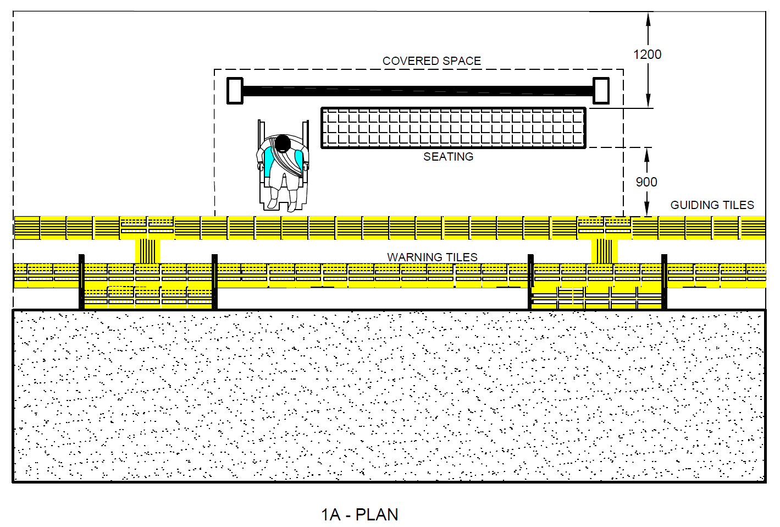
98 A - Plan
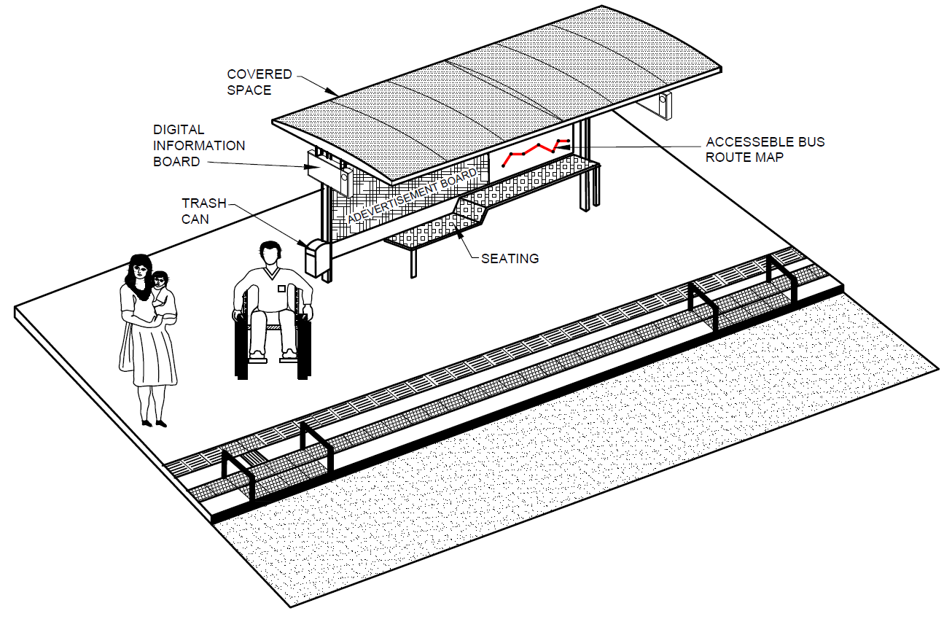
98 B – 3D View
Fig. 98 Example of Accessible Bus Stops/ Shelters

30.1.2 Rail Transport
30.1.2.1 Whether over-ground or underground, rail travel is a highly effective mode of transport.
- Level Approach – Approach route shall not have level differences. If the station is not on the same level as the walkway or pathway, it shall have a ramp. Walkway surfaces shall be non-slip. Approach walkway shall have TGSIs for persons with visual impairments.
- Station Entrances and Exits – These shall have a minimum width of 1 800 mm and must be levelled or ramped.
- General Station Interiors – There shall be a tactile layout map of the station with Braille and audio labels placed at the entrance. Tactile map shall be marked by floor tactile guidance for persons with visual impairments to access it. The lobby/corridor width shall be at least 1 800 mm. The floor surfaces shall be non-slip and level.
- There shall be directional signs indicating all the facilities and the various platform numbers.
- The signage shall also be displayed in Braille/raised numbers to aid people with visual impairments.
- Guiding and warning blocks shall be installed on the corridors/concourse.
- Wherever there is a provision of stairs and ramps, they shall conform to 11.
- All the audio announcements shall be supplemented with visual information displays for people with hearing impairments.
- Seating areas shall be provided at regular intervals for people with ambulatory disabilities preferably every 30 m.
- For persons with hearing impairments, an electronic signboard (digital display) shall be displayed on each platform at conspicuous location for all announcements made by the railways.
- The washrooms shall be universally designed and shall conform to the design requirements listed in 14.
- Staff shall be trained in methods of assistance and available on request.
- Stations for rail travel shall be fully accessible with extra wide turnstile/ automatic fare collection (AFC) system where possible alongside wheelchair accessible doorways.
- Staff shall be available to assist Persons with Disabilities to enter or exit through convenient gates.
- Provisions of battery-operated vehicles shall be made for ferrying persons with disabilities and their baggage from station entrance to platform and vice a versa.
- All new railway stations shall be designed to be fully accessible, while those being retrofitted should comply with standards given herein.
30.1.2.2 Reservation and Information Counters
- Shall have clear floor space of at least 900 mm x 1200 mm in front of the counters.
- There shall be at least one low counter at a height of 750 mm to 800 mm from the floor with clear knee space of 750 mm high by 900 mm wide and 480 mm deep.
- At least one of the counters shall have an induction loop unit to aid people with hearing impairments.
- The counters should have pictographic maps indicating all the services offered at the counter and at least one of the counter staff shall be sign language literate.
30.1.2.3 Platforms
To make the platforms accessible, platforms shall:
- have a row of warning blocks installed 600 mm before the track edge;
- in case of railway stations, have tactile guiding blocks 1800 mm before the platform edge;
- have non-slip, non-flare and level flooring;
- have priority seating areas for people with vision and ambulatory disabilities;
- be well illuminated, minimum 100 lux;
- have no horizontal gap exceeding 12 mm between the coach and the platform; and
- be inter-connect by means of accessible routes (through accessible lifts or ramps).
30.1.2.4 Emergency Escape/ Evacuation from Rail Tracks
Where there is level difference between the station platform and the track areas in tunnels, bridges, viaducts; suitable non-slip ramps with handrails shall be provided at the ends of platforms towards the track areas. Ramps shall be provided on both sides of the track leading to platforms on either side of the track. Handrails leading to track areas shall be suitably earthed to avoid any shocks due to induced current from nearby charged high voltage traction power cables / conductors.
30.2 Air Transport
Air transport shall be accessible from the point of departure to the point of arrival at the destination. The core purpose is to enable and facilitate travel for passengers with diverse mobility needs and functional limitations both in airport infrastructure as well in the aircraft. Some of the accessibility requirements for airport infrastructure are given below.
30.2.1 Airport Infrastructure
- Self-check in counters shall be provided to reduce the waiting time in check in counters.
- Good wayfinding system shall be used from the entrance till the departure gates.
- Tactile map and braille map shall be installed at suitable locations for persons with vision impairments.
- The management shall have wheelchairs and rollators at the airport for different user groups.
- Golf buggies should be used to move around the airport for persons with reduced mobility and persons with disabilities to reach the correct gates conveniently.
- Personal assistance to persons with disabilities to help them through their journey within the airport and to help them reach their designated seat within the aircraft.
- Personal assistants shall be trained to help persons with disabilities and persons with reduced mobility (PRM) to navigate safely and comfortably within the airport facility.
- Elevators, escalators, travellators shall be installed to ease horizontal and vertical circulation around the airport.
- The flooring surfaces shall be non-slip and smooth for easy manoeuvrability of wheelchairs, luggage trolleys and carts.
- The washrooms shall be universally designed and shall conform with the design requirements mentioned in 14.
- There shall be family friendly facilities like family washrooms, lactation rooms for nursing mothers, diaper changing facility and child protection seats in both male and female washrooms.
- Illumination shall be uniform and glare free. The interior surfaces shall be matt finish and not glossy and shiny.
31 ACOUSTIC ENVIRONMENT
31.1 General
The acoustic environment in a building should be suitable for its intended function for all building users. This includes all hearing people especially the hard of hearing. For deaf and hard of hearing people, good lighting is essential to understand the sign language interpreter and/or optical information devices. Many people with some degree of hearing loss have assistive devices to amplify sound, such as hearing aids or cochlear implants.
However, if the acoustic environment is not supportive of these devices, they do not work effectively. In addition, many people who have a mild or temporary hearing loss and do not have assistive devices may not be able to access information or communicate effectively. Most people with hearing loss and people without hearing loss rely on sight to lip read or interpret facial expressions; therefore, where the acoustic environment is regarded as important, suitable lighting, colour and visual contrast should be considered to benefit all building users.
Information normally conveyed in visual form may not be accessible to people who are blind or partially sighted. This information should also be conveyed audibly; the clarity (speech transmission index) of this information is affected by the acoustic environment.
The following design considerations should be taken into account to maximize the functionality of the acoustic environment, and to support the use of assistive devices.
31.2 Acoustic Requirements
People with hearing impairments have particular difficulty in making out sounds and words in noisy environments. Adequate sound insulation should minimize noise from both outside and inside the building. Noise can often be mitigated, for example by introducing a buffer zone between a meeting area and extraneous noise or partitioning a restaurant. The acoustics in a room are essentially connected with its location in the building and with the acoustic insulation of the building elements. The distribution of noise within the room itself and from exterior sources depends on the sound absorption of the surrounding surfaces and furnishing of the room. The calculation of acoustic absorption is significant in rooms where acoustic quality is important and also where noise reduction is required.
Good acoustics shall be achieved by optimizing the reverberation time, by considering the use/purpose of the room and by ensuring a low background noise level. The optimum reverberation time of a room should be determined having regard to the volume and the intended purpose of the room.
The geometry and shape of the room, as well as the distribution of sound absorbing and reflecting surfaces, are important. Surfaces that absorb sound should be carefully selected, as well as surfaces that reflect it. To develop an effective acoustic environment, sound absorbent surfaces can be used on floors and ceilings.
The optimum reverberation times for communication, speech only or music performance are different and depend on the size and shape of the room. Requirements for reverberation time shall be as per Part 8 ‘Building Services’, Section 4 ‘Acoustics, Sound Insulation and Noise Control’ of the National Building Code of India 2016.
31.3 Hearing Enhancement Systems
A hearing enhancement system fitted at an information point can significantly assist communication for a person with a hearing impairment who uses a personal hearing aid or has a cochlear implant. Hearing aids or cochlear implants may have a Telecoil (T-switch) which allows the listener to receive the sound signal directly.
NOTE ― Hearing enhancement systems amplify audible communication and can be helpful to people who have a hearing impairment. They include a direct wire system, an inductive loop system, an infrared system, or a radio frequency system. All of these systems transmit a signal. Special purpose receivers are required for infrared and radio frequency systems, while hearing aids equipped with a T-switch are capable of receiving the signal from an induction loop system. Receivers can be equipped to be compatible with hearing aids.
Hearing enhancement systems, for example induction loops and infrared signal transmitting systems, shall be provided in conference and meeting areas. All seats, including the front scene, should be covered by hearing enhancement systems like induction loops (see Fig. 99). Portable hearing enhancement systems may be an alternative.
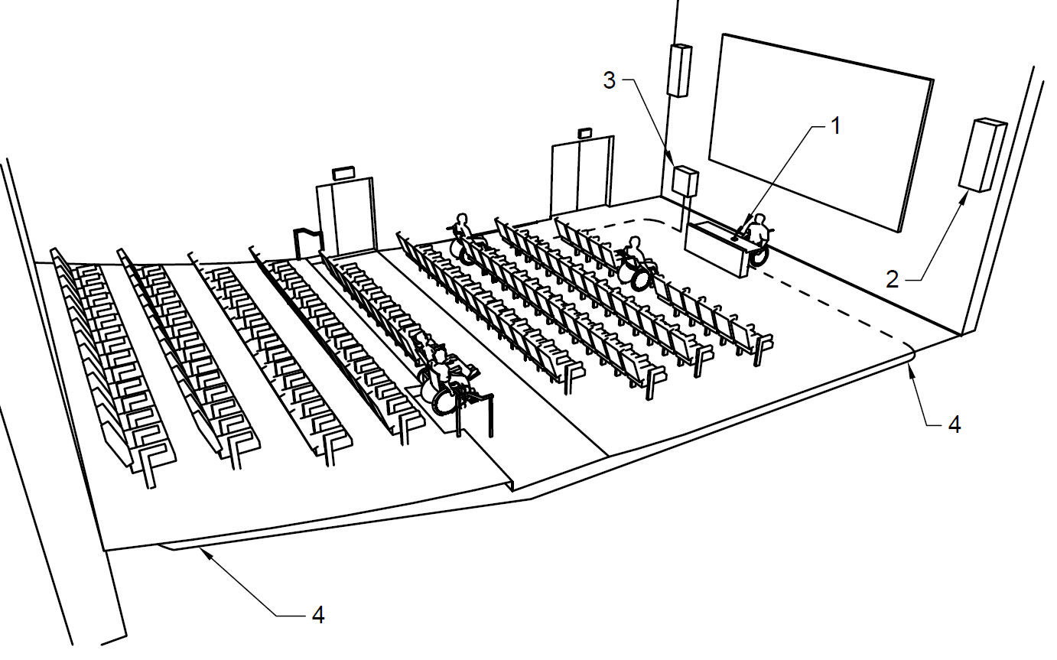
Key
- Microphones
- Loudspeakers
- Induction loop amplifier
- Induction loop
Fig. 99 Example of Induction Loop System in Conference Room
32 LIGHTING
32.1 General
The planning of artificial lighting should be co-ordinated with the planning of natural lighting, the choice of surfaces and colours. Lighting can be used to accentuate interior colour, tone and texture schemes, and to facilitate orientation. The lighting should not lead to glare or excessive contrast.
32.2 External Lighting
The routes to and around a building shall have sufficient artificial lighting to facilitate awareness of changes of level or gradient. The positioning of lights should not cause glare, reflection or shadows. Ramps, entrances, steps, signage, etc, to the building should be well lit artificially, with an illuminance of at least 100 lux.
32.3 Natural Lighting
It should be possible to shade windows from bright light.
32.4 Artificial Lighting
Lighting should provide visual conditions consistent with the visual task, orientation and safety. Key factors are,
- level of illumination of horizontal and vertical surfaces;
- limitation of glare from a light source or reflections;
- uniformity and luminance distribution;
- direction of lighting and shading; and
- colour rendering.
NOTE ― Good artificial lighting where needed is crucial for everyone, ensuring that vision impaired people are able to use buildings safely and conveniently, and that people with hearing impairments are able to lip read.
32.5 Lighting to Facilitate Way finding
Lighting should facilitate way finding. Building elements should be marked by increased illumination. The lighting in critical locations such as entrances, corridors, stairs, changes of level and workstations should facilitate their identification.
Time dependent switch devices shall have a progressive switch off to reach the next switch. An automatic switch on detection system shall cover the complete surface of ramps and stairs. Lighting shall provide sufficient time necessary for users to travel safely along ramps.
Lighting which switches off when people are still on ramps or stairs should be avoided.
NOTE ― Ramps and stairs are the most hazardous places for falls.
32.6 Controllable and Adjustable Lighting
All lighting, including natural light, should be controllable to avoid glare. Artificial lighting may be adjustable to suit individual needs.
32.7 Light Levels in Different Areas
Good light levels should be provided in hazardous areas such as stairs or changes in levels along a route, around doors and at communication or information systems. A minimum light level should be provided according to the visual task as given in different clauses of this standard. For minimum requirements and recommendations for working in indoor environments, IS 3646 (Part 1) shall be referred.
32.8 Lighting in Auditoriums
Lighting conditions that support lip reading and sign language should be provided. The environment should be designed to avoid reflection and glare, and it should be possible to adjust both natural and artificial light.
32.9 Glare and Shadows
Lighting should not produce glare. Glare and shadows may be avoided by,
- shielding or shading light sources;
- use of indirect lighting;
- appropriate location of light source in relation to the direction of vision and to the object that is to be observed;
- up lighters, with light sources at floor or low level, should not be used;
- avoidance of windows at the end of corridors;
- avoidance of light sources against dark surfaces by choosing light colours for ceilings or walls; and
- avoidance of abrupt transitions from light to dark spaces. Indoor and outdoor lighting around the doorway should be suitably adjusted to prevent dazzle when entering or leaving the building.
NOTE ― Due to the increase of optical scatter in the eye, the effects of glare are exacerbated for elderly people and for individuals with some types of vision impairments (for example cataracts, corneal edema, and vitreous opacities). Glare can cause discomfort and interfere with task performance by decreasing the perceived contrast in visual displays (that is disability glare).
Glare shall also be complied with the provisions given in Part 8 ‘Building services’, Section 1 ‘Lighting and Natural Ventilation’ of the National Building Code of India 2016.
33 EMERGENCY EVACUATION IN BUILDINGS
Means of egress, alarm panel, alerting systems, evacuation plans, emergency evacuation routes, provision of area of rescue assistance/refuge areas and signages in such areas shall be in accordance with Part 4 ‘Fire and Life Safety' of the National Building Code of India 2016.
34 ORIENTATION AND INFORMATION, SIGNAGE, GRAPHICAL SYMBOLS AND VISUAL CONTRAST
34.1 Orientation and Information
34.1.1 General
The built environment should be designed, constructed and managed to facilitate orientation. Orientation means to find one's way, to avoid obstacles which could cause hazards, and to know when one has reached the destination.
Suitable provision shall be made at the entrance to the building and at decision points within the building to describe the location and nature of the building. In very complex buildings, visual, audible and tactile information should be provided.
Means to achieving satisfactory orientation conditions are,
- planning layouts;
- way finding and guided paths with TGSI (as given in this standard), other physical support of information (see 34.3);
- signage and symbols (see 34.2);
- visual contrast (see 34.3);
- choice of colours (see 34.3.2);
- avoiding surfaces which might make orientation more difficult;
- lighting (see 32); and
- visual , audible and tactile information according to the two-sense principle (see 34.1.2).
Orientation should be facilitated by differences in acoustics, material, light and colour. The design should indicate the use of the building elements.
To facilitate people with vision impairments who have some residual vision, routes to be followed should have a difference in luminance to the surroundings (see 34.3).
Additional illumination or visual contrast and tactile information, such as a change in material or tactile walking surface indicators, should be provided at decision points such as entrances, staircases, lifts, etc, to assist orientation and way finding.
Tactile ground surface indicators should be used to indicate directional orientation information where no other clues indicate the path of travel. Across large areas, halls.
In complex buildings, an audible beacon should be installed in addition to visual and tactile information to provide information on decision points.
34.1.2 Principle of Two Senses
Supportive measures for information and way finding shall be provided in a format that is accessible to people with sensory impairments according to the principle of two senses, as given below (see also 11.4.7):
- audible/tactile information for people with vision impairments, and
- visual information for people with hearing impairments.
34.1.3 Audible Information
Consideration should be given to provide suitable amplification and acoustic conditions; the message should be easily understandable and unambiguous. See also the principle of two senses in 34.1.2.
Public address systems should be clearly audible and equipped with a hearing enhancement system as described as given in 31.
Emergency information and warning systems are described in 11.4.9, 14.13 and 14.14.
34.1.4 Levels of Information
Information should be clear, concise, accurate and timely. Clarity of information can be defined as information that is legible and easily understood. Clarity of information therefore presupposes that people are able to distinguish between the different types of information that they receive.
Information can be divided into three levels,
- Level 1‒ Safety information;
- Level 2‒ General information; and
- Level 3‒ Advertising information.
It is important that these three levels of information be clearly distinguished.
Information should be complete but concise. Too much information is difficult for people to retain. All information provided should be accurate and consistent.
NOTE ― Universally accepted pictograms should be used in preference to text.
34.2 Signage and Graphical Symbols
34.2.1 General
Signs should be readable and legible for people who have vision or mental impairments. Well-illuminated, clear and readable signs shall be placed at a consistent height (see 34.2.4).
Information with text should be supplemented with graphical symbols to facilitate comprehension for everyone (see 34.2.16 for graphical symbols).
Signs should be provided in relief and Braille (see 34.2.10).
The signs should be made of robust materials and be easy to change, clean and repair. Some suggested materials for signage are wood, acrylic and aluminium composite panel (ACP).
An excessive quantity of signs in close proximity should be avoided, as well as visual material placed too close to wall fixed signs (for example posters, timetables, etc).
Where Braille is used as a complementary or independent feature to tactile signs it should be easy to locate.
34.2.2 Main Types of Signs
The main types of signs are:
- Orientation signs ‒Sketches, plans, models, etc.
- Directional signs ‒ Directional information from point A to B.
- Functional signs ‒ Explanatory information.
- Informative signs ‒ Purely informative, for example a name.
- Signs for emergency exits (see Part 4 ‘Fire and Life safety’ of the National Building Code of India 2016).
34.2.3 Placement of Signs
34.2.3.1 Placement outside the building
Informative signs shall be located adjacent to the entrance door and be illuminated and clearly visible. The sign shall be placed on the latch side. Design and size of letters shall be in accordance with 34.2.5.
Communication systems shall also be placed on the latch side and preferably in a range of 1 000 mm to 1 200 mm above ground level.
34.2.3.2 Placement in the building
Orientation signs should be located in accessible places adjacent to, but not directly in, main access routes so that they can be examined without disturbance.
In public buildings there should be an orientation plan immediately inside the main entrance. This plan should follow all relevant design criteria as below and in 34.3.
Directional signs should clearly direct people to the facilities. They should be located where directional decisions are made and constitute a logical orientation sequence from the starting point to different points of destination. They should be repeated, not too often, but every time there is a possibility of alteration in the traffic direction.
Directional signage to washrooms should be provided in all parts of a precinct or building.
Stairwells should have information signs identifying all points of entry and exit.
Floor numbers shall be located on each floor at top and bottom of stairs, on handrails and on each side of the outer frame of each lift-car entrance on each floor and prominently displayed elsewhere so they are visible from the lift car at each level.
34.2.4 Height and Location of Signs
Directional and functional signs should be located below 1 600 mm where they are easy to approach, to touch and read the raised signs with the fingers (see 34.2.10 to 34.2.12).
Signs should be located where they are clearly visible to people who are seated, standing or walking.
Signs should be placed between 1 200 mm and 1 600 mm from the floor or ground surface. It should be possible to approach the sign to be read from a short distance (see Fig. 100).
Where it is likely that the sign may be obstructed, as in a crowded situation, the signs shall be placed at a height of at least 2 100 mm above the floor. The same requirement applies to signs fixed to the ceiling or projecting from walls. In that case, there should be two signs; one that can be seen from a distance above other people's heads, one as a complement at the height recommended above.
Where there is sufficient space, door signs shall be located on the latch side of the door within 50 mm to 100 mm of the architrave (see Fig. 101).
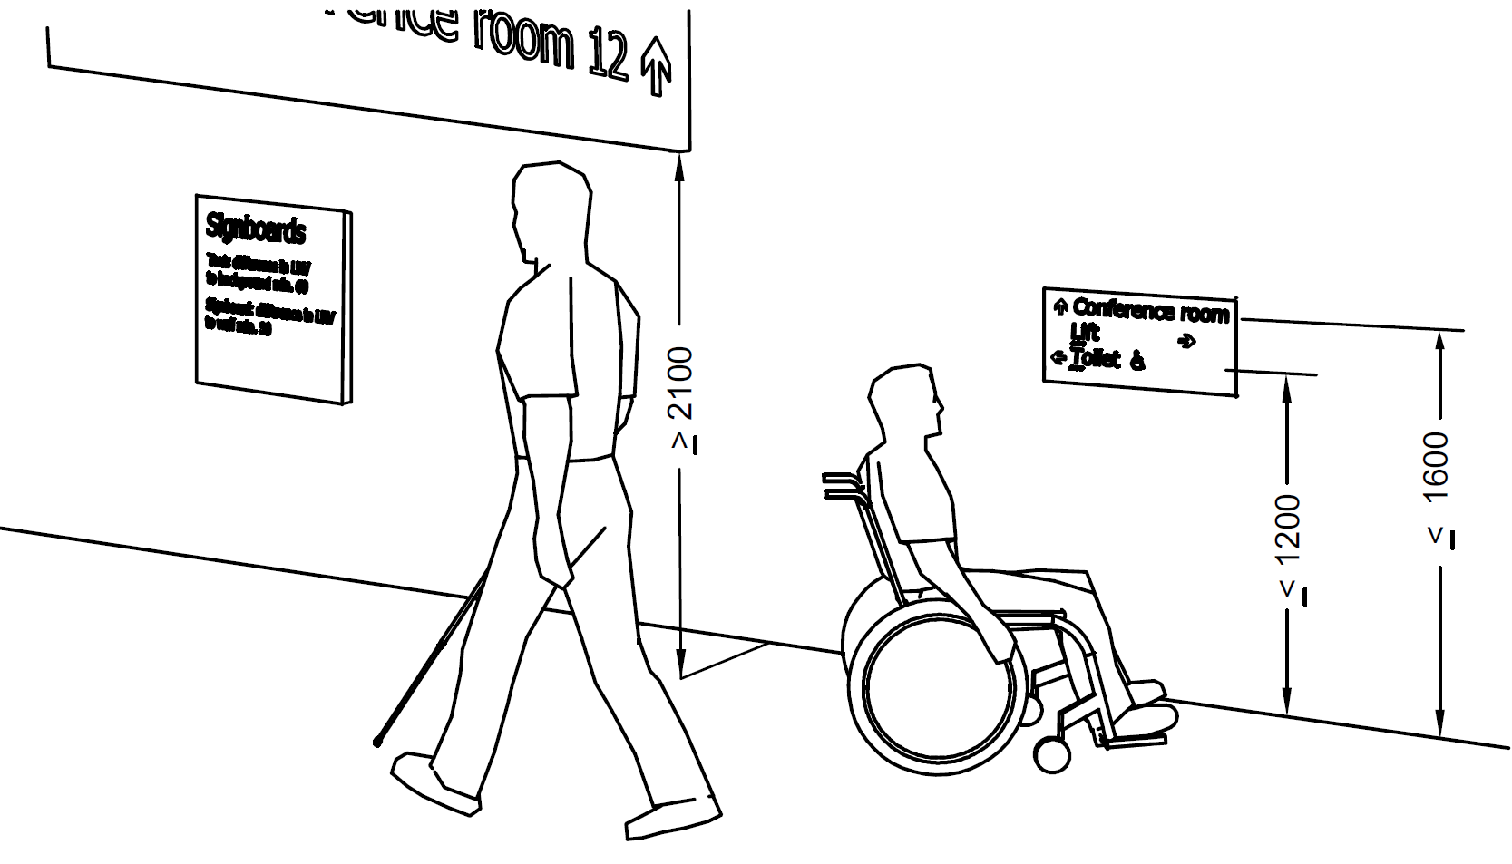
All dimensions in millimetres
Fig. 100 Height of Signs
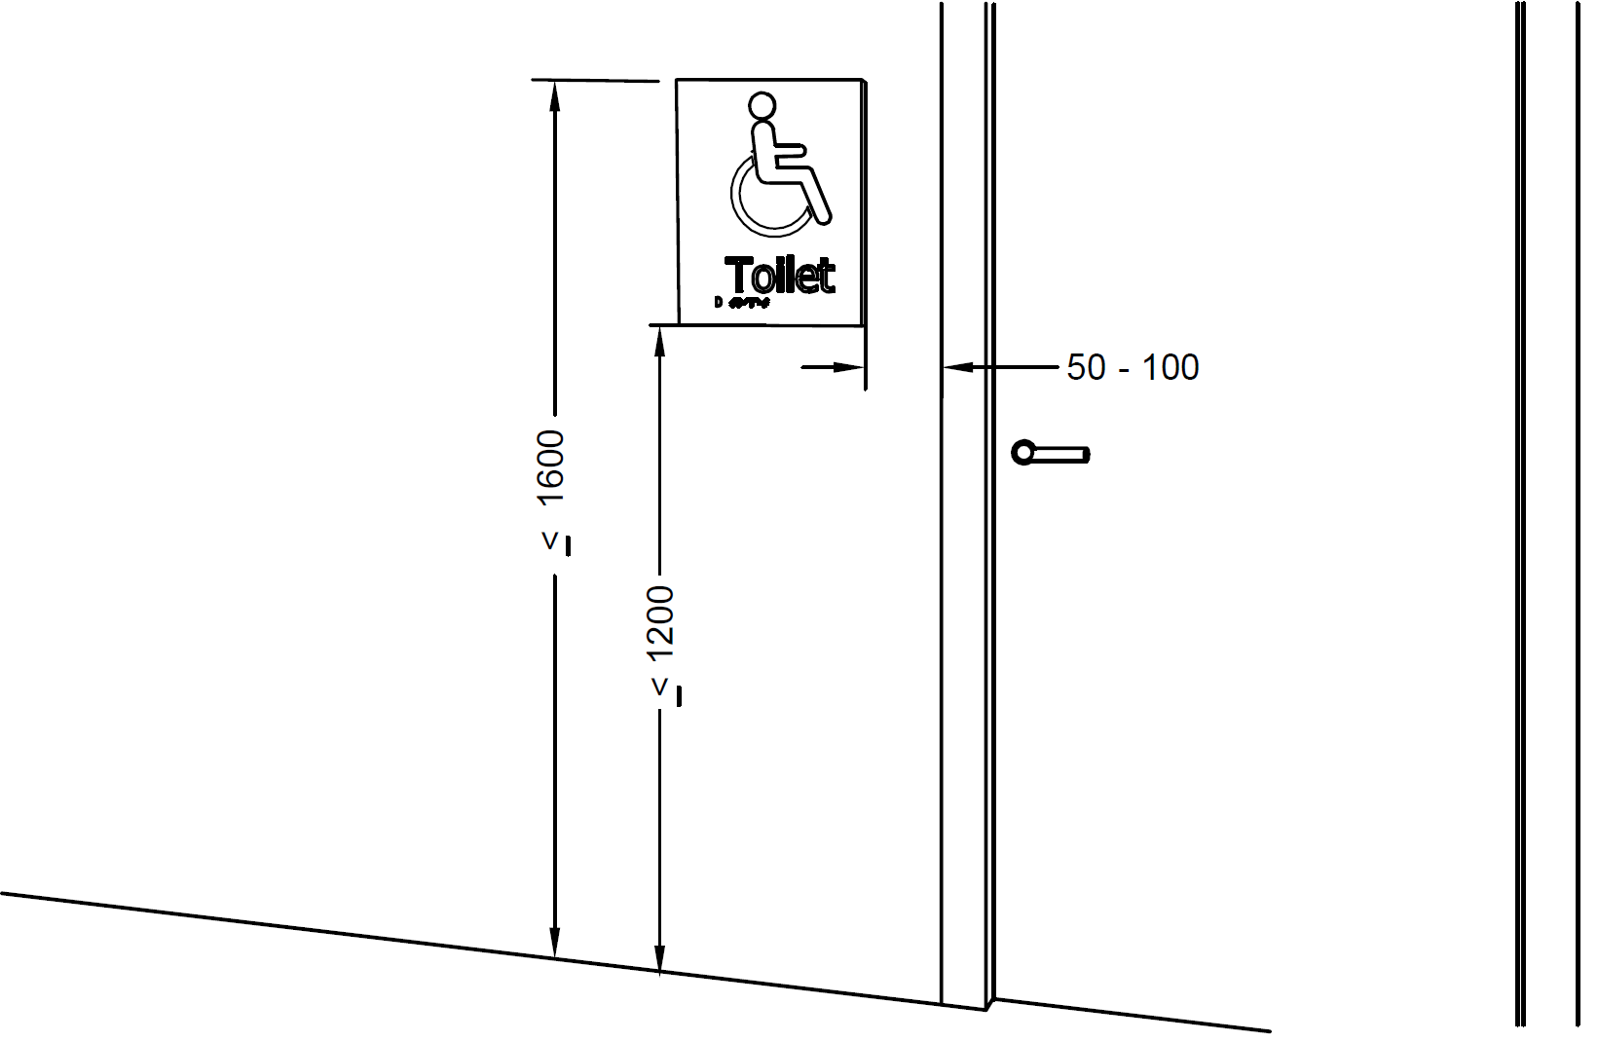
All dimensions in millimetres
Fig. 101 Location of Door Signs on the Latch Side of the Door
34.2.5 Font and Size of Lettering
The fonts should be easy to read. The font style should be a sans serif font similar to Helvetica or Arial medium.
The letter height depends on the reading distance. A letter height between 20 mm and 30 mm for each metre of viewing distance is preferred. The letter height should not be less than 15 mm.
Usage of too many type sizes on any one sign should be avoided. Also, italics, script texts, condensed texts, light stems should be avoided. Consistent font stem widths should be used.
It is recommended that messages of single words or groups of words begin with an upper-case letter and continue with lower case letters (sentence case).
The words should not be placed too close together. Adequate height spacing should separate the lines. Lines of text should be ranged from a vertical line (unjustified).
Signs with a single word may be centre justified, else the text should be left justified. The spacing between two lines shall be 50 percent of the line height (see Fig. 102).
A style shall be chosen based on a character width-to-height ratio within 3:5 and 1:1 and the stroke width-to-height ratio between 1:5 and 1:10. It shall be consistent for each sign (see Fig. 103).

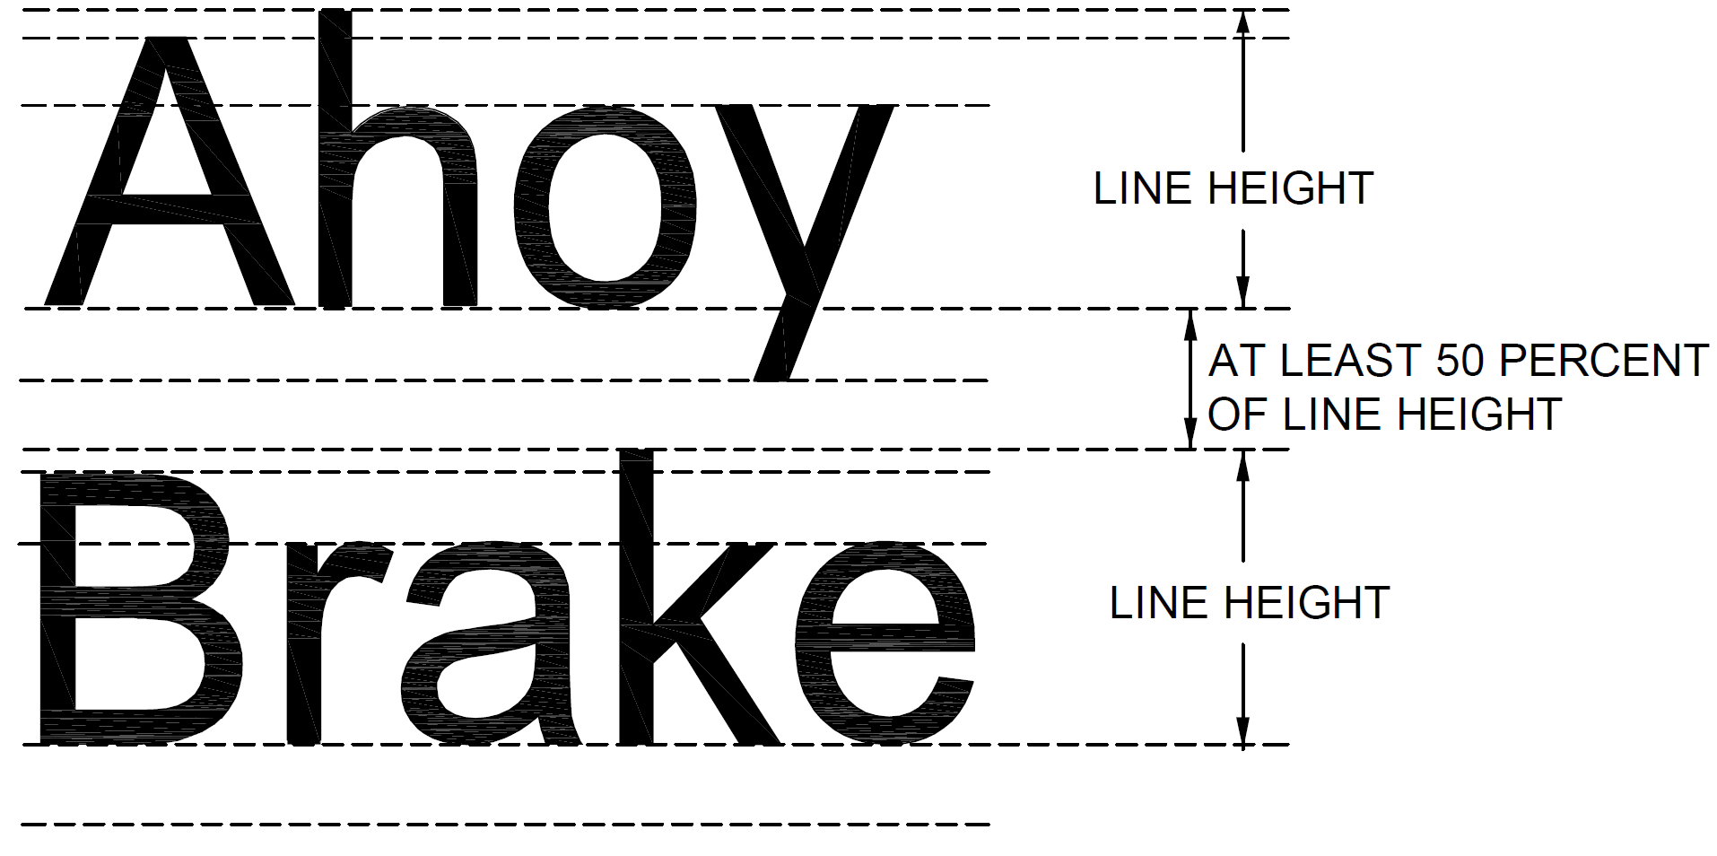
Fig. 102 Line Height and Spacing
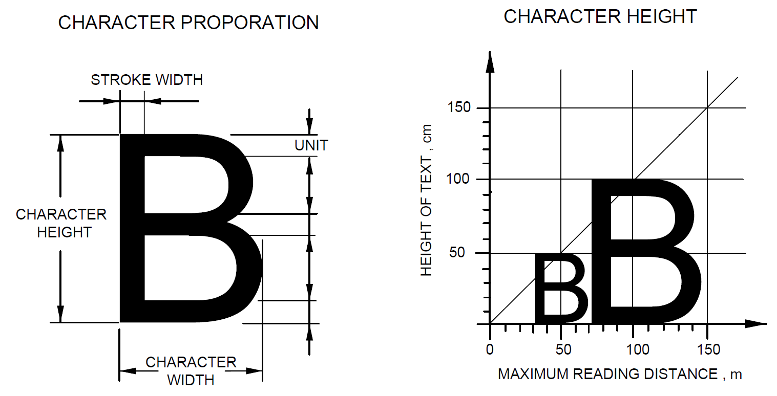
Fig. 103 Dimensions of Character in a Signage System
34.2.6 Differences in LRV
Minimum difference in LRV for small targets, such as signs and inscriptions, to signboards, should be 70 points.
Signboards should have a minimum difference in LRV from the background of 30 points.
Red-green combination should be avoided. Difficulties in perception can also appear when using the colours green, olive green, yellow, orange, pink and red (see also 34.3 for contrast).
34.2.7 Glare Free
Signs should be glare free when mounted. This depends on how the sign is placed, the material and the illumination. The background, graphical symbols, logos and other features shall be of a matte or low sheen finish.
34.2.8 Illumination
Signs should be well illuminated with no glare with uniform lighting over the surface of the sign of between 200 and 300 lux. Minimum acceptable level of lighting for directional signage, maps and text panel is 200 lux. Signs can be luminescent or artificially lit.
34.2.9 Understandable
Signs should be readily understandable. They should be designed so as to be simple and easy to interpret. The message should be unambiguous.
Short sentences and simple words should be used. Abbreviations and very long words are hard to understand and should be avoided.
34.2.10 Provision of Raised Tactile and Braille signs
Signs on panels in lifts, room numbers of rooms in hotels, doors to public toilets and so on shall be raised tactile and include Braille (see also 34.2.4).
The preferred height of raised tactile information is between 1 200 mm and 1 600 mm. Signs with tactile information placed at a lower height should be mounted at an angle from the horizontal (preferably 20° to 30°, maximum 45°).
34.2.11 Tactile Letters, Figures, Signs and Graphical Symbols
The height of letters, figures, signs and graphical symbols shall be between 15 mm and 55 mm (see Fig. 104).
The minimum height of its relief shall be 0.8 mm; a height between 1 mm and 1.5 mm is preferred (see Fig. 104).
The profile of the relief should be shaped as a rounded upside-down turned letter V.
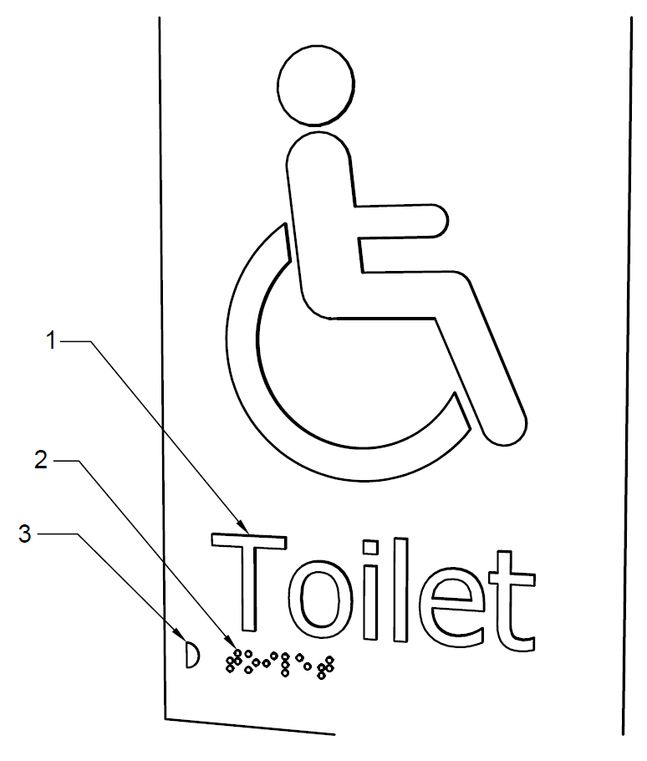
Key
- Raised tactile letters and graphical symbols, height 15 mm to 55 mm, minimum relief 0.8 mm (1 mm to 1.5 mm relief is preferred)
- Braille text
- Braille locator
Fig. 104 Example of Raised Tactile Signs and Braille
34.2.12 Braille
Where an arrow is used in the tactile sign, a small arrow shall be provided for Braille readers.
On signs with multiple lines of text and characters, a semi-circular Braille locator on the left margin shall be horizontally aligned with the first line of Braille text.
Braille should be raised, domed and comfortable to touch. It should be located 8 mm below the bottom line of the text and be left justified.
Common alternative formats may be used to assist people with visual impairments who are best able to interpret information through hearing or touch. Embossed letters, raised pictograms and raised arrows are tactile features that may be incorporated into signs, which may be particularly helpful to persons with visual impairments.
34.2.13 Tactile Symbols
Tactile symbols applied on handrails, doors, maps or floor plans shall have a raised relief contour similar to tactile letters.
34.2.14 Tactile Maps and Floor Plans
Only essential information should be included on a tactile map or floor plan.
Tactile maps shall be angled between 20° and 30° from the horizontal for ease of reading, and the bottom edge shall be at a minimum height of 900 mm. The map should have a level of illumination between 350 lux and 450 lux, without glare.
The key should be located at the bottom of the map and left justified. The use of a recessed Braille locator on the left hand side should assist in locating the legend.
The map shall be orientated with the building.
34.2.15 Information Displays
If video and media information displays are used, they should be placed at a height according to 34.2.4 and their lettering, etc, should be in conformity with the recommendations above.
Glare from artificial and natural lighting on the screen shall be avoided by,
- positioning the display or the screen out of direct light; or
- shading the display or the screen.
A complementary audible information system should be provided.
34.2.16 Graphical Symbols
The international symbol of accessibility (see Fig. 105) shall be replicated consistently in all wheelchair signage. The preferred colour is navy blue with white lettering.
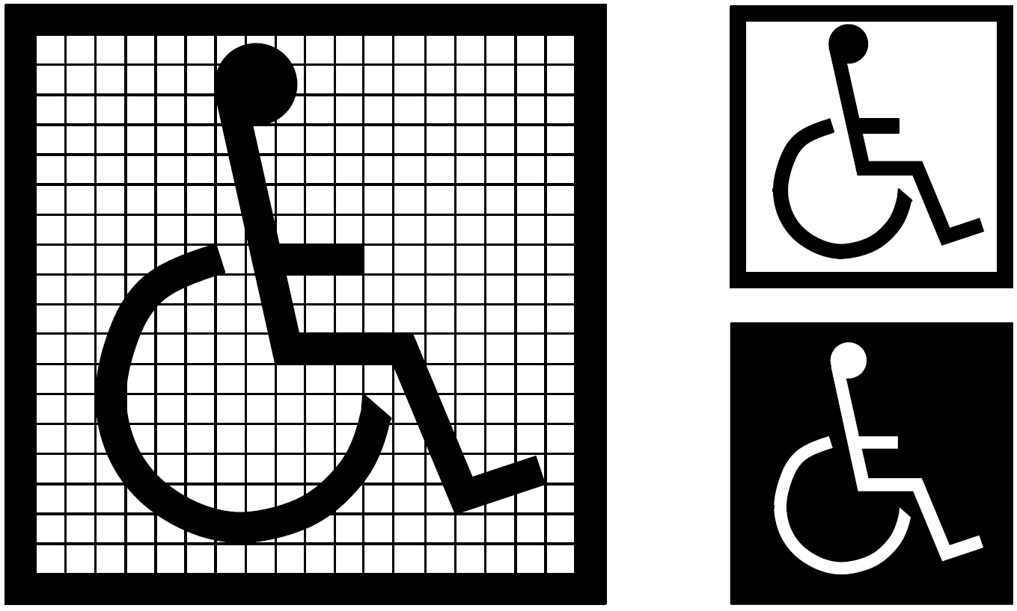
105 A Proportions | 105 B Display Conditions
Fig. 105 International Symbol of Accessibility
Graphical symbols should be used in conjunction with building signage systems wherever possible.
Graphical symbols shall be highly contrasted with a minimum difference in LRV of 70 points and properly illuminated. They shall be used on guides and directional signage (see also 34.3).
Graphical symbols on directional and door signs should be tactile and should be accompanied by raised lettering and Braille (see 34.2.13). Signs above a height of 1 600 mm do not need to be tactile, nor to include raised lettering or Braille information.
The size of graphical symbols is dependent on the viewing distance (D). The minimum size of the inner outline of the frame of graphical symbols (s) can be derived from formula s = 0.09 D, applicable for a viewing distance of 1 000 mm to 10 000 mm.
The following accessible graphical symbols shall be used to denote particular components of a facility. The following facilities for disabled persons shall be marked as:
- Those relating to people with mobility impairments,
- car parking places (parking places, garages);
- access and entrances without steps to buildings, especially where they are not identical with the main entrance;
- accessible lifts, in cases where not all lifts are accessible; lifting platforms and similar mounting devices;
- accessible sanitary rooms;
- wheelchair viewing spaces and accessible seating;
- changing rooms; and
- steps or hoists providing access to swimming pools.
- Those relating to people with vision impairments: locations where audible and tactile information is provided.
- Those relating to people with hearing impairments:
- Telephones and emergency call facilities, equipped with sound amplification; and
- provision of an assistive listening system.
Some of the graphical symbols relevant to accessibility are shown in Figs. 106 to 118.
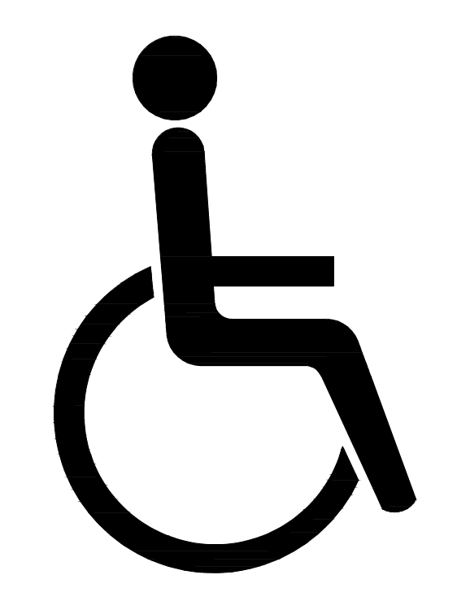
NOTE – This graphical symbol also indicates full accessibility or accessible toilets
Fig. 106 Accessible Facility or Entrance
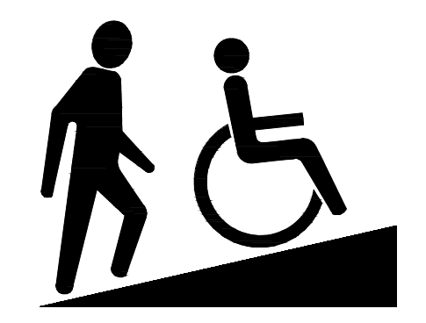
Fig. 107 Sloped or Ramped Access
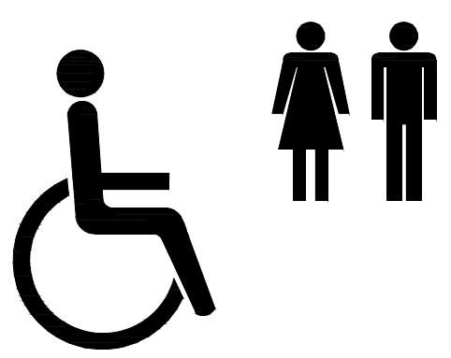
Fig. 108 Toilets Accessible, Female and Male
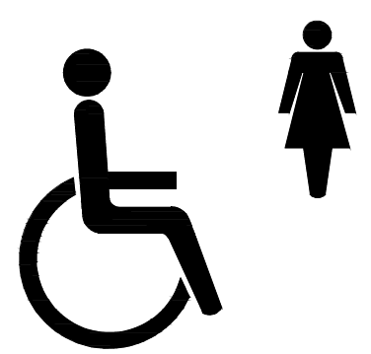
Fig. 109 Toilets Accessible, Female
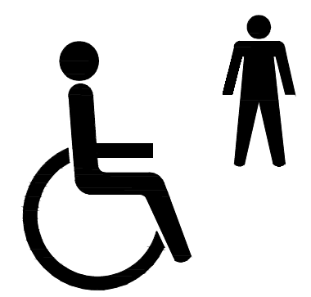
Fig. 110 Toilets Accessible, Male
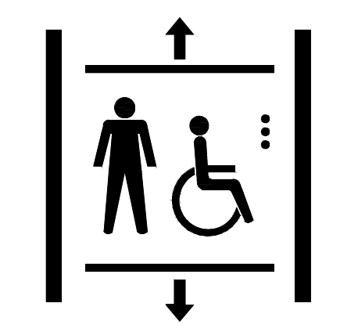
Fig. 111 Accessible Lift
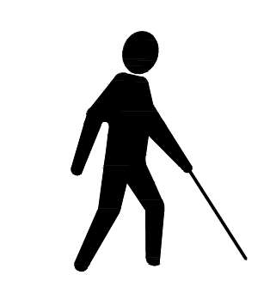
Fig. 112 Accessibility, Blind or Low Vision
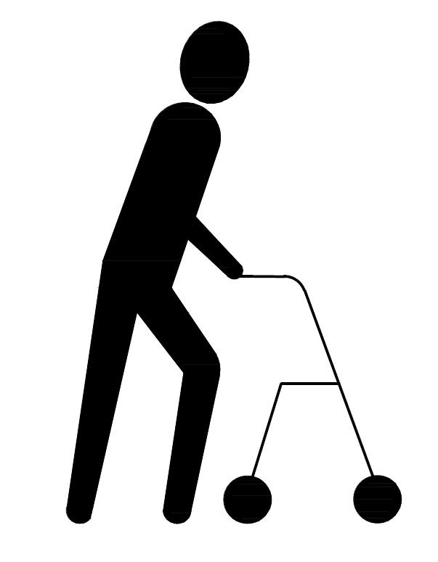
Fig. 113 Accessibility, Limited Walking Capability
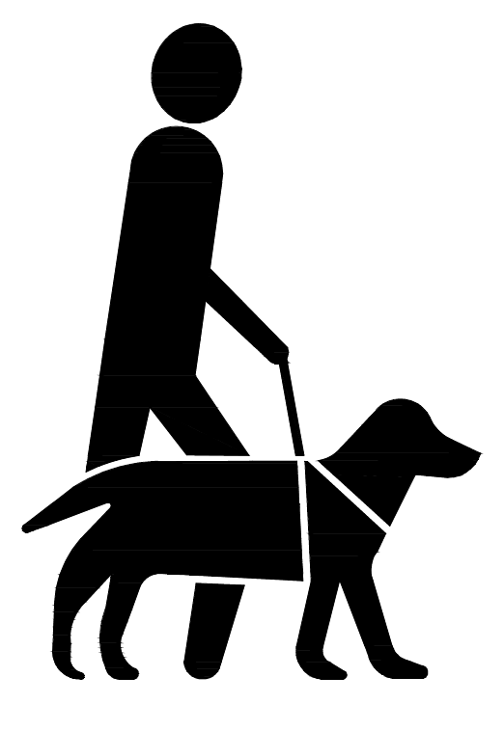
Fig. 114 Accessibility, Assistance Dog

Fig. 115 Accessibility, Hard of Hearing

Fig. 116 Accessibility, Personal Assistant Available

Fig. 117 Accessibility, Vision Impaired

NOTE ― Figure 118 is a combination sign which combines a safety sign and one or more associated supplementary signs on the same rectangular carrier. The signs used in the figure are the following:
- Running man (centre of the combination sign) ‒ Emergency exit (right hand).
- Arrow (right) ‒ Supplementary arrow sign used with the emergency exit sign to indicate its location in the right direction.
- Supplementary sign (opposite to the arrow) ‒ Full accessibility or toilets accessible.
Fig. 118 Accessible Emergency Exit Route
34.3 Visual Contrast
34.3.1 General
In order to facilitate orientation and to ensure safe use of an environment, adjacent surfaces, information and potential hazards shall provide a discernible visual contrast. A minimum difference in LRV shall be provided in relation to the visual task in accordance with Table 5. Additionally, one of the two surfaces should have an LRV value of minimum 30 points for door furniture, 40 points for large area surfaces and 70 points for potential hazards and text information.
The minimum difference in the LRV shall be achieved and maintained throughout the life of the building elements. Deterioration and maintenance shall be considered at installation.
For lighting conditions lower than specified in this standard, the difference in LRVs should be higher.
NOTES
- The LRV, sometimes also called the luminance reflectance value, or CIE Y value, is expressed on a scale of 0 – 100, with a value of 0 points for pure black and a value of 100 points for pure white.
- The perception of visual contrast increases with better lighting conditions.
- Reflections and glare from shiny surfaces can reduce visual contrast and can confuse people with vision impairments.
For door hardware (that is, the elements and components to facilitate opening and closing doors) a difference in LRV between the product and its background of at least 15 points and a minimum light reflectance value of 30 points for one of the two surfaces is acceptable.
NOTE ― Door hardware is normally positioned at the same height on a door and is either on the left or right side. This makes the location of door hardware easier than other features. In addition, the three-dimensional features of door hardware create shadows and bright spots, which further enhance their location.
Floor patterns should have a visual contrast of less than 20 points difference on the LRV scale.
NOTE ― Highly contrasted floor patterns can be perceived as differences in floor level, which may confuse people with vision impairments or cognition capacity. Highly contrasted floor patterns may trigger an attack of vertigo.
Table 5 Minimum Difference in LRV according to the Visual Task
(Clause 34.3.1)
Sl No. | Visual Task | Difference on the LRV Scale | Approximate Examples of Colour Contrasting
(1) | (2) | (3) | (4)
 | Large surface areas (that is, walls, floors, doors, ceiling), elements and components to facilitate orientation (that is, handrails, switches and controls, tactile walking surface indicators, and visual indicators on glazed areas) | ≥ 30 points | 
 | Potential hazards and self-contrasting markings (that is, visual indicator on steps) and text information (that is, signage) | ≥ 70 points | 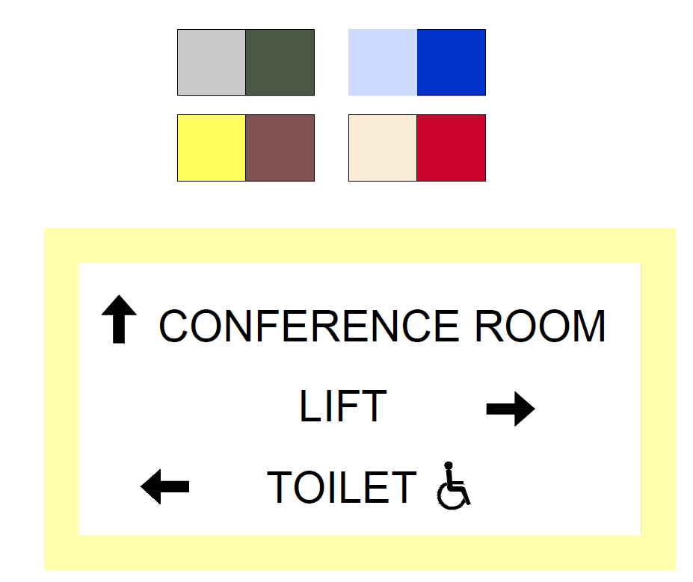
34.3.2 Choice of Colours and Patterns
Different colours should be used for identification of doors, different storeys or departments in a building to aid persons with impaired cognitive ability. The colours used to facilitate orientation shall also provide minimum difference in LRV according to 34.3.1. Combinations of red tones and green tones should be avoided.
Different storeys should be marked with clearly defined large numbers relating to the floor (that is, ‘2’ for the second floor, and so on) both in the stairwells to assist those evacuating and at the lift and stair lobbies on each level.
NOTE ― Colour coding floors may not be practical from a long-term maintenance perspective.
In case of signage and graphical symbols, contrasting colours shall be used to differentiate the figures from the background on the signboard. The colours of signboard shall also contrast with the surrounding surface so as to be clearly distinguishable (see 34.2.6). Information from signs may be conveyed by the colour and brightness differentials between the letter and the background. For graphical symbols, it is preferable to use blue and white colours. Colours same as safety signs shall be avoided in other signs. Primarily red, yellow or green colour is used for safety signs. The colour combinations red/green and yellow/blue should not be used in order to avoid confusing persons who are colour blind. Use of the shades of the same colour in the sign and also use of more than 5 colours in a signage should be avoided.
A preferred schedule of colour contrast for signs from their background is given below:
Sl. No. | Background | Sign Board | Legend
(1) | (2) | (3) | (4)
 | Red brick or dark  stone | White | Black, dark green or  dark blue
 | Light brick or light  stone | Black/dark | White or yellow
 | Whitewashed walls | Black/dark | White/Yellow
 | Green vegetation | White | Black, dark green or dark blue
 | Back-lit sign | Black | White or yellow
35 MANAGEMENT AND MAINTENANCE ISSUES
35.1 Effective management of the built environment is essential to ensure that a building can be used by everyone. Management policies and procedures will be required to ensure that accessibility is maintained on an ongoing basis. The following management and maintenance issues are important factors in ensuring that a building is easily accessed and used by disabled people.
35.2 External Issues
- Keeping external routes, including steps and ramps, clean, unobstructed and free of surface water, dead leaves, lichen, debris, etc;
- In car parking areas: ensuring that designated spaces are not being used by non-disabled motorists;
- Where possible, allocating specific designated parking spaces to individual employees, marked by name or number;
- Checking side-hung doors accompanying revolving doors to ensure they are not kept locked; and
- Making available auxiliary aids such as portable ramps and removing them when not in use.
35.3 Internal Issues
- Ensuring that wheelchair spaces are available in seating areas;
- Ensuring that staff understand the management issues relating to disabled people, including emergency procedures;
- Ensuring that storage, planters, bins, etc, do not obstruct circulation space, WCs or lift call buttons;
- Ensuring that cleaning and polishing does not produce a slippery surface;
- Ensuring that trip hazards, such as at junctions between floor surfaces, are removed;
- Ensuring access between moveable tables in refreshment areas;
- Ensuring that in sanitary facilities, written instructions on the use of equipment is displayed beside each item;
- Ensuring in sanitary facilities, that information is available on the type of sling connector and the types of sling that are compatible with their installed hoist and track;
- Ensuring that a procedure is set up to respond to alarm calls from sanitary accommodation;
- Ensuring that waterproof mattress covers can be made available for use in accessible bedrooms in non-domestic buildings;
- Ensuring that, where floor sockets are provided (for example in meeting rooms), access to sockets is also available at desk level;
- Ensuring that any temporary barriers that are used to channel customers to reception or serving points, and whose configuration needs to be changed frequently, have a semi-rigid top barrier (for example a spring-loaded band) which contrasts visually with the background against which it is seen; and
- Ensuring that assistance is made available to carry trays where needed in refreshment areas.
35.4 Maintenance Issues
- Maintaining doors, door closers and building hardware, including checking that the opening forces of self-closing doors are within acceptable limits;
- Maintaining access control systems;
- Checking floor surfaces, matting, surface-mounted carpets, etc, re-fixing to the floor where necessary, and replacing where damaged or worn (particularly at entrances to buildings);
- Maintaining hearing enhancement systems;
- Maintaining sanitary fittings, including checking that toilet seats are securely fixed, cleaning tap nozzles to ensure correct water flow, emptying and cleaning bins, and keeping equipment clean;
- Ensuring that adjustable shower heads are lowered to be ready for the next user;
- Ensuring that emergency assistance pull cords are kept fully extended and in working order at all times;
- Checking the mountings of all grab bars, and the mechanism of drop-down bars, re-fixing or replacing, where necessary;
- Servicing of all types of lifts and hoists;
- Ensuring that facilities, such as lifts, hoists, etc, are in working order between servicing schedules, and providing alternative arrangements in case of facilities being out of order;
- Maintaining ventilation and heating equipment;
- Replacing defunct light bulbs and flickering fluorescent tubes quickly; and
- Keeping windows, lamps and blinds clean to maximize lighting.
35.5 Communication Issues
- Providing information on strobe lighting prior to entry;
- Removing and/or changing signage as necessary, for example when departments relocate;
- Providing accurate information on facilities prior to arrival;
- Providing audio description services;
- Providing all relevant literature, and reviewing/revising it when necessary;
- Ensuring that a permanently manned position is available for the emergency lift telephone communications;
- Updating maps of buildings following changes; and
- Replacing signs correctly after decoration.
35.6 Policy Issues
- Allocating and reviewing parking spaces;
- Changing signs when departments move;
- Reviewing the number of disabled people attending and needing facilities;
- Establishing and running user groups;
- Reviewing the number of instruments supporting infra-red systems;
- Adopting a signage policy;
- Having the loop position always manned in branches;
- Providing portable ramps;
- Arranging audits of journeys made by visitors;
- Instructing accessibility audits;
- Ensuring that services are provided when facilities such as lifts break down;
- Ensuring that responsibilities are defined within the organization;
- Ensuring that accessibility improvements are picked up whenever possible
during maintenance and refurbishment work;
- Reviewing and improving evacuation procedures;
- Training of staff;
- Reviewing all policies, procedures and practices;
- Reviewing the provision of auxiliary aids; and
- Considering the impact of background noise (for example music, equipment, ventilation) on people with a range of sensory conditions (hearing, vision, autism). This is especially important in areas where voice communication is necessary such as reception, meeting and learning spaces.

ANNEX A
( Foreword )

COMMITTEE COMPOSITION

FUNCTIONAL REQUIREMENTS IN BUILDINGS SECTIONAL COMMITTEE, CED 12

Organization | Representative(s)
CSIR- Central Building Research Institute, Roorkee | Prof R. Pradeep Kumar (Chairperson)
Adlakha Associates Pvt Ltd, New Delhi | Shri Pramod Adlakha
 | Ms Abhaya Adlakha (Alternate)
All India Glass Manufacturers’ Federation, New Delhi | Representative
Arena Consultants, Thane | Ar. Archana Salil
Building Materials and Technology Promotion Council, New Delhi | Dr Shailesh Kr. Agrawal
 | Shri S. K. Gupta (Alternate)
Bureau of Energy Efficiency, New Delhi | Representative
Central Pollution Control Board, New Delhi | Shri Sharandeep Singh
Central Public Works Department, New Delhi | Shri A. K. Sharma
 | Shri Saju Siddharthan (Alternate)
Centre for Accessibility in Built Environment Foundation, New Delhi | Shri Subhash Chandra Vashishth
CSIR-Central Building Research Institute, Roorkee | Dr S. K. Negi
 | Dr Kishore S. Kulkarni (Alternate)
 | Shri Naveen Nishant (YP)
Delhi Development Authority, New Delhi | Shri Ashok Khurana
 | Shri Ashok Ghodeshwar (Alternate)
Engineers India Limited, New Delhi | Shri Samir Das
 | Shri Anish Kundu (Alternate)
 | Shri Anish Mahala (YP)
Indian Buildings Congress, New Delhi | Shri Vishv Ratan Bansal
 | Shri Maman Chand Bansal (Alternate)
Indian Institute of Science, Bangalore | Prof Monto Mani
Indian Institute of Technology Kharagpur, Kharagpur | Prof Baidurya Bhattacharya
 | Prof Nirjhar Dhang (Alternate)
Indian Institute of Technology Roorkee, Roorkee | Dr R. K. Jain
Indian Society of Lighting Engineers, New Delhi | Shri N. Nagarajan
 | Shri Satyabrata Chakraborty (Alternate)
Institute of Town Planners, India, New Delhi | Dr S. K. Kulshrestha
Kolkata Municipal Corporation, Kolkata | Deputy Commissioner (Buildings)
Lloyd Insulations (India) Limited, New Delhi | Smt. Sonal Gupta
Military Engineer Services, Engineer-in- Chief's Branch, Integrated HQ of MoD (Army), New Delhi | Smt S Gayatri Mukherjee
 | Shri Sanjay Kumar Mittal (Alternate)
Ministry of Health and Family Welfare, New Delhi | Shri Rajeev Kanaujia
 | Shri Mukesh Bajpai (Alternate)
Ministry of New and Renewable Energy, New Delhi | Dr Arun K. Tripathi
 | Shri Hiren Chandra Borah (Alternate)
Samarthyam, New Delhi | Ms Anjlee Agarwal
 | Ms Nidhi Madan (Alternate)
School of Planning & Architecture, New Delhi | Dr Mandeep Singh
 | Dr Manoj Mathur (Alternate)
Svayam, New Delhi | Ms Vandana Boolchand
 | Shri Bhupinder Singh (Alternate)
The Energy Resources Institute, New Delhi | Shri Sanjay Seth
 | Shri Yatin Choudhary
The Indian Institute of Architects, New Delhi | Shri Charanjit S. Shah
 | Shri Yudhvir Singh (Alternate)
The Institution of Engineers (India), Kolkata | Shri C. S. Prasad
 | Shri H. R. P. Yadav (Alternate)
Town and Country Planning Organization, Ministry of Urban Development, New Delhi | Chief Planner
 | Ms Anjali Pancholy (Alternate)
Vastukala Academy, College of Architecture, New Delhi | Prof Sanjay Mehra
In Personal Capacity, Roorkee | Shri Ishwar Chand
In Personal Capacity | Dr K Janakiraman
In Personal Capacity | Shri Gautam Suri
In Personal Capacity, Thiruvananthapuram | Shri V. Suresh
BIS Directorate General | Shri Dwaipayan Bhadra, Scientist ‘E’ And Head (Civil Engineering) [Representing Director General (Ex-officio)]
Member Secretary
Shri Dheeraj Damachya
Scientist ‘B’/Assistant Director
(Civil Engineering), BIS

