*भारतीय मानक*

**IS 1173 : 2024**

***Indian Standard***

**इस्पात के तप्त बेलित और स्लिट टी सरिए**

**आयाम और गुण**

(*तीसरा पुनरीक्षण* )

**Hot Rolled and Slit Steel Tee Bars**

**Dimensions and Properties**

(*Third Revision*)

(ICS No. 77.140.70)

© BIS 2024

भारतीय मानक ब्यूरो

BUREAU OF INDIAN STANDARDS

मानक भवन, 9, बहादुरशाह ज़फर मार्ग, नई दिल्ली — 110002

MANAK BHAVAN, 9, BAHADUR SHAH ZAFAR MARG NEW DELHI-110002

[www.bis.gov.in](http://www.bis.gov.in) [www.standardsbis.in](http://www.standardsbis.in)

*March* 2024

**Price Group XX**

Structural Engineering and Structural Sections Sectional Committee, CED 07

**FOREWORD**

This Indian Standard was adopted by the Bureau of Indian Standards, after the draft finalized by the Structural Engineering and Structural Sections Sectional Committee had been approved by the Civil Engineering Division Council.

This standard was first published in 1957 covering a wide range of hot rolled and slit tee bars and was subsequently revised in 1967 and 1978, which covered slit tee bars to be produced by slitting some of the Indian Standard light weight, medium weight and H-beam sections.

In the preparation of this standard, the Sectional Committee has kept in view the manufacturing and trade practices followed in the country in this field.

In this revision, the following modifications have been effected:

1. New clause for customization of sizes through optimum flange width, beam depth, thicknesses of flange and web has been added.
2. References clause has been updated.

This standard also aims at satisfying some Sustainable Development Goals by United Nations, especially Goal 9 ‘Industry, innovation and infrastructure’, particularly its target **9.1**.

The composition of the Committee responsible for the formulation of this standard is given in Annex A.

For the purpose of deciding whether a particular requirement of this standard is complied with the final value, observed or calculated, expressing the result of a test or analysis, shall be rounded off in accordance with IS 2 : 2022 ‘Rules for rounding off numerical values (*second revision*)’. The number of significant places retained in the rounded off value should be the same as that of the specified value in this standard.

*Indian Standard*

**Hot Rolled and Slit Steel Tee Bars – Dimensions and Properties**

(*Third Revision* of IS 1173)

**1 SCOPE**

**1.1** This standard lays down the nominal dimensions, weight and basic sectional properties of hot rolled and slit steel tee bars.

**2 REFERENCES**

The standards listed below contain provisions, which through reference in this text constitute provisions of this standard. At the time of publication, the editions indicated were valid. All standards are subject to revision and parties to agreement based on this standard are encouraged to investigate the possibility of applying the most recent editions of the standards indicated below:

|  |  |
| --- | --- |
| *IS No.* | *Title* |
| IS 808 : 2021 | Hot Rolled Steel Beam, Column, Channel and Angle Sections — Dimensions and Properties (*fourth revision*). |
| IS 1852 : 1985 | Specification for rolling and cutting tolerances for hot - Rolled steel products (*fourth* *revision*) |
| IS 2062 : 2011 | Hot rolled medium and high tensile structural steel - Specification (*Seventh Revision*) |

**3 TERMINOLOGY**

For the purpose of this standard, the definitions given in IS 2062 and the following shall apply.

**3.1 Y-Y Axis –** A line passing through the centre of gravity of the profile of the section, parallel to the axis of the web of the section.

**3.2 Z-Z Axis –** A line passing through the centre of gravity of the profile of the section and at right angles to the Y-Y axis.

**4 SYMBOLS**

**4.1** Letter symbols used in this standard have been indicated in fig.1, fig.2 and Table 1. Other letter symbols used in the standard have the meaning indicated against each as given below:

$a=$ Sectional area in sq mm

$w=$ Calculated weight in kg/m $=(0.75 a)$

$C_{zz}=$ Distance of centre of gravity from top of flange

$I_{zz}=$ Moment of inertia about the Z-Z axis

$I_{yy}=$ Moment of inertia about the Y-Y axis

$e_{zz}=$ Distance of extreme fibre from the Z-Z axis

$e_{yy}=$ Distance of extreme fibre from Y-Y axis

$Z_{zz}= \frac{I_{zz}}{e_{zz}}=$ Modulus of section about the Z-Z axis

$Z_{yy}= \frac{I_{yy}}{e_{yy}}=$ Modulus section about the Y-Y axis

$r_{zz}=$ $\sqrt{\frac{I_{zz}}{a}}=$ Radius of gyration about the Z-Z axis

$r_{yy}=$ $\sqrt{\frac{I_{yy}}{a}}=$ Radius of gyration about the Y-Y axis

$D=$ The angle between the web and flange of the section, in degrees.

**5 CLASSIFICATON**

**5.1** Indian standard hot-rolled steel tee bars may be classified as follows:

1. Indian standard rolled normal tee bars (ISNT).
2. Indian standard rolled deep legged tee bars (ISDT),
3. Indian standard slit light weight tee bars (ISLT),
4. Indian standard slit medium weight tee bars (ISMT), and
5. Indian standard slit tee bars from h-sections (ISHT).

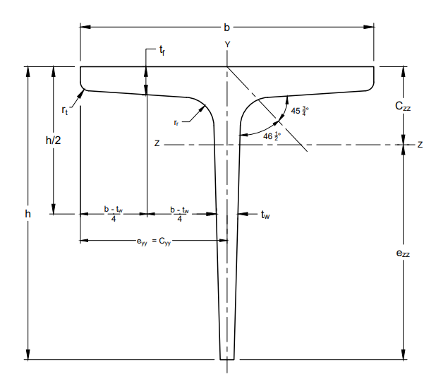

Fig. 1 Rolled Normal Tee Bar (ISNT)

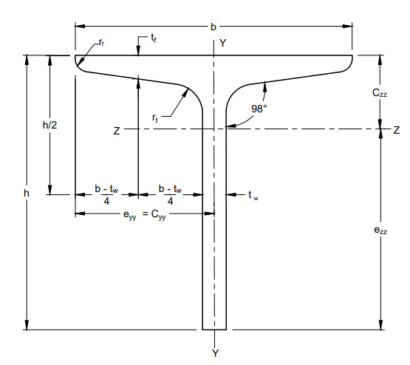

Fig. 2 Slit Tee Bar and Deep Legged Tee Bar

**5.2** For shop marking and drawing office purposes, the following abbreviated reference symbols may also be permitted provided specific understanding exists between the fabricator, the producer and the drawing office that members designated by these symbols refer only to Indian Standard Sections:

|  |  |
| --- | --- |
| *Classification* | *Abbreviated Reference Symbols* |
| ISNT | NT |
| ISNT | DT |
| ISNT | LT |
| ISNT | MT |
| ISNT | HT |

**6 DIMENSIONS AND PROPERTIES**

**6.1** Nominal dimensions and weight of Indian standard tee bars shall be as given in Table 1.

**6.2** The tolerances on the dimensions shall be specified in IS 1852.

**6.3** The customization of sizes through optimum flange width, beam depth, thicknesses of flange and web will enable cost savings on the overall steel take off in addition to the reliability of connections achieved. A new range of sections suiting to the need of the design requirements can be produced based on the formulae to calculate the geometrical sectional properties as per Annex A and Annex B of IS 808 that fulfils the design criteria.

|  |  |  |  |  |  |  |  |  |  |  |  |  |  |  |  |
| --- | --- | --- | --- | --- | --- | --- | --- | --- | --- | --- | --- | --- | --- | --- | --- |
| **TABLE 1 NOMINAL DIMENSIONS, WEIGHT AND GEOMETICAL PROPERTIES OF INDIAN STANDARD TEE BARS**  (*Clauses* **4.1 and 6.1**) | | | | | | | | | | | | | | | |
| **DESIGNATION** | **WEIGHT ($w$)** | **SECTIONAL AREA ($a$)** | **SIZE (NOMINAL) ($h × b$)** | **THICKNESS OF WEB ($t_{w}$)** | **THICKNESS OF FLANGE $(t_{f})$** | **RADIUS AT ROOT ($r_{r}$)** | **RADIUS AT TOE ($r_{t}$)** | **SLOPE OF FLANGE ($D$ °)** | **CENTRE OF GRAVITY POSITION ($C_{zz}$)** | **MOMENT OF INERTIA** | | **RADII OF GYRATION** | | **MOUDLI OF SECTION** | |
|  |  |  |  |  |  |  |  | $$I_{zz}$$ | $$I_{yy}$$ | $$r_{zz}$$ | $$r_{yy}$$ | $$Z_{zz}$$ | $$Z_{yy}$$ |
| **(1)** | **(2)** | **(3)** | **(4)** | **(5)** | **(6)** | **(7)** | **(8)** | **(9)** | **(10)** | **(11)** | **(12)** | **(13)** | **(14)** | **(15)** | **(16)** |
|  | **kg/m** | **mm2** | **mm × mm** | **mm** | **mm** | **mm** | **mm** |  | **mm** | **106 mm4** | **106 mm4** | **mm** | **mm** | **103 mm3** | **103 mm3** |
| **Indian Standard Normal Tee Bars** | | | | | | | | | | | | | | | |
| ISNT 20 | 1.1 | 145 | 20 × 20 | 4.0 | 4.0 | 4.0 | 3.0 | (*See* Fig. 1) | 6.0 | 0.005 | 0.002 | 5.8 | 4.1 | 0.3 | 0.2 |
| ISNT 30 | 1.8 | 226 | 30 × 30 | 4.0 | 4.0 | 5.0 | 3.5 | 8.2 | 0.018 | 0.008 | 8.9 | 5.9 | 0.8 | 0.5 |
| ISNT 40 | 3.5 | 445 | 40 × 40 | 6.0 | 6.0 | 5.5 | 4.0 | 11.4 | 0.061 | 0.029 | 11.8 | 8.1 | 2.1 | 1.5 |
| ISNT 50 | 4.4 | 566 | 50 × 50 | 6.0 | 6.0 | 6.0 | 4.0 | 13.5 | 0.123 | 0.057 | 14.7 | 10.1 | 3.4 | 2.3 |
| ISNT 60 | 5.4 | 685 | 60 × 60 | 6.0 | 6.0 | 6.5 | 4.5 | 15.6 | 0.214 | 0.097 | 17.7 | 11.9 | 4.8 | 3.2 |
| ISNT 75 | 10.0 | 1270 | 75 × 75 | 9.0 | 9.0 | 8.0 | 5.5 | 20.4 | 0.620 | 0.292 | 22.1 | 15.2 | 11.4 | 7.8 |
| ISNT 100 | 14.9 | 1900 | 100 ×100 | 10.0 | 10.0 | 9.0 | 6.0 | 26.2 | 1.64 | 0.768 | 29.4 | 20.1 | 22.2 | 15.4 |
| ISNT 150 | 22.7 | 2890 | 150 × 150 | 10.0 | 10.0 | 10.0 | 7.0 | 36.1 | 5.41 | 2.50 | 43.3 | 29.4 | 47.5 | 33.4 |
| **Indian Standard Deep Legged Tee Bars** | | | | | | | | | | | | | | | |
| ISDT 100 | 8.1 | 1040 | 100 × 150 | 5.8 | 10.0 | 8.0 | 4.0 | 98° | 30.3 | 0.990 | 0.096 | 30.9 | 9.6 | 14.2 | 3.8 |
| ISDT 150 | 15.7 | 2000 | 150 × 75 | 8.0 | 11.6 | 9.0 | 4.5 | 98° | 47.5 | 4.50 | 0.370 | 47.5 | 13.6 | 43.9 | 9.9 |
| **Indian Standard Slit Light Weight Tee Bars\*** | | | | | | | | | | | | | | | |
| ISLT 200 | 28.4 | 3620 | 200 × 165 | 8.0 | 12.5 | 16.0 | 8.0 | 98° | 47.8 | 12.7 | 3.58 | 59.2 | 31.5 | 83.3 | 43.4 |
| ISLT 250 | 37.5 | 4780 | 250 × 180 | 9.2 | 14.1 | 17.0 | 8.5 | 98° | 64.0 | 27.7 | 5.32 | 76.2 | 33.4 | 149.2 | 59.1 |
| **Indian Standard Slit Medium Weight Tee Bars†** | | | | | | | | | | | | | | | |
| ISMT 50 | 5.8 | 735 | 50 × 70 | 4.5 | 7.5 | 9.0 | 4.5 | 98° | 10.4 | 0.108 | 0.177 | 12.1 | 15.5 | 2.7 | 5.05 |
| ISMT 62.5 | 6.7 | 850 | 62.5 × 70 | 5.0 | 8.0 | 9.0 | 4.5 | 98° | 13.9 | 0.218 | 0.192 | 16.5 | 15.1 | 4.4 | 5.50 |
| ISMT 75 | 7.5 | 955 | 75 × 75 | 5.0 | 8.0 | 9.0 | 4.5 | 98° | 17.3 | 0.412 | 0.234 | 20.8 | 15.7 | 7.1 | 6.25 |
| ISMT 87.5 | 9.8 | 1240 | 87.5 × 85 | 5.8 | 9.0 | 10.0 | 5.0 | 98° | 20.6 | 0.756 | 0.384 | 24.7 | 17.6 | 11.3 | 9.00 |
| ISMT 100 | 12.7 | 1620 | 100 × 100 | 5.7 | 10.8 | 11.0 | 5.5 | 98° | 21.3 | 1.16 | 0.750 | 26.8 | 21.5 | 14.7 | 15.0 |
| **Indian Standard Slit Tee Bars from H-Section‡** | | | | | | | | | | | | | | | |
| ISHT 75 | 15.3 | 1950 | 75 × 150 | 8.4 | 9.0 | 8.0 | 4.0 | 94° | 16.2 | 0.962 | 2.30 | 22.2 | 34.4 | 16.4 | 30.1 |
| ISHT 100 | 20.0 | 2550 | 100 × 200 | 7.8 | 9.0 | 9.0 | 4.5 | 94° | 19.1 | 1.94 | 4.97 | 27.6 | 44.2 | 24.0 | 49.3 |
| ISHT 125 | 27.4 | 3480 | 125 × 250 | 8.8 | 9.7 | 10.0 | 5.0 | 94° | 23.7 | 4.15 | 10.0 | 34.5 | 53.7 | 41.0 | 79.9 |
| ISHT 150 | 29.4 | 3740 | 150 × 250 | 7.6 | 10.6 | 11.0 | 5.5 | 94° | 26.6 | 5.74 | 11.0 | 39.2 | 54.1 | 46.5 | 87.7 |
| *Slit from ISLB 200 and ISLB 500. | | | | | | | | | | | | | | | |
| †SIit from MB 100, 125, 150, 175 and 200. | | | | | | | | | | | | | | | |
| ‡Slit from ISHB 150, 200, 250 and 300. | | | | | | | | | | | | | | | |

**ANNEX A**

( *Foreword* )

**COMMITTEE COMPOSITION**

Structural Engineering Sectional Committee, CED 07

|  |  |
| --- | --- |
| *Organization* | *Representative(s)* |
| In Personal Capacity, Chennai | Dr V. Kalyanaraman (*Chairperson*) |
| Ashwathnarayana & Eswara, Chennai | Shri H. E. Sriprakash Shastry |
| Bhilai Institute of Technology, Durg | Dr Mohan Kumar Gupta |
| C.R. Narayana Rao, Architects & Engineers, Chennai | Dr C. N. Srinivasan  Shri C. R. Arvind (Alternate) |
| Central Electricity Authority, New Delhi | Shri A. K. Jain  Director (Transmission) (Alternate) |
| Central Public Works Department, New Delhi | Shri D. K. Garg  Shri N. K. Bansal (Alternate) |
| Construma Consultancy Pvt Limited, Mumbai | Dr Harshavardhan Subbarao |
| CSIR-Structural Engineering Research Centre, Chennai | Dr G. S. Palani |
| Dr Napa Prasad Rao (Alternate I)  Dr. R. Balagopal (Alternate II) |
| Engineers India Limited, New Delhi | Shri Anurag Sinha  Dr Sudip Paul (Alternate)  Shri Saptdip Sarkar (YP) |
| GAIL India Ltd, New Delhi | Shri S. Ashish Vaidya |
| Indian Institute of Engineering Science and Technology, Shibpur | Dr Subrata Chackraborty  Ms Chaitali Ray (Alternate) |
| Indian Institute of Technology Delhi, New Delhi | Dr Dipti Ranjan Sahoo  Dr Alok Madan (Alternate) |
| Institute for Steel Development & Growth, Kolkata | Shri Arijit Guha  Shri Lakhamana Rao Pydi (Alternate) |
| In Personal Capacity, | Shri Gayana Ranjan Mohainty |
| In Personal Capacity, Chennai | Shri V.N. Heggade |
| Jindal Steel & Power Ltd, Gurugram | Shri Sanjay Nandanwar |
| Larsen & Toubro Limited, Chennai | Shri T. Venkatesh Rao |
| M. N. Dastur & Company Pvt Limited, Kolkata | Shri Shuvendu Chattopadhyay  Shri Gargi Aditya Basu (Alternate-I)  Smt Mohua Chatterjee (Alternate-II) |
| MECON Limited, Ranchi | Shri B. K. Pandey  Shri J. K. Sarkar (Alternate) |
| NTPC Ltd, Noida | Shri Himanshu Kundu  Shri Chander Shekhar (Alternate) |
| Powergrid Corporation of India Limited, New Delhi | Shri Abhishek  Ms Sumana Mukherjee (Alternate) |
| Ramboll India, Hyderabad | Shri D Sankar Ganesh |
| Salasar Techno Engg Limited, Noida | Shri Dayanand K |
| Steel Authority of India Limited, Ranchi | Shri Gautam Kumar Mitra  Shri Deepak Rangarao (Alternate) |
| STUP Consultants Pvt Ltd, Kolkata | Shri Anirban Sengupta  Shri Sumantra Sengupta (Alternate-I)  Shri Mandar Sardesai (Alternate-II) |
| Tata Consulting Engineers Ltd, Mumbai | Shri Pratip Bhattacharya  Shri T. Shriprasad (Alternate) |
| Takalkar Power Engineering and Consultants Private Limited, Vadodara | Shri S.M. Takalkar  Shri Shreedhar V. Rana (Alternate) |
| The Institution of Engineers (India), Kolkata | Shri S. H. Jain |
| BIS Directorate General | Shri Dwaipayan Bhadra, Scientist ‘E’ And Head (Civil Engineering) [Representing Director General (*Ex-officio*)] |
| *Member Secretary*  Shri Abhishek Pal  Scientist ‘D’/Joint Director  (Civil Engineering), BIS  Shri Dheeraj Damachya  Scientist ‘B’/Assistant Director  (Civil Engineering), BIS | |