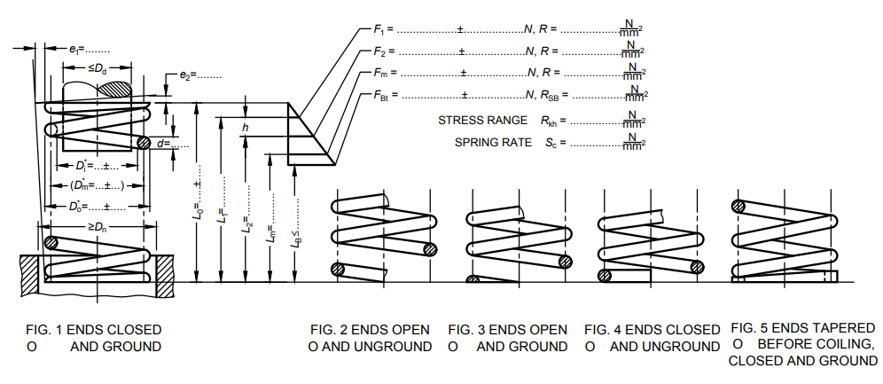

* Replace the figures given in standard with above figures.
* Insert the following line below figures “*For details of parameters specified in data sheet please refer Fig. 1, Fig. 2, Fig. 3, Fig. 4 and Fig. 5*”