**BIS LITD 36/P-II Study Report:**

**Feasibility of Standardization of Ink Cartridge Form Factor & Ink.**

We begin with understanding the history of printing & its various landmarks to set the context and significance of the research & development by the industry that is continuously striving to develop newer technologies & the solutions to meet the ever-changing customer needs over the many decades. With the adoption of digital technology, Printing industry also migrated from Analog to digital. Changing/ upgrading technology in hardware is not alone a challenge but it was imperative for the industry to rework on other key components/ elements developed to work seamlessly with the change in technology in the computing segment. Printing industry in last 3 decades had reworked heavily to upgrade its printing solutions to deliver as per the market demand.

Hence, Print hardware, Software, Firmware & its Ink cannot be seen in isolation. They are interdependent & developed by the research & development team to work in tandem for the application for which the same has been developed. After many trials & many failures, a final product which is developed have no surety of its commercial success or may just die its own death due to technological obsolescence or change in customer preference during the research period & competition offerings.

In today’s highly competitive printing technology market, only those organisations can sustain who are continuously investing in the latest technology to meet changing customer printing needs and offering sustainable printing solutions. This huge research & development cost for such large corporations are generated by not just selling the hardware but also its consumables or by providing the overall printing solutions to the customers under various commercial business models over a period.

Hence, Printing system is a combination of three important factors, which are - Technology & technical specification of Hardware, Technology & specification of Ink & the Software All three factors work together to deliver the desired printing experience. In all these decades, industry could manage to develop many printer models which are economical & cost competitive in terms of its acquisition cost & printing cost.

**History of Printing:**

**Tank based printers transformed the total market dynamics & ruled out THE QUESTION of standardization of cartridge slot.**

The history of Printing starts as early as 3500 BCE. The industry enabled the communication of ideas and sharing of knowledge on an unprecedent scale. Along side the development of text printing, new & lower cost methods of image production were developed, including lithography, screen printing and photocopying.

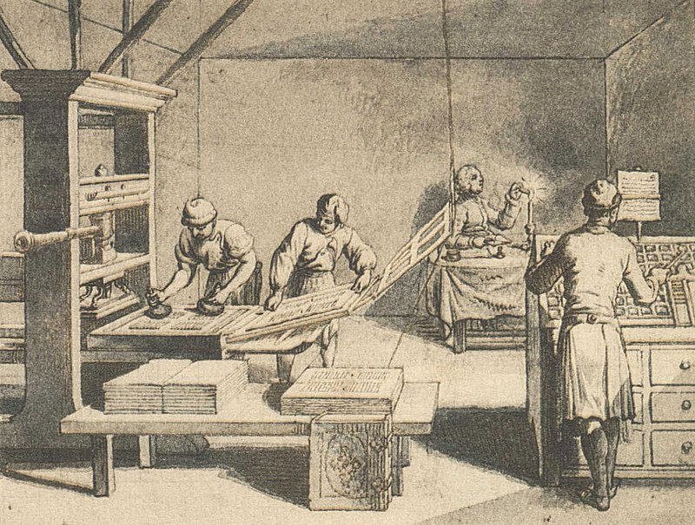

Digital Printing in 1991 has changed the over all printing market & since then lot of revolutionary changes were introduced due to various R & D initiatives taken by the printing industry.

Printing Hardware, Firmware, software & quality of ink had seen many stages to reach to the current level what todays customers are experiencing in their day-to-day life.

The research is on & putting any restriction on the researchers will limit the significant R & D taking place across the world.

Industry is reinvesting its capital to bring-out new cost-effective printing solutions which has already resulted a significant drop in cost of printing.

|  |  |  |  |
| --- | --- | --- | --- |
| [Woodblock printing](https://en.wikipedia.org/wiki/Woodblock_printing) | 200 | [Photostat and rectigraph](https://en.wikipedia.org/wiki/Photostat_machine) | 1907 |
| [Movable type](https://en.wikipedia.org/wiki/Movable_type) | 1040 | [Screen printing](https://en.wikipedia.org/wiki/Screen_printing) | 1911 |
| [Printing press](https://en.wikipedia.org/wiki/Printing_press) | c. 1440 | [Spirit duplicator](https://en.wikipedia.org/wiki/Spirit_duplicator) | 1923 |
| [Etching](https://en.wikipedia.org/wiki/Etching) | c. 1515 | [Dot matrix printing](https://en.wikipedia.org/wiki/Dot_matrix_printing) | 1925 |
| [Mezzotint](https://en.wikipedia.org/wiki/Mezzotint) | 1642 | [Xerography](https://en.wikipedia.org/wiki/Xerography) | 1938 |
| [Aquatint](https://en.wikipedia.org/wiki/Aquatint) | 1772 | [Spark printing](https://en.wikipedia.org/wiki/Spark_printing) | 1940 |
| [Lithography](https://en.wikipedia.org/wiki/Lithography) | 1796 | [Phototypesetting](https://en.wikipedia.org/wiki/Phototypesetting) | 1949 |
| [Chromolithography](https://en.wikipedia.org/wiki/Chromolithography) | 1837 | [Inkjet printing](https://en.wikipedia.org/wiki/Inkjet_printing) | 1950 |
| [Rotary press](https://en.wikipedia.org/wiki/Rotary_printing_press) | 1843 | [Dye-sublimation](https://en.wikipedia.org/wiki/Dye-sublimation_printer) | 1957 |
| [Hectograph](https://en.wikipedia.org/wiki/Hectograph) | 1860 | [Laser printing](https://en.wikipedia.org/wiki/Laser_printing) | 1969 |
| [Offset printing](https://en.wikipedia.org/wiki/Offset_printing) | 1875 | [Thermal printing](https://en.wikipedia.org/wiki/Thermal_printing) | c. 1972 |
| [Hot metal typesetting](https://en.wikipedia.org/wiki/Hot_metal_typesetting) | 1884 | [Solid ink printing](https://en.wikipedia.org/wiki/Solid_ink) | 1972 |
| [Mimeograph](https://en.wikipedia.org/wiki/Mimeograph) | 1885 | [3D printing](https://en.wikipedia.org/wiki/3D_printing) | 1986 |
| [Digital printing](https://en.wikipedia.org/wiki/Digital_printing) | | | **1991** |

**Some critical stages of Printing industry: -**

**Brief history of Ink Cartridges**

* With the continuous research & development efforts from leading brands, the monochrome inkjet printers and cartridges were introduced for the mass market customers in the early 1980s.  This inkjet printing technology had created a new dimension in the printing industry & became a customer choice of moving from dot-matrix printer to Graphic Printers.
* Next with the efforts of the industry, in the late 1980’s full-color inkjet printing became widely available.  Color cartridges suitable for document printing and photos on glossy coated paper were developed.  Over time, many new ink cartridges became available each designed for a different use.  This includes dye-based color ink cartridges with pigment black ink for versatile home printing of both plain paper documents and photos, photo ink cartridges for enhanced color range, and office all-pigment inks for fast printing of documents with resistance to damage from water and smearing in the tray.  Customers have different options for types of OEM inkjet cartridges to meet different customer needs.

**Topic under discussion: -**

1. Cost of ownership for printer is very high due to high cost of ink cartridges.
2. Fading of printed bills issued by retailers thus losing the printed records.

**To explore the possibility: -**

1. Through a process of standardization of Form Factor & Chemicals of Ink cartridges. Can we reduce the cost?
2. Can we develop standards for quality and usage of paper, ink etc. used in printers for issuing bills?

**Challenge: -**

All brands in the Printer segment are global companies and possibility of introducing any modification in the products for India market specifically will require technological related challenges which needs a detailed deliberation.

**Industry Findings/ Comments: -**

1. **Standardisation of Ink cartridges and Toners of Printers.**

Standardization of Ink cartridges and Toners of Printers will not result in reducing the cost of “Printers” & “Toners”, but rather it will increase lot of complications for most users in terms of print quality, performance of the printer, increased cost of service, life of the printer & finally the overall increased cost of ownership for the users instead of getting it reduced.

To further understand this, below findings emerged in the study.

1. The study threw up that the Printing system is a combination of three important factors, which are -Quality of Hardware, Quality of Inks/ Toners & the Software along with its firmware to support the various printing needs of the users. Today, all brands have a large range of Printers which are not only differentiated based on duty cycle (maximum no. of prints in a month) during its lifetime but are also differentiated based on the application/ usage to meet various printing needs of the different users. Today, there are lot of efforts put-in by each global brand in creating the best print engine supported by the quality of inks & toners developed in tandem with the change in the internal hardware for the best user experience. If any of the combination is changed, then the overall performance & life of the printer will be adversely affected.
2. Within one brand’s range of printers, different models don’t have the same toner cartridge/ inks since the application/ usage & designing of the printer is done based on the target consumer segment which is the Unique Selling Preposition for each brand. So interoperability is not possible even within the same brand. Industry shared its serious concerns if printers have uniform cartridge slot then customer may unknowingly use a wrong cartridge which can harm the printer life or overall performance of the machine.
3. **If India takes a** unique position for Standardization of ink-cartridges, then it will disrupt the whole supply chain as global companies will have to re-design some unique India specific models. Even if this were to be done by some, This will then restrict many new models to get launched in India that are offered to rest of world. Such a scenario is extremely impractical. This will also result in the price increase for India market whereas rest of the world will continue to get the latest models & the best prices due to economies of scale since out of total global market, India market contribute just 5% of it. Such an increase in the cost of printer hardware will defeat the prime objective of reducing cost for the consumer. It is very important to note that today, India market is getting almost the same models which are sold globally & it is practically impossible for the industry to create India specific unique models. It is important that in this high technology rapidly evolving field India standards are in harmony with World Standards.
4. In order to attract customers, R& D is being done by different brands to create a USP in terms of providing better print quality, print speed, reliability of the printer & better product design at the most competitive price. Competing Standardization of uniform cartridge form factor & Ink will limit the scope of technological innovations, product design improvements & cost reductions to to meet changing customer-needs.
5. Keeping in view the fast-changing printing needs of various customer segments like document printing, mono printing, colour printing, or fine photo printing, the hardware, software & quality of ink is developed. By using the wrong Ink including non-genuine ink there is a very high risk of damaging printer hardware/ parts & impacting the print quality which will then require higher servicing/ repairing cost for the consumers. For example today there are printers available for printing plain paper flyers that will resist fading longer than dye colour inks when posted outside in the sun as it is using “All-Pigment Inks” developed by the all major brands. Using any ink in such printers will completely defeat the purpose of developing inks for such specific customers & may even damage the printer.
6. Today, most companies have launched printers which are ink efficient (tank based, using bottles instead of cartridges) with low-cost printing, both for Mono & colour. Those who have high printing needs, are generally selecting these models which has helped in reducing the total cost of ownership of the product thereby getting better print quality, at affordable cost by even using genuine ink. Most user close to 80% have already started buying tank-based printers which have less than Re 1/ page printing cost for mono & less than Rs 2/ page for colour by using genuine inks. Moreover, such latest printers are tank based in which user is just pouring the genuine inks available in the market & thus there is **no further question of creating a uniform cartridge slot**. As per the industry, close to only 20% of the total printer sales is from non-tank printer models which are preferred choice of those customers who have specific printing needs.

In addition, manufacturing companies are continuously striving to fulfill the needs of varied customer segment in terms of low cost of printing from home use to office use without compromising on quality & performance. Addressing the needs of different customer segments will not be possible without continued research & development in this printing industry. Standardization of cartridge slot will bring a complete halt to various initiatives of the researchers, which we have seen in last 3-4 decades.

Manufacturing companies design product at a component level by developing Hardware and its consumables simultaneously. Therefore, maintaining a uniform cartridge slot will limit the innovation in terms of product internal design to enhance the product performance and overall esthetics which are the core USPs for the OEMs.

For Inkjet printers, all printer manufacturing companies have their unique/ different print head, number of nozzles, quality & size of nozzles to control the size of droplets for best photo/ grey scale printing & the quality of ink is also manufactured as per the design & the application of the printer. The OEM ink formula precisely matches the unique technical requirements of the specific printer while avoiding chemicals which are unsafe. The Firmware controls print engine & various other application which differentiate one brand with the other.

Similarly, regarding laser printers, companies have different compositions and characteristics of toner powder. It is necessary to use an appropriate toner powder that matches HW specifications such as printing speed, right melting point to get the best printing solution. From the technical viewpoint, it is difficult to standardize across brands because the polarities of the toner powder may differ from positively charged method to negatively charged one.

1. All brands need to comply various global standards; therefore, it will be very difficult for the brands to maintain a synergy between various compliances & bringing innovation while maintaining standardize cartridges slot across all models.
2. To attain the desired print quality & optimum printing results, all brands suggest using original spare parts, original consumable & software.

Thus, Standardization of ink cartridges and toners will require a complete design change to meet India specific requirement, which is not possible & will even not help India to achieve the prime objective of reducing the total cost of ownership for the consumers. On the contrary, it will only increase the price of the product and total cost of ownership for the Consumer with a risk of lower print quality & compromising with product performance. -------------------------------------------------------------  
  
**Some printer models for SOHO, SMEs – less than 1 Rupee/ page cost of printing.**

**G series Printers by Canon, Tank based Printers by HP & eco tank printers by EPSON are few examples.**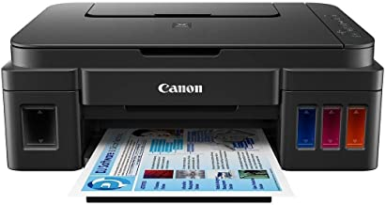

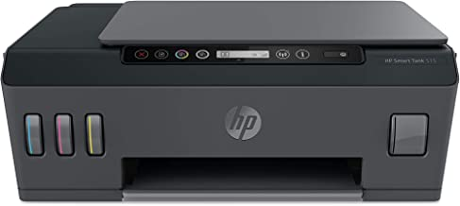

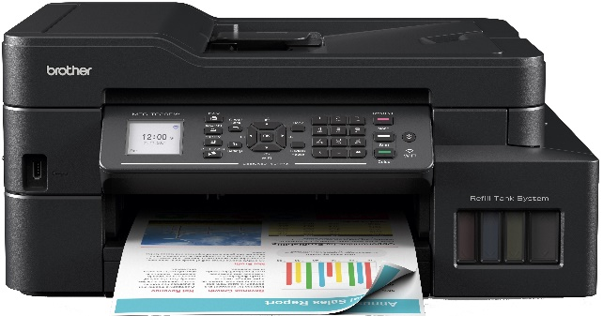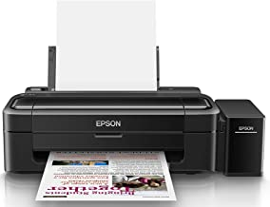

**Challenges of Printing Industry:**

The Printing industry landscape is evolving rapidly & this industry is challenged with new evolving technologies. The major challenges of printing industry are digitization trends, declining demands from industries like banking, advertising, postal services as digital channels have already taken over. Price pressures with declining demand and increasing asset costs impacts this sector. Under the current challenges, the printing industry is still managing by reinvesting in creating better technology, reducing the cost of printing without compromising the quality & thus meeting the customers expectation of delivering the most optimum printing solutions at the optimum cost of ownership.

**TANK BASED PRINTERS HAVE TRANSFORMED THE TOTAL PRINTING MARKET DYNAMICS GIVING CONSUMER VERY COST-EFFECTIVE OPTIONS.**

**TODAY 80% OF THE GENERIC MARKET HAS SWITCHED TO TANK BASED PRINTING**

**2. Developing standards for quality and usage of paper, ink etc. used in printers for issuing bills.**

It is the choice of the retailer to select a printer out of the various options available in the market. It is not a matter of quality of print but it is a matter of what printing technology any retailer is using to generate their invoices.

Many large or small retailer are using thermal printers at their billing counters because of the low cost of equipment. The print life of any thermal printer last from few days to few months depending upon how the print is stored by the consumer.

Today the retailers have several choices in terms of Printer types for issue of bills. Ranging from dot matrix printers to Ink Printers to Thermal printers. The quality & longevity of print impression is a function of the Printers Tech & the consumable.

The said issue is seen in the context of thermal printers used by most large or small retailers because of the cost-effective solution it offers.

The impression life of a thermal printer tools from a few day to months depending on the type of a thermal paper used and also on the storage of the printed receipts.

Thus, in an application that requires long duration presentation of impression the corresponding thermal paper is to be used.