**IS 5918**

*Indian Standard*

**SPECIFICATION FOR TAPER PIN, MACHINE REAMERS**

**WITH MORSE TAPER SHANKS**

(  *Revision* )

**1 SCOPE**

Covers the dimensions and requirements for taper pin machine reamers with morse taper shanks, used for producing tapered holes for taper pins conforming to IS 6688 : 2005 'Specification for taper pins, unhardened'.

**2 DIMENSIONS**

Shall be as given in Table 1.

**Table 1 Dimensions for Taper Pin, Machine Reamers with Morse Taper Shanks**

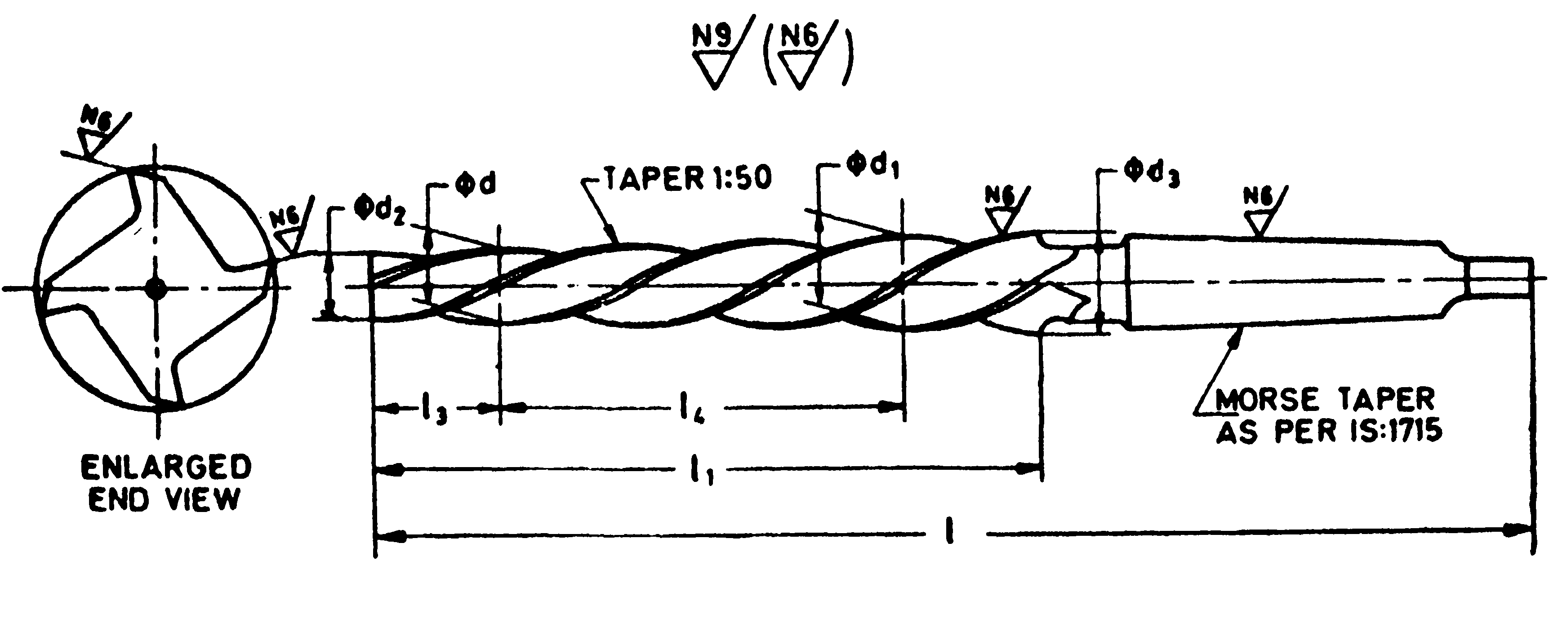

In fig ↑ l2 and l3 may be written in place of l3 and l4 respectively, as per Amd-2.

|  |  |  |  |  |  |  |  |  |
| --- | --- | --- | --- | --- | --- | --- | --- | --- |
| ***d Nom*** | *d*1 | *d*2 | *d*3 | **/** | **/**1 | **/2** | **/3** | **Morse Taper** |
| 5 | 6.2 | 4.9 | 6.36 | 155 187 | 73 105 | 5 | 60 | 1 |
| 6 | 7.8 | 5.9 | 8 00 | 5 | 90 | 1 |
| 8 | 10.6 | 7 9 | 10 80 | 227 | 145 | 5 | 130 | 1 |
| 10  12 | 13.2 | 9.9 | 13.40 | 257 | 175 | 5 | 160 | 1 |
| 15.6 | 11.8 | 16.00 | 315 | 210 | 10 | 180 | 2 |
| 16 | 20.0 | 15.8 | 20.40 | 335 | 230 | 10 | 200 | 3 |
| 20 | 24.4 | 19.8 | 24 80 | 377 | 250 | 10 | 220 | 3 |
| 25 | 29 8 | 24.7 | 30.10 | 427 | 300 | 15 | 240 | 3 |
| 30 | 35.2 | 29.7 | 36.10 46.50 | 475  495 | 320 | 15 | 260 | 4 |
| 40 | 45.6 | 39.7 | 340 | 15 | 280 | 4 |
| 50 | 56.0 | 49.7 | 56.90 | 550 | 360 | 15 | 300 | 5 |
| **NOTE** — For the *d* nominal, the diameter *d* corresponds to the nominal diameter of the taper pin. | | | | | | | | |

**2.1** The taper on taper pin reamers shall be 1:50. The cone angle tolerance shall be-AT8 as given in IS 7615 : 2003 'System of cone tolerances'.

**3 TOLERANCES**

Tolerances on cutting length *l*1 and overall length *l* shall be as given below:

All dimensions in millimetres.

|  |  |  |
| --- | --- | --- |
| **Cutting Length *l*1 and Overall length *l*** | | **Tolerance** |
| Over | Up to and Including |
| 30 | 120 | ± 1.5 |
| 120 | 315 | ± 2.0 |
| 315 | 1 000 | ± 3.0 |

**4 GENERAL REQUIREMENTS**

**4.1 Flutes** — Unless otherwise specified, left hand spiral flutes for right-hand cutting shall be provided.

**4.2** For requirements not covered in this standard, it shall conform to the requirements given in IS 5443 : 1994 'Technical supply conditions for reamers ( *first revision* )'.

**5 SAMPLING**

The sampling and criteria of acceptance shall be in accordance with IS 7778 : 2003 'Methods for sampling small tools'.

**6 DESIGNATION**

A taper pin, machine reamer with morse taper shank having diameter d = 10 mm, made from high speed steel and conforming to this standard, shall be designated as:

Taper Pin Machine Reamer 10 IS 5918

**7 CERTIFICATION MARKING**

Details available with the Bureau of Indian Standards.

**EXPLANATORY NOTE**

This standard was first published in 1970 and has been revised to bring it in line with the work done at ISO level. Earlier this standard had covered the sizes from 1.6 mm to 50 mm. Now as small sizes are being covered in the specification for taper pin machine reamers with parallel shanks, sizes 5 and above are included in this standard. Moreover, there are some changes in some other related dimensions which have been brought in line with ISO 3467 : 2016. All the dimensions given in this standard now conform to that ISO standard. In addition, the surface roughness of cutting portion and tolerances for cutting length and overall length have also been specified.

In the preparation of this standard, considerable assistance has been drawn from the following standards:

ISO 3467 : 2016 'Machine taper pin reamers with morse taper shanks. International Organization for Standardization (ISO).

DIN 2180 : 1975 'Machinen-Kegelreibachlen fur Kegchstiftbohrungen suit Morsekegelschaft' (Machine taper pin reamers with morse taper shank). Deutsches Institute fur Normung (DIN).

Taper pin machine reamers with morse taper shanks were earlier covered in IS 1836 : 1961 'Specification for reamers'. This standard apart from covering the taper pin machine reamers had also covered the dimensions and requirements for various types of reamers. In 1969, it was decided to withdraw IS 1836 and to issue a series of standards covering various types of reamers and technical supply conditions in separate standards. This standard is one of the standard of that series. The other standards in the series are:

IS 5881-1984 'Taper pin, hand reamers (*first revision*)'.

IS 10851-1984 ' T a p e r pin, machine reamers with parallel shanks'.