FOREWARD

This Indian Standard (First Revision) was adopted by the Bureau of Indian Standards, after the draft finalized by the Domestic and Commercial Gas Burning Appliances Sectional Committee has been approved by the Heavy Mechanical Engineering Division Council.

This standard was originally issued in 1987. This revision is being undertaken to incorporate the requirement of flame failure device when it is a part of the gas tap.

This standard is one of a series of Indian Standards on various domestic and commercial gas burning appliances (pressure type) used with LPG. General requirement of this product are covered in IS 5116:2020 ‘Domestic and Commercial Equipment for Use with LPG — General Requirements ( Fourth Revision )’ which is a necessary adjunct to commercial equipment for use any deviation exists between the requirements given in IS 5116 :2020 and those of this standard, provisions of the letter shall apply.

The tests in these standards are not intended to cover the effects excessive of temperature that may arise through faulty operation of an appliance.

Notwithstanding the requirement given in this standard, any new design, materials and methods or assembly shall be examined for compliance with manufacture’s claims and may be considered acceptable if they give results at least equivalent to those specified in this standard.

In preparing this standard, assistance has been derived from BS EN 1106:2010 ‘Manually operated taps for gas burning appliances’ issued by British Standards Institution.

For the purpose of deciding whether a particular requirement of this standard is complied with, the final value, observed or calculated, expressing the result of a test, shall be rounded off in accordance with IS 2: 1960 ‘Rules for rounding off numerical values (revised)’ The number of significant places retained in the rounded off value should be the same as that of the specified value in this standard.

**Indian standard**

**IS 12012:1992**

**GAS TAPS WITH OR WITHOUT FLAME FAILURE DEVICE FOR DOMESTIC AND COMMERCIAL LIQUEFIED PERROLEUM GAS BURNING APPLLINCES –SPECIFICATION**

**(Second revision)**

**1. SCOPE**

This standard covers requirements for safety, design, materials, and performance of gas taps ‘With or Without flame failure device’ (including pilot taps ) of nominal inlet size not exceeding 20 mm and intended for use with domestic and commercial appliances operating on LPG.

**2. REFERENCES**

The Indian standards listed in Annex A are necessary adjuncts to this standard.

**3. DEFINITIONS**

**3.1** For the purpose of this standard, the following definitions in addition to those given in IS 6480:1988 shall apply.

**3.2 Axial Tap**

A tap in which one or more pistons or valves move axially to open and close ports.

**3.3 Disc Tap**

A tap which is operated by rotating a disc, having one or more ports or channels, against a flat surface containing one or more port or channel.

**3.4 Lineal Seal**

The distance measured along the sealing surface of a tap in which the closure member rotates.

**3.5 Nominal Flow Rate**

The air flow rate at a specified pressure loss as claimed by the manufacturer.

**3.6 Plug Tap**

A tap which operated by rotating a taper plug is a mating bore.

**3.7 Safety Latch**

A device which self-locks the tap in the positive stop position and requires a different action to move the tap into the control mode.

**3.8 Poppet Valve**

A valve in which the seal is achieved by the axial movement of a closing member against a sealing face substantially at right-angles to the direction of the axial movement.

**3.9 Heat sensing Device**

A device which senses the heat such as thermocouple.

**3.10 Solenoid**

For the purpose of this standard, solenoid is a device which shuts off the gas outlet passage mechanically or electrically, until unless operated manually.

3.11 **Control tap**

Direct or indirect manually operated devices with one or more outlets for the control of the flow of gas from an off to an on position and vice versa.

3.12 **Tap closure member**

Part of the tap which releases, varies or shuts off the gas flow

3.13 **Bearing seal**

Shortest distance between gas-carrying parts and the atmosphere measured along the length of the sealing surfaces.

**4 OPERATIONAL DATA**

**4.1** The manufacture shall declare the following:

a) The working temperature range for which the tap has been designed.

b) The nominal flow rate at full ‘ON’ position (see Fig. 1)

c) The service suitability number (see 13), and

d) For multi-outlet taps, whether the tap is suitable for supplying burner ports in more than one combustion chamber.

e) For gas taps with flame failure device the method of fitting the sensing devices with the burner head.

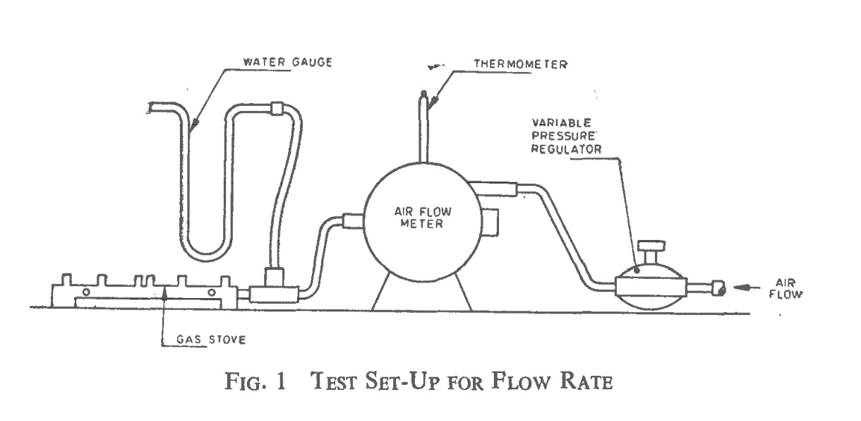

**5 GENERAL REQUIREMENTS**

**5.1** The relevant requirements given in 4 to 18 of section 1 of IS 5116:2020 shall apply.

**5.2** The tap shall not leak during the normal usage. The tap shall be suitable for L.P. gas.

**5.3** The tap shall be so made that in normal use the gas passages do not become blocked.

**5.4** The tap shall be capable of operating smoothly over the temperature range for which it is designed and quoted by the manufacture.

**5.5** All components effecting safety and durability shall be of sound quality and free from burrs, dirt or foreign matter which could adversely affect the operation of the tap.

**5.6** Where a means of ignition is incorporated, the tap shall be sufficiently robust to prevent distortion or damage in performing this additional operation.

**5.7** Taper plug type taps shall have a taper of not less than 1 of 6 on diameter for spring loaded taps. The operative diameter at the top of plug shall be not greater than the axial length of taper in contact with the body.

**5.8** The taper plug at the larger diameter shall be recessed into the body and the plug shall protrude beyond the taper of the body at the small end. There shall be adequate clearance provided for this protrusion.

**5.9** For multi-outlet taps, where the tap has two or more gas passages and the manufacturer specifies that these are only to be connected to burner ports in a single combustion chamber, specified gas tap position should have an independent gas passage through the gas tap linking the gas tap to a single combustion chamber without interference by any other gas passage in the same tap through lineal/circumferential seal.

**5.10** Niting (connecting) components or tap shall be sufficiently robust to avoid damage or distortion in normal use.

**5.11** Every taper plug or disc type tap for L.P. gas shall be spring loaded to maintain a gas type fit at all times including during operation.

**5.12** When a tap is set to any specific position it shall remain in that position.

**5.13** When a knob is supplied, the method of transmission of the torque from the knob to the tap spindle shall not depend on any spring clip/ screw which is intended solely for retaining purposes.

**5.14** Non-functional holes used for manufacture of the tap, that form a passage between gas –ways and the atmosphere shall be permanently sealed by mechanical means.

**5.15** Where taps are intended to be dismantled for servicing, for example, re-lubrication, where shall be ready access to the closing member, for example, plug-disc, and the design of the parts that have to be removed in the servicing operation shall not permit in correct assembly.

**5.16** When the tap becomes the part of the appliance, which is subject of another standard, and/or fitted with additional components, additional design features recommended to ensure compatibility with the requirement of this standard are given in Annex B

**5.17** The gas taps with flame failure device shall meet the requirements given in **5.17.1** and **5.17.2** in addition to requirements given in 14 of IS 5116:2020.

**5.17.1** Flame failure device may have provision for by passing. Temporary by pass using manual operation at the time of ignition is permitted.

**5.17.1** Relative position of the burner, ignition and flame sensing device shall be such that, in the event of shortening, distortion or blockage of igniting jet or other part of ignition system. The supply of gas to the burner shall be cut off.

**6 MATERIALS**

**6.1** Material that constitute the body of the tap, excluding the seals and other internal parts and the knob shall not melt at temperature up to 425 ˚C. Example of suitable materials given in Annex C are guidance only.

**6.2** Zinc alloys shall be used only if:

a) they comply with all the requirements of IS 742 :1981.

b) the casting is manufactured in accordance with the recommendation of IS 1655 :1991.

c) the parts are not to be subjected to a temperature higher than 80 ˚C.

d) they meet the requirement of **6.1.**

**6.2.1**. For gas carrying parts and parts which could affect the safe operation of the valve only alloy ZnAl4 of IS 742 : 1981 shall be used.

**6.3** Where organic sealing materials, including impregnating agents and synthetic rubber, are likely to come into contact with the gas, the tap or organic components shall comply with the requirement **6.3.2**.

**6.3.1** Diaphragms, if used, shall comply with the requirements given in **6.3.2.1**.

**6.3.2** All non –metallic materials shall show no marked deterioration when subjected to an accelerated ageing test for (see **11.5**) seven days at a temperature of 20 ˚C in excess of the manufacture’s maximum recommended temperature.

Note: The above requirement may not be met by materials made of some silicon rubbers although these rubbers are claimed to be satisfactory. Criteria for testing silicon rubber materials are still under consideration and, in the meantime, components and appliances containing such a material will be considered acceptable provided that the appropriate manufacturer can demonstrate that they have proved satisfactory in use.

**6.3.2.1** A diaphragm, if used. Shall not pull out or burst when the outlet of the assembled tap is subjected to an air pressure of 3× 105 N/m2 (2.7 kgf/cm2).

**6.4** Flame sensing device in the gas tap with flame failure device shall not distort or melt during continuous use of 4 hours.

**7 SPRINGS**

Where springs are used to retain plugs, discs, pistons or valves on their settings they shall be protected against corrosion and against any deleterious effects arising from the working environment.

Closing force and sealing force shall be provided by spring action.

Springs providing the sealing and/or closing force for any closure member of the control shall be made of corrosion-resistant materials.

Springs with wire diameter up to and including 2,5 mm shall be made from corrosion-resistant

materials.

Springs with wire diameter above 2,5 mm shall either be made from corrosion-resistant materials or shall be protected against corrosion.

**8 CONNECTIONS**

Where taps are provided with threaded-connections, those connections shall meet the requirements of IS 5116: 2020 and IS 4246:2002.

**9 GAS SOUNDNESS**

**9.1** The gas tap shall be tested for gas soundness by the method given in 9.1.1.

**9.1.1** Subject the gas to be tested to an air supply at a pressure of 150 gf/cm2 with the bubble leak indicator (see Fig.2) in the air supply line. Apply this pressure with the tap closed and examine the bubble indicator for the appearance of bubbles. This interval between successive bubbles passing through it shall not be less than 10 seconds. Repeat the test with the jet sealed and the tap opened. Repeat the two tests after the tap has been turned ‘ON’ and ‘OFF’ ten times.

**9.2** The method given in 9.2.1 shall be used to locate the point of leakage.

**9.2.1** Immerse the gas tap to be tested in a water bath at room temperature, then connect it to an air supply at a pressure of 150 gf/cm2 for a minimum period of 10 second with the tap closed. The tap shall be examined for leakage of air. The tap shall be repeated with jet sealed and tap opened. The two tests shall be repeated after the tap has been turned ‘OFF’ and ‘ON’ ten times. The interval between successive bubbles passing through it shall not be less than 10 seconds.

**10 MECHANICAL PERFORMANCE TEST**

**10.1 Safety Latch**

The tap shall not unlock from ‘OFF’ position when a torque of 4 Nm is applied. The performance of the tap shall not be permanently impaired by this torque.

**10.2 Mechanical Strength**

The tap shall be of sufficient mechanical strength to resist the stresses and conditions of normal use. A tap that satisfies the requirements of the torque and bending moments tests, given in **10.2.1** and **10.2.2** respectively, and thereafter remain functional without exceeding the leakage rates given in **9** and without showing signs of distortion and cracking shall be deemed to have sufficient mechanical strength.

**10.2.1 *Torque Test***

**10.2.1.1** *Gas tap with threaded female inlet and outlet* –Threaded pipe at least 300 mm in length shall be screwed hand tight to the inlet and outlet of the tap and the inlet pipe shall be clamped. The test torque (see Table 1) shall be applied to the outlet pipe for approximately 10 seconds. The outlet pipe shall be clamped and the test torque shall be applied to the inlet pipe for approximately 10 seconds. The tap shall not show any deformation and leakage after the test.

**10.2.1.2** *Gas tap with male threaded inlet or female threaded inlet* - Threaded pipe of at least 300 mm in length shall be screwed hand tight to the inlet and body is clamped. The test torque covered in Table 1 shall be applied to the inlet pipe for approximately 10 seconds. The tap shall not show any deformation and leakage after the test.

**Table 1 Torque and Bending Moment**

(Clauses 10.2.1.1, 10.2.1.2, 10.2.1.3, 10.2.1.5 and 10.2.2)

|  |  |  |
| --- | --- | --- |
| **Nominal Inlet Size**  mm | **Torque**  Nm | **Bending Moment**  Nm |
| 4 | 10 | 15 |
| 6 | 15 | 25 |
| 8 | 20 | 35 |
| 10 | 35 | 70 |
| 15 | 50 | 105 |
| 20 | 85 | 225 |
| 25 | 125 | 340 |

**10.2.1.3** *Olive compression connections* –Use a steel tube with a new brass olive of the recommended size, apply the torque (see Table 1) to the nut and proceed as in **10.2.1.1** above. Discount any deformation on the olive seating or matting surface consistent with the torque applied.

**10.2.1.4** *Flanged connections*- Clamp the flanged connection in the normal manner, apply the torque to the opposite connection and proceed as in **10.2.1.1** above.

**10.2.1.5** *Threaded outlet for injectors*- Select a torque from Table 1 for a thread size (by major diameter) at least as large as the injector thread equivalent to a particular nominal inlet size. Apply this torque to the injector for 10 seconds. Check the tap for deformation and leakage.

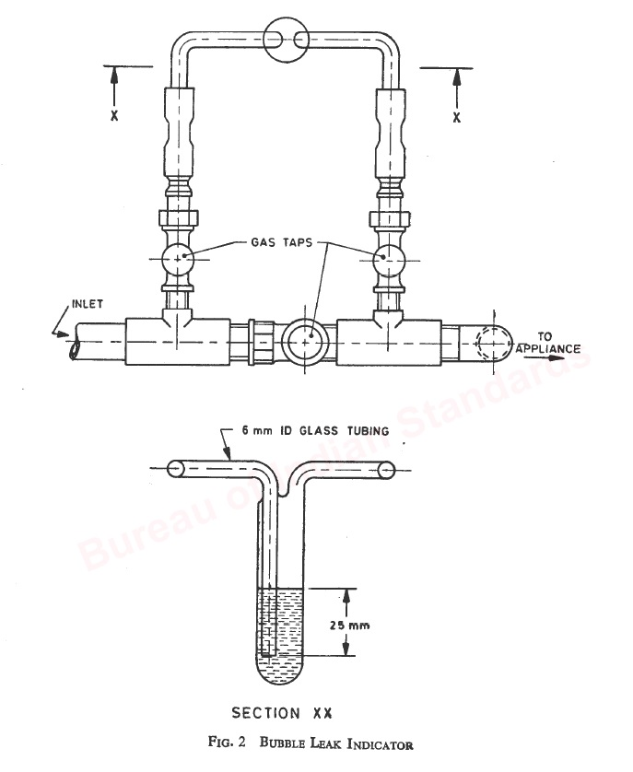

**10.2.1.3** *Olive compression connections* –Use a steel tube with a new brass olive of the recommended size, apply the torque (see Table 1) to the nut and proceed as in **10.2.1.1** above. Discount any deformation on the olive seating or matting surface consistent with the torque applied.

**10.2.1.4** *Flanged connections*- Clamp the flanged connection in the normal manner, apply the torque to the opposite connection and proceed as in **10.2.1.1** above.

**10.2.1.5** *Threaded outlet for injectors*- Select a torque from Table 1 for a thread size (by major diameter) at least as large as the injector thread equivalent to a particular nominal inlet size. Apply this torque to the injector for 10 seconds. Check the tap for deformation and leakage.

**10.2.2** *Bending Moment Test (Applicable to Threaded Connections only )*

Following the torque test given in 10.2.1 either the inlet pipe is clamped within 5 D of the connection boss, where D is the nominal diameter of the pipe, or the flanged connection is clamped in the normal manner. A force equivalent to the bending moment (see Table 1) shall be applied to the outlet connection. This force shall be applied either to the outlet pipe used in **10.2.1** or to a suitable flanged pipe which is clamped to the flanged outlet connection in the normal manner. The force shall be applied for approximately 10 seconds in each of four directions perpendicular to each other and to the axis of the pipe.

**10.2.2.1.** Clamp the outlet pipe and apply the test force to the inlet pipe. Check the tap for deformation and leakage.

**11 ENDURANCE TEST**

**11.1 Requirement**

Two taps shall be subjected to an endurance test comprising a cycling test and a subsequent static test according to the procedures given in **11.2**, **11.3** and **11.4**.

**11.2** **General conditions of Test**

**11.2.1** The taps shall be tested with air at a pressure of 2.942 to 3.432 kN/m3 (30 to 35 gf/cm2).

**11.2.2** The taps shall be tested in a chamber which can be heated and cooled to the required temperature within 15 to 20 minutes.

**11.2.3** The tapes shall not be regreased during the test.

**11.3 Cycling Test**

**11.3.1** *Definition*

For the purpose of these tests a ‘cycle’ consists of OFF-ON-OFF operation, that is, starting from the closed position (but unlocked), whereby the tap is turned (or operated) at specified rate of movement to the end of its travel and back at the same rate of movement to the closed position without locking or retaining a pressure against the stop.

**11.3.2** *Conditions*

The rate of movement of the operating member shall be between 1.5 rad/s and 2.6 rad/s irrespective of the total angular movement for rotary operation, or approximately 10 mm/s for axial operation.

**11.3.2.1** In a multi-station test rig. Adjustment for variation in angular or linear movement between taps shall be available. Where continued supervision is not available for the test, it is advisable to incorporate friction clutch or other device to cut out any particular tap if, and when, the maximum torque or axial force is exceeded.

**11.3.2.2** Alternatively the test may be carried out manually using reliable counting device.

**11.3.2.** *Procedure*

The tests shall be carried out for periods alternately at the working temperature of 80 ˚C or at the maximum operating temperature as stated in the operating instructions, whichever is the higher and at ambient temperature or at the minimum operating temperature as stated in the operating instructions, whichever is the lower. Each period shall consist of the number of cycles according to the ‘service suitability number’ ( see **13** ) stated in Table 2 and the test shall continue until completion of the total number of cycle required or the tap fails.

**Table 2 Endurance Test cycles**

|  |  |  |  |
| --- | --- | --- | --- |
| **Service suitable Number** | **Number of Cycles for Each Period at** | | **Total number of cycles** |
| **Maximum Temperature** | **Ambient Temperature** |
| 1 | (5h ON) | 50 | 300 |
| 2 | Nil | 300 | 300 |
| 3 | 1000 | 1000 | 3000 |
| 4 | 1200 | 1200 | 6000 |
| 5 | 2000 | 2000 | 10000 |
| 6 | 2000 | 2000 | 20000 |

**11.4 Static Test**

On completion of the cycling test. The taps shall be heated for period of 2 hours at the maximum working temperature in the ON position. After this the tap shall satisfy the requirement of **9**.

**11.5 Accelerated Ageing Test**

The tap shall be maintained at a temperature of 10˚C above the maximum working temperature with the inlet and outlet ports open to atmosphere for a period of 4 weeks. The tap shall meet the requirement of **5.4, 11.2, 11.3 and 11.4** after this period. Accelerated Ageing test shall be type test (design approval).

**12 TESTS FOR FLAME FAILURE DEVICE**

**12.1** Requirements for the flame failure device shall be as under:

a) Shall cut off gas to the main burner if the flame is not established.

b) May be actuated manually or by ignition system, if provided, to ignite the main burner or pilot without failure or delay,

c) Shall open and close in time not exceeding the followings:

*Operation Time*

*Manually operated, Non Manually operated*

*Seconds Seconds*

Opening from cold 10 90

Closing from the 60 90

Fully heated condition

**12.2** The flame failure device shall be tested by the method given in Annex D.

**13 SERVICE SUITABLITY NUMBER**

The service suitability number of a tap designates the degree of severity of service for which the tap is intended. Typical service applications corresponding to the six service suitability number are given in **Table 3.**

**Table 3 Service Suitable Number**

|  |  |  |
| --- | --- | --- |
| **Service Suitable** | **Average rate of Usage** | **Examples of Application** |
| 1 | Up to 30 per year | Pilot (domestic) |
| 2 | Up to 30 per year | Refrigerator |
| 3 | 6 operations per week | Drying Cabinet, hot cupboard, oven, wash boiler |
| 4 | 12 operations per week | Pilot (Catering), Space heater |
| 5 | 20 operations per week | Grill |
| 6 | 60 operations per week | Hotplate |

**14 FINISH**

Where a finish coating is applied, it shall comply with the requirements in the appropriate appliance standard. Adequate precautions shall be taken to ensure that any form of coating shall not impair the safety performance of the tap.

**15 BIS Standard Mark**

**15.1** Each tap shall be clearly and permanently marked with the manufacturer’s name or identification mark.

**15.2** The gas taps also shall be marked with the BIS Standard Mark.

The use of the Standard Mark is governed by the provisions of *Bureau of Indian Standards Act,* 2016 and the Rules and Regulations made thereunder. The details of conditions under which the license for the use of the Standard Mark may be granted to the manufacturers or producers may be obtained from the Bureau of Indian Standards.

**ANNEX A**

**(Clause 2)**

**IS No. Title**

IS 319: 2007 Free cutting brass bars, rods and section - Specification (Fifth Revision)

IS 410: 1977 Specification for cold rolled brass sheet, strip and foil (Third Revision)

IS 617: 1994 Cast aluminium and its alloys - Ingots and castings for general engineering purposes - Specification (Third Revision)

IS 742: 1981 Specification for zinc base alloy die castings (Second Revision)

IS 1264: 1997 Brass gravity die castings - Specification (Fourth Revision)

IS 1655: 1991 Metallic materials - Zinc alloys - Code of practice for manufacture of pressure die castings (Second Revision)

IS 2501: 1995 Solid drawn copper tubesfor general engineering purposes - Specification (Third Revision)

IS 4246:2002 Domestic gas stoves for use with liquefied petroleum gases - Specification (Fifth Revision)

IS 4454(Part 4):2001 Steel wires for mechanical springs: Part 4 stainless steel wire (Second Revision))

IS 5116:2020 Domestic and Commercial Equipment for Use with LPG — General Requirements (Fourth Revision)

IS 6480:1988 Glossary of terms relating to domestic and commercial gas burning appliances (First Revision)

IS 6912: 2005 Copper and copper alloys forging stock and forging - Specification (Second Revision)

IS 7608:1987 Specification for phosphor bronze wire for general engineering purposes (First Revision)

**ANNEX B**

**(Clause 5.16 )**

**RECOMMENDED REQUIREMENT FOR TAP APPLICATION**

**B-1 KNOB**

**B-1.1** The knob shall only be able to be replaced in the correct position.

**B-1.2** The knob shall have a minimum length of positive engagement of 6 mm with the ‘D’ Section or other engagement of the spindle. The engagement shall not depend upon any retaining spring clip used solely retaining purposes.

**B-1.3** The knob shall withstand a minimum hand applied torque of 3 Nm without damage.

**B-2 TAP**

**B-2.1** The effect of light-back, faulty door seals, etc., should be considered (see Foreword for the effects of excessive temperature that may arise through faulty operation of an appliance).

**ANNEX C**

**( Clause 6.1 )**

**MATERIALS**

Examples of suitable materials are specified are specified below :

Alloy LM 6, LM 20 Bodies – Alloy 4600 and 4600 of IS 617 : 1994

Alloy DCB 1 Bodies (die castings )- DCB 1 of IS 1264 :1997

Alloy DCB 3 Bodies (pressure die castings ) -DCB 2 of IS 1264 : 1997

Alloy CZ 122 Bodies, Plugs (hot pressed ) – Leaded Brass of IS 6912 : 2005

Alloy CZ 121 Nut, etc- Grade I of IS 319 : 2007

Alloy PB 102, PB 103 Springs (photophour bronze ) Grade I and II of IS 7608 :1987

Alloy En 56 series Springs (Stainless steel) – Grade 1 of IS 4454 (Part 4 ):2001

Alloy C 106, C 107 Tubes – Grade Cu-DHP and Cu-DPA of IS 2501:1995

Alloy CZ 108 Washers- Alloy CuZn37 of IS 410:1977

**ANNEX D**

**(Clause 12)**

**METHOD OF TEST FOR FLAME FAILURE DEVICE**

**D-1** The following equipment’s are required for the test:

a) A device having a burner and arrangement for fitting the gas tap (to control the gas supply to the burner). The burner shall also have arrangement for fixing the heat sensing device with burner head;

b) Pilot burner with igniting jet having provision of fitting the heat sensing device and to be fitted with main burner head.

c) LPG cylinder with regulator and rubber tube;

d) Stop watch; and

e) Igniting device.

**D-2** Gas tap and heat sensing device shall be fitted with device given in **D-1** (a) according to the recommendation of the manufacturer. Switch on gas tap and allow gas supply to the tap. Hold the igniting device [refer **D-1** (e)] near burner head and ignite the burner by operating the device of the gas tap as per manufacture’s recommendation. When burner is ignited start the stop watch. Release the device after 10 seconds and watch the flame. The flame shall not extinguish.

**D-3** The flame shall be brought to simmer position by operating the gas tap. Watch the flame for 5 minutes and the flame shall not extinguish.

**D-4** Allow the burner to operate at “FULL ON” for 30 minutes. Extinguish the flame and start stop watch. Immediately after 60 seconds the burner shall not get ignited without operating the device manually.

**D-5** For burner with pilot flame provision the pilot burner with igniting jet shall be fitted as per manufacturer recommendation.

**D-5.1 Opening**

With the appliance cold and the main gas turned off, turn on and ignite the pilot jet. Turn on the main burner tap or tap and water taps, if necessary. Note the time required from ignition of the pilot for the gas in the main burner to ignite.

**D-5.2** Extinguish the pilot flame (where heat sensing device is fitted). The flame of the main burner should extinguish automatically (due to cut-off of gas supply) within 90 seconds.

**D-6** After the flame failure and the device is preventing the gas the main burner (while the gas cock is at “FULL ON” position) the total gas leakage shall hot exceed 1.5 l/h at standard pressure.