**ACTION RESEARCH REPORT**

**MED 22 - (Compressor, Blowers and Exhausters)**

**IS 13124: Breathing air compressor package - Specification**

**1. History**

This Indian Standard was adopted by the Bureau of Indian Standards, after the draft finalized by the Compressors, Blowers and Exhausters Sectional Committee had been approved by the Mechanical Engineering Division Council.

Assistance has been derived from following International standard while preparing the draft of the IS.

|  |  |  |  |
| --- | --- | --- | --- |
| **Standard**  **(No. & Title)** | **Whether the standard has since been revised** | **Major changes** | **Action proposed** |
| BS EN 12021 Respiratory protective devices - Compressed air for breathing apparatus. | Revised in 2001 | No change | No change required. |

However the provisions of MIL-PRF-32195:2005 and BWB TL 4310-0039: 2ED 1991

can be considered while reviewing the IS.

|  |  |  |
| --- | --- | --- |
| **Standard**  **(No. & Title)** | **Provisions that could be relevant while reviewing the IS** | **Action proposed** |
| MIL-PRF-32195:2005  Large Capacity High Pressure Breathing Air Compressor (HPBAC). Published by US Military Specs/Standards/Handbooks | This specification covers the High Pressure Breathing Air Compressor (HPBAC) used by Navy personnel as part of the shipboard breathing air system to refill breathing air cylinders used with the open-circuit self-contained breathing apparatus (SCBA). | The provisions of US military standards can be considered while preparing the review of the IS. |
| BWB TL 4310-0039 : 2ED 1991  Breathing Air Compressor, 0.25 CBM/Min, 200/300 Bar, Electric Motor 440 V/60 Hz, Shockproof. Published by Federal Office for Defense Technology and Procurement, Germany | The standard needs to be studied thoroughly to find out the relevant provisions. | No change required. |

**2. Literature Survey**

**2.1 About Breathing air compressor:**

A breathing air compressor is used to fill up the oxygen bottles used for fire-fighting or entering enclosed spaces. The breathing air compressors, as they are known, needs to be operated in a special way. They are smaller than the conventional compressors found on ship.

While operating the breathing air compressor, there are certain points that should be followed in order to ensure smooth starting and operation of the compressor. The article describes the procedure for starting a breathing air compressor on a ship.

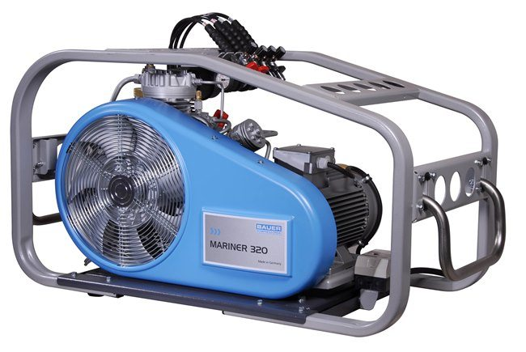

***Fig*. Breathing Air compressor**

**3. Manufacturers and respective stakeholders:**

* Burckhardt Compression India Private Limited, Noida (Committee Member)
* Dresser-Rand India Pvt. Ltd. Pune (Committee Member)
* Kirloskar Pneumatic Company Limited, Pune (Committee Member)
* Neuman and Esser Compressor Application Centre Private Limited, Pune (Committee Member)

**4. Views of Industry Experts:**

* References can be updated with revision

**5. Conclusion**

As breathing air compressorare of vital importance, and for optimizing the performance and safety of the same, so aligning the current version of IS 15879 with latest technological developments and industrial practices is the need of hour.