**ACTION RESEARCH REPORT**

**SPECIFICATION FOR HOT FOOD CABINETS FOR USE WITH LPG AS PER IS 5544: 1970**

**1. Background**

This Indian Standard was adopted by the Indian Standards Institution on 8 January 1970, after the draft finalized by the Domestic and Commercial Gas Burning Appliances (Pressure Type) Sectional Committee had been approved by the Consumer Products Division Council.

In preparing this standard, assistance has been derived from BS 4104: 1967 ‘Specification for catering equipment burning liquefied petroleum gases’, issued by the British Standards Institution. The standard BS 4104: 1967 has been superseded by difference standard such as BS 5809: 1980 ‘Specification for safety and efficiency of the gas heating equipment of commercial dishwashing machines’ and BS 5314 (Part 2): 1976 'Specification for boiling burners' which is again superseded by BS EN 203-1:2014 – ‘Gas heated Catering equipment’.

The product is one of a series of Indian Standards on various domestic and commercial gas burning appliances used with liquefied petroleum gas and hence most of the requirements given in IS 5116: 2020 are relevant in IS 5544. Moreover, IS 5116 was prepared with the assistance of BS 5314(Part 2): 1976 which was superseded by BS EN 203-1: 2014. IS 5544 is currently under the technical committee MED 23 (Domestic and Commercial Gas Burning Appliances Sectional Committee).

**2. Introduction:**

Hot Food Cabinet is an appliance used to keep a food warm for a long period of time. The appliance is widely used in hotel and restaurant for storage and display of food for the customer. Nowadays, it is also commonly used in home and offices as it play an important role for keeping the food longer and ready to serve.

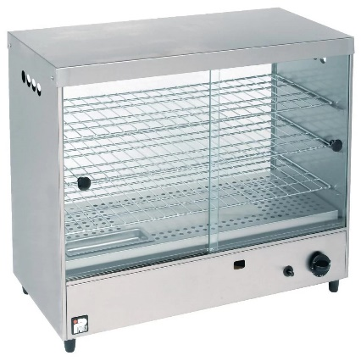

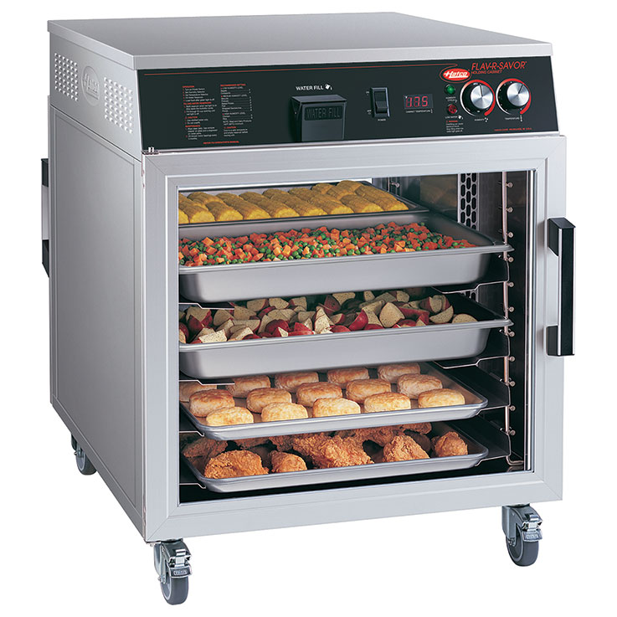

Fig. Hot food Cabinet

The appliance can operate from ambient temperature to 90˚C and 24 h a day. The source of power for hot food cabinet is through electrical or LPG or Batteries. Hot Food Cabinet having electrical power source has dominated the Indian market and the customer preferred it more due to its efficiency and ease of availability of power source. On the contrary, Hot Food Cabinets for use with LPG products are less common and unpopular in Indian market. In view of this, the drafting of Indian Standard for Electric Hot Food Cabinet is highly required.

**3. Literature Survey:**

**3.1 Types of Hot Food Cabinet:**

The following are the different types of hot food cabinets:

**3.1.1 Source of Power:**

* Electric powered hot food cabinet,
* LPG based hot food cabinet and
* Batter powered hot food cabinet.

**3.1.2** **Source of Heating**:

(a) For LPG based Hot Food Cabinet:

* With heated top
* Without heated top

(b) For electric powered hot food cabinet:

* **Bottom-mounted -** Heating elements mounted in the bottom of the cabinet or base of the unit let heat rise.
* **Top-mounted -** Models with heating elements on top typically require a fan to distribute heat evenly throughout the cabinet.
* **Convection -** Some models have fans to circulate hot air through the cabinet, keeping food warm with convection. Heating elements may be top- or bottom-mounted.
* **Wraparound -** Designs models with heating elements in the walls of the cabinet, surrounding the food inside with radiant heat, eliminating the need for a fan.

**3.1.3 Insulation:**

* **Fiberglass Insulation:** It is used in double wall insulated cabinets and have a thickness of 38 to 50 mm.
* **Polyurethane Insulation:** The insulation is a foam type and it can retain heat even better.

**3.1.4 Based on Humidity:**

* **Passive humidity:** These systems let you fill a pan of water, usually about a gallon, in the base of the unit. The heated pan releases moisture.
* **Active humidity:** Many models have separate, enclosed water tanks and heaters to control moisture in the cabinet.

**3.1.5 Base on Mobility:**

* **Stationery:** It is mostly located in a particular place and common for low weight and dimension.
* **Non Stationery:** It is mostly for bulky product. It is also provided with a castors and can be moved from one place to another.

**3.2 Manufacturing process of Hot Food Cabinets:**

The manufacturing process flowchart of Hot Food Cabinet is illustrated as below, however, it may be varied based on the types and design of the cabinet.

Raw Material Such as Steel angles for frame, Aluminium or Stainless Steel Sheet and Strips, Insulator, thermostat, knobs, cables, handles etc

Construction of the frames by welding and attachment of the Inside panels by Spot Welding and closed with the outside panel after insertion of the insulator.

Assembly of heating element and fixing of wire/

Installation of gas burner or warmer inside the cabinet

Fixing of Thermostat

Assembly of Knobs and Pilot Lamp

Fixing of shelves followed by door slider or hinges

Fixing of handles and castor if required

Testing of the Product

Dispatch

**3.3 Technical and Safety Requirement of Hot Food Cabinets:**

The safety requirement, construction and performance requirement of Hot Food Cabinets powered by LPG is available in BS EN 203-1: 2014 and IS 5116: 2020. Most of the requirements can be incorporated in the standard IS 5544. In addition to this, the temperature distribution test and heating test as mentioned in IS 5544 are the important requirement of hot food cabinets for use with LPG.

Moreover, the technical and safety requirement of electrically operated hot food cabinets can be derived from IS 10264: 1982 ‘Specification for Trolley, Hot Food for Hospital and Industrial Canteens and IS 302: Part 1: 2008 ‘Safety of Household and Similar Electrical Appliances’. However, IS 10264 also required revision considering the latest technical development in the field.

**3.4 Latest Developments in Hot Food Cabinets:**

Hot food cabinets for used with LPG are manufactured with back-up power source such as battery or electricity and vice versa. The appliance are fitted with digital panel for control and display. And most of the products in the market are only powered by electrical source.

**4. Manufacturers of** **Hot food cabinets in India:** The following are some of the manufacturers of hot food cabinets in India-

1. Akasa International, Shadipur, New Delhi
2. Deokali Engineering Works, Delhi
3. BSH Household Appliances Manufacturing Private Limited, Chennai
4. Global kitchen equipment’s company, Tamil Nadu

**5. Recommendation:**

The following point may be noted while revision or redrafting of the standard IS 5544:

* The materials along with its grade and the relevant Indian Standards to be referred may be incorporated in the revised or redrafted IS.
* The requirement for electrically operated hot food cabinet may be incorporated. However, it is recommended that separate standard may be drafted for electrical hot food cabinet.
* All the important relevant clause of IS 5116: 2020 and BS EN 203-1: 2014 may be incorporated.
* The marking and packing clause should be revised. And guidelines for instruction sheets may be provided.
* The provision for important safety caution to be marked on the product may be provided in the standard.
* The requirement for castors may be provided for non-stationery appliances.

**6. Conclusion**

Considering the importance of safety and performance requirement, latest development in technology, popularity and demand in Indian Market, the current standard for hot food cabinet IS 5544 may be redrafted or prepared especially for electrically powered hot food cabinets or both electric and LPG powered vehicles for the benefits of all the stakeholders.

**7. References**

* <https://mobcater.com/product-category/catering-appliances/pie-warmer/>
* <https://www.fermag.com/articles/9280-hot-transport-mobile-hot-holding-cabinets/>
* <https://www.services.bis.gov.in:8071/tmp/139970746_5544.pdf>
* http://www.dcmsme.gov.in/old/publications/pmryprof/electrical/ch15.pd