**FORMAT FOR SENDING COMMENTS ON BIS DOCUMENTS**

**DOC. NO. : TED 7**

**TITLE: IS 10694:2009 Tyre Valves — AUTOMOTIVE VEHICLES – RIMS – GENERAL REQUIREMENTS**

**PART 1 : NOMENCLATURE, DESIGNATION, MARKING AND MEASUREMENT**

**(Second Revision)**

**NAME OF THE COMMENTATOR / ORGANIZATION : KALYANI MAXION WHEELS**

|  |  |  |  |  |
| --- | --- | --- | --- | --- |
| **Sl. No.** | **Clause/Sub-clause/ Para/Table/Fig. No. commented** | **Type of Comments**  **(General/Editorial/ Technical)** | **Proposed change** | **Justification** |
| 1. | Page 3  Cl. 3.1.f | Editorial | Remove  **“f) Number of relevant Indian standard”** | IS Marking is not done on wheel for size designation etc. |
| 2 | Page 4  “**4½ J x 15 or 15 x 4½ J”**  “**4½ J x 15 H2 or 15 x 4½ J H2”**  **(Under width column)**  **4½** | General | “**4½ J x 15 or 15 x 4½ J or 4.5 J x 15 or 15 x 4.5 J”**  “**4½ J x 15 H2 or 15 x 4 J H2 or 4.5 J x 15 H2 or 15 x 4.5 J H2”**  **4½ or 4.5** | The marking is done is in decimal form also. |
| 3 | Page 7 (Fig 8 right column)  “Valve hole”  “Valve hole location” | General | “Valve hole / slot”  “Valve hole / slot location” |  |
| 4 | Cl. 4.1.1.  “3 mm”  Cl. 4.1.2  “outer side”  Cl. 4.1.2.  “inside” | Technical  Editorial  Editorial | “2 mm”  ”outer side or weather side”  “inside or tyre side” |  |
| 5 | Cl. 4.2. c  Date of manufacturing: year and month or year and quarter of the year. (For example: “8403” indicates March 1984, “84 III” indicates Third quarter of 1984) | Editorial / Technical | “Date of manufacturing: At least year and month or year and quarter of the year. Actual marking may with numbers or alphabets with suitable coding system as decided by wheel manufacturer. (Some examples: “1403” indicates March 2014, “14 III” indicates Third quarter of 2014, “AB” indicates A as a month and B as a Year) |  |
| 6 | Page 12 | Technical | Add attached figure |  |
| 7 | Page 13  Fig. 20:  Tape thickness: 0.3 ± 0.085 | Technical | Tape thickness: 0.3 ± 0.015 |  |
| 8 | Page 13  (Below Fig. 20) | Technical | Add notes:  Reference Temperature 20°C.  The tape must be marked with details of rim width code and nominal diameter.  Note:   1. Measurement are to be made on rims ready for tyre mounting. 2. Rim measurement is to be done with reference to mandrel |  |
| 9 | Page 12:  5.3 “shall be as per Fig. 22, Fig.23 and Fig. 24 and…” |  | “shall be as per Fig. 22 and Fig. 23 and…” | (Fig 22 and Fig. 23 on page 15 are same) |
| 10 | Page 13, Fig 20  Tape Mandrel D  Surface roughness: N6  Change Tolerance on tape thickness 0.3 ± 0.085    Fig. 21 A: Change Dimension 11.5 ± 0.2  Fig. 21 B: Change Dimension 15.9 ± 0.2  Fig. 21 C: Change Dimension 15.9 ± 0.2  Fig. 21A, B, C, D Notes on chamfer: Change “REMOVE SHARP EDGES MAX CHAMFER 0.5”  Fig. 21 A, 21 B: “VALVE HOLE CENTRALLY LOCATED ON NARROW BEAD SEAT OF WELL SIDE” |  | Tape Mandrel D – 0.05  N5  0.3 ± 0.015  11.3 +0.4  15.7 +0.4  🡪 15.7 +0.4  “ THE EDGE OF RIM HOLE SHALL BE ROUNDED OR CHAMFERED 0.5 MAX”  Remove this note | Add tolerance  In line with national and International manuals |
| 11 | Page 14  Fig. 21E and 21 F Notes on chamfer: “REMOVE SHARP EDGES MAX CHAMFER 0.5” | Technical | “ THE EDGE OF RIM HOLE SHALL BE ROUNDED OR CHAMFERED 0.5 MAX” |  |
| 12 | Page 15  Figure 22  FIG 24.  “TWO MOUNTABLE FLANGES” | Editorial  Editorial | Remove Fig. 22  FIG. 24. “TWO DEMOUNTABLE FLANGES” |  |
| 13 | Page 16:  Table 2:  No table | Technical | Add table - below |  |
|  |  |  |  |  |

**Change 6:**

FIG. XX METHOD OF USING TAPE

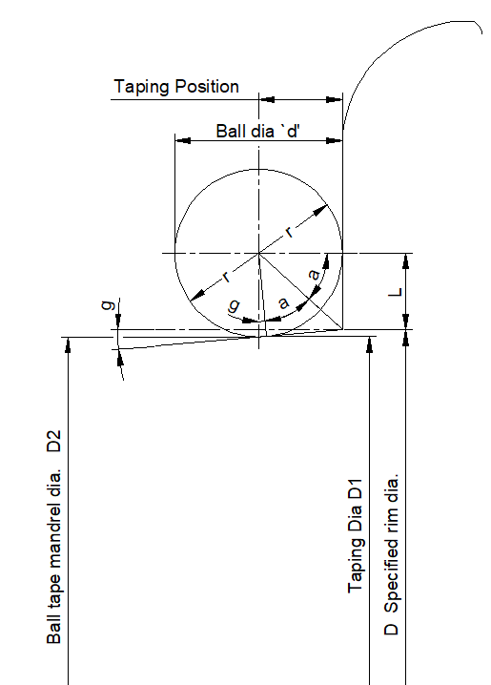

D1 = D - 2 (*r – l*) where *l* = *r* * tan (a) and

∴ D = D1 + 2 (*r – r* * tan (a))

∴ D = D1 + 2 (*r – r* * tan ($\frac{90° – g}{2}$))

*Examples:*

For *ϕ* 20 ball, and for a = 5°

D = D1 + 2 (10 – 10* tan ())

∴ D = D1 + 2 (10 – 10* 0.91633)

∴ D = D1 + 1.673377

For *ϕ* 16 ball, and for a = 5°

D = D1 + 2 (8 – 8x tan ())

∴ D = D1 + 2 (8 – 8x 0.91633)

∴ D = D1 + 1.338701

|  |  |  |  |  |  |
| --- | --- | --- | --- | --- | --- |
| Angle of Taper  (g) | Ball Tape Diameter (mm) | | | | |
| 8 | 10 | 14 | 16 | 20 |
| Factor ɛ | | | | |
| 1° 30° | 0.206745 | 0.258431 | -- | 0.413490 | 0.516863 |
| 3° | 0.408283 | 0.510354 | -- | 0.816567 | 1.020709 |
| 5° | 0.669351 | 0.836688 | 1.171364 | 1.338701 | 1.673377 |
| The original inch values of specified rim diameters are used for the calculations of tape mandrels (D) | | | | | |

FIG. xx METHOD OF USING TAPE AND CALCULATION OF DIMESIONS FOR THE MEASUREMENT OF TAPERED BEAD SEAT RIMS

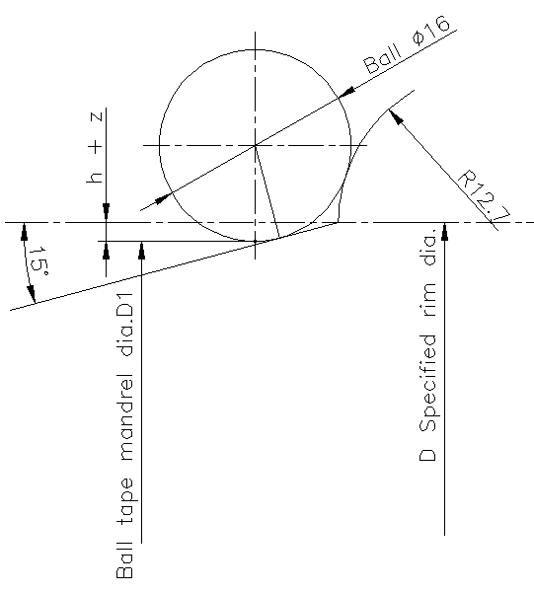 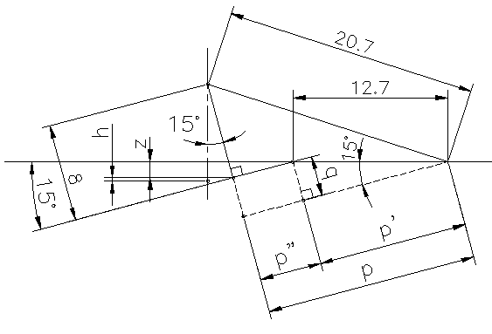

q = 2.7 x sin 15° x 0.2588190451 = 3.287001873

p = $\sqrt{20.7²-\left(8+q\right)²}$ = $\sqrt{301.0935887}$ = 17.35204855

p’ = 12.7 x cos 15° = 12.7 x 0.9659258263 = 12.26725799

p” = p – p’ = 17.35204855 – 12.26725799 = 5.084790552

z = p” x sin 15° = 5.084790552 x 0.2588190451 = 1.316040635

h = 8 (1-cos 15°) = 8 x 0.0340741737 = 0.2725933897

h+z = 1.588634025

D1 = D - 2 (h+z) = D – 3.17726805

FIG. XX METHOD OF USING TAPE AND CALCULATION OF DIMESIONS FOR THE MEASUREMENT OF 15° DROP-CENTRE RIMS

**Change 13:**

Add 5 rows for 5° taper with Ball dia 14 as below

|  |  |  |  |
| --- | --- | --- | --- |
| 5° TAPER | | Ball dia 14 | |
| 15 | 380.2 | 379.03 | 1190.8 |
| 16 | 405.6 | 404.43 | 1270.6 |
| 17 | 436.6 | 435.43 | 1367.9 |
| 18 | 462.0 | 460.83 | 1447.7 |
| 19 | 487.4 | 486.23 | 1527.5 |
| 20 | 512.8 | 511.63 | 1607.3 |

**For Comments only**