Indian Standard
APPLICATION GUIDE FOR
ELECTRICAL RELAYS FOR ac SYSTEMS

PART II OYERCURREHT RELAYS FOR
GENERATORS AND MOTORS

( Si.xth Reprint AUGUST 1996 )

UDC 621.316.925.43:621.3 13

O C'op›u‘i¿lit 1967
D II II E A U O F I N D I A N S T A N D A R D S MANAK BI IA VAN, 9 B.AI IAD UR SI IAH ZAFAR MAR G N EW D E LI1 I 11(1002


Marcb 1967

Indian Standard
APPLICATION GUIDE FOR ELECTRICAL RELAYS FOR ac SYSTEMS
PART II OVERCURRENT RELAYS FOR GENERATORS AND btOTORS

Relays Sectional Committee, ETDC 3â

Tata Hydro-Electric Power Supply Go Lid, Bombay
Shri K. M. Chinnappa )
Sagi M. C. Bxsavxzinoxixo Mysore State Electricity Board, Bangalore gear S.K. B+txns Heavy Eltctrical• t India ) Ltd, Bhopal
Star A. RaJzazo Alrrnat‹ 1
Scar V.S. Baxzia Siemens Engineering and Manufacturing Co of India
Ltd, Bombay

Seaz A. Dana J ' *imiled, Baroda
Seri B.K. Muxiizmas National Test House, Calcutta
Syst R. Psnuxnzaoxu The Tata Iron and Steel Co Ltd, Jamshedpur
Snei S.G. Pxazsoz Directorate General of Supplies & Disposals ( Inspec-
tion Wing ) ( Ministry of Supply, Technical Development & Materials Planning )
 The English Electric Co of India Ltd, Madras
Paor H. N. Rxux en xxnez R xo Indian Institute of Science, Bangalore San P. Renoxawau v Hindustan Steel Limited, Ranchi
Seri V. Ssszs•sxu xiv Railway Board ( Ministry of Railways ) Suai P.K. See Punjab State Electricity Board, Patiala
Seat C.S. S+tsunivzsxx Central Yt'ater & Power Commission ( Power Wing )
Directorate General of Posts & Telegraphs  rransport & Communications )
Sun H.S. Viawaawaniza Radio & Electricals Manufacturing Co Ltd, Bangalore STfni Y. S. VEnznzsswanan. Director Generals BIS ( ñ•-•Qcio Member )
Director ( Elec tech )


Srisi R. C. BxJrni Assistant Director ( Elec tech )
BUR E AU O F I N D IAN STAND A R D S MANAK BHA VAN, 9 BAHADUR SHAH ZAFA R MARO NEW DELHI 110002
Pa nel for Application Guide for Electrical Relays, ETDC 35/ P2

PxorH.N.R*x*ca*xoxAR&o

Siisi M. C. Bxsavaziuoaizit Siisi S. K. Benzix
Siiai N. Nama Suzi P. K. Szn
Siisi G. S. Terms
Indian Institute of.Science, Bangalore

lvlysore State Electricity Board, Bangalore Heavy Electricals ( India ) Ltd, Bhopal
The Engl ish Electric Co of Ind ia Ltd, Madra.s Punjab State Electricity Board, Patio la
Tata Hydro-Electric Power Supply Co Ltd, Bombay

Indian Standard
APPLICATION GUIDE FOR
ELECTRICAL RELAYS FOR ac SYSTEMS
PART I I OVERCURRENT RELAYS FOR GENERATORS AN D f*lOTORS

0. F O R E W O R D
  - This Indian Standard ( Part II ) was adopted by the Indian Standards Institution on 19 December l9Gfi, after the draft finalized by the Relays Sectional Committee had been approved by the Electrotechnical Division Council.
  - Modern power systems are designed to provide uninterrupted electrical supply, yet the possibility of failure cannot be ruled out. The protective relays stand watch and in the event of failures, short-circuits or abnormal operating conditions help de-energize the unhealthy section of the power system and restrain interference with the remainder of it and thus limit damage to equipment and ensure safety of personnel. They are also used to indicate the type and location of failure so as to assess the effectiveness of the protective schemes.
  - In spite of the many refined protective schemes available today, the overcurrent protection has held its osvn because of its simplicity and econo- mical cost. Subsequent to the publication of IS : 3231-1965*, it was felt that an application guide for overcurrent relays be prepared so that the system planning engineers may select and apply the overcurrent relays correctly from among the multitude of those available today.
  - The features which the protective relays should possess are:
    - Relialaility, that is, to ensure correct action even after icia¿c J eriods of inactivity and also offer repeated opei ations under severe condi- tions;
    - Selectivity, that is, to ensure that only the unhealthy part of the system is disconnected;
    - Sensitivity, that is, detection of the short-circuit or abnormal operating condition;
    - Speed to prevent or minimize damage ate d risk of instability of rotating plant; and
°Specification fo r electrical relays for power system protection .

3

Stability, that ii, the ability to operate only under those conditions that call for its operation and to remain either passive or biaied against operation under all other conditions.

  - Thii guide dealt mirth only those relays wiiich are covered by IS : 3231-1965*. When overcurrent protection for motors is provided in the motor starters reference should be made to IS : 1822 -1967 and IS : 3914-

  - This guide hai been prepared mainly to hssist protection engineer in application of overcurrent relays installed as a separate unit for genera- tors and motors. Few practical exarpples have also been included to illustrate the application of these relays, their settings, etc. However, it is emphasized that this guide has been prepared to assist rather than to specify the relay to be used. This guide deals only with the principles of application of overcurrent relays and does not deal with the selection of any particular protective scheme. The actual circuit conditions in all probability may be different from those described here. The examples, even though drawn from actual field applications, should be regarded as mere illustration of one or the other point.

  - In the preparation of this guide considerable assistance has been derived from several published books and from manufacturers’ trade literature. Assistance has also been rendered by State Electricity Boards in collecting actual examples.

  - This guide is one of the series of Indian Standard application guides for electrical relays for ac systems. The other guides in this series are:
IS : 3638-1966 Application guide for gas-operated relays
IS : 3842 ( Part I ) -1967 Application guide for electrical relays for ac systems: Part I Overcurrent relays for feeders and transformers

IS : 3842 ( Part III )-1966 Application guide liar electrical relays for ac systems: Part I II Phase unbalance relays including negative phase sequence relays
IS : 3842 ( Part IV )-1966 Application guide for electrical relays for ac systems: Part IV Thermal relays
•.Specificatfon for electrical relays for power system protection.
}S§ecification for ac motor starters of voltage not exceeding 1 000 t›I ts ( fret rei ision j
t Code of practice for selection of ac induction motor starters ( s oltage not exceeding
1 00b YOl ts ) •

4
I.8COPE
I.1 This guide deals with application of overcurrent relays for ac systems covered by IS : 3231-1965* for generators and motors.

This guide does not cover:
    - the principles of system design and system protection, and
    - application of such relays which form an integral part of a motor starter.
- TERMINOLOGY
  - For the purpose of this guide, the definitions given in IS : 1885 ( Part IX )-1966{ and Part I of this guide shall apply.

OVERCURRENT RELAYS FOR GENERATORS
8.1 General

3.1.i Overcurrent relays have a limited application in the protection schemes for generators as they cannot provide as good a protection for the generators as differential relays. They are principally applied to provide back-up protection for sustained external faults, that is, on the bus-bars or on the feeders. However, they also act as back-up to the differential protection on internal faults where bus-bars can feed into the faults.
3.1.2 Simple inverse definite minimum time-lag ( IDMTL ) overcurrent relays as described for the protection of feeders and transformers are, in general, unsatisfactory for phase-to-earth fault back-up protection because certain methods of earthing of the generator, that is, distribution transformer or voltage transformer earthing limit the maximum available earth fault current to a value below the normal settings of inverse time relays.
S.1.3 When used as a back-up protection for sustained external phase faults, the selection of the relay and their settings must be very carefully considered. The synchronous impedance ( which will vary anywhere between’ 110 to 250 percent ), limits the sustained fault current fed by the generators to about the same as, or less than, the rated load current. Due to the rapid decrement of the short-circuit current ( ice Fig. l ), the relay should be so set that it allows sufficient margin over the rated overload capacity of the machine, and, at the same time, is capable of operating at the short-circuit value at full decrement.
    - With an automatic voltage regulator used with machine the sustained fault current would be higher than the maximum load current. In such cares, a simple attracted armature electromagnetic type of overcurrent
°Specification for electrical relays for power system protection.
JRlcctrotechnical vocabulary: Part IX Electrical relays.
X"d CU | R RE NT
 |  |  |  |  |  |  | 7 OR (II | 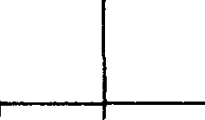  k v C IR C ui'/ j  
 |  |  |  |  |  | EG UL A





NOzz — Voltage regulator In use and ezciter ceiling voltage limited to 1 -35 pu.
0 | 0•5 | T •0 | 1 •5 | 2 0 SE C ONOS
0 | 25 | 50 | 7 5 | i 00 C Y C LE S

Fin. 1 A Tvricac SHORT-Cir curr DEGREh4ENT CURVE

relay in conjunction with a definite time delay relay is used to protect the generator. The overcurrent setting may be about 125 to 150 percent of the full load current of the generator and the definite timing may be between 3 to 6 secor.ds, depending on the individual case. Sometimes three such units are incorporated, one in each phase of the generator; sometimes only one relay in any one phase, along with a phase unbalance relay is used. Instead of the attracted armature relay with definite time delay, an IDMTI. relay may also be used for a generator with an automatic voltage regulator, and is set at about 120 percent of the full load current of the generator.
    - As a back-up for the unit protection of the generator in case of internal phase faults, the setting mentioned earlier is quite satisfactory in cases where the bus-bar fault MVA is appreciably greater than the sustained fault MVA fed by the machine. As a protection against such faults, it is necessary to de-excite the machine by the overcurrent relay.
    - Where generators are not fitted with automatic voltage regulators, the sustained fault currents fed by the generator on an external fault may be less than the maximum load current. In these eases, a voltage restraint or a voltage controlled inverse time provides the necessary discrimination between generator feeding the normal loads, and the generator feeding zuitained external fault currents. These are dealt with in 3.2 and 3A.

6
3•1.7 Overcurrent relays continue to be used to prevent overheating of
the generator rotors on account of prolonged unbalanced currents. These
are described in Part II I of this guide. Overcurrent relays interlocked

with the unit protection are also available where the cost current transformers on both sides of the circuit-breaker is
of providing not justified,

for example, when air blast circuit-breakers are used ( ice ebo 3.B).
  - Overcurrent Relay with Voltage Restraint
    - It is an induction disc relay with a voltage restraint circuit which restrains the action of the current element. The restraining coil distin-
guishes between a normal operating and a short-circuit condition by the
change of voltage even if the magnitudes of currents in the two conditions are equal. The restraining effect is reduced as the voltage drops whenever there is a short-circuit and the overcurrent element then operates. In Fig. 2 time current characteristics of this relay are shown and it may be seen that the sensitivity and speed increase as the voltage restraint decreases. The curves for intermediate values for voltage restraint fall inside the two extremes shown in Fig. 2 but it is better to obtain them from the manu- facturer. Like all other induction overcurrent relays, current taps and time dial arrangement are also provided.

    - It is recommended that current setting of between 200 to 25O percent of the generator rating at rated voltage is selected if there is a continuously acting automatic voltage regulator. The current setting is reduced to 150 to 200 percent if there is no continuously acting automatic voltage regulator. The time multiplier scale is chosen for the zero volt restraint time current characteristic for three-phase faults close to the bus-bar. If the system connection is such that a three-phase fault on or close to the bus-bar did not produce zero volt restraint on the relay, it is necessary to use an appropriate time current curve for voltage restraint between zero and 11$ volts. In Fig. 3 is shown a generator connected to the bus-bar which is feeding a radial circuit. Ordinarily, it is quite sufficient to obtain the time and current settings of the relays at C, B and A, allowing for the co-ordinating time interval of 0 4 second. The time of operation of the back-up relay at A may, however, be reduced if the effect of the decaying current on the performance of the relay at B and A is calculated. A typical decrement curve is shown in Fig. 1.

    - The calculation of the behaviour of relays at A and B on decaying fault current, is ’done by trial and error method. For details of this method reference is invited to 6.4.3.1 of IS : 3842 ( Part I )-1967•. To start with, the time of operation of relay at B is assumed. Then the average current from time zero to the time of operation of relay at B is
•Application guide for electrical relays for ac systems: Part 1 Overcurrent relays for
feeders and Oansformcrs

IS:]84 (PmmII)-1966
obtained from the decrement curve by step-by-step method. If the average current so obtained is insufficient to close the contacts of the relay at Zt, the time of operation of this relay is accordingly raised and the step-by-step method is continued until a satisfactory answer is obtained. The next step is to select a time dial setting for the relav at N to make it selective with relav at B. As may be seen from Fig. 3, that by taking account of the decrement of the fault current, the operation of the generator relay can be made faster by about half a second.

3•3 Voltage Ctozztrol1ed Overcurxezzt Retays
J.'I.1 1his reiay teas an intiuction disc overcurrent eiement with time delay operation and an undervoltage element. The two eJeinents are so connected that undervoltage element on operation modifies the characteristic of tire inverse time element, that is, the operating current is reciuced ñeiow full load current of the machine and the operating time curve is changed to
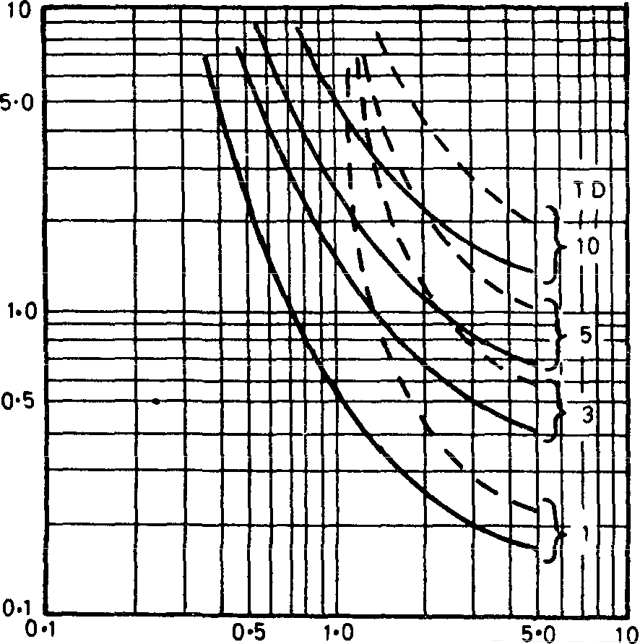

Fo. 2
REmv
C UR RE NT IN MUL7 IP L E S OF PLU G SE T *ING

- - - - 115 VOLTS RESTRA!NT
TIM EIN _SI C ON0 »!
0 YOLT RESTRAINT
TO- RELAY TINE DIAL SETTING
Tm -CURRENT flHARACTER1STIC CURVES OF OVRRCURREMT

8

the standard curve ( set IS : 3231-1965* ) to enable grading under fault conditions to take place more easily. The overcurrent element may be provided with any of the inverse characteristics described earlier, with cur- rent taps and time dial adjustments. The relay may be set to operate on less than full load current when the voltage falls below a predetermined value.

C T RAT IO • z•00/5
25•/.

FAULT

200 0 MVA
x: 0•055 pu

200/5 600/5
J25"/, ›so •/.

OUSBAR
10 MVA GENERATOR
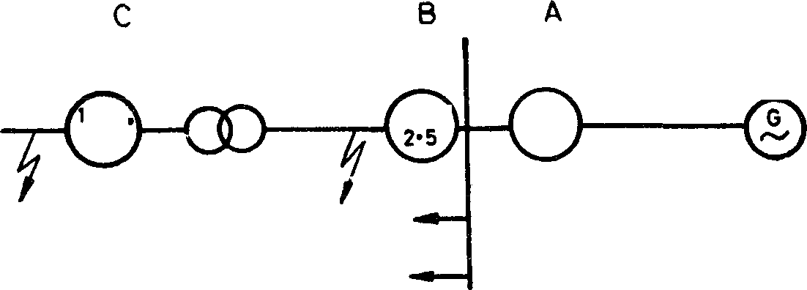
X’d ° 0 •135 pu x^ d' 0•095 pu

 | A - 4•5 TN S Z ERO vOLT
 | A- ?•0 T N S REST RAINT
 | A’— 4•5 T f4 S i0d •k YO L7AGE
 | RESTR TINT
AV E R A GE
5 HO RT - C IR CUIT CURRE N T 0 BTAINE FR0I I DEC RENEUT CU RV E (F | G. l ) T 0 C LOS E
SHORT-C IRCUIT C URRE NT AT C
GENERAL OR FU LL- LOAD CURRENT |  | d SHORT  C IR C UIT CURRENT AT


100
1000 1000 0

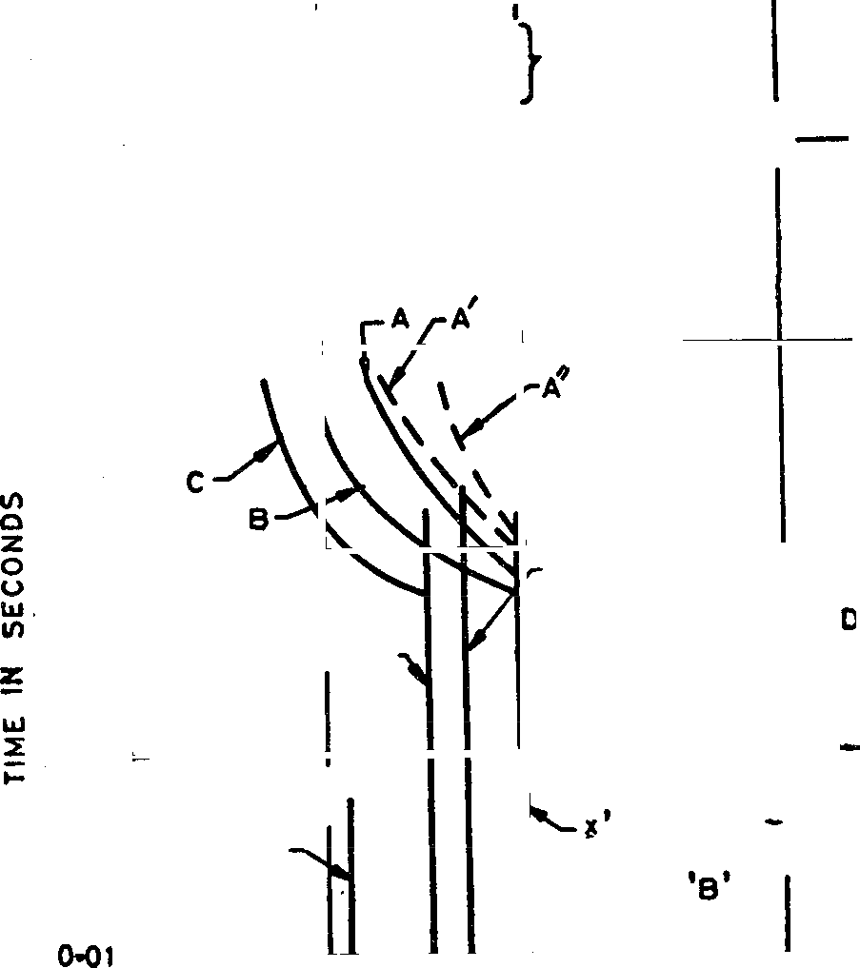
CURRENT IN AN PE RES ( BASE D ON 3300 V)
500
1 00
i0
1•0
01
100000

Fio. 3 Co-onninazen True-Cunezirr CURVES OF GzxeRATOR Ovxacunnzx RzLAYS

9

3.3.2 This relay is a combination of undervoltage and overcurrent units. The undervoltape relay operates instantaneously but the time current characteristics of the overcurrent unit is similar to that of an IDMTL relay. Figure 4 shows the typical characteristics of a voltage controlled overcurrent relay. Curve 1 gives the time-current characteristics for over- load conditions and curve 2 gives the same characteristics for short-circuit conditions, that is, when the voltage falls on account of the short-circuit.

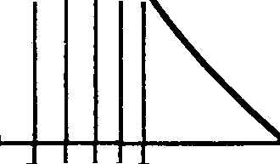
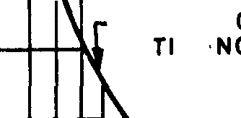
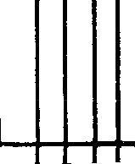






100
l
I \ I I I
k II I 1
1 J I
I
C HARAC T E RIS - V OL TA GE )
i i
111
HARACTE RISTIC VOLTAGE )
C W
LT
( LO
WFAU
1111
M
DA D
3RNAL
I - OVE R L
C (
I I I I
1 1 1 I
I
i iui
I J
8 0
60

40

20
OPERATING TIME IN SECOND5

10
8•0
6•0

2•0

1•0
0•2 o•t o•s
i 2 4
t0 20

EU LTlPc E 5 OF PLUG SET TING
Fio. 4 CHAR ACTRRI6TIC:8 OF VOLTAGE CO2' TROLLR OVERCURRENT
Relav
3.3.3 Instantaneous undervoltage element controls operation of the induction overcurrent element and should be set to operate at a voltage above the minimum value expected under the fa’ult conditions likely to be met on the system. The overcurrent unit is set to ride over the normal load swingi. It should be checked that the voltage at the generator terminals
10

is sufficient to operate the undervoltage element for all external faults for which the overcurrent relay should back-up. This is particularly rele- vant for a generator-transformer unit connection because the impedance of the transformer together with the effect of automatic voltage regulator may not produce sufficient voltage drop ( the voltage being taken from the genera- tor voltage transformer ) for a fault just outside the transformer secondary terminals.
3.3.a rhe operating characteristics of this relay do not change with the voltage as it does in the case of overcurrent relays with voltage restraint between zero to rated voltage. On the contrary the relay operates or not according as the voltage is below or above the setting.
3.3.5 An example of’ application of voltage controlled overcurrent relay with definite time characteristic is given in Appendix A.

3.4 Ixsterloclced 0 'ercurreat Protectxoa
3.•1.1 Interlocked overcurrent protection is required if all the protective current transformers are located on one side of the circuit-breaker only as shown in Fig. 5. A fault occurring between the circuit-breaker contacts and the current transformers cannot be cleared completely either by the bus-bar protection or the differential protection of the generator. Figurr 5 shows two possible locations of the current transformers. A fault at point A is continued to be fed by the generator even after the circuit-breaker has been opened by bus-bar protection. Similarly, a fault at B, although detected by the generator differential protection, is not cleared by the resultant opening of the circuit-breaker.
3.•1.2 A special overcurrent relay interlocked with either of them depending on the location of the current transformers, is used to isolate the fault completely. An overcurrent relay with a sufficient time delay setting is interlocked with the appropriate protection, that is, bus-bar protection or the differential protection. For a fault at A, the tripping relay associated with the bus-bar protection closes a normally open contact to complete the circuit of the shading winding of the overcurrent relay allowing the latter to shut down the generator. For a fault at B, the tripping relay of the differential protection completes the circuit of the shading winding of the overcurrent relay which in turn operates the bus-bar protection tripping relay to clear the faulty section..
3.4.3 Normally these relays are provided with a current setting of about
75 percent of rated current for three-phase faults for a fault at A. The operatng time of the relay is about 0 4 second at 5 times the current setting. However, the relay settings for fault at B should be carefully selected after ascertaining the fault in-feed frotn the bus-bar side.
3.4.I The relay usually employs an induction di‘sc pattern construction having a summation type of main electromagnet winding ( src Fig. 6 ). The

- BUS6AP 5 —O

BREAK E R

FAULT A





tE 0 KEN{ ""
i? iii â
PROTE CTION RELAY

P ROT ECTION RELAY
D

FAULT B



SA Fault on Generator Slde SB Fault on Line Slda
Fio. 5 IxTRRLOC2tBD OVER CURRENT PROTECTION

shading circuit consists of a wound shading coil, a saturating choke and a capacitance. The choke is designed so that it starts to saturate juit below the setting current of the relay. This feature gives the relay a high torque near the setting and definite minimum time characteristic. The shading circuit is closed by a normally open contact of the bus-bar or generator differential protection, as the case may be, to make the relay operative.
3.4.5 Instantaneous highset overcurrent relays are used to give high speed tripping on phase faults. The current setting provided is normally continuously variable and the relay is set above the maximum starting cur- rent. Relays with low transient over-reach may be used which can be act very close to the maximum starting current. Typical settings are 800 to 1 600 percent of rated current transformer secondary current.
3J Sett:jags ated Go-ordJoatxozt of Overcuxxeat Relays

IDMTL relays when used are given a setting between 125 to 200 percent of the rated current depending upon the overload charac- teristics of the generator. These relays are used for back-up protection only when continuously acting automatic voltage regulators are provided. Settings depend to a large extent on whether operation on loss of field is
required or not. If it is desired that the overcurrent relay should not

operate on loss of field then it ii necessary to select the current settings such
12

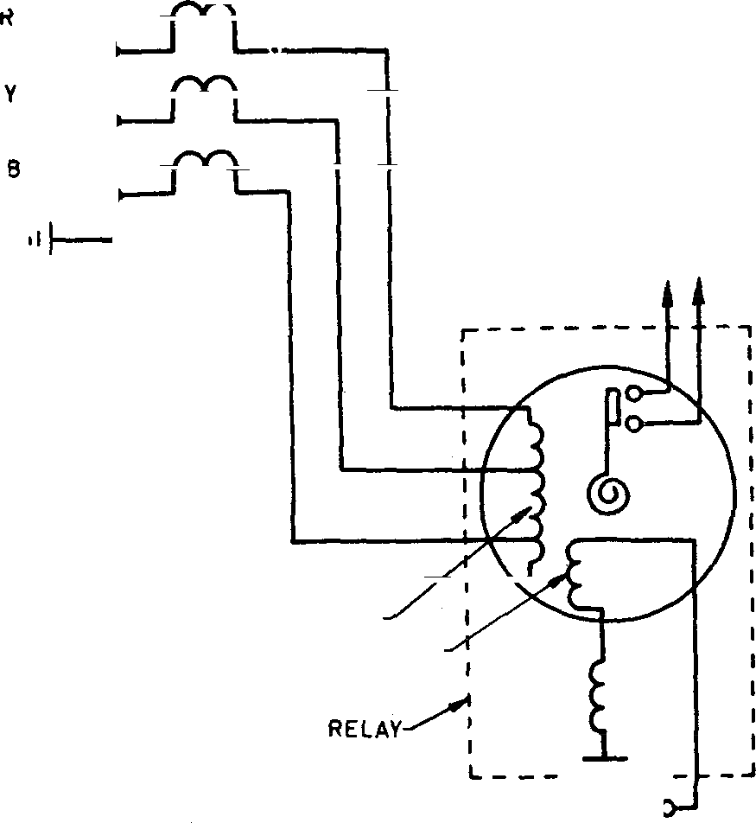
TO GENERATOR TRIP
OPERAS ING COIL TUNED SHADING COIL
Fio. 6 IN THRLOCKB» O V£•R CURRENT PROTECTION R e xv

that it will not operate on the excitation current drawn by the generator from the system. The grading of these relays with similar relays on the feeders may be worked out on the same r rinciple as outlined in Part I of this guide.
    - Voltage controlled and voltage restraint overcurrent relays are normally provided on machines which are not fitted with automatic voltage regulators and where back-up protection with an overcurrent relay is difficult because the synchronous impedance limits the three-phase fault current on sustained faults to about the same or even less than the maximum load cur- rent. When these relays are used, it is preferable to use similar relays on the bus-bars for the outgoing feeders so that proper and easy grading may be ensured for feeder faults. Where a voltage restraint type of relay is used, the current-time characteristic of the relay is affected by the voltage, making it difficult to co-ordinate with other relays on the feeders. Unless carer«lly applied, such relays may also provide grading difficulty when distance relays are used for the feeders. Zone 2 and zone 3 operating time of the distance relays should be less than the operating time of the voltage restraint relays under various fault conditions.

    - Voltage restraint and •oltage on inadvertent loss of voltage supply.
controlled relayi can mal-operate
In order to prevent false tripping

on load, fuse failure relays may be used to supervise the voltage transformer
secondary fuses.
  - The guiding factor for overcurrent relays for motors is that they should not operate due to the momentary excess currents during the normal starting condition but they should provide adequate protection to the motor during abnormal starting conditions as well as during sustained overloads in running conditions.
  - Usually there are two types of overcurrent relays used for the protection of motors, namely:
    - Thermal rcla ys ( i« IS : 1822 -1967* for relays forming an integral part of motor starters and IS : 3231-1965} for relays installed separately ), and
    - Induction type relays ( see IS : 3231-1965} ).
  - Instantaneous overcurrent relays having a setting range of about 200 to 800 percent or 400 to 1 600 percent of current transformer secondary current may be used to provide protection against phase faults on the moton. The exact setting of such relays is normally determined at the time of com- missioning. The setting should be high enough to prevent mal-operation under motor starting conditions.
6.4 For overload protection of motors, it is common to use thermal relays [ see IS : 384"2 ( Part IV ) - 1966} ]. However, in certain cases, overcurrent relays with very inverse and extremely inverse characteristics may also be used. In some applications, both thermal and induction type overcurrent relays are used to provide complete overload protection to motors, both under light overloads and heavy overloads. One such example is shown in Fig. 7. The type ot’ relay required depends on motor starting and thermal withstand characteristic [ see IS : 3842 ( Part IV ) - 19661-I
  - In addition to thermal relays, long time induction disc relays are also used for motor protection. However, thermal protection has an advantage over long time induction disc relays because of the spread between hot and cold characteristics. This allows a tripping time of less than the starting time when a hot motor is stalled, so that separate stalling protection is less likely to be necessary. This, of course, depends upon the starting conditions of the motor and applies when the motors are not expected to start when hot, that is, thermal relay characteristics permitting the motor to start only when cold. Details regarding application of thermal relays are covered in Part IV of this guide.
    - Specification for ac motor starters of voltage not exceeding 1 000 volts (Jrst reeiiton).
}Specificat ion for electrical relays for power syst em prote _{C}tion.
t Application guide for electrical relays for ac systems: Part IV Thermal rel aye.




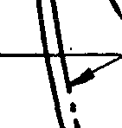

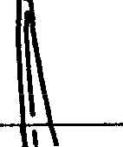

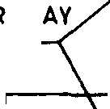





t0000

6000

*000
i

2000
'

1 00 0
800

400

-
I'
'

200
E IN SEC ON OS

100
8O
60
11

E R M AL
OPERATING
T H WI7
H ST A ND
IA RAC T E RI STI C ” M OT 0 R
TY P
CAL THE C HARAC
Rk\AL F T E RISTI
E L C
6 I N DUC T ION D I SC R E LAY ( EX

M E LY
T RE - TlC )—
6
INVERSE
C HARACT E RI S

2 4 6 t0
CURRENT IN MULTIPL E S OF PE R CE NTAG€ CU R RENT SET TIN 6 IN AM P E RE S
Tio. 1 PROTECTION OF A 480 kW, 3 -3 kV MOTOR USING TxERMAL A ID
INDUCTION DISc RE LA YS

Instantaneous earth fault protection having a setting of about 20 percent of rated current transformer secondary current may also be provided on motors which are connected to systems earthed through a resistance or reactance. Such relays may be operated in series with a stabilizing resistance to prevent mal-operation under starting.
A P P E N D I X A
( Clause 3.3.5 )
EXAwrrn snore AsArrLICATION OF VOLTAGE CONTROLLED OVERCURRENT RELAY WITH DEFINITE TIME CHARACTERISTIC

Rated full load generator current at 11 kV = 7 050 A
Current transformer ratio = 8 000J5 1 600
Relay drop-out coesieient — 0-85

Current setting of the relay = where l -25 is the reliability factor.
1-25 x 7 050
0-85 x 1 600
6•5 A,

The voltage setting has been made equal to 70 percent of minimum
operating voltage.
Voltage setting = 0 7 x l1 x 10' = 77 volts,
100

where 100 is the voltage transformer ratio and 11 000 volts is the
rated voltage.
As the protection is of definite time, it is set to operate after a time lag
of 4 seconds.
After setting the relays as above, a check has also been made regarding the response on three-phase fault at 220 kV bus-bar. It may be mentioned here that in between the 11 kV generator bus-bar and the 220 kV bus-bar, there is 1 I }220 kV unit transformer.

Fault current on 11 kV side for a fault
on 220 kV bus-bar 20 800 A

Current sensitivity
20 800

— 6-5 x l 6(10

ratio.
where 6‘5 is the current setting and 1 600 is the current transformer

Voltage at 11 kV side for a three-phase

fault at 220 kV bus-bar
Voltage sensitivity

4 3 kV
77 x 100 — l -8

$.-3 x 10a

This shows that both the current element as well as the voltage element

will operate positively for a fault on 220 kV bus-bar.
16

BUREAU OF INDIAN STANDARDS

Manak Bhavan, 9 Bahadur Shah Zafar Marg, NEW DELHI 110002 Telephones: 323 0131, 323 8375, 323 9402
Fax : 91 11 3234062, 91 11 32ae3es

Plot No. 20/9, Site IV, Sahibabad Industrial Area, Sahibabad 201010
Haglonal Offices:

Telegrams : Manaksanstha (Common to all Offices)
Telephone
8-JT0032

Central : Manak Bhavan, e Bahadur Shah Zafar Marg, NEW DELHI 110002 323 76 17
*Eastern : 1/14 CIT Scheme VII M, V.I.P. Road, Maniktola, CALCUTTA 700054 337 86 62
Northern : SCO 335-336, Sector 34-A, CHANDIGARH 160022 60 38 43
Southern : C.I.T. Campus, IV Cross Road, MADRAS 600113 235 23 15
tWestern : Manakalaya, E9, Behind Marol Telephone Exchange, Andheri (East), B32 s2 es MUMBAI 400093

'Pushpak', Nurmohamed Shaikh Marg, Khanpur, AHMEDABAD 380001 3Peenya Industrial Area, 1st Stage, Bangalore-Tumkur Road,
BANGALORE 56O058
550 13 4e
eae 4s 55

Gangobi Complex, Sth Floor, Bhadbhada Road, T.T. Nagar, BHOPAL 462003 55 40 21
Plot No. 62-63, Unit VI, Ganga Nagar, BHUBANESHWAR 751001 4O 36 27
Kalaikathir Buildings, 670 Avinashi Road, COIMBATORE 641037 21 01 41
Plot No. 43, Sector 16 A, Mathura Road, FARIDABAD 12J001 B-2e 88 01
Savitri Complex, 116 G.T. Road, GHAZIABAD 201001 B-71 19 96 M/5 Ward No.29, R.G. Barua Road, Sth By-lane, GUWAHATI 7B1003 54 11 37
5-8-56C, L.N. Gupta Marg, Nampally Station Road, HYDERABAD 500001 2O 10 83 E-52, Chitaranjan Marg, C-Scheme, JAIPUR 302001 37 Z6 25
117/418 B, Sarvodaya Nagar, KANPUR 208005 21 68 76
Seth Bhawan, 2nd Fbor, Behind Laela Cinema, Naval Kishore Road, 23 80 23
LUCKNOW 226001
Pa¥ipuSa Indusbial Estate, PATNA 800013 26 23 05
T.C. No. J4/1421, University P. O. Palayam, THIRUVANANTHAPURAM 605034 6 21 17
/nsp•etfon Dffiaec (With Sale Point) :
Pushpanjali, 1st Floor, 205-A, West High Court Road, Shankar Nagar Square, 52 51 71
NAGPUR 440010

Institution of Engineers (India) Building 1332 Shivaji Nagar, PUNE 411005

°Sales Office is at 5 Chowringhee Approach, P.O. Princep Sbeet CALCUTTA 700072
tsales Office is at Novelty Chambers,”Grant Road, MUMBAI 400007 tsales Offioe is at ’F' Block, Unity Building, Narashima •i• Square,
BANGALORE 56OIXI2
32 36 35

27 10 05

309 65 25
222 89 7J

Reprography Unit, BIS, Mew Delbi, India

