IS 6523 : 2023

**Draft Indian Standard**

**Draft-SPECIFICATION FOR PRECAST REINFORCED**

**CONCRETE DOOR AND WINDOW FRAMES**

**{First Revision)**

**0. FOREWORD**

0.1 This Indian Standard (First Revision) was adopted by the Indian Standards Institution on 28 February 1983, after the draft finalized by the Cement and Concrete Sectional Committee had been approved by the Civil Engineering Division Council.

0.2 The increasing scarcity and high cost of good timber has considerably increased the utility of precast reinforced cement concrete door and window frames, which are not only durable and termite proof but also appreciably economical and easy to manufacture

0.3 This standard was first published in 1972 to provide guidance in the manufacture and supply of precast reinforced concrete door and window frames of suitable finish and quality and with reliable fixing arrangements for door and window shutters.

0.3.1 The present revision (second revision) has been made in view of the experience gained during the course of past years in the use of this standard. In the present revision of IS 6523 the important modifications are as given below:

1) Amendments No 1 and 2 has been incorporated.

2) Use of alternatives material like PP block has been suggested to be used to have better and durable holding of hinges plate with the frame.

3) Use of Flyash, GGBS and fibres has been permitted considering using of waste to comply with the requirement of SDG goals.

4) Sizes and tolerance has been aligned as per the prevailing sizes mentioned in Delhi Scheduled of Rates 2018 and the requirements given in IS 2202(P-1)

0.4 The use of precast reinforced concrete door and window frames is recommended to be restricted to a maximum opening width of 2.25 m.

0.5 A scheme for labelling environment friendly products known as ECO Mark has been introduced at the instance of the Ministry of Environment and Forests (MEF), Government of India The ECO Mark would be administered by the Bureau of Indian Standards (BIS) under the BIS Act, 1986 as per the Resolution No 85 (E) dated 21 February 1991 and No 589 (E) dated 10 June 1992 Published in the Gazette of the Government of India For a product to be eligible for marking with ECO logo, it shall also carry the ISI Mark of BIS besides meeting additional optional environment friendly requirements For this purpose, the Standard Mark of BIS would be a single mark being a combination of the IS] Mark and the ECO logo Requirements to be satisfied for a product to qualify for the BIS Standard Mark for ECO friendliness will be optional, manufacturing units will be free to opt for the ISI Mark alone also.

0.6 For the purpose of deciding whether a particular requirement of this standard is complied with, the final value, observed or calculated, expressing the result of a test or analysis, shall be rounded off in accordance with IS: 2-1960. The number of significant places returned in the rounded off Value should be the same as that of the specified value in this standard.

0.7 Provisions given in the standard and usage of this product will help in achieving goals set for SDG11, 12 and 13.

IS 6523 : 2023

Indian Standard

SPECIFICATION FOR PRECAST REINFORCED

CONCRETE DOOR AND WINDOW FRAMES

{First Revision)

1. SCOPE

1.1 This standard covers the requirements for precast reinforced concrete door and window frames.

2. REFERENCES

The standards given in Annex A contain provisions which through reference in this text constitute provisions of this standard. At the time of publication, the editions indicated were valid. All standards are subject to revision and parties to agreements based on this standard are encouraged to investigate the possibility of applying the most recent editions of the standards indicated in Annex A

3. SHAPE AND DIMENSIONS

3.1 Precast reinforced concrete door and window frames shall be 60 X 100 mm or 70 x 75 mm in cross-section for single shutter door and 60 X 125 mm for double shutter door, the cross-section being generally in accordance with Fig 1 and 3. The overall sizes ( width and height ) of the frames shall conform to the requirements of IS : 4021

|  |
| --- |
| One more size has been added as there is demand for these size also:   1. 60mm x 125mm for double shutter. This size has also been mentioned in the Delhi Scheduled of Rates 2018   IS 4021:1976 has been replaced by IS 4021:1995 |

Note 1 — Suitable adjustment in cross-sectional shape may be made by agreement between the purchase and the supplier to provide suitable groove for wall plaster, etc, provided the overall dimensional requirements given above are not affected.

Note 2 — For overall dimensions of the frame, the width of the frame shall be the total length of the horizontal piece measured out-to-out, the height of the frame shall be the total height measured from the lowest end of the vertical piece ( in case of three member frame or the outer edge of the lower horizontal member in case of four member frame ) to the outer edge of the top horizontal piece ( see Fig 2 )

3.1.1 Tolerances — A tolerance of +5mm shall be permitted on the cross-sectional dimensions of the frames.

|  |
| --- |
| Tolerance has been changed to +5mm as the present tolerance is very narrow to achieve while manufacturing. As per IS 2202(Part 1):2019, the tolerance on the door and shutter has been specified as +5mm |

4. MATERIALS

4.1 Cement

Cement complying with any of the following Indian Standards may be used:

a) Ordinary Portland cement conforming to IS 269,

b) Portland slag cement conforming to IS 455,

c) Portland pozzolana cement conforming to IS 1489 (Part 1),

d) Portland pozzolana cement, calcined clay based conforming to IS 1489 (Part 2),

e) Supersulphated cement conforming to IS 6909,

f) Rapid hardening Portland cement conforming to IS 8041,

g) Sulphate resisting Portland cement conforming to IS 12330, and

h) Hydrophobic cement conforming to IS 8043.

NOTES 1 The manufacturer shall give a certificate indicating the type and quantity of cement used in the concrete mix.

2 Site blending with fly ash up to a maximum of 30 percent may be carried out provided its uniform blending with ordinary Portland cement is ensured.

3 Site blending with GGBS up to a maximum of 50 percent may be carried out provided its uniform blending with ordinary Portland cement is ensured.

4 Blending of any one out of fly ash and GGBS is permitted.

4.2 Aggregates

4.2.1 Fine and coarse aggregates used in the manufacture shall conform to IS 383. The coarse aggregate shall be graded aggregate of maximum 10 mm nominal size.

4.2.2 The maximum nominal size of coarse aggregates may be as large as possible within the limits specified but in no case greater than one-fourth of the minimum thickness of the unit.

4.3 Pulverized Fuel Ash Pulverized fuel ash, if used shall conform to IS 3812 (Part 1).

4.4 Ground Granulated Blast Furnace Slag Ground granulated blast furnace slag, if used shall conform to IS 16714.

4.5 Additives or Chemical Admixtures Additives or chemical admixtures may be added in the preparation the concrete mix. Chemical admixture used shall conform to IS 9103.

4.6 Reinforcement Steel for reinforcement of concrete complying with any of the following standards may be used:

a) Mild steel and medium tensile steel bars conforming to IS 432 (Part 1);

b) Hard-drawn steel wire conforming to IS 432 (Part 2);

c) High strength deformed steel bars and wires conforming to IS 1786; and

d) Hot rolled medium and high tensile structural steel conforming to IS 2062.

4.7 Water The water used in production shall conform to the requirements specified in IS 456.

4.8 Synthetic fibers may be used in small amounts (approximately 0.1% by volume of concrete) to reduce plastic shrinkage cracking.

|  |
| --- |
| Above material clause has been modified inorder to include latest practices and to align it with requirements given other similar standards |

**5 MANUFACTURES**

**5.1 Construction and Finish**

5.1.1 All precast concrete frame should be manufactured under hydraulic pressure/mechanical hydraulic vibration and compaction with design mix concrete as specified in IS 456. The concrete used in the manufacture of frame components shall not be lower than M 25. However, nominal cover may be increased depending on the severity of site conditions. The method of manufacture should be such that the forms and dimensions of the finished product are accurate within the limits specified in this standard. The surfaces and edges should be well defined and true, and their ends should be square with the longitudinal axis. Concrete should be weight in weigh batcher and mixed in mechanical mixer. Mixing should be continued until there is a uniform distribution of the materials and the mass is uniform in colour and consistency, but in no case should the mixing be done for less than 2 min for a batch.

Note — Compaction by vibration may be done using a vibrating table or a shutter vibrator.

|  |
| --- |
| Clause 4.1.1 have been modified by following giving more detailing about concrete making |

5.1.2 Each member of the frame shall have a dense surface finish showing no coarse aggregate and shall have no crevices likely to assist in the disintegration of concrete or rusting of steel by the action of natural agencies.

5.1.3 While a good finish may generally be obtained by using smooth surface moulds and proper vibration of concrete, any small defects remaining may be removed by rubbing with carborundum stone or by grinding and rubbing with stone before erection of the frame. Plastering or touching shall not be done under any circumstances.

|  |
| --- |
| Provision for grinding and rubbing with stone has been added |

5.1.4 By mutual agreement between the purchaser and the supplier decorative treatment, such as painting or terrazzo finish may be given to the three exposed surfaces of the frame, the terrazzo finish shall be given while casting the frame.

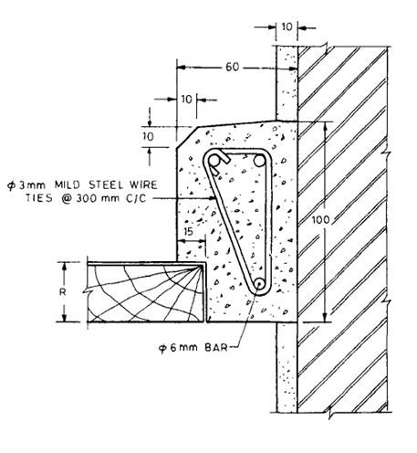

R = 25, 30, 35 or 40 mm depending upon the thickness of shutter.

1A Typical Cross Section of Precast Reinforced Concrete Door and Window Frame Showing Reinforcement.

FIG 1A REINFORCED CONCRETE DOOR AND WINDOW FRAME—Contd.

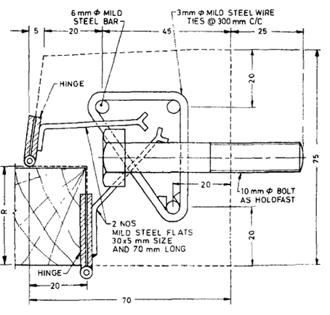

R = 25, 30, 35 or 40 mm depending upon the thickness of shutter.

NOTE 1 Instead of bolts for holdfast, mild steel rod 10mm dia. may be embedded in concrete and the projected pieces may be bent after casting.

NOTE 2 Alternatively a through hole to accommodate 10mm holdfast in the frame may be provided at suitable distance so that after erection of door frame, holdfast of 10mm may be inserted in the hole and embedded in the wall by hammering the bolt.

(Note 2 has been added)

1B Alternative Details of Precast Reinforced Concrete Door and Window Frame Showing Arrangement for Reinforcement, Holdfasts and Hinges

All dimensions in millimeters

FIG 1 REINFORCED CONCRETE DOOR AND WINDOW FRAME

5.2 **Positioning of Reinforcement** — The vertical as well as the horizontal members of the frame shall be reinforced with longitudinal bars as in 3.6. The longitudinal reinforcement for each of the vertical or horizontal member shall be in one piece. The longitudinal bar shall be firmly held by means of at least 3 mm dia steel ties spaced at not more than 300 mm centre to centre.

5.2.1 Cover — The longitudinal reinforcement shall have a minimum clear cover of 15 mm or twice the diameter of the main bar, whichever is more.

|  |
| --- |
| Amendment no 1 has been incorporated in the above clause for making clear cover as 15mm instead of 12mm |

5.3 Casting

5.3.1 The entire frame maybe cast complete in one piece or each of the vertical and horizontal members of the frame may be cast separately to be assembled into the complete frame at site. The former method has the advantage of reducing the work at site but introduces difficulties in fabrication of the moulds, and also in transporting and handling of the complete frame; there is likelihood of damage to the frame during transit. Since damage to even one member will result in the rejection of the whole frame, the latter method is relatively simple and economical.

5.3.1.1 When the frame is cast in separate parts (see Fig. 2 ), one of the reinforcing bars of the vertical members of the frame shall be kept projecting so as to tennon into the corresponding holes in the horizontal member. The hole in the horizontal member for taking the projecting reinforcement from the vertical members shall be slightly larger than the bar diameter to facilitate easy insertion of the projecting bar. After assembly at site the holes shall be grouted with cement slurry 1:1:1/2 (cement: sand ). Alternatively a suitable groove/projection may be provided at top edge of the vertical frame which will get interlock with the groove/projection provided at the horizontal frame

|  |
| --- |
| Provision for an alternative, groove has been permitted on the top frame which will get interlock with groove provided at top end of the vertical frame. |

5.3.2 Mould — The mould for casting shall be of steel or of good quality timber suitably lined with iron sheet or of any other suitable material which shall ensure adequate surface finish of the cast frame. Provision shall be made in the mould to accommodate fixing devices for hinges and the holdfasts. If required, suitable rebate may also be provided to act as plaster groove.

5.4 Curing — After placing, the concrete shall be adequately protected, during setting and in the first stages of hardening, from shocks, running or surface water and the harmful effects of sunshine, drying winds and cold. The concrete shall be cured for at least 7 days unless special curing methods are adopted. Steam curing of concrete may be adopted if so desired by the manufacturer, provided the requirements of pressure or non-pressure steam curing are fulfilled.

Note—For non-pressure steam curing, the frames shall be subjected to the action of saturated steam at a temperature of 60 to 80oC for a period of 16 to 18 h; or for such additional time as may be necessary to enable the frame to meet the strength requirements, When a curing chamber is not available, frames shall be placed in an enclosure of canvas or other closely woven material and subjected to saturated steam at the temperature and for the time specified above. The enclosure shall be so erected as to allow full circulation of steam around the entire frame. The interior surface of the curing room or canvas jacket and the surface of the frames shall be entirely moist at all times.

5.4.1 Maturing — from the date of casting, the frames shall be matured for the following period (including the period of curing] depending on the type of cement used for manufacture of the frames before testing or despatch:

Ordinary Portland cement or Portland 28 days

slag cement or Portland pozzolana cement

Rapid-hardening Portland cement or 14 days

high-strength ordinary Portland cement.

5.4.2 Minimum Strength of Concrete for Handling of Frames — The concrete shall have sufficient strength to prevent damage to units when first handled.

**6. ARRANGEMENTS FOR FIXING OF HINGES TO FRAMES**

6.1 Suitable arrangements for fixing of hinges shall be provided in the frame by any one of the methods described in 6.2 to 6.7 or any other equally suitable method approved by the purchaser If so required by the purchaser, the frames supplied shall be completed with the required number of hinges fixed in position.

6.1.1 All the exposed area of hinges, holdfast and other steel fixtures shall be painted with anti-corrosive paint, before casting, to prevent rusting

**6.2 Fixtures for Hinges**

6.2.1 Aluminum Tube Fixture — Aluminum tube sleeve having internal Threading and length to suit 5 mm machine screw ( see IS : 1365) shall be taken and the rear end of the tube sleeve shall be pressed flat. Threading in the tube may be done by holding the tube in a vice. A number of such sleeves shall be made, one sleeve for each screw hole of the hinge (see Fig, 2). The sleeves shall be inserted in the moulds from the inner side and the flattened ends of adjacent tubes shall be kept facing in different directions for better bond. Screws shall be inserted in the tubes from outside of the mould to keep the fitting in position during pouring of concrete and also to prevent concrete from getting into the tube. After Completion of casting, curing and maturing of the frame, the screws shall be withdrawn from. The frame, the hinges placed in position and screws tightened in position to fix the hinges ( see Fig. 3A ).

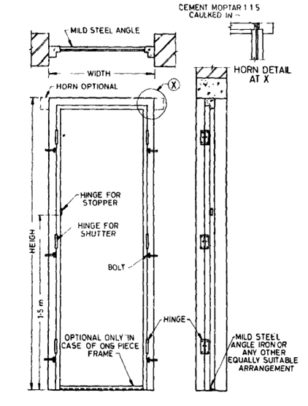

Fig 2 Overall Dimensions of Precast Reinforced Concrete Door Frame.

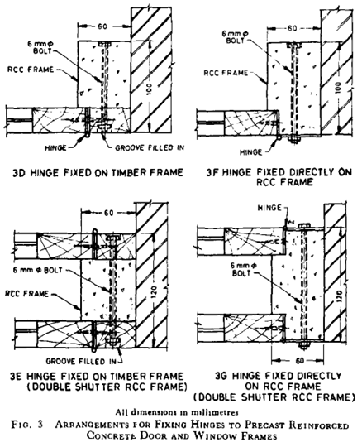

6.2.2 For facilitating proper and easy fixing of hinges, the hinges may be supplied by the manufacturer along with the frame.

6.3 Wire Fixture — Mild steel wire conforming to IS: 280 and of thickness 0 8 mm shall be helically wound on a wood screw, the size of the wood screw being selected to suit the hinges ( see IS : 1341 and IS: 451) for this purpose, the screw shall be held in a vice and the wire wound around it till the wire covers the screw and trails out by about 15 mm on either end of the screw. The wire along with the screw (one fixture for each screw hole of the hinge) shall be left in position in the mould at the place where hinges are to be fixed to the frame (see 5.2.1). After completion of casting, curing and maturing of the frame, the screws shall be withdrawn from the frame, the hinges placed in position and screws tightened in position to fix the hinges (see Fig. 3B ).

6.4 Hardwood Block Fixture — Hardwood blocks of suitable timber such as well seasoned teak wood 150 mm long, 45 or 50 mm x 30 to 40 mm in cross-sections with suitable holes to allow for insertion of two 6 mm mild steel bolts shall be used. Suitable spacers shall be kept in the mould while casting the frame so that one block for each of the hinge can be fixed in position with 6 mm mild steel bolts, nuts and washers, after the frame has been cast, cured and matured. After tightening the nuts, the bolt heads and the nuts shall be suitably covered with hard wood fillets, finished flush with concrete surfaces of the frame ( see Fig. 3G ). Alternative arrangement of wooden framing as shown in Fig. 3D and 3E may be adopted.

**6.5 Hinge Directly Attached to Frame** — L type flap hinge may be attached directly to the reinforced cement concrete frame with the help of 6 mm mild steel bolt ( see Fig. 3F, 3G and 3H ).

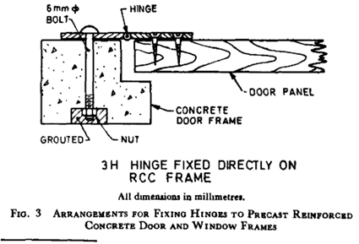

**6.6 Hinge Welded to Frame** - The hinge may be welded to 2 numbers mild steel flat 30 X 5 mm size and 70 mm long, embedded in the reinforced concrete frames (see Fig.B) Gas welding is recommended in the case of welding hinges to the mild steel plates.

**6.7 Hinge screwed to Polymer block inserted in the frame-** High Strength Polymer block may be inserted in the frame while casting at the place where hinges have to be fixed. These high strength block may be made of suitable material like Nylon.

|  |
| --- |
| As an alternate, use of High Strength Polymer block has been incorporated for fixing hinges through screw This use of Polymer block has also been mentioned in the Delhi Scheduled of Rates 2018 |

**7. ARRANGEMENTS FOR DOOR AND WINDOW FIXTURES**

7.1 Suitable arrangements shall be provided in the frame for receiving tower bolts, sliding bolts and other door and windows fixtures, one such arrangement is shown in Fig. 4. High Strength Polymer Block with slots may be used in the frame where mortice lock is to be installed. Use of PVC tube for holding rod of aldrob, Tower bolt inside the frame may also be provided and same can be embedded in the frame during casting.

|  |
| --- |
| Use of High Strength Polymer Block and PVC tube has been proposed |

**8. ERECTION**

8.1 When a three-piece frame is used, the vertical members shall be held in position as in case of timber frames and they shall be plumbed and aligned, and firmly supported till the concrete around the holdfasts in the masonry has properly set and hardened. The concrete frames being no heavier require little extra care in handling, the joints are liable to give way, if not handled carefully

8.1. 1 alternatively, the vertical members may be held in position and the top member placed over the vertical members The whole frame is plumbed and aligned, and supported temporarily till the concrete around holdfasts has properly set and hardened

8.2 Where a four-piece frame as in the case of window frames or door frames having sills, is used, the bottom members shall be first placed in position and the others erected on this base.

8.3 Cement slurry 1:1:1/2 ( cement : sand ) shall be used in grouting the joints between the vertical and horizontal members of door frame ( see Fig 2 ). Alternatively, chemical loading agents such as epoxy resins may be used.

**9 WORKMANSHIP AND FINISH**

9.1 Finish frame shall be straight, free from cracks and free from honeycombing Each member of the frame shall have a dense surface finish showing no coarse aggregate and shall have no crevices likely to assist in the disintegration of concrete or rusting of steel by the action of natural agencies.

**10 REQUIREMENTS**

10.1 Deviation from Straight

10.1.1 The deviation from straight in any frame throughout its effective length, tested by means of a rigid straight edge, the maximum deviation from a 1.5 m straight edge placed in any position on a nominal plane surface shall not exceed 2 mm

**11 ADDITIONAL REQUIREMENTS FOR ECO MARK**

**11.1.1 General Requirements**

11.2.1 The products shall conform to the requirements for quality and performance as specified in the standard

11.3.2 The product manufacturer must produce the consent clearance from the Concerned State Pollution Control Board as per the provisions of Water (Prevention and Control of Pollution) Act, 1974 and Air (Prevention and Control of Pollution) Act. 1981 and Water (Prevention and Control of Pollution) Cess Act. 1977 along with the authorization, if required under Environment (Protection) Act, 1986 and the Rules made thereunder to BIS while applying for ECO Mark appropriate with enforced Rules and Regulations of the Forest Department

11.3.3 The product or product packaging may display in brief the criteria based on which the product has been labelled environment friendly.

11.4.4 The material used for product packing (if any) shall be recyclable, reusable or biodegradable

**11.2 Specific Requirements**

11.2.1 Door and window frames used for buildings shall be made from reinforced cement concrete

NOTE — The manufacturer shall provide documentary evidence by way of certificate or Declaration to this effect to BIS while applying for ECO Mark.

**12. SAMPLING AND INSPECTION**

12.1 The method of drawing representative samples and the criteria for conformity shall be as described in Appendix B.

**13. MANUFACTURER'S CERTIFICATE**

13.1 The manufacturer shall satisfy himself that the frames conform to the requirements of this specification and if requested, shall supply a certificate to this effect to the purchaser or his representative.

**14. MARKING**

14.1 The frame shall be clearly and indelibly marked with the following information on the face of the frame coming in contact with the masonry:

a) Manufacturer’s name or trade-mark,

b) Year of manufacture, and

c) Overall height and width of frame.

d) The criteria for which the product has been labelled with ECO Mark (if ECO marked)’

14.1.1 Each frame may also be marked with the Standard Mark.

NOTE — The use of the Standard Mark is governed by the provisions of the Bureau of Indian Standards Act, 1986 and the Rule and Regulation made there-under. The Standard Mark on products covered by an Indian Standard conveys the assurance that they have been produced to comply with the requirements of that standard under a well defined system or inspection, testing and quality control which IS devised and supervised by BIS and operated by the producer, Standard marked products are also continuously checked by BIS for conformity to that standard as a further safeguard Details of conditions under which a license for the use of the Standard Mark may be granted to manufacturers or producers may be obtained from the Bureau of Indian Standards.

ANNEX A ( Clause 2 )

LIST OF REFERRED INDIAN STANDARDS

IS 269 : 2015 Ordinary portland cement - Specification (Sixth Revision)

IS 455 : 2015 Portland slag cement – Specification

IS 1489 (Part 1) : 2015 Portland pozzolana cement - Specification: Part 1 fly Ash Based

IS 1489 (Part 2) : 2015 Portland - Pozzolana cement - Specification: Part 2 calcined clay based

IS 6909 : 1990 Supersulphated cement ? specification

IS 8041 : 1990 Rapid hardening portland cement - Specific4tion (Second Revision)

IS 12330 : 1988 Specification for sulphate resisting Portland cement

IS 8043 : 1991 Specification for hydrophobic Portland cement

IS 383 : 2016 Coarse and Fine Aggregate for Concrete - Specification (Third Revision)

IS 432 (Part 1) : 1982 Mild Steel and Medium Tensile Steel Bars and Hard-Drawn Steel Wire for Concrete Reinforcement: Part 1 Mild Steel and Medium Tensile Steel Bars

IS 432 (Part 2) : 1982   
Mild Steel and Medium Tensile Steel Bars and Hard-Drawn Steel Wire for Concrete Reinforcement: Part 2 Hard-Drawn Steel Wire

IS 1786 : 2008 High strength deformed steel bars and wires for concrete reinforcement - Specification (Fourth Revision)

IS 2062 : 2011 Hot rolled medium and high tensile structural steel - Specification (Seventh Revision)

IS 456 : 2000 Plain and reinforced concrete - Code of practice (Fourth Revision)

IS 1365 : 2022 Slotted countersunk flat head screws Product grade A Fifth Revision of IS 1365  
ISO 2009 : 2011

IS 1341 : 2018 Steel Butt Hinges - Specification (Sixth Revision)

IS 451 : 1999 Technical supply conditions for wood screws (Third Revision)

IS 280 : 2006 Mild steel wire for general engineering purposes (Fourth Revision)

IS 4021 : 1995 Timber door, window and ventilator frames – specification

IS 3812 (Part 1) : 2013 Pulverized fuel ash - Specification: Part 1 For use as pozzolana in cement, cement mortar and concrete

IS 16714 : 2018 Ground granulated blast furnace slag for use in cement, mortar and concrete – Specification

IS 9103 : 1999 Specification for Concrete Admixtures –

IS 2202 (Part 1) : 2023 WOODEN FLUSH DOOR SHUTTERS SOLID CORE TYPE SPECIFICATION PART 1 PLYWOOD FACE PANELS Seventh Revision

APPENDIX B

(Clause 12.1)

SAMPLING AND CRITERIA FOR CONFORMITY

B-1 SCALE OF SAMPLING

B-1. 1 Lot — In any batch, all frames of the same type and same dimensions shall be grouped together to constitute a lot.

B-l.1.1 Sub-lot — if the number of frames in a lot exceeds SOO, the lot shall be divided into a suitable number of sub-lots such that the number of frames in any sub-lot shall not exceed 500. The acceptance or otherwise of a sub-lot shall be determined on the basis of sample selected from it.

B-1.1.2 the number of frames to be selected from a lot or a sub-lot shall depend upon its size and shall, be m accordance with col 1 and 2 of Table 2.

B-1.1.3 The frames shall be selected at random. In order to ensure randomness, all the frames in the lot or the sub-lot may be arranged in a serial order and starting from any frame, every rth frame may be included in the sample, being the integral part of N/n, where N is the size of the lot or the sub-lot and n the sample size.

B-2. NUMBER OF TESTS

B-2.1 All the frames as selected in B-1.1.2 shall be tested for overall length, Cross-section and uprightness.

B-3. CRITERIA FOR CONFORMITY

B-3.1 A lot or a sub-lot shall be considered as conforming to this specification if the conditions under B-3.2 are satisfied.

B-3.2 The number of frames which do not satisfy the requirements of overall length, cross-section and uprightness shall not exceed the corresponding number given in col 3 of Table 2. If the number of such frames exceed the corresponding number; all frames in the lot or sub-lot shall be tested for these requirements and those not satisfying the requirements shall be rejected.

TABLE 2 SAMPLE SIZE AND CRITERIA FOR CONFORMITY

(clauses B-l.l.2 and B.3.2}

Size or Lot or Dimensional Requirements

Sub-lot Sample Size Permissible

N A No of Defects

(1) (2) (3)

Up to 100 10 1

101 to 200 15 1

201 to 300 20 2

301 to 500 30 3