Draft for testing of carrot washer

1. SCOPE OF TEST
The scope of test is to check and assess the following:
  - Specification of Vegetable washing machine (carrot)
1.2 Field tests to evaluate the suitability of machine with regard to:
- Quality of work
- Rate of work
- Labour requirement
- Power requirement
- Ease of operation and adjustment

2. TEST PROCEDURE

3. METHOD OF SELECTION

4. BRIEF DESCRIPTION OF EQUIPMENT

Fresh vegetables are important component of the human diet. To avoid spoilage of vegetables they must be washed after harvesting from the field. Washing of vegetables can be done manually or mechanically. Manual washing of vegetables are very time and labour consuming process. The problem of labour availability is much more at present time. The use of continuous type vegetable washing machine can be used for washing carrot, ginger (adarak), colocasia (arbi) and turmeric (haldi) which can reduce the labour requirement and is also a time saving method of washing of vegetables. This machine is a tractor trailed type PTO driven machine which is tested for carrot crop. This machine can also be run on stationary diesel engine which is supplied as optional feature.

Basically, the continuous type vegetable washing machine consists of a rotor which runs at 25 rpm approximately. The rotating drum is made of 197 nos. of square MS bars of 7× 7 mm size on the periphery of drum of dia. 910 mm. The length of the drum is 3.60 m and mounted between two bearings fixed on the frame through a hallow shaft of dia. 57 mm. A centrifugal pump is used for spraying water on the drum so that the vegetables are cleaned. From one end of the rotor, the vegetable is fed through the feeding chute and allowed to travel the entire length of the drum i.e. 3.60 m and thus the carrot gets cleaned up as it reaches the outlet.

To evaluate the mechanical washing efficiency, microbial washing efficiency and bruise percentage of continuous type carrot washer, experimental test should be conducted following the standard procedure in literature and by Bureau of Indian Standard (BIS).

5. SPECIFICATIONS

  - GENERAL

 | Name & address of manufacture / applicant | :
 | Name of Implement | : | Vegetable Washing Machine (Carrot)
 | Type | : | Tractor PTO operated (Optional: Engine operated) Trailed type
 | Make | :
 | Serial No. | :
 | Model | :
 | Nominal Length, mm | :
 | Year of manufacture | :
 | Source of power | :
 | Recommended speed of the machine | :
 | Recommended power of tractor | :

  - PRIME MOVER USED
1. | Tractor | :
2. | Chassis No. / Engine No. | :
3. | Max. PTO Power Kw | :
4. | Year of manufacture of tractor | :

  - CHASSIS
1. | Type of frame | : | Fabrication of MS angle & supporting MS channel
2. | Size of MS angle, mm | : | 75 × 75× 5 (Upper side)  65 × 65× 5 (Lower side)
3. | Size of MS channel, mm | : | 70 × 35 × 4 (Four supports on each side i.e. LHS & RHS)

  - POWER TRANSMISSION SYSTEM
1. | Method of transmission | : | Power input shaft receives drive from tractor PTO shaft and transmits power to centrifugal pump and rotor assembly through V-belt and pulley and set of gears.

Drive train and components used in power transmission system of machine
Sl.NO | From | To | Through
1. | Tractor PTO | Drive Shaft  (36 mm)  Bearing hub: P-207 | Universal shaft  (6 splines at both the ends)
2. | Drive shaft  (36 mm) | Driven pulleys  ( 250 mm × 1C &  100 mm × 2C) | Shaft (36 mm)
3. | Driven pulley  ( 250 mm × 1C) | Water Pump pulley  (72 mm × IC) | V-belt
4. | Driven pulley  ( 100 mm × 2C) | Rotor pulley  (340 mm× 2C) | V-belt (B-52)
5. | Rotor pulley  (340 mm× 2C) | Rotor Drive gear | Shaft
6. | Rotor Drive gear  (13 teeth) | Rotor Driven gear  (82 teeth on the periphery of rotor) | Gear

  - PROPELLER SHAFT
1. | Type | : | Telescopic in 2 segments having spring at both ends
2. | Length of propeller shaft, mm | : | Min-610, Max-730
3. | Mass of shaft, kg | : | 2.6
4. | Provision for locking | : | Provided
5. | Provision for safety Clutch /device | : | Not provided

Hub Description, mm (Refer Fig.1)
Notation | As per IS:4931- Oct. 2004, mm | As observed, mm | Remarks
Dφ | 34.93 ± 0.03 | 34.96 | Conforms
dφ | 29.7 ± 0.1 | 29.8 | Conforms
W | 8.69 (Min.) | 9.1 | Conforms
A | 54.0 | 54.0 | Conforms

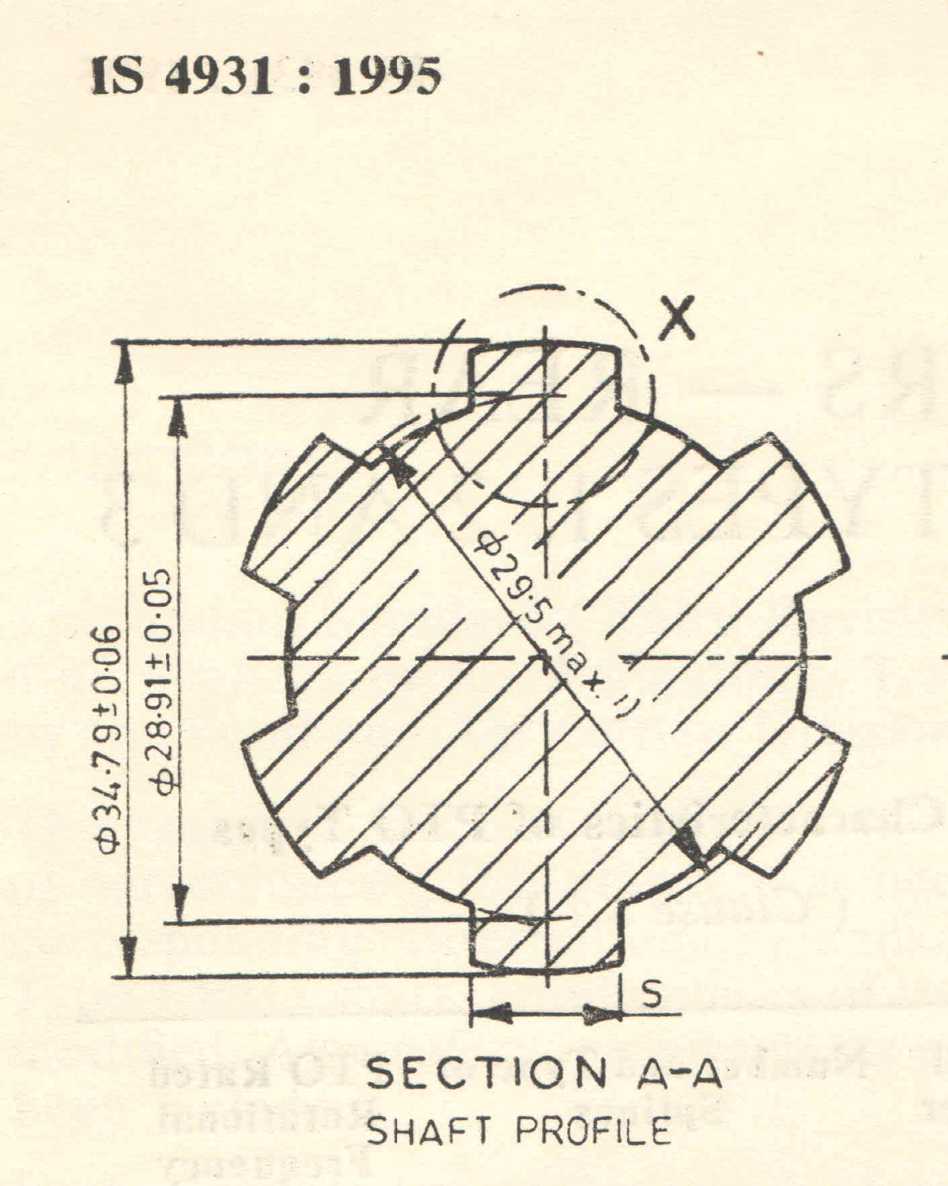

D = 34.96
d = 29.8
W = 9.1
A = 54.0
Fig.1. Propeller Shaft Hub Dimensions

  - Rotor
 | Type | : | Circular in shape which is fabricated of mild steel
 | Details of construction | : | The outer cage of the rotor is made of eight no. vertical circular strips of size 20 × 5 mm flats at a spacing of 500 mm. 197 nos. of horizontal square bars of size 7 × 7 mm is welded to the vertical circular strips. The rotor is supported on the axis of hollow shaft which is supported with two bearing blocks of P210 on the main frame. The rotor frame is attached to the rotor shaft with the help of four radial arms.
 | Size of rotor, mm  - Length  - Diameter | : | 3600  910
 | Size of rotor shaft, mm  - Length  - Diameter | : | 3800  57
 | Attachment of rotor shaft with rotor frame | : | Through radial arms at four places at a spacing of 1030 mm
 | Mounting of radial arm, mm | : | 31 mm circular hollow pipe welded to the rotor shaft of 57 mm and MS box of 40 × 40 mm which runs through the entire length of the rotor frame.
 | Dimensions of outer circular flanges on both sides of the rotor | : | Circular flange of 40 × 5 mm
 | Size of grate opening | : | Approx. 7 mm opening between the square rods of 7 × 7 mm which helps the contaminated water to pass through.

  - Water Pump
 | Type | : | Centrifugal water pump driven by V-belt and pulley
 | Pump Model | :
 | Rating of pump | : | 5.8 kW
 | Discharge, lps | : | 21
 | Duty point head, m | : | 13
 | RPM | : | 1500
 | Head range | : | 10.4 to 14.3
 | Suction pipe size, mm | : | 46.8 OD
 | Delivery pipe size, mm | : | 42.8 OD

  - Water Distribution
1. | Type | : | Through MS pipe which is connected to water pump delivery
2. | Size of pipe, mm | : | 42
3. | No. of water outlets on pipe | : | 22 nos. at a spacing of 15 cm
4. | Position of water outlet pipe | : | Over the rotor drum at a height of 1410 mm from the ground
5. | Diameter of the water outlet hole, mm | : | 10
6. | Collection of contaminated water | : | Out of 3.6 m length of the rotor drum, water falling from 2 m length (approx.) is collected on a tray provided under the drum which is again drained off. Rest of the water falls on the ground directly, thus wetting the surrounding areas.
7. | Dimensions of water tray | : | Inclination: 9⁰  Length: 2035 mm  Width : 1020 mm  Min. Clearance between the tray and rotor: 31 mm  Max. Clearance between the tray and rotor: 255 mm

  - Feeding chute
1. | Type | : | Trapezoidal MS sheet fabrication
2. | Size of chute, mm  - Length  - Width  - Height | : | 825  770 (front end) and 520 (towards rotor)  120
3. | Thickness of feeding chute, mm | : | 2.4
4. | Height from ground, mm | : | 1420
5. | Inclination of chute | : | 24⁰ towards inlet
6. | Provision of foot pad for feeding person | : | Foot pad of size 1100 × 1100 mm is provided at a height of 530 mm from ground.
7. | Construction of foot pad | : | Foot pad is fabricated with MS angles and flats of size 65 × 65 × 6 mm and 32 × 5 mm respectively.

  - Outlet
1. | Type | : | Trapezoidal MS sheet fabrication
2. | Size of outlet, mm  - Length  - Width  - Height | : | 470  300 (collection end) and 560 (towards rotor)  700 from ground
3. | Thickness of outlet chute, mm | : | 2

  - Hitch assembly
1. | Type | : | Trailed type supported on two pneumatic wheels
2. | Mounting of hook for hitching with tractor | : | A threaded hook of 28 mm diameter is attached to the ’Y’ shaped frame made of MS channel of size 90 × 45 × 6 mm with nut
3. | Dia. Of the hole of hook | : | 50 mm
4. | Height of hitch, mm | : | 750
5. | Distance between hook and the main chassis | : | 1100
6. | Provision of wheels | : | The machine is supported by two pneumatic wheels of size 6.00 × 16 10 PR which is mounted on square axle of 55 × 55 mm size.
7. | Track width of wheels, mm | : | 1320
8. | Location of wheels | : | At a distance of 1840 mm from the feeding chute side.
9. | Provision of stand | : | Two telescopic stands are provided near the outlet side of the machine. It also serves the purpose of raising the rotor frame by 5⁰ to increase the retention time of the vegetables being washed.

5.10 Overall Dimensions, mm
The overall dimensions are given in Fig.2.
Length | : | 6150
Width | : | 1790
Height | : | 1500

5.11
Mass, Kg | : | 960
No. of greasing/oiling points | : | Greasing: 5

6. RUNNING -IN
The Vegetable washing machine shall be run-in for one hour. Bolts and nuts shall be tightened and lubrication is done before the start of the actual test.
7. FIELD TEST
Field test of vegetable washing machine should be conducted in carrot crop for 20 hours consisting of 4 trials. The detailed test results are given in Annexure-II and are summarized as under-:
Summary of field test results:
Sl. No. | Parameters | Range of measurement
1. | Feed rate, kg/h | 2480 to 2720
2. | Retention time, minutes | 4 to 5
3. | Mechanical Washing Efficiency, % | 72.5 to 78.0
4. | Microbial Washing Efficiency, % | 88.2 to 91.8
5. | Bruising Efficiency, % | 5.80 to 8.50
6. | Speed of rotor drum, rpm | 25
7. | Fuel consumption, l/h | 1.8 to 2.2
8. | Labour requirement | Three

8.1 Quality of work

The mechanical washing efficiency varied from 72.5 to 78.0 % whereas the microbial washing efficiency varied from 88.2 to 91.8 %. The bruising efficiency varied from 5.80 to 8.50 %

8.2 Rate of work and fuel consumption
The feed rate varied from 2480 to 2720 kg/h and the fuel consumption with Swaraj-735 tractor, it varied from 1.8 to 2.2 litres/h.

8.3 Labour requirement
Three persons are required to operate the tractor.

8. LUBRICATION & SERVICING
All lubrication points are lubricated/greased daily before starting the operation.

9. EASE OF OPERATION AND ADJUSTMENT
Operation and adjustment of vegetable washing machine are observed to be satisfactory.

10. SOUNDNESS OF CONSTRUCTION

11. COMMENTS AND RECOMMENDATIONS

12. APPLICANTS COMMENTS

