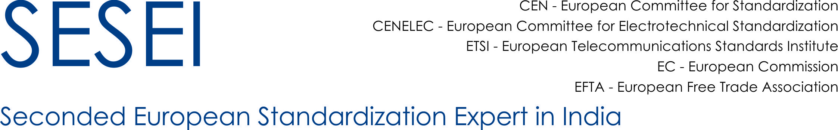

###### 

###### Dinesh Chand Sharma

*Director – Standards & Public Policy, EU Project SESEI*

Since 2012, Mr. Dinesh Sharma is associated with EUROPEAN STANDARDISATION PROJECT, SESEI as Director – Standards and Public Policy. In this role, Mr. Sharma acts as the focal point in India representing European Standards Organizations (ETSI, CEN, CENELEC), European Commission (EC) and European Free Trade Association (EFTA). The activity of the Project SESEI is focused around sectors covering Smart City, ICT, Automotive and Electrical Equipment including Consumer Electronics.

Prior to this, Mr. Sharma worked with Ericsson for 15 years, having last working profile as “Director – Regulatory Affairs & Industry Relation”. Mr. Sharma began his career in Technical Customer Support back in 1992 and has over 28 plus years of industry experience both in India and abroad. Mr. Sharma holds a bachelor’s degree in Electronics, highest honors in Business Management from Stratford Institute, USA, and a SUN Solaris certification.

