**IS 9155: 20XX**

**Doc. No.: CHD 17(23456) F**

**December 2024**

**गैस मीटर डायफ्राम के लिए**

**चमड़ा - विशिष्टि *(पहला पुनरीक्षण)***

**Leather for Gas Meter**

**Diaphragms – Specification**

(*First Revision*)

ICS 59.140.35

© BIS 2024

भारतीय मानक ब्यूरो

BUREAU OF INDIAN STANDARDS

मानक भवन, 9 बहादुर शाह ज़फर मार्ग, नई दिल्ली - 110002

MANAK BHAVAN, 9 BAHADUR SHAH ZAFAR MARG

NEW DELHI - 110002

[www.bis.gov.in](http://www.bis.org.in) [www.standardsbis.in](http://www.standardsbis.in)

**December 2024 Price Group X**

Leather, Tanning Materials and Allied Products Sectional Committee, CHD 17

FOREWORD

This Indian Standard (First Revision) was adopted by the Bureau of Indian Standards after the draft finalized by the Leather, Tanning Materials and Allied Products Sectional Committee had been approved by the Chemical Division Council.

Diaphragm leathers are used for the manufacture of diaphragms required by certain types of gas meters known as ‘dry’ meters. The diaphragms are made by cutting circles of various sizes. In every meter two circular diaphragms are fixed in metal ring holders and constitute a bellows. While in operation the bellows register the volume of the gas which fills them and thereafter allow it to go out. Studies, carried out in this field, has also shown that this type of leather may also be used in fuel injection pumps.

The leather use for the purpose should be soft, flexible, free from stretchiness and completely impermeable to air or gas. It should neither be affected by the chemicals in the gas nor be corroded or deteriorated by the metal band for holding the diaphragms.

This standard was first published in 1979. This revision has been taken up in order to bring out the standard in latest style and format of the Indian Standards. The relevant clauses and test methods have been added and the references have been updated.

The Committee responsible for formulation of this standard is given in Annex D.

For the purpose of deciding whether a particular requirements of this standard is complied with, the final value, observed or calculated, expressing the result of a test or analysis, shall be rounded off in accordance with IS 2: 2022 ‘Rules for rounding off numerical values (*second revision*)’ The number of significant places retained in the rounded off value should be the same as that of the specified value in this standard.

*Indian Standard*

**Leather for Gas Meter Diaphragms – Specification**

(*First Revision*)

**1 SCOPE**

This standard prescribes requirements and methods of sampling and test for different types of leather used of the manufacture of diaphragms required for gas meters for registering the volume of gas passed through them and in fuel injection pumps.

**2 REFERENCES**

The standards listed below in Annex A contain provisions, which through reference in the text, constitute provisions and necessary adjuncts to this standard. At the time of publication, the editions indicated were valid. All standards are subject to revision and parties to agreement based on this standard are encouraged to investigate the possibility of applying the most recent editions of the standards indicated in Annex A.

**3 TERMINOLOGY**

**3.1** For the purpose of this standard, the definitions given in IS 1640 and the following shall apply.

**3.1.1** *Diaphragms —* Materials generally used for fixing in metal ring holders constituting a bellows which in turn measure the volume of gas passed through it.

**4 TYPES**

This standard covers two types of leather for the manufacture of diaphragms, namely:

1. *Type 1 —* Semichrome tanned sheep or goat skin, and
2. *Type 2 —* Full chrome sheep or cowcalf skin (for use in very large gas meters).

**5 REQUIREMENTS**

**5.1 Tanning**

**5.1.1** *For Type 1 —* Vegetable tanned leathers, after selection, shall be soaked and shaved to uniform thickness, and after stripping, shall be semichromed with basic chrome liquor.

NOTE – Generally E L tanned skins are used for this purpose.

**5.1.2** *For Type 2 —* Pelts shall be tanned with basic chrome tanning salts.

**5.2 Finishing —** After tanning, the leather shall be cleanly buffed on the flesh side and may be lightly shaved or buffed on the grain side a final operation.

**5.2.1** A dressing of graphite along with oil shall be applied on the leather if desired by the purchaser.

**5.3** The thickness of the leather shall be as agreed to between the purchaser and the supplier. The agreed thickness shall be uniform throughout within ± 0.2 mm.

**5.4 Physical Requirements —** The material shall comply with the requirements given in Table 1.

**TABLE 1 PHYSICAL REQUIREMENTS FOR LEATHER FOR DIAPHRAGMS**

(*Clause* 5.4)

|  |  |  |  |
| --- | --- | --- | --- |
| **Sl. No.** | **Characteristic** | **Requirement** | **Method of test,**  **Ref to** |
| **(1)** | **(2)** | **(3)** | **(4)** |
|  | Tensile Strength, MPa *Min* | 9.8 | IS 5914 (Part 8) |
|  | Elongation at break , percent , *Max* | 50 | IS 5914 (Part 8) |
|  | Grain crack resistance | The grain shall not crack at fold when the leather is folded with grain side out | — |
|  | Bursting strength, MPa, *Min* | 29.4 | Annex B |

**5.5 Chemical Requirements —** The leather shall comply with the requirements given in Table 2.

**TABLE 2 CHEMICAL REQUIREMENTS FOR LEATHER FOR DIAPHRAGMS**

**(***Clause*5.5)

|  |  |  |  |  |
| --- | --- | --- | --- | --- |
| **Sl. No** | **Characteristics** | **Requirement** | | **Method of test,**  **Ref to** |
|  |  | Type 1 | Type 2 |  |
| (1) | (2) | (3) | (4) | (5) |
|  | Total ash, percent by mass, *Max* | 7.0 | 7.0 | IS 582 (Part 3) |
|  | Hide substance, percent by mass, *Min* | 48 | 60 | IS 582 (Part 12) |
|  | Solvent extractable substances , percent by mass, *Min* | 10 | 10 | IS 582 (Part 14) |
|  | Cr2O3 Content, percent by mass, *Min* | 2.8 | 3.5 | IS 582 (Part 10/Sec 1)/ IS 582 (Part 10/Sec 4) |
|  | Iron content, mg/kg, *Max* | 100 | 100 | IS 582 (Part 6/Sec 2) |
|  | pH of water solubles, *Min* | 3.5 | 3.5 | IS 582 (Part 9) |

NOTE — All requirements expect the one at serial No (vi) shall be calculated on zero percent moisture basis. The moisture content shall be determined as prescribed in LC: 1of IS 582 or Part 1 of IS 582.

**5.6 Additional Requirements for Leather for Gas Meter Diaphragms**

**5.6.1** The finished leather shall be treated with some fungicidal additive such that it becomes resistant to fungal attack. For this purpose, the manufacture shall issue a certificate that the leather has been treated with such additive. The material shall show no growth of mildew on visual examination.

**5.6.2** *Boiling Water Immersion Test —* The leather shall withstand the test when tested in accordance with the method prescribed in Annex C. The mean percentage decrease in the diameter of the test piece shall not exceed 3 percent.

**6 PACKING AND MARKING**

**6.1 Packing —** The leather shall be packed as agreed to between the purchaser and the supplier.

**6.2 Marking —** Each package shall be marked legibly with the following information:

1. Number of pieces and total area in dm2 ;
2. Type;
3. Date of manufacture and recognized trade-mark, if any; and
4. Indication that the leather has been treated with fungicidal additive.

**6.2.1** The product(s) conforming to the requirements of this standard may be certified as per the conformity assessment schemes under the provisions of the *Bureau of Indian Standards Act*, 2016 and the Rules and Regulations framed thereunder, and the products may be marked with the standard mark

**7 SAMPLING AND CRITERIA FOR CONFORMITY**

The scale of sampling and the criteria for conformity of the material to the requirements of this standard shall be as prescribed in IS 5868.

**Annex A**

(*Clause* 2)

**LIST OF REFERRED STANDARDS**

|  |  |
| --- | --- |
| *IS No.* | *Title* |
| IS 582: 1970 | Methods of chemical testing of leather (*first revision*) |
| IS 582 | Methods of chemical testing of leather |
| (Part 1): 2017/  ISO 4684: 2005 | Determination of volatile matter (*second revision*) |
| (Part 3):2017/  ISO 4047: 1977 | Determination of sulphated total ash and sulphated water - insoluble ash (*second revision*) |
| (Part 6/ Sec 2): 2024/ ISO 17072-2: 2022 | Determination of metal content Section 2 Total metal content |
| (Part 9): 2022/  ISO 4045: 2018 | Determination of *p*H and difference figure |
| Part 10 | Determination of chromic oxide content |
| (Sec 1) :2022/  ISO 5398-1: 2018 | Quantification by titration |
| (Sec 4) :2022/  ISO 5398-4: 2018 | Quantification by inductively coupled plasma (ICP) |
| (Part 12): 2022/  ISO 5397:1984 | Determination of nitrogen content and hide substance titrimetric method |
| IS 1070: 2023 | Reagent grade water - Specification (*fourth revision)* |
| IS 1640: 2007 | Glossary of terms relating to hides, skins and leather (*first revision*) |
| IS 5868: 1969 | Method of sampling for leather (*first revision*) |
| IS 5914 (Part 8):2023/  ISO 3376: 2020 | Methods of physical testing of leather Part 8 Determination of tensile strength and percentage elongation |

**ANNEX B**

*(Table 1)*

**DETERMINATION OF BURSTING STRENGTH**

**B GENERAL**

**B-1** The popularity of bursting strength test depends not only on the ease with which the test is made but also on the combination of strength and toughness which it measure and which serves as a measure of the serviceability of the material in various applications. It has the disadvantage, however, that it depends in a complicated way on the machine direction tensile strength, stretch and size of the burst area. Also it does not give any indication of the cross-direction tensile strength. Bursting strength is measured by the pressure developed behind a circular rubber diaphragm when it is forced through the leather so as to burst it.

**B-2 EQUIPMENT**

**B-2.1** The tester, in which testing is done by hydraulic pressure communicated through the medium of glycerine or by compressed air to a gauge used, shall be so chosen that the individual reading shall be not less than 25 percent or more than 75 percent of the total indicated capacity of the gauge.

NOTE — The use of hand-operated hydraulic type tester is not recommended as a standard practice.

**B-2.1.1** *Diaphragm* — The diaphgram used in the equipment shall be such that it does not materially affect the bursting pressure and shall be between 0.35 mm and 0.45 mm thick The rubber sheet used shall be pure gum vulcanizate containing not less than 95 percent by volume of first quality smoked sheet rubber; the only ingredients in the mix, apart from rubber, shall be those necessary to effect correct vulcanization and resistance to premature ageing at normal temperatures. The pressure required to bulge the diaphragm 5 mm above the top plane of the lower clamping surface of the test instrument shall be not more than 0 007 MPa ( 0 07 kgf/cm2 ).

The diaphragm shall be clamped with its outside edge under the lower clamping plate and shall have been renewed less than six weeks prior to test.

**B-3 PROCEDURE**

**B-3.1** Clamp the test piece firmly over the diaphragm without slippage during the test between two annular, plane, unpolished (matt) surface of 30 mm internal diameter. Run the machine so that pressure increases at a uniform rate of approximately 0 075 Mpa (0.75 kgf/cm2) per second until the test piece bursts Note from the pressure gauge the pressure in kilograms per square centimetre at which the test piece bursts. Take two readings with each sample sheet, one with the grain-side uppermost and the other with the flesh-side uppermost.

NOTE — A rate of 120 revolutions per minute in the glycerine operated machine is usually satisfactory.

**B-4 REPORT**

**B-4.1** Report the type of the tester used and give the average, maximum and minimum values of the reading for each side separately.

**ANNEX C**

(*Clause* 5.6.2)

**DETERMINATION OF SHRINKAGE IN BOILING WATER**

**C-1 APPARATUS AND MATERIALS**

**C-1.1** **Glass Dish** — flat-bottom, circular, of diameter between 75 mm and 105 mm and capacity at least 350 ml.

**C-1.2 Glass Rods** — approximately 2.5 mm in diameter, 100 mm in length, and bent in the middle to an angle of 60°.

**C-1.3 Beaker** — 250 ml.

**C-1.4** **Desiccator or Similar Glass Vessel** — capable of being evacuated.

**C-1.5 Vacuum Pump** — capable of reducing the absolute pressure in the desiccator to less than 25 mbar within 120 seconds of being switched on.

NOTE — 1 bar = 102 N/m3 = 100 kPa.

**C-1.6 Scale** — calibrated in millimeters.

**C-1.7 Stopclock**

**C-1.8 Pressure Vessel** — constructed of aluminum or aluminum alloy, in which water can be boiled at a pressure greater than atmospheric pressure. The vessel shall incorporate the following features.

**C-1.8.1** *Lid* — rapidly removable and replaceable

**C-1.8.2** *Thermometer* — covering the range 100 to 105°C. The thermometer shall be fitted in the lid near one side so that with the lid in position the thermometer bulb extends to within 20 mm of the bottom of the vessel.

**C-1.8.3** *Gas Ring* — capable of heating the vessel so that the temperature of 1 000 ml of water in the vessel is raised from 98 to 100°C in less than 60 seconds.

**C-1.8.4** *Adjustable Release Valve* — spring-loaded, capable of adjustment (in conjunction with the gas flow to the gas ring) such that the temperature of water boiling in the vessel is maintained at 102.0 °C. ± 0.3°C.

NOTE — A domestic pressure cooker may be modified 10 form a suitable pressure vessel for the test. The volume of water in the pressure vessel is unlikely to be of critical importance; losses as steam are restricted by following the method described.

**C-1.9** **Test Piece Holder** — to prevent the test piece from curling during heating in boiling water.

The holder (see Fig. 1) shall have a brass plate *A* of diameter about 100 mm and thickness about 3 mm standing on legs formed by brass screws which raise it about 10 mm .The test piece *B* (shaded), when in position, shall rest on plate *A*, and a bent copper wire of diameter about 1 mm shall rest on the test piece (for clarity, the wire is drawn thicker than 1 mm in the plan). On the wire shall rest another similar brass plate *A*', which shall carry a bridge formed by two brass screws and a brass rod. When the holder has been assembled with the test piece in position, a brass nut shall be screwed on to each of the three vertical screws attached to the lower plate, so that the holder can be lifted from boiling water by a bent wire hooked under the bridge, but the holes in the upper plate shall have sufficient clearance on the three screws to permit the upper plate to slide freely on them. The nuts on these screws shall screw on sufficiently to prevent the upper plate from being lifted off, but shall leave it free to rise at least 5 mm, so that the force constraining the specimen to remain flat during its heating is merely the weight of the upper plate and the bridge. To allow free access of the boding water to the specimen, holes of 10 mm diameter shall be bored as shown in both the upper and the lower plates. The mass of the upper plate and the bridge shall be 250 g ± 20 g.

**C-1.10 Two Circular Brass Plates** — of diameter approximately 100 mm and thickness approximately 3 mm.

**C-1.11 Water** — complying with the requirements of IS 1070.

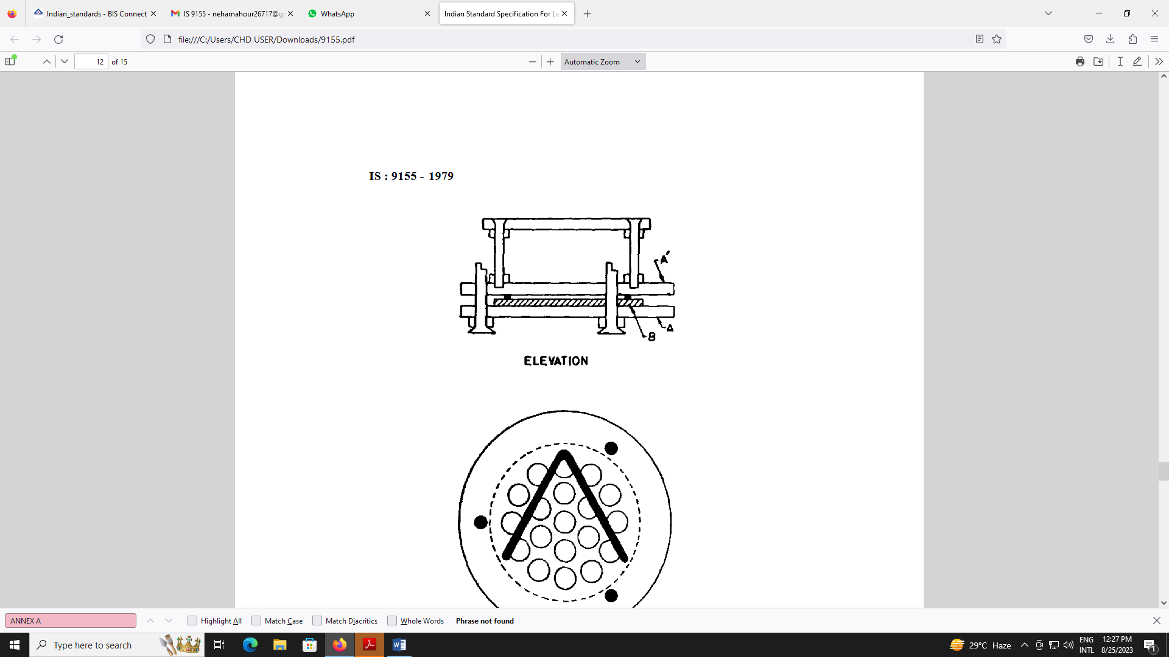

**ELEVATION**

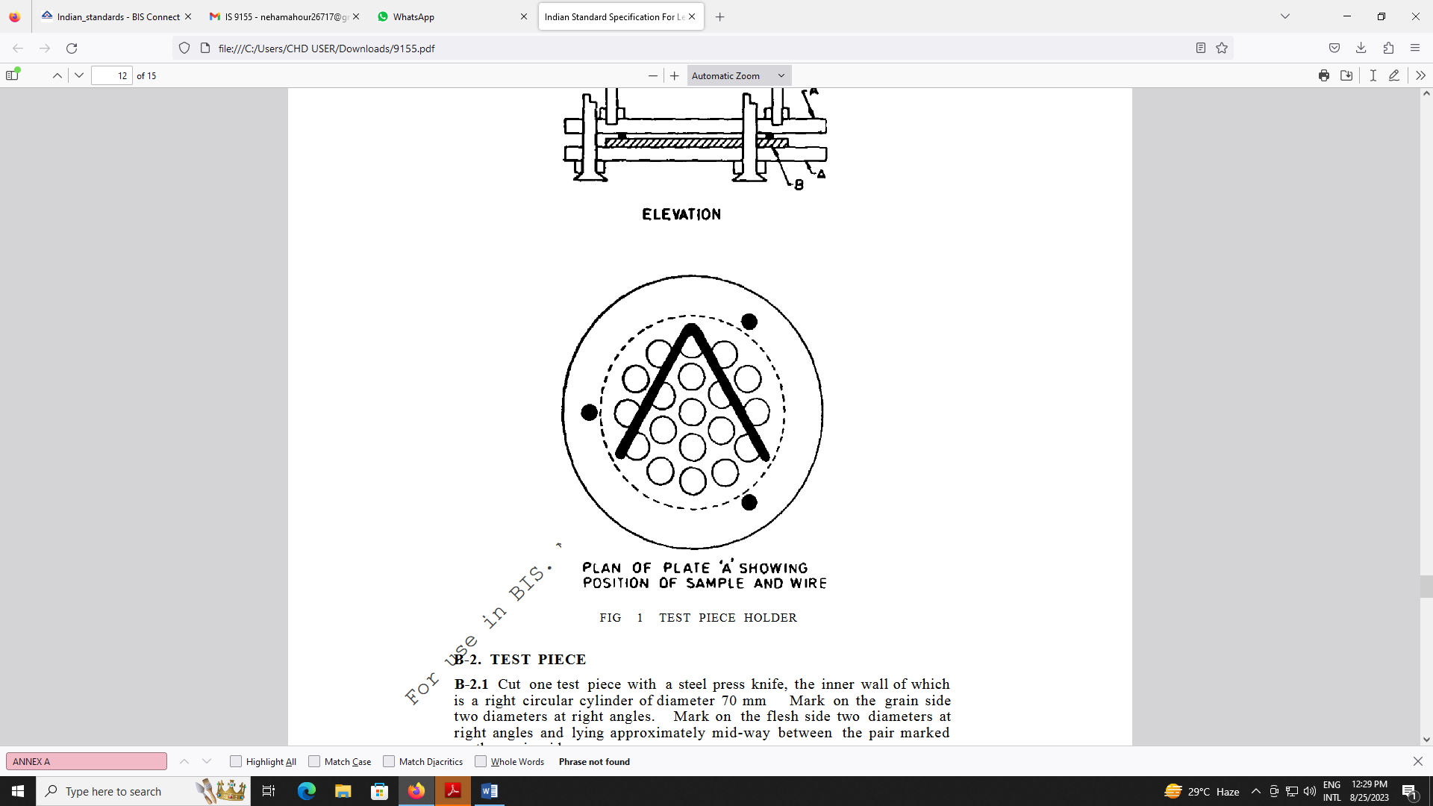

**PLAN OF PLATE ‘A’ SHOWING POSITION OF SAMPLE AND WIRE**

FIG 1 TEST PIECE HOLDER

**C-2. TEST PIECE**

**C-2.1** Cut one test piece with a steel press knife, the inner wall of which is a right circular cylinder of diameter 70 mm. Mark on the grain side two diameters at right angles. Mark on the flesh side two diameters at right angles and lying approximately mid-way between the pair marked on the grain side.

**C-3 PROCEDURE**

**C-3.1** Place one of the bent glass rods on the bottom of the glass dish. Place the test piece on the rod, the second rod on the test piece, and a brass plate on the rod. Add 200 ± 5 ml of water to the dish, transfer the dish to the desiccator and evacuate the desiccator for 180 ± 10 seconds. Allow air to enter the desiccator to restore atmospheric pressure and force water into the specimen.

NOTES

1 The object or reducing the pressure and restoring it again is to remove most of the air from the leather and to force water into it so that all its fibers become wetted Mere immersion without pressure changes is insufficient to wet some leathers.

2 The percentage shrinkages of some leathers in the boil test depend to a marked extent on *p*H value, to obtain consistent results, fixed volumes of water shall be used to wet and boil the test pieces.

**C-3.2** Put into the pressure vessel 1 000 ± 20 ml of water and with the lid on, but not screwed down, heat the water to the boiling point. Then reduce the rate of heating, so that the water continues to boil gently without much escape of steam.

**C-3.3** Sixty minutes after beginning evacuation (and 57 minutes after restoring the pressure to atmospheric), remove the test piece from its dish of water and blot its surfaces gently with blotting paper to remove surplus water Lay the test piece on a flat surface, taking care not to extend it, and measure the four marked diameters to the nearest 05 mm.

**C-3.4** Adjust the heating to its maximum , quickly fit the test piece in the test piece holder and immediately transfer the holder to the pressure vessel, noting the time when it enters the water. Fasten down the lid and allow the temperature to rise to 102 0°C .By adjusting the heating and the release valve of the pressure vessel, maintain the temperature at 102°C ± 0.3°C with a slow escape of steam through the release valve.

NOTE — The temperature of boiling water depends on atmospheric pressure. To maintain the temperature of boiling water at 100 0°C requires relatively elaborate apparatus; 102 0°C is used in the method because this is a temperature (near 100°C) which is easily maintained.

**C-3.5** After the test piece has been in the pressure vessel for 15 min ± 0.1 min, transfer the vessel to a sink and play a rapid stream of cold tap water on the lid to cool it, and after 1 or 2 seconds, allow 2 or 3 liters of tap water to enter the vessel. Remove the test piece holder from the vessel and the test piece from the holder .Lay the test piece horizontally on one of the brass plates. Place the other plate on the test piece and on the upper plate place a beaker containing sufficient water so that a total mass of 250g ± 20 g is applying gravitational force on to the test piece.

**C-3.6** After the specimen has cooled for 5 min ± 0.5 min, remove it, blot its surfaces gently and again measure its four marked diameters to the nearest 0.5 mm.

**C-4 EXPRESSION OF RESULTS**

**C-4.1** Calculate the mean percentage decrease in the diameter of the test piece (P) by the following formula:

*P =*

where

S0 = the sum of the four marked diameters measured before heating, and

S1 = the sum of the four marked diameters measured after heating.

NOTE — Test pieces which are initially circular and which shrink considerably in the boil test are sometimes far from circular after shrinkage For such test pieces, the formula for P gives only a rough approximation of the mean percentage linear shrinkage. In such cases, however, the exact amount of shrinkage is seldom, if ever, of interest .The simple formula given is reasonably accurate for test pieces whose shrinkage is less than 10 percent.

**ANNEX D**

(*Foreword*)

**COMMITTEE COMPOSITION**

Leather, Tanning Materials and Allied Products, Sectional Committee CHD 17

|  |  |
| --- | --- |
| *Organization* | *Representative(s)* |
| CSIR - Central Leather Research Institute, Adyar Chennai | Dr K. J. Sreeram **(Chairperson)** |
| ATC Chemicals India Private Limited, Chennai | Shri Subbarayan Govardhanan |
| Avanti Leathers Limited, Chennai | Shri O. K. Kaul |
| Council for Leather Exports, Chennai | Shri A. Fayaz Ahmad Shri D. Gokulakrishnan (Alternate) |
| CSIR - Central Leather Research Institute, Chennai | Dr R. Chandrasekar Dr R. Mohan (Alternate) |
| Directorate General of Quality Assurance, CQA (Textiles and Clothing), Kanpur | Shri S. Chakraborty Shri T. P. Banerjee (Alternate) |
| Indian Finished Leather Manufacturers and Exporters Association, Chennai | Shri N. Shafeeq Ahmed  Shri P. K. Aslam Basha (Alternate) |
| Indian Shoe Federation, Chennai | Shri V. Muthukumaran  Shri Abdul Rahman (Alternate) |
| National Institute of Fashion Technology, Chennai | Shri. E. Sivasakthi  Dr M. Aravendan (Alternate) |
| Office of Development Commissioner (MSME), New Delhi | Shrimati M s Rammiya |
| SGS India Private Limited, Chennai | Shri P. Venkatesan Shri G. Muthukumar (Alternate) |
| Stahl India Pvt Ltd., Chennai | Shri A. Nagarathinam Shri S. Suryanarayan (Alternate) |
| TUV-SUD South Asia Private Limited, Bengaluru | Shri Vinodh Kumar K. |
| In Personal Capacity (*CSIR-Central Leather Research Institute, Adyar Chennai- 600020*) | Dr B. Chandrasekaran |
| In Personal Capacity (*Flat F1, Bhoopathy Apartment,10, Ethiraj Street, Palipattu, Chennai - 600113*) | Dr B. N. Das |
| In Personal Capacity (*SA3, Thendral Flats, 2, Balakrishnan Road, Valmikinagar, Thiruvanmiyur - 600041*) | Dr S. Sadulla |
| BIS Directorate General | Shri Ajay Kumar Lal, Scientist ‘F’/Senior Director and Head (Chemical) [Representing Director General (Ex-officio)] |

*Member Secretary*

Ms Preeti Prabha

Scientist ‘D’/ JOINT Director

(Chemical), BIS