**IS: 1946 – 2024**

***Indian Standard***

Fixing Devices In Walls, Ceilings And Floors Of Solid Construction

Part 1 Devices Other Than Post-Installed

Anchors - Code Of Practice

**FOREWORD**

1. Fixing devices, such as cast-in place anchors, cast-in anchor channels, post-installed anchors, nails, for use in solid construction (concrete and masonry are of considerable usefulness in building work. The use of these fixing devices is becoming more common with the evolution of the construction industry and the practices.
2. Use of proper devices and trained installer will ensure a neat fixing work with minimum effort and little damage, and the fixtures will have adequate strength and durability. This standard attempts to provide the necessary guidance for their selection and fixing, also giving their essential dimensions and features, and situations of use.
3. Another specification on fixing devices for use in cavity construction and other base materials is under preparation.
4. Wherever a reference to any Indian Standard appears in this code, it shall be taken as a reference to the latest version of the standard.
5. Metric system has been adopted in India and all quantities and dimensions appearing in this standard have been given in this system.
6. In the formulation of this standard, assistance has been derived from EN 1992-4:2018, Eurocode 2 - Design of concrete structures - Part 4: Design of fastenings for use in concrete
7. For the purpose of deciding whether a particular requirement of this standard is complied with, the final value, observed or calculated, expressing the result of a test, shall be rounded off in accordance with IS:2-2022 “Rules for Rounding Off Numerical Values *(Revised)”.* The number of significant places retained in the rounded off value should be the same as that of the specified value in this standard.
8. This code is intended chiefly to lay down requirements regarding the different types of fixing devices commonly used in the industry and methods of installation, and it does not include all the necessary provisions of a contract.
9. The standard will be developed in 5 different parts as follows and more parts shall be added with subsequent development –

The standard will be developed in 5 different parts as follows and more parts shall be added with subsequent development –

1. Part 1 Devices Other Than Post-Installed Anchors - Code of Practice
2. Part 2 Design Of Post-Installed Anchorage To Concrete - Code Of Practice
3. Part 3 Testing and Assessment Of Post-Installed Adhesive Anchoring Systems
4. Part 4 Testing and Assessment of Post-Installed Mechanical Anchoring Systems
5. Part 5 Post-Installed Anchorage to Concrete - Installation and On-site Inspection – Code of Practice
6. **SCOPE**

This standard lays down the essential features and methods of use of the following fixing devices –

1. cast-in place anchors,
2. cast-in anchor channels,
3. post-installed anchors and
4. nails

These fixing devices need to be suitable for use in walls, floors, and ceilings of solid construction (concrete – PCC/ RCC and masonry – brick/ AAC blocks)

1. **REFERENCE**

The standards (and documents) given in Annex A contain provisions which, through reference in this text, constitute provisions of this standard. At the time of publication, the editions indicated were valid. All standards are subject to revision, and parties to agreements based on these standards are encouraged to investigate the possibility of applying the most recent editions of the standard given in Annex A.

1. **TERMINOLOGY**

The terminologies given in this standard shall be read in conjunction with the definition of terms given in IS 1946 Part 2, IS 1946 Part 3, IS 1946 Part 4 and IS 800. In addition, the following terms shall apply.

* 1. Cast-in place anchor – Cast-in place anchors are built-in devices, as the name applies, that are embedded in concrete at the time of construction, and they may house a metallic thread for bolt fixtures.
  2. Cast-in anchor channels – Cast-in anchor channels are pre-positioned cast-in fixing solutions, consisting of steel profile with rigidly connected anchors.
  3. Channel bolt – It is a bolt which connects the base plate or the element to be fixed to the cast-in anchor channel.
  4. Concrete blow-out failure – This refers to failure of the concrete on the side face of the concrete member at the level of the embedded head of cast-in place anchor, with no major break-out at the top concrete surface.
  5. Good for construction drawings – These are drawings prepared and approved by the concerned engineer-in-charge based on specifications and are crucial to construction industry’s decision making process.
  6. Manufacturer’s printed installation instruction – These are published instructions, provided by the manufacturer, for the correct installation of a fixing device under all covered installation conditions as supplied in the product packaging.
  7. Nails –Nails are slender [metal](https://www.britannica.com/science/metal-chemistry) [shaft](https://www.britannica.com/dictionary/shaft) that is pointed at one end and flattened at the other end and is used for fastening one or more objects to each other.

1. **SYMBOLS**

CIA – Cast-in place anchors

CIC – Cast-in anchor channels

GFC – Good for construction

MPII – Manufacturer’s printed installation instructions

PIA – Post-installed anchor

1. **PRINCIPLES OF FIXING**

The fixing devices make use of tensile strength of concrete. Generally, they work on the principle of friction and keying, mechanical interlock, adhesive bonding, or a combination. For details on the working principles reference may be made to IS 1946 Part 2 (under preparation).

Nails (specially the direct fastening nails) work on the principle of sintering and interlocking. When a nail is pushed into the concrete, it creates a space on the side by pushing the concrete and compacting it in the process. Intense heat generated during the process causes the concrete to be sintered onto the surface of the nail. The sintered concrete in the region of the fastening point forms ridges on the surface of the nail which helps in micro interlocking between the nail and the concrete.

For all installation instructions and guidance related to post-installed anchors in concrete, reference may be made to IS 1946 part 4.

The installation of fixing devices, other than post installed anchors, shall be undertaken by installers who have been adequately trained by the manufacturer to install the same. The installer shall produce a certificate of training issued by the manufacturer to the individual, having a validity of not more than one year. A certificate of completion must be provided by the installer after installation of the anchors stating that installation has been done as per MPII and submitted to the concerned engineer/ supervisor. A typical format is provided in Annex D.

1. **APPLICATIONS**

The fixing devices can be used for a wide range of applications – from light duty to heavy duty fixings. They can be used for temporary as well as for permanent fixing applications. Some of the applications are illustrated in Fig. 1 to Fig. 11.

A general guideline for selection of fixing devices for the most commonly observed applications is given in Table 1.

TABLE 1 GENERAL GUIDELINE FOR SELECTION OF FIXING DEVICES FOR COMMON APPLICATIONS (a)

|  |  |  |
| --- | --- | --- |
| **Application** | **Base material** | **Type of fixing device** |
| Fixing of stadium seats | Concrete | CIA, CIC, PIA, |
| Fixing of elevator guide rails and divider beams (see Fig. 1) | Concrete | CIA, CIC, PIA |
| Masonry | PIA |
| Fixing of equipment | Concrete | CIA, PIA |
| Fixing of utility systems (cable trays, hvac ducts, sprinkler pipes, etc.) (see Fig. 2) | Concrete | CIA, CIC, PIA, Nails |
| Masonry | PIA, Nails |
| Fixing of bracket for structural glazing, canopy, skylight, etc. (see Fig. 3) | Concrete | CIA, CIC, PIA |
| Masonry | PIA |
| Fixing of bracket for supporting crane beam (see Fig. 4) | Concrete | CIA, PIA |
| Fixing of bracket for mezzanine floor (see Fig. 5) | Concrete | CIA, CIC, PIA |
| Masonry | PIA |
| Fixing of noise barriers, crash barriers, OHE poles, light poles (see Fig. 6) | Concrete | CIA, PIA |
| Fixing of strut waler beams in underground structures (see Fig. 7) | Concrete | CIA, CIC, PIA |
| Fixing of railing & handrailing | Concrete/ masonry | CIC, PIA |
| Walkway fixing (see Fig. 8) | Concrete | CIA, CIC, PIA |
| Door and window frame fixing | Concrete/ masonry | PIA |
| Dry Stone cladding | Concrete/ masonry | PIA (b) |
| Fixing of light weight fixtures like furniture, television, etc. directly to the wall | Concrete/ masonry | PIA |
| Prop fixing in precast structures (see Fig. 9) | Concrete | PIA |
| Fixing of kicker-ring during TBM launch (see Fig.10) | Concrete | PIA |
| Fixing of guide rail for TBM | Concrete | PIA |
| Fixing of TBM retrieval shaft | Concrete | PIA |
| Fixing of lifting hook | Concrete | PIA |
| Fixing of Over Track Exhaust Fan, Tunnel Ventilation Fan, UPS Fan in tunnels | Concrete | PIA |
| Fixing thin metal sheets: roof decking wall liners and floor decking | Concrete | Nails |
| Fixing thicker steel members e.g., metal brackets, clips | Concrete | Nails |
| Fixing soft materials such as wooden battens or insulation to concrete or masonry | Concrete/ Masonry | Nails |
| Track fixing for dry walls (see Fig. 11) | Concrete | PIA, Nails |
| Connections for composite structures - Fixing nailed composite shear connectors | Concrete | PIA, Nails |

**NOTE –**

1. The above table is only for guidance. It does not restrict the user from adoption of a particular system if technically acceptable.
2. For dry stone cladding, either the clamp has to be fixed to the concrete or masonry member through post-installed anchoring or the subframe is fixed to the base material (concrete or masonry) with the help of post-installed anchoring and clamps are connected to the subframe through welds or rivets.
3. Essentially the fixing devices shall be selected such that they are able to withstand all possible load effects likely to act on them. For example, the fixing device used to suspend sprinkler pipes from the ceilings shall be adequate to withstand the self-weight of the pipes plus weight of water, hammering effect of the water during flow as well as earthquake forces transmitted to the sprinkler pipe support system during an earthquake event. The fixing devices used to connect a machine foundation shall be able to withstand dynamic effects due to operation of the machine.

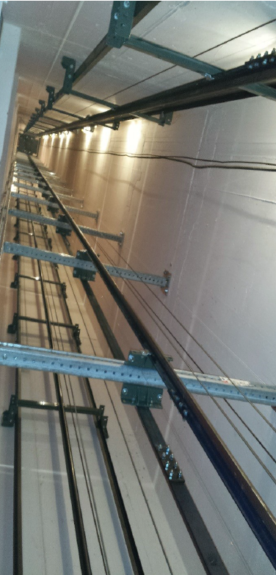

FIG. 1 FIXING OF ELEVATOR GUIDE RAIL AND DIVIDER BEAM

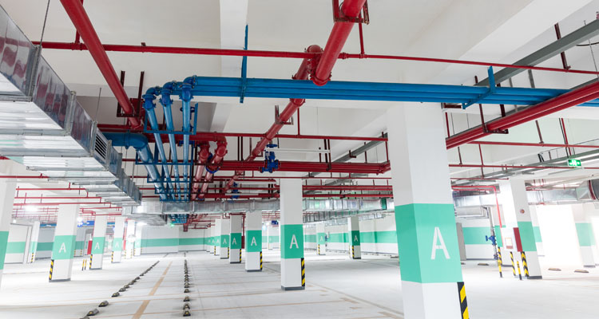 

FIG. 2 FIXING OF UTILITY SYSTEM

 

FIG. 3 FIXING OF BRACKET FOR CANOPY AND SKYLIGHT

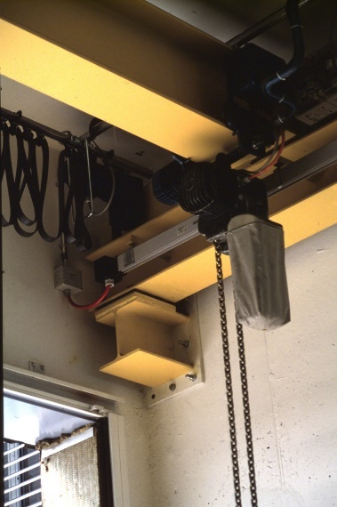 

FIG. 4 FIXING OF BRACKET FIG. 5 FIXING OF BRACKET FOR MEZZANINE FLOOR

FOR SUPPORTING CRANE BEAM

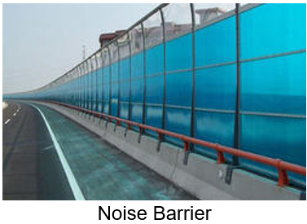

FIG. 6 FIXING OF NOISE BARRIER FIG. 7 FIXING OF STRUT WALER

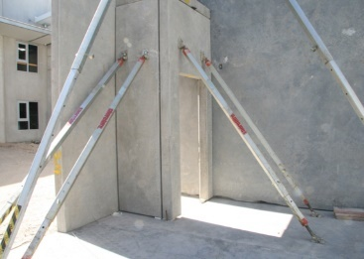

FIG. 8 FIXING OF WALKWAY FIG. 9 PROP FOR PRECAST STRUCTURE

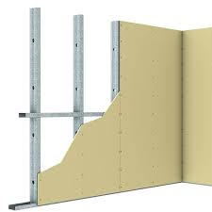

FIG 11. FIXING OF KICKER-RING FIG 11. DRY WALL TRACK FIXING

DURING TBM LAUNCH

1. **SELECTION CRITERIA FOR FIXING AND EVALUATION OF CAPACITY**

The selection of a fixing device shall be solely governed by the application type and criticality of the application. The performance of a fixing device is dependent on number of factors like the magnitude and the type of load (static, quasi static, dynamic, fire, fatigue, etc.), the type of base material (like concrete, masonry), dimension of base material, grade of concrete, condition of the concrete (i.e., presence of concrete cracks), presence of adjacent fixing devices. They shall be verified and confirmed for adequacy taking into consideration all influencing factors. The resistance/ capacity shall be determined based on design, performed against all possible failure modes of steel and base material (i.e., concrete or masonry) and evaluated for group behavior for specific application conditions, in accordance with national standards or accepted engineering practices. For expansion plug anchor and nails, the data as per the technical data sheet of the manufacturer shall be used.

In general, the fixing devices shall be selected to suit the environmental/ exposure conditions and required design service life of the structure. It is suggested to use a minimum of 5 micron galvanized fixing device shall be used for dry internal condition and stainless steel (304 or 316 grade) or hot-dipped galvanized devices for other exposure conditions depending on the severity. For severity of exposure conditions, reference may be made to relevant national or equivalent international standards.

1. **CAST-IN PLACE ANCHORS** 
   1. **General –** These are the conventional types of fixing devices. Cast-in-place anchors are cast-in position in wet concrete before it sets. They are commonly referred to as cast-in bolts. Bolts with hexagonal head, hooked J bolts, L bolts etc. (Fig.12) are some examples of cast-in-place anchors. They may house a metallic thread for bolt fixtures.

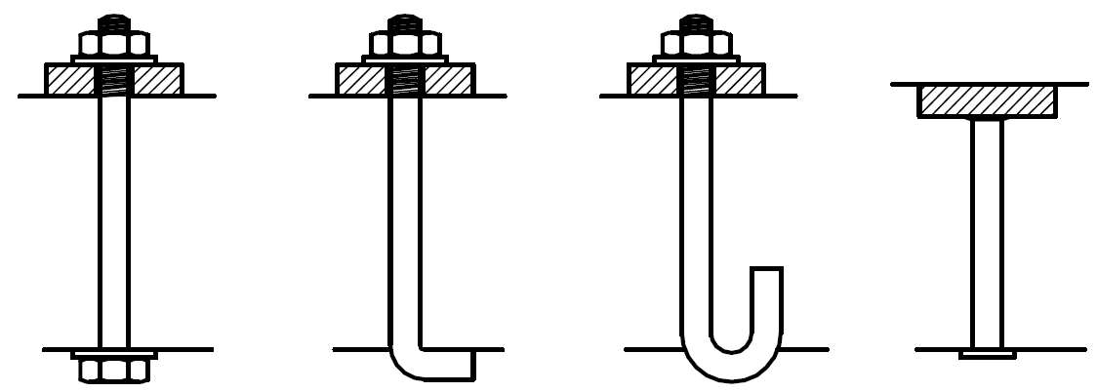

FIG. 12 CAST-IN PLACE ANCHORS

* 1. **Requirement –** The cast-in place anchors to be used shall be as per approved drawings by the concerned structural engineer. The parameters like grade of the bolt, anchorage depth, diameter of the anchor, number and orientation shall be clearly specified in the GFC drawing based on analysis and design. The material specifications shall be as per the respective manufacturer; however, this should not contradict any provision of existing national standards. For design of cast-in place anchors, reference may be made to specialist literature. A preliminary guideline for design is provided in Annex B.
  2. **Method of fixing –** The manufacturer’s printed installation instructions (MPII) should be followed. Some of the general steps are listed below (See Fig. 13)

1. Prior to fixing the anchors, a temporary wooden plate containing holes relevant to the diameter, location, and number of anchor bolts as per approved drawings is prepared.
2. The bolts are fixed to the temporary wooden plate accurately.
3. After survey work, the bottom part of the anchors shall be inserted inside the neck columns as per approved drawings.
4. After fixing the temporary wooden plates align, the anchors shall be levelled and fixed properly as per approved drawings.
5. The alignment and the level of the anchors have to checked after fixing.
6. The Engineer-in-charge shall check the anchor bolts after fixing and post approval cover the anchors with masking tape protection before concreting.

FIG. 13 METHOD OF FIXING OF CAST-IN PLACE ANCHORS

1. **CAST-IN ANCHOR CHANNELS**
   1. **General –** These are innovative type of cast-in-place anchors. In this system, a channel is fitted with multiple headed anchor legs (two or more) (see Fig. 14). The headed anchor legs are either welded or screwed to the anchor channel. The anchor channel is usually square, rectangle or V-shaped. T-bolts fitted into the anchor channel serves as the fixing point. This fixing device offers multipoint anchoring system in a single assembly. Cast-in anchor channels can accommodate positioning tolerances in one direction. This fixing solution is commonly used where it is difficult to drill, for example - in high strength concrete, densely reinforced concrete, prestressed concrete etc.

FIG. 14 CAST-IN ANCHOR CHANNELS

* 1. **Requirement –** The selection of the cast-in channel section shall bemade based on the design requirement and recommendation by the concerned engineer-in charge. Dimensional requirements such as length of the channel, embedment depth, etc. shall be governed by the structural design and as per recommendation of respective manufacturer. These details shall be clearly indicated in the GFC drawing. The material specifications shall be as per the respective manufacturer; however, this should not contradict any provision of existing standards (see Fig. 15). For design of cast-in anchor channels, reference may be made to specialist literature. A preliminary guideline for design is provided in Annex C.

A cast-in anchor channel consists of a channel profile with two lips and at least two metal anchors on the channel back. The anchors are fixed to the anchor channel at the manufacturing plant only and there can be as many anchors as desired that can be fastened to the anchor channel at constant spacing.

**

FIG. 15 DIMENSIONAL REQUIRMENT OF CAST-IN ANCHOR CHANNELS

* 1. **Types -**

The cast-in anchor channel profiles, anchors and channel bolts are made of carbon steel (hot dipped galvanized) or stainless steel. Based on the manufacturing process, cast-in anchor channels can be classified as

1. **Hot rolled section –** In this method the channels are heated and shaped above the recrystallization point of the metal. This leads to an increased diffusion and distribution of chemical components in the steel (see Fig. 16)

FIG. 16 HOT ROLLED CAST-IN ANCHOR CHANNELS

1. **Cold formed section –** In this method the metal sheet is folded under ambient temperature featuring constant thickness throughout the entire profile. This leads to low consumption of material and energy (see Fig. 17).

FIG. 17 COLD FORMED CAST-IN ANCHOR CHANNELS

1. **Temperature controlled roll shaping (TCRS) –** This is an innovative way of roll shaping. The metal sheet can be bent and straightened during the process. This process enables the production of geometries similar to hot rolled channels but with higher precision (see Fig. 18)

FIG. 18 TCRS CAST-IN ANCHOR CHANNELS

The cast-in anchor channels shall be verified and confirmed for adequacy against the appropriate load condition (static, seismic, fire, fatigue, etc.) basis the structural requirement, taking into consideration all influencing factors. They shall be designed against all possible failure modes of steel (which include the different elements like anchor, channel, connection between the anchor and the channel, the channel lip, etc.) and concrete.

* 1. **Method of fixing –**MPII should be followed. Some of the general steps are listed below.

1. The anchor channel shall be selected based on design requirement and cut to the required length, if necessary, maintaining end spacing. Minimum two anchors shall be ensured per channel.
2. The anchor channels shall be positioned such that the channel lips will be flush with the surface of the concrete.
3. The anchor channels shall be secured to the formwork or adjoining reinforcing steel with nails, staples, rivets, or wire ties as appropriate.
4. Supports and attachments shall be adequate to ensure that anchor channels remain in position during concrete placement.
5. Anchor channels shall not be pushed into fresh concrete.
6. Anchors shall not be bent, cut, or otherwise modified.
7. The anchor channels shall be protected from intrusion of concrete and slurry into the channel during concrete placement.
8. The concrete around the anchor channels shall be compacted to mitigate voids.
9. The channels shall be leveled. The installed anchor channels shall be flush with the concrete surface.
10. The foam filler shall be removed after hardening of concrete and striking the formwork.
11. The channel bolt type shall be selected in accordance with the design specification.
12. Place the channel bolt in the channel and lock the channel bolt in the channel by turning it 90 degrees. The alignment of the bolt shall be verified with the groove. The channel bolt is not located outside of that portion of the channel bounded by the outermost anchors.
13. The channel bolts should not be cut.
14. The fixture shall be installed.
15. Right installation torque shall be applied to the channel bolt with a calibrated torque wrench.

The detailed installation instructions are provided in Fig. 19.

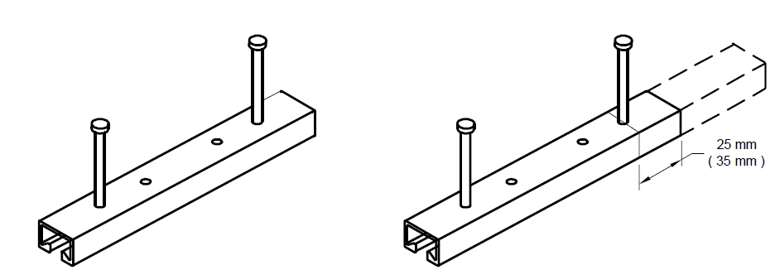

FIG. 19A INSTALLATION INSTRUCTIONS FOR CAST-IN ANCHOR CHANNELS

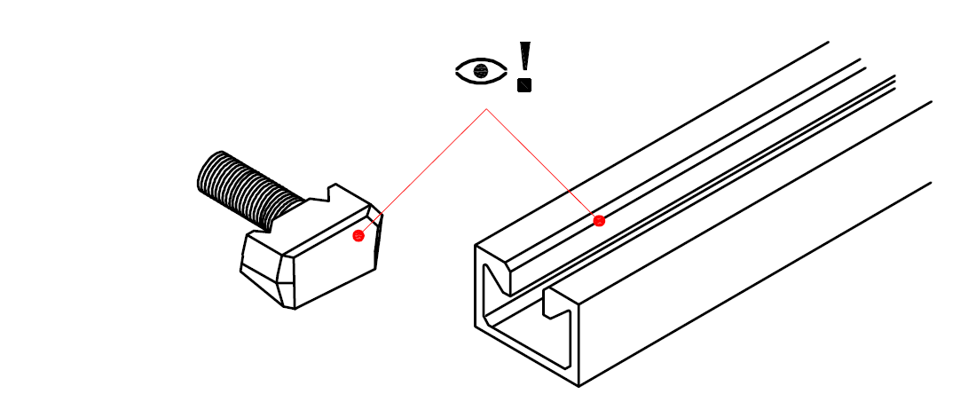

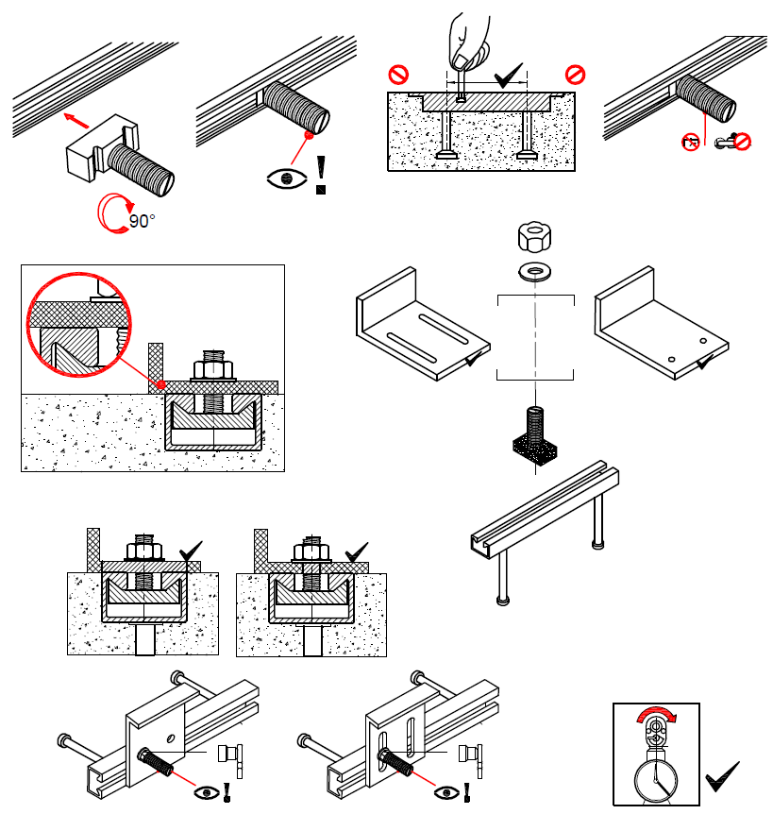

FIG. 19B INSTALLATION INSTRUCTIONS FOR CAST-IN ANCHOR CHANNEL BOLTS

FIG. 19 INSTALLATION INSTRUCTIONS FOR CAST-IN ANCHOR CHANNELS

1. **POST-INSTALLED ANCHORS**
   1. **General** – Post-installed anchors are installed into hardened concrete or masonry and hence the name “post-installed”. This fixing technology requires a hole to be drilled the base material prior to installation of the anchor (see Fig. 20).

FIG. 20 POST-INSTALLED ANCHORS

* 1. **Requirement –** For design requirement of post-installed anchor in concrete, reference may be made to IS 1946 Part 2.

For design of post-installed anchors in masonry, reference may be made to specialist literature.

* 1. **Types –** For details on different types of post-installed anchors in concrete, reference may be made to IS 1946 part 2 (under development).

Generally post-installed adhesive anchors, screws, and expansion plug anchors are recommended for use in masonry. However, other types of anchors, if tested and assessed for adequate performance in masonry, may also be used.

For details of expansion plug anchors, refer section 11.

* 1. **Method of fixing** –

**10.4.1** For details on methods of fixing of post-installed anchors in concrete, reference may be made to IS 1946 part 4 (under development)

**10.4.2** For installation of post-installed adhesive anchors and screws in masonry, the general installation instructions are same as for post installed adhesive anchors and screws for concrete. For any specific recommendation, reference shall be made to MPII.

1. **Expansion plug anchors –**
   1. General – Expansion wall plugs are hollow cylindrical sleeves inserted into a hole to which

the fixture is attached by means of a screw. It holds the fixture by expanding and gripping tightly to the sides of the hole in which it is housed (see Fig. 21).

The expansion plugs or sleeves are generally made of polyamide or plastic. These are generally two way expansion or four way expansion sleeves. The screws can be galvanized, hot dipped galvanized or stainless steel depending on the application of the anchor.

The screws may have hexagonal head or countersunk heads depending on the application requirement. For example, for fixing of door frames, countersunk screws are required.

* 1. Requirement - The diameter and embedment depth of the plug shall be specified by the manufacturer and the overall length of the screw, or the anchor depends on the fastenable thickness or the fixture. The minimum diameter shall not be less than 6 mm.

FIG. 21 EXPANSION PLUG ANCHORS

* 1. **Method of fixing –** MPII should be followed. Some of the general steps are listed below.

1. The hole is to be drilled to the required embedment depth using a hammer drill machine with an appropriate carbide drill bit. The diameter of the drill hole shall be as per MPII.
2. Proper measures shall be taken to clean the hole.
3. The sleeve shall be installed in the hole.
4. The screw shall be fixed initially with hammering followed by the setting tool till full expansion of the sleeve is achieved.

The detailed installation instructions are provided in Fig. 22.

FIG. 22 INSTALLATION INSTRUCTION FOR EXPANSION PLUG ANCHORS

**12 NAILS**

**12.1 General –** These are driven directly into the base material. These fixing devices do not require drilling of hole in the base material prior to installation, in most applications. Conventionally they are hammered into base material.

The demand for quick installation and productivity has driven innovation in this segment as well leading to the development of tool based direct fastening technology. They may be broadly classified into – powder actuated fixing system, gas-actuated fixing system and battery powered fixing system (see Fig. 23)

In case of powder-actuated systems, the nail is driven using tool powered by propellant charge. Whereas gas powered tools are used for gas-actuated systems and battery powered tools are used for battery powered systems. This fixing technology is commonly used for light duty applications like wire mesh fixing, waterproofing membrane fixing etc.

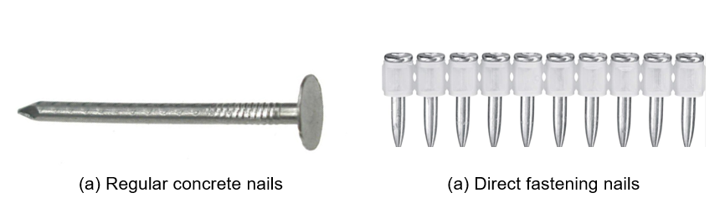

FIG. 23 NAILS

* 1. **Types –**

**(A) Conventional nails –**

For details on types and properties of concrete nails, reference to be made to IS 18741:2024 “Concrete Nails – Specification”.

**Method of fixing –**

1. It is important to choose the right nail for the application.
2. Before driving nails, it is essential to prepare the surface to ensure a secure installation.
3. The surface shall be cleaned from any dirt, dust, or debris that could affect the nail’s penetration.
4. If the nailing is being done into concrete, a hammer drill with a masonry bit shall be used to create pilot holes for the nails. The diameter of the pilot hole should be slightly smaller than the nail’s diameter to provide a tight fit.
5. The nail shall be held in position, aligning it with the pilot hole or the desired location on the surface.
6. A hammer shall be used to start driving the nail into the surface, ensuring it is straight and perpendicular to the surface.
7. Using a hammer, the nail shall be driven into the surface with firm and consistent blows.
8. The depth shall be periodically checked to ensure it reaches the desired depth without penetrating too far or coming short.

**(B) Direct Fastening** –

Direct fastening technology is a technique in which specially hardened nails or studs are driven into concrete, or masonry by a piston-type tool. Materials suitable for fixing by this method are steel, wood, insulation, and some kinds of plastic. Nail driving power is generated by a power load (a cartridge containing combustible propellant powder, also known as a “booster”), combustible gas or by a battery. During the driving process, base material is displaced and not removed. The nails can be made of carbon steel or stainless steel.

Note - Regulations for use of powder actuated fasteners in India shall be adhered to.

For positioning and guiding during the driving operation, additional plastic or metal washer may be used.

The parts of the nails shall be specified by the manufacturer with reference to dimensions (diameter, thread length, etc.) and mechanical properties (core and surface hardness and zinc plating) including possible tolerance.

The nails can be classified in three general types: nails, threaded studs, and composite nails (see Fig. 24)

The nails used (also known as drive pins) are of a special type equipped with washers to meet the needs of the application and to provide guidance when driven.

Threaded studs are essentially nails with a threaded upper section instead of a head.

Composite nails are an assembly consisting of a nail with an application-specific fixing component such as a clip, plate or disk made of metal or plastic. Siding and decking nails can be recognized by their washers which are specially designed to hold down the metal sheets and to absorb excess driving energy.

Nails and threaded studs are commonly zinc-plated for resistance to corrosion during transport, storage and construction. As this degree of protection is inadequate for long-term resistance to corrosion, use of these zinc-plated nails is limited to applications where they are not exposed to the weather or a corrosive atmosphere during their service life.

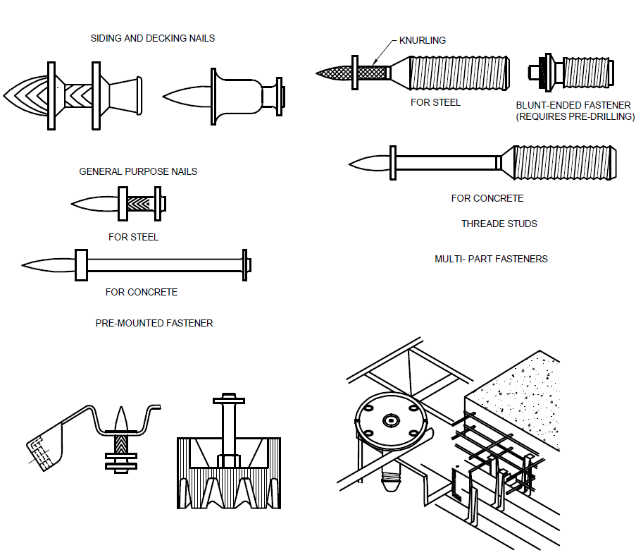

FIG. 24 TYPES OF DIRECT FASTENING NAILS

**Method of fixing –** A power actuated fixing tool shall be used in order to install the nails. The driving force of the fixing tool is provided by power load of the cartridge in case of powder actuated tools, expanding gases in case of gas driven tools or electrical energy provided by battery for a battery driven tool. For proper installation of the nails, necessary tools as per the manufacturer shall be used and instructions as per MPII shall be strictly followed (see Fig. 25)

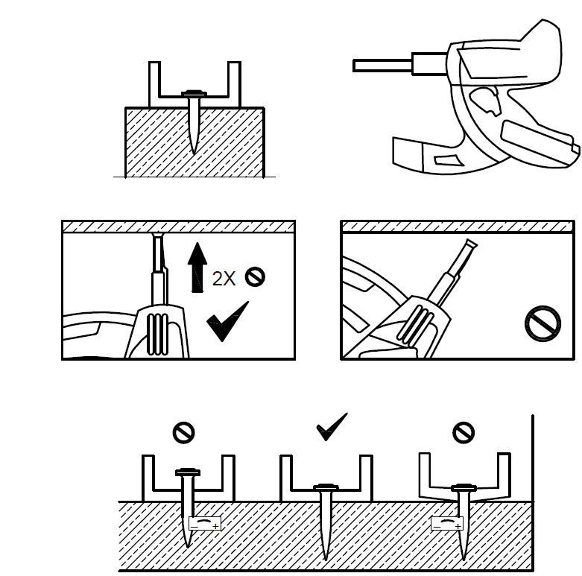

FIG. 25 INSTALLATION INSTRUCTIONS FOR POWER ACTUATED NAILS

1. **INSPECTION AND CERTIFICATION OF INSTALLED DEVICES**

installation of fixing devices shall be supervised by an authorized member of the site management team, who is appropriately qualified.

For recommendation on inspection and certification of post-installed anchors, guideline has been provided in IS 1946 part 5 (under development).

Similar provisions may be followed for other fixing devices as well.

1. **PROOF TESTING OF FIXING DEVICES**

Wherever proof testing is required after the installation of fixing devices to validate the quality of workmanship, the same may be done in accordance with IS 1946 part 5 (under development).

**ANNEX A**

**LIST OF CROSS REFERRED INDIAN STANDARDS**

|  |  |  |
| --- | --- | --- |
| *IS No.* | *Title* | |
| IS 1946 | Fixing Devices In Walls, Ceilings And Floors Of Solid Construction | |
| Part 2 | Design Of Post-Installed Anchorage To Concrete - Code Of Practice |
| Part 3 | Testing and Assessment Of Post-Installed Adhesive Anchoring Systems |
| Part 4 | Testing and Assessment of Post-Installed Mechanical Anchoring Systems |
| Part 5 | Post-Installed Anchorage to Concrete -Installation and On-site Inspection – Code of Practice |
| IS 1608 (Part 1) | Mechanical testing of metals – Tensile testing | |
| IS 456 | Plain and reinforced concrete - Code of practice (fourth *revision*) | |
| IS 800 | General construction in steel – Code of practice | |
| IS 1367 | Technical Supply Conditions for Threaded Steel Fasteners | |
| PGD 37 (24037) | Concrete Nails - Specification | |

**ANNEX B**

**OVERVIEW OF DESIGN OF CAST-IN PLACE ANCHORS**

The annexure provides a brief overview of the parameters to be checked for design of cast-in place anchors.

The resistance for individual failure modes in tension and shear shall be verified separately for adequacy and the minimum shall govern.

In case of both tension and shear loads acting simultaneously, additionally an interaction check shall be performed.

**Verification in tension**

|  |  |
| --- | --- |
| Failure mode | Details |
| Steel failure of anchor |  |
| Concrete cone |  |
| Pull-out |  |
| Concrete splitting |  |
| Concrete blow-out |  |

**Verification in shear**

|  |  |
| --- | --- |
| Failure mode | Details |
| Steel failure of anchor |  |
| Concrete pry-out failure |  |
| Concrete Edge failure |  |

**ANNEX C**

**OVERVIEW OF DESIGN OF CAST-IN ANCHOR CHANNELS**

The annexure provides a brief overview of the parameters to be checked for design of cast-in channels.

The resistance for individual failure modes in tension and shear shall be verified separately for adequacy and the minimum shall govern.

In case of both tension and shear loads acting simultaneously, additionally an interaction check shall be performed.

**Verification in tension**

|  |  |
| --- | --- |
| Failure mode | Details |
| Anchor |  |
| Connection between anchor and channel |  |
| Local flexure of channel lip |  |
| Channel bolt |  |
| Flexure of channel |  |
| Pull-out failure |  |
| Concrete cone failure |  |
| Concrete splitting failure |  |
| Concrete blow-out failure |  |

**Verification in shear**

|  |  |
| --- | --- |
| Failure mode | Details |
| Channel bolt |  |
| Anchor |  |
| Connection between anchor and channel |  |
| Local flexure of channel lip |  |
| Concrete pry-out failure |  |
| Concrete edge failure |  |

**ANNEX D**

**SAMPLE FORM FOR CERTIFICATE OF COMPLETION OF WORK BY INSTALLER**

With respect to the installation of post installed anchor in……………………………………………Project, on Plot No....................................in Colony/Street ..........................................Mohalla/Bazar/Road ....................................City...................................., we certify

a) that the installation has been executed by us according to the structural design and drawings issued to the site by the Structural Engineer and

b) that the work has been completed with high level of workmanship observing due diligence and all the

materials have been used strictly in accordance with the detailed specifications and in compliance with the Manufacturer’s Printed Installation Instructions (attached herewith), using the designated installation tools.

The checklist containing all information is as follows -

|  |  |
| --- | --- |
| **Detail of fixing device** | |
| Detail of fixing device type | cast-in place anchor/ cast-in anchor channel/ expansion plug anchor/ nails |
| Name of the fastening device |  |
| Make of the fastening device |  |
| Diameter of the fastening device (mm)  *(Except cast-in anchor channel)* |  |
| Embedment depth of the fastening device (mm) |  |
| Length of the fastening device (mm)  *(For cast-in anchor channel)* |  |
| Base material & grade | Concrete/ masonry (brick/ AAC), compressive strength in N/mm2 |
| Calibrated torque wrench/ machine torquing, if applicable | If applicable |
| Installation torque (Nm) | If applicable |
| Use of setting tool for expansion plug anchors or nails | Tool name or configuration (energy setting for power actuated fasteners |

Signature of authorized personnel of the installer

Name (in block letters): ……………………………

Address: ..............................................................

Date: …………………………………………………

**ANNEX E**

(Committee composition will be added after finalization)