 

**PERFORMANCE EVALUATION OF DECENTRALIZED INCINERATORS FOR INCINERATION OF SANITARY NAPKINS**

**Progress Report – October 2024**

**Submitted By**

**Prof. Indumathi M Nambi,** Professor, Department of Civil Engineering,

Indian Institute of Technology Madras, Chennai - 600036

**Dr. K. Sivagami**, Associate Professor, School of Chemical Engineering, VIT Vellore

**Executive Summary**

The project's primary objective is to identify and document the optimal time and temperature settings needed to reduce the formation and release of pollutants, such as dioxins and furans, during the incineration of sanitary pads. This research focuses on assessing temperature levels at various stages within the incineration process and measuring gaseous emissions to ensure adherence to the standards established by the Central Pollution Control Board (CPCB).

This report outlines the progress made in the second half of September and throughout October 2024 on the performance evaluation of decentralized incinerators. In alignment with our last discussion, specific areas of focus and enhancements were undertaken to address key points, as detailed, Given the increasing need for safe disposal of menstrual waste, a dedicated analysis was conducted on the operational and environmental implications of sanitary napkin incineration in India. This included cultural, regulatory, and waste-management considerations for holistic evaluation. A comparative review of international emission standards specific to sanitary napkin incinerators was compiled, highlighting best practices and regulatory benchmarks. Arrangements were made to conduct a detailed dioxin and furan analysis in collaboration with the CSIR-NIIST Dioxin Research Laboratory. This effort aims to provide critical data on the impact of toxic emissions during the incineration process, ensuring comprehensive safety evaluations. We have conducted a thorough analysis of ash generated by decentralized incinerators, examining its composition, toxicity levels, and potential environmental impacts. This also includes recommendations for safe ash disposal methods, taking into consideration the best available techniques and community safety.

In addition to these focus areas, site visits were conducted at the manufacturing units to gain insights into production, quality control, and operational protocols, further strengthening our evaluation framework. This holistic approach underscores our commitment to enhancing the sustainability and efficacy of decentralized incinerators progress made in September – October includes significant advancements in data collection, literature review, and preliminary analysis, positioning the project well for the next phase of work.

**INDEX**

|  |  |
| --- | --- |
| **Contents** | **Page numbers** |
| **Executive summary** | **2** |
| 1. **Introduction** | **6** |
| 1. **Comparative Literature Review on Sanitary Napkin Incinerator Conditions and Emission Standards**   **2.1 Technological Advancements and Emission Standards**  **2.2 Comparative Analysis of Incinerator Technologies**  ***2.2.1 Low-Cost Locally Made Incinerators in India***  ***2.2.2 Electric Incinerators***  ***2.2.3 High-Temperature Biomedical Waste Incinerators***  ***2.2.4 Waste-to-Energy Incinerators***    **2.3 Specifications and Pollution Control Norms for Sanitary Napkin Incinerators**  **2.4 Emission Control and Environmental Impacts**  **2.5 Energy Recovery and Efficiency Considerations**  **2.6 Overview of different incinerator technologies in various nations**  ***2.6.1 Incinerator Technologies in India***  ***2.6.2 Incinerator Technologies in Japan***  ***2.6.3 Incinerator Technologies in the USA***  ***2.6.4 Incinerator Technologies in Europe***  **2.7 Emission standards for incinerators**  ***2.7.1 Indian standards for incinerators***  ***2.7.2 Japan standards for incinerators***  ***2.7.3 European standards for incinerators***  ***2.7.4 American standards for incinerators***  ***2.7.5 Measurement of Toxic Gas Concentrations*** | **6**  **7**  **8**  **8**  **8**  **8**  **8**  **9**  **9**  **9**  **13**  **13**  **16**  **17**  **18**  **21**  **21**  **24**  **25**  **26**  **26** |
| **3. Work Progress**  **3.1 Sample Collection**  **3.2 Ash Characterisation**  ***3.2.1 Heavy metal analysis***  ***3.2.2 Toxicity Characterization Leaching Procedure* (TCLP)**  **3.3 Flue gas analysis**  ***3.3.1******Sampling Procedure***  ***3.3.2******Results*** | **27**  **28**  **29**  **31**  **31**  **32**  **32**  **33** |
| **4 . Manufacturing Unit Visit** | **35** |
| **5. Conclusion** | **40** |
| **References** | **41** |
| **Annexure** | **41-44** |

**List of Figures**

|  |  |  |
| --- | --- | --- |
| **Figure 1** | **Incinerator technologies in various countries** | **10** |
| **Figure 2** | **Sampling site 1** | **28** |
| **Figure 3** | **Sampling sites 2 & 3** | **29** |
| **Figure 4** | **Sampling conducted at different sites** | **32** |
| **Figure 5** | **Insulator protection and heating coil** | **36** |

**List of Tables**

|  |  |  |
| --- | --- | --- |
| **Table 1** | **Comparison of available incineration technologies and emission standards** | **11-12** |
| **Table 2** | **Specifications and Pollution Control Norms** | **14-16** |
| **Table 3** | **Prevalent sanitary napkin incinerators** | **19** |
| **Table 4** | **Parameters and emissions from electrical incinerators** | **21-22** |
| **Table 5** | **Parameters and emissions from High-temperature incinerators for biomedical waste** | **23** |
| **Table 6** | **Flue gas emissions from various sanitary napkin incinerators** | **26-27** |
| **Table 7** | **List of heavy metals detected in ash sample 450 o** | **30** |
| **Table 8** | **List of heavy metals detected in ash sample 650** | **30** |
| **Table 9** | **Parameters analysed** | **33** |
| **Table 10** | **Comparisons between two flue gas analysis** | **33** |

1. **Introduction**

The project primarily aims to collect data on the optimal time and temperature corresponding to minimal emissions from sanitary pad incinerators. The project began with a comprehensive literature review, followed by selecting incinerators of various capacities for sampling flue gases and characterizing the resulting ash. Additionally, data on portable incinerators' manufacturing and export details are being gathered to support the study.

The project tasks are divided between IIT Madras and VIT, with work commencing at the end of July. The literature review, completed by VIT, provided a solid foundation for the study. IIT Madras identified suitable sampling locations and incinerator capacities, with two sites located within the IIT Madras campus. Permissions for sampling at these locations were secured in July. These initial tasks were completed in July. Subsequently, in September, new sampling locations were identified due to challenges encountered with the previous sites. To address these issues, we selected locations within IIT Madras, featuring two distinct temperature settings to ensure a more controlled and accurate data collection process.

**Objectives of the project**

* To undertake a comparative study of the available literature on sanitary napkin incinerators
* To study the type and concentration of pollutants released into the atmosphere during incineration
* Characterization of ash to recommend safe disposal
* Data collection on manufacturing units

1. **Comparative Literature Review on Sanitary Napkin Incinerator Conditions and Emission Standards**

Sanitary napkin waste management poses a critical challenge worldwide due to the composition of napkins, which often include super absorbent polymers, synthetic fibers, and other non-biodegradable materials. The safe and effective disposal of menstrual waste is a pressing environmental and public health concern. Incineration offers a potential solution, though its implementation, technological advancement, and regulatory standards vary widely across countries, reflecting regional socio-economic and infrastructural contexts.

* 1. **Technological Advancements and Emission Standards**

**USA**

The United States employs a range of advanced incineration technologies for waste management, including sanitary and medical waste. Under the Clean Air Act and Resource Conservation and Recovery Act (RCRA), incineration units are required to incorporate state-of-the-art filtration and pollution control technologies. Emission standards are stringent, encompassing particulate matter, dioxins, furans, nitrogen oxides (NOx), and sulfur oxides (SOx). While there is less emphasis on energy recovery from sanitary waste incineration, regulatory frameworks ensure high levels of public and environmental safety. Compliance varies by state, reflecting localized enforcement.

**Europe**

European countries are known for their highly advanced incineration systems, such as fluidized bed combustion and grate firing. Regulations under the Industrial Emissions Directive (IED) enforce strict controls on pollutants, including dioxins and particulates, necessitating multi-stage flue gas cleaning systems. Combined heat and power (CHP) plants are often integrated into these incinerators, ensuring energy recovery. Europe's focus on emission control and resource recovery places it at the forefront of sustainable waste management practices.

**Japan**

Japan emphasizes engineering precision in its incineration technologies, focusing on high thermal efficiency and stringent emission controls in accordance with Ministry of Environment guidelines. Preventive measures are enforced to curb dioxin formation, reflecting Japan's commitment to reducing public health risks. While waste-to-energy initiatives are limited, there is significant emphasis on recycling ash and minimizing emissions from sanitary waste incinerators.

**India**

India employs a diverse range of incinerators, spanning low-cost, locally made units to centralized biomedical waste facilities. However, many units lack advanced emission control measures, and compliance with regulatory standards is inconsistent. This poses significant challenges in terms of environmental impact and public health risks. While electric and high-temperature incinerators are increasingly being adopted in institutions and public settings, their deployment remains limited due to high costs and infrastructural barriers. India's approach emphasizes waste volume reduction rather than energy recovery, and the lack of comprehensive standards further exacerbates the issue.

* 1. **Comparative Analysis of Incinerator Technologies**
     1. **Low-Cost Locally Made Incinerators in India**

These incinerators are prevalent in households and communities due to their affordability and ease of construction using locally available materials. They operate at low temperatures and typically lack emission control, resulting in incomplete combustion and potential environmental hazards. These units, commonly seen in schools and communal toilets in rural Uttar Pradesh and Tamil Nadu, serve as a basic option for menstrual waste disposal but are inefficient for pads with high moisture content or super absorbent polymers (SAP).

* + 1. **Electric Incinerators**

Electric incinerators, used predominantly in institutions such as schools, hospitals, and public toilets, offer advanced features like emission control filters, automated cycles, and temperature maintenance systems. While they ensure more efficient burning and ash reduction, their reliance on a consistent electricity supply and high-cost limit widespread adoption. Examples of deployment include public facilities at Chennai Central Railway Station and Dindigul Bus Stand in Tamil Nadu.

* + 1. **High-Temperature Biomedical Waste Incinerators**

Centralized high-temperature incinerators operate at temperatures exceeding 800°C, ensuring efficient combustion of all types of sanitary pads and biomedical waste. They are equipped with Air Pollution Control Devices (APCDs) to minimize emissions and adhere to strict standards. However, logistical challenges related to waste collection, segregation, and transportation, coupled with high operational costs, hinder broader implementation.

* + 1. **Waste-to-Energy Incinerators**

Though limited in number, waste-to-energy incinerators offer a promising solution by converting sanitary waste into usable energy. Equipped with advanced emission control systems, these units can handle various pad types, though their high capital and operational costs restrict widespread deployment in India.

* 1. **Specifications and Pollution Control Norms for Sanitary Napkin Incinerators**

India's regulatory guidelines for incinerators vary by type. Low-cost incinerators typically operate at temperatures up to 300°C and have limited emission controls, resulting in smoke opacity and odor issues. Electric incinerators ensure nearly complete combustion, with ash generation limited to less than 5% per napkin. High-temperature biomedical incinerators, designed to handle up to 50 kg/hr, feature double-chamber designs and require skilled operators for safe and efficient functioning.

* 1. **Emission Control and Environmental Impacts**

Countries like the USA, Europe, and Japan have established stringent emission controls to minimize the environmental impact of incineration. These controls include multi-stage flue gas cleaning systems and regulations to limit dioxin, furan, and other harmful emissions. In contrast, India faces challenges in enforcing uniform standards and ensuring compliance, resulting in significant public health risks and environmental degradation. The absence of comprehensive regulatory frameworks exacerbates these issues, necessitating reforms for more consistent oversight.

* 1. **Energy Recovery and Efficiency Considerations**

Energy recovery from incineration varies by region. European countries lead in integrating combined heat and power (CHP) systems, while the USA focuses primarily on waste reduction. Japan emphasizes ash recycling and emissions control. India's efforts are constrained by infrastructural and financial challenges, with limited initiatives for energy recovery from sanitary waste incineration.

The global landscape of sanitary napkin incineration technologies and emission standards highlights significant disparities in technological advancement, regulatory enforcement, and environmental impact. While countries like the USA, Europe, and Japan demonstrate a high level of technological sophistication and regulatory compliance, India's approach is characterized by diverse, often inconsistent, practices. Addressing these challenges requires concerted efforts to standardize technologies, enforce regulatory norms, and explore cost-effective solutions that balance public health and environmental safety.

**Fig 1. Incinerator technologies in various countries**

European incineration technologies are the most advanced, focusing on efficiency, energy recovery, and stringent emission control standards. Japan also employs sophisticated technologies but faces criticism for its reliance on incineration over recycling. The USA has a range of incineration technologies tailored for specific waste types but with less focus on energy recovery. India, on the other hand, has a mix of basic and advanced incinerators, with significant room for improvement in emission control, standardization, and regulatory enforcement.

**Table 1. Comparison of available incineration technologies and emission standards**

|  |  |  |  |  |
| --- | --- | --- | --- | --- |
| **Based on** | **USA** | **Europe** | **Japan** | **India** |
| Technological Advancements and Types of Incinerators | Utilizes a range of incineration technologies, particularly for medical waste, with regulations under the Clean Air Act and RCRA requiring advanced filtration systems and state-of-the-art technologies. | Highly advanced incinerators with technologies like fluidized bed combustion and grate firing systems, coupled with sophisticated flue gas cleaning. | employs advanced engineering solutions for sanitary napkin incinerators, focusing on high thermal efficiency and low emissions. Regular monitoring and maintenance ensure compliance with MOE guidelines. | Employs a diverse range of incinerators, but many lack standardization and advanced emission control, limiting their effectiveness in reducing environmental impact. |

|  |  |  |  |  |
| --- | --- | --- | --- | --- |
| Emission Control and Environmental Impact | Strict standards for waste incineration | Stringent regulations and advanced multi-stage flue gas cleaning systems to minimize emissions. | Preventive measures for dioxin formation only. | Inadequate provision for emission control |
| Energy Recovery and Efficiency | Less emphasis on energy recovery primarily focused on waste reduction and specific waste types. | CHP plants for energy recovery | Limited deployment of waste-to-energy incinerators, with more emphasis on ash recycling and reducing emissions. | Limited energy recovery due to high costs and infrastructural challenges, primarily used for waste volume reduction. |
| Regulations and Compliance | Regulations vary by state and waste type, with some technologies producing higher emissions. | Strict controls on dioxins, NOx, and SOx , compel the use of advanced flue gas cleaning systems and energy-efficient technologies | Advanced emission controls and high environmental standards | Inconsistent compliance, lack of comprehensive standards and enforcement lead to significant risks. |

* 1. **Overview of different incinerator technologies in various nations**
     1. **Incinerator Technologies in India**

Incinerators for waste management vary widely in type, use, advantages, and disadvantages. Clay pots, or Matkas, are commonly used in households due to their low cost, easy availability, and simple operation with locally available fuels. However, they lack emission control and burn at low temperatures, making them inefficient for high-moisture pads and those with super-absorbent polymers. The ash produced may not be safe for gardening, and the designs are inconsistent and not standardized. These are used in households in Papna Mau village, Uttar Pradesh, India.

Low-cost locally made incinerators are used in institutional and public settings, as well as households. They are inexpensive, easy to install, and made from local materials. Their construction can involve community members, reducing taboos around menstrual waste. They are easy to use and maintain but share drawbacks with clay pots, such as no emission control, low-temperature burning, and non-standardized designs. Ash from these incinerators is also potentially unsafe for gardening. Examples include schools in Nepal, Uttar Pradesh, Tamil Nadu, and Malawi, and communal EcoSan toilets in Tamil Nadu. Electric incinerators are primarily used in institutional and public settings. They are more advanced and expensive, often featuring emission control filters and requiring no fuel. Some models have quality certifications, but they depend on a reliable electricity supply, and their high cost limits widespread adoption. Their efficiency with high-moisture pads is uncertain, and they vary in design without standard quality certification. These are used in public toilets in Chennai Central railway station, Dindigul bus stand in Tamil Nadu, and schools across several Indian states, including Tamil Nadu, Kerala, Delhi, Rajasthan, Madhya Pradesh, Maharashtra, Haryana, and West Bengal. High-temperature incinerators for biomedical waste are used in centralized facilities, burning waste at over 800°C, making them efficient for all types of pads. However, they require the collection, transportation, and storage of segregated menstrual waste to a central facility, and classification as biomedical waste, which can complicate implementation and increase costs. Incinerators with waste-to-energy technology are used in institutional and public settings to produce energy from waste. These systems are highly controlled with advanced emission control features and can handle all types of pads. Despite their potential, there are few such incinerators due to their high cost and the need for further development.

In summary, each type of incinerator has its pros and cons, with suitability depending on community or institutional needs and resources. Factors like cost, material availability, emission control, and the type of waste being managed are crucial in selecting the appropriate incinerator for effective and environmentally safe waste disposal.

**Table 2: Specifications and Pollution Control Norms**

|  |  |  |
| --- | --- | --- |
| Technology | Type of waste | Specifications/Pollution control norms |
| Low-cost, locally made incinerators | Napkins and other wastes. Best suited for pads with high cellulose content, not those that have super absorbent polymers (SAP) | Minimum Size: 3’ × 3’ × 3’  • Design: As given in MHM Guidelines, Technical Guide 2  • Capacity should be ~200 Napkins/Day  • Comprises of two chambers (for firing and ash collection)  • An emission control system along with a door for firing  • Made of brick masonry  • Opacity of the smoke shall not exceed 20%.  • All the emissions to air other than steam or water vapor shall be odorless and free from mist, fume and droplets.  • Operation temperature reaches up to 300°C.  • Assure 100% burning effectiveness.  • The incineration chamber shall be designed to include an auxiliary gas or oil burner to be used as necessary to maintain the prescribed minimum combustion temperatures.  • If diesel is used, low Sulphur diesel shall be used as fuel in the incinerator. |
| Electric incinerators | Bulk amount of napkin wastes | Ensure complete burning of napkin.  • Ensure instant disposal in a scientific and hygienic way with fully automatic way and burn completely.  • Burns 150 to 200 napkins/day, can be programmed for cycles/day.  • Self-disposal by user by directly putting into the incinerator.  • Ash generation should not exceed more than 5% per napkin • Ash should be collected in separate tray and ensure stack on that tray.  • Auto power & thermal cut-off and automatic temperature maintenance should be there for safety of user.  • Inside refractory lining should be excellent heat retention to avoid thermal loss.  • The residence time for gaseous products in the combustion chamber will be designed to be at least 2 seconds to ensure complete combustion. |
| High temperature incinerators for biomedical waste | Incinerate all types of pads (those with high cellulose content, high moisture content, and those with SAP) and all types of biomedical waste | The incinerator shall be designed for capacity more than 50 kg/hr.  • The double chamber incinerator shall preferably be designed on "controlled-air" incineration principle, as particulate matter emission is low in such incinerator. Minimum 100% excess air shall be used for overall design.  • No incinerator shall be allowed to operate unless equipped with Air Pollution Control Device (APCD).  • The incineration ash shall be stored in a closed sturdy container in a masonry room to avoid any pilferage. Finally, the ash shall be disposed in a secured landfill.  • A skilled person shall be designated to operate and maintain the incinerator. |
| Source: [10] | | |

* + 1. **Incinerator technologies in Japan**

From about 1960, Japan began disposing urban garbage by incineration, and today, Japan possesses the world's leading garbage incineration facilities. Japan has one of the lowest recycling rates in the OECD – and 78% of the remaining waste is incinerated. In the fiscal year 2009, there were 1243 incineration facilities in Japan, incinerating garbage using several methods - stoker furnaces, fluidized bed furnaces, and gasification fusion resource furnaces with the objective of ash recycling. Stoker furnaces account for 70% of all furnaces, and improvement of this type of furnace is progressing rapidly. It is known that incineration plants for municipal waste generate SOx, HCl, NOx, smoke and dioxin. From the perspective of environmental preservation and to obtain approval from people residing near the plant, harmful substances in the exhaust gas must be sufficiently reduced. In response to this need, many studies have been conducted by public and private institutes, where many countermeasure technologies were developed and improvements have been made on operation technology. Studies have shown that dioxin is produced by incomplete combustion of waste, and measures have been taken to prevent and reduce dioxin generation with complete combustion in the furnace. Other countermeasures taken includes exhaust cooling to prevent the resynthesis of dioxin, application of bag filters to thoroughly eliminate dioxin contained in smoke, and the development of activated coal, which adsorbs and eliminates dioxin in exhaust fumes and a catalyst that decomposes dioxin. Based on the above-mentioned studies, structural and maintenance management standards for the incineration plants were established, as illustrated below. The standards apply not only to new facilities but also to existing facilities, where improvements have been achieved. Methods of control for dioxin and other poisonous gas emissions that have been employed by the private and public sectors are as shown in the figure, and problems related to dioxin from incineration have been nearly resolved. Sufficient environmental measures are also taken for SOx, HCl, NOx and other substances. Other than harmful bacteria and viruses, medical waste contains vinyl chloride and organochlorine chemicals, and simple incineration may generate hydrogen chloride and dioxin. Japan has strict regulations regarding the generation of dioxin and measures are taken to reduce dioxin through incinerator structure, operation methods, and dioxin elimination systems, and incinerators specifically for medical waste are used to reduce dioxin content in the gas emissions. Some of the furnaces used as medical waste incinerators to control the emission of dioxin are gasification furnaces, kiln furnaces and vertical furnaces that safely and completely burn waste. Without filtering technology, incineration releases a huge quantity of dioxins and CO2 into the atmosphere. In the 90s, this meant that waste-disposing areas like Saitama, a convenient backyard for the Tokyo metropolis, became visibly polluted. This triggered health concerns – many of the emissions were carcinogenic – and stigma against local produce. The mounting wave of condemnation compelled some businesses like Ishizaka Group to minimize combustibles and increase recycling. Today, ‘environmentally friendly’ incinerator technologies, which use ultra-high-temperature furnaces and filter systems to avoid polluting the atmosphere, have become the de-facto process of waste combustion. Dioxins no longer pose a major threat. Still, all these burning produces exhaust fumes that contribute to climate change, while Japan’s reliance on burning its waste fails to put the “3Rs” – reduce, reuse, recycle – at the heart of its waste strategy. The out of sight, out of mind attitude enabled by incineration keeps waste invisible and its problems hard to grasp [15,16].

* + 1. **Incinerator Technologies in the USA**

Sanitary napkin incinerators in the United States are developed and regulated to ensure safe and environmentally responsible disposal of menstrual waste. These incinerators are built to meet stringent emission standards, prioritizing public health while minimizing environmental impacts. Regulated under frameworks like the Clean Air Act (CAA) and the Resource Conservation and Recovery Act (RCRA), sanitary napkin incineration in the U.S. aligns with a broader commitment to effective waste management and air quality protection.

Technological Advancements and Features

U.S. sanitary napkin incinerators utilize advanced incineration technology that focuses on efficient and thorough combustion to achieve complete breakdown of materials within menstrual products, including superabsorbent polymers (SAPs) and other components. Key technological features include.

Automated Control Systems: These systems allow for easy operation, where users can safely initiate the incineration process by setting a timer, after which the incinerator automatically completes the cycle. Automated controls enhance user safety by minimizing direct handling of waste and exposure to heat.

High-Temperature Combustion: Many incinerators operate at temperatures exceeding 800°C, which is necessary to ensure full degradation of waste materials and minimize the production of harmful byproducts like dioxins and furans.

Smokeless and Odorless Operation: Sanitary napkin incinerators are often equipped with filters and advanced combustion technologies that reduce visible smoke and odors, making them suitable for use in various public and private settings, including restrooms, schools, and offices. U.S. regulations mandate that sanitary napkin incinerators incorporate effective emission control systems to ensure compliance with air quality standards. The Clean Air Act regulates pollutants that incinerators might emit, including particulates, volatile organic compounds (VOCs), and trace metals. Advanced Filtration Systems: Many U.S.-based incinerators have multi-stage filtration to capture particulates and minimize release of harmful compounds. Filtration systems typically include high-efficiency particulate air (HEPA) filters or activated carbon filters to trap both particulates and gaseous pollutants. Incinerators must adhere to stringent thresholds for hazardous air pollutants, including dioxins, furans, and heavy metals. By utilizing combustion technologies that maintain optimal temperatures and residence times, U.S. sanitary napkin incinerators minimize the formation of these pollutants, supporting environmental and public health standards.

.

Efficient Ash Collection: The residual ash from the incineration process is usually collected in a secure, removable tray, allowing for easy disposal without direct contact. The ash produced is typically sterile and reduced to less than 5% of the original waste volume, making disposal both manageable and hygienic.

Environmental and Public Health Benefits

Sanitary napkin incinerators offer multiple environmental and health benefits by eliminating menstrual waste at the source, preventing the spread of pathogens, and reducing landfill burden. Key benefits include:

Pathogen Control: Incineration at high temperatures kills potential pathogens, thereby reducing the risk of contamination and disease spread, especially in public or shared facilities.

* + 1. **Incinerator Technologies in Europe**

In Europe, while sanitary pad incinerators are not widely used due to concerns about potential emissions, some countries still utilize them, particularly in settings where proper waste management infrastructure is limited, but strict regulations require high-temperature incineration to minimize harmful pollutants like dioxins, ensuring the burning process occurs at temperatures above 850°C to comply with the European Waste Incineration Directive; however, there is growing movement towards more sustainable menstrual waste management solutions like composting or specialized collection systems..

**Table 3: Prevalent sanitary napkin incinerators**

|  |  |  |  |  |  |  |  |
| --- | --- | --- | --- | --- | --- | --- | --- |
| Sl no | Incinerator | Temperature | Ash | Power consumption | Material of construction | Insulation | Operating mechanism/Characteristics |
| 1 | Green Dispo | Greater than 800oC | less than 5% ash per napkin | only 250 W of power consumption per 15 min batch of operation |  |  |  |
| 2 | Relycure | Minimum burning temperature-400 oC | Residue ash per napkin is less than 1 milligram | 230V (16 Amp) | Mild steel body with epoxy anti-rust proof powder | Double thermal insulation for extra protection of ceramic fibre board (thickness: 25 mm) and glass fibre blanket (density:64) | Turn on MCB and press push button start to the machine and wait for 15-20 minutes for the burning process. |
| 3 | AVB Compact incinerator | - | - | 220 V (1.2-1.5 A) | Mild Steel, Stainless Steel | 129 density Ceramic wool insulation and powder coating | - |
| 4 | Vendigo incinerator | Upto 800oC | Less than 1 g per napkin | 1.25 kWh | Powder-coated steel body | Ceramic insulation with thermal protection, 5mm thickness | - |
| 5 | EnvCure | Up to 1400°C | Not specified | 1500 kW | High-density ceramic fiberboards | Glass wool, 60mm thickness | Make sure that green bulb is on else turn on main and MCB switch and collect ash after burning. |
| 6 | Microteknik incinerator | 600°C | Not specified | 220-240V / 7.5A, 50HZ | Mild Steel, Stainless steel | Ceramic thickness not specified | Automatic with digital indicators for temperature control and emergency stop features |
| 7 | Greentech incinerator | 600°C | Not specified | 900-1200 watts | Mild steel with powder coating | Ceramic; thickness not specified |  |
| 8 | StayHappy incinerator | Upto 1200°C | Less than 1.25 milli gram per Napkin with Ash Removal Tray | 230V 15 Amp | Mild steel | Ceramic Insulation & Glass wool Insulation | Shockproof MCB protection. |
| 9 | Bionics incinerator | Not specified | Not specified | 220 Volts / 50 Hz | Mild steel/Stainless steel | Ceramic insulation | Automatic, with features like auto power-off and temperature control​ |
| 10 | Ananta incinerators | 800°C | Not specified | Not specified | Mild steel | Ceramic insulation |  |
| 11 | Dahini incinerator | 800°C | Not specified | 150 watt per napkin | Heat resistant internal chamber made of ash, composed of silicon, aluminium, iron and calcium oxides | Not specified | in-built pollution filters minimize the release of particulate matter. |
| 12 | Genesis Incinerator | Not specified | 1g ash | Not specified | Mild Steel | High density heat proof ceramic board (1850) and puff insulation | Micro Processor |

* 1. **Emission standards for incinerators**
     1. ***Indian standards for incinerators***

The BioMedical Waste Management Rules, 2016 indicate that items contaminated with blood and body fluids, including cotton, dressings, soiled plaster casts, lines and bedding, are bio-medical waste and should be incinerated, autoclaved or microwaved to destroy pathogens. Funds under SLWM head may be used for setting up incinerators in community toilets.

i) **Electrical incinerators**

**Table 4. Parameters and emissions from electrical incinerators**

|  |  |  |
| --- | --- | --- |
| Parameter | Emission |  |
| Particulates | 50 mg/Nm3 | Standard refers to half hourly average value |
| HCl | 50 mg/Nm3 | Standard refers to half hourly average value |
| SO2 | 200 mg/Nm3 | Standard refers to half hourly average value |
| CO | 100 mg/Nm3 | Standard refers to half hourly average value |
| 50 mg/Nm3 | Standard refers to half hourly average value |
| Total Organic Carbon | 20 mg/Nm3 | Standard refers to half hourly average value |
| HF | 4 mg/Nm3 | Standard refers to half hourly average value |
| NOx (NO and NO2 expressed as NO2) | 400 mg/Nm3 | Standard refers to half hourly average value |
| Total dioxins and furans | 0.1 ng TEQ/Nm3 | Standard refers to 6-8 hours sampling. Please refer guidelines for 17 concerned congeners for toxic equivalence values to arrive at total toxic equivalence. |
| Cd + Th + their compounds | 0.05 mg/Nm3 | Standard refers to sampling time anywhere between 30 minutes and 8 hours. |
| Hg and its compounds | 0.05 mg/Nm3 | Standard refers to sampling time anywhere between 30 minutes and 8 hours. |
| Sb + As + Pb + Cr + Co + Cu + Mn + Ni + V + their compounds | 0.5 mg/Nm3 | Standard refers to sampling time anywhere between 30 minutes and 8 hours. |
| All values corrected to 11% oxygen on a dry basis.  Source: SWM, 2016 |  |  |

Note:

1. Suitably designed pollution control devices shall be installed or retrofitted with the incinerator to achieve the above emission limits.
2. Waste to be incinerated shall not be chemically treated with any chlorinated disinfectants.
3. Incineration of chlorinated plastics shall be phased out within two years.
4. If the concentration of toxic metals in incineration ash exceeds the limits specified in the Hazardous Waste (Management, Handling and Trans boundary Movement) Rules, 2008, as amended from time to time, the ash shall be sent to the hazardous waste treatment, storage and disposal facility.
5. Only low sulphur fuel like LDO, LSHS, Diesel, bio-mass, coal, LNG, CNG, RDF and biogas shall be used as fuel in the incinerator.
6. The CO2 concentration in tail gas shall not be more than 7%.
7. All the facilities in twin chamber incinerators shall be designed to achieve a minimum temperature of 9500C in secondary combustion chamber and with a gas residence time in secondary combustion chamber not less than 2 (two) seconds.
8. Incineration plants shall be operated (combustion chambers) with such temperature, retention time and turbulence, as to achieve total Organic Carbon (TOC) content in the slag and bottom ash less than 3%, or the loss on ignition is less than 5% of the dry weight.
9. Odour from sites shall be managed as per guidelines of CPCB issued from time to time.

*Emission Standards*

**Table 5. Parameters and emissions from High-temperature incinerators for biomedical waste**

|  |  |  |  |
| --- | --- | --- | --- |
| Sl No | Parameter | Standards | |
|  |  | Limiting concentration in mg Nm3 unless stated | Sampling Duration in minutes, unless stated |
| 1 | Particulate matter | 50 | 30 or 1Nm3 of sample volume, whichever is more |
| 2 | Nitrogen Oxides NO and NO2 | 400 | 30 for online sampling or grab sample |
| 3 | HCl | 50 | 30 or 1Nm3 of sample volume, whichever is more |
| 4 | Total Dioxins and Furans | 0.1ngTEQ/Nm3 (at 11% O2) | 8 hours or 5Nm3 of sample volume, whichever is more |
| 5 | Hg and its compounds | 0.05 | 2 hours or 1Nm3 of sample volume, whichever is more |

C. Stack Height: Minimum stack height shall be 30 meters above the ground and shall be attached with the necessary monitoring facilities as per requirement of monitoring of ‘general parameters’ as notified under the Environment (Protection) Act, 1986 and in accordance with the Central Pollution Control Board Guidelines of Emission Regulation Part-III.

Note:

(a) The existing incinerators shall comply with the above within a period of two years from the date of the notification.

(b) The existing incinerators shall comply with the standards for Dioxins and Furans of 0.1ngTEQ/Nm3, as given below within two years from the date of commencement of these rules.

(c) All upcoming common bio-medical waste treatment facilities having incineration facility or captive incinerator shall comply with standards for Dioxins and Furans.

(d) The existing secondary combustion chambers of the incinerator and the pollution control devices shall be suitably retrofitted, if necessary, to achieve the emission limits.

(e) Wastes to be incinerated shall not be chemically treated with any chlorinated disinfectants.

(f) Ash from incineration of biomedical waste shall be disposed of at common hazardous waste treatment and disposal facility. However, it may be disposed of in municipal landfill, if the toxic metals in incineration ash are within the regulatory quantities as defined under the Hazardous Waste (Management and Handling and Transboundary Movement) Rules, 2008 as amended from time to time.

(g) Only low Sulphur fuel like Light Diesel Oil or Low Sulphur Heavy Stock or Diesel, Compressed Natural Gas, Liquefied Natural Gas or Liquefied Petroleum Gas shall be used as fuel in the incinerator.

(h) The occupier or operator of a common bio-medical waste treatment facility shall monitor the stack gaseous emissions (under optimum capacity of the incinerator) once in three months through a laboratory approved under the Environment (Protection) Act, 1986 and record of such analysis results shall be maintained and submitted to the prescribed authority. In case of dioxins and furans, monitoring should be done once in a year.

(i) The occupier or operator of the common bio-medical waste treatment facility shall install continuous emission monitoring system for the parameters as stipulated by State Pollution Control Board or Pollution Control Committees in authorisation and transmit the data real time to the servers at State Pollution Control Board or Pollution Control Committees and Central Pollution Control Board.

(j) All monitored values shall be corrected to 11% Oxygen on dry basis.

(k) Incinerators (combustion chambers) shall be operated with such temperature, retention time and turbulence, as to achieve Total Organic Carbon content in the slag and bottom ashes less than 3% or their loss on ignition shall be less than 5% of the dry weight.

(l) The occupier or operator of a common bio-medical waste incinerator shall use combustion gas analyzer to measure CO2, CO and O2.

***2.7.2 Japan standards for incinerators***

Japan’s approach to the manufacturing of sanitary napkin incinerators is characterized by its commitment to technological innovation and stringent environmental standards. The Ministry of the Environment (MOE) oversees the regulations, enforcing strict guidelines on emissions and operational efficiency. Japanese manufacturers are known for their advanced engineering solutions, incorporating cutting-edge technologies to achieve high thermal efficiency and low emissions. The emphasis is on reducing dioxins and other harmful pollutants, with regular monitoring and maintenance to ensure compliance with environmental standards. Japan’s focus on sustainability also drives the development of incinerators that are energy-efficient and have minimal environmental footprint.

***2.7.3 European standards for incinerators***

Operational standards for incineration plants in Europe are designed to optimize performance and minimize environmental impact.

**Emission Limits**: The IED sets strict emission limits for pollutants, requiring continuous monitoring and reporting. Emission limit values (ELVs) for key pollutants are specified, and plants must operate within these limits to remain compliant.

**Waste Input Control**: Incineration plants are required to implement stringent waste input controls to ensure only permissible waste types are incinerated. Pre-treatment processes such as sorting, shredding, and dewatering are employed to enhance combustion efficiency and reduce the formation of pollutants.

**Residue Management**: The management of incineration residues, including bottom ash and fly ash, is a critical aspect of operational standards. Bottom ash is often processed for recycling, while fly ash, which contains higher concentrations of hazardous substances, is treated and disposed of in compliance with hazardous waste regulations.

The primary regulatory framework governing incineration in Europe is the Waste Incineration Directive (2000/76/EC), which was superseded by the Industrial Emissions Directive (IED, 2010/75/EU) in 2013. The IED consolidates various directives related to industrial emissions, setting stringent limits on emissions from incineration plants. The directive aims to prevent or reduce pollution to air, water, and soil by regulating the emissions of pollutants such as dioxins, furans, heavy metals, nitrogen oxides (NOx), sulfur dioxide (SO2), and particulate matter (PM). Each EU member state is responsible for implementing the directive through national legislation, ensuring that incineration plants comply with these standards. Regular monitoring, reporting, and inspections are mandated to ensure adherence to the prescribed limits.

In European countries, the manufacturing of sanitary napkin incinerators is regulated by the European Union's Waste Incineration Directive (2000/76/EC). This directive sets stringent limits on emissions of pollutants, including particulate matter, sulfur dioxide, nitrogen oxides, and heavy metals. Manufacturers must comply with these regulations to ensure their incinerators meet the required environmental standards. The directive also mandates continuous monitoring of emissions and regular maintenance of incineration equipment to ensure optimal performance. European manufacturers often incorporate advanced technologies such as flue gas cleaning systems, catalytic reduction systems, and energy recovery mechanisms to enhance efficiency and minimize environmental impact. Countries like Germany, France, and the UK have additional national regulations that further specify operational standards and emissions limits, ensuring high environmental protection levels.

***2.7.4 American standards for incinerators***

In the United States, the manufacturing of sanitary napkin incinerators is regulated by the Environmental Protection Agency (EPA). The EPA’s stringent guidelines under the Clean Air Act ensure that incinerators meet high standards for emissions control, focusing on reducing pollutants such as dioxins, furans, and heavy metals. The Resource Conservation and Recovery Act (RCRA) also plays a pivotal role in regulating the handling and disposal of hazardous waste, including menstrual waste. Manufacturers are required to implement advanced filtration systems and employ state-of-the-art technologies to minimize environmental impact. The emphasis is on high-efficiency particulate air (HEPA) filters and catalytic converters to ensure the incinerators operate within safe environmental parameters. In Canada, sanitary napkin incinerator manufacturing is overseen by Environment and Climate Change Canada (ECCC). Canadian regulations align closely with those of the United States, emphasizing stringent emission standards and the use of advanced technologies to reduce environmental impact. The Canadian Council of Ministers of the Environment (CCME) provides guidelines for the disposal of sanitary waste, promoting the use of incinerators that are both efficient and environmentally friendly. Manufacturers are encouraged to adopt innovative designs that enhance the efficiency of incineration and reduce harmful emissions. The focus is also on ensuring the incinerators are user-friendly and can be easily integrated into public and private facilities

#### **2.7.5 Measurement of Toxic Gas Concentrations**

**Table 6: Flue gas emissions from various sanitary napkin incinerators**

|  |  |  |  |  |  |  |  |  |
| --- | --- | --- | --- | --- | --- | --- | --- | --- |
| Sl no | Incinerator | Total Particulate Matter (mg/m3) | CO (mg/m3) | SO2 (mg/m3) | NOx (mg/m3) | Methane (mg/m3) | Propane (mg/m3) | Reference |
| 1 | Green Dispo | 46.1 ± 6.7 mg/m3 | 74.0 ± 4.5 | 38.6 ± 5.9 | 1.3 ± 0.4 mg/m3 | - | - | [8] |
| 2 | Solar powered napkin incinerator | - | 68.7 | - | - | 1271.33 | 896.18 | [1] |
| 3 | Fixed circular gate incinerator | 12.2 | 25,190 | 8 | 14.8 | - | - | [7] |
| 4 | Incinerator with cuboidal combustion chamber | 22.4 | 0.1145 | 9.1 | 10.4 | - | - | [7] |

1. **Work Progress**

Here is the work progress until the start of the project, including the plan for the next months.

|  |  |  |  |  |  |  |  |  |  |
| --- | --- | --- | --- | --- | --- | --- | --- | --- | --- |
| S.  No. | Task | Res  Entity |  | | Six Months  (2024-2025) | | | |  |
| 1-2 | 2-3 | | 3-4 | | 4-5 | 5-6 |
| 1 | Literature Review (Indian and International status of regulatory requirements) | VIT Vellore |  | |  | | | |  |
| 2 | Industrial visit to the sanitary napkin and incinerator manufacturing facilities to understand the product features, insulation used, and efficiency comparison with international standards | IIT Madras |  |  | | |  | |  |
| 3 | Comparing different incinerators, sampling and analysing incinerator flue gases for every 100  C increase till 1000 C | IIT Madras  VIT Vellore |  |  | |  | |  |  |
| 4 | Physico-chemical characterization of  Incinerator ash and establishing its disposal  standards | VIT Vellore |  |  | |  | |  |  |
| 5 | Analyzing the efficacy of the incinerators and recommending the best probable solution for disposal of soiled sanitary napkins. | IIT Madras  VIT Vellore |  | | |  | |  |  |

|  |  |
| --- | --- |
|  |  |

**Started and ongoing Completed**

* 1. **Sample Collection**

As previously noted, there was a slight change in the sampling sites due to maintenance issues and the inability to control temperature in the initially selected incinerators. One of the sampling sites remains Vanavani, while the new sites are within IIT Madras.

Apart from the primary sites selected for our study, we have also identified several additional incinerators located within the campus.

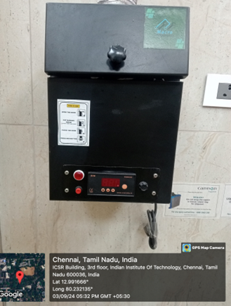 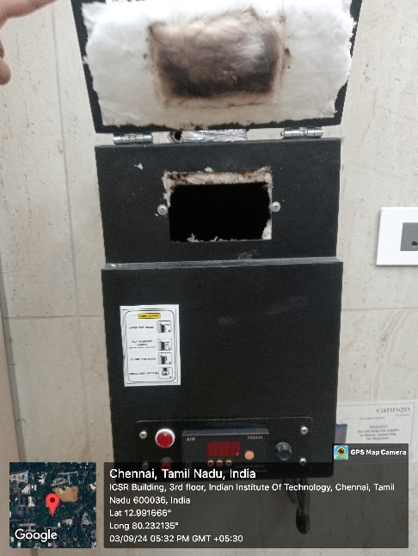 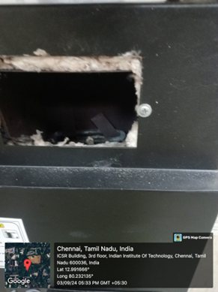

**Fig .2 Sampling site 1**

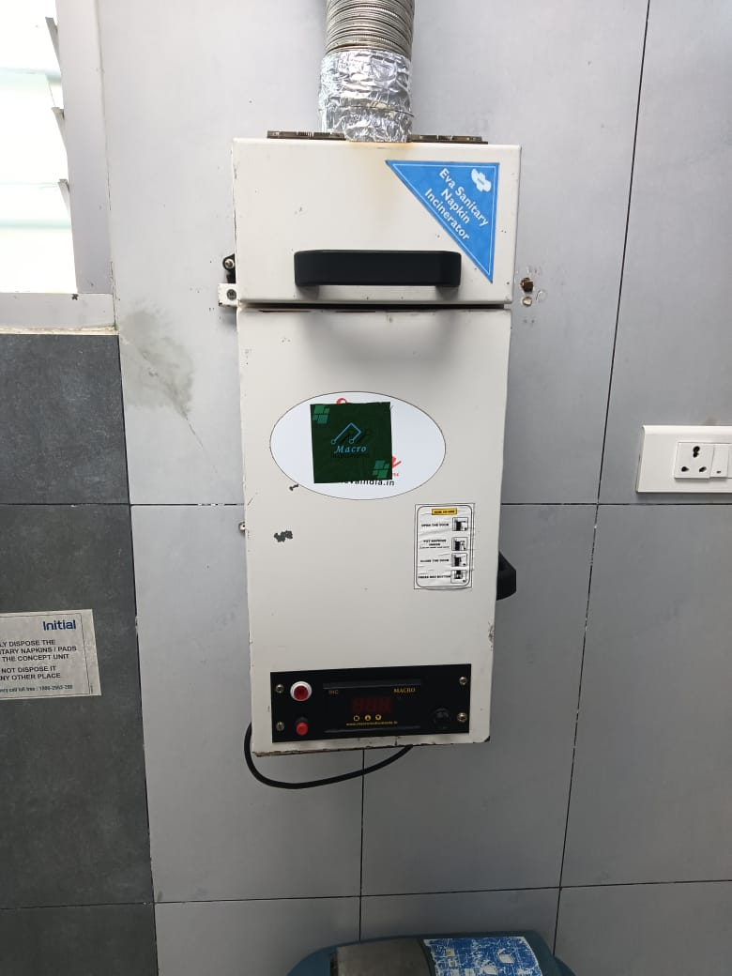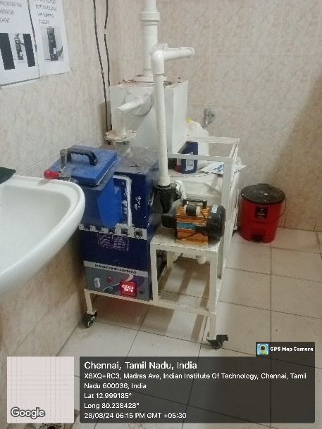 **Fig 3. Sampling sites 2 & 3**

* 1. **Ash Characterisation**

The ash generated after incineration was initially collected and subjected to X-Ray Fluorescence (XRF) analysis to quantify the presence of heavy metals. Following this, a detailed heavy metal analysis was performed using Inductively Coupled Plasma Optical Emission Spectroscopy (ICP-OES). We also conducted a Toxicity Characterization Leaching Procedure (TCLP) following the EPA SW-846 Test Method 1311 guidelines to assess leaching efficiency and toxicity levels.

The detailed methodology and corresponding results are presented below.

* + 1. **Heavy metal analysis**

Based on the XRF results, the quantities of each heavy metal are provided in the tables below. Among the metals detected, iron and titanium were present in the highest concentrations in both samples. Other metals, ranging from zinc to arsenic, were also detected at varying concentrations. Notably, small amounts of radioactive metals, such as thorium and uranium, were also identified, which could be due to their presence in the sanitary napkins themselves. Most of the identified compounds exceed the regulatory limits set by the Central Pollution Control Board (CPCB).

| **Metal Concentration Range** | **Metals Detected** |
| --- | --- |
| **Greater than 1000 mg/Kg** | Fe, Ti, Zn |
| **500 - 1000 mg/Kg** | Mn, Co, Cu |
| **100 - 500 mg/Kg** | Ni, Sn, Sr, Cr |
| **Less than 100 mg/Kg** | Zr, Th, Nb, Pb, Rb, As, U |

**Table 7. List of heavy metals detected in ash sample 4500C**

**Table 8. List of heavy metals detected in ash sample at 650°C**

| **Metal Concentration Range** | **Metals Detected** |
| --- | --- |
| **Greater than 1000 mg/Kg** | Fe, Ti, Cr, Ba, Mn |
| **500 - 1000 mg/Kg** | - |
| **100 - 500 mg/Kg** | Zn, Cu, Co, Ni |
| **Less than 100 mg/Kg** | Sr, Th, Zr, Nb, Pb, Rb, Mo, As |

* + 1. **Toxicity Characterization Leaching Procedure (TCLP)**

To perform the Toxicity Characteristic Leaching Procedure (TCLP) on ash samples, the following steps were conducted to simulate conditions typically found in landfill leachate. The preparation began with the formulation of the extraction liquid. This involved adding 5.7 ml of glacial acetic acid into 500 ml of distilled water. 64.3 ml of 1N NaOH was slowly incorporated into the solution to adjust the pH. The final step in preparing the extraction liquid was diluting it to a total volume of 1000 ml. The resulting solution, designed to replicate the landfill leachate's chemical conditions, had a pH of 4.98, aligning precisely with the specifications outlined in the EPA SW-846 Test Method 1311.

Next, a 4 g sample of ash was prepared for testing. The extraction liquid was added to the ash sample at a volume 20 times its weight, resulting in 80 ml of liquid for the 4 g of ash. This mixture was then placed in a rotary agitator and subjected to continuous rotation for 18 hours at a speed of 30 rpm. This extended period of rotation ensured thorough mixing and consistent exposure of the ash to the extraction solution, facilitating the leaching process and capturing potential contaminants released under simulated landfill conditions.

Following the extraction period, the mixture underwent a filtration process. A glass filter paper with a pore size of 0.22 microns was used to separate the solid and liquid phases. The resulting filtrate, representing the leachate, was carefully collected and stored at a temperature of 4°C in a refrigerator to preserve its integrity until further analysis.

Finally, the leachate samples were analyzed using Atomic Absorption Spectroscopy (AAS) to quantify the levels of heavy metals present. This analysis provided critical data on the leaching behavior of the ash, offering insights into its potential toxicity and environmental impact when disposed of under landfill conditions.

* 1. **Flue gas analysis**

**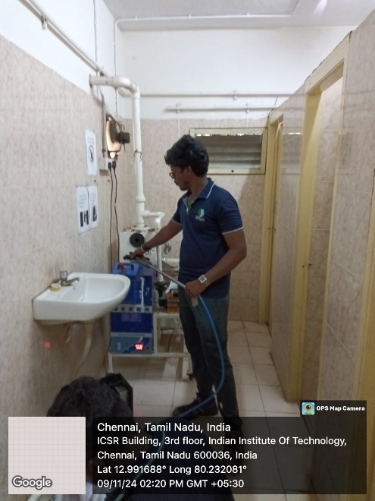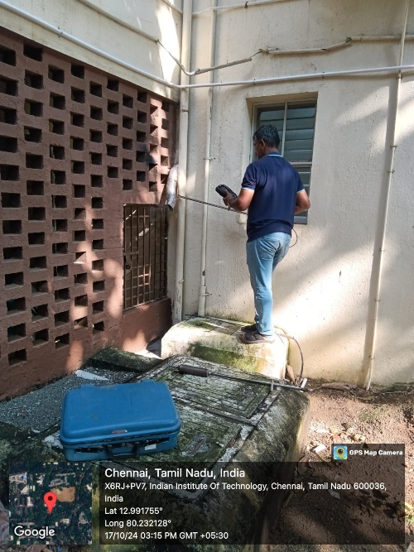  
Fig 4. Sampling conducted at different sites**

* + 1. **Sampling Procedure**

The sampling process was carried out using a standard flue gas analyzer, which provided real-time measurements during inspection and sampling. Online monitoring allowed for the accurate quantification of CO, CO₂, SO₂, and NO₂ levels present in the representative samples. Sampling for the selected incinerator was conducted at three distinct temperature points: 350°C, 450°C, and 650°C. Additionally, samples were collected for the analysis of polycyclic aromatic hydrocarbons (PAH), volatile organic compounds (VOCs), particulate matter, and chlorine. These samples were subsequently analyzed in laboratory conditions. The specific sampling times adhered to for each sample are detailed below.

**Table 9. Parameters analysed**

|  |  |  |  |  |
| --- | --- | --- | --- | --- |
| [**S.NO**](http://s.no/) | **Parameter** | **Sampling Media** | **Duration Minimum** | **Values** |
| 1 | Carbon Dioxide as CO2 | Flue gas analyser | 10 Mins | Direct Reading |
| 2 | Carbon Monoxide as CO | Flue gas analyzer | 10 Mins | Direct Reading |
| 3 | Nitrogen Oxides as NOx | Flue gas analyzer | 10 Mins | Direct Reading |
| 4 | Particulate Matter | Stack Kit and Thimble | 60 Mins | Analysis in Lab |
| 5 | Sulphur Dioxide as SO2 | Flue gas analyzer | 10 Mins | Direct Reading |
| 6 | PAHs | Stack Kit and XAD-2 | 30 Mins | Analysis in Lab |
| 7 | VOC-54 Mix | Stack Kit and Charcoal | 30 Mins | Analysis in Lab |

* + 1. **Results**

**Table 10. Comparisons between two flue gas analyses**

|  |  |  |  |  |  |  |  |
| --- | --- | --- | --- | --- | --- | --- | --- |
| Details of incinerator | CO | CO2 | NOx | SO2 | PAH | PM | VOCs |
| 6120 C (T1) | - | - | - | 10.47 | - | 13.6 | - |
| 650 (T1) | - | - | - | 13.10 | - | 14.56 | - |
| 450 (T1) | 4622 | - | 125 | - | - | 38.3 |  |

|  |  |  |  |  |  |  |  |
| --- | --- | --- | --- | --- | --- | --- | --- |
| Details of incinerator | CO | CO2 | NOx | SO2 | PAH | PM | VOCs |
| 350 (T2) | **2460** | **2.70** | **69** | **176** |  | **47** |  |
| 450 (T2) | **4332** | **0.1** | **104** | **26.76** |  | **68.9** |  |
| 650 (T2) | **1460** | **0.2** | **150** | **17.95** |  | **74** |  |

**Analysis and discussion**

Carbon Monoxide (CO) Emissions:

Initial Analysis (T1) at 450°C recorded 4622 mg/m³ CO, while the Second Analysis (T2) reported a lower value of 4332 mg/m³.

Possible Reason: This reduction may be due to improved combustion efficiency or enhanced incineration processes.

At 650°C (T2), the CO emissions were significantly lower (1460 mg/m³) compared to the 450°C case, indicating more complete oxidation at higher temperatures.

1. Carbon Dioxide (CO₂) Emissions:

CO₂ data was not available for the initial analysis (T1). In the second set, emissions at 350°C were the highest (2.70%), decreasing at 450°C (0.1%) and 650°C (0.2%).

Possible Reason: Higher temperatures generally indicate more complete combustion, converting more CO to CO₂. The low CO₂ value at 450°C (T2) suggests incomplete combustion or different operational conditions.

1. Nitrogen Oxides (NOₓ) Emissions:

NOₓ emissions were highest at 650°C (T2) with 150 mg/m³, compared to 104 mg/m³ at 450°C and 69 mg/m³ at 350°C.

Possible Reason: The formation of NOₓ increases at higher temperatures due to the thermal oxidation of nitrogen in the air. The data aligns with this trend.

1. Sulfur Dioxide (SO₂) Emissions:

The initial analysis showed SO₂ levels of 10.47 mg/m³ (612°C) and 13.10 mg/m³ (650°C), while in the second set, values ranged from 26.76 mg/m³ (450°C) to 176 mg/m³ (350°C).

Possible Reason: Variations could be due to differences in sulfur content in the sanitary napkins being incinerated or varying combustion efficiency.

1. Particulate Matter (PM) Emissions:

PM emissions were significantly higher in the second analysis, with 47 mg/m³ at 350°C, 68.9 mg/m³ at 450°C, and 74 mg/m³ at 650°C, compared to initial readings (13.6 mg/m³ at 612°C and 14.56 mg/m³ at 650°C).

Possible Reason: The higher levels could be attributed to operational differences, poor combustion conditions, or different types of waste.

Potential Reasons for Observed Trends and Differences:

Temperature Effects: Combustion temperature plays a critical role in determining emission levels. Higher temperatures generally result in more complete combustion, reducing CO and PM but potentially increasing NOₓ.

Operational Variations: Differences in incinerator operation, such as airflow rates, residence time, or loading conditions, can significantly influence emissions.

Waste Composition: Variations in the composition of sanitary napkins (e.g., additives, absorbent materials) between tests may lead to differences in emissions, especially SO₂ and PM.

Combustion Efficiency: Incomplete combustion can increase CO and decrease CO₂ emissions, as observed at 450°C in the second analysis.

1. **Manufacturing unit visit**

The visit to the MSME unit specializing in the manufacturing of sanitary napkin incinerators at Macro Instruments in Porur aimed to provide a comprehensive understanding of the production processes, technologies, and quality control measures employed in the assembly and distribution of these incinerators. This visit formed a critical part of our study to evaluate manufacturing capacities, production scalability, and adherence to quality standards across a range of manufacturers, including both large-scale enterprises and Micro, Small, and Medium Enterprises (MSMEs). Macro Instruments, currently in its growth phase, operates the Porur facility as a central hub for the assembly of its incinerator models. Ms. Hemavathi, the unit’s Sales Executive, welcomed us and provided a detailed overview of the company’s operations, emphasizing their commitment to quality and innovation within the sanitary waste management sector.

The manufacturing process at the Porur facility follows a decentralized model where components such as outer containers, heating coils, and thermal insulation materials are fabricated at various locations around Chennai. These components are then brought to the facility for final assembly. This approach allows for streamlined production while maintaining flexibility in component sourcing. The incinerator models produced at the unit vary in capacity, ranging from those capable of processing 10 to 20 sanitary napkins per cycle to larger models designed for up to 40 napkins. Smaller models incorporate spiral heating coils that are optimized for handling lower loads efficiently, while the larger units are equipped with tubular heating coils, which provide uniform and effective heat distribution for higher-capacity incineration cycles. The emphasis on efficient heat distribution underscores the unit’s focus on enhancing operational performance and reducing energy consumption.

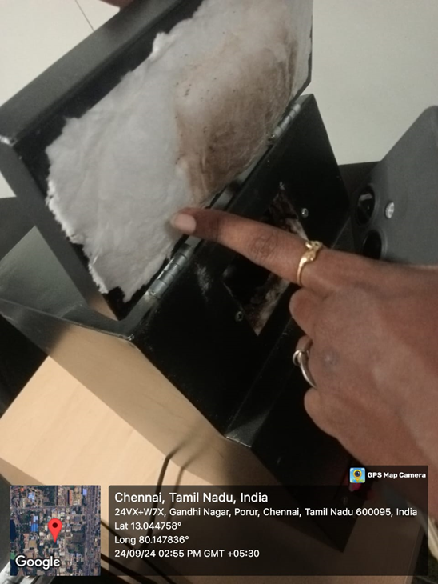 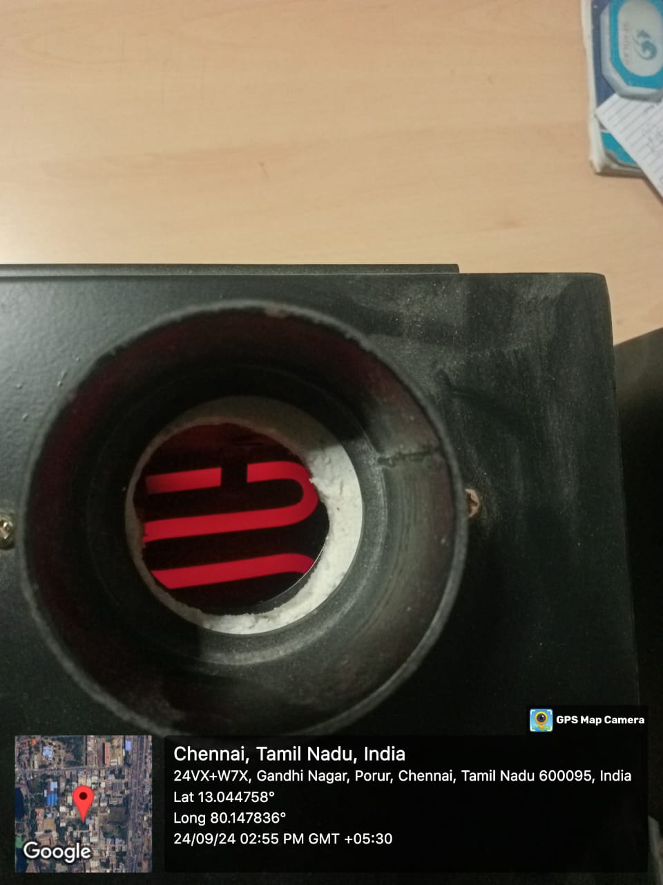

**Fig 5. Insulator protection and heating coil**

In terms of material specifications, the incinerators' outer frames are constructed using mild steel, providing structural integrity and durability even under high thermal stress. The heating coils, which serve as the core of the incineration process, are made from stainless steel, offering both corrosion resistance and the ability to withstand high temperatures over extended periods. To ensure safety and thermal efficiency, glass wool insulation is used within the incinerators. This insulation is applied in a precise manner to retain heat within the combustion chamber, thereby improving operational efficiency while preventing excess heat from escaping to the exterior surfaces. Such attention to insulation design plays a crucial role in maximizing the incinerators' energy efficiency and safety.

Operational efficiency is further demonstrated by the rapid heat-up time of the incinerators. Once activated, the units reach their designated operating temperature within a short span of 3 to 5 minutes. A complete incineration cycle typically takes between 15 and 20 minutes, depending on the specific model and the load capacity. This quick operational turnaround makes the units suitable for continuous use, a feature that is particularly beneficial in settings such as schools, hospitals, and community centers, where there may be a consistent demand for sanitary waste disposal. However, the incinerators are designed with preset temperature settings based on customer requirements, and they currently lack the flexibility for adjustable temperature controls. This limitation presents an opportunity for product improvement, as incorporating adjustable temperature settings could further optimize combustion efficiency, reduce harmful emissions, and improve the overall control of the incineration process.

One of the key challenges identified during the visit is the lack of formal emissions testing conducted at the unit. Given the environmental implications associated with incineration, particularly concerning the potential release of hazardous pollutants such as dioxins and furans, the absence of rigorous emissions monitoring is a notable gap. This represents a significant opportunity for improvement. Collaboration with environmental specialists or the integration of emissions testing protocols within the manufacturing process could help ensure compliance with environmental regulations, reduce the environmental impact of incineration, and enhance public health and safety. Furthermore, developing and adhering to comprehensive emissions control measures would bolster the unit’s credibility and market reputation, demonstrating a commitment to sustainability and responsible manufacturing.

The unit's production lifespan and warranty policy reflect their focus on product durability and customer satisfaction. Each incinerator is expected to last between 4 and 6 years, and the unit offers a warranty that aligns with this lifespan. The domestic market remains the primary focus of their distribution efforts, and their recent large order from the government of Nagaland, which involved supplying 400 incinerators for public use, highlights the growing demand for such products across India. This order not only demonstrates the unit’s production capacity but also underscores the increasing importance of decentralized waste management solutions in addressing sanitary waste challenges.

Despite these strengths, there is room for growth and improvement, particularly concerning environmental compliance and product flexibility. Implementing emissions testing, enhancing combustion efficiency through adjustable temperature controls, and ensuring compliance with stringent environmental standards would position the unit to better meet market demands and regulatory requirements. Such advancements would also align with global trends toward sustainable and environmentally responsible waste management practices. As sanitary waste incineration continues to gain traction as a viable disposal solution, ensuring operational efficiency, safety, and minimal environmental impact will be key factors driving the long-term success of the unit and similar enterprises across the sector.

In the coming months, the project will focus on several key activities to build upon the findings from the previous phases and address the challenges identified:

Visits to Manufacturing Units and Data Collection: We plan to visit various manufacturing units, including both large-scale and small-to-medium enterprises (MSMEs), to collect comprehensive data on the production processes, technologies, and materials used in the construction of sanitary napkin incinerators. These visits will provide valuable insights into the current manufacturing standards, quality control measures, and any variations across different manufacturers.

Preparation of a Data Sheet on Import and Export of Sanitary Incinerators:

A detailed data sheet will be prepared to analyze the import and export patterns of sanitary napkin incinerators. This will include information on the countries of origin, export destinations, quantities, and types of incinerators traded. Understanding these patterns will help identify market trends, regulatory impacts, and potential areas for improvement in the production and distribution of environmentally friendly incinerators.

Development of Proper Ash Disposal Methods:

To address the environmental and health concerns associated with the disposal of ash generated from the incineration of sanitary napkins, we will explore and develop safe and sustainable disposal methods. This may involve researching best practices for ash stabilization, recycling, and alternative uses, as well as identifying suitable hazardous waste management facilities for disposing of ash containing toxic heavy metals.

Flue Gas Analysis Across Different Types of Incinerators:

A comprehensive flue gas analysis will be conducted on various types of incinerators available in the market. This will involve sampling flue gases from different incinerator models, including those with adjustable temperature settings, to determine their emissions profile. The goal is to assess the effectiveness of different incinerators in minimizing the release of pollutants and to identify models that perform best under different operational conditions.

Collection of Data on the Manufacturing Processes of Incinerators:

We will gather detailed information on the manufacturing processes of various sanitary napkin incinerators, including the types of materials used, the technology employed, and any innovations in design or construction. This data will help identify best practices and areas for improvement in the production of incinerators that are more efficient and less harmful to the environment.

Measurement of Dioxin and Furan Emissions from Representative Samples:

A targeted study will be conducted to measure the emission levels of dioxins and furans from representative incinerator samples. This will involve collecting data under controlled conditions to accurately quantify these emissions and identify the factors influencing their formation. The findings will be critical in recommending adjustments to incinerator design or operational parameters to minimize the release of these highly toxic compounds.

These future activities will help advance the project’s objectives by providing a deeper understanding of the current state of sanitary napkin incineration technologies, identifying areas for improvement, and developing actionable recommendations for reducing the environmental impact of these devices.

1. **Conclusion**

This report presents a comprehensive evaluation of the decentralized incinerators, focusing on various key aspects such as manufacturing processes, emissions monitoring, ash analysis, and operational efficiency. Significant progress has been made over the reporting period, including detailed assessments of flue gas emissions, comprehensive ash analysis using the Toxicity Characteristic Leaching Procedure (TCLP), and collaborative engagements with relevant research and environmental bodies.

The flue gas analysis, conducted using a standard flue gas analyzer, provided real-time data on critical emissions, including CO, CO₂, SO₂, and NO₂. Sampling was conducted at varying temperatures to capture representative conditions during incineration. This analysis has been pivotal in identifying areas where emission levels can be optimized to meet or exceed local and international standards.

The Toxicity Characteristic Leaching Procedure (TCLP) provided valuable insights into the composition and leaching potential of ash generated by the incinerators. Through methodologies such as XRF analysis for heavy metal content and further analysis with ICP-OES, we were able to quantify potential environmental hazards and recommend safe disposal methods. This highlights the importance of controlling toxic releases, such as heavy metals, and emphasizes the need for continued monitoring and adherence to best practices.

Our visits to MSME units manufacturing sanitary napkin incinerators provided a deeper understanding of production technologies and challenges. While these units demonstrate strong market engagement and operational efficiency, opportunities for improvement, such as emissions testing and flexible temperature controls, were identified. Addressing these gaps will enhance product performance, compliance with environmental regulations, and market competitiveness.

Moving forward, the project will continue to focus on optimizing incinerator performance, reducing environmental impacts, and engaging with stakeholders for the adoption of best practices. By combining operational improvements, stringent emissions control, and robust data analysis, we aim to contribute meaningfully to sustainable and effective waste management solutions.

**References:**

1. Bakiyalakshmi, R., Dey, R., & Vasanthmurali, N. (2024). Analysis of flue gases in a solar powered napkin incinerator.
2. Aneesa, M., & Subash, A. K. DISPOSAL OF DIAPERS AND SANITARY NAPKINS AT PARAPPANANGADI MUNICIPALITY.
3. Sharika, C., Adumbil, C. C., Joy, D., Paul, E. J., & Thomas, A. (2019). Sanitary Waste Disposer. International Research Journal of Innovations in Engineering and Technology, 3(9), 28.
4. Danawala, S. Technical Assessment of Incinerators to Support Girls’ WASH Programming.
5. Chatterjee, S., & Mishra, V. (2020). Green chemistry–Remedy to societal hygiene: A graphical review. Current Research in Green and Sustainable Chemistry, 3, 100025.
6. Bose, S., & Singh, R. Energy recovery from proper recycling and incineration of waste absorbent hygiene products for environmental sustainability.
7. Borooah, R., Chanakya, H. N., & Dasappa, S. (2020). Investigations into the performance of single chamber sanitary napkin incinerators with emphasis on CO and CO2 emissions. *Waste management*, *102*, 667-676.
8. <https://dst.gov.in/green-dispo-eco-friendly-sanitary-napkin-incinerators-reaching-all-corners-country>
9. IS 5405 : 2019: Sanitary Napkins — Specification ( Second Revision)
10. Guidelines For Management Of Sanitary Waste, As per Solid Waste Management Rules, 2016
11. <https://www.mhlw.go.jp/>
12. <https://tokyoreview.net/2019/07/burning-problem-japan-waste-recycling/>
13. <https://www.fda.gov/regulatory-information/search-fda-guidance-documents/menstrual-tampons-and-pads-information-premarket-notification-submissions-510ks-guidance-industry>
14. <https://www.unicef.org/supply/media/12301/file/technical-specification-disposable-sanitary-pads-2022.pdf>
15. <https://mainichi.jp/english/articles/20210212/p2a/00m/0na/020000c>
16. Solid Waste Management and Recycling Technology of Japan, MoE
17. <https://www.epa.gov/sites/default/files/2020-10/documents/c02s03.pdf>
18. Aouini, I., Ledouxa, A., Estel, L., Mary, S., Evrard, P., & Valognes, B. (2012). Experimental study of carbon dioxide capture from synthetic industrial incinerator flue gas with a pilot and laboratory measurements. *Procedia Engineering*, *42*, 704-720.

**Annexure**

The details collected from Few MSME ventures, including their specifications and other relevant information, are included in this section.

**Model 1: Nakinci D- 300**

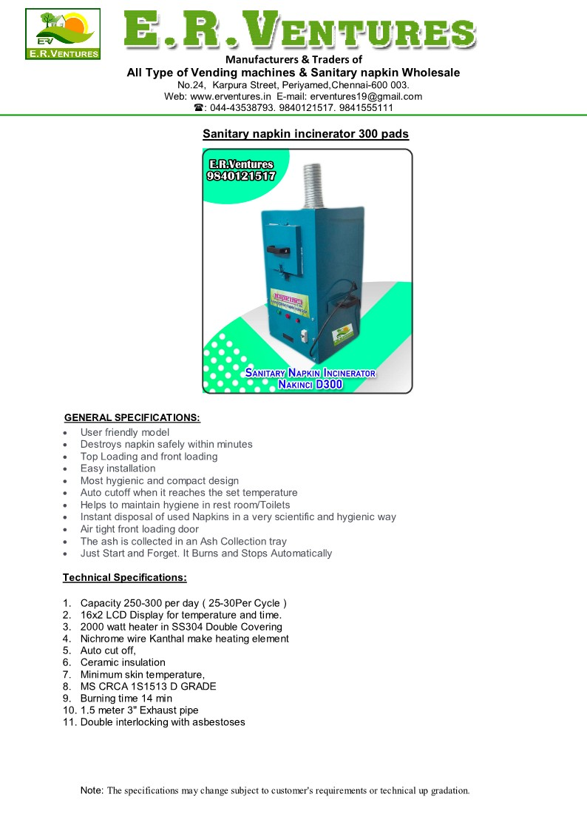

|  |  |
| --- | --- |
| Capacity | 25-30 per cycle |
| Display | 16*2 display for temperature and time |
| Heating | 2000 watts heater in SS304 double covering |
| Heating element | Nichrome wire |
| Insulation | Ceramic |
| Burning Time | 14 minutes |
| Exhaust pipe | 1.5 m 3” |

**Model 2: Nakinci D50**

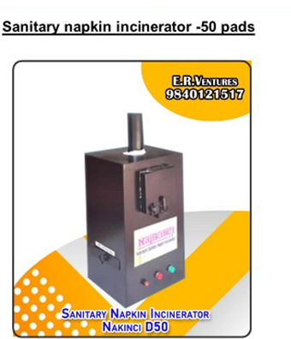

|  |  |
| --- | --- |
| Capacity | 50 pads |
| Size | 315*330*620 mm |
| Heating | 1000 watts heater |
| Inner chamber | 1.2mm MS, SS & GI |
| Insulation | Shockproof epoxy coating |
| Burning Time | 20 minutes |
| Mounting | Wall mount |

**Model 3: Nakinci D100**

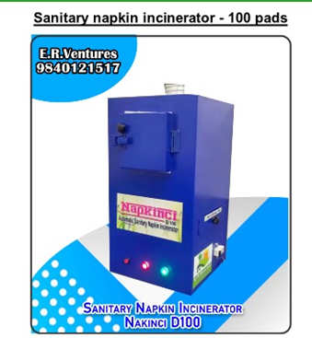

|  |  |
| --- | --- |
| Capacity | 100 pads |
| Heating | 2000 watts heater |
| Inner chamber | 1.2mm MS, SS & GI |
| Insulation | Shockproof epoxy coating |
| Burning Time | 20 minutes |
| Mounting | Wall mount/Table to |

The table below shows Details of Incinerator models from another ventures :

|  |  |  |  |  |  |
| --- | --- | --- | --- | --- | --- |
| **Model** | **INC-05** | **INC-10** | **INC-20** | **INC-30** | **INC-40** |
| **Capacity** | 5-8 napkins | 10 napkins | 20 napkins | 30 napkins | 40 napkins |
| **Input Volatge** | 1 PH ,230v , 50Hz | 1 PH ,230v , 50Hz | 1 PH ,230v , 50Hz | 1 PH ,230v , 50Hz | 1 PH ,230v , 50Hz |
| **Power in watts** | 1200 w | 1200 w | 1200 w | 2400w | 2400w |
| **External thermal production** | Fiber convert insulation | Fiber convert insulation | Fiber convert insulation | Fiber convert insulation | Fiber convert insulation |
| **Weight ( kg)** | 10 kg | 15 kg | 25 kg | 45 kg | 45 kg |
| **Mounting** | Wall | Wall | Wall | Wall | Wall |
| **Dimension** | 200*200*300 | 235*235*530 | 275*275*600 | 300*300*700 | 300*300*700 |