Preliminary Draft Indian Standard

School Shoe for Boys and Girls Specification

FOREWORD
This Indian Standard was prepared by the Bureau of Indian Standards, after the draft finalized by the Footwear Sectional Committee had been approved by the Chemical Division Council.
There is no Indian standard available in the country for school shoe, keeping in mind and also there are quite a number of the state governments procuring for their school children. It is a very much essential to develop the standard for the country to get quality and durable shoe to be used in school students.
Realizing the need of standard of school shoes in the country, the Footwear Sectional Committee decided to develop the standard keeping in line with the recent technological developments a that have taken place in developing this standard and also the standard was prescribed constructional and functional performance requirements of school shoes used by students and more importantly committee incorporated the wearer of shoe shall protect hazardous chemicals while manufacturing the shoe and also prevent environmental impact also taking care while developing this school shoe standard.
For the purpose of deciding whether a particular requirement of this standard is complied with the final value, observed or calculated, expressing the result of a test or analysis shall be rounded off in accordance with IS 2 : 2022 ‘Rules for rounding off numerical values (second revision)’. The number of significant places retained in the rounded off value should be the same as that of the specified value in this standard.
Preliminary Draft Indian Standard
School Shoe for Boys and Girls Specification

1. Scope
This standard prescribed the requirements, method of testing and sampling of footwear which are used for school shoe for boys and girls.

2. References

The standards listed in Annex ‘A’ contain provisions which through reference in this text, constitute provisions of this standard. At the time of publication, the editions indicated were valid. All standards are subject to revision, and parties to agreements based on this Indian Standard are encouraged to investigate the possibility of applying the most recent editions of these standards.

3. Terminology
For the purpose of this standard, the definitions given below along with definitions of terms, symbols, and units given in IS 2050 shall apply.

4. Sampling and conditioning
Wherever, possible test pieces shall be taken from the whole footwear unless otherwise stated.
If it is not possible to obtain test pieces from footwear large enough to comply with tests requirements, then samples may be taken from the raw material from which the component has been manufactured. However, this should be reported in the test report.

All test shall be conditioned at 27±2ºC and 65±5% Relative Humidity (RH)
5.Shape and design
Shape and design of the school shoe for boys and girls may be any design as agreed between manufacturer and purchaser.
School shoe designs for boys and girls are given in the Annex ‘B’ for reference purpose only.
6. Size and fittings
The recommended size and fittings of School shoe sizes for Boys and Girls is given below and will be guided in accordance with IS 1638

CATEGORY | GROUPS | AGE | SIZE
Category 1 | Kids Group | 4- 8 years | 9,10,11
Category 2 | Children Group | 8-11 years | 12, 13, 1
Category 3 | Boys and Girls Group | 11 – 12 years | 2,3,4,5
Category 4 | Youth Group | Above 13 years | 6,7,8,9

7. Construction
Upper construction may be made Strobel or string lasting construction.
Sole attachment to the shoe upper shall be direct moulded or cemented or stitched.

The footwear may be made in fully moulded construction or stitched or assembled or through cemented by lasting operation as required by design and style. It may also have single or multiple layers at bottom sole.
8. Requirement
8.1 Material and construction
The upper may be made up of any type of natural or synthetic material or combinations thereof. Upper construction may be made Strobel or string lasting or cemented lasting operation as required by design and style.
Lining, if used may be made up of any type of natural or synthetic material or combinations thereof. It may or may not be sandwiched with foam.
Bottom sole and mid sole (if used) may be made up of any type of natural or synthetic material or combinations thereof. The bottom sole may be solid or cellular in structure. Bottom sole shall be made anti slip tread pattern for better grip to avoid slip.
Sole attachment to the upper may be made by direct moulded or cemented or stitched or assembled
In-sock may be top layer of absorbent fabric laminated with cushioned foam to give comfort to the wearer.
Insole may be used natural or synthetic material.
Edge binding, if required may be used.
9.Thickness
Thickness of the upper/lining/Stiffeners/Bottom sole/Mid Sole and other components of the shoe may be as agreed between manufacture and purchaser.

10. Complete footwear performance for all types of school shoe groups
The school Shoe shall conform to requirement as prescribed in Table 1 wherever as applicable.

S.No | Characteristics | Requirements |  |  | Test Method
 |  | Kids group | Other groups
 |  |  | Type 1 | Type 2
1 | Bond strength, N/mm  Upper to Outsole | Min 1.0  Min 1.0 for Material tear | Min 3.5  Min 2.5 for Material tear | Min 1.5  Min 1.0 for Material tear | IS 15844 (Part 1)  Annex C
2 | Inter layer bond strength, N/mm  Midsole to Outsole  (Applicable only for multilayer sole) | Min 1.0  Min 1.0 for Material tear | Min 2.5  Min 2.0 for Material tear | Min 1.0  Min 1.0 for Material tear
3 | Whole shoe flexing, Flexes | At 50,000 flexes No Crack /Damage to the upper/sole crack and  No sole opening | At 2,00,000 flexes No Crack /Damage to the upper/sole crack and  No sole opening | At 1,00,000 flexes No Crack /Damage to the upper/sole crack and  No sole opening | ISO 24266 (Method A)
4 | Slip resistance, Cof  Dry and Wet  (Quarry Tile)  (Not applicable for leather sole)  Forward Heel slip  Backward forepart slip | Min 0.2  Min 0.2 | Min 0.3  Min 0.3 | Min 0.2  Min 0.2 | Annex E of IS 15844(Part 1)
5 | Attachment strength of strap and Buckle / D-ring N,( If present) | Min 35 | Min 125 | Min 60 | IS 6721 Annex D
6 | Attachment strength of strap and Velcro , N  (If, present) | Min 40 | Min 125 | Min 60 | IS 6721 Annex D
7 | Strength of eyelet attachment, N  (If, present) | Min 60 | Min 200 | Min 80 | IS 17043 Part 2  Annex C
9 | Seam strength, N/mm | Min 5.0 | Min 7.5 | Min 6.0 | IS 8085 (Part 13) Method B
10 | Abrasion resistance of sole, mm3  (Volume loss)  a) Cellular Sole ( 5N force)  b) Solid sole (10 N force) | 1000  600 | Max 500  Max 300 | 750  500 | IS 15298 Par 1  Clause 8.3 /  ISO 4649: 2017
11 | Chemical requirement  (Hazardous chemicals) | All the components of shoes which are in direct contact of foot shall comply with Table 1 of IS 17011 for critical substances Category I and Category II as specified under 3.6 of IS 17011. | All the components of shoes which are in direct contact of foot shall comply with Table 1 of IS 17011 for critical substances Category I and Category II as specified under 3.6 of IS 17011. | All the components of shoes which are in direct contact of foot shall comply with Table 1 of IS 17011 for critical substances Category I and Category II as specified under 3.6 of IS 17011. | IS 17011
11 | Lead content, (as Pb) ppm,  (applicable only for PVC) | Max 2 | Max 2 | Max 2 | IS 12240 (Part 5)
12 | Hydrolysis resistance, cut growth at 150 000 flexes, mm, Max (applicable for PU sole only) (not applicable for rigid sole) | Max 6 | Max 6 | Max 6 | IS 15298 (Part 1)

11. Optional requirements for School shoe components
The tests for the various components used in the manufacture of school shoes as given in the Table 2 to Table 13 shall be optional and may be tested. The characteristics to be tested and the requirements specified against them are given for guidance purpose only.
Upper
The upper of the shoe made from leather material shall conform to the requirement as specified in Table 2
Table 2- Upper Material Leather
S.No. | Characteristics | Requirement |  |  | Test Methods
 |  | Kids Group | All Groups
 |  | Kids | Type 1 | Type 2
1 | Tear Strength, N  Skin(Goat/sheep)  Hide (Cow/Buff)  Split/Vegetable tanned Leather | - | Min 15  Min 50  Min 40 | - | IS 5914 (Part 5/Sec 2)/ISO 3377-2
2 | Flexing Resistance, Flexes  Dry 75,000 flexes  Wet 50,000 flexes  At -5⁰C 25,000 flexes  ( Applicable only cold region) | - | No crack  No crack and salt spue  No crack and fat spue | - | IS 5914 (Part 6/Sec1)/ISO 5402-1
3 | Colour fastness to rubbing (Marring/Staining)  Dry 150 rubs  Wet 50 rubs | - | Gray Scale Rate  Grade 3  Grade 3 | - | ISO 11640 : 2012
4 | Colour fastness to Water  ( Contact method- Multi fabrics) | - | Gray scale Rate  Grade 3 | - | ISO 11642
5 | Water Vapour Permeability, mg/cm2/hr  Water vapour coefficient, mg/cm2 | - | Min 0.8  Min 15 | - | IS 15298 (Part 1)
6 | Stitch tear Strength, N/mm | - | Min 35 | - | LP 8 of IS 5914
7 | Abrasion resistance  Dry 51,200 cycles  Wet 25,600 cycles  (Applicable unlined upper ) | - | No Hole formed  No Hole formed | - | IS 15298 (Part 1)

The upper of the school shoe made from Non-leather material shall conform to the requirement as specified in Table 3

Table 3 - Upper Material -Non leather (Coated Fabric and Textile)
S.No. | Characteristics | Requirement |  |  | Test Methods
 |  | Kids Group | All groups
 |  | Kid | Type 1 | Type 2
1. | Breaking strength, N/mm  Elongation at Break, % | - | Min 7.0  Min 7.0 | - | Method 1 OF IS 7016 (Part 2)/ISO 1421:2016 or ISO 17706
2 | Tear Strength, N | - | Min 30 | - | IS 15298 (Part 1)
3 | Strength at Needle perforation, N/mm | - | Min 3.5 | - | IS 8085 Method A (Part13)/  ISO 17697
3 | Flexing Resistance, Flexes  Dry 1,00,000 flexes  Wet 50,000 flexes  At -5⁰C 25,000 flexes  ( Applicable only cold region) | - | No crack  No crack  No crack | - | ISO 17694
4 | Water Vapour Permeability, mg/cm2/hr  Water vapour coefficient, mg/cm2  (Applicable only for Textile) | - | Min 0.8  Min 2.0 | - | IS 15298 (Part 1)
5 | Hydrolysis resistance  (After ageing at70ºC and 95 percent RH for 7 days)  (Applicable for PU coated material) |  | No crack at 100 000 flexes |  | IS 16645/ISO 5423: 1992
6 | Abrasion resistance  Dry 51,200 cycles  Wet 25,600 cycles  (Applicable unlined upper ) | - | No Hole formed  No Hole formed | - | IS 15298 (Part 1)

Lining
Lining material if used in the school shoe shall conform to the requirement prescribed in the Table 4
Table 4 Lining for all materials
S.No. | Characteristics | Requirement |  |  | Test Methods
 |  | Kids Group | All groups
 |  | Kids | Type 1 | Type 2
1 | Tear Strength, N | - | Min 30 |  | IS 15298 (Part 1)
3 | Abrasion resistance  Dry at 25,600 cycles  Wet 12,800 cycles | - | No hole formed  No hole formed | - | IS 15298 (Part 1)
3 | Colour fastness rubbing (Staining)  Dry 10 rubs  Wet 10 rubs | - | Gray Scale Rate  Min Grade 3  Min Grade 3 | - | IS/ISO 105-X12
4 | Colour fastness to perspiration  (contact method- Staining) | - | Gray Scale Rate  Min Grade 3 | - | IS 6191 (Part 6)/ISO 11641
5 | Water Vapour Permeability, mg/cm2/hr  Water vapour coefficient, mg/cm2  (Applicable only for Textile) | - | Min 2.0  Min 20 | - | IS 15298 (Part 1)

Insole
The insole, if used in footwear shall conform to requirements prescribed in Table 5

Insole - Table 5
S.No. | Characteristics | Requirement |  |  | Test Methods
 |  | Kids Group | All groups
 |  | Kids | Type 1 | Type 2
1 | Flexing Index  (Cellulose and Leather board) | - | Min 2 | - | Annex F of IS 15844(Part 1)
2 | Abrasion resistance  At 400 cycles | - | No surface tearing | - | IS 15298 (Part 1)
3 | Water absorption, mg/cm²  Water desorption, % | - | Min 35  Min 60 | - | IS 15298 (Part 1)

In-sock (Sock-liner)
The in-sock used in the school shoe shall conform to requirement as prescribed in Table 6
In-sock- Table 6
S.No. | Characteristics | Requirement |  |  | Test Methods
 |  | Kids Group | All groups
 |  | Kids | Type 1 | Type 2
1 | Abrasion resistance  Dry at 25,600 cycles  Wet 12,800 cycles | - | No hole formed  No hole formed | - | IS 15298 (Part 1)
2 | Water absorption, mg/cm²  Water desorption, %  (Applicable fabric only) | - | Min 40  Min 60 | - | IS 15298 (Part 1)
Outsole-Synthetic sole
The outsole used in the footwear shall conform to requirement as prescribed in the Table 7
Outsole synthetic- Table 7
S.No | Characteristics | Requirements |  |  | Test Method
 |  | Kids Group | All groups
 |  | Kids | Type 1 | Type 2
2 | Flexing resistance (Belt Method)  At 30,000 flexes  ( 90 mm Mandral ) | - | No Crack | - | IS 8085 (Part 4)/ISO 16177: 2012
4 | Compression set, %  (Applicable for cellular sole only) | - | Max 20 | - | Annex G of IS 15844(Part 1)
Solid sole: Density greater than 0.9 g/cc , Cellular sole-Density less than or equal to 0.9g/cc
Mid sole
The midsole if used in the school shoe shall conform to requirement as prescribed in the Table 8
Midsole- Table 8
S.No  1 | Characteristics | Requirements |  |  | Test Method
 |  | Kids Group | All groups
 |  | Kids | Type 1 | Type 2
2 | Heat shrinkage, % | - | Max 3.0 | - | Annex J of IS 15844(Part 1)
4 | Split tear strength, Kg/25mm | - | Min 2.0 | - | Annex H of IS 15844(Part 1)
 | Compression set, %  (Applicable for cellular sole only) | - | Max 30 | - | Annex G of IS 15844(Part 1)

Toe and counter stiffener
The stiffener if used in the footwear shall conform to requirement as prescribed in the Table 9
Toe and counter stiffener- Table 9
S.No | Characteristics | Requirements |  |  | Test Method
 |  | Kids Group | All groups
 |  | Kids | Type 1 | Type 2
1 | Hardness, N  Filmic  Other than filmic | - | ≤30  ≥30 | - | Annex A of IS 7554  A-3.2.6
2 | Resilience, %  Filmic  Other than filmic | - | Min 60  Min 50 | - | A-3.2.6
3 | Moisture resistance, %  Filmic  Other than filmic | - | Min 60  Min 50 | - | A-3.2.6

Velcro fastener
The stiffener if used in the footwear shall conform to requirement as prescribed in the Table 10
Vercro fastener- Table 10
S.No | Characteristics | Requirements |  |  | Test Method
 |  | Kids Group | All groups
 |  | Kids | Type 1 | Type 2
1 | Peel strength, N/mm  Initial  After 5000 wear cycles | - | Min 1.0  Min 0.08 | - | IS 8085 (Part 18) / ISO 22777
2 | Shear strength, kPa  Initial  After 5000 wear cycles | - | Min 75  Min 65 | - | ISO 22776

Elastic tape
The stiffener if used in the footwear shall conform to requirement as prescribed in the Table 11
Elastic Tape- Table 1
S. No | Characteristics | Requirements |  |  | Test Method
 |  | Kids Group | All groups
 |  | Kids | Type 1 | Type 2
1 | Limit of useful extension, %, | - | Min 90 | - | IS 8085 (Part 12) / ISO 10765
2 | Needle strength, N/mm, | - | Min 3.5 | - | IS 8085 (Part 13) Method A  / ISO 17697

Fasteners (Lace/ Buckle/Eyelet/D-Ring/Ski-hook/ Metal trims)
The fasteners for gripping (not for decorative purpose), if used in the school footwear shall conform to requirement as prescribed in Table 12
Fasteners (Lace/ Buckle/Eyelet/D-Ring/Ski-H/Metal trims)- Table 12
S.No | Characteristics | Requirements |  |  | Test Method
 |  | Kids Group | All groups
 |  | Kids | Type 1 | Type 2
1 | Lace breaking strength, N | - | Min 200 | - | Annex K of IS 15844(Part 1)
2 | Lace tag strength, N | - | Min 120 | - | Annex L of IS 15844(Part 1)
3 | Lace to lace abrasion resistance,  Cycles | - | No breakage before 5000 cycles | - | IS 8085 (Part 17)/  ISO 22774
4 | Colour fastness to water for Lace  Contact Method- Staining | - | Gray Scale Rate  Min Grade 3 | - | IS 6191 (Part 2) /  ISO 11642 : 2012
5 | Corrosion resistance  (Applicable for all including decorative metal part) | - | Not worse than slight uniform change | - | IS 17098

Zipper
The fasteners Zipper if used in the school shoe shall conform to requirement as prescribed in Table 13
Zipper –Table 13
S.No | Characteristics | Requirements |  |  | Test Method
 |  | Kids Group | All groups
 |  | Kids | Type 1 | Type 2
1 | Fatigue resistance | - | Min 1000 cycles | - | IS0 10751
2 | Security of Puller attachment  strength, N | - | Min 250 | - | ISO 10734
3 | Lateral load, N | - | Min 400 | - | ISO 10764

Marking and Packing
8.1 Marking
8.1.1 The shoes shall be marked legibly with the following:
a) Size;
b) Type;
c) Identification of the source of manufacturer or brand name;
d) CR to be marked in case flexing resistance for cold region is claimed.
8.1.2 BIS Certification Marking
The use of the Standard Mark is governed by the provisions of the Bureau of Indian Standards Act, 2016 and the Rules and Regulations made thereunder.
The details of the conditions under which the license for use of the Standard Mark may be granted to manufacturers or producers may be obtained from the Bureau of Indian Standards.
8.2 Packing The shoes shall be packed as agreed to between the purchaser and the manufacturer. Each individual package shall contain shoes of one size only and may be marked with the name of the item, size, colour, and type, best before date, identification of the source of manufacture and batch number and any other marking if so desired.
Annex ‘A’-LIST OF REFERRED INDIAN STANDARDS

IS No. | Title
IS 5914: 1970 | Methods of physical testing of leather
(Part 5/Sec 2) | Part 5 Determination of tear load Section 2 Double edge tear
(Part 6/Sec 1) | Part 6 Determination of flex resistance Section 1 Flexometer method
IS 6191: 1971 | Micro - Biological colour fastness and microscopical tests for leather
IS 6191 (Part 2): 2017/ISO 11642: 2012 | Methods of Micro-Biological, Colour Fastness and Microcopical Tests for Leather Part 2 Colour Fastness to Water
IS 6191 (Part 4): 2018/ISO 11640: 2012 | Methods of Micro-Biological, Colour Fastness and Microscopical Tests for Leather Part 4 Colour Fastness to Cycles of to-and-fro Rubbing
IS 6191 (Part 6)/ISO 11641 | Methods of Micro-Biological Colour Fastness and Microscopical Tests for Leather Part 6 Colour Fastness to Perspiration
IS 7554: 2009 | Toe puff and counter stiffener - Specification (first revision)
IS 15298 (Part 1): 2015 | Personal Protective Equipment Part 1 Test Methods for Footwear (second revision)
IS 17011: 2018 | Chemical requirements for footwear and footwear materials
IS 7016 (Part 2): 2015/ ISO 1421:1998  ISO 1421: 2016 | Methods of test for coated and treated fabrics: Part 2 determination of tensile strength and elongation at break (Second Revision)  Rubber- or plastics-coated fabrics — Determination of tensile strength and elongation at break
IS 3400 (Part 3): 2021/ISO 4649:2016  ISO 4649: 2017 | Methods of Test for Vulcanized Rubbers Part 3 Abrasion Resistance using a Rotating Cylindrical Drum Device (Third Revision )  Rubber, vulcanized or thermoplastic — Determination of abrasion resistance using a rotating cylindrical drum device
IS 16645: 2018/ISO 5423:1992 | Moulded Plastics Footwear — Lined or Unlined Polyurethane Boots for General Industrial use Specification
IS/ISO 105 B02:2014 | Textiles – Tests for colour fastness – Part B02 Colour fastness to artificial light: Xenon arc fading lamp test
IS/ISO 105-X12: 2016 | Textiles – Tests for colour fastness Part X12 Colour fastness to rubbing (first revision)
IS 8085 (Part 4): 2019/ISO 16177: 2012 | Methods of Test for Footwear Part 4 Resistance to Crack Initiation and Growth — Belt Flex Method
IS 8085 (Part 12): 2023/ISO 10765:2010 | Methods of Test for Footwear Part 12 Tensile Performance of Elastic Materials
IS 8085 (Part 13): 2023/ISO 17697: 2016 | Methods of Test for Footwear Part 13 Seam strength for uppers lining and insocks
IS 8085 (Part 17): 2023/ISO 22774: 2004 | Methods of Test for Footwear Part 17 Abrasion resistance for accessories shoe laces
IS 8085 (Part 18): 2023/ISO 22777: 2004 | Methods of Test for Footwear Part 18 Peel strength before and after repeated closing for accessories Touch and close fasteners
ISO 24266:2020 | Footwear — Test methods for whole shoe — Flexing durability
IS 17098: 2019/ISO 22775: 2004 | Footwear — Test Methods for Accessories: Metallic Accessories — Corrosion Resistance
ISO 17694: 2016 | Footwear — Test methods for uppers and lining — Flex resistance
ISO 17706: 2003 | Footwear — Test methods for uppers — Tensile strength and elongation

General design for School shoe for boys and girls for reference purpose - Annex ‘B’
Boys Shoe Derby
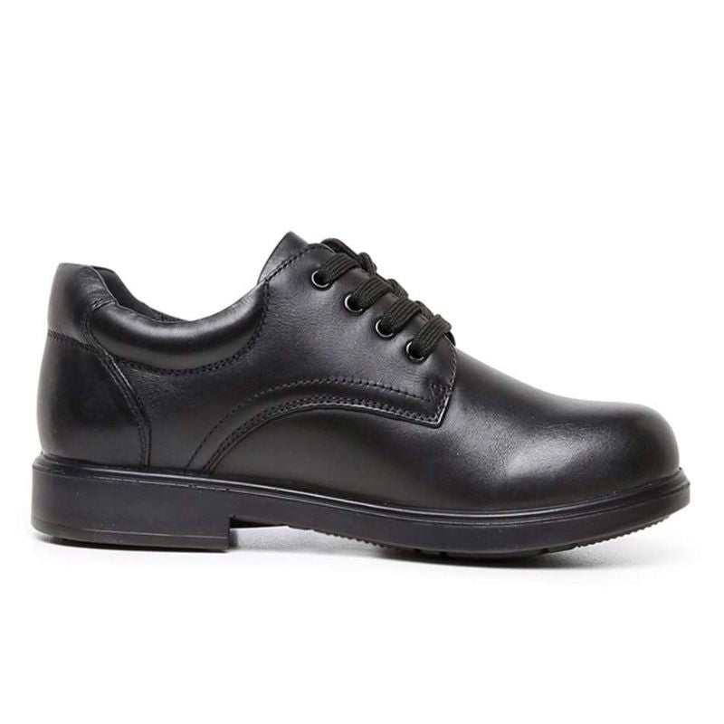

Boys shoe- Oxford

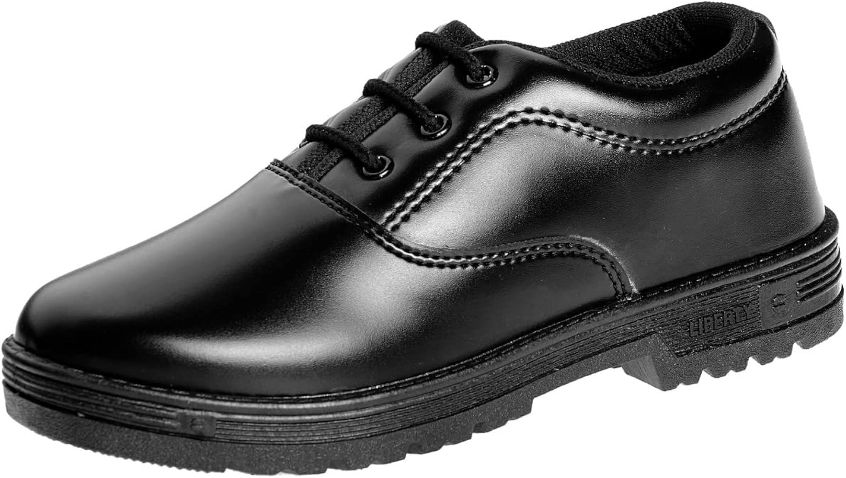

Boys shoe with Velcro strap

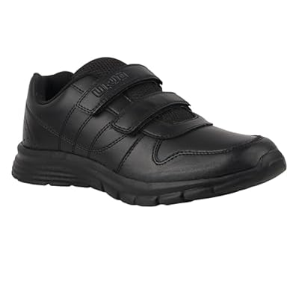

Boys shoe

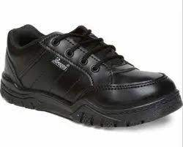

School shoe with strap
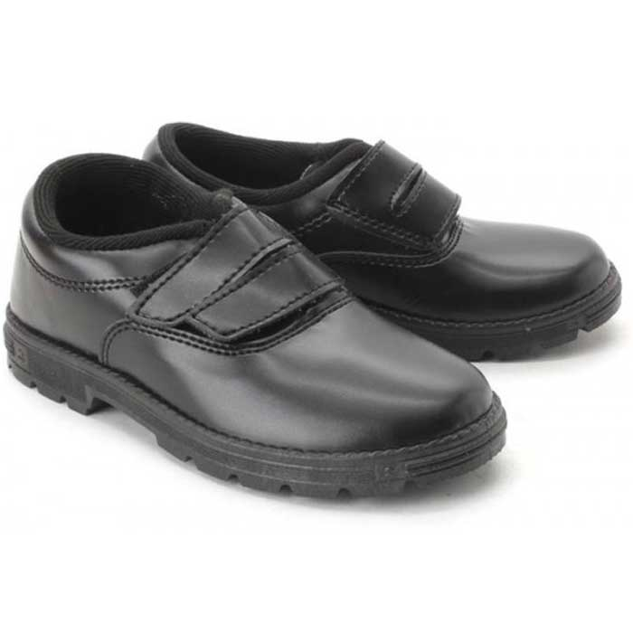
Girls shoe- Slip on
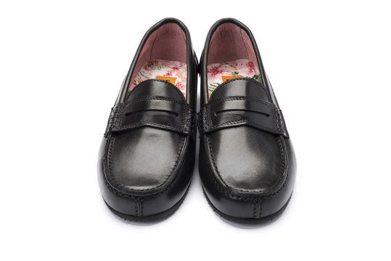

Girls shoe- Slip on

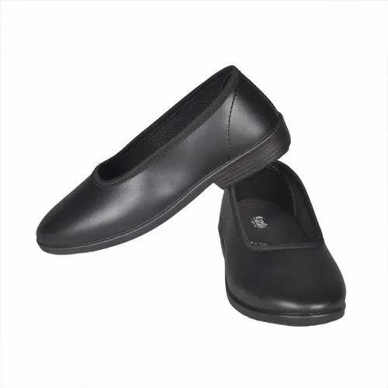

Girls shoe-Single strap with Buckle

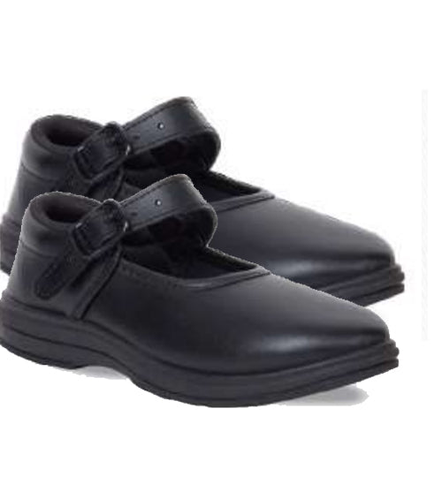

Shoe shoe – single velcro strap

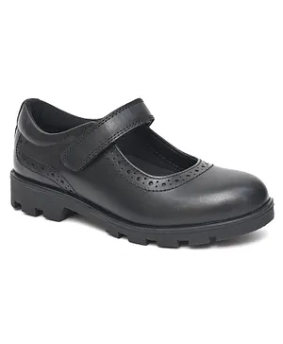

Shoe shoe – single strap with Buckle

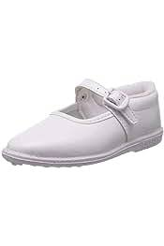

Shoe - velcro double strap
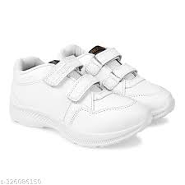

Girls- School shoe
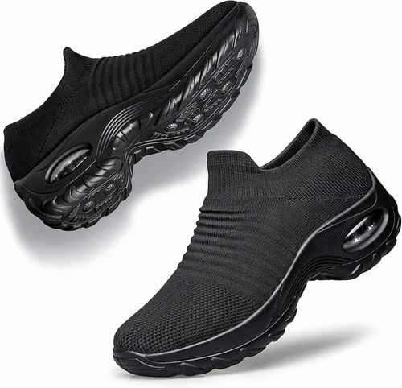
School shoe

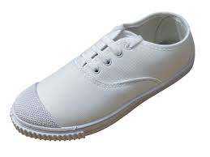

Girls shoe

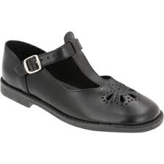

Scool shoe

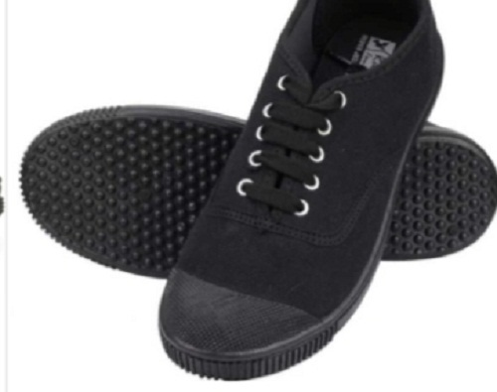

School shoe with centre bar velcro strap

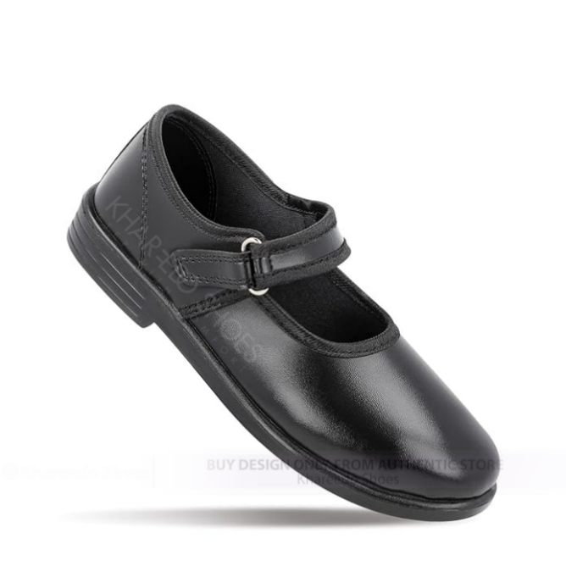

Slip on girls shoe

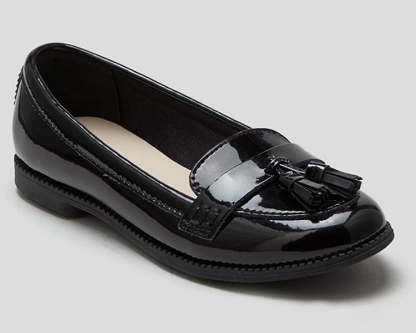

Slip on girls shoe

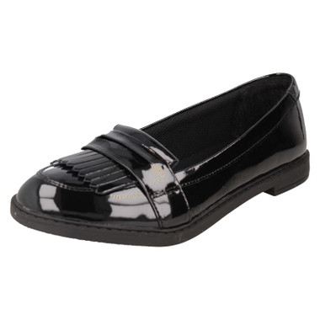
Laced moccassin for boys

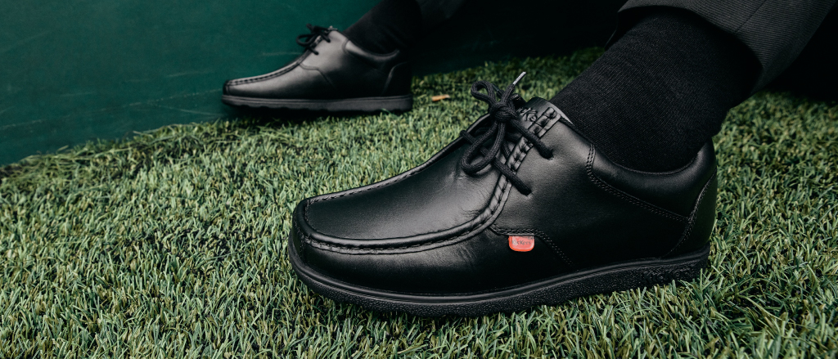
Boys moccassin shoe –Vecro strap
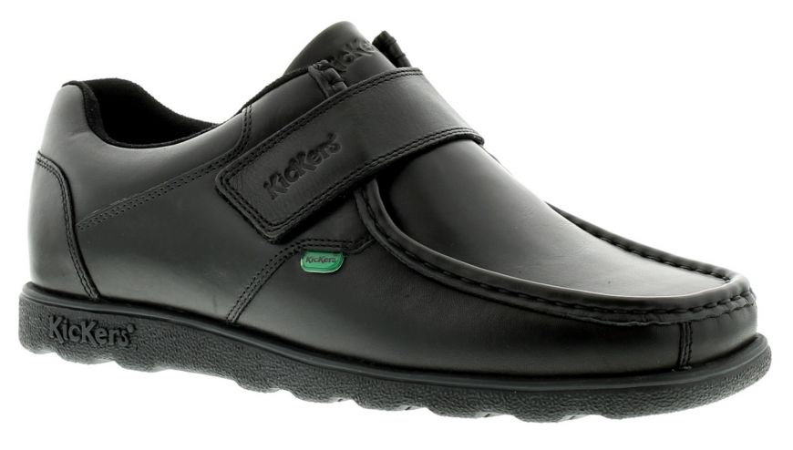

Schoo shoe

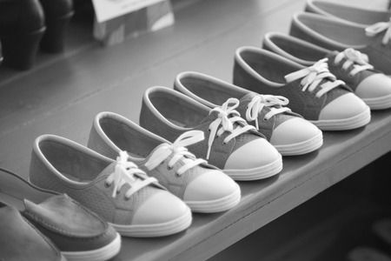

School shoe-Girls

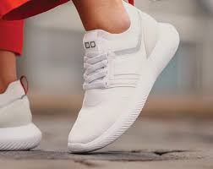

Slip on shoe for boys

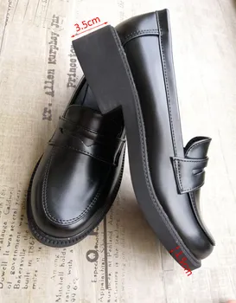

Boys School shoe

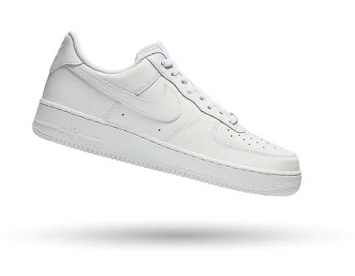
Girls shoe single bar
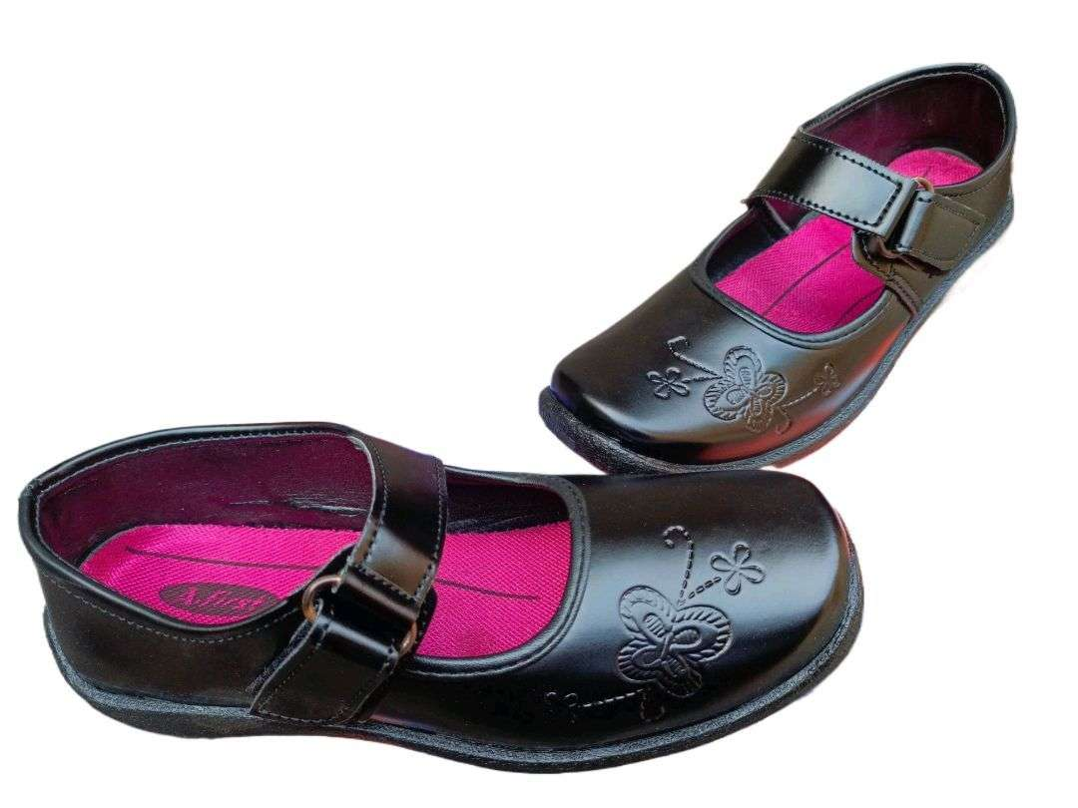

School shoe – Velcro strap
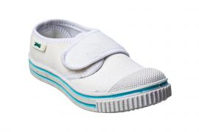

Girl shoe – Velcro strap
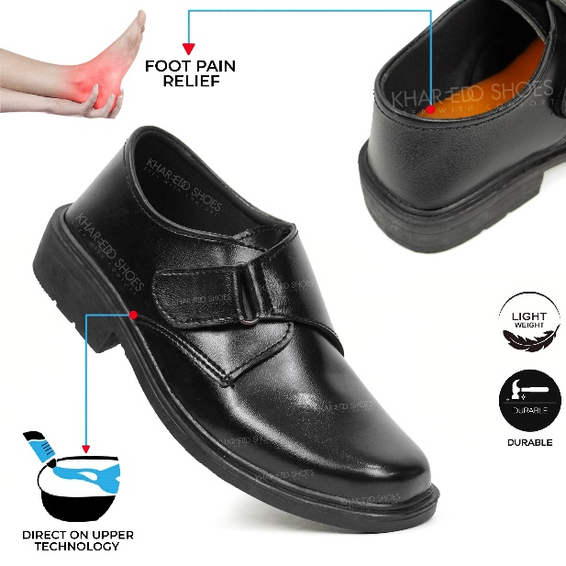
Girls shoe with centre bar buclke strap

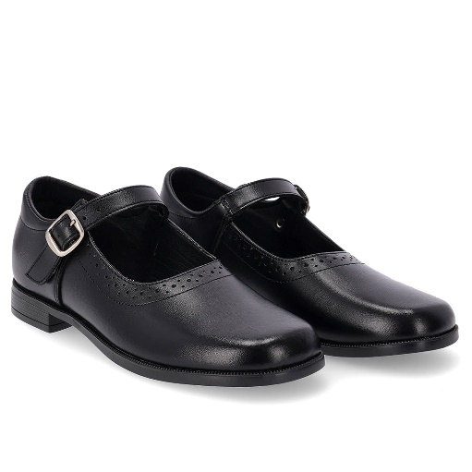
Boys shoe – Velcro strap

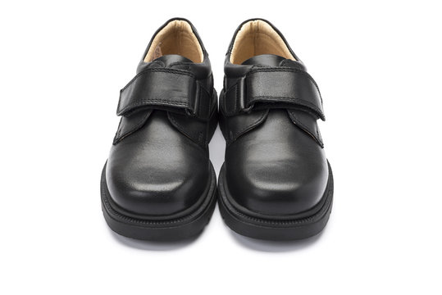

Shool shoe for kids
