**BUREAU OF INDIAN STANDARDS**

**DRAFT FOR COMMENTS ONLY**

*(Not to be reproduced without the permission of BIS or used as an Indian Standards)*

|  |
| --- |
| *भारतीय मानक मसौदा* **कृत्रिम गर्भाधान के लिए डिस्पोजेबल दस्ताने — विशिष्टि**  *(आई एस 7180 का पहला पुनरीक्षण)*  *Draft Indian Standard*  **DISPOSABLE ARTIFICIAL INSEMINATION GLOVES — SPECIFICATION**  *(First Revision of IS 7180)*  **ICS 65.020.30** |
| Animal Husbandry and Equipment Last date of comment: 2023  Sectional Committee, FAD 32 |

**FOREWORD**

*(Adoption clause will be added later)*

At present latex gloves are in vogue for artificial insemination (AI), pregnancy diagnosis and gynaecological investigations involving rectal examination. With increasing application of AI technique in the national livestock development plans, it is becoming imperative to use disposable gloves for the safety of operators as well as animals. These gloves should be preferred specially because latex gloves become extremely uncomfortable during summers. This standard is, therefore, being evolved to guide the manufacturers for production of disposable artificial insemination gloves.

In light of the manufacturing practices prevailing abroad and heat processing of AI gloves, the Committee felt that further sterilization of the gloves is superfluous from technical as well as economic considerations. Therefore, this standard was originally published in 1973 to maintain the quality and establishing the dimensional uniformity of gloves to streamline the artificial insemination practices across the country. However, in order to make this standard in line with the current practices and upgraded anthropological data, the committee decided to revise it.

In this revision following major modifications have been made:

a) In packing clause, the bag size is given as 100 gloves instead of 50 or 100 for bringing clarification in the sampling of gloves.

b) Gloves used by female veterinarian is also included with different dimensional requirements.

For the purpose of deciding whether a particular requirement of this standard is complied with, the final value, observed or calculated, expressing the result of a test or analysis, shall be rounded off in accordance with IS 2: 2022 ‘Rules for rounding off numerical values (*second revision*)’. The number of significant places retained in the rounded off value should be the same as that of the specified value in this standard.

**1 SCOPE**

**1.1** This standard prescribes the requirements and methods of sampling and test for disposable artificial insemination gloves.

**2 REFERENCE**

The following standards contain provisions which through reference in this text, constitute provision of this standard. At the time of publication, the editions indicated were valid. All standards are subject to revision and parties to agreements based on this standard are encouraged to investigate the possibility of applying the most recent editions of the standards indicated below:

|  |  |
| --- | --- |
| ***IS No.*** | ***Tittle*** |
| IS 7328 : 2020 | Specification for polyethylene material for moulding and extrusion  (*third revision*) |
| IS 1997 : 2008 | Laboratory glassware — Burettes (*third revision*) |

**3 MATERIAL**

**3.1** The gloves shall be made of low density polyethylene films conforming to IS 7328.

**3.2** The gloves shall not contain any ingredients known to be harmful to mucus membrane of animals when they come in contact with them.

**4 DIMENSIONS**

**4.1** The gloves shall be fabricated with the dimensions shown in Fig. 1 and Fig. 2. The tolerance permissible on all the dimensions shall be 5 percent.

**4.2 Thickness** ⎯ The thickness of the film shall be not less than 20 µm.

**5 APPEARANCE**

The gloves shall be free from pin holes, undispersed raw material, streaks and particles of foreign matter. It shall also be free from tears and blisters. The edges shall be free of nicks and cuts visible to the unaided eye.

**6 TENSILE STRENGTH OF THE FILM**

**6.1** The tensile strength of the film, when tested by the method prescribed in Annex A, shall be not less than 120 kgf/ cm2.

**7 ELONGATION AT BREAK**

**7.1** The elongation of the film at break when tested as prescribed in Annex A shall be not less than 100 percent in lengthwise direction and 350 percent in crosswise direction.

**8 DENSITY**

**8.1** The density of the material when determined in accordance with Annex B shall be between 0.912 and 0.929 g/ml.

**9 COLOUR**

**9.1** Gloves may be fabricated from colourless or suitable light coloured, preferably light cream, films.

**10 REACTION TO AQUEOUS EXTRACT**

**10.1** The aqueous extract shall not be acidic to methyl orange or alkaline to phenolphthalein.

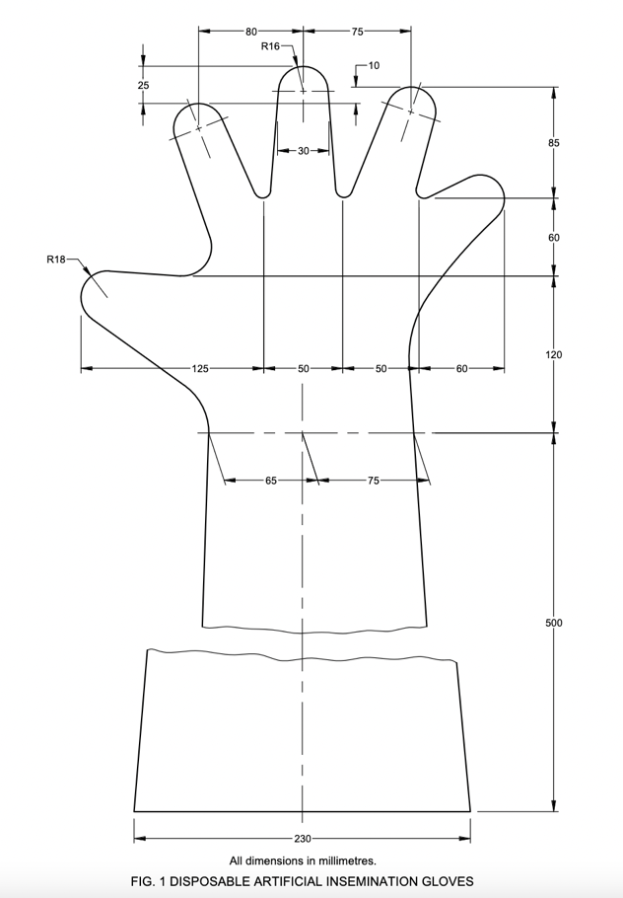

All dimensions in millimetres.

FIG. 1 DISPOSABLE ARTIFICIAL INSEMINATION GLOVES FOR MEN

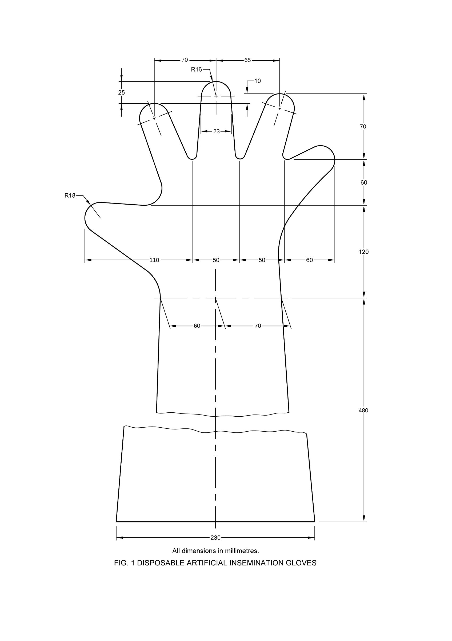

All dimensions in millimetres.

FIG. 2 DISPOSABLE ARTIFICIAL INSEMINATION GLOVES FOR WOMEN

**11 PACKING AND MARKING**

**11.1 Packing** ⎯ 100 gloves shall be packed in a plastic bag and the bag should be hermetically sealed.

**11.2 Marking** ⎯ Each pack of gloves shall be marked legibly with the following information:

a) Manufacturer’s name or trade-mark,

b) Number of gloves,

c) Mass of the pack, and

d) Batch number of manufacture.

**11.3 BIS Certification Marking**

The product(s) conforming to the requirements of this standard may be certified as per the conformity assessment schemes under the provisions of the *Bureau of Indian Standards Act*, 2016 and the Rules and Regulations framed there under, and the products may be marked with the Standard Mark.

**12 SAMPLING**

For the purpose of ascertaining the conformity of the glows in a consignment to the requirements of this standard, the scale of sampling and criteria for conformity shall be as prescribed in Annex C.

**13 TEST**

**13.1 Seam Test** ⎯ Blow in the air awl test for any leak by placing it in water and observing air bubble should be seen on the outer surface.

**13.2** The tests for tensile strength, elongation at break and density shall be carried out as prescribed in **6.1, 7.1** and **8.1.**

**ANNEX A**

(*Clauses* **6.1** *and* **7.1**)

**DETERMINATION OF TENSILE STRENGTH AND**

**ELONGATION AT BREAK**

**A-1 APPARATUS**

**A-1.1 Tensile Testing Machine** ⎯ The tensile testing machine used shall maintain a rate of movement of one grip as constant as possible. The mean value of the speed of separation shall be 250 ± 25 mm per minute. The load scale shall be accurate to within one percent or 0.1 kg whichever less is. The load range shall be such that the breaking load of the test pieces falls between 15 percent and 85 percent of the full scale reading.

NOTE ⎯ It is recommended that the load scale be calibrated at least once every 12 months, using deadweight’s added successively.

**A-1.2 Preparation of Test Pieces** ⎯ Test specimens shall be 0.5 to 2.5 cm in width and not less than 4 cm in length. Cut five test pieces from the sample in the lengthwise direction and a further five in crosswise direction.

**A-1.3 Procedure** ⎯ Condition the test pieces for not less than one hour at a temperature of 27 ± 2°C and clamp them in the machine at their widened ends. Start the machine and note the load and elongation at break. Reject the test pieces breaking outside the reference lines and repeat the test.

**A-1.4 Calculation and Report**

**A-1.4.1** *Tensile Strength at Break* ⎯ The tensile strength shall be calculated in kgf/cm2 from the original area of cross section. The mean of five results shall be expressed for the lengthwise and crosswise samples.

**A-1.4.2** *Elongation at Break* ⎯ Elongation at break shall be expressed as percentage of the original length between the reference lines. The mean of five results shall 1x expressed for the lengthwise and crosswise samples.

**ANNEX B**

(*Clause* **8.1**)

**DETERMINATION OF DENSITY**

**B-1 REAGENT**

**B-1.1 Dilute Alcohol** ⎯Having a density of 0.905 g/ml at 23°C, prepared by diluting ethyl alcohol with distilled water.

**B-1.2 Preparation of Test Specimens** ⎯ Cut from the roll two specimens of an area of 100 to 225 mm2 from different parts of the roll using a sharp blade.

**B-1.3 Procedure** ⎯ Pipette 100 ml of dilute alcohol into a clean Drechsel bottle kept immersed in a water-bath maintained at 23.0 ± 0.1°C. After temperature equilibrium has been attained. Lower one test specimen of polyethylene film carefully into the dilute solution, avoiding any adhering air bubbles. Add from a burette (conforming to class A of IS 1997) distilled water, 0.2 ml at a time, with stirring. When the specimen remains just suspended in the solution well away from the glass surface, the density of the solution and the specimen is taken to be the same. Prepare a calibration curve for the density of dilute alcohol by adding increasing amounts of water and determining the density. Read off the density of the specimen from the calibration curve. For an accurate result, density of solution at the end may also be obtained with a pyknometer or specific gravity bottle at 23.0 ± 0.1°C. Carry out the test in a similar manner on the second specimen.

**B-1.4 Calculation** ⎯ Calculate the density of the two specimens to the fourth decimal place. If the two values vary by more than 0.0005, reject the readings and repeat the tests until the difference between the two values is not greater than 0.000 5. Report the mean of the two values as the density.

**ANNEX C**

(*Clause* **12.1**)

**SAMPLING OF ARTIFICIAL INSEMINATION GLOVES**

**C-1 SCALE OF SAMPLING**

**C-1.1 Lot** ⎯ In any consignment the gloves of the same size, material and preferably belonging to the same batch of manufacture shall be grouped together to constitute a lot.

**C-1.2** For ascertaining the conformity to the requirements of this specification test shall be carried out separately for each lot.

**C-1.3** The number of gloves to be sampled from a lot shall be in accordance with Table 1.

|  |  |  |  |
| --- | --- | --- | --- |
| **TABLE 1 SCALE OF SAMPLING** | | | |
| **NO. OF BAGS IN THE LOT**  ***N*** | **NO. OF BAGS TO BE SELECTED**  ***n*** | **NUMBER OF GLOVES TO BE SELECTED FOR SAMPLING** | **PERMISSIBLE NUMBER OF DEFECTIVE FOR APPEARANCE, DIMENSION AND COLOUR** |
| (1) | (2) | (3) | (4) |
| Up to 50 | 10 | 80 | 7 |
| 51 to 100 | 25 | 125 | 10 |
| 101 to 500 | 50 | 200 | 14 |
| 501 to 1000 | 100 | 300 | 21 |
| 1001 to 3000 | 250 | 500 | 28 |
| 3001 and above | 400 | 800 | 35 |
| NOTE ⎯ If the number of bags supplied is less than 5 the sampling may be done as agreed between the purchaser and supplier. | | | |

**C-1.4** The number *n* of bags to be chosen from the lot shall depend upon the size of the lot *N*, and shall be in accordance with co1 1 ant1 2 of Table 1. From each of the selected bags approximately equal number of gloves shall be taken at random so as to give the required number of samples (*see* col 3 of Table 1 ) for testing dimensions (*see* **4**), appearance ( *see* **5** ) and colour (*see* **9**).

**C-2 THE NUMBER OF TEST AND CRITERIA FOR CONFORMITY**

**C-2.1 Tests for Dimension, Appearance and Colour** ⎯ All the gloves as selected in **C-1.3** shall be subjected to dimensional, appearance and colour examinations. A glove fails to satisfy any one of these requirements shall be called a defective. If the number of defectives in the sample is less than or equal to the permissible number of defectives given in co1 4 of Table 1 the lot shall be considered as conforming to these requirements.

**C-2.2 Tests for Tensile Strength, Elongation at Break, Density and Reaction to Aqueous Extract**

**C-2.2.1** The lot passing the tests prescribed in **C-2.1** shall be tested for tensile strength, elongation, density and reaction to aqueous extract. Samples shall be taken for each test according to the double sampling plan given in Table 2.

|  |  |  |  |  |
| --- | --- | --- | --- | --- |
| **TABLE 2 DOUBLE SAMPLING PLAN** | | | | |
| **State of**  **Sampling** | **No. of Gloves** | **Total Examined** | **Acceptance Number** | **Rejection Number** |
| First | 8 | 8 | 0 | 2 |
| Second | 8 | 16 | 1 | 2 |

**C-2.2.2** Out of the samples examined for visual and other characteristics (*see* **C-2.1**), 64 gloves shall be selected at random and divided into 4 groups of 16 gloves each. These four groups shall be used for testing the characteristics given in **C-2.2.1.**

**C-2.2.2.1** A glove which fails to meet the relevant requirement of a test is called a defective. If the number of gloves failing to satisfy the test is zero, the lot shall be accepted in respect of the test. But if the number of defective gloves is 2 or more the whole lot shall be rejected in respect of that test. If the number of defective is 1, another sampling of 8 shall be taken from the remaining gloves and subjected to the same test. At this second stage the lot shall be rejected in respect of this test as given in the sampling plan. In the same way the lot shall be examined in respect of other tests.

**C-2.3** The lot shall be considered as conforming to this specification if **C-2.1** and **C-2.2.1** are satisfied.