**BUREAU OF INDIAN STANDARDS**

**DRAFT FOR COMMENTS ONLY**

(*Not to be reproduced without the permission of BIS or used as an Indian Standards*)

|  |  |
| --- | --- |
| *भारतीय मानक मसौदा*  **कृत्रिम गर्भाधान उपकरण — गॉब्लेट — विशिष्टि**  (*आई एस 13125 का पहला पुनरीक्षण*)  *Draft Indian Standard*  **ARTIFICIAL INSEMINATION EQUIPMENT — GOBLETS — SPECIFICATION**  (*First Revision of IS 13125*)  **ICS 65.020.30** | |
| Animal Husbandry and Equipment Sectional Committee, FAD 32 | Last date of comment: 22 May 2024 |

**FOREWORD**

(*Formal clauses will be added later*)

Goblets are used for storing frozen semen straws in cry containers filled with liquid nitrogen. These are used by all the semen centres/stations across the country, therefore, the specifications of this goblets are crucial to be maintained and need to be standardized for reducing the variability and non-uniformity in colour and dimensions.

In this revision, the standard has been brought out in the latest style and format of the Indian Standards and following major modifications have been made based on the recent manufacturing practices:

a) Use of aluminum for manufacture of goblets has been omitted and only high-density polyethylene

recommended.

b) Classification of goblets into types have been removed and dimensional requirements have been

updated accordingly.

c) Goblets are recommended to be of white color only for establishing uniformity and easy

identification of stored semen.

For the purpose of deciding whether a particular requirement of this standard is complied with, the final value observed or calculated, expressing the result of a test or analysis, shall be rounded off in accordance with IS 2: 2022 ‘Rules for rounding off numerical values (*second revision*)’. The number of significant places retained in the rounded off value should be the same as that of the specified value in this standard.

**1 SCOPE**

This standard prescribes the material, dimensions and other requirements for goblets (*see* Fig. 1).

**2 REFERENCES**

The following Indian Standards are necessary adjuncts to this standard:

|  |  |
| --- | --- |
| *IS No.* | *Title* |
| IS 7328: 2020 | Specification for Polyethylene Material for Moulding and Extrusion (*third revision*) |

**3 MATERIALS**

The goblet shall be made of high density polyethylene (*see* IS 7328: 2020).

**4 DIMENSIONS**

**4.1** The height (H) of goblet shall be 120 ± 1 mm, and the outer diameter (D) of goblet may vary based on the requirement. However, the permissible tolerance on the outer diameter shall be ± 0.5 mm.

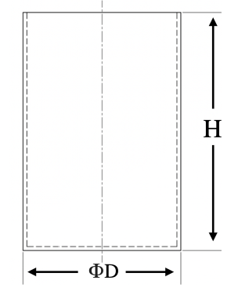

FIG. 1 GOBLET

**4.2** The wall thickness of the goblet shall be 1.0 mm respectively. The tolerances on the thickness shall be ± 0.l mm.

**5 MANUFACTURE AND FINISH**

The goblets shall be evenly and smoothly finished and shall be free from holes, pits, cracks, grooves and other defects. It shall be white colored for easy identification of stored semen.

**6 PACKING**

The goblets shall be packed as agreed to between the purchaser and the supplier.

**7 MARKING**

**7.1 BIS Certification Marking** — The product(s) conforming to the requirements of this standard may be certified as per the conformity assessment schemes under the provisions of the *Bureau of Indian Standards Act*, *2016* and the Rules and Regulations framed thereunder, and the products may be marked with the Standard Mark.

**7.2** Each goblet shall be marked with the following particulars:

a) Name of the material,

b) Batch or code number.

c) Indication of the source of manufacture,