**BUREAU OF INDIAN STANDARDS**

**(New Delhi)**

**AGENDA**

**Textiles Protective Clothing Sectional Committee, TXD 32 20th Meeting**

|  |  |  |
| --- | --- | --- |
| **Date/Day** | **Time** | **Venue** |
| 08 July 2024 | 1130 h | Through Video Conferencing |

**CHAIRMAN:** Dr. Arindam Basu, NITRA, Ghaziabad

**MEMBER SECRETARY:** Shri Mayur Katiyar

**Item 0 WELCOME AND INTRODUCTORY REMARKS BY THE CHAIRMAN**

**Item 1 CONFIRMATION OF THE MINUTES OF THE PREVIOUS MEETING**

**1.1** The minutes of the 19th meeting of the TXD 32 held on 21 May 2024 were circulated vide BIS DG letter No. TXD32/A2.19 dated 05 June 2024. No comments have been received.

## 1.1.1 The Committee may NOTE.

**Item 2 COMPOSITION OF TXD 32**

**2.1** The present composition and scope of TXD 32 is given in **Annex 1 (P-3 to 5).**

* + 1. The committee may **DECIDE**.

**2.2** As directed by DG, BIS the memberships of the organizations which did not attend last two sectional committee meetings was terminated. The list of all such organizations is given below.

|  |
| --- |
| 1. TUV Rhineland (India) Private Limited, Mumbai 2. JCT Limited, Hoshiarpur |

**2.2.1** The committee may **DECIDE**.

**Item 3 ISSUES ARISING OUT OF THE PREVIOUS MEETINGS**

**3.1** Summary of actions taken on the various decisions of the previous meetings are given in **Annex 2 (Page 6 to 7).**

**3.1.1** The committee may **NOTE.**

**Item 4 COMMENTS ON PUBLISHED STANDARDS**

**4.1** The comments received from the following organizations on IS 15768 : 2008 are given in **Annex 3 (P- 8 to 16).** The comments received from Shri Vikrant Gogoi, Custom house agent is given in **Annex 4** **(Attached separetly)**.

1. Damro Furnitures Pvt. Ltd., Chennai
2. Omega QMS Pvt Ltd., New Delhi
3. Godrej & Boyce Mfg. Co. Ltd., Mumbai
4. Nitori India Pvt Ltd., New Delhi
5. Shri Karthik

**4.1.1** The committee may DECIDE.

**4.2** It is informed that the definition of upholstered fabric is not provided in IS 15768 : 2008. A query pertaining to the definition of upholstery fabric was received from Ministry of Textiles. Furthermore, it is important to note that this standard also falls under the Protective Textiles (Quality Control) Order, 2022. In view of the above and considering urgency of the matter due to the standard being under QCO, it was proposed that the following definition of upholstered fabric may be suitably incorporated in the above-mentioned standard:

‘Upholstered Fabric — Upholstered fabric is defined as the textile fabric used for covering furniture such as sofas, chairs, ottomans, and other furniture items.

NOTES

**1** It may be made of cotton, wool, linen, silk, manufactured fibres or any other fibres and their blends.

**2** The weave of the fabric may be plain, twill, satin, etc.’

Accordingly, the above-mentioned definition was circulated to the members of TXD 32 sectional committee. The comments received on the above-mentioned definition are given in **Annex 5 (P- 17 to 18)**. Based on the comments received the proposed amendment has been prepared and given at **Annex 6 (P-19)**.

**4.2.1** The committee may **DECIDE**.

**Item 5 ANY OTHER BUSINESS**

**ANNEX 1**

**(Item 2.1)**

**COMPOSITION OF TEXTILE PROTECTIVE CLOTHING SECTIONAL COMMITTEE, TXD 32**

**SCOPE -** To formulate Indian Standards for testing and specification for textile protective clothing for protection from fire and other health/life hazards

|  |  |  |  |  |  |
| --- | --- | --- | --- | --- | --- |
| **Sl No.** | **NAME OF THE ORGANIZATION** | **REPRESENTED BY** | **MEETING ATTENDANCE** | | |
| **17th** | **18th** | **19th** |
|  | Northern India Textile Research Association, (NITRA)Ghaziabad | Dr. Arindam Basu (**CHAIRMAN)** | P | P | P |
|  | Aeronav Industrial Safety Appliances, Noida | Shri Sandeep Hora | P | P | P |
|  | Arvind Limited, Ahmedabad | Shri Narinder Thapa  Shri Pabitra Sahoo  Smt Palak Kakkar (Alternate) | P | A | P |
|  | Border Security Force, New Delhi | Shri Satish Chandra  Shri Tarun Ravi (Alternate) | A | A | A |
|  | Avient Protective Materials Limited, Pune | Shri Harsh Wardhan Sharma  Shri Rakesh Gaikwad (Alternate) | P | A | P |
|  | Central Industrial Security Force, New Delhi | Shri Anand Saxena  Shri Ravindra Kumar Meel (Alternate) | P | A | A |
|  | Central Reserve Police Force, New Delhi | Shri D.N Lal  Shri Sanjeev Kumar Singh (Alternate) | P | A | P |
|  | Centre for Fire and Explosive Environment Safety, Defence Institute of Fire Research, Delhi | Shri Mahipal Meena  Ms Anjlina Kerketta (Alternate) | A | P | P |
|  | Confederation of Indian Industry, New Delhi | Shri Saunak Banerjee | P | P | P |
|  | Defence Bio-Engineering and Electromedical Laboratory, Ministry of Defence, Bengaluru | Dr T M Kotresh  Shri Vinoth. P (Alternate) | A | A | A |
|  | Defence Institute of Physiology and Allied Science (DRDO), New Delhi | Dr. Madhusudan Pal  Shri Sunil Kumar Hota (Alternate) | P | A | A |
|  | Defence Materials and Stores Research and Development Establishment, Kanpur | Smt. Priyanka Katiyar  Smt. Shraddha Mishra (Alternate) | P | A | P |
|  | Defence Research and Development Organisation, Terminal Ballistics Research Laboratory, Chandigarh | Dr. Preeti Jain  Shri Sandeep Bagga (Alternate) | A | A | A |
|  | Department of Delhi Fire Services, Govt of NCT of Delhi, Delhi | Atul Garg  Shri Sanjay Tomar (Alternate) | A | A | A |
|  | Department of Jute and Fibre Technology, University of Kolkata, Kolkata | Dr Swapan Kumar Ghosh  Dr. Amiya Kumar Singha (Alternate) | P | A | P |
|  | Directorate General Fire Services, Civil Defence and Home Guards, Ministry of Home Affairs, New Delhi | Shri Prashant Longkar | A | A | P |
|  | Directorate General of Quality Assurance, Ministry of Defence, New Delhi | Shri Mahendra Singh  Shri P De (Alternate) | A | P | A |
|  | E.I. DuPont India Private Limited, Gurugram | Shri Manoj Jhaver  Smt. Mithali Chenggapa (Alternate) | P | P | P |
|  | Foremost Technico Private Limited, New Delhi | Shri Vinay Khanna  Shri Anoop Khanna (Alternate) | P | P | P |
|  | Indian Institute of Technology Delhi, New Delhi | Prof. Abhijit Majumdar  Dr Bipin Kumar (Alternate) | P | P | P |
|  | Indian Technical Textiles Association, Mumbai | Dr Anup Rakshit  Shri Sanjay Sathe (Alternate) | A | P | P |
|  | Indo Tibetan Border Police, New Delhi | Shri M Kumar  Shri Uttam Kumar (Alternate) | P | P | P |
|  | Kusumgar Corporates Private Limited, Vapi | Shri Sidhartha Kusumgar  Dr M K Talukdar (Alternate) | P | P | A |
|  | Mishra Dhatu Nigam Limited, Hyderabad | Col Ashwani Kumar | A | A | A |
|  | National Forensic Sciences University, Gandhinagar | Shri S K Khandelwal  Shri Saurabh Kumar (Alternate) | P | A | A |
|  | Northern India Textile Research Association, Ghaziabad | Dr M S Parmar  Smt Shweta Saxena (Alternate) | P | P | P |
|  | National Security Guard, New Delhi | Shri Manu Lochab | A | P | P |
|  | Office of the Textile Commissioner, Mumbai | Shri N. K. Singh  Shri Sanjay Charak (Alternate) | P | P | P |
|  | Oil Industry Safety Directorate, Noida | Shri Devendra M. Mahajan  Shri Harendra Yadav (Alternate) | A | P | A |
|  | Ordnance Clothing Factory, Shahjahanpur | Shri V Mathivanan  Shri Shanmugam B (Alternate) | P | P | P |
|  | SGS India Private Limited, Mumbai | Dr. Anitha Jeyaraj  Dr. Karthikeyan K (Alternate) | P | P | P |
|  | SMPP Private Limited, New Dehi | Shri Ashish Kansal  Dr. S. C. Kansal (Alternate) | P | P | A |
|  | Star Safety Hub, Faridabad | Shri Pawan Kumar Gupta  Shri Naveen Gupta (Alternate) | P | P | P |
|  | System 5S Private Limited, Chennai | Shri Sudhir Takkar  Smt. Bhavna Sr. Takkar (Alternate) | P | P | P |
|  | Teijin India Private Limited, Gurugram | Shri Ravi Kumar  Shri Sahil Aneja (Alternate) | P | P | A |
|  | Tex Corporation Limited, Gurugram | Shri Vijay Toley  Shri Sanjay Aggarwal (Alternate) | A | A | P |
|  | Textiles Committee, Mumbai | Shri Kartikay Dhanda  Smt Shilpi Chauhan (Alternate) | P | P | A |
|  | The Synthetic and Art Silk Mills Research Association, Mumbai | Dr. Manisha Mathur  Smt. Ashwini Sudam (Alternate) | A | A | A |

**ANNEX 2**

**(Item 2.2)**

**SUMMARY OF ACTIONS TAKEN ON THE MINUTES OF THE**

**LAST MEETINGS OF TXD 32**

|  |  |  |
| --- | --- | --- |
| **ITEM NO.** | **DESCRIPTION OF ACTION REQUIRED** | **ACTION TAKEN** |
| **2.1 & 2.2** | **SCOPE AND COMPOSITION OF TXD 32** | Updated composition is given in **Annex 1** |
| **4.1** | The committee decided to finalize the following standards:   1. [Doc: TXD/32/24728] ISO 16073-3:2019 Wildland firefighting personal protective equipment Requirements and test methods part 3: Clothing 2. [Doc: TXD/32/24727] ISO 16073-4 : 2019 Wildland firefighting personal protective equipment Requirements and test methods Part 4: Gloves 3. [Doc: TXD/32/24726] ISO 23616 : 2022 Cleaning Inspection and Repair of Firefighters Personal Protective Equipment PPE | Under publication |
| **5.1** | The committee decided to wide circulate the draft revision of IS 16890 for protective clothing for firefighters. | Issued under Wide Circulation |
| **6.2** | The committee decided to finalize the amendment to IS 15748 : 2008 for Clothing to protect against heat and flame | Under publication |
| **6.3** | The committee decided to finalize the amendment to IS 15809 : 2017 on High Visibility Warning Clothing | Under publication |
| **7.3** | The committee decided to wide circulate the draft for Fire resistant fabric made of Cotton, Man-made fibres/filaments and their blends | Under wide circulation |
| **8.1** | The committee decided to reaffirm the following standards for a period of 5 years.  IS 17286 : 2019 Textiles – Water-proof multipurpose rain poncho with convertibility as bivouac – Specification  IS 17291 : 2019 Textiles – Flame retardant jute based decorative and cover fabric for temporary structure – Specification | Reaffirmed |
| **10.1** | The committee decided to finalize the amendment to IS 16655 : 2017 for Clothing for use in Welding and Allied Process | Under publication |

**Annex 3**

**(Item 4.1)**

**COMMENTS RECEIVED ON IS 15768 : 2008**

1. **Damro Furnitures Pvt. Ltd., Chennai**

**Sub: Clarification on import of upholstered furniture — IS 15768:2008 — Reg.**

Dear Sir/Madam,

We are writing to seek clarification regarding the necessity of Bureau of Indian Standards (BIS) certification for the import of upholstered furniture from Sri Lanka into India.

As a company importing upholstered furniture from Sri Lanka, we have encountered uncertainty regarding the requirement for BIS certification. While there is no explicitly prescribed BIS standard for upholstered furniture, we note the existence of standards for upholstered composites used in non-domestic furniture under the "Protective Textiles (Quality Control) Order 2022," issued by the Ministry of Textiles on April 10, 2023.

We are concerned about the lack of clarity in the definition of "Non-Domestic Furniture" mentioned in the order. Our imported furniture from Sri Lanka and we need to know if our products fall under this order and require BIS certification.

Furthermore, we have observed that customs authorities interpret the "Protective Textiles (Quality Control) Order 2022" broadly, imposing BIS certification requirements on all imported upholstered furniture, regardless of their intended residential or non-residential use.

In light of these circumstances, we kindly request clarification on the following points:

1. Is BIS certification mandatory for the import of **upholstered furniture** into India? If so, we seek the relevant Gazette Notification, including the reference number and date of issuance.

2. Could you provide clarification on the definition of "Non-Domestic Furniture" as per the "Protective Textiles (Quality Control) Order 2022"?

3. Has the "Furniture (Quality Control) Order 2023" been published in the Government Gazette? If affirmative, we request a copy of the same or details regarding the Gazette S.O. number and date of publication.

Clarity on these matters will greatly assist us in ensuring compliance with regulatory requirements and facilitating smooth import operations.

We appreciate your prompt attention and look forward to your response. Thank you for being so cooperative.

Yours faithfully

For Damro Furniture Private Limited

1. **Omega QMS Pvt Ltd., New Delhi**

**Subject** : Inquiry Regarding Coverage of Mesh Used in Office Chairs under BIS Standard IS 15768

Dear Sir,

I hope this message finds you well. I am writing to seek clarification regarding the applicability of BIS standard IS 15768 (Textiles - Resistance to Ignition of Upholstered Composites used for Non-Domestic Furniture) to a specific product we manufacture.

**Product Details:**

**Product Name**: Mesh (used for office chairs)

**Product Style**: Cloth

**Material Composition**: 55% TPEE (Thermoplastic Polyester Elastomer) and 45% Polyester Knitted Fabric

**Usage/Application**: This mesh fabric is utilized for office chairs, particularly for the seats and backrests.

We would like to confirm whether this type of mesh fabric falls under the scope of IS 15768. Understanding this is crucial for ensuring that our products comply with all necessary safety standards.

Attached Documents:

**Shipping Photos**: Photos of the mesh fabric as shipped are attached for your reference.

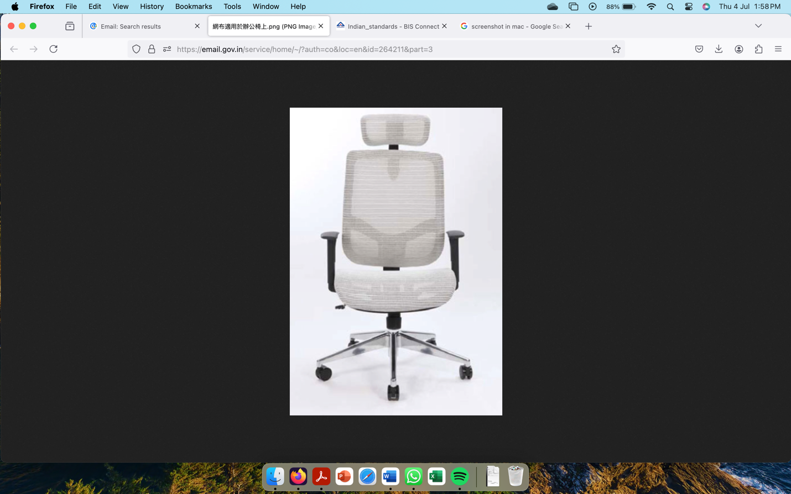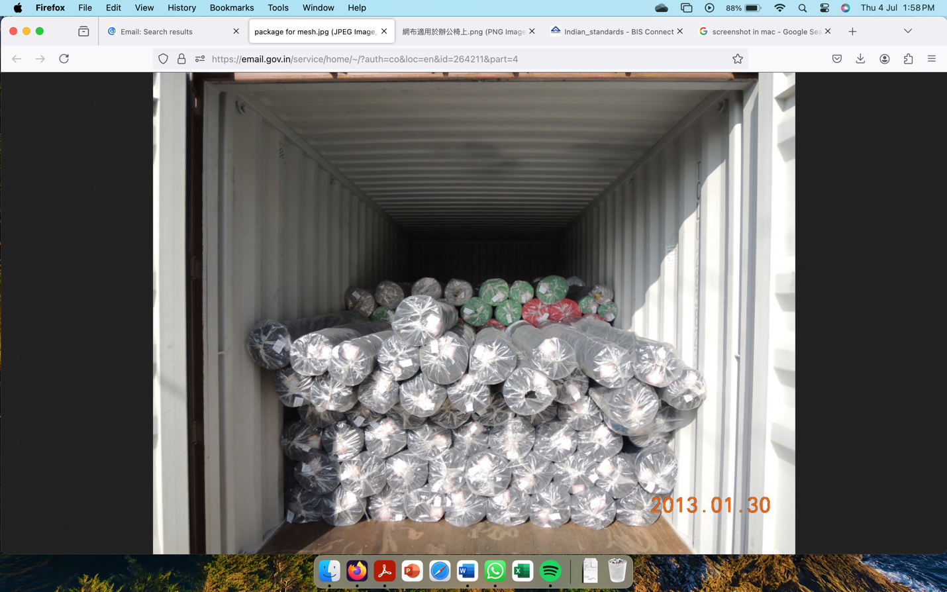

**Material Certificate**: A certificate detailing the material composition.

1. **Intertek**

Applicant:: Ynh Sheng Weaving Co.

No.6, Lucao Rd., Lukang Township,

Changhua Country 505,

Talwan, R.O.C

Sample Description:

One(1) piece of submitted sample said to be 55% TPEE 45% Polyester knitted fabric, in Black.

Applicant’s Provided Care Instructions/Label:-

Date Received/ Date Test Started: Sep 23, 2023

Standard : -

Style/Article No. : -

Order No. : -

Mill : -

Buyer’s Name : -

Agent’s Name : -

Brand Name : -

Ref. : PM01A (PM11A, H138LS)

Authorized By:

On behalf of Intertek Testing Services

Taiwan Limited

Anna Jing

**Test Report**

Test conducted (As Requested By The applicant)

1 Flammability Test (California Technical Bulletin 117-2013 Section1: cover Fabric Test):

Test Method

The apparatus and method of testing were those described in California technical bulletin 117-2013, Section 1, for measuring the tendency of upholstery cover fabrics to smolder and contribute to fire propagation, when subjected to a smoldering ignition source.

Pass/Fail Criteria

A cover fabric material is considered pass or fail based on following criteria:

1. A single mock-up test specimen fails to meet the requirement of this test procedure if any of the following criteria occurs:
2. The mock-up test specimen continues to smolder after the 45 minutes test duration.
3. A vertical char length (measured as specified in step 11,9 of ASTM E1353-08a E1 ) of more than 1,8 inches (45mm) develops on the cover fabric.
4. The mock-up test specimen transitions to open flaming.
5. The cover fabric passes the test if three initial mock-up specimens pass the test, i.e. the cigarettes burn their full length and the mock-ups are no longer smoldering.
6. If more than one initial specimen fails, the cover fabric falls the test.
7. If any one of the three initial specimens falls, repeat the test on additional three specimens.
8. If all three additional specimens pass the test, the cover fabric passes the test. If any one of the additional three specimens fails, the cover fabric falls the test.

Test Result

|  |  |  |  |  |
| --- | --- | --- | --- | --- |
| Initial Test | | | | |
|  | Vertical Char length (Inches) | Mock-up specimen continues to smolder After 45 Minutes | Mock-up test specimen transitions to open flaming | Test Result |
| Specimen 1 | 0.7 | No | No | Pass |
| Specimen 2 | 0.8 | No | No | Pass |
| Specimen 3 | 0.8 | No | No | Pass |
| Condition; At least 24 hours in and atmosphere having a temperature of 21˚ ± 3˚ C (70˚ ± 5˚ F) and less than 55% relative humidity.  Remarks : No= Was not observed | | | | |

**MSDS Report**: The Material Safety Data Sheet (MSDS) provided by SGS.

Could you please provide us with guidance on whether our product is covered under the BIS standard IS 15768? Your assistance in this matter will be greatly appreciated.

Thank you for your time and consideration. We look forward to your response.

Best regards

Abdhesh Kumar

1. **Godrej & Boyce Mfg. Co. Ltd., Mumbai**

**Subject** : Clarification on IS 15768:2008 / S.O. 1070 (E) / Upholstered composites used for non-domestic furniture.

Dear Mr. Katiyar Sir,

W.r.t. QCO 1707 (E) issued on 10th April 2023 and clarification letter issued on 5th April 2024, we requested you to provide further clarification on following points mentioned in attached request letter.

1. Definition of Upholstered Composites/Fabric

2. Is IS-15768:2008 applicable for fabric (roll form or Stitched form)?

3. If IS-15768:2008 applicable for fabric in rolls then how to fix permanent stickers. As fabric can be further processed into covers or upholstery furniture.

4. Is standard applicable on structural mesh fabric (Polyester + Polyamide) which is not manufactured in India ?? (Refer to the attached regret letters from Indian fabric manufacturer).

5. Is IS-15768:2008 applicable for finished products like Office Chairs? As custom still asking for BIS certification for office chairs.

We request your valuable time to provide clarity on scope of QCO.

Thanks & Regards,

Mr Prashant Phapale

Assistant General Manager, Corporate Procurement

1. **GEOTEX WEAVES INDIA PRIVATE LIMITED**

Dear Godrej Interio Team,

This is regarding below mesh fabric samples sent to us for development.

1. Fabric Ply Mesh Wintex AIA Grey

2. Fabric Ply Mesh Wintex AIA 64" Black

Godrej Specification sheet number INT/DSN/MSS/UPH/085 Thank you for giving us this new business opportunity.

We have gone through the mesh fabric samples, above Product Specification, Yarn used and aesthetics part of the fabric.

Following are primary major observations:

1. These mesh fabrics requires multiple type of yarns and some of the yarns seems to be imported and not available indigenously.

2. We cannot produce these fabrics with yarns, which are available indigenously.

3. We are in fabric production business since last 6 decades and we have all machinery setup required for producing various fabrics. Even then, with our current setup we are sorry to inform you that we cannot produce these fabrics on the machinery setup we currently have.

4. The processing of the fabric is quite different from what we normally are doing for most of our customers.

With so many issues, we regret to convey that we would not be able to match the desired specifications and look and feel of the fabric.

We are thankful for the interest shown in us.

Thanks & regards

For Geotex Weaves India Pvt. Ltd

Director

Yogesh Gupta

1. **Response India Pvt Ltd.**

Dear Godrej HO Team,

Refer below update on development of these mesh fabrics. Specification sheet number provided to us is INT/DSN/MSS/UPH/085. Fabric names are as below.

1. Fabric Ply Mesh Wintex AIA Grey

2. Fabric Ply Mesh Wintex AIA 64" Black

Please note below points.

We don’t have required machinery available at our end for producing these fabrics. Yarns used in these mesh fabrics is also different than yarns available locally. We are unable to find any supplier for these yarns and as per yarn suppliers these yarns are imported. Mesh pattern and structure also very complicated and we don’t have expertise in this kind of production.

Due to above reasons we regret to inform you that we won’t be able to develop these mesh fabrics at our end. If you have any other fabrics requirements do send us for development.

We are obliged and thankful for belief shown in us.

Thanks &regards,

Anuj Agrawal

Director

Response Fabrics Pvt Ltd.

1. **Government of India, Ministry of Textiles**

To,

(i) The Commissioner of Customs, Chennai

(ii) The Customs Commissioner, Mumbai

**Subject: Upholstered Composites used for non-domestic furniture - BIS standard 15768:2008 - Applicability on imported upholstered furniture clarification – reg.**

Sir/Madam,

The undersigned is directed to refer to letter no. CUS/APR/BE/MISC/454/2024-GR6 dated 01.03.2024 received from the O/o Commissioner of Customs, Chennai-II (Imports) and Letter No. Gen/MISC/52/2020-GR-6 dated 12.03.2024 received from O/o The Commissioner of Customs (Import-I), Mumbai on the subject cited above and to convey that BIS standard 15768 : 2008 covered under Protective Textiles (Quality Control) order, 2023 is applicable to upholstered composites/fabric traded as raw material as well as on the upholstered fabric used in furniture meant for non-domestic purpose. This decision is based on the scope definition of the standard and |Sectoin 17 of BIS |Act, 2026, which mandates adherence to relevant standards for manufacturing, importing, distributing, selling, etc., of goods.

2. In this regard, the copy of the BIS Standard IS 15768 : 2008 and its amendment is attached with this letter, for ready reference.

3. This issues with the approval of the Competent Authority.

Yours faithfully

Ria Sinha

1. **Shri Karthik**

**Subject**: Clarification and corrections in the QCO 15768

Hi Team,

I have query regarding the QCO IS 15768:3S 15768 : 2008 Upholstered composites used for non-domestic furniture.

The QCO calls out upholstered composite used for Non domestic furniture, however the are no reference to the same in the standard. However there are reference to Industrial and non Industrial occupancies.

Hence request to revise the QCO title to Industrial (Non Domestic) as below.

15768:3S 15768 : 2008 Upholstered composites used for Industrial furniture.

Best regards

Karthik

1. **Nitori India Pvt Ltd., New Delhi**

**Subject**: BIS Support required for a Japanese Investor Nitori- Reg.

Dear Sir / Madam,

Greetings from Invest India!

A Japanese home furnishings company is looking to enter India and have raised a few questions regarding BIS standards for a few products they intend to sell in India. More context is as tabulated below:

Context on Nitori:

Company has requested clarification on two Indian Standards for products they plan to sell

in India. Further details are tabulated below:

|  |  |  |
| --- | --- | --- |
| **Brief on the company**  Nitori Co., Ltd is a Japanese furniture and home accessories retail company. It is the largest furniture and home furnishing chain in Japan. Founded in Sapporo in 1967 by the company's current President Akio Nitori. Nitori currently has more than 700 stores in Japan and more than 70 stores in China, more than 50 stores in Taiwan, Singapore, Malaysia, the Philippines, Thailand, and South Korea. | | |
| **Plan**  The company is looking to set up presence in India for retail of furniture and home goods in India, and has incorporated an India entity, Nitori India Private Limited. | | |
| **Query Detail** | **Question** | |
| 1. Company plans to sell **double zipper freezer bags.**  Company needs clarification regarding applicability of Indian Standard 17569: 2001 “Insulated Containers for Food Storage – Specification” on “Freezer Bag – Double Zipper” (HSN 39241099) | Q1: Company would like to understand if the  zipper bags for the purpose of storing cold and  hot items are subject to the standard mentioned.  [ **Item Description and image ATTACHED**] | |
| 1. Company plans to sell **chairs and sofas** for general consumers and homes.  Company believes the following Indian Standard would be applicable to their products:-  IS. 15768:2008 " Resistance to Ignition of Upholstered Composites Used for Non –Domestic Furniture ". (HSN 94016100 | Q1: Is the standard applicable to the company  given that it plans to retail “chairs and sofas” for general consumers?  Q2: Given the standard reads "NON-DOMESTIC", does it imply it is not applicable to products intended for home use only?  Q3: If the standard does not apply, should the  label indicate “FOR DOMESTIC ONLY" on the label to express the point correctly ? | |
| Product Code | 25000 |
| Product Type | N/A |
| Size (cm) | N/A |
| Net Qty | N/A |
| Country of Origin | N/A |
| Importer/Marketer: NIT or INDIA Limited  Address: Room No. 304, 3rd floor, DLF South Court, Saket, New Delhi-110017, India  E-mail: Brand Name:NITORI Co. Ltd  Date of Manufacture: 2024/05/27 | |
|  |  |

Requesting if these standards queries could be addressed by your office. Looking forward to your response.

regards,

Lav Bhardwaj

Assistant Vice President

Central Government Team

**Annex 5**

**(Item 4.2)**

**COMMENTS RECEIVED ON THE PROPOSED DEFINITION**

1. **Comment from M/s IIT, Delhi**

I agree. The definition looks fine to me.

1. **Comments received from M/s Ordinance clothing Factory**

The definition is appropriate, the same may be incorporated in the standard.

1. **Comments received from M/s NITRA, Ghaziabad**

In my opinion, the definition given by you is appropriate.

1. **Comments received from M/s Tex Corporation**

The definition as stated by you is appropriate and we agree that it be incorporated in the

standard under reference.

1. **Comments received from M/s SASMIRA**
2. With reference to the trailing mail, we hereby confirm the given definition.
3. As per the Amendment No. 1,July 2014 for IS 15768, the scope reads as follows.

1. SCOPE This standard specifies requirements for the resistance to ignition

of upholstery fabrics used for non-domestic furniture.’

Hence the definition may be given for upholstery fabrics instead of upholstered fabric.

Upholstery fabrics is a fabric or textiles used for covering furniture such as sofas, chairs, ottomans, and other furniture items. Notes mentioned are sufficiently described.

1. **Comments received from M/s E.I. DuPont India Private Limited, Gurugram**

Thanks for reaching out to clarify the definition of the upholstery fabric.

Upholstery fabric is a fabric used to upholster an article not limited to furniture but also cover seats/ beds of ships, automobiles, railways, planes; even walls and dividers panels etc. Purpose of

using a upholstery fabric can be aesthetic as well as functional. This could be a fair definition of a upholstery fabric.

The document IS 15768, lays down the scope for the articles that will be covered under standard - upholstered composites used for nondomestic furniture. It means that the testing has to be done on the composite and not on the top fabric layer only. At times, the foam used under the top layer generated more smoke and create difficult situation during a fire incident.

Trust it is helpful. Thanks

**Annex 6**

**(Item 4.2)**

**DRAFT AMENDMENT TO IS 15768 : 2008**

(*Page* 1, *Clause* 3.3) — Insert the following clause after clause 3.3 and renumber the subsequent clauses:

‘**3.4 Non-Domestic Furniture** — Non-domestic furniture refers to the furniture to be used in public places like offices, malls, airports, restaurants, underground shopping complexes, museums, hospitals, place of worships, educational institutions etc’

(*Page* 1, *Clause* 3.5) — Substitute the following for existing:

‘**3.5** **Upholstery Fabric** — Upholstery fabric is defined as the textile fabric used for covering furniture such as sofas, chairs, ottomans, and other furniture items.

NOTES

**1** It may be made of cotton, wool, linen, silk, manufactured fibres or any other fibres and their blends.

**2** The weave of the fabric may be plain, twill, satin, etc.’