#### AMENDMENT NO.1 OCTOBER 2008

TO

#### IS 12169 :1987 CRITERIA FOR DESIGN OF SMALL EMBANKMENT DAMS

*(Page* 9, *clause* 4.1.4) - Substitute “IS 4999: 1991” *for* 'IS 4999: 1968*'.

*(Page* 9, *footnote marked* •) - Substitute the following for the existing

footnote:

'Recommendation for grouping of previous soils *(first revision*).'

*(Page* 11, *clause* 4.8) -Substitute 'IS *5050:* 1992§'*for* 'IS *5050:* 1968§'.

*(Page* 11, *footnote marked* §) - Substitute the following for the existing

footnote:

'Code of practice for design, Construction and maintenance of relief walls *(first revision).* •

*(Page* 12, *clause* 5.1 .1) - Substitute 'IS 10635: 1993*' *for* 'IS 10635: 1983*'.

*(Page* 12, *footnote marked* •) - Substitute the following for the existing

footnote:

'Freeboard requirements in embankment dams -guidelines *(first revision*).'

*(Page* 18, *clause* 7. .2.1) -Insert the following sentence at the end:

'After assessment of geo-technical parameters of flyash and based on techno­ economic considerations, flyash conforming to IS 3812: 1981 may be used in the random zones on downstream of inclined filter in a zoned dam.'

Draft Revision-December 2023  **IS:12169-1987**

(Reaffirmed 1997)

(Reaffirmed 2013)

*Indian Standard* (Reaffirmed 2020)

CRITER IA FOR

DESIG N OF SMALL EMBANKM ENT DAMS

(First Reprint February 1999)

UDC 627.81: 624.136: 624.31

© *Copyright* 1988

B U R E A U OF I N D I A N S T A N D A R D S

MANAK BHAVAN, 9 BAHADUR SHAH ZAFAR MARG

NEW DELHI 110002

Draft Revision-December 2023  **IS:12169-1987**

*Indian Standard*

CRITE R IA FOR

DESIGN OF SMALL EMBANKMENT DAMS

1. FO R EW O R D (to be modified)
2. This Indian Standard was adopted by the Bureau of Indian Standards on 24 August 1987, after the draft finalized by the Dams (Overflow and Non-overflow) Sectional Committee had been approved by the Civil Engineering Division Council.
3. A fairly large number of small embankment dams are being built all over the country. These are generally designed locally and central design facilities are not made use of. In designing, a small embankment dam many of the provisions specified in IS: 8826-1978• arc required to be modified or relaxed. It was, therefore, felt that a separate standard should be prepared for guiding the design of small embankment dams.
4. For the purpose of deciding whether a particular requirement of this standard is complied with, the final value, observed or calculated, expressing the result of a test or analysis, shall be rounded off in accordance with IS: 2-1960*. The number of significant places retained in the rounded off value should be the same as that of the specified value in this standard.
5. **SCOPE**
   1. This standard lays down guidelines for design of small embankment dams.
6. **TERMINOLOGY**
   1. For the purpose of this standard, the following definition in addition to those given in IS: 8826-1978 shall apply.
   2. Embankment Dam -A dam composed of any type of soil including rock.
   3. Homogeneous Embankment Dam -An embankment dam composed of single type of material.
   4. Large Dam -~~A dam exceeding 15 m in height above deepest river bed level and a dam between 10 and 15 m height provided volume of earthwork exceeds 0·75 million m3 and storage exceeds l million m3 or the maximum flood discharge exceeds 2000 Cumecs.~~

(*i*) A dam above 15 meters in height, measured from the lowest portion of the

general foundation area to the top of dam; or

(*ii*) between 10 meters to 15 meters in height and satisfies at least

one of the following, namely: —

(*A*) the length of crest is not less than 500 meters; or

(*B*) the capacity of the reservoir formed by the dam is not less than

one million cubic meters; or

(*C*) the maximum flood discharge dealt with by the dam is not less

than two thousand cubic meters per second; or

(*D*) the dam has especially difficult foundation problems; or

(*E*) the dam is of unusual design;

* + 1. *Modified Homogeneous Embankment Dam* -An embankment dam in which small quantities of pervious material, selected to control the action of seepage, are carefully placed in an otherwise homogeneous dam (see Fig. 1).
  1. Rockfill Dam - An embankment dam consisting of ~~various~~ variable sizes of rock to provide stability and an impervious core or membrane to provide water· tightness.
     1. *Earth Core Type Rockfill Dam* - A rockfill dam composed of an internal core of rolled earthfill supported *by* shells of dumped/compacted rockfill on either side of the core. The core may be vertical or sloping upstream.
     2. *Rockfill Dam with Upstream Membrane* - A dam composed of loose rock usually dumped/compacted in place, with an upstream impervious membrane of concrete or asphaltic concrete. or a geo-membrane.
  2. Small Dam -A dam not satisfying the criteria of a large dam (See 2.3).
  3. Zoned Embankment Dam -An embankment dam composed of zones of different types of soil (see Fig. 2A and 2B).

1. **COMPONENTS OF EMBAKMENT DAM**
   1. An embankment dam generally consists of the following components (Fig. 2A, ~~and~~ 2B, 2C and 2D).
2. Cut-off;
3. Core or membrane
4. Casing;
5. Internal drainage system and foundations;
6. Slope protection; and
7. Surface drainage.
   1. The following component are provided in special cases:
      1. Impervious blanket; and
      2. Relief well.
8. **FOUNDATION AND DESIGN REQUIREMENTS**
   1. The functions and design requirement of the components are described in 4.1 to 4.8.
   2. **Cut-off**

**A barrier to reduce seepage of water through foundation and abutments.**

* + 1. The cut-off is required for the following functions:

1. To reduce loss of stored water through foundations and abutments;
2. To prevent subsurface erosion by piping.

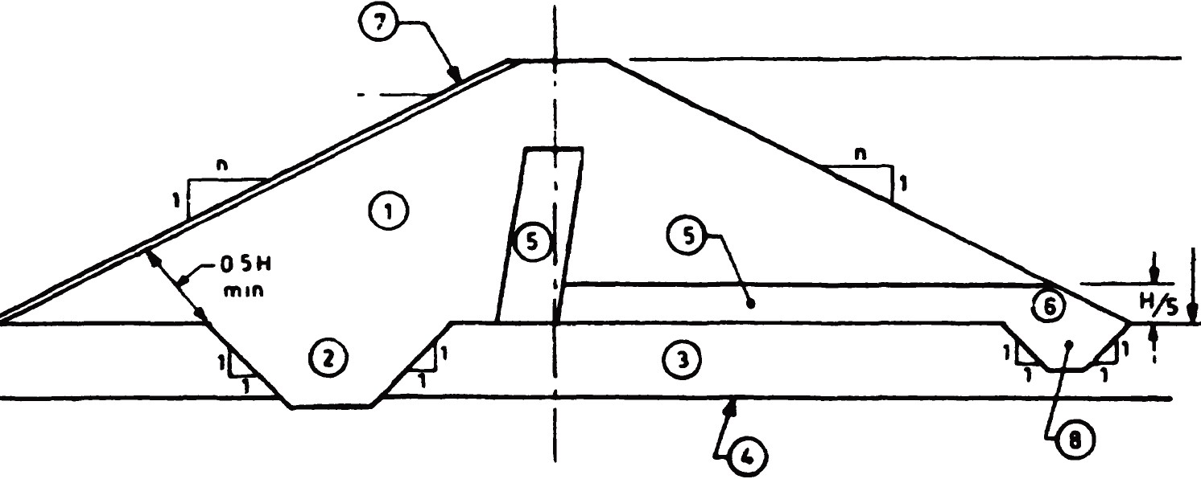

**FRL**

**H**

|  |  |
| --- | --- |
| 1. Selected Earth Fill 2. Impervious Fill 3. Foundation 4. Impervious sub stratum | 1. Sand Filter 2. Rock Toe 3. Rubble Pitching 4. Tee Drain |

FIG. 1 CROSS-SECTION OF MODIFIED HOMOGENEOUS EARTH DAM

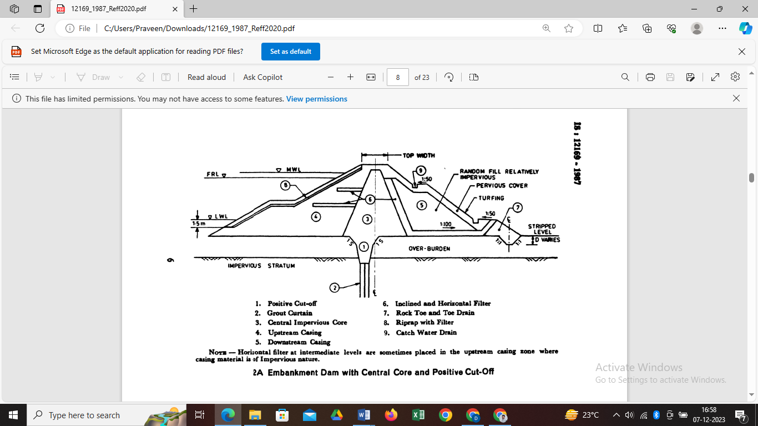

|  |  |
| --- | --- |
| 1. Positive Cut-off 2. Grout Curtain 3. Central Impervious Core 4. Upstream Casing 5. Downstream Casing | 1. Inclined and Horizontal Filter 2. Rock Toe and Toe Drain 3. Riprap with Filter 4. Catch Water Drain |
| NOTES –Horizontal filter at intermediate levels are sometimes placed in the upstream casing zone where casing material is of Impervious nature. | |
| 2A Embankment Dam with Central Core and Positive Cut-Off | |

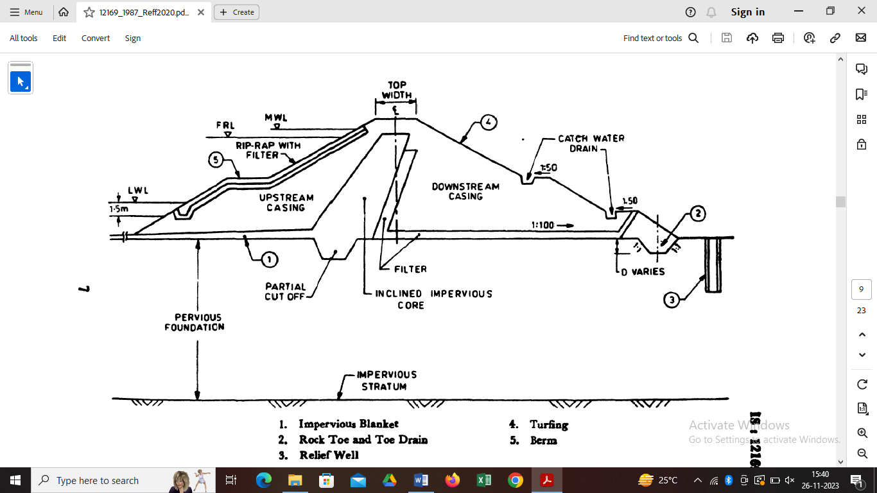

1. Impervious Blanket 4. Turfing
2. Rock Toe and Toe Drain 5. Berm
3. Relief Well

2B Embankment Dam with Inclined Core and Partial Cut-Off

Fig. 2 COMPONENTS OF EMBANKMENT DAM

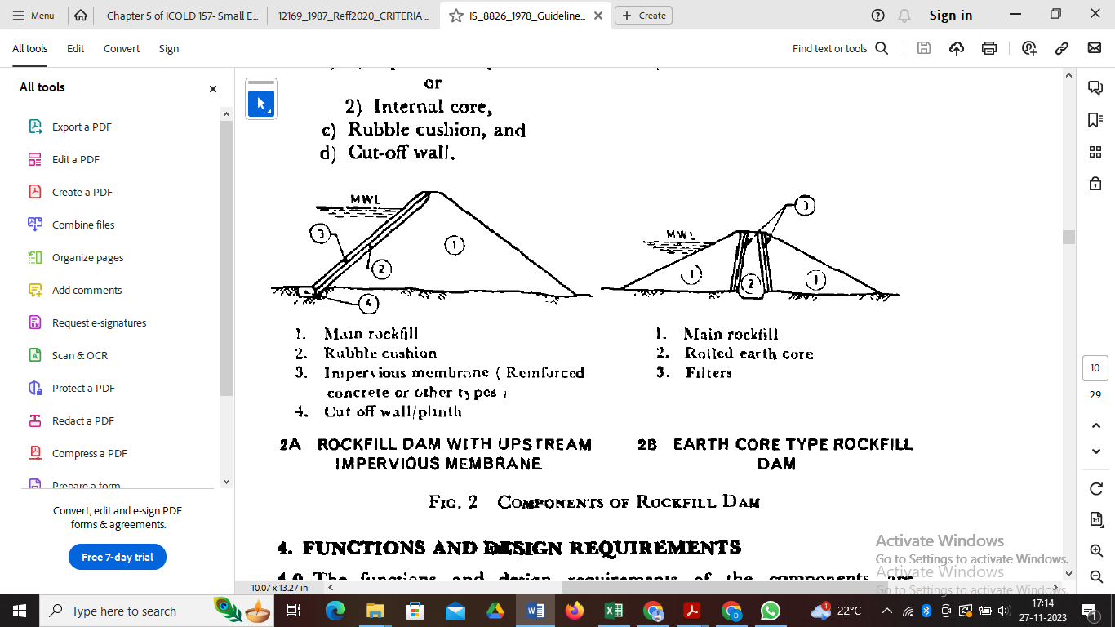

1. Main Rockfill
2. Rubble Cushion
3. Impervious Membrane (Reinforced concrete or other types)
4. Cut off wall/plinth

1. Main Rockfill

2. Rolled Earth Core

3. Filters

2A ROCKFILL DAM WITH UPSTREAM

2B EARTHCORE TYPE ROCKFILL DAM

IMPERVIOUS MEMBRANE

##### Introduce Fig regarding rockfill dam with upstream impervious membrane and Earth core type rockfill dam as given in IS 8826.

* + 1. The type of cut-off should be decided on the basis of detailed geological investigation. It is desirable to provide a positive cut-off. Where this is not possible, partial cut-off with or without upstream impervious blanket may be provided. In any case, adequate drainage arrangements may be provided on the downstream which may, inter-alia, include relief well. Cut-off may be in the form of trench, sheet piling, ~~cement bound curation~~, grout curtain, diaphragm of bentonite, concrete or other impervious materials. IS 8414- 2014 provides Guidelines for Design of Under- Seepage Control Measures for Earth and Rockfill Dams.
    2. Recommendations for location and size of cut-off are given in **4.1.3.1** to **4.1.3.6**. A drainage cut-off is the most common form of cut-off.
       1. The alignment of the cut-off should be fixed in such a way that its central line should be within the base of the impervious core. In case of upstream membrane facing (concrete, asphalt, or geomembrane) as impervious element, the cut-off shall be provided at the upstream end of embankment dam.
       2. In case of positive· cut-off, it should be keyed at least to a depth of 0·4 m into continuous impervious sub-stratum or inerodible rock formation.
       3. The partial cut-off is specially suited for horizontally stratified foundations with relatively more pervious layer near top. The depth of the partial cut-off in deep pervious alluvium will be governed by:

1. Permeability of substrata; and
2. Relative economics of depth of excavation governed usually by cost of dewatering versus length of upstream impervious blanket.
   * + 1. The bottom width of the cut-off trench may be fixed taking following factors into consideration:
3. Provide sufficient working space for compaction equipments;
4. Provide sufficient working space to carry-out curtain grouting; and
5. Provide safety against piping.

A minimum width of 4·0 m is recommended. A bottom width of 10 to 30 percent of hydraulic head may be provided to satisfy requirement of piping. This may be suitably increase to satisfy other requirements of mechanical equipments and curtain grouting. The side slopes depend upon sub-strata. Side slopes of at least 1:1 or flatter may be provided in case of overburden, while ½:1 and ¼:1 may be provided in soft rock and hard rock respectively. The back fill material for cut-off trench shall have same properties as those specified for impervious core in 4.2.1.

* + - 1. The cut-off in the flanks on either side should normally extend up to the top of impervious core.
      2. At the abutment contacts or the cut-off trench, care should be taken to avoid seepage by outflanking.
    1. Necessity of grouting below the bed of cut-off trench will arise if the cut-off trench is terminated in rock formation and the rock is weathe­ red or having cracks, joints and crevices. Necessity of grouting may be decided based on percolation tests. Rock having a lugeon value or more than 10 should be grouted so as to bring post-grouting lugeon value of about 5. The depth or grouting does not normally exceed half the head of water at the level from which grouting is done. The necessity of grouting below the bed in case of partial cut-off trench will be governed by the cost and effectiveness of the grout curtain vis-a-vis the value of water loss through seepage below and beyond the partial cut-off trench If grouting is done, provisions of IS: 4999-1991 may be followed. Alluvial strata having permeability in excess of 10-2 cm/s shall be treated thoroughly by grouting with a suitable material. Strata of permeability between 10-2 cm/s and 10-3 cm/s may be treated to reduce the permeability to the extent possible. The grouting of strata having permeability less than 10-3 cm/s will be difficult, expensive and time consuming.
  1. **Core**
     1. The core provides impermeable barrier within the body of the dam. Impervious soils are generally suitable for the core. IS: 1498-1970 may be referred to for suitability of soils for the core. Appendix A gives recommendations based on IS: 1498-1970. However, soils having high compressibility and liquid limit and having organic content may be avoided, if possible, as they are prone to swelling and formation of cracks.
     2. The core may be located either centrally or inclined upstream. The locations will depend mainly on the availability of materials, topography of site, foundation conditions, diversion considerations, etc. The main advantage of a central core is that it provides higher pressure at the contact between the core and the foundation reducing the possibility of leakage and piping. On the other hand, inclined core reduces the pore pressure in the downstream part of the dam and thereby increases its safety. It also permits the construction of downstream casing ahead of the core. The section with an inclined core allows the use of relatively large volume of random material on the downstream side.
     3. The following practical considerations govern the thickness of the core:

1. Availability of suitable impervious material;
2. Resistance to piping;
3. Permissible seepage through dam;
4. Availability of other materials for casing, filter, etc.; and
5. Minimum width that will permit proper construction.

The minimum top width of the core should be 3 m. Its thickness at any section shall not be lesser than 30 percent (preferably not lesser than 50 percent) of maximum head of water acting at that section.

* + 1. The top level of the core should be fixed at 0·5 m above MWL.
  1. **Casing**
     1. The function of casing is to impart stability and protect the core. The relatively pervious materials, which are not subject to cracking on direct exposure to the atmosphere, are suitable for casing. IS :1498-l970* may be referred to for suitability of soils for casing. Appendix A gives recommendations based on IS: 1498-1970*.
  2. **Internal Drainage System**
     1. Internal drainage system comprises an inclined or vertical filter, a horizontal filter, a rock toe, a toe drain, etc. For the design of the components of the internal drainage system IS: 9429-1980 may be referred to. As far as possible locally available sands, gravels, etc, should be used.
     2. The design of filter consists of applying the conventional filter criteria which take into account only the grain size distribution and the shape of the grains. However, in addition to the grain size, the stability of the base soil adjacent to a given filter depends on its resistance to drag forces.

In view of this, when the soil containing 20 percent or more clay is used as a base soil and has non-dispersive properties, the filter criteria may not be enforced strictly and the clean sand available locally may be used irrespective of the gradation. This relaxation should be applied to dams up to 10 m height only. For dams of height more than 10 m, the criteria for filters protecting cohesive soil may be relaxed by the designer depending upon his judgement and experience.

* + 1. Inclined or vertical filter together with the base filter, if required, is desirable to be provided especially to protect silty core material. How­ ever, the inclined or vertical filter may be deleted in zoned sections having pervious downstream shell and clayey cores but a transition filter between the core and the downstream shell would be necessary in case of dams where rockfill is used as shell material. In case of dam reaches, where the head of water is 3 m or less, it may not be necessary to provide blanket or chimney filters. Adequate toe protection shall, however, be provided.
    2. Wherever there is silty material to be filled in the cut-off and the downstream face of the cut-off is sufficiently open to receive soil particles migrating under high seepage gradients, it is advisable to provide a protective filter layer along the downstream face of the cut off' trench also.
  1. **Slope Protection**
     1. *Upstream Slope.* - The upstream slope protection is ensured by providing riprap. For design of the riprap, IS: 8237-1985* may be referred. A minimum of 300 mm thick riprap over 150 mm thick filter layer may be provided.
     2. *Downstream Slope -*The downstream slope protection is ensured by providing riprap or turfing. It is usual practice to protect the down­ stream slope from rain cuts by providing suitable turfing on the entire slope. For details of downstream slope protection, IS: 8237-1985• may be referred.

In view of climate change induced scenarios being experienced frequently, and reported cases of failure of embankment dams due to overtopping, serious consideration may be given to provide well designed overtopping protection to the downstream slope of the dam to sustain overtopping or overflowing in case of unforeseen situations.

* 1. **Surface Drainage-** For surface drainage of the downstream slope of the dam, reference may be made to IS: 8237-1985•.
  2. **Impervious Blanket**
     1. The horizontal upstream impervious blanket is provided to increase the path of seepage when full cut-off' is not practicable on pervious foundations. The impervious blanket may be provided either with or without partial cut-off. Impervious blanket shall be connected to 'core of the dam as shown in Fig. 2B.
     2. The material used for impervious blanket should have far less permeability than the foundation soil. To avoid formation of cracks, the material should not be highly plastic. Reference may be made to IS: l498-1970 for suitability of soils for blanket. Appendix A gives recommendations based on IS: 1498-1970. A 300 mm thick layer of random material over the blanket is recommended to prevent cracking due to exposure to atmosphere.
     3. The impervious blanket may be designed in accordance with IS :8414-1977. As a general guideline, impervious blanket with a minimum thickness of l.0 m and a minimum length of 5 times the maximum water head measured from upstream toe of the core may be provided.
  3. **Relief Wells-** -If relief wells are provided, they should meet the requirements of IS :5050-1968§.

1. **BASIC DESIGN REQUIREMENTS**
   1. The basic requirements for design of embankment dam are to ensure:
2. safety against overtopping,
3. stability, and
4. safety against internal erosion.
   * 1. *Overtopping* - Sufficient spillway capacity should be provided to prevent overtopping of embankment during and after construction. The freeboard should be sufficient to prevent overtopping by waves and should take into account the settlement of the embankment and foundation. Free board for wave run up on slope shall be provided in accordance with the provisions contained in IS: 10635-2014*.

Provision of ungated spillways and liberal freeboard provide assurance to protection against overtopping. Gated spillways, if provided, will require utmost attention to their continued functionality and operation, maintenance and surveillance protocols in respect of reliable functioning have to be adhered to under all circumstances. For extreme situations, consideration should be given to providing well designed overtopping protections to sustain overtopping due to overflow over the embankment dam.

* + 1. *Stability Analysis*
       1. The slopes of the embankment shall be stable under all loading conditions. They should also be flat enough so as not to impose excessive stresses on foundation.
       2. For small dams stability analysis may not be necessary provided a good foundation is available and the designer with his experience can decide adequate side slopes. However, where weak foundation conditions viz. fissured clay, expensive soils, shales, over consolidated highly plastic clays, soft clays dispersive soils, etc., are met within the substratum in the dam-seat, extensive investigations of the foundation soil and borrow area soil are required to be carried out and the design of the embankment dam carried out in accordance with IS:7894-1975.
       3. The design of small embankment dam sections may be divided into the following three categories based upon the height of the embankment in its deepest portion.

1. Embankment~~s~~ dams where the height is below and up to 5 m;
2. Embankment~~s~~ dams where the height is more than 5 m and up to10 m; and
3. Small Embankment~~s~~ dams where the height is above 10 m and up to 15 m.

For small dams under category (a) and (b) above the stability analysis may not be necessary. General guidelines of the sections and the recommended slopes are given in Table l for guidance of the designer. The average properties considered for different soils are given in Table 2. However, the designer with his experience and judgement may decide the adequate side slopes where special technical or economic considerations may have to be taken into account. Stability analysis may be carried out in accordance with IS: 7894-l975• based upon the detailed foundation and borrow area investigation and laboratory testing if the soil strata below the dam seat consist of weak foundation as given in 5.1.2 2 and/or the height of embankment is more than 10 m.

1. **SPECIAL DESIGN REQUIREMENTS**
   1. In add addition to basic design requirements given in 5, the following special design requirements, should also be satisfied for embankment dams.
   2. Control of Cracking- Cracking of impervious zone results in the failure of an embankment dam by erosion, piping, breaching, etc. Due consideration to cracking phenomenon shall, therefor e, be given in the design of embankment dam. For classification of cracks and their importance, **6.1.1** to **6.1.3** of IS: 8826-1978 may be referred.
      1. *Measures of Control of Cracking* - Following measures are recommended for control of cracking:
         1. Use of plastic clay core and rolling the core material at slightly more than optimum moisture content. In case of less plastic clay, 2 to 5 percent bentonite of 200 to 300 liquid limit may be mixed to increase the plasticity.
         2. Use of wider core to reduce the possibility of transverse or horizontal cracks extending through it.
         3. Careful selection of fill materials to reduce the differential movement. To restrict the rockfill in lightly loaded outer casings and to use well graded materials in the inner casings on either side of the core.
         4. Wide transition zones of properly graded filters of adequate width for handling drainage, if cracks develop.
         5. Special treatment, such as preloading, presaturation, removal of weak material, etc., to the foundation and abutment, if warranted.
         6. Delaying placement of core material in the crack region till most of the settlement takes place.
         7. Arching the dam horizontally between steep abutments.
         8. Flattening the downstream slopes to increase slope stability in the event of saturation from crack leakage.

Cutting back the steep abutment slopes.

* 1. ***Stability at junctions-*** Junctions of embankment dam with foundation abutments, masonry structures, like overflow and non-overflow dams and outlets need special attention with reference to one or all of the following criteria:
     1. Good bond between embankment dam and foundation;
     2. Adequate creep length at the contact plane;
     3. Protection of embankment dam slope against scouring action; and
     4. Easy movement of traffic.
     5. ***Junction with Foundation* -** Embankment dam may be founded on soil overburden or rock. For foundation on soils or non-rocky strata, vegetation like bushes, grass roots, trees, etc., should be completely removed.' After removal of these materials, the foundation surface should be moistened to the required extent and adequately rolled before placing embankment material. For rocky foundation, the surface should be cleaned of all loose fragments including semi-detached and overhanging surface blocks of rocks. Proper bond should be established between the embankment and the rock surface prepared.
     6. ***Junctions with Abutments -*** The rocky abutments should be suitably shaped and prepared in order to get good contact between the impervious core of the embankment and the rock over-hangs, if any, should be removed. Vertical surfaces should be excavated to form slopes, not steeper than 0·25 H to 1 V. A wider impervious zone and thicker transitions should be provided, at the abutment contacts to increase the length of path of seepage and to protect against erosion.
        1. The bond between rocky or non-rocky abutment should be established as in 6.2.1. In addition, sufficient creep length should provide between impervious section of the dam and the abutment, so as to provide safety against piping. The creep length should be not less than 4 times the hydraulic head.
     7. ***Junction with Non-Overflow Dam -***Junction of non-overflow masonry concrete dam with embankment dam is provided by a better not steeper than 0·5 H to 1 V to the end face of the non-overflow block coming in contact with the impervious core. A wider impervious zone and thicker transition shall be provided at the abutment contacts to increase the length of path of seepage and to protect against erosion. Sometimes these contact layers are mixed with 2 to 5 percent bentonite with liquid limit of 200 to 300 to cause expansion and hence to have tight joints. Sometimes the junction of earth dam with non-overflow dam is provided with earth retaining walls perpendicular or skew at the junction of non-overflow dam with the overflow dam. Such retaining walls shorten the length of non- overflow dam (transition length) but they themselves add to the cost. The alignment of the dam and the junction may sometimes have to be modified to suit smooth transition of road on top of dam from non-overflow section to embankment dam section.
     8. ***Junction with Out1ets -*** Proper bond should be provided between the earthwork and the outlet walls. Staunching rings should be provided along the outlet conduits in the impervious zone, at intervals, so as to increase the path of percolation along the contact. Backfilling of the trench for the outlet conduit should be done with concrete up to the top of rock surface and the portion of the trench above the rock level should be refilled with impervious material compacted with moisture contact about 2 percent more than optimum. The shape of conduit coming in contact with earthwork shall be given a side batter of 0·25 H to 1 V to provide a better contact with the earthwork. Sharp corners at the top should be avoided. Special care should be taken to ensure tight contacts between the trench fact and the backfill.

|  |  |  |  |  |  |  |  |  |
| --- | --- | --- | --- | --- | --- | --- | --- | --- |
| TABLE 1 GENERAL GUIDELINES FOR EMBANKMENT SECTIONS | | | | | | | | |
| (Clause 5.1.2.3) | | | | | | | | |
| Sr No. | DESCRIPTION | | HEIGHT UPTO 5M | | HEIGHT ABOVE 5M AND UPTO 10M | | HEIGHT ABOVE 10M AND UP TO 15M | |
| i | Type of Section | | Homogeneous section/Modified homogeneous section | | Zoned Section/ Modified Homogeneous section/ Homogeneous section | | Zoned Section/ Modified Homogeneous section/ Homogeneous section | |
| ii | Slopes | | Upstream | Downstream | Upstream | Downstream | Upstream | Downstream |
|  | a) | Coarse Grained Soil | Not suitable |  | Not suitable |  | Not suitable for core | |
|  |  | (GW,GP,SW,SP) |  |  |  |  | Suitable for casing zone | |
|  |  |  |  |  |  |  |  |  |
|  | b) | Coarse Grained Soil | (H)(V) | (H)(V) | (H)(V) | (H)(V) | Section to be decided based upon the stability analysis in accordance with IS:7894-1975 | |
|  |  | (GC,GM,SC,SM) | 2:1 | 2:1 | 2:1 | 2:1 |
|  |  |  |  |  |  |  |
|  | c) | Fine Grained Soil | (H)(V) | (H)(V) | (H)(V) | (H)(V) |  |  |
|  |  | (CL,ML,CI,MI) | 2:1 | 2:1 | 2.5:1 | 2.25:1 | do | |
|  |  |  |  |  |  |  |  |  |
|  | d) | Fine Grained Soil | (H)(V) | (H)(V) | (H)(V) | (H)(V) |  |  |
|  |  | (CH,MH) | 2:1 | 2:1 | 3.75:1 | 2.5:1 | do | |
|  |  |  |  |  |  |  |  |  |
| iii | Hearting zone | | Not required | - | May be provided |  | Necessary |  |
|  | a) | Top width |  | - | 3m |  | 3m |  |
|  | b) | Top level |  | - | 0.5m above MWL |  | 0.5m above MWL |  |
|  |  |  |  |  |  |  |  |  |
| iv | Rock toe height | | Not necessary upto 3m. Above 3m height, 1m height of rock toe may be provided | | Necessary |  | Necessary |  |
|  |  |  | H/5, where H is the height of embankment | | H/5, where H is the height of embankment | |
|  |  |  |
|  |  |  |  |  |  |  |  |  |
| v) | Berms | | Not necessary | | Not necessary | | The berm may be provided as per design. The minimum berm width shall be 3m. The berm may be provided also on the downstream slope for facilities during maintenance. | |
|  |  |  |  |  |  |  |
|  |  |  |  |  |  |  |
|  |  |  |  |  |  |  |
|  |  |  |  |  |  |  |
|  |  |  |  |  |  |  |

|  |  |  |  |  |  |  |  |  |  |
| --- | --- | --- | --- | --- | --- | --- | --- | --- | --- |
| **TABLE 2 AVERAGE PROPERTIES FOR DIFFERENT TYPES OF SOILS** | | | | | | | | | |
| Clause 5.1.2.3 | | | | | | | | | |
| Sr. No. | ENGINEERING CLASSIFICATION OF SOILS (see IS: 1498-1970) | AVERAGE PROPERTIES OF SOIL | | | | SOIL CONSTANTS FOR RECOMMENDED SLOPES | | | |
|  | MDD | OMC | Cohesion | TanØ | MDD | OMC | Cohesion | TanØ |
|  | Kg/m3 | percent | kg/m3 |  | Kg/m3 | percent | kg/m3 |  |
|  |  |  |  |  |  |  |  |  |
| i) | GC | >1840 | <15 | NA | >0.60 |  |  |  |  |
| ii) | GM | >1830 | <15 | NA | >0.67 |  |  |  |  |
| iii) | SM | 1830±16 | 15±0.4 | 500±500 | 0.58±0.07 | 1800 | 15 | 1100 | 0.6 |
| iv) | SC | 1830±16 | 15±0.4 | 1100±600 | 0.6±0.07 |  |  |  |  |
| v) | ML | 1830±16 | 19±0.7 | 900±NA | 0.62±0.04 |  |  |  |  |
| vi) | CL | 1830±16 | 17±0.03 | 1200±200 | 0.54±0.04 | 1650 | 19 | 900 | 0.55 |
| vii) | CH | 1830±32 | 25±1.2 | 1300±600 | 0.35±0.09 |  |  |  |  |
| viii) | MH | 1830±64 | 36±3.2 | 2000±900 | 0.47±0.05 | 1300 | 35 | 1300 | 0.35 |
|  |  |  |  |  |  |  |  |  |  |
|  | *Classification and identification of soils for general engineering purposes(first revision) | | | | | | |  |  |

1. **SELECTION OF DAM SITE**
   1. No single type of core-section of embankment dam is suited for all site conditions. The adoption of the particular type of embankment section depends upon the following factors:
   2. Availability of the suitable local material in sufficient quantity within reasonable range;
   3. Foundation conditions and cut-off requirements;
   4. Types of construction plant, earth moving, compaction and other equipment;
   5. Diversion considerations and construction schedule;
   6. Climatic conditions in relation to placement, moisture content control, subsequent moisture content change, etc.; and
   7. Safety with respect to stability and seepage.
   8. **Zoning-** If only one type of suitable material is readily available nearby, a homogeneous section is generally preferred. If the material available is impervious or semi pervious, a small quantity of pervious material is required as casing for protection against cracking. On the other hand, if it is impervious, a thin impervious membrane is required so as to form a water barrier.
      1. A zoned dam is, however, preferred where different types of soils are available from borrow area. It also facilitates the use of compulsory excavation from foundation, approach channel, tail channel, etc. The zoned embankment dam is generally composed of an impervious core bounded by transitions and/or outer casing of pervious material. In zoned embankment dam, the weaker materials are often utilized most economically in the form of random zones. Maximum utilization of the material available from compulsory excavation should be aimed at. Random zones arc generally provided below minimum draw down level on upstream side and on downstream of inclined filter. When upstream casing zone is of relatively impervious material, horizontal filters at suitable intervals, say 5 to 6 m, may be provided to limit the drawdown pore pressures for dams of height more than 10 m. (See Note below Fig. 2A).
      2. The zoning of embankment dam as planned in the design may have to be altered or modified during execution stage in view of the following:
   9. The materials estimated arc not available according to requirement;
   10. Different types of material encountered which could not be ascertained during investigations;
   11. Construction difficulties;
   12. Construction schedule; and
   13. New foundation features.
   14. **Top Width --** The width of the dam at the crest should be fixed according to the working space required at the top. No dam should have crest width of less than 4·5 m.

#### A P P E N D I X - A

(Clauses4.2.l, 4.3.l and 4.7.2)

SUITABILITY OF SOIL FOR CONSTRUCTION OF DAMS

|  |  |  |  |  |
| --- | --- | --- | --- | --- |
| Relative Suitability | Homogeneous Dykes | Zoned Dam | | Impervious Blanket |
|  |  | Impervious Core | Pervious Casing |  |
| Very suitable | GC | GC | SW, GW | GC |
| Suitable | CL, CJ | CL, Cl | GM | CL, CI |
| Fairly suitable | SP, SM | GM, GC | SP, GP | CH, SM |
|  | CH | SM, SC, CH |  | SC, GC |
| Poor |  | ML, Ml. MH |  |  |
| Net suitable |  | OL, OJ, OH |  |  |
|  |  | Pt. |  |  |
|  |  |  |  |  |
| NOTE - Refer to IS: 1498-1970 ‘Classification and identification of soils for general engineering purposes (first revision) | | | | |

**BUREAU OF INDIAN STANDARDS**

***Headquarters:***

**Manak Bhavan, 9 Bahadur Shah Zafar Marg, NEW DELHI 1100012 Telephones: 323 0131, 323 3375, 323 9402**

**Fax : 91 113234062, 91 11 3239399, 91 11 3239382**

|  |  |  |  |
| --- | --- | --- | --- |
| **Telegrams : Manaksanstha (Common to all Offices)**  ***Central Laboratory:* Telephone** | | | |
| **Plot No. 20/9, Site IV, Sahibabad Industrial Area, SAH1BABAD 201010** | **8-77** | **00** | **32** |
| ***Regional Offices:*** |  |  |  |
| **Central : Manak Bhavan, 9 Bahadur Shah Zafar Marg, NEW DELHI 110002** | **323** | **76** | **17** |
| **Eastern : 1/14 CIT Scheme VII M, V.1.P. Road, Maniktola, CALCUTTA700054** | **337** | **86** | **62** |
| **Northern: SCO 335-336, Sector 34-A, CHANDIGARH 160022** | **60** | **38** | **43** |
| **Southern : Q.I.T. Campus, IV Cross Road, CHENNAI 600112** | **235** | **23** | **15** |
| **Western : Manakalaya, E9 Behind Marol Telephone Exchange, Andheri (East),** | **832** | **92** | **95** |
| **MUMBAI 400093** |  |  |  |
| ***Branch Offices:*** |  |  |  |
| **‘Pushpak’, Nurmohamed Shaikh Marg, Khanpur, AHMEDABAD 380001** | **550** | **13** | **48** |
| **Peenya Industrial Area, 1st Stage, Bangalore-Tumkur Road.** | **839** | **49** | **55** |
| **BANGALORE 560058** |  |  |  |
| **Gangotri Complex, 5th Floor, Bhadbhada Road, T. T. Nagar, BHOPAL 462003** | **55** | **40** | **21** |
| **Plot No. 62-63, Unit VI, Ganga Nagar. BHUBANESHWAR 751001** | **40** | **36** | **27** |
| **Kalaikathir Buildings, 670 Avinashi Road, COIMBATORE 641037** | **21** | **01** | **41** |
| **Plot No. 43, Sector 16 A, Mathura Road, FARIDABAD 121001** | **8-28** | **88** | **01** |
| **Savitri Complex, 116 G. T. Road, GHAZIABAD 201001** | **8-71** | **19** | **96** |
| **53/5 Ward No. 29, R. G. Barua Road, 5th By-lane, GUWAHATI 781003** | **54** | **11** | **37** |
| **5-8-58C, L. N. Gupta Marg, Nampally Station Road, HYDERABAD 500001** | **20** | **10** | **83** |
| **E-52, Chitaranjan Marg, C-Scheme, JAIPUR 302001** | **37** | **29** | **25** |
| **117/418 B, Sarvodaya Nagar, KANPUR 208005** | **21** | **68** | **76** |
| **Seth Bhawan, 2nd Floor, Behind Leela Cinema, Naval Kishore Road,** | **23** | **89** | **23** |
| **LUCKNOW 226001** |  |  |  |
| **Patliputra Industrial Estate, PATNA 800013** | **26** | **23** | **05** |
| **T. C. No. 14/1421, University P. 0. Palayam,** | **6** | **21** | **17** |
| **THIRUVANANTHAPURAM 695034** |  |  |  |
| **NIT Building. Second Floor, Gokulpat Market, NAGPUR 440010** | **52** | **51** | **71** |
| **Institution of Engineers (-India ) Building, 1332 Shivaji Nagar, -PUNE 411005** | **32** | **36** | **35** |
| **'Sales Office is at 5 Chowringhee Approach, P. O. Princep Street, CALCUTTA 700072** | **.27** | **10** | **85** |
| **1-Sales Office is at Novelty Chambers, Grant Road, MUMBAI 400007** | **309** | **65** | **28** |
| **$Sales Office is at 'F' Block, Unity Building, Narashimaraja Square,** | **222** | **39** | **71** |
| **BANGALORE 560002** |  |  |  |

**Printed at New India Printing Press, Khurja. India**