**IS 12804 : 2023**

***भारतीय मानक***

***Indian Standard***

|  |
| --- |
|  |

***उत्प्लाव वातकों के हाइड्रोलिक डिजाइन***

***के लिए दिशानिर्देश***

*( पहला पुनरीक्षण )*

**GUIDELINES FOR HYDRAULIC**

**DESIGN OF SPILLWAY AERATORS**

*( First Revision )*

ICS 93.160

© BIS 2023



भारतीय मानक ब्यूरो

BUREAU OF INDIAN STANDARDS

मानक भवन, 9 बहादुर शाह ज़फर मार्ग, नई दिल्ली - 110002

MANAK BHAVAN, 9 BAHADUR SHAH ZAFAR MARG

NEW DELHI - 110002

[www.bis.gov.in](http://www.bis.org.in) [www.standardsbis.in](http://www.standardsbis.in)

**August 2023 Price Group X**

Dams and Spillways Sectional Committee, WRD 09

FOREWORD

The Indian Standard (First Revision) was adopted by the Bureau of Indian Standards after the draft was finalized by the Dams & Spillways Sectional Committee and had been approved by the Water Resources Division Council.

Spillways and outlets of high head dams may be exposed to high velocity flows and the associated destructive phenomenon of cavitation. The extent of cavitation erosion depends to a large extent on the surface finish of spillway/outlet. As velocity increases above a certain limit, the surface finish required to prevent cavitation erosion exceeds the tolerance to be expected from standard construction practice. In such cases, the spillway surfaces are usually protected from cavitation damage by introducing air near the flow boundary. Devices called aerators which supply the air are located on the spillway floors.

The procedure outlined in the existing standard (1989) provided the guidelines for preliminary design of aerator for overflow spillway. However, the orifice spillway is a recent development in spillway design for dual purpose of passing the flood and flushing of sediment from the reservoir. The hydraulic characteristics of the orifice spillway are entirely different than the overflow spillway. The hydraulics of orifice spillway changes with varying reservoir levels. The flow is Free flow for reservoir water levels below the roof of the sluice, for higher water levels the flow is orifice flow. Therefore, the design guidelines for aerator on overflow spillway are not applicable to design the aerator on orifice spillway. Aerators on deep seated orifice spillways with heads more than 50m are required for mitigating cavitation damage. However, no systematic studies have been reported until now for the aerators on orifice spillways except for a few project specific studies.

The first revision of this standard incorporates the latest information available for designing the spillway aeration system including need of aerator, types of aerators and its spacing, types of air passages to aerator, jet trajectory calculation, design aspects of aerators and air entrainment mechanism for overflow and orifice type of spillway. The title of the standards has also been updated as guidelines for hydraulic design of spillway aerators.

The composition of the Committee, responsible for the formulation of this standard is listed in Annex 3.

For the purpose of deciding whether a particular requirement of this standard is complied with, the final value, observed or calculated, expressing the result of a test, shall be rounded off in accordance with IS 2 : 2022 *'Rounding off numerical values (Second revised)'.* The number of significant places retained in the rounded off value should be the same as that of the specified value in this standard.

**IS 12804 : 2023**

*Indian Standard*

GUIDELINES FOR HYDRAULIC DESIGN OF SPILLWAY AERATORS

(*First Revision*)

**1 SCOPE**

**1.1** This standard deals with provision of aeration for spillways to prevent or minimize cavitation damage.

**2 TERMINOLOGY**

The following terms and definitions shall apply for the purpose of this standard.

**2.1 Cavitation**

The phenomenon and consequential formation of cavities or pittings caused by sudden vaporization of a flowing liquid in a zone of excessively low pressure.

**2.2** **Incipient cavitation**

The onset of vaporization is called Incipient cavitation.

**2.3.** **Cavitation index $(σ)$**

**2.3.1** The cavitation index is a parameter enabling prediction of onset of cavitation in a particular flow situation. It may be written in the form

$σ=\left(\frac{p_{o}-p_{v}}{\frac{ρV_{0}^{2}}{2}}\right)$............(1)

where

$σ$ = cavitation index

$p_{o}$*=* pressure (absolute) at some reference point in the flow, N/m2

*=* vapour pressure (absolute) of the fluid, N/m2

= mass density of fluid, kg/m3

= reference velocity near to the cavitation source, m/s

NOTE: ${ p}_{o}$ needs to be assessed by scaled model studies or experience from similar projects

**2.4. Incipient cavitation index $\left(σ_{i}\right)$**

The cavitation index at the condition of incipient cavitation is called the incipient cavitation index.

**2.4.1** While the cavitation index $\left(σ\right)$ is relevant to the flow condition, incipient cavitation index $\left(σ\right)$ is relevant to the object or surface in question. In general, for the value $\left(σ\right)$ > $\left(σ_{i}\right)$ cavitation will not occur.

**2.5. Aerator**

A device is installed on the spillway floor to provide air to the flow near the boundary of the flow surface. This includes the ramp, step, offset, groove, and also the air intake conduit in the body of the spillway or the side walls.

**3 NEED FOR AERATION**

**3.1** Spillways of high head dams may be exposed to high velocity flows and the associated destructive phenomenon of cavitation. The inception of cavitation erosion depends to a large extent on the surface finish of the spillway. As velocity increases above a certain limit the surface finish required to prevent cavitation erosion exceeds the tolerance to be expected from standard construction practice with velocities greater than about 25 m/s, protection of flow boundaries by means of streamlining, lining critical areas with steel sheets, using improved surface finishes and/or cavitation erosion resistant material is neither economical nor completely successful. In such cases, entrainment of adequate quantity of air incavitating flow significantly reduces the damage caused by cavitation. The air dispersed throughout the region where cavitation originates is believed to suppress formation of vapourous cavitation and provides cushioning effect. Hence, aeration of high velocity flow is becoming a widely accepted method of preventing cavitation damage in hydraulic structures.

**3.2** Based on the experience from the operation of several spillways, the following general guidelines for cavitation protection, based on cavitation index alone are given below:

*Cavitation Index $(σ)$ Cavitation protection*

-

|  |  |
| --- | --- |
| > 1.80 | No surface protection required. |
| 0.25 – 1.80 | Flow surface can be protected by surface treatments including grinding of all roughness elements to specified chamfers. |
| 0.17 – 0.25 | Flow surface can be protected by incorporating design modifications to the chute profile *(e.g.,* reducing convex curvature) or by incorporating aeration devices etc. |
| 0.12 – 0.17 | Flow surfaces can be protected by incorporating aeration devices into the design. |
| < 0.12 | Flow surface probably cannot be protected from cavitation a new design should be selected. |

**3.3** Minimum air concentration near the solid surface required to mitigate cavitation damage over the spillway surface is about 6 to 8 percent.

**4 SPILLWAY AERATION DEVICE**

**4.1 Description of device**

**4.1.1.** Types of devices that could be used to introduce air into flowing water on a spillway chute include deflectors or ramps, offsets, steps, grooves, and combinations thereof. The basic types of aeration devices are shown schematically in Fig. 1. An aerator also, requires that a passage may be provided to admit air to the underside of the jet. Wall slots or recesses, lateral wall deflectors or wedges, and air intake conduits are Frequently used for the air admission system. A schematic diagram of an aeration system with a ramp, offset, and air intake conduit is shown in Fig. 2. Another type of system using a ramp, step, and air gallery with a distribution duct is shown in Fig. 3. The zones describing aerator mechanism are shown in Fig.4.

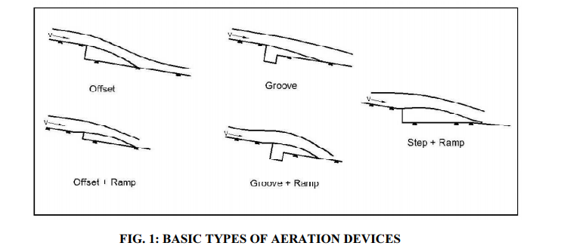

FIG. 1 BASIC TYPES OF AERATION DEVICES

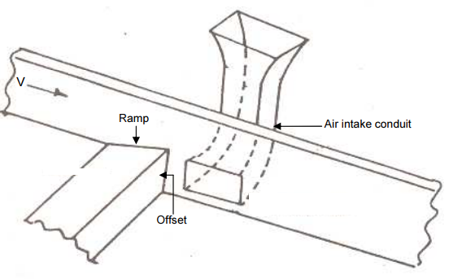

FIG. 2 AERATION SYSTEM WITH INTAKE CONDUIT

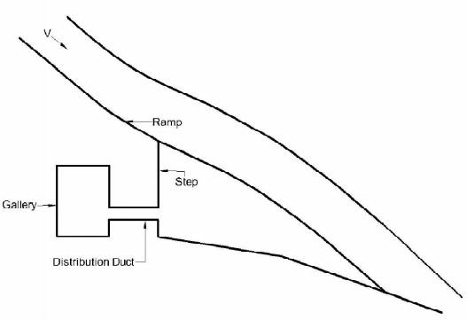

FIG. 3 AERATION SYSTEM WITH GALLERY AND DUCT

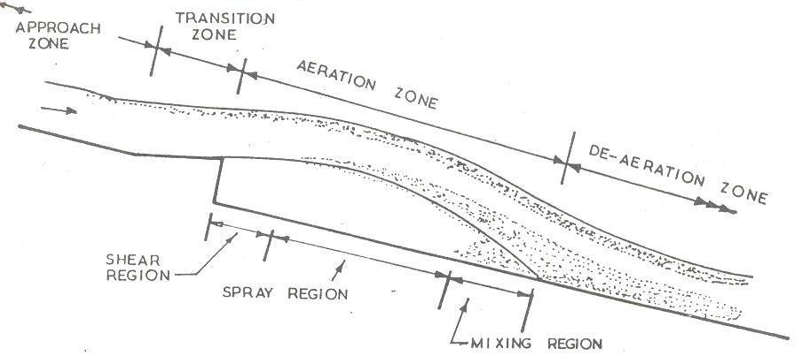

FIG.4 ZONES IN AERATOR MECHANISM

**4.2 Hydraulic action**

**4.2.1** The hydraulic action of a spillway aerator system consisting of ramp, step, air slot, and air intake system is similar to a water jet pump. The high velocity water jet issuing over the ramp draws some air already trapped in the groove and creates a partial vacuum. The rate of air demand of the jet depends principally on the velocity and length of the trajectory (which is affected by the presence of sub-atmospheric pressure in the groove). The sub-atmospheric pressure in the groove causes some air to be drawn through the atmosphere via the air intake system. The airflow rate through the air intake system is governed by the head loss through the system which in turn determines the magnitude of sub-atmospheric pressure in the cavity and consequently the jet trajectory length. This interaction continues until local equilibrium is established for a given set of conditions. An air velocity of 30m/s could be considered reasonable, however, velocities up to 100m/s may also be allowed at some places with adequate precaution. However, the velocities greater than 60m/s create noise.

**5 DESIGN CRITERIA FOR OVERFLOW AND ORIFICE SPILLWAY AERATOR**

**5.1 General**

**5.1.1** The procedure for designing an aerator is currently very much state-of-art and subject to changes as advancements are made. Designing an aerator system involves the location of the first aerator, pressure distribution on the spillway surface to decide the location of the second aerator, type, and size of the aerator, volume of air entrained at the aerator, type, and size of the air supply system and spacing between the aerators to maintain a given protection level. The performance of the aerator can be assessed by calculating the jet length, cavity pressures, air entrainment coefficient, and air concentration throughout the length of the spillway.

The hydraulic characteristics of the orifice spillway are entirely different from the overflow spillway. Therefore, the design criteria for aerator on overflow spillway are not applicable to aerator on orifice spillway. Present design practice includes the use of empirical relationships developed from model and prototype measurements and a limited amount of theoretical analysis. The guidelines given in the present code may be used for evolving the preliminary design of aerators for overflow and orifice types of spillways which should be checked on a hydraulic model.

**5.2 Locating the first aerator**

**5.2.1 The** aerator should be located first where the potential for cavitation damage is deemed possible i.e. the cavitation index of the flow is less than 0.2. If the bottom air concentration after the impact of the jet of the first aerator falls below the acceptable level of 6 to 8%, another aerator is required. The location of the second or subsequent aerators should be decided based on the pressure distribution and air concentration along the bottom profile of the spillway. The same should be checked by conducting hydraulic model studies.

**5.3 Aerator air intake configuration**

**5.3.1** The following are the air supply systems that can be applied in the various projects as per the requirement:

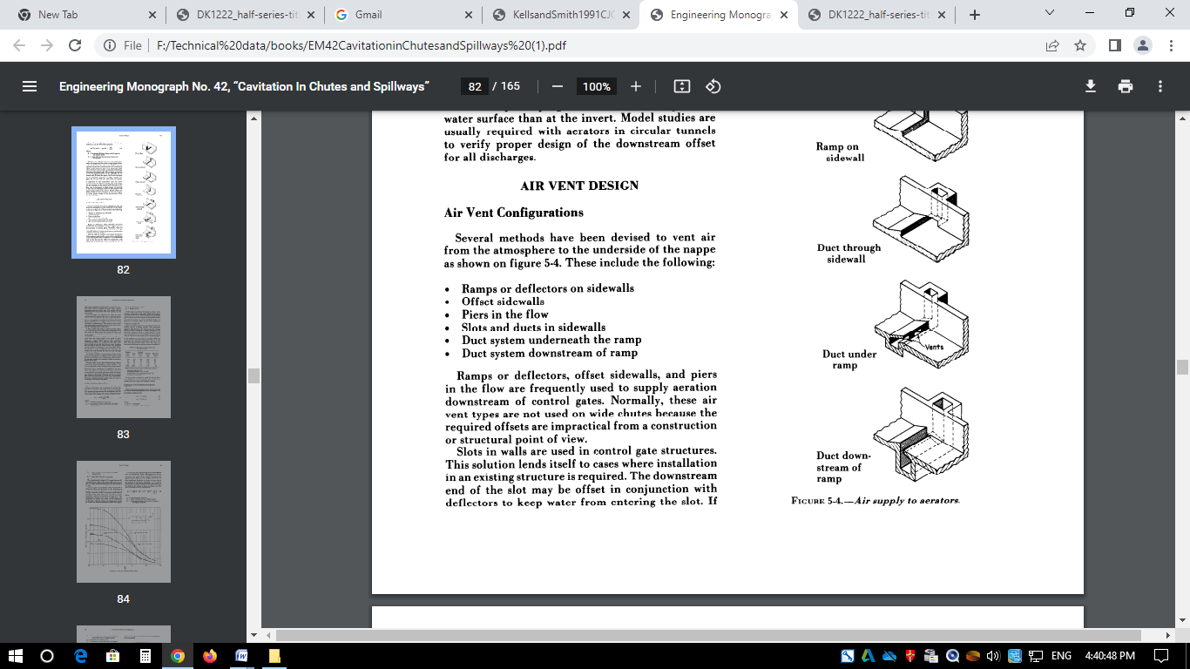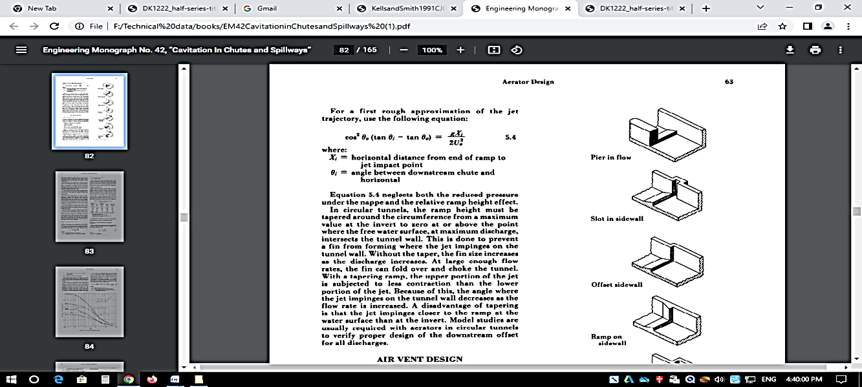

FIG. 5 AIR SUPPLY SYSTEM TO AERATORS

**5.3.2** In the absence of any firm and definite guidelines, pertinent dimensions of, the aerator and intake systems can be chosen, at least as a first approximation, by referring to the details of existing installations and finding a parallel case. More refined calculations, if necessary, can be carried out in subsequent trials.

**5.3.3** Pertinent dimensions and other details with respect to existing aerator systems of some projects have been given at ANNEX 1.

**5.3.4** Relevant notations appearing in the design, calculations are shown in Fig. 6.

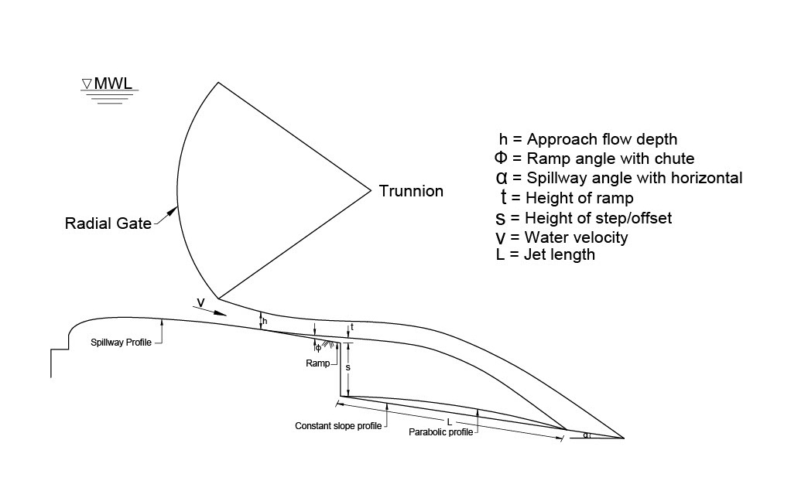

FIG. 6 DEFINITION SKETCH

**5.4. Estimation of desired air demand**

The quantity of air requirement can be worked out from the following equation:

$β= \frac{Q_{a}}{Q_{w}}$

Where,

β = Ratio between quantity of air demand vs quantity of water discharge

Qa = Quantity of air demand in m3/s

Qw = Quantity of water discharge in m3/s

The value of β for overflow and orifice spillway can be calculated from the equations given in the section 5.5 to 5.10. By knowing the value of QW and β, Qa can be calculated.

The size of the air vent can be worked out by knowing the quantity of air demand and considering the maximum allowable air vent velocity of 40m/s.

**5.5 Estimation of non-dimensional jet length (λ) for aerator of overflow spillway**

$λ=\frac{L}{h}=0.77F_{r}{(1+sinα)}^{1.5}\left[\sqrt{\frac{s+t}{h}}+ F_{r}tanφ\right]$, for 0 < $\frac{L}{h}$ < 50 ........(3)

Where,

$L$ = Jet length in m

$h$ = approach flow depth in m

$F_{r}$ = approach flow Froude number $(\frac{V}{\sqrt{gh}})$,

$α$ = spillway angle in degrees,

$s$ = height of step/offset in m.

$t$ = height of ramp in m, and

*φ* = ramp angle in degrees

Equation 3 may be applied to aerators consisting of aerators, offsets, or combinations and is valid for:

$5.8 ≤F_{r}≤10.4,$

1. ${12}^{o}≤α≤{50}^{o}$,

c) $0.1 ≤\left(\frac{s+t}{h}\right)≤2.1$,  
d) $0^{o }≤φ≤$, and

e) $h_{s}≈0$ where $h_{s}$ is cavity sub-pressure head

**5.6 Estimation of air entrainment coefficient (β) for aerator of overflow spillway**

$β=\frac{Qa}{Qw}=0.0028 F_{r}^{2}\left[1+ F_{r}\tan{φ}\right]– 0.1$, for 0 <*β*< 0.80 ........ (4)

Where,

$Qa$ = air discharge

$Qw$ = water discharge

Equations 4 may be applied to aerators consisting of aerators, offsets, or combinations and is valid for:

$5.8 ≤F_{r}≤16.1,$

1. $0^{o}≤α≤{50}^{o}$,

c) $0.06 ≤\left(\frac{s+t}{h}\right)≤2.1$,  
d) $0^{o }≤φ≤{11.3}^{o}$, and

e) $h_{s}≈0$ where $h_{s}$ is cavity sub-pressure head

**5.7 Estimation of non-dimensional jet length (λ) for aerator of orifice spillway with parabolic profile**

$λ=\frac{L}{h}= 0.83*{F_{r}}^{1.21}*{(1+sinα)}^{4.296}*{\left(\frac{A_{a}}{A_{w}}\right)}^{0.129 }*{\left(\frac{s+t}{h}\right)}^{0.201}*{\left(1+tanφ\right)}^{5.393}$......... ... (5)

for 0.72< $λ$ <35

**5.8 Estimation of air entrainment coefficient ($β$) for aerator of orifice spillway with parabolic profile**

$β=0.01011*{F_{r}}^{1.52}*{\left(\frac{A_{a}}{A_{w}}\right)}^{0.4244}*{\left(1+tanφ\right)}^{7.22}*{(1+sinα)}^{1.8789}*{\left(\frac{s+t}{h}\right)}^{-0.4796}$........ (6)

for 0 < $β$ < 0.4

Where,

*A*a = area of air vent in $m^{2}$

*A*w = area of water flow in $m^{2}$

Equations 5 and 6 may be applied to aerators consisting of ramp, offsets or combinations and are valid for:

a) 2.23 < $F_{r}$ < 9.81

b) 0.13 < $\left(\frac{s+t}{h}\right)$ < 1.77 $F_{r}$

c) ${10}^{0}$ < $α$ < ${20}^{0}$

${d) 0}^{0}$ < $φ$ < $3^{0}$

e) 0.001< $\frac{A_{a}}{A_{w}}$ < 0.32

**5.9 Estimation of non-dimensional jet length ($λ$) for aerator on orifice spillway for constant slope profile**

$λ=0.4781*{F_{r}}^{1.3464}*{(1+sinα)}^{4.7762}*{\left(\frac{A_{a}}{A_{w}}\right)}^{-0.04553 }*{\left(\frac{s+t}{h}\right)}^{0.3265}*{\left(1+tanφ\right)}^{5.3569}$........(7)

for 0.72 < $λ$ < 48

**5.10 Estimation of air entrainment coefficient ($β$) for aerator on orifice spillway for constant slope profile**

$β=0.00604*{F_{r}}^{1.5151}*{\left(\frac{A_{a}}{A_{w}}\right)}^{0.4686}*{\left(1+tanφ\right)}^{6.4491}*{(1+sinα)}^{4.8592}*{\left(\frac{s+t}{h}\right)}^{-0.3029}$........(8)

for 0 < $β$ < 0.56

Where,

$A_{a}$ = area of air vent in $m^{2}$

$A_{w}$ = area of water flow in $m^{2}$

Equations (7) and (8) may be applied to aerators consisting of ramp, offsets or combinations and valid for

a) 2.23 < $F_{r}$ < 9.81,

b) 0.13 < (s + t) / h < 1.77,

c) ${10}^{0}$ < $α$ < ${20}^{0}$,

d) $0^{0}$ < $φ$ < $3^{0}$, and

e) 0.03 < $\frac{A_{a}}{A_{w}}$ < 0.32

**5.11 Aerator spacing**

**5.11.1** Design criteria for deciding aerator spacing have not been established yet. Data on aerator spacings of some existing installations given in Annex 1 would serve to provide useful guidelines. Aerators produce an air-water mixture at the flow boundary. If the concentration of the mixture is large enough, cavitation damage will be prevented. In general, the aerator should be located first where the potential for cavitation damage is deemed possible i.e the cavitation index of the flow is less than 0.2. The pressure in the cavity is nearly atmospheric and increases again at the point of impact. It drops to the hydrostatic pressure after the reattachment of the jet. The high-pressure gradient in this region causes rapid changes in air distribution. As the flow progresses downstream from an aerator, the air concentration decreases because of buoyancy of the bubbles. If the bottom concentration falls below the acceptable level, another aerator is required. The minimum air concentration required to mitigate cavitation damage is about 6 to 8%.

The location of the second aerators and subsequent aerators may be decided based on the available length of chute, pressure distribution on the surface, and air concentration along the bottom of spillway surface. While an aerator is desirable at a grade change, installing aerators in vertical bends that are concave upward should be avoided. Aeration shaft should be designed in such a way that minimum head loss should occur in the shaft. The sharp bend should also be avoided in the design. Flow conditions in the vicinity of the aerator must be observed in a hydraulic model to ensure that the groove does not get filled in with water when low discharges are passed down the spillway and ski-action is not initiated.

Care must be taken to construct the aerator surface with steel/ high performance concrete as the sediment laden flow would erode the spillway surface during draw-down flushing. It is important that the dimensions of the geometry of aerator do not change with the passage of time as the air entrainment characteristic of the aerator is very sensitive to the geometry of aerator.

**5.11.2** A sample calculation for design of aeration system for an overflow and orifice spillway is given in Annex 2.

**5.12 Model studies**

Model studies are important in the development of spillway aeration systems. Physical models are useful in obtaining the proper shapes for aeration devices so as to produce satisfactory flow conditions. Parameters such as length of jet, location, and dimensions of the aerator can be optimized using physical models. The necessity of aerator can be identified based on the measured parameters such as pressure, velocity, and estimated cavitation index. Numerical model studies may be used as a complementary tool to reduce the number of alternatives to be studied on the physical model.

As indicated in **5.1.1**, the guidelines given above would be useful in preparing a preliminary design of an aerator system. However, the final design should be evolved on the basis of studies on a physical model constructed to an appropriate scale and taking into consideration the scale effects involved in such a model study.

**ANNEX 1**

(*Clause* 5.3.2)

**DETAILS OF EXISTING AERATOR SYSTEMS**

|  |  |  |  |  |  |  |  |  |  |  |  |  |  |  |  |  |  |  |
| --- | --- | --- | --- | --- | --- | --- | --- | --- | --- | --- | --- | --- | --- | --- | --- | --- | --- | --- |
| S.No**.** | **Project Details** | | | | **Spillway Design Details** | | | | **Air Supply System Details** | | | | | | | | **Aerator Design Details** | |
| Name | Country | Height | Type  of dam | Discharge1) | Length | Width  /Dia. | Slope | Drop | Type | No.  used | Spacing | Ramp  Ht. | Ramp  angle | Step/  Offset **heigth** | First  Aerator2) | Intake3)  size/Type | Lateral  Distribution4) |
|  |  |  |  |  | **m3/s** | **m** | **m** | **Degree** | **m** |  |  | **m** | **m** | **Degree** | **m** | **m** |  |  |
| 1 | Alicura | Argentina | 130 | Ch |  | 537 | 39 | 2.86:1 | 141 | R/S | 4 | 63 | 0.17 | 9.9 |  | 126 | [2@1.3x3.0C.](mailto:2@1.3x3.0C.)  SYMP | Natural5) |
| 2 | Amaluza | Ecuador | 155 | Gr. | 7700 |  | 90.34 | 0.414:1 |  | R |  |  | 0.06 |  | 1.66 |  |  |  |
| 3 | Baishan | China | 149.5 | Gr. | 5072 |  | 49.2 | 0.5:1 | 106.  3 | S | 1 |  |  | 5.7 |  |  |  |  |
| 4 | Bratsk | Russia | 100 | Gr. | 6050 | 100 | 216 | 0.8:1 | 90 | R | 1 |  | 0.45 | 11.3 |  | 39 | P | Natural |
| 5 | Chamera I | India | 121 | Gr. | 22000 | 107 | 8 X 10m | 1.26:1 | 67 | G | 1 | - | - | - | 2 | 41 | 2 X 2 C SYMP | G |
| 6 | Clyde | New Zealand |  | Gr. |  |  |  | 0.77:1 |  | R/S | 1 |  | 0.45 | 5.7 | 0.45 |  |  |  |
| 7 | Colbun | Chile | 116 | Ch | 8500 | 281.8 | 71.1 | 100:1  to  1.96:1 | 86 | R/S | 2 | 60 | 0.25 | 11.3 | 2.25 |  | 3x1.5CSYMP | 2.25 x3G |
| 8 | Emborcacao | Brazil |  | Ch | 7800 | 330 |  | 5.5 to  3.35:1 | 79.8  5 | R/S | 2 | 103 | 0.3,0.2 | 7.1 |  |  |  | 2x2AG,G |
| 9 | Fengjiashan | China |  | T | 1140/725 | 922 | 7.2x11 | 50.1.5 | 64 | R/G,R | 2 | 50 | 0.6,0.1  8 | 3.8,7.1 |  | 84 | 0.9C | 0.6 z.0.9 g,  Natural |
| 10 | Fozdo  Areia | Brazil | 160 | Ch | 11000 | 400 | 70.6 | 3.87:1 | 119 | R/S | 3 | 72,90 | 0.2,0.1  5 | 7.1,0.1  0 | 1.5 | 146 | 1.8x4.OC,  SYM | Natural |
| 11 | Glen  Canyon | USA | 216 | T | 2@3908 | 400 | 12.5 | 0.7:1 | 175 | R/G/S | 1 |  | 0.0.18 | 0.7.7 | 0.31 | 50 | 1.2x1.2G,  SYM | 1.2x1.2 G |
| 12 | Guri  (Chute 1) | Venezuela | 150 | Gr. | 6000 | 140 | 48 | 0.8:1 | 130 | R/RS | 2 | 93 | 1,0.25 | 7  5 | 2.84 | 30 | PC,ASYM | Natural,2x4  AG6@  1.25x1.25D |
| 13 | Guri  (Chute 2) | Venezuela | 150 | Gr. | 6000 | 145 | 51 | 0.8,1.3  2.5:1 | 120 | R/RS | 2 | 103 | 1,1.5 | 7  25 | 2.2 | 30 | PAF,SYM | 1.2x1.2 D |
| 14 | Karjan | India | 81 | Gr. | 16475 |  | 17.61 | 0.8:1 | 79 | R | 1 | - | 0.563 | 8 |  |  | AG,SYM,2.5  x3.75 |  |
| 15 | Karkaya | Turkey |  | Gr. | 17000 |  | 392 | 0.67:1 | 103 | S | 1 | - | 0.5 | - |  | 110 | AG3 m |  |
| 16 | KingTalal | Jordan |  | Ch | 2160 |  | 35 | 2.78:1 |  | S.R | 2 | - | 0.574 | 7.8 | 1.4 | 40 | W | Natural |
| 17 | Laiban | Philippines |  | Ch | 2960 | 397 | 25 | 33.3:1t  02.7:1 | 81 | R/S,R/G | 4 | 40,64,56 | 0.20,0.4 | 5.2,5.71 |  | 180 | C,C | Natural,  AG/0.8 G |

|  |  |  |  |  |  |  |  |  |  |  |  |  |  |  |  |  |  |  |  |
| --- | --- | --- | --- | --- | --- | --- | --- | --- | --- | --- | --- | --- | --- | --- | --- | --- | --- | --- | --- |
| 18 | McPhee | USA | 82 | Ch | 950 | 303 | 18.3 | 9:1 to  2:1 | 90 | R | 1 | - | 0.91 | 6.4 |  | 172 | 1.2x1.2C | | 0.91 x1.22  Po |
| 19 | Narmada Sagar | India | 100 | Gr. | 88315 | 109 | 495 | 0.86:1 | 60.3 | R | 1 | - | 0.2 | 2.5 | - | 15 | | Pier end | Natural |
| 20 | Nurek | Russia |  | T, Ch | 2400 |  | 10 | Varies |  | G/O | 8 | 10-15 |  |  | 0.40 |  | | 1.4x1.5 G,C |  |
| 21 | PiedraDel | Argentina | 111 | Ch | 10000 | 27.15 | Varies  60-52 | 30:1 | 87 |  | 4 | 40-68 |  |  |  | 58 | |  |  |
| 22 | San  Roaue | Philippines | 210 | Ch | 12800 | 550 | 105 | 4:1  Max. | 128. 4 | R/O | 7 | 50-60 | 0.5 | 9.6 | 0.75 | 158 | | 1.1x2.0C  SYM | 1.8 X2.0  AG,0.5X  1.5 Po |
| 23 | SardarSarovar | India | 165 | Gr. | 65000 | 300 | 524.3 | 0.6:1 | 56.68 | R/G | 1 | - | 0.25 | 4 | - | 40 | | 2.54 X 2.54 | 2.54X2.54 G |
| 24 | Tarbela | Pakistan |  | Ch | 2690 | 126 | Variable | Variable | 140 | R/S | 1 | - | 0.16 | 9.1 | 0.18 | 19 | |  |  |
| 25 | Tehri | India | 261 | Ch | 5487 | 718 | 39.5 | 1.94:1 | 41.87 | R/G | 3 | 80  100 | 0.2  0.15  0.1 | 5.71 | - | 230 | | 1.2 x1.2 C | 1.4 X 1.4 AG |
| 26 | Three Gorges | China | 181 | Gr. | 47900 | 127.5 | 23 X 7 m | 4:1 | 95.17 | O | 1 | - | - | - | 1.2 | 28 | | 1.1 m Ф C | G |
| 27 | Toktogul | Russia |  | Gr. | 2430 |  | - | 0.71:1 | 116 | R/S,R/  G | 2 | 60,1.5 | 0.15  0.45 | 9.5 | 2.0 | 60 | | P | 1.0 AG |
| 28 | Uribante | Venezuela | 130 | Ch | 1100/300 | 391.6 | 12 | 8:1 to  2.5:1 |  | R/S | 2 | 153 | 0.25  0.30 | 4.7  5 | 3.0  2.45 | 174.4 | | 0.5x1.5 G,  0.8x0.9 G | G |
| 29 | Ullum | Argentina |  | Ch | 1000 | 228.8 | 35 | 4:1 | 72.5 | R | 1 |  | 1.0 | 14 | - | 123 | | Wall wedge  7.1 ateach side protruding0.5 inthe flow | Natural |
| 30 | Vst-Ilim | Russia |  | Gr. |  |  |  | 0.7:1 |  | R | 1 |  | 0.6 | 9.5 |  | 35 | | C | 0.5x4.5Po |
| 31 | Yellowtall | USA |  | T | 2600 | 450 | 9.75 | 0.7:1 | 150 | R/G/S | 1 |  | 0to0.07  6 | Oto6.3 | 0.076 | 100 | | 0.9x0.9 G,  SYM | 0.9x0.9 G |
| 32 | Subansiri | India | 125 | Gr. | 37500 | 175.5 | 11.5x14m | variable | - | R/S | 2 | 61 | 0.56 | 4 | 2.5 | 27 | | 2 square ducts (1.5x1.5 m) each side of span for first aerator and second aerator at pier end | Aeration through shaft at first aerator and natural aeration at second aerator |

NOTE -

1) Where two values are given the first is spillway design discharge and the second the aerator design discharge.

2) The distance given is from the spillway crest to the first aerator

3) Describes how the air is delivered to the aerator from the atmosphere and whether delivery is from both sides of the chute.

4) Describes how the air is conducted to the underside of the jet at the aerator.

5) The term 'Natural' means that no special appurtenances have been used to distribute the air in the jet cavity void

List of abbrevations used:

|  |  |  |
| --- | --- | --- |
| AG | : | AirGallery |
| ASYM | : | Asymmetrical inlet condition. |
| C | : | Airintakeconduit |
| Ch | : | Chute |
| D | : | Distributionduct |
| G | : | Groove |
| O | : | Offset |
| P | : | Pier |
| Po | : | Portal |
| R | : | Ramp |
| S | : | Step |
| SYM | : | Symmetricalinletcondition |
| T | : | Tunnel |
| W | : | Wallwedge |

**ANNEX 2**

(*Clause* 5.11.2)

**SAMPLE FOR DESIGN CALCULATION OF AERATION SYSTEM**

1. **Estimation of non-dimensional jet length ( $λ)$ and air entrainment coefficient ( $β$) for overflow spillway**

**A.1 Input Data**:

Approach flow depth $h$ = 3.7 m

Approach flow Froude number $F_{r}$ = 6

Chute bottom angle $α$ = ${40}^{o }$

Offset height s = 2.45 m

ramp height t = 0.4 m

ramp angle $φ=4^{o }$

**A.2 Estimation of non-dimensional jet length ($λ)$** :

$$λ=\frac{L}{h_{o}}=0.77F_{r}{\left(1+\sin{α}\right)}^{1.5}\left[\sqrt{\frac{s+t}{h}}+F_{r}\tan{φ}\right]$$

$$λ=\frac{L}{h_{o}}=0.77*6* {\left(1+\sin{{40}^{o }}\right)}^{1.5}\left[\sqrt{\frac{2.45+0.4}{3.7}}+ 6*\tan{4^{o }}\right]$$

$$λ=0.77*6* 2.106*\left(0.878+0.419\right)$$

$$λ=12.62$$

**A.3 Estimation of air entrainment coefficient ($β)$** :

$$β=0.0028 F_{r}^{2}\left[1+ F_{r}\tan{φ}\right]– 0.1$$

$$β=0.0028*6^{2}* \left[1+ 6* \tan{4^{o }}\right]– 0.1$$

$$β=0.0028*36* 1.419 – 0.1$$

$$β=0.043$$

1. **Estimation of non-dimensional jet length ( $λ)$ and air entrainment coefficient ( $β$)for orifice spillway with parabolic profile**

**B.1 Input Data:**

Froude number $F_{r}$ = 7.53

spillway angle in degrees $α$ = ${10}^{0}$

ramp angle in degrees $φ$ = $3^{0}$

offset height in ‘m’ *s* = 1.5 m

ramp height in ‘m’ *t* = 0.25 m

Incoming depth of flow h = 1 m

area of air vent in $m^{2}$*A*a = 0.785

area of water flow in $m^{2}$*A*w = 3.825 $m^{2}$

**B.2 Estimation of non-dimensional jet length ($λ)$** :

$$λ=0.83*{F_{r}}^{1.21}*{(1+sinα)}^{4.296}*{\left(\frac{A_{a}}{A_{w}}\right)}^{0.129 }*{\left(\frac{s+t}{h}\right)}^{0.201}*{\left(1+tanφ\right)}^{5.393}$$

$$λ=0.83*{7.53}^{1.21}*{\left(1+\sin{{10}^{0}}\right)}^{4.296}*{\left(\frac{0.785}{3.825}\right)}^{0.129 }*{\left(\frac{1.5+0.25}{1}\right)}^{0.201}*{\left(1+\tan{3^{0}}\right)}^{5.393}$$

$$λ=0.83*11.51*1.989*0.815*1.119*1.317$$

$$λ= 22.82$$

**B.3 Estimation of air entrainment coefficient ($β)$** :

$β=0.01011*{F_{r}}^{1.52}*{\left(\frac{A_{a}}{A_{w}}\right)}^{0.4244}*{\left(1+tanφ\right)}^{7.22}*{(1+sinα)}^{1.8789}*{\left(\frac{s+t}{h}\right)}^{-0.4796}$

$$β=0.01011*{7.53}^{1.52}*{\left(\frac{0.785}{3.825}\right)}^{0.4244}*{\left(1+\tan{3^{0}}\right)}^{7.22}*{\left(1+\sin{{10}^{0}}\right)}^{1.8789 }*{\left(\frac{1.5+0.25}{1}\right)}^{-0.4796}$$

$$β=0.01011*21.51* 0.510*1.446*1.351*0.765$$

$$β=0.165$$

**(C) Estimation of non-dimensional jet length ( $λ)$ and air entrainment coefficient ( $β$) for orifice spillway with constant slope profile**

**C.1 Input Data:**

Froude number $F_{r}$ = 7.53

spillway angle in degrees $α$ = ${10}^{0}$

ramp angle in degrees $φ$ = $3^{0}$

offset height in ‘m’ *s* = 1.5 m

ramp height in ‘m’ *t* = 0.25 m

incoming depth of flow in ‘m’ *h* = 1 m

area of air vent in $m^{2}$*A*a = 0.785

area of water flow in $m^{2}$*A*w = 3.825

**C.2 Estimation of non-dimensional jet length ($λ)$** :

$λ=0.4781*{F_{r}}^{1.3464}*{(1+sinα)}^{4.7762}*{\left(\frac{A_{a}}{A_{w}}\right)}^{-0.04553 }*{\left(\frac{s+t}{h}\right)}^{0.3265}*{\left(1+tanφ\right)}^{5.3569}$

$λ=0.4781*{7.53}^{1.3464}*{(1+sin{10}^{0})}^{4.7762}*{\left(\frac{0.785}{3.825}\right)}^{-0.04553 }*{\left(\frac{1.5+0.25}{1}\right)}^{0.3265}*{\left(1+tan3^{0}\right)}^{5.3569}$

$$λ=0.4781*15.15*2.148*1.075*1.20*1.315$$

$$λ=26.39$$

**C.3 Estimation of air entrainment coefficient ($β)$** :

$$β=0.00604*{F_{r}}^{1.5151}*{\left(\frac{A_{a}}{A_{w}}\right)}^{0.4686}*{\left(1+tanφ\right)}^{6.4491}*{(1+sinα)}^{4.8592}*{\left(\frac{s+t}{h}\right)}^{-0.3029}$$

$$β=0.00604*{7.53}^{1.5151}*{\left(\frac{0.785}{3.825}\right)}^{0.4686}*{\left(1+tan3^{0}\right)}^{6.4491}*{(1+sin{10}^{0})}^{4.8592}*{\left(\frac{1.5+0.25}{1}\right)}^{-0.3029}$$

$$β=0.00604*21.3*0.476*1.390*2.177*0.844$$

$$β=0.156$$

ANNEX 3

(*Foreword*)

**COMMITTEE COMPOSITION**

Dams and Spillways Sectional Committee, WRD 09

|  |  |
| --- | --- |
| *Organization* | *Representative(s)* |
| Central Water Commission, New Delhi | SHRI VIVEK TRIPATHI (***Chairperson***) |
| Bhakra Beas Management Board,  Nangal Township | CHIEF ENGINEER (BHAKRA DAM)  DIRECTOR (DESIGN) (*Alternate*) |
| Central Board of Irrigation & Power,  New Delhi | DR. G.P. PATEL  MR SUNIL SHARMA (*Alternate*) |
| Central Soil & Material Research  Station, New Delhi | DR. MANISH GUPTA  SHRI U.S. VIDYARTHI (*Alternate*) |
| Central Water & Power Research  Station, Pune | SHRI Y. N. SRIVASTAVA  DR P P GADGE (*Alternate* 1)  MRS. S. R. PATNAIK (*Alternate* 2) |
| Central Water Commission, New Delhi | SHRI KAYUM MOHAMMAD  SHRI NARENDRA SINGH SHEKHAWAT (*Alternate*) |
| DMR Hydroengineering &  Infrastructure Ltd., Faridabad | SHRI S.C. MITTAL  SHRI NABAKISHORE NEOG (*Alternate* 1)  SHRI SHUBHAM BANSAL (*Alternate* 2) |
| Department of Water Resources,  Punjab | SHRI RAKESH KUMAR SOOD  DIRECTOR (*Alternate*) |
| Energy Infratech Pvt. Ltd, Gurugram | SHRI MANOJ KUMAR GUPTA  SHRI PRAMOD CHAND TIWARI (*Alternate*) |
| Geological Survey of India, Kolkata | SHRI BHUPENDER SINGH  SHRI K. ARAVIND (*Alternate*) |
| Himachal Pradesh Power Corporation  Limited, Sundernagar | SHRI ER. R.K. KAUNDAL  SHRI ER. RAJESH GULERIA (*Alternate*) |
| Indian Institute of Technology,  Banaras Hindu University, Varanasi | PROF. PRABHAT KUMAR SINGH DIKSHIT |
| Indian Institute of Technology, New  Delhi | PROF.A.K.KESHARI |
| Indian Institute of Technology Bombay, Mumbai | PROF. V JOTHIPRAKASH |
| Indian Institute of Technology, Roorkee | PROF N. K. GOEL  PROF. DEEPAK KHARE (*Alternate*) |
| Irrigation and Water Resources Department  Haryana | SHRI SANDEEP TANEJA  SHRI RAKESH KUMAR SOOD (*Alternate*) |
| Irrigation Research Institute, Roorkee | SHRI DINESH CHANDRA  SHRI NAVEEN SINGHAL (*Alternate*) |
| Kerala State Electricity Board,  Thiruvananthapuram | SMT. ANNI PHILIP  DEPUTY C.E. (DESIGNS) (*Alternate*) |
| Narmada & Water Resources, Water Supply & Kalpsar Department, Gandhinagar | SHRI R.M. PATEL  MRS. D. N. PRADHAN (*Alternate*) |
| National Institute of Rock Mechanics,  Bangalore | DR. SRIPAD R NAIK  SHRI B H VIJAY SEKAR (*Alternate*) |
| National Hydroelectric Power Corporation Ltd, Faridabad | SHRI R.M.A. KHAN  SH. SAKET KUMAR (*Alternate* 1)  SHRI ANKUR VISHWAKARMA (*Alternate* 2) |
| North Easern Electric Power Corporation  Ltd, Guwahati | SHRI S. DHAR  MR. DIPJYOTI SHARMA (*Alternate*) |
| National Thermal Power Corporation Ltd, Noida | SHRI NAVEEN KUMAR JAIN  SHRI PRASHANT NARAYAN GAUR (*Alternate*) |
| SNC Lavalin Engineering India Pvt, Ltd. | ARUN MEHTA  JANARDAN BARUAH (*Alternate*) |
| Tehri Hydro Development Corporation India Ltd., Uttarakhand | SHRI ATUL JAIN  DR. NEERAJ AGRAWAL (*Alternate*) |
| Uttarakhand Irrigation Department | DINESH CHANDRA  NAVEEN SINGHAL (*Alternate*) |
| Water Resources Department, Govt of Andhra Pradesh | CHIEF ENGINEER  SUPERINTENDING ENGINEER (*Alternate*) |
| Water Resources Department., Govt of Madhya Pradesh | CHIEF ENGINEER  SHRI K. SRINIVAS (*Alternate*) |
| Water Resources Department, Govt of Maharashtra | SUPERINTENDING ENGINEER  EXECUTIVE ENGINEER (*Alternate*) |
| Water Resources Organization, Public  Works Department, Govt of Tamilnadu | SHRI P. RAMAN  AMELIA BALRAJ (*Alternate*) |
| In Personal Capacity, *G-601, (Prateek Stylome,*  *Sector 45, Noida – 201301*) | DR. NAYAN SHARMA |
| In Personal Capacity, (*Salil Society, 16*  *Chintamaninagar Sahakarnagar 2 Pune 41109*) | SHRI P. DEOLALIKAR |
| BIS DIRECTORATE GENERAL | Shri R. Bhanu Prakash Scientist-E **/** Director & Head (WRD) [Representing Director General (*Ex-Officio)]* |

*Member Secretary*

Shri Vaibhav Jindal

Assistant Director/Scientist ‘B’

(Water Resources), BIS