IS No. : 11388-2012
Title: Recommendations for design of trash racks for intake

Sl. No. | Organization/ Individual | Clause/Sub clause/ Paragraph/ Figure/ Table | Type of Comment (General/ Technical/ Editorial) | Comments  (Justification for change) | PROPOSED CHANGE | The decision of the panel in the 2nd meeting | The decision of Panel in 3rd meeting on 6th Sept 2023 | Comments of CWC recd. on 12 Sept 2023 (For discussion) | Decision of panel in the 4th meeting on 30th Oct 2023
1 | Central Water and Power Research Station, Pune | 5  Inclination of racks | Technical/ General | For racks which are to be cleaned by mechanical means, the slope should be 10° to 15° with the vertical unless otherwise specified by the trash rack cleaning machine manufacturer’s manual. | It is proposed to increase the range of the slope of the trash rack with vertical 5º to 30º for mechanically cleaned rackes.  Reference US Bureau of reclamation's Design standard no. 6 "Hydraulic and mechanical equipment" and Trash Control Structures and Equipment: A Literature Review and Survey of Bureau of Reclamation Experience; U.S. Department of the Interior: Denver, CO, USA, 1992; Report no. R-92-05 suggested "If trashracks to be racked mechanically then sloped should be kept between 5º to 30º with vertical."  Proposed change " For racks which are to be cleaned by mechanical means, the slope should be 5° to 30° with the vertical unless otherwise specified by the trash rack cleaning machine manufacturer’s manual or installation difficulties due geologically weaker strata underneath." | Panel members deliberated and did not agree to incorporate the change. | -- | -- | --
2 |  | 6 VELOCITY THROUGH RACKS | Technical/ General | 6.1 For low pressure intakes with small units (and consequently closely set rack bars) and where manual cleaning of racks is provided the velocity should be  limited to 0.75 m/s. | Provide the definition of the low pressure intake and high pressure intake on the basis of head.  Depending on the head, the intakes are categorized as under:  a) Low Pressure Intake - head up to 15 m  b) High Pressure Intake - head more than 15 m  Reference: IS 11570 (1985) clause no. 2.3.1 | Panel members deliberated and CWC agreed to provide the modified clause to be discussed in the next panel meeting. | -- | For Low pressure intakes (with head upto 15 m) where manual cleaning of racks is provided the velocity should be limited to 0.75m/s. With units where mechanical cleaning of racks is provided velocity up to 1.5m/s should be permitted. | Panel members deliberated and agreed to incorporate the proposed change by CWC.
3 |  | 6 VELOCITY THROUGH RACKS | Technical/ General | 6.1 For low pressure intakes with small units (and consequently closely set rack bars) and where manual cleaning of racks is provided the velocity should be  limited to 0.75 m/s. With large units (and wider spacing of rack bars) and where mechanical cleaning of racks is provided a velocity up to 1.5 m/s should be permitted.  6.2 For high pressure intakes the overall economy will determine the velocity to be used in racks. Velocity up to 3 m/s on the gross area of racks may be permitted where serious clogging of trash racks is not expected for high-pressure intakes. | Proposed Addition  6.3 Velocities of 1.22 m/s to 1.82 m/s (4 to 6 fps) or lower are recommended for normal operation, but designs with velocities up to 6 m/s (20 fps) may be possible with hydraulic model studies for conditions where fine control of selective withdrawal is not a governing consideration.  Reference: Department of the Army, U.S. Army Corps of Engineers manual " Engineering and Design HYDRAULIC DESIGN OF RESERVOIR OUTLET WORKS", EM 1110-2-1602 6-2a,15 Oct. 80  b. Design Information. (1) Inlet Ports. | Panel members deliberated and agreed to include the following modified clause.  6.3 For velocities greater than 3m/s, designs may be explored with model studies. | -- | Comment on 6.2  Velocity may be computed on net area of racks.  Comment on modified 6.3  For intakes where velocity on net area of racks is greater than 3.0 m/s the hydraulic model studies should be undertaken. | Panel members deliberated and agreed to incorporate both the proposed changes by CWC.
4 |  | 7 LOSSES AT TRASH RACKS  7.1 The loss of head should be calculated from the  following formula: | Technical/ General | Alternatively, the following Kirschmer formula can also be used :  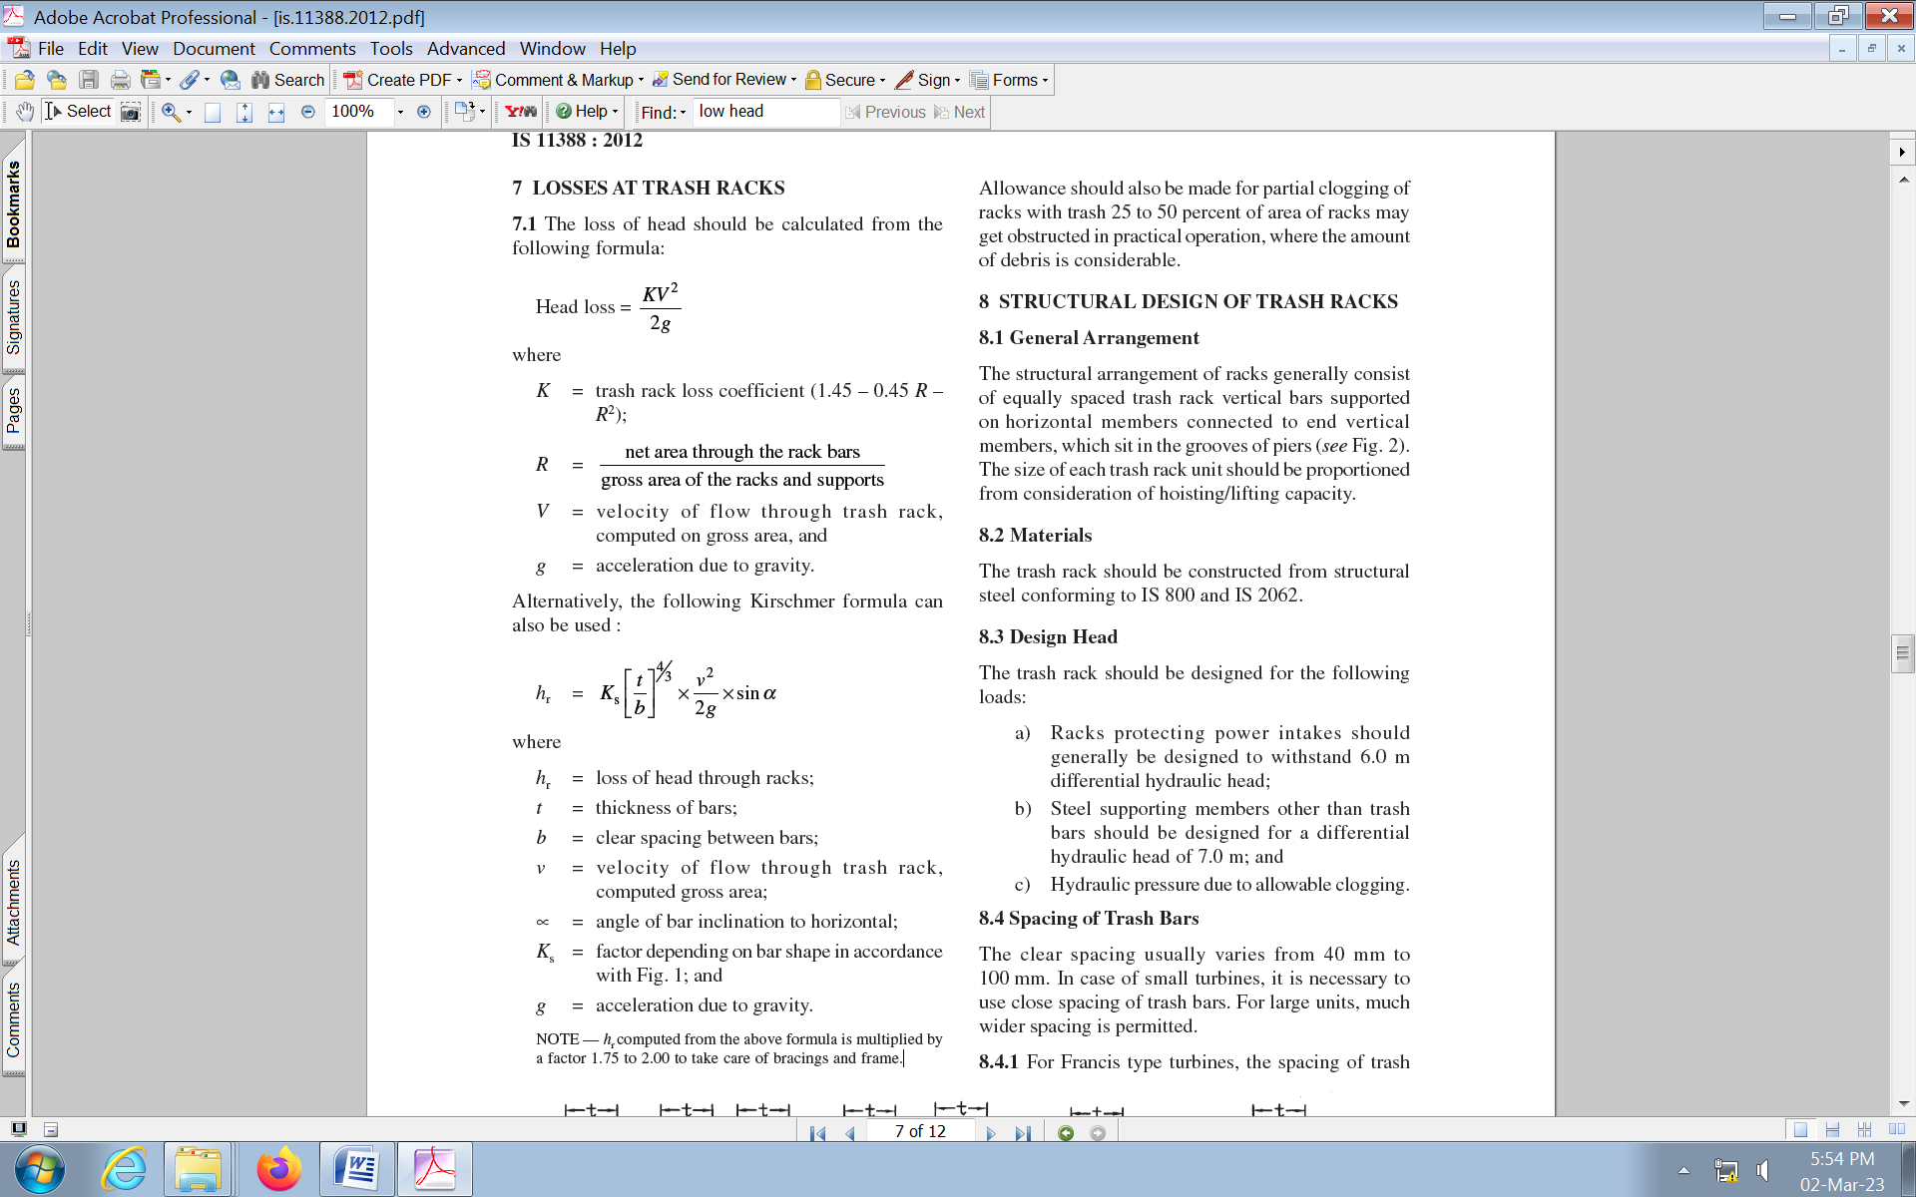  where  hr = loss of head through racks;  t = thickness of bars;  b = clear spacing between bars;  v = velocity of flow through trash rack,  computed gross area;  α= angle of bar inclination to horizontal;  Ks = factor depending on bar shape in accordance  with Fig. 1; and  g = acceleration due to gravity.  NOTE — hr computed from the above formula is multiplied by a factor 1.75 to 2.00 to take care of bracings and frame. | Proposed units of different parameters used in equation. Modification in note suggested.  Alternatively, the following Kirschmer formula can also be used for inclined trash racks :  where  hr = loss of head through racks in ft or m;  t = thickness of bars in inches or mm;  b = clear spacing between bars in inches or mm;  v = Approach velocity or velocity of flow through trash rack in ft/sec or m/sec, computed from gross area;  α= angle of bar inclination to horizontal in degrees;  Ks = factor depending on bar shape in accordance  with Fig. 1; and  g = acceleration due to gravity in ft/sec² or m/sec².  NOTE — hr computed from the above formula is multiplied by a factor 1.75 to 2.00 to take care of bracings and frame and where severe clogging occurs (between 25% and 50% of the rack) this factor should be increased to between 1.78 and 4.0. | Panel members deliberated and did not agree to incorporate the proposed change. Further, SJVN highlighted comment on velocity in formula KV2/2g whether the velocity should be calculated on gross area or net area. The Committee requested SJVN to share the reference document for deliberation in the next meeting. | Panel members deliberated on the formula of Head Loss=KV2/2g  V is Velocity through Net flow area.  (Reference from Trash Control Structures and Equipment: A Literature Review and Survey of Bureau of Reclamation Experience; U.S. Department of the Interior: Denver, CO, USA, 1992; Report no. R-92-05 and Guidelines for Design of Intakes for Hydroelectric Plants by by the Committee on Hydropower Intakes of the Energy Division of the American Society of Civil Engineers) | 7.1  Velocity may be computed on net area of racks in all the formulae. | Panel members deliberated and not agreed to incorporate the proposed change by CWC. (The decision made in the earlier meeting will be incorporated.)
5 |  | 8.4 Spacing of Trash Bars | Technical/ General | 8.4.1 Trash rack bars should be so spaced so that the net opening between them should not be greater than the minimum opening between turbine runner buckets. | Trash rack bars should be so spaced so that the net opening between them should not be greater than the minimum opening between turbine runner buckets or maximum opening of the wicket gates, whichever is smaller. | Panel members deliberated and agreed to incorporate the proposed change. | -- | -- | --
6 |  | 8.5 Design of Trash Bars | Technical/ General | 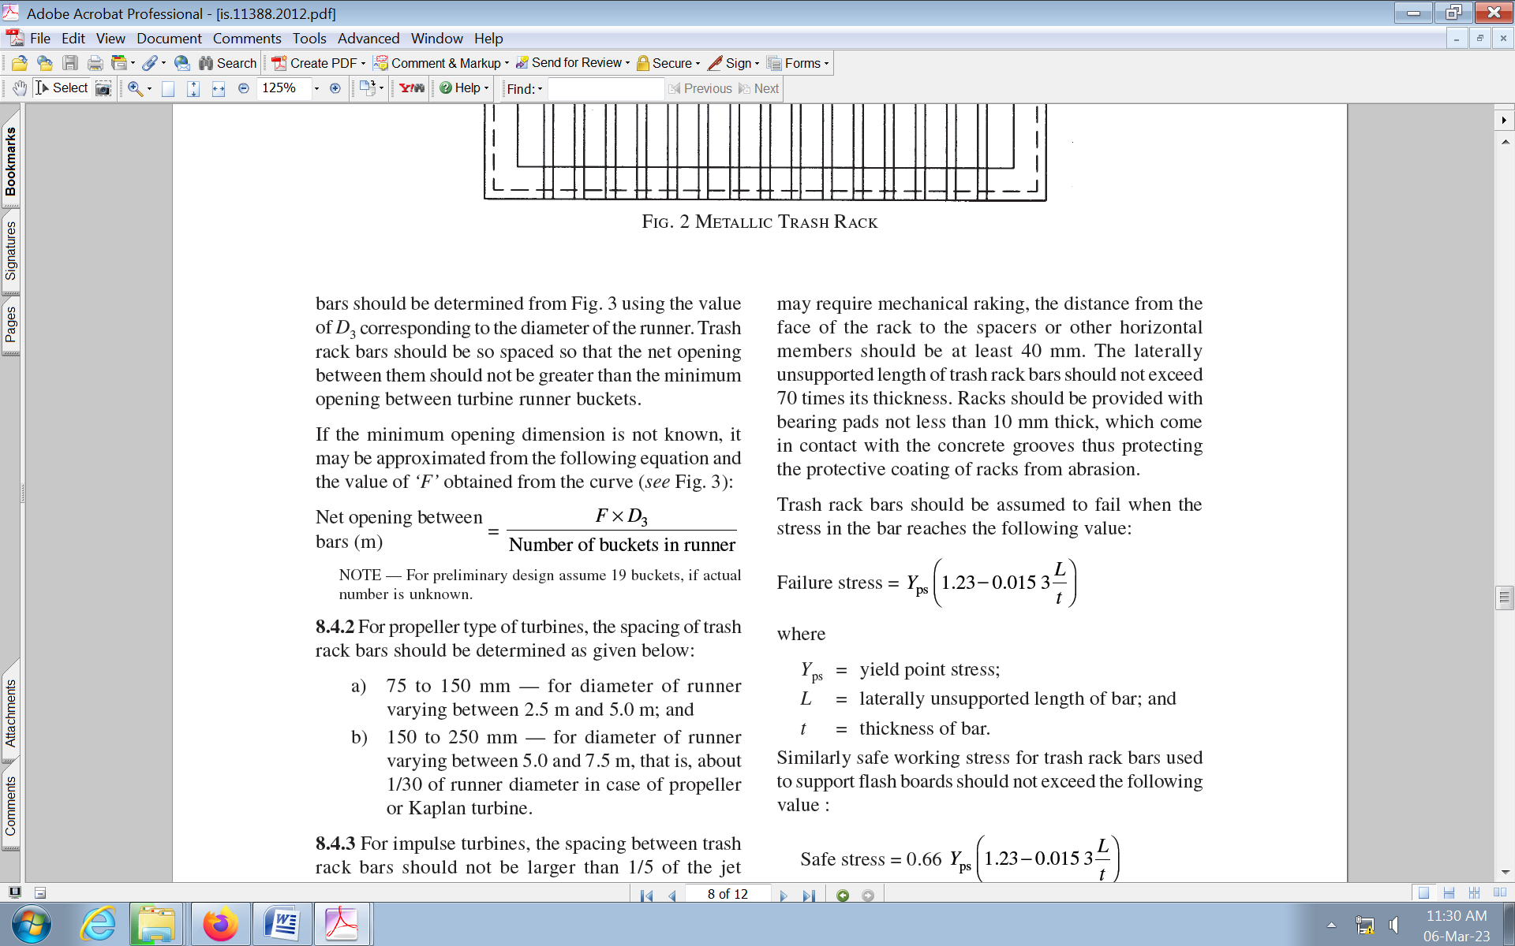  where  Y_{ps} = yield point stress;  L = laterally unsupported length of bar; and  t = thickness of bar. | Proposed units of different parameters used in equation.  where  Y_{ps} = Yield point stress in psi;  L = laterally unsupported length of bar in inches ; and  t = thickness of bar in inches. | Panel members deliberated and did not agree to incorporate the change. | -- | -- | --
7 | THDC India Limited | 8.5  Design of Trash Bars | Editorial | Typographical error in the Second sentence. | ‘may require mechanical raking, the distance from the’  shall be inserted after the text  ‘For racks which’ in the 2nd sentence.  Corrected sentence of para:  The depth of trash bar should not be more than 12 times its thickness and not less than 50 mm. For racks which may require mechanical raking, the distance from the face of the rack to the spacers or other horizontal members should be at least 40 mm. | -- | Panel members deliberated and agreed to incorporate the proposed change. | -- | --
8 | THDC India Limited | 8.7 Check for Stability against Vibrations  Figure-4 | Editorial | Figure 4 for Strouhal Number missing | Insert the following with fig given below:  Fig.4 Strouhal Numbers Pertaining to Various Shapings of the Cross-Section of the Rack Bars | -- | Panel members deliberated and agreed to incorporate the proposed change. | -- | --
9 | THDC India Limited | 8.7 Check for Stability against Vibrations | Technical | Formula for calculating Natural Frequency F_{n} is dimensionally incorrect. | F_{n}= (p * K_{f} ² / 2) sqrt (E*I*g / (V* ((g_{s} + g b_{e})/t)/ 3)  Be replaced by following eqn  F_{n} = (π K_{f}² /2) * sqrt (E I g / (V (g_{s} +gb_{e} / t ) L³ )) | -- | Panel member deliberated and agreed to incorporate the following expression for natural frequency $F_{n}$ in sec.  $$F_{n}= \frac{π {K_{f}}^{2}}{2}\sqrt{(\frac{E I g}{v ( γ_{s}+ γ \left(\frac{b_{e}}{t}\right))l^{3}}})$$ | -- | --

