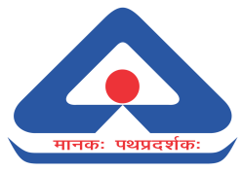 **भारतीयमानकब्यूरो**

**BUREAU OF INDIAN STANDARDS**

|  |  |  |
| --- | --- | --- |
| **Meeting** | **Date and Time** | **Venue** |
| **24th Meeting of Energy Management and Energy Savings Sectional Committee, MED 39** | **12.12.2024 (Tuesday)**  **11:00 AM** | Hybrid Mode |

**CHAIRMAN:** Shri S. R. Lohokare, In Individual Capacity

**MEMBER SECRETARY:** Ms Ankita Vidhyarthi, Scientist ‘D’/Joint Director, Bureau of Indian Standards, New Delhi

**Following important decisions taken during the meeting:**

1. The Chairperson urged M/s Tata Steel and M/s Reliance India Limited to be part of the ISO working groups.
2. The Chairperson requested MS to find out the stages of documents going on in the working groups and inform the committee about the same.
3. The 89th meeting of ISO/TC/WG/1 is scheduled to be held on 17th Feb 2025. The committee members were requested to send their nominations for the working groups as experts.
4. MS to contact TERI and CII for their inclusion in the committee and apprise the committee of the same.
5. The committee recommended that a panel of experts be formed for studying the gap areas in the standardization of the energy sector.

Note: The minutes of the meeting are under preparation, once prepared it will be shared with the members after final approval of Chairperson, MED 39.