***FOR BIS, USE ONLY***

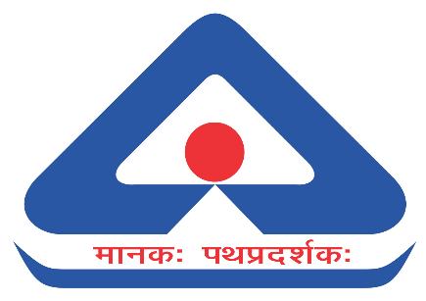

**भारतीयमानकब्‍यूरो**

**BUREAU OF INDIAN STANDARDS**

**Resolution**

|  |  |  |
| --- | --- | --- |
| **COMMITTEE** | **DATE & DAY** | **TIME** |
| **29th Meeting of Oil Burning Appliances Sectional Committee MED 26 through Webex** | **09th October 2024 (Wednesday)** | **10:30 AM**  **(Webex)** |

###### MAJOR DISCUSSION AND DECISION HELD MEETING

During the meeting, Shri Sarbjot Singh Sandhu, NIT Jalandhar,presented the progress made in the R&D project (MED 0177) to "Determine the technical requirements of Industrial Oil Fired Burners" to date. The committee discussed the progress report and the utilization certificate as submitted by NIT Jalandhar in detail.

Shri Sarbjot Singh Sandhu further requested the project extension by two more months as some tasks of procuring international standards and visiting some more manufacturers and users are pending for the completion of the project.

The committee noted the information and recommended the following:

1. The progress report and the utilization certificate of funds (enclosed below) as submitted by Shri Sarbjot Singh Sandhu are accepted, and



1. The project may be extended by two more months for its completion.

The committee further suggested expediting the completion of the project along with the following major points:

1. As per the TOR, Shri Sarbjot Singh Sandhu is to provide more information on classification, dimensional requirements, performance parameters, operation range, safety parameters and regulations, etc., in the final project report and
2. A detailed work plan is to be provided by 13.10.2024 for the two-month extension period by Shri Sarbjot Singh Sandhu, including the tasks to be completed.

Shri Sarbjot Singh Sandhu noted and agreed to the same.

*******