***FOR BIS USE ONLY.***

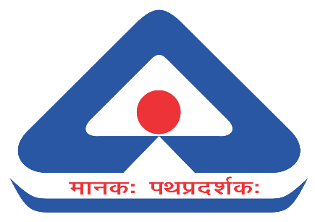

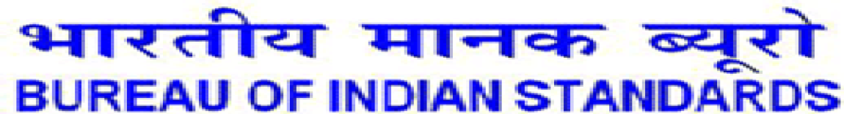

**RESOLUTION**

|  |  |  |
| --- | --- | --- |
| **COMMITTEE** | **DATE and DAY** | **TIME** |
| **28th Meeting of Mining Techniques and Equipment Sectional Committee, MED 08**  **(Virtual Mode)** | **20 December 2024** | **10:30 AM onwards** |

**CHAIRMAN:** Shri Saifullah Ansari, Director (MSE), Directorate General of Mines Safety, Dhanbad.

**MEMBER SECRETARY:** Shri Shubham Tiwari, Joint Director/Scientist-D (MED), BIS, New Delhi.

**RECOMMENDATIONS OF THE COMMITTEE MED 08 IN ITS 28TH MEETING**

1. The committee constituted the experts for giving votes and comments related to the ballots received from ISO mirror committee, ISO/TC 82 Mining.
2. The committee approved the IS 7587 (Part 8), IS 5114:1969, IS 13230:1992 for wide circulation for 30 days.
3. The committee decided to drop the wide circulated IS 10970:1984, IS 12527:1988, IS 13618:1993 and re-examine again by the working group formulated.
4. The committee recommended to conduct panel meeting on 10th January 2024 for review of IS 9123:1979.
5. The committee suggested to send for review of wide circulated document IS 4005:1967 for 7 days. If no comment received then the draft document shall be sent for printing.
6. The committee decided to drop the NWIP ‘Cage suspension gears used in koepe winder’ and NWIP ‘Diesel engine systems for underground coal mines: explosion protected’ and re-examine again by the working group formulated for R&D Project.
7. The committee rejected the proposal to transfer the standard on cage suspension gear (all parts of IS 7487) from MED 08 to MED 10.
8. The committee suggested MS to follow up the committee members for active participation and also for the work assigned to them.
9. The committee suggested MS to send the list of members whose contact details is incomplete/missing..
10. The committee suggested MS to prepare the draft amendment for the IS 12488 : 2023 on the basis of comments received by the Shri J.P. Goenka.