**BUREAU OF INDIAN STANDARDS**

**DRAFT FOR COMMENTS ONLY**

(*Not to be reproduced without the permission of BIS or used as an Indian Standard*)

|  |  |
| --- | --- |
| *भारतीय मानक मसौदा*  **खाद्यान्नों का भंडारण ⎯ कीड़ों द्वारा भंडारण हानि ⎯**  **अनुमान लगाने की विधियाँ**  (*आइ एस 12529 का पहला पुनरीक्षण*)  *Draft* ***Indian Standard***  **STORAGE OF FOODGRAINS ⎯ STORAGE LOSSES BY**  **INSECTS ⎯ METHODS FOR ESTIMATION**  (*First Revision of IS 12529*)  **ICS** | |
| Foodgrains, Allied products, and other agricultural produce Sectional Committee, FAD 16 | Last date of comments:  **DD-MM-2024** |

**FOREWORD**

(*Adoption clause will be added later*)

The word ‘loss’ has been defined by the committee on losses of foodgrains during post-harvest handling as, reduction in food supply brought about by either reduction in weight or deterioration between two handlings and on the whole between two handlings between production and consumption. There are considerable losses during storage by insects, rodents, micro-organisms, birds and mites. Lack of adequate storage facilities and knowledge of safe storage cause enormous losses in quality and quantity. The assessment of storage losses at farm level or in commercial warehouses caused by stored grain insect pests has, since long been an intricate problem. Though various methods and number of formulae have been used to estimate the storage losses by insect, no standard procedures for estimating storage losses due to insects have been laid down which may be uniformly accepted and utilized by all agencies engaged in this work.

For the purpose of deciding whether a particular requirement of this standard is complied with, the final value observed or calculated, expressing the result of a test or analysis, shall be rounded off in accordance with IS 2: 2022 ‘Rules for rounding off numerical values (*second revision*)’. The number of significant places retained in the rounded off value should be the same as that of the specified value in this standard.

***Indian Standard***

**STORAGE OF FOODGRAINS ⎯ STORAGE LOSSES BY**

**INSECTS ⎯ METHODS FOR ESTIMATION**

**(*First Revision*)**

**1 SCOPE**

This standard lays down the methods for estimation of storage losses in foodgrains by insects.

**2 REFERENCES**

The following Indian Standards contain provisions which through references in this text, constitute provisions of this standard. At the time of publication, the editions indicated were valid. All standards are subject to revision, and parties to agreements based on this standard are encouraged to investigate the possibility of applying the most recent editions of the standards indicated below:

|  |  |
| --- | --- |
| *IS No.* | *Title* |
| IS 2813 : 2018 | Terminology for Foodgrains (*third revision*) |
| IS 14818 : 2017/  ISO 24333 : 2009 | Cereal and Cereal Products — Sampling (*first revision*) |

**3 TERMINOLOGY**

For the purpose of this standard the definitions given in IS 2813 shall apply except definition of germ eaten grains, which is given as under:

1. *Germ eaten grains* — Kernels in which only germ part has been eaten/destroyed by stored grain insect pests.
2. *Damaged grains* — Kernels or pieces of kernels that are sprouted or internally damaged as a result of heat, moisture, weather or microbes. (*see* IS 2813)
3. *Slightly damaged or touched* — Kernels or pieces of kernels that are damaged or discoloured, superficially so as not to affect the quality of the material. (*see* IS 2813)
4. *Insect damaged*—Kernels that are partially or wholly bored by insects injurious to grain. (*see* IS 2813)
5. *Weeviled grains*—Weeviled grains are grain kernels that are partially or wholly bored by insects injurious to grain but do not include germ-eaten grains and egg-spotted grains. (*see* IS 2813)

**4 METHODS**

Four methods have been laid down for estimation of storage losses by insects. Any of these may be used.

**4.1 Weevilled and Germ-Eaten, Grain Counting Method**

The insects such as rice weevil, lesser grain borer eat out the contents of the grain from within and result into weevilled grains. The Khapra beetle larvae prefer the germ portion of the grains and eat away the germ from outside.

**4.1.1** *Sample Size*

A sample size of 50 grams shall be drawn .in accordance with the methods prescribed sampling methods. (*see* IS 14818)

~~IS 2814: 1978 or IS 3714: 1978, as the case may be~~.

**4.1.2** *Procedure*

1. Grain sample of 50 g is taken;
2. From which a random sample of 100 grains is drawn;
3. Out of these 100 grains, weevilled grains and germ eaten grains are sorted out and are separated from the samples;
4. Weevilled and germ eaten grains are counted and weighed separately; and
5. The 100 more purely health grains are randomly selected and weighed

**4.1.3** *Calculation*

Percent mass loss is calculated as per the formula:

Mass Loss (%) = (W + G) – 100/S (W1 + G1)

where,

*W* = Percentage by number of weeviled grains

*G* = Percentage by number of germ eaten grains

*W*1 = mass of *W* grains (in grams)

*G*1 = mass of *G* grains (in grams)

*S* = mass of 100 healthy grains

**4.2 By Comparing Healthy Grains and Damaged Grains**

**4.2.1** *Sample Size*

A sample size of 50 grams shall be drawn in accordance with the prescribed sampling methods (*see* IS 14818)

**4.2.2** *Procedure*

1. Hundred grains are randomly selected from the sample;
2. Out of these hundred grains, the number of damaged grains are separated and counted and the same are then weighed;
3. Then an equal number of healthy grains are selected and counted; and
4. One more separate set of hundred exclusively healthy grains is selected and weighed.

**4.2.3** *Calculation*

The loss due to insect pests is then calculated as per the formula

Percent mass loss = $\frac{n - n_{1}}{n_{2}}×$ 100

Where,

*n* = mass of the equal number of healthy grains in grams,

*n*1 = mass of the number of damaged grains in 100 grains in grams, and

*n*2 = mass of 100 healthy grains in grams.

**4.3 Counting and Weighing Method (Gravimetric Method)**

**4.3.1** *Sample Size*

A sample size of 50 grams or 1000 grains shall be drawn. (*see* IS 14818).

~~in accordance with the methods prescribed in IS 2814: 1978 or IS 3714: 1978, as the case may be.~~

**4.3.2** *Equipment*

1. *Weighing balance*  ⎯ 0.5 grams to 1.5 kilograms range with an accuracy of 0.1 gram.
2. *Enamelled plate*

**4.3.3** *Procedure*

The 1000 grains drawn as per the procedure described in **4.3.1** shall be separated into undamaged and damaged categories. Then count the grains of each category and weigh them. Record the following data:

1. Mass of 1000 grains,
2. Number and mass of undamaged grains, and
3. Number and mass of damaged grains.

**4.3.4** *Calculation*

Percent mass loss = $\frac{\left(U.Nd\right) - \left(D.Nu\right)}{U\left(Nd + Nu\right)}×$ 100

where,

*U* = mass of undamaged grains in grams;

*Nd* = number of damaged grains;

*D* = mass of damaged grains, in grams; and

*Nu* = number of undamaged grains.

**4.4 Standard Volume/Mass Method-** to be deleted as method not relevant to insect damage

**~~4.4.1~~***~~Sample Size~~*

~~A sample size of 50 grams shall be drawn in accordance with the prescribed sampling standards.~~

~~in IS 2814: 1978 or IS 3714: 1978, as the case may be.~~

**~~4.4.2~~** *~~Equipment~~*

~~a)~~ *~~Test mass apparatus~~* ~~⎯ For obtaining the standardized volume of grains.~~

~~b)~~ *~~Weighing balance~~* ~~⎯ 0.5 to 1.5 kilogram range with an accuracy of 0.1 gram.~~

~~c)~~ *~~Moisture meter~~*

~~d)~~ *~~Sieve~~* ~~⎯ For removal of insects, dust and other foreign matter.~~

**~~4.4.3~~***~~Procedure~~*

**~~4.4.3.1~~** ~~Form a base line figure between different moisture content and dry mass of foodgrains.~~

**~~4.4.3.2~~** ~~Sieve the sample and measure the moisture content. Measure the mass of a volume of the sample from the volume container. Repeat thrice and take the mean of the readings. Convert the mass to dry mass using the moisture content with the following, formula:~~

~~Moisture content on dry basis = 100~~

~~where~~

*~~Wm~~* ~~= mass of moisture in grams, and~~

~~= mass of dry matter in grams.~~

**~~4.4.3.3~~** ~~From the graph, find the dry mass of the sample at the same moisture content taken at the~~

~~time of storage.~~

*~~Example:~~*

~~If the moisture content and the dry mass of the sample was 12.0 percent, and 600 grams respectively, then on referring to Fig. 1 the dry mass would be 680 grams.~~

~~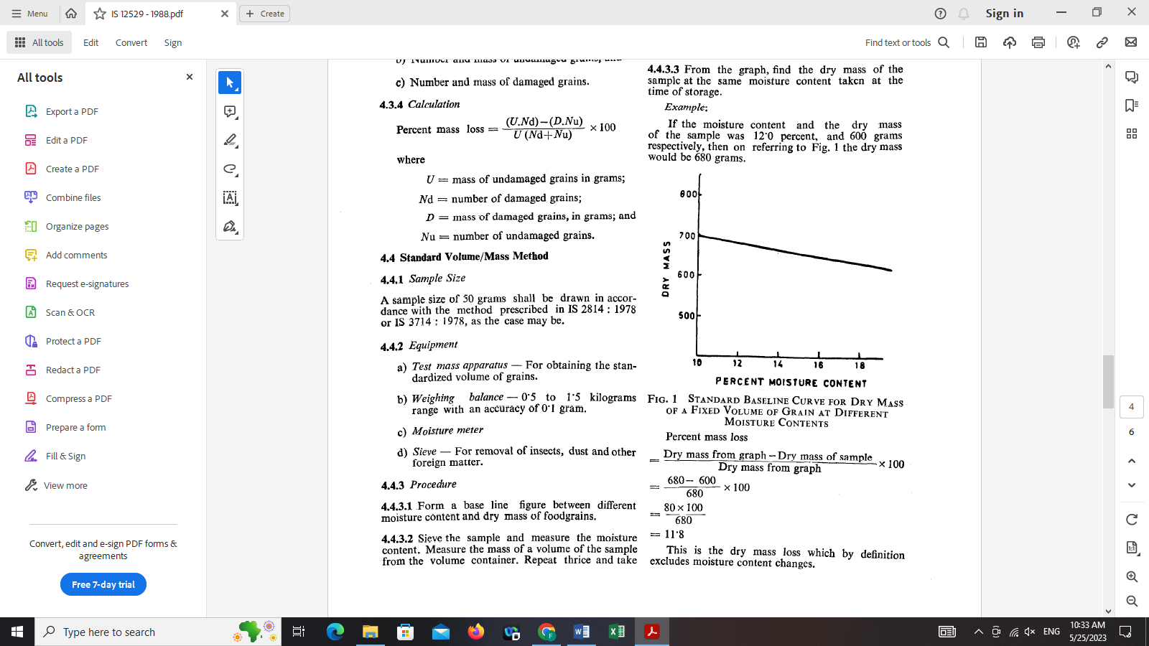~~

**~~FIG. 1 STANDARD BASELINE CURVE FOR DRY MASS OF A FIXED VOLUME OF GRAIN AT~~**

**~~DIFFERENT MOISTURE CONTENTS~~**

~~Percent mass loss~~

=  ~~100~~

~~= 100~~

~~= 11.8~~