# BUREAU OF INDIAN STANDARDS

**DRAFT FOR COMMENTS ONLY**

(*Not to be reproduced without the permission of BIS or used as an Indian Standard*)

|  |  |
| --- | --- |
| *भारतीय मानक मसौदा*  **कृषि उत्पादन मिलिंग तंत्र ⎯ दालों की मिलिंग ⎯ शब्दावली और प्रवाह आरेख**  (*आई एस 13793 का पहला पुनरीक्षण*)  *Draft Indian Standard*  **AGRICULTURAL PRODUCE MILLING MACHINERY ⎯ MILLING OF PULSES ⎯ TERMIINOLOGY AND FLOW DIAGRAM**  (*First Revision of IS 13793*)  **ICS 65.060** | |
| Agriculture and Food Processing Equipment Sectional Committee, FAD 20 | Last date of comments: **04/02/2024** |

# FOREWORD

(*Adoption clause will be added later*)

This standard has been prepared to provide the basic information about the various operations and equipment involved in pulse milling. This standard was originally published in 1993 and further amended in 2007.

In this revision, following modifications have been incorporated keeping in view the technological advancements in the field and the standard has been brought out in the latest style and format of the Indian Standards:

1. The tittle has been changed by including terminology in it as the standard also covers the terms used for products, equipment and operation used in pulse milling.
2. Terminologies have been updated and two new terms ‘screw conveyor’ and ‘byproduct’ have been added, where two terms ‘bean’ and ‘powder’ have been removed.
3. In all the flow diagram, the method of drying has not been specified and can be used as sun drying or mechanical drying.
4. Process flow chart for pigeon pea dehulling (dry method) by PDKV mini dal mill has been added.

For the purpose of deciding whether a particular requirement of this standard is complied with, the final value observed or calculated, expressing the result of a test or analysis, shall be rounded off in accordance with IS 2: 2022 ‘Rules for rounding off numerical values *(second revision)*’. The number of significant places retained in the rounded off value should be the same as that of the specified value in this standard.

# SCOPE

This standard covers the terminology and flow diagrams for pulse milling.

# TERMINOLOGY

For the purpose of this standard, the following definitions shall apply.

# Product

* + 1. *Brokens* — Broken dehusked or unhusked splits of a pulse grain.
    2. *Dehusked Whole Grain* — Whole pulse grain with husk/hull removed.
    3. *Dal* — Dehusked whole/split or unhusked split cotyledon of the pulse grain.
    4. *Germ* — The embryo in a pulse grain which grows into the new plant.
    5. *Husk* — Seed coat, hull, or covering surrounding the pulse grain.
    6. *Byproduct* — By-product obtained from milling of pulses is a mixture of outer seed coat, germ, and scoured cotyledons of peripheral region of pulses in powder form.
    7. *Pulse* — Dried edible seed of a leguminous plant.
    8. *Unhusked Whole Grain* — Whole pulse grain with husk/hull intact.

# Operation

* + 1. *Aspiration* — The process of cleaning by air blast and separating the foreign material which is substantially lower in specific gravity than the produce to be cleaned.
    2. *Chaffing* — The process of pneumatic separation of very light material from the product.
    3. *Cleaning* — The process of removal of foreign or dissimilar material by washing, screening, hand picking, aspiration or by any other mechanical means.

**2.2.4.** *Dehusking/Dehulling* — The process of removing hull or husk from the pulse grain.

* + 1. *Drying* — The process of reduction of moisture in the product usually to a predetermined value.
    2. *Grading* — The process of sorting grains into different lots conforming to certain predetermined standards, usually based on physical parameters, such as, size, shape, color, specific gravity.
    3. *Pitting/Scratching* — The process in which the surface of the grain is scratched to impart cracks in the husk/hull so as to facilitate oil or water penetration.
    4. *Polishing* —The operation of providing glossiness to dal by suitable mechanical operation.
    5. *Pretreatment* — The operation of treating the grain in order to loosen the husk or hull (seed coat). The pretreatment may consist of water and/or oil application, soaking and drying, heating and tempering, light roasting, or chemical treatment.
    6. *Scalping* — The process of cleaning in which good grains are dropped through screen opening while larger material is carried over the screen into a separate spout.
    7. *Scouring* — The process in which outer layers (mainly those comprising the husk/bull) are removed through abrasive action.
    8. *Screening* — The process of separation of grains by a mechanical device, i.e., multiple set of sieves, where the oversize material is retained and undersize material is passed away. Desired material is collected from the middle sieve. It is the method of separating grains according to size alone.
    9. *Separation* — The operation in which a product is separated from other products using the difference in physical, thermal, electrical or any other property of the product.
    10. *Soaking/Steeping* — The process in which the grain is soaked in water in order to raise its moisture content.
    11. *Sorting* — Sorting is essentially a separation operation supplementary to grading.
    12. *Splitting* — The operation in which the pulse grain is separated into two cotyledons.
    13. *Roasting/Toasting/Parching* — The process in which the grains are subjected to dry heating for predetermined period of time.
    14. *Tempering* — The process where the grain is held temporarily between two successive operations, so that the moisture content and temperature within the grain mass and within the kernel equalizes.

# Equipment

* + 1. *Aspirator* — A component used for cleaning the grains/seeds by drawing air through the grain/seed.
    2. *Cleaner* — A machine to remove foreign matter from grain mass.
    3. *Conveyer* — An equipment or component through which material is moved from one point to another.
    4. *Cyclone Separator* — A separating device in which strong centrifugal force acting radially is used in place of relatively weak gravitational force acting vertically downwards.
    5. *Dehuller* — Dehuller is a machine used for hulling. While removing the hull it also scours the kernel surface.
    6. *Dehusker/Sheller* — Dehusker is a machine used to remove husk/hull from the pulse grain. The sheller may be vertical stone type/horizontal stone type or emery coated burr mill. Abrasive emery rollers are used commercially for dehusking of grain.
    7. *Destoner* — A mechanical device which separates stones from the grain.
    8. *Disc Separator* — An equipment in which particles longer or shorter than pulse grains but similar diameter are separated by means of indented discs with idents of predetermined shape and size.
    9. *Dryer* — An equipment used to dry the grain to the desired moisture content/predetermined value.
    10. *Elevator* — A conveyor in which the material is moved upwards.
    11. *Screw conveyor* — Used for horizontal conveyance of the grains. With oil application mechanism, these conveyors are used for mixing of oil and water in pre-milling treatments.
    12. *Grader* — A machine used for grading the grain.
    13. *Rollers* — It consists of a pair of cylindrical rolls arranged with their exist parallel and set in a heavy frame. Rolls may be steel, stone or emery coated.
    14. *Sieve* — Slotted sheet metal or woven wire mesh which separates grains by size.
    15. *Separator* — A machine used to separate the milled product into different fractions.
    16. *Splitting Machine* — A machine used for splitting the dehusked/unhusked pulse grain into two cotyledons.
    17. *Thickness Grader* — A machine which separates product by thickness.
    18. *Under Runner-Disc Sheller* — A machine which is used to remove husk/hull and consists of two horizontal discs, the top one stationary and the lower one rotating. The discs may be of emery or stone.

# FLOW DIAGRAMS

The following flow diagrams indicating various sequence of operations in pulse milling are given.

1. Basic process flow diagram of the mill system (see Fig. 1);
2. Process flow diagram of pigeonpea milling (dry process) (see Fig. 2);
3. Process flow diagram of pigeonpea milling (wet process) (see Fig. 3);
4. Process flow diagram of pigeon pea milling (thermal process) (see Fig. 4);
5. Process flow chart pigeon pea dehulling (dry method) by pkv mini dal mill (see Fig. 5);
6. Process flow diagram of black gram (urad bean) and green gram (mung bean) milling (dry process) (see Fig. 6);
7. Process flow diagram for peas and lentil (see Fig. 7);
8. Process flow diagram for ciae process of pulse milling (see Fig. 8); and

j) Process flow diagram of chickpea milling (see Fig. 9).

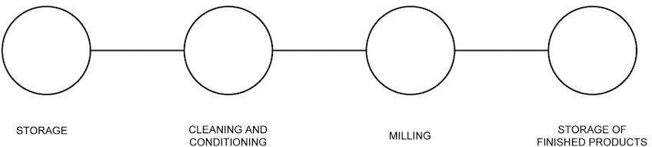

FIG. 1 BASIC PROCESS FLOW DIAGRAM OF THE MILL SYSTEM

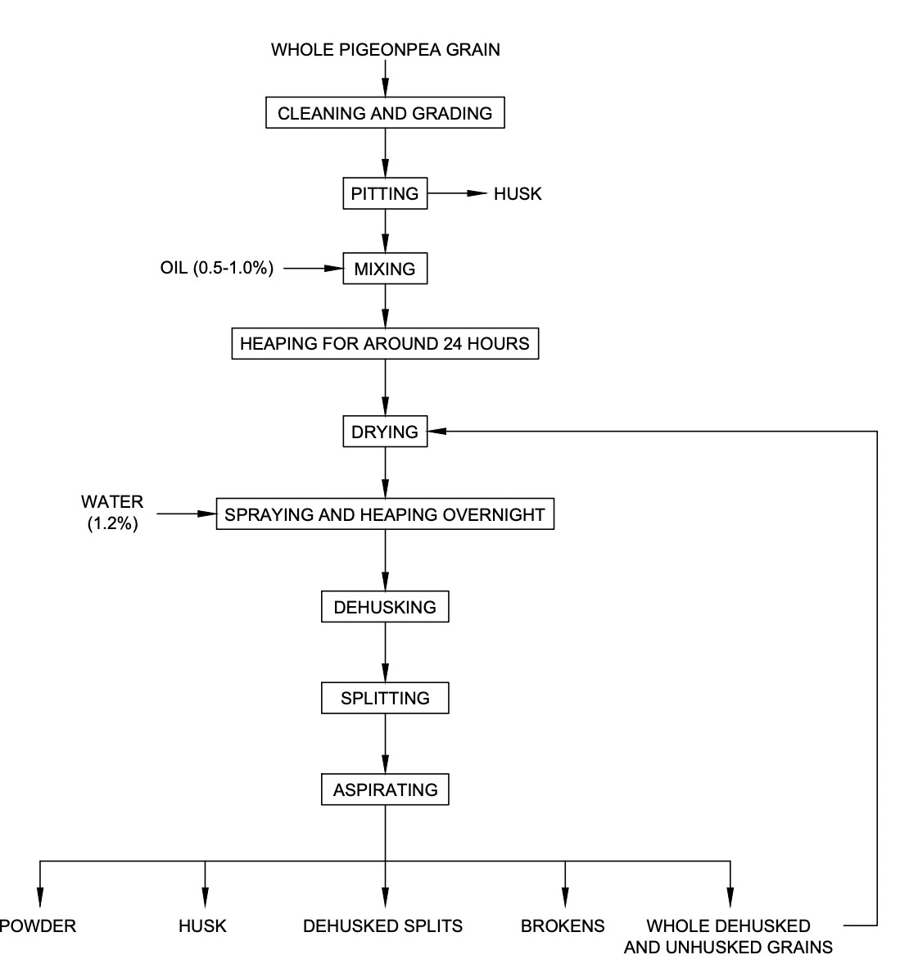

FIG. 2 PROCESS FLOW DIAGRAM OF PIGEONPEA MILLING (DRY PROCESS)

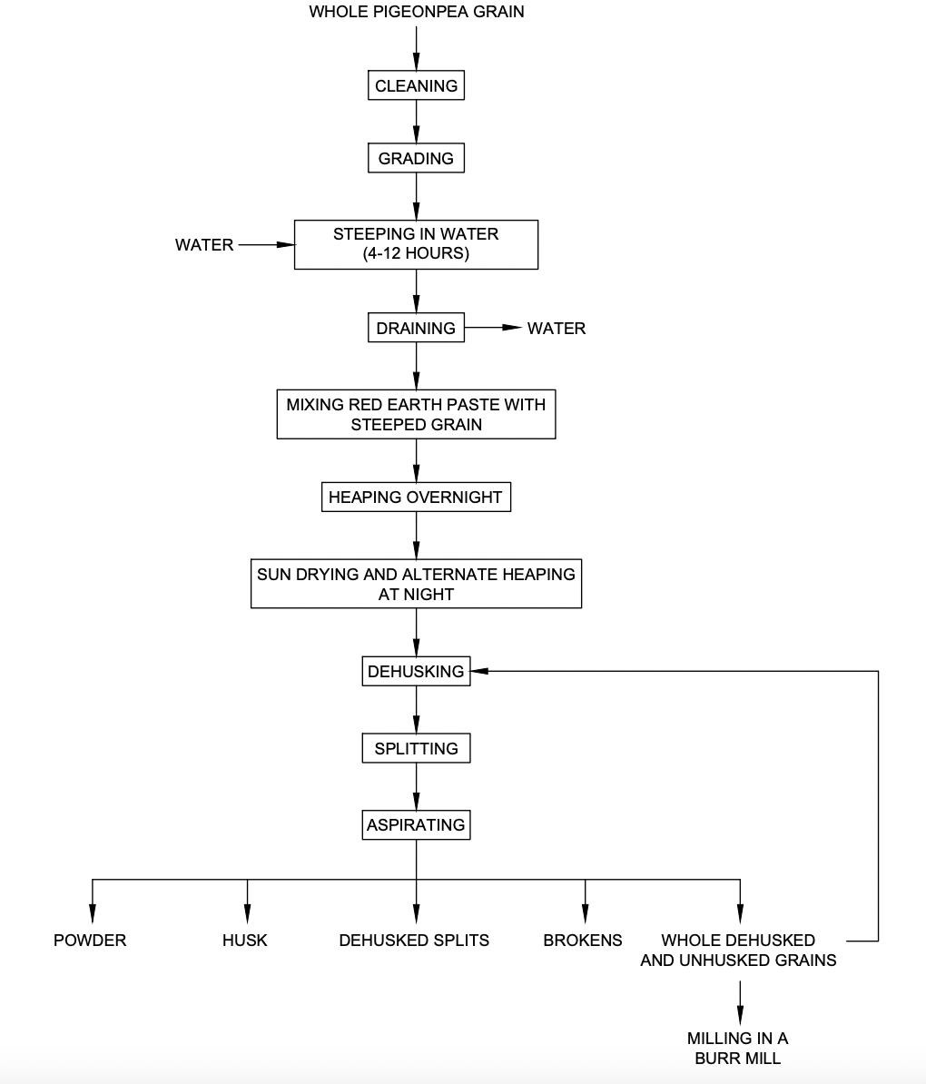

FIG. 3 PROCESS FLOW DIAGRAM OF PIGEONPEA MILLING (WET PROCESS)

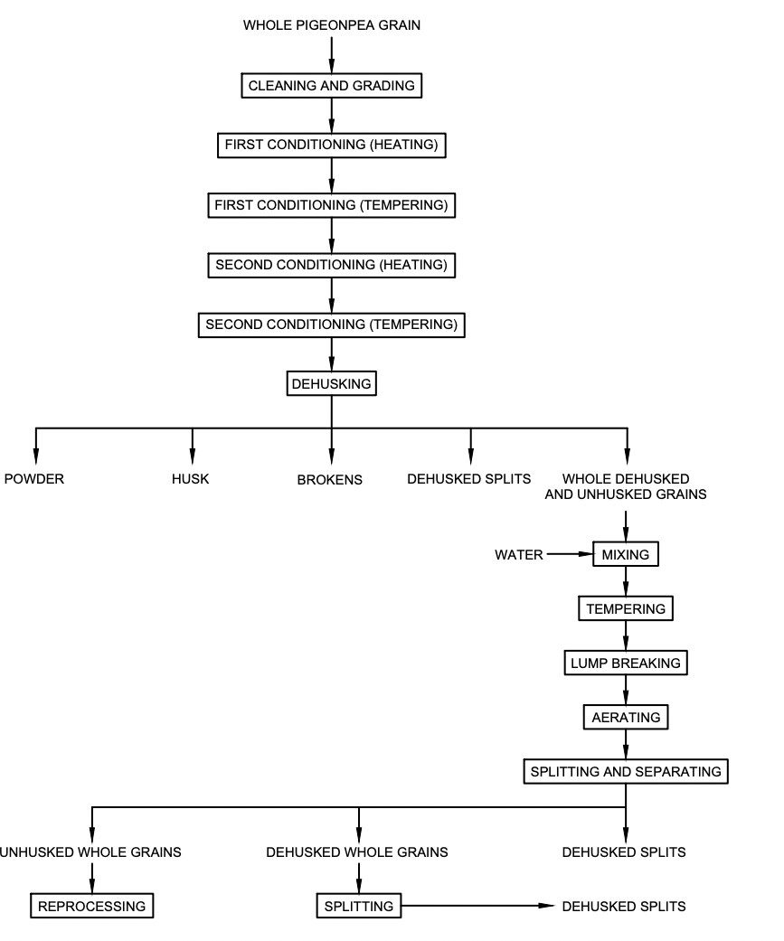

FIG. 4 PROCESS FLOW DIAGRAM OF PIGEON PEA MILLING (THERMAL PROCESS)

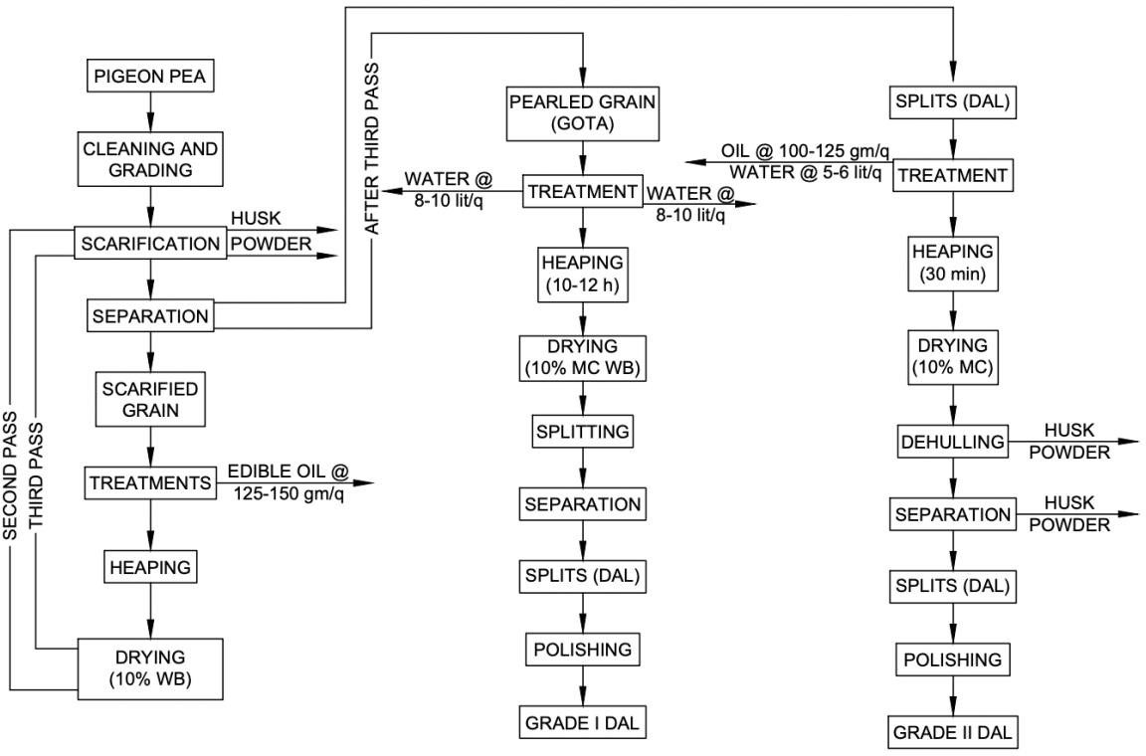

FIG. 5 PROCESS FLOW CHART PIGEON PEA DEHULLING (DRY METHOD) BY PKV MINI DAL MILL

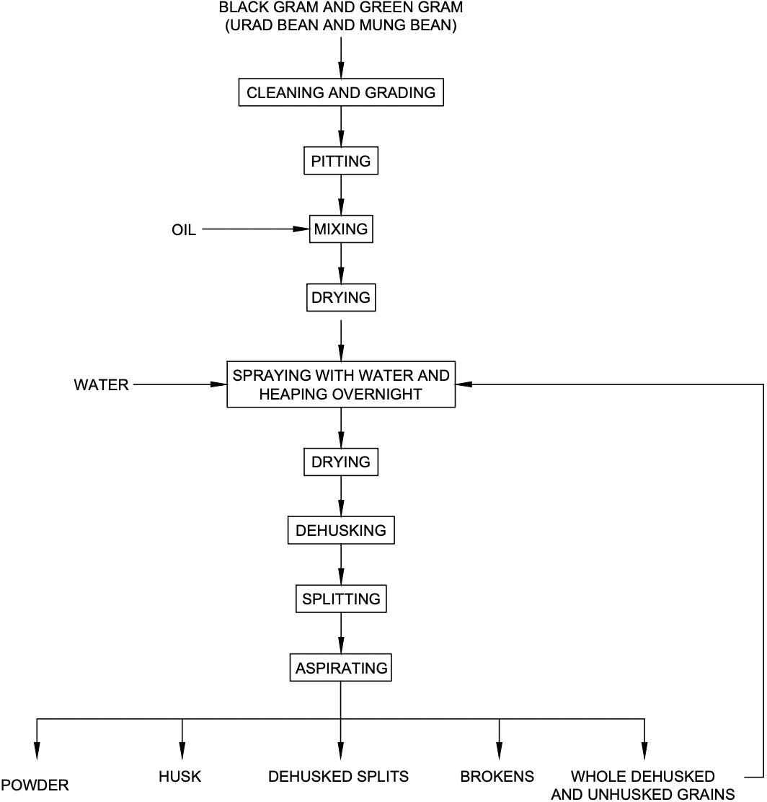

FIG. 6 PROCESS FLOW DIAGRAM OF BLACK GRAM (URD BEAN) AND GREEN GRAM (MUNG BEAN) MILLING (DRY PROCESS)

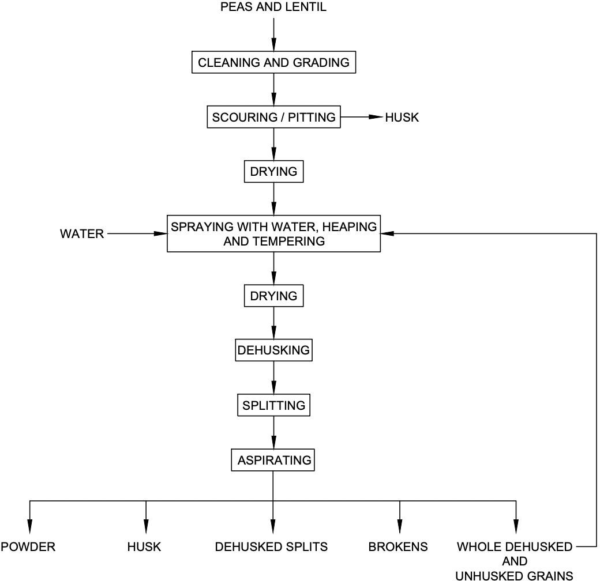

FIG. 7 PROCESS FLOW DIAGRAM FOR PEAS AND LENTIL

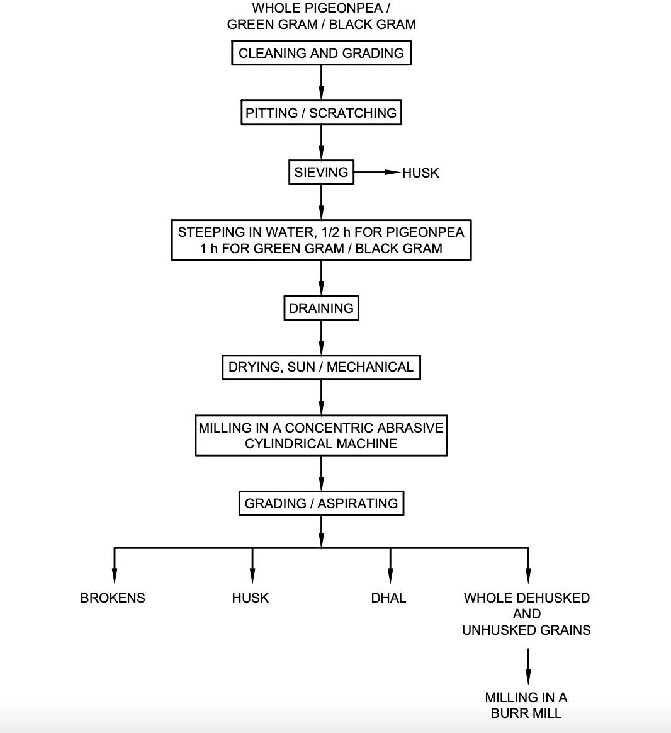

FIG. 8 PROCESS FLOW DIAGRAM FOR CIAE PROCESS OF PULSE MILLING

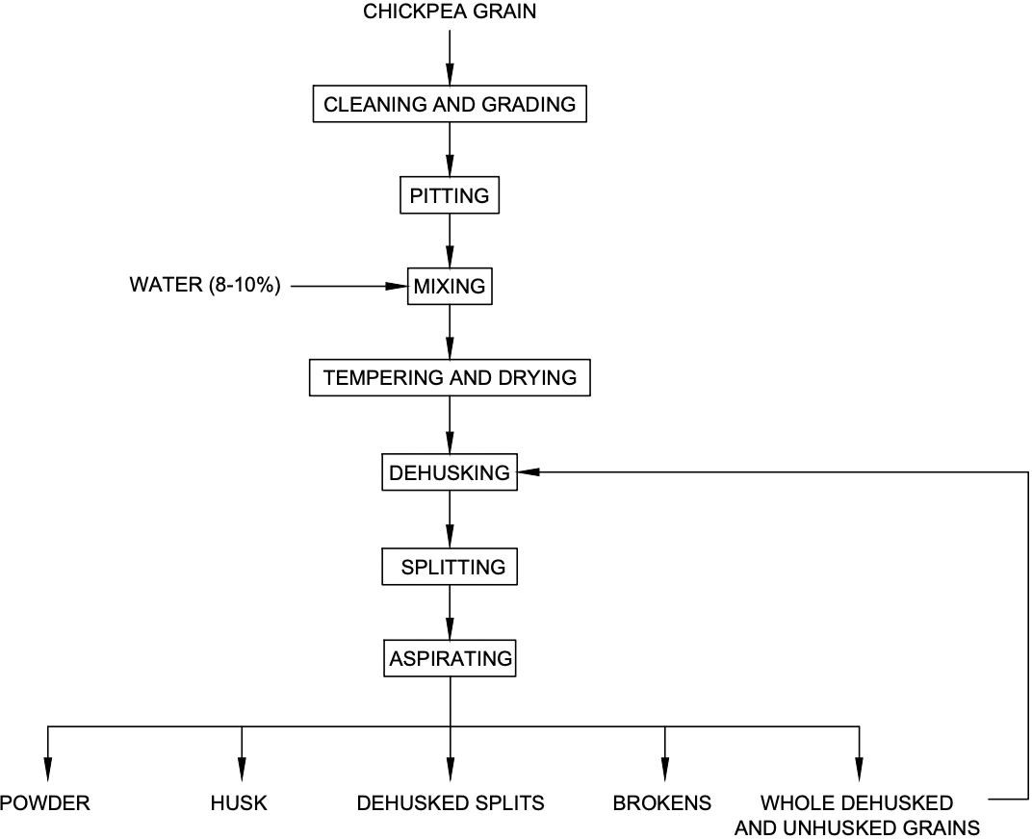

FIG. 9 PROCESS FLOW DIAGRAM OF CHICKPEA MILLING