# BUREAU OF INDIAN STANDARDS

**DRAFT FOR COMMENTS ONLY**

(*Not to be reproduced without the permission of BIS or used as an Indian Standard*)

|  |  |
| --- | --- |
| *भारतीय मानक मसौदा*  **कृषि उत्पाद मिलिंग ⎯ मशीनरी ⎯ रोलर आटा मिल ⎯ प्रवाह आरेख**  *(आई एस 12833 का पहला पुनरीक्षण)*  *Draft Indian Standard*  **Agricultural Produce Milling ⎯ Machinery ⎯ Roller Flour Mills ⎯ Flow Diagram**  *(First Revision of IS 12833)*  **ICS 65.060** | |
| Agriculture and Food Processing Equipment Sectional Committee, FAD 20 | Last Date of Comments: **04/02/2024** |

# FOREWORD

(*Adoption clause will be added later*)

This standard has been prepared to provide basic information for various processes and equipment involved in roller flour milling for the guidance of the millers particularly for modernization and setting up of new mills.

This standard was originally published in 1989. In this revision, the standard has been brought out in the latest style and format of the Indian Standards where three terms ‘Whizzer’, ‘Aeration’, and ‘Roller Unit’ have been corrected and figures redrawn for better clarity.

For the purpose of deciding whether a particular requirement of this standard is complied with, the final value observed or calculated, expressing the result of a test or analysis, shall be rounded off in accordance with IS 2: 2022 ‘Rules for rounding off numerical values *(second revision)*’. The number of significant places retained in the rounded off value should be the same as that of the specified value in this standard.

# SCOPE

This standard covers the terminology and flow diagrams for roller flour milling.

# TERMINOLOGY

For the purpose of this standard, the following definitions shall apply.

# Equipment

* + 1. *Aspirator —* An equipment used for aspiration.
    2. *Break Roll Mill —* A mill equipped with a pair of corrugated rolls placed diagonally or horizontally in parallel alignment, rotating at differential speed towards each other.
    3. *Conveyor —* An equipment or component through which material is moved from one point to other.
    4. *Cyclone Separator —* A separating device in which strong centrifugal force acting radially is used in place of relatively weak gravitational force acting vertically downwards.
    5. *Destoner —* A mechanical device which separates stones from the grain.
    6. *Disc Separator —* An equipment in which particles longer or shorter than wheat grains but similar in diameter can be separated from wheat by means of indented discs with indents of pre- determined shape and size.
    7. *Elevator —* A conveyor in which the material is moved upwards.
    8. *Magnetic Separator —* A device to remove magnetic materials from the grain mass.
    9. *Middlings Rolls —*A pair or pairs of smooth rolls used to reduce middlings in process, to flour particles size. It is also called reduction rolls.
    10. *Plane Sifter —* A shifting machine consisting of a number of super-imposed sieves gyrating together in a horizontal plane, having a rotary motion.
    11. *Purifier —* A machine with one to three layers or ducts of sieves set in an oscillating frame. It employs the principle of separation by size and density to separate a mixture of pure endosperm, composite pieces of endosperm and bran and branny material from each other.
    12. *Reels or Revolving Screens —* Cylindrical screens with slight inclination into which the material enters at. one end and falls through openings into a collecting mechanism while over-size material is discharged at the opposite end.
    13. *Roller Unit —* A mechanism used to grind wheat into flour and by-products. It consists of one or more pairs of cylindrical rolls arranged with their axis parallel and set in a heavy frame. Rolls may be corrugated (Break rolls) or smooth (Reduction rolls) rotating in opposite directions at differential speeds.
    14. *Spiral Trieur —* A device used principally for separating raw seeds from fractioned or shrivelled wheat kernels. It consists of several spiral canals wound concentrically round on a vertical shaft.
    15. *Thickness Grader —* A machine which separates particles by thickness. It is effective for separation of unripe grain from whole grain.
    16. *Whizzer —* A machine which removes water sticking on grain surface after washing by centrifugal force.

# Operations

* + 1. *Aeration —* The process of blowing small quantity of air through bulk of agricultural commodity for temperature and moisture equilibration and to prevent biological deterioration.
    2. *Air Classification —* A process which uses air currents in combination with centrifugal force, to effect the separation of flour particles into different ranges according to size and density.
    3. *Aspiration —* The process of cleaning by air blast and separating the foreign material which is substantially lower in specific gravity than the produce to be cleaned.
    4. *Blending of Wheat —* The process of drawing measured amount of different lots from bins and mixing these parts into a uniform blend.
    5. *Bolting —* Sifting of mill stocks (flour) by means of wire, silk or nylon covered seives.
    6. *Break System —* The stage in the milling process where the grain is broken open and treated on successive rolls to separate the endosperm from the bran coat.
    7. *Brushing —* A step in cleaning of wheat, where dust remaining after scouring is removed by action of brushes on the surface of grains.
    8. *Chafing —* Pneumatic separation of very light materials from the produce.
    9. *Cleaning —* The removal of foreign or dissimilar material by washing, screening, hand picking, aspiration or any other mechanical means.
    10. *Conditioning —* Adjustment of moisture content under controlled conditions, followed by a resting period to achieve a proper equilibrium of moisture through individual grains which toughens bran and mellows the endosperm, thereby improving the separation of endosperm from bran.
    11. *Damping —* Addition of water for inducing optimum moisture for operation of milling process and for getting the desired moisture content of the final products.
    12. *Grading —* In terms of milling, it means the classification by sifting, prior to purification, of the endosperm particles emanating from the break system into a relatively narrow range of particle size.
    13. *Gradual Reduction —* The process by which wheat is broken down to flour and by-products in several stages. This makes it possible to separate much of the bran before wheat is pulverized into flour particle size, resulting in a whiter flour with improved baking properties.
    14. *Impact Milling —* The reduction in size of particles by flinging them at very high speed against a hard surface.
    15. *Middling —* Particles of wheat endosperm extracted from the break system which have yet to be ground into flour. Also commercially, a by-product of milling, consisting mainly of the coarse material tailing over the end of the reduction system.
    16. *Pneumatic Conveying —* Transporting of material in enclosed tubes using air under negative or positive pressure as the conveying medium.
    17. *Reconstitution —* The blending or mixing of original constituents in the same proportions as found in the original complex substance.
    18. *Scouring —* Part of the cleaning section in the wheat mill where superficial dirt and loose shreds beeswing are removed by abrasion of wheat surface against perforated metal or emery lined cylinder and thereby blowing away the dirt by air current.
    19. *Screening —* Separation of grains by a mechanical device (sieves) where desired material is carried over and undesired material pass through it. It is a method of separating particles on the basis of size.
    20. *Tempering —* A process less elaborate than conditioning which produces desired physical changes, resulting in optimum milling in wheat by means of water additions and time for penetration.

# Products

* + 1. *ATTA —* Whole wheat flour of 90 to 95 percent extraction rate.
    2. *Bleaching Agent —* A substance added to flour to bleach out the yellow pigment, naturally present in flour and thereby gives a whiter appearance to the flour and the bread product from it, for example, benzoyl peroxide.
    3. *Bran —* The outer most covering or seed coat of the wheat grain.

NOTE *—* Commercially, it is a by-product of the milling process consisting of the large pieces of bran remaining after the flour has been extracted from wheat.

* + 1. *Break Flour —* Flour produced by the break rolls as the grain passes through the break system of the milling process.
    2. *Clean Wheat —* The wheat that has been run through a receiving separator for the removal of dockage and other extraneous materials such that it is fit for conditioning and milling.
    3. *Germ —* The embryo in a cereal grain which grows into the new plant.
    4. *Resultant ATTA —* A by-product of roller flour mills. After removal of MAIDA, SUJI and bran, the rest of the endosperm adhered with bran is ground to make resultant ATTA. This ATTA is quite different from whole meal ATTA.
    5. *Shorts —* A mixture of small pieces of bran and fibrous material remaining after flour has been extracted from the wheat. It is a by-product used for animal feed.

# FLOW DIAGRAM

* 1. A basic flow diagram of the flour milling is given in Fig. 1.
  2. A general flow diagram of milling section is given in Fig. 2.
  3. A flow diagram for roller flour mill is given in Fig. 3.
  4. Flow diagram for fractioning process of flour mill is given in Fig. 4.

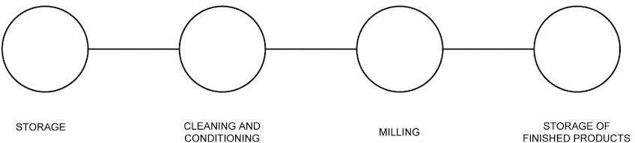

FIG. 1 BASIC FLOW

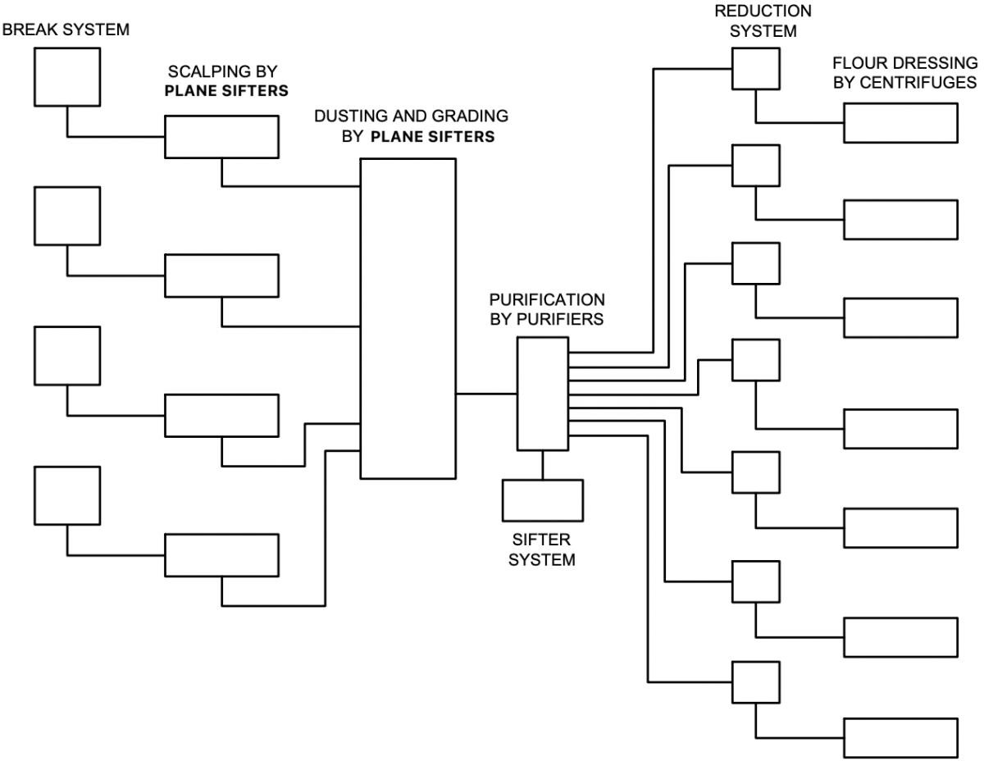

FIG. 2 FLOW SHEET MILLING SECTION

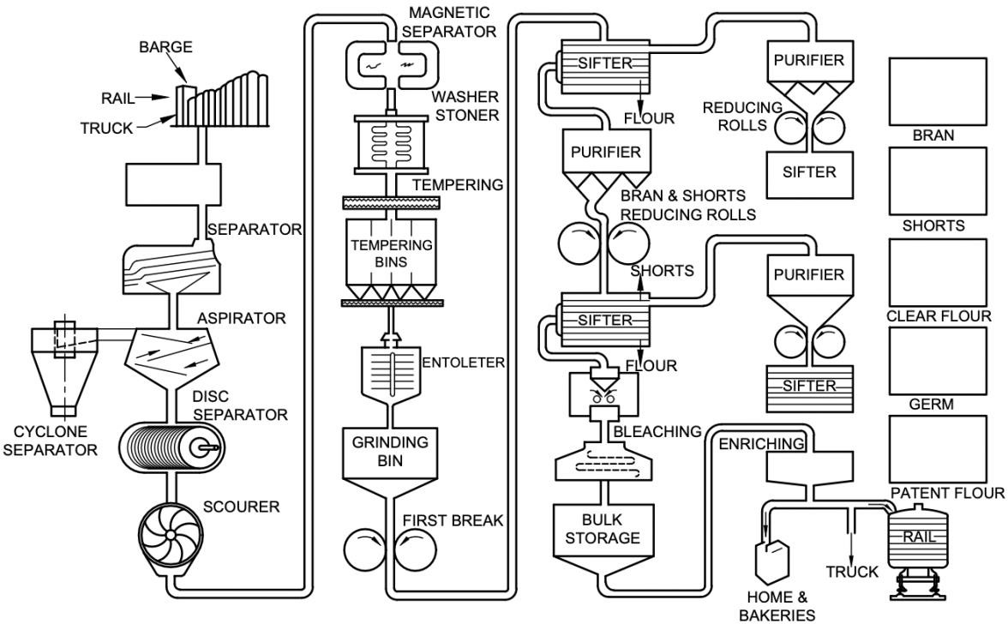

FIG. 3 FLOW DIAGRAM FOR ROLLER FLOUR MILL

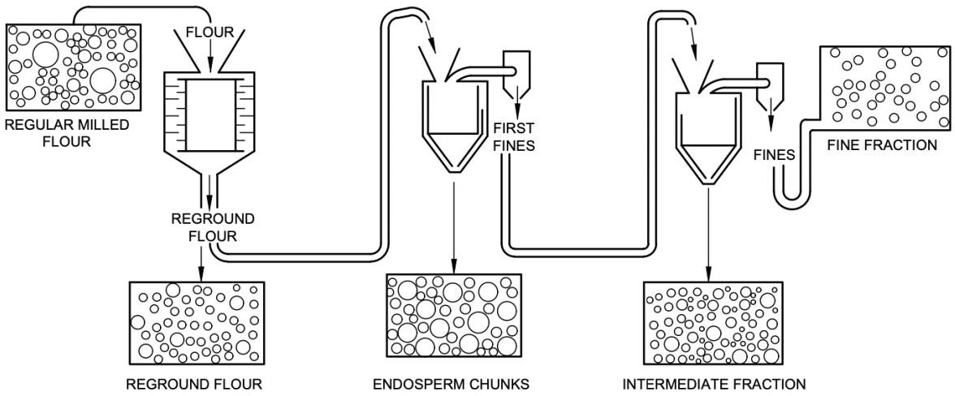

FIG. 4 FRACTIONING PROCESS OF FLOUR