**BUREAU OF INDIAN STANDARDS**

# DRAFT FOR COMMENTS ONLY

(*Not to be reproduced without the permission of BIS or used as an Indian Standard*)

|  |  |
| --- | --- |
| *भारतीय मानक मसौदा*  **एयर स्क्रीन बीज/अनाज क्लीनर — विशिष्टि**  *(आई एस 11041 का पहला पुनरीक्षण)*  *Draft Indian Standard*  **AIR-SCREEN SEED/GRAIN CLEANER — SPECIFICATION**  *(First Revision of IS 11041)*  **ICS 65.060** | |
| Agriculture and Food Processing Equipment Sectional Committee, FAD 20 | Last Date of Comments: 3 February 2024 |

# FOREWORD

(*Adoption clause will be added later*)

The freshly harvested seeds often contain inert matter like chaff, stems, stones, deteriorated and damaged seeds, weeds and other crop seeds. Air screen cleaners are used to remove these impurities from the pure seeds, therefore, it is important to select cleaner with better cleaning efficiency and keep it maintained while in operation.

This standard providing guidelines to the manufacturers and users in production, purchase and operation of air screen cleaner was published in 1984. In order to solve certain problems faced in implementation of the standard, a need was felt to revise the standard. In this revision, to update the standard with the latest industrial development and manufacturing practices, the following major modifications have been made:

1. Addition performance requirements have been incorporated like noise level, no sagging in screen and no leakage in air chamber.
2. Material of construction is updated, and requirements have been given for individual component of the cleaner.
3. The minimum load that guards shall withstand without any permanent set has been decreased from 1200 N/0.1 m² to 600 N/0.1 m².

For the purpose of deciding whether a particular requirement of this standard is complied with, the final value observed or calculated, expressing the result of a test or analysis, shall be rounded off

in accordance with IS 2: 2022 ‘Rules for rounding off numerical values *(second revision)*’. The number of significant places retained in the rounded off value should be the same as that of the specified value in this standard.

# SCOPE

This standard specifies material, constructional, performance and other requirements for air screen seed cleaners (see Fig. 1).

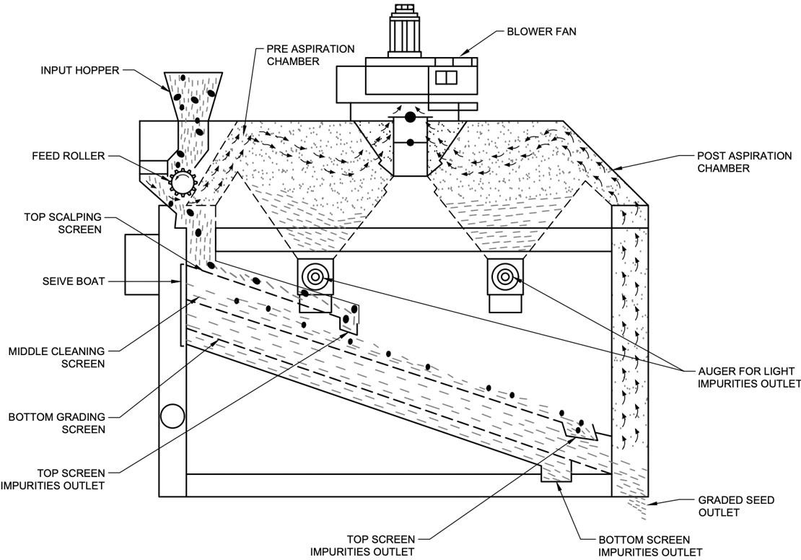

Fig. 1 General Arrangement Of Seed Cleaner

# REFERENCES

The standards given below contain provisions which through reference in this text, constitute provisions of this standard. At the time of publication, the editions indicated were valid. All standards are subject to revision and parties to agreements based on this standard are encouraged to investigate the possibility of applying the most recent editions of the standards indicated below:

|  |  |
| --- | --- |
| ***IS No.*** | ***Title*** |
| IS 210: 2009 | Grey iron castings — Specification (*fifth revision*) |
| IS 399: 1963 | Classification of Commercial Timbers and Their Zonal Distribution  *(first revision)* |

|  |  |
| --- | --- |
| IS 816: 1969 | Code of practice for use of metal arc welding for general construction in mild steel (*first revision*) |
| IS 1891 (Part 1) :  2021 | Conveyor and elevator textile belting — Specification Part 1 General purpose belting (*fifth revision*) |
| IS 2062 : 2011 | Hot rolled medium and high tensile structural steel — Specification  *(seventh revision)* |
| IS 5718: 2000 | Agricultural produce processing equipment — Seed cleaners — Test code (*second revision*) |
| IS 6911 : 2017 | Stainless steel plate, sheet and strip — Specification *(second revision)* |
| IS 8132: 2023 /  ISO 3600 | Tractors and Machinery for Agriculture and Forestry, Powered Lawn and Garden Equipment — Operator's Manuals — Content and Format (*third revision*) |
| IS 14635 (Part 1) :  2020 | Fluoropolymer dispersions and moulding and extrusion materials Part 1 Designation system (*first revision*) |

# TERMINOLOGY

For the purpose of this standard the definitions given in IS 5718 shall apply.

# MATERIALS

* 1. The material used in construction of various components shall be as given in Table 1. The thickness of sheets used shall be not less than 1 mm.

## Table 1 Material of Construction

(*Clause* 4.1)

|  |  |  |  |
| --- | --- | --- | --- |
| **Sl. No.** | **Component** | **Material** | **Reference to IS** |
| 1 | Bearing housing / Plummer block | Cast iron | IS 210 |
| 2 | Blower casing | Cast iron | IS 210 |
|  |  | Mild steel | IS 2062 |
| 3 | Blower impeller (blade holder) | Cast iron | IS 210 |
| 4 | Feed hopper | Mild steel | IS 2062 |
|  |  | Stainless steel | Grade 204 / 304 of IS 6911 |

|  |  |  |  |
| --- | --- | --- | --- |
| 5 | Feed roll | Cast iron | IS 210 |
|  |  | Teflon | IS 14635 Part1 |
| 6 | Feed rate/ distribution plates | Mild steel | IS 2062 |
|  |  | Stainless steel | Grade 204 / 304 of IS 6911 |
| 7 | Frame | Mild steel | IS 2062 |
| 8 | Gears | High carbon steel | - |
| 9 | Cam | High carbon steel | - |
| 10 | Hand wheels / adjustment levers | Cast iron | IS 210 |
|  |  | Mild steel | IS 2062 |
| 11 | Plummer block | Cast iron | IS 210 |
| 12 | Pulley | Cast iron | IS 210 |
|  |  | Mild steel | IS 2062 |
|  |  | Aluminum | - |
| 13 | Belt | Textile Belts | IS 1891 (Part 1) |
| 14 | Screen/sieves | Stainless steel | Grade 204 / 304 of IS 6911 |
| 15 | Shafts | Mild steel | IS 2062 |
| 16 | Sieve Frame/Shoe | Mild steel | IS 2062 |
|  |  | wood | IS 399 |

* 1. The material for various components not covered in the Table 1 shall be declared by the manufacturer.

# PERFORMANCE REQUIREMENTS

* 1. The cleaner shall be operated at no load as given in **8.1** of IS 5718. During the no-load run, the visual observation shall not indicate the following:

1. Presence of any marked vibration during operation;
2. Presence of undue knocking or rattling sound;
3. Frequent slippage of belts;
4. Non-smooth running of shafts in their respective bearings;
5. Any marked unusual wear or slackness in any component;
6. Any marked rise in bearing and motor temperature;
7. Vibration in fan running;
8. Noise level at more than 90 db at 1 meter from the machine;
9. Sagging of screen; and
10. Any leakage in air chamber.
    1. The rated input capacity in quintals per kWh energy consumed, with 5 and 10 percent foreign matter in the seed, shall be declared by the manufacture. The various adjustments, clearances and

speeds for that capacity shall be declared. When tested in accordance with the method given in

**9.1.6** of IS 5718, the declared capacity shall not differ by ± 5 percent.

* + 1. During and after the capacity test, the visual observation shall not indicate the following:
       1. Observations given under **5.1** (a) to (k);
       2. Frequent clogging of screen perforations;
       3. None smooth flowing of material through different components;
       4. Frequent clogging of grain in elevator unit;
       5. Frequent clogging of aspiration unit;
       6. Frequent loosening of fasteners;
       7. Variation in the position of the screen due to vibration;
       8. Leakage of seeds from the cleaner while in operation; and

j) Unequal and non-uniform distribution of seeds and grains on screen.

* 1. When tested in accordance with **9.2** of IS 5718, no breakdown shall occur in any unit of the cleaner.

# CONSTRUCTIONAL REQUIREMENTS

* 1. **Feed Hopper** — It shall be adequately proportioned so as to provide for total cover of the feed roll or the full length of the discharge opening. A safety release plate may be fitted behind the feed roll so that hard tramps are released to the scalper screen without damaging the feed roll. The thickness of sheets used shall be not less than 1 mm and preferably more than 1 mm thick.
  2. **Feed Regulating System** — The system shall be such that the feeding rate can be varied as in the range of capacity of machine for any specific crop.
  3. **Scalping System** — The shoe should carry a scalping system of a screen or set of screens comprising such a system. Suitable outlet to discharge the scalpings away from the machine should be provided.
  4. **Primary Air Cleaning** — In two-air cleaning machines, the scalped seed should fall in a uniform layer into an aspirating leg (suction duct). The light tramps having been drawn up should be discharged through adequately proportioned discharge chutes fitted with flap air seals to prevent air leakage into the aspirating chamber (causing drop in pick up). If a positive air pressure-blow system is adopted, a properly designed venturi and expansion chamber should be provided. Where a common fan is used for primary (initial) and secondary (final) aspiration, suitable control valves should be provided to permit independent regulation of aspirating pressures on both legs.
  5. **Transfer of Seed from Aspirating Leg** — The transfer may be by gravity (by dropping directly from the aspirating leg) or through a perforated reciprocating plate fitted to the shoe and reaching into the aspirating leg.

## Shoe

* + 1. The shoe should be so designed that the screen can be removed and inserted from one end and also be suitably clamped in position. The construction of the shoe should be such that it is geometrically symmetric so that it reciprocates along a single plane not exceeding 20 mm on full stroke.
    2. The shoe shall be provided with screen guides of which at least two in the case of 3 screen models and at least one in the case of 2 screen models may be pitched to different angles up to 10º from an initial inclination of 5º to 7.5 º. The guides should be capable of being locked in any desired position within this range.
  1. **Grading Screens** — The grading screens should preferably be punched sheets. The punching should be clean with all burrs removed. Maximum permissible distortion of the sheet shall be 32 mm over 400 mm. Mounting of screens should be such as to ensure maximum uniformity of the screening surface. Suitable provision should be made to prevent screen blinding during use.
  2. **Secondary or Final Air Cleaning** — The secondary cleaning shall be carried out in an aspirating leg with suitable arrangements for uniform presentation of graded seed, for control of suction air through the aspirating column and for discharge of the separated immature and air lifted tramp. The expansion chamber in this leg should have window to view.
  3. **Tramp Discharge** — All tramp should be discharged from chutes suitably placed away from machine with the provisions to fit bags or lead-down spouts.
  4. **Main Aspirating Chamber** — The main aspirating chamber shall be mounted rigidly on the frame at a convenient point. Where the fan volutes form a part of the chamber access to the volutes should be made easy with controls placed preferably on the suction end. All control handles for air regulation should be positioned for easy access from outside the machine and at a convenient height. Windows should be provided wherever expansion and drop in pressure is planned. Reinforcement of the chamber should be done wherever necessary to prevent vibration. Fan outlets should be flanged to accept ducts. All internal partitions should be rigidly riveted or welded so that air leakage between partitions is prevented. The initial and final aspiration legs should be preferably removable and flanges connected with suitable gaskets.
  5. **Fan** — The blades should be statically and dynamically balanced. The shaft should be carried on self-aligning ball bearings with dust protected bearing housings or plummer blocks.
  6. **Shoe Shaking Device** — The shake imparted to the shoe may be by a self-contained geared unbalanced system or by a pair of eccentrics. On three screen and larger machines, a variable speed of shake should be preferred. The speed of shake should range from 350 to 900 stroke/ min. The eccentrics should be fitted preferably with ball bearings, however other types suitably lubricated and protected bearings may be used. The eccentric shaft should be carried on ball bearings in housings rigidly bolted to the main frame.
  7. **Bearing** — All high speed shafts should be carried on ball bearings. Where bearing housings are carried on non-machined supports or where the shaft deflection is expected to be more than l/

500 of its span, self-aligning ball bearings shall be used. Adequate locking of the bearings on the shaft shall be provided.

* 1. **Lubrication** — All rotating parts should have provision for lubrication. All bearings should be adequately protected from dust and dirt and all housings should have sufficient capacity to hold the lubricant. Lubricating points should be accessible and marked for lubrication. When oil lubrication is required, oil hold covers should be provided, except for pawl and rachet wheel, where manual oil brushing is adequate.
  2. **Frame** — The machine frame should be of welded construction with all members formed or cut from structural steel sections. Bracings should be provided in the vertical panels to resist sway. Gusset plates are to be welded at the joints to stiffen these. Four to six foundation bolts not less than 16 mm should hold down the machine. The frame be geometrically aligned to within 3 mm on extreme diagonals.

## Transmission Guards

* + 1. Guards shall be provided to prevent accidental contact of persons or parts of clothing being caught in the transmission system, unless the system is so constructed or placed as to be safe without guards.
    2. The guards shall be so designed as not to hinder in easy adjustment, servicing and operation of the cleaner.
    3. It is preferable that all guards shall be either permanently attached or firmly secured to prevent their removal without the aid of the tools. The servicing and adjustments should be possible without complete removal of the guards.
    4. The guards shall have sufficient strength to support load of 600 N applied at any point over an area of 0.1 m2 without permanent set.

# OTHER REQUIREMENTS

* 1. Provisions for the adjustments of the following shall be made:

1. Feed rate;
2. Shaking speed;
3. Screen slope;
4. Air displacement;
5. Screen cleaning assembly;
6. Stroke of shoe assembly;
7. Broken grains discharge trough; and
8. Emergency switch off button.
   1. All the controls shall be easily accessible and capable of being locked in a chosen position.
   2. Provision for belt tightening shall be made.
   3. Provision for easy transportation and towing with tractor shall be provided. In case of stationary unit, the cleaner should be grounded adequately to withstand static and dynamic loads.
   4. The cleaner shall be provided with the operator’s manual (*see* **4.2** of IS 8132). Manual shall also contain the information given in Annex A of IS 5718.

# WORKMANSHIP AND FINISH

* 1. Welding used for joining different components shall not be porous (*see* IS 816).
  2. The components of the cleaner shall be free from cracks, cuts and other visual defects which may be detrimental for their use. Rust preventive coating to the steel components and varnish to the wooden components shall be provided.

# MARKING AND PACKING

* 1. **Marking** — Each cleaner shall be marked with the following particulars:

1. Manufacturer’s name and recognized trademark, if any;
2. Model number;
3. Batch, code or serial number;
4. Power rating, kW; and
5. Rated input capacity.
6. Year of manufacture
   * 1. A minimum cautionary notice worded as follows shall be written in vernacular language legibly and prominently on the main body of the cleaner:
        1. Do not wear loose dress, bangles, watch, etc, while working;
        2. Do not work under the influence of intoxicants like liquor, opium, etc;
        3. Children and aged persons should be discouraged for working on cleaner;
        4. Do not cross over moving belts;
        5. Do not operate cleaner without guards and safety devices;
        6. Do not make adjustment when cleaner is working; and
        7. Do not put or take-off belt while pulley is running.
   1. **Packing** — The cleaner or its components shall be packed as agreed to between the purchaser and the supplier.

## BIS Certification Marking

The product(s) conforming to the requirements of this standard may be certified as per the conformity assessment schemes under the provisions of the *Bureau of Indian Standards Act, 2016*

and the Rules and Regulations framed thereunder, and the products may be marked with the Standard Mark.

# SAMPLING AND TESTS

* 1. At least one cleaner of a production model shall be tested under type testing for all the requirements of this specification.
  2. Each cleaner shall be tested under routine testing for the following:

1. Requirements given under **5.1, 7.5** and **9**; and
2. Dimensional measurement of the characteristics given in **A-3** to **A-11** of IS 5718 and comparing the values with those which were obtained for the cleaner type tested:
   1. For lot acceptance, the method of sampling and criteria of conformity shall be as agreed to between the purchaser and the supplier.