BUREAU OF INDIAN STANDARDS
DRAFT FOR COMMENTS ONLY
(Not to be reproduced without the permission of BIS or used as an Indian Standard)
Proposed Draft Indian Standard
Mobile Agro-Processing Equipment Unit for Food Grains – Safety Requiremens

Agriculture and Food Processing Equipment Last Date for Comment : 6 February 2024 Sectional Committee, FAD 20

FOREWORD
(Formal clause will be added later)
All the food, feed, fibre and fuel commodities go through a number of post harvest processing operations such as cleaning, grading, separation, drying, storage, milling, food processing, packaging, transportation and marketing before it reaches the consumers. Agricultural processing is directed towards conservation of produce and value addition to make the material more readily usable and economically more remunerative.
Food habits are changing as a result of lifestyle changes and this is leading to increasing demand for processed foods. Mobile agro processing units have thus become more & more popular. The urgency to provide for safety provisions in the mobile agro processing units for food grains has become more pronounced.
Figures of various components given in this standard are meant for illustration and should not be treated as suggestive of any standard design.

1. SCOPE
This standard specifies safety requirements for mobile agro-processing units for food grains. This standard applies to grain handling and processing equipment, conveyors and common hazards associated with mobile agricultural machinery.
2. REFERENCES
The Indian Standards listed below contain provisions which through reference in this text, constitute provision of this standard. At the time of publication, the editions indicated were valid. All standards are subject to revision and parties to agreements based on this standard are encouraged to investigate the possibility of applying the most recent editions of the standards indicated.
3. DEFINITIONS
For the purpose of this standard the following definitions shall apply.
3.1 Nip Point — The point at which an element of the conveyor machinery moving in a line or rotating meets another element which is either rotating or moving in a line in such a manner that it is possible to nip, pinch, squeeze, or entrap objects coming in contact with one of the two elements.
3.2 Pinch Points — The point where two or more parts move together with at least one part moving in a circle.
3.3 Crush Points — The point at which two components move toward each other.
4. LIST OF HAZARDS
4.1 Common Mobile Machinery Hazards
Machines are designed to use power, torque, motion, and energy to perform work. They may be powered by power take off drivelines, hydraulic oil pressure, electrical motors, internal combustion engines, or ground traction. Regardless of how machines are powered, they present a number of hazards to those working around them.
There are several dangerous areas that can cause injury, dismemberment, and/or the death of the operator. Machinery related hazard areas are as follows.
- The pinch points on rotating parts may catch clothing, hands, arms and feet of operator or person working around mobile agro-processing units. The areas where drive belts contact pulleys or sprockets mesh with chains are prime examples of pinch points (Fig. 1)
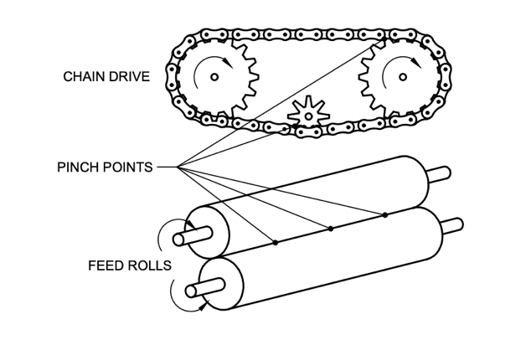
Fig. 1 PINCH POINTS ON ROTATING PARTS
- Crush-point hazards on machines occurs during raising and lowering equipment with a three-point hitch, moving of components by hydraulic cylinders etc (Fig. 2).
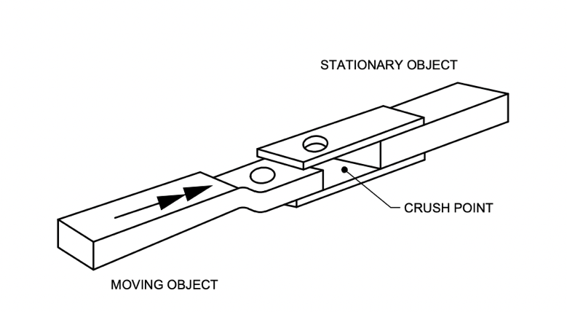
Fig. 2 CRUSH POINT
- Wrap (entanglement) point hazards pertain to any exposed rotating component (shaft or driveline). Exposed bolts, universal joints, burrs, or other projections on rotating components can grab clothing, resulting in serious injuries. (Fig. 3)
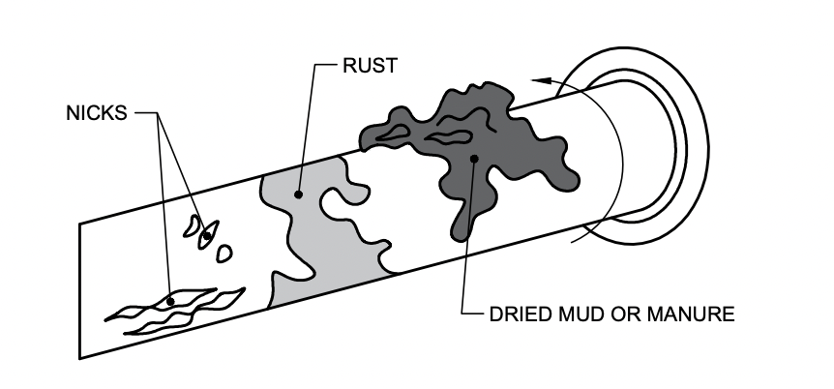
Fig. 3 WRAP POINTS HAZARD ON ROTATING COMPONENTS
- Pull-in point hazards involve mechanisms designed to take in crops or other materials for processing. They include windrow pickups, forage chopper headers, and grinders. Feeding sugarcane crusher is an example of pull-in hazard (Fig. 4)
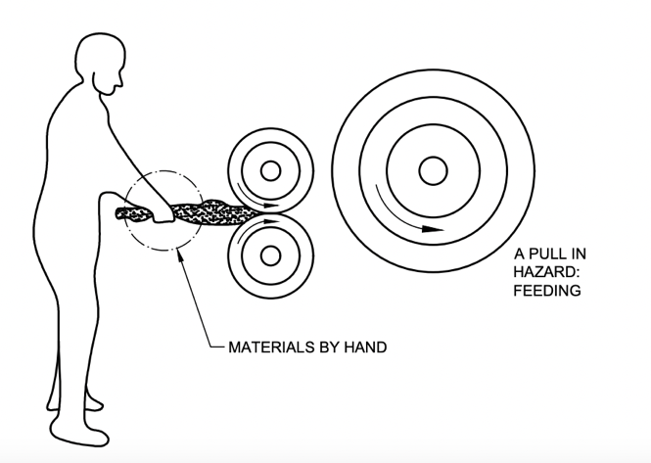
Fig. 4 PULL-IN HAZARDS IN MACHINES

e) Shear and cutting point hazards are areas where two parts move across one another or one moves across a stationary object. Grain augers are examples of cutting and shear points.
f) Thrown objects present another type of machine hazard, Metal, glass, wire, sticks, or other materials may be picked up by a machine and propelled with extreme force.
g) Stored energy hazards are present in pressurized systems such as hydraulics, compressed air, and springs. The sudden or unsuspected pressurization or depressurization of these systems can result in crushing and other types of accidents, depending on the use of the system. High pressure leaks are also forms of stored energy hazards.
4.2 Grain Handling and Processing Equipment Hazards
Grain processing equipment and storage facilities may present a host of risks if a farmer fails to carefully look at the potential hazards in the workplace. These hazards include entanglement in augers, electrocution from contacting overhead powerlines, entrapment in flowing grain, respiratory illnesses from dust and molds, and other health and safety risks.
4.2.1 Electrocution Hazard
Electrocution hazard from the auger contacting overhead powerlines occur when the operator fails to lower the auger before moving it. The metal auger touches the overhead line conducting electricity through the auger to the individual.
4.2.2 Dust and Molds
Dusts are a common hazard in farming and agro processing industries. All dusts have the potential to cause health problems, but some organic or toxic dusts may permanently impair farmers’ health. The type of dust and duration of exposure will determine the severity of the health problem.
The movement and processing of forage, cereals and animal feed inevitably produce dust in the form of fine and very fine particles from these materials. The dust may be irritating to the eyes, lungs or skin, but in circumstances where the dry forage or cereals get overheated producing mold, a far more insidious effect may result. Some dusts, especially dust from moldy forage, grain, or hay, carry antigens that can cause severe irritation to the respiratory tract. Breathing dust from moldy feed materials can result in a permanent lung condition commonly known as “Farmer’s Lung”.
4.2.4 Noise Pollution
Dal, wheat and rice mills, grain drying and handling equipment may produce enough noise to damage the hearing of an individual working in the area. Typically, a dull, ringing sensation in one’s ears after a long day of working with noisy equipment is an indication that he has exceeded a sound level that can be comfortably tolerated. This ringing is frequently accompanied with a slight loss of hearing, where it may be difficult to hear faint sounds that could normally be detected. Overnight rest will generally restore complete hearing, but repeated, prolonged exposure to noises of this intensity will likely result in permanent hearing loss.
4.2.5 Vibration Hazards
The use of hand-held or guided machines can transmit vibrations through the handles/seats to the operator and can cause vascular damage and musculoskeletal disorders, leading to ‘White finger disease’. Such effects are intensified when system components are not properly balanced.
4.2.6 Thermal Hazards
Sudden contacts with unguarded hot surfaces like engine exhausts, hydraulic pipes, processing lines, steam ducts can cause burns and scalds. During handling of grain and forage in processing equipment, the risk of fire and explosion due to the overheating of machine parts and materials should never be neglected. Furthermore, the heat or cold stress on the operator during working operations can also result in adverse health effects and reduce operator efficiency.
4.2.7 Visibility
Grain handling and processing machines are usually large in size and may impair the direct visibility over the working area for the operator. As such, sufficient provisions including working lights, indirect means of vision (e.g, CCTVs), viewing panels, level indicators must be fitted in the working area.
4.3 Conveyer Operating Hazards
The top hazard points for conveyors are:
- Power transmissions
- Nip points
- Shear points
- Pinch points
- Spill points
- Areas under counterweights
- Transfer mechanisms
- Passage areas under conveyor
5. SAFETY REQUIREMENTS AND SAFETY MEASURES
5.1 General Guidelines for Safe Machinery Operation
The general guidelines for safe machinery operation are as follows.
- Learn to operate your machinery properly. Use the operator’s manual (see 7.2.2) as a guide.
- Learn the hazards involved with machinery operation; be proactive and anticipate dangerous situations.
- Be alert at all times when operating machinery. Take breaks and get sufficient food and rest to stay alert.
- Always follow recommended safe practices for operating machinery.
5.1.1 Safety Guards and Warning Signs
Modern agro-processing machinery is factory equipped with a variety of safety features, including guards, shields, and warning signs designed to reduce injuries. Needless injuries and deaths occur because safety guards are removed, broken, or torn off during operation(.)
- Regularly inspect the machinery for missing or damaged safety guards and signs.
- If guards or signs are missing or damaged, repair or replace them before using the machine.
- Never operate a machine with missing guards.
- First aid box should be readily available with mobile agro processing unit and it should be regularly checked for date of expiry of the medicines/ointments.
5.1.2 Repairs and Adjustments
Repairs and adjustments are frequently necessary to ensure optimum machinery performance and efficiency. Numerous accidents occur because operators attempt to make repairs or adjustments while a machine was running. Others have been injured or killed by being crushed when equipment fell while they were working underneath it.
- Be sure to turn off the machine and take the key out before making any repair or adjustment.
- Do not depend on the hydraulic system to keep the implement or attachments in the raised position; prevent them from failing by placing blocks beneath them. Only then adjustments or repairs can be done safely.
5.1.3 Power Take Off (PTO) Drivelines
Power-take-off drivelines (shafts) are among the oldest and the most common machinery hazards. In order to reduce PTO injuries and deaths:
- Ensure PTO drivelines are fully shielded.
- Never attempt to step over rotating PTO drivelines, no matter how slowly they may be turning.
- Never wear loose, baggy clothing around PTO drivelines.
- Keep long hair pulled back to avoid entanglement.
- Stay well clear of rotating PTO drivelines.
5.1.4 Visibility
Grain handling and processing machines are usually large in size and may impair the direct visibility over the working area for the operator. As such, sufficient provisions including working lights, indirect means of vision (e.g, CCTVs), viewing panels, level indicators must be fitted in the working area.
5.2 Grain Handling and Processing Equipment
5.2.1 Electrocution Hazard
To avoid the risk of touching overhead electrical lines, lower the auger before transporting and follow State Electricity Board recommendations
5.2.2 Dust and Molds Hazards
To protect workers in general industry against byssinosis, a chronic lung disease, a maximum limit should be 15 mg/m³ for total dust and 5 mg/m³ for respirable dust. The maximum exposure limit for dust, organic dust and quartz should be as given in Table 1.
Table 1 Maximum Exposure Limits
(Clause 5.2.2)

Sl. No. | Particular | Time-weighted average* |  | Peak limit or short-term limit**
 |  | Total dust | Respirable dust
(1) | (2) | (3) | (4) | (5)
1 | Dust, mg m⁻³ | 10 | 5 | -
2 | Organic dust, mg m⁻³ | 5 | - | -
3 | Quartz, mg m⁻³ | - | 0.1 | -

* Time-weighted average limit during a workday
**Highest acceptable time-weighted average concentration during a 15-minute period (short term exposure limit)
5.2.2.1 Safety precautions
- Farmers should use disposable dust masks or a respirator with a replaceable cartridge designed to filter dusts, which ensures an adequate supply of clean air to the farmer. NIOSH recommends that exposed workers wear the most practical respirator with the highest assigned protection factor (APF).
- Change the mask or cartridge frequently for the greatest protection.
- Preferably cleaner and grader should be provided with cyclone dust collector to reduce pollution in the air within the premises of mobile cleaning units.
- A self-contained breathing apparatus similar to those worn by fire fighters is needed to work in oxygen deficient areas such as in freshly filled silos, manure pits, or in grain bins during and after fumigation.
- Grain processing equipment which are likely to produce dust should accompany with cyclone separator.
- To reduce the risk of respiratory problems from dusts, a farmer should store only dry grain and dry well cured forages and hay. Mold develops in moist or wet grain, forages, hay and many other moist or stale organic materials.
- Agricultural workers and employers should minimize the risk of exposure to organic dusts by taking the following precautions:

- Be aware of the health effects of breathing organic dust. Symptoms of organic dust toxic syndrome (ODTS) occur 4 to 12 h after exposure and may include fever, weakness, headache, chills, body aches, cough, and shortness of breath.
- Inform your doctor about recent dust exposures when seeking treatment for respiratory illness.
- Carefully harvest and store agricultural products.
- Use automated or mechanized equipment to move decayed materials.
- Use local exhaust ventilation and wet methods of dust suppression to minimize exposure to organic dusts.
5.3 Noise
As the intensity of the noise increases, the amount of exposure necessary to cause hearing damage decreases (Fig. 5). Therefore, to avoid hearing loss, a farmer should wear ear plugs or ear muffs whenever exposed to noisy equipment that causes any hearing loss symptoms.
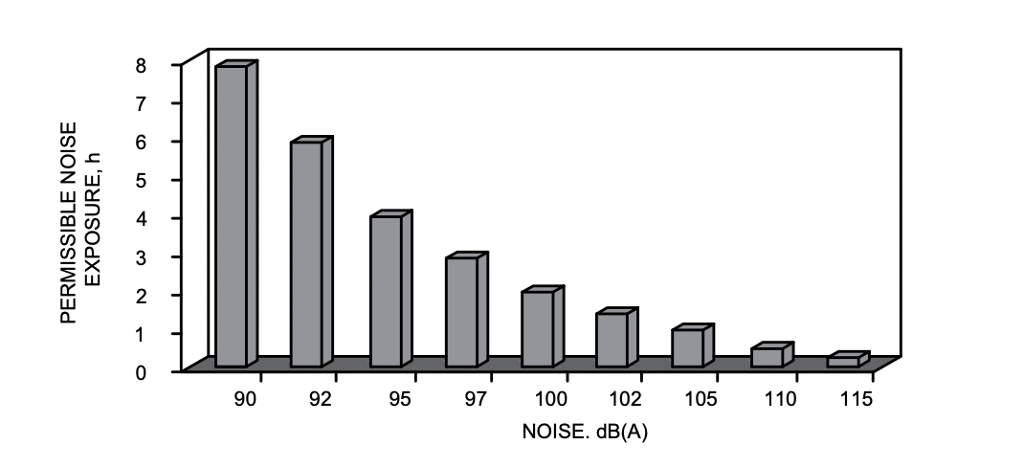
FIG. 5 PERMISSIBLE NOISE EXPOSURE
5.3 Conveyor hazards
5.3.1 Guards - Guards constitute one of the most common types of safety devices used for the protection of conveyors. Guards are coverings or barricades provided for safety purposes on such parts as gears, chains or nip point guards etc. The following safety precautions shall be taken care of:
- Never operate conveyor/conveyor system unless the guarding provided is in place.
- All guards provided on conveyor should be maintained in a safe condition and warning signs be kept in legible condition.
5.3.2 Power Transmission
The need for power transmission system is common to all types of powered conveyors involving items such as drives, gears, shafts, couplings, etc.
Carefully examine conveyor equipment to assure that guarding is provided for all exposed power transmission equipment to protect operators and others in the work area from accidental contact. Typical items to be observed include:
- Drive Guards for chain, v-belt, and gear must be both practical and durable. Guards can be constructed of expanded metal, perforated or solid sheet metal, wire mesh, plastic, or other materials securely fastened to the conveyor framework.
- Coupling Guards must be provided around all direct connections between motors and gearboxes when couplings are used to connect shafts.
- Line shaft drives are still utilized on some types of conveyors to distribute power to the conveying mechanisms. Care should be taken in their location to prevent fingers, aprons, strings, or hair entering the line haft guard.
- The protruding ends of rotating shafts or keyed shafts are particularly dangerous. Plastic end caps can be used to enclose ends to prevent items from becoming caught in shafts.
- All exposed, moving parts of a conveyor which present a hazard to employees at their workstation should be mechanically or electrically guarded or guarded by position or location.
- Ease of access or approach to conveying equipment is essential to assure proper and continuous usage. To assure an accessible and safe conveyor operation requires understanding between the design/manufacturer and safety training by the owner.
- Providing a safe working place involving conveyors also requires consideration of electrical controls. Companies that use powered conveyors should make reference to these sections of the Safety Standards regarding conveyor guarding using electrical controls and stop switches for safety.

6.CONSTRUCTIONAL REQUIREMENTS FOR TROLLEY/VEHICLE
To ensure the safety, following points shall be considered while manufacturing/fabrication of trolley:
- Height of platform from ground shall be minimum 0.90 m (3ft) to have space for filling of grains after cleaning directly in the bag containers and also to avoid hitting speed breakers on the roads to bottom of the platform.
- Height of machines on the platform shall be maximum 6.0 m to maintain proper balance of the machines and also to avoid hitting the machines to overhead cables and wires and to suit movement of mobile unit in the cities with low height bridges and height limited domestic areas.

- The maximum width of any vehicle or trolley on the road shall be 2.43 m (8 ft.) and for easy turning, the maximum length of any vehicle shall be 7.0 m. And, the over all dimensions of the standard mobile plant should meet the regulatory traffic road parameters.

- Safety railings of either pipe or angle or any other suitable material shall be provided to avoid accidents due to falling down from the platform. Similarly, suitable stairs shall be provided to climb on the platform.

- Stability of machines in operations and stable platform are necessary for longer life of machines. So suitable mechanical strongjacks have to be provided to the trolly to hold the platform steady without vibrations of machines and platform.

- Dynamic balancing of machines fixed on mobile platform is necessary to avoid over-turning of mobile on either left, right or back and front side due to weight imbalance . Dead weight of the machines has to be equally distributed to keep center of Gravity inthe middle of platform.

- Four or more red lights need to be fixed on the two corners from side and two lights at the back side and if available on sides also so that the mobile trolley can be recognized in the dark of night. These lights are useful for parking lights also. Similarly, the reflective stickers also need to be used to avoid the accidents.

- The toe lever on front side of mobile trolley for pulling the mobile unit by vehicle should be designed properly so that while pulling mobile plant by tractor or any vehicle or even bullocks the toe should not get stuck to any mobile platform part. Turning radius of the towing lever has to be limited so that turning of mobile platform will be smooth.

- The mobile trolley should be provided with suitable Pneumatic or solid Tyre wheels or any other suitable type of wheels to pull the mobile unit from farm to farm or within premises of APMC or shed.

- Wheel Breaks should be provided to the wheel of trolley so that onhilly areas trolley speed and direction can be controlled with the help of individual break system.

- Trolley should be sturdy, strong, light weight and easy to bear dead load of machines, live load and operational load of grains while in working condition.
7. INFORMATION FOR USE
7.1 Marking
The following shall be marked on the machine;
- Name of the manufacturer and/or seller or hirer,
- Type of machine;
- Serial number;
- Year of construction;
- Data on power supply: voltage in volts, frequency consumption expressed in kilowatts, andsound power level if necessary.
7.2 Handbook of Instructions
This handbook shall be written in the official language(s) of the state where the machine is intended to be used and the units shall be SI units.
The instruction handbook shall include the following.
7.2.1Technical Data
- General description of the machine with dimensions sketches, etc.
- Normal operating conditions,
- Machine weight and component weights if the machine is supplied in parts,
- Slinging and handling precautions,
- Loads on fixing points, if the machine is to be fixed, and
- Wiring diagram
7.2.2 Operation Manual
7.2.2.1 Normal operating conditions
This handbook shall explain the various operating modes, especially the order in which starting and stopping operations shall be made.
7.2.2.2 Maintenance manual
This manual shall include:
- The lubrication drawing, frequency of operations and list of products to be used
- The recommended technique for cleaning the machine
- Instructions to isolate the machine in a safe condition in the event of the need to repair or maintain any safety device.
- A list for identification of spare parts, etc.
7.2.2.3 The operating and maintenance manual shall be readily available with the mobile agro-processing unit.

