**BUREAU OF INDIAN STANDARDS**

# DRAFT FOR COMMENTS ONLY

(*Not to be reproduced without the permission of BIS or used as an Indian Standard*)

|  |  |
| --- | --- |
| भारतीय मानक मसौदा  **बीज प्रसंस्करण उपकरण - गुरुत्व विभाजक—विशिष्ठी**  *(आई एस 14460 का पहला पुनरीक्षण)*  **Draft Indian Standard**  **SEED PROCESSING EQUIPMENT - GRAVITY SEPARATOR—SPECIFICATION**  (*First Revision of IS 14460*) | |
| Agriculture and Food Processing Equipment Sectional Committee, FAD 20 | Last date of comments: **9 March 2024** |

# FOREWORD

(*Adoption clause will be added later*)

Seed of the same size and general shape can often be separated because they differ in specific gravity. This difference is very useful in removing light immature seed or heavy seed and rocks to improve the purity and germination of crop seed. This is basically the separation made by the gravity separator, which uses air as a separation substrate.

In the preparation of this standard assistance has been derived from the Maharashtra Hybrid Seed Corporation, Akola and National Seeds Corporation Ltd., Delhi. This standard was originally published in 1989. In this revision, following modifications have been incorporated keeping in view the technological advancements in the field and the standard has been brought out in the latest style and format of the Indian Standards:

1. Test methods to evaluate the performance of this equipment have been incorporated.
2. The material specifications for individual components of the equipment have been updated and the referred standards updated.

This standard contains **11.2** which call for agreement between the purchaser and the supplier.

For the purpose of deciding whether a particular requirement of this standard is complied with, the final value, observed or calculated, expressing the result of a test or analysis, shall be rounded off in accordance with IS 2: 2022 ‘Rules for rounding off numerical values (*second revision*)’. The number of significant places retained in the rounded off value should be the same as that of the specified value in this standard.

# SCOPE

This standard specifies material, performance, constructional and other requirement of specific gravity separator. It also prescribes the methods of test for evaluating the performances of this equipment.

# REFERENCES

The Indian Standards given reference in this text, constitute provision of this standard. At the time of publication, the editions indicated were valid. All standards are subject to revision and parties to agreements based on this standard are encouraged to investigate the possibility of applying the most recent editions of the standards indicated.

|  |  |
| --- | --- |
| *IS No.* | *Title* |
| IS 210: 2009 | Grey iron castings — Specification (*fifth revision*) |
| IS 277: 2018 | Galvanized steel strips and sheets (Plain And Corrugated) — Specification  (*seventh revision*) |
| IS 399: 1963 | Classification of commercial timbers and their zonal distribution (*first revision*) |
| IS 2062: 2011 | Hot rolled medium and high tensile structural steel — Specification (*seventh*  *revision*) |
| IS 4333 (Part 2): 2017/  ISO 712: 2009 | Methods of analysis for foodgrains: Part 2 Determination of moisture content  (*second revision*) |
| IS 4454 (Part 4): 2001 | Steel wires for mechanical springs: Part 4 Stainless steel wire (*second revision*) |
| IS 6911 : 2016 | Stainless steel plate, sheet and strip — Specification (*second revision*) |

# TERMINOLOGY

For the purpose of this standard the following definitions shall apply.

* 1. **Adjustments —** The gravity separator is a versatile machine and can accomplish a wide range of separations primarily because it has many adjustments which allow the operator to control the separating action precisely. Five main adjustments areas given in **3.1.1** to **3.1.5**.
     1. *Feed Regulating Mechanism* **—** The mechanism which regulates the feed rate to the specific gravity separator.
     2. *Air Control Device* **—** A mechanism at the air-inlet to the fans which regulates the air velocity or air pressure through the deck base and surface material at the outlet.

NOTE — Air is used for stratification of seed material vertically on the deck, in which seed of higher specific gravity fall down through the substrata while seed of lower gravity will be buoyed up the strata.

* + 1. *End Slope* **—** Slope of deck from the feed hopper to the extreme discharge end, which controls the output capacity of the machine.
    2. *Side Slope* **—** The tilt or inclination of the deck from the low side to the high side of the discharge end.
    3. *Deck Oscillation Speed Control* **—** The mechanism which regulates the motion of the deck per unit time.
  1. **Body —** The stationary machine base frame with fans and air chamber connected with the deck with flexible tarpaulin shroud.
  2. **Deck —** Adjustable frame fitted in the body with oscillating mechanism or table on which fluidization of material and separation is affected.
  3. **Cleaned Seed —** The seed lot which is free from chaff, dust, undersize impurities, oversize impurities, stones, metal pieces, seeds of other crops, seeds of other varieties, damaged seeds, *etc.* are as removed using appropriate seed processing units.
  4. **Cutting Fingers —** The devices used for collecting the seed in the deck delivery edges based on visual observation into graded sound seed, reject and middling.
  5. **Feed Rate —** The quantity of the cleaned seed fed into the specific gravity separator per unit time. It is important to maintain steady feed rate after machine setting to ensure quality.
  6. **Germination —** It is the emergence and development from the seed embryo of those essential structures which for the kind of seed in question are indicative of its ability to produce a normal plant under favorable conditions.
  7. **Gravity Separator —** A machine used for upgrading of cleaned seed passed through an air-screen- cleaner. It separates from uniform sized seed material, lighter immature and insect damaged, rain damaged seed and heavy inert material based on specific gravity of different components in order to get good seed. The separation is achieved with the co-ordination of five adjustments (*see* **3.1**).
  8. **Good Seed —** The graded seed having high degree of physical purity as per standards prescribed under the *Seed Act*, 1966.
  9. **Healthy or Viable Seed —** The physically pure seed capable of germination to give healthy plant. Healthy seed percent is obtained by multiplying purity percent and germination percent and divided by 100.
  10. **Middling —** The intermediate product in the gravity deck between heavier good seed and the light material contains too many good seed to be thrown away but too few to permit blending it into the good seed fraction. This product is run over the gravity separator again to salvage the good seed. In larger plants the middling is run in second gravity separator and the good seed obtained in two-part separation is blended with that obtained from the first machine.
  11. **Pure Seed —** The graded seed completely free from visible physical impurity.
  12. **Raw Seed —**The seed received after threshing, containing good seed, inert matter, light and shriveled seed, oversized and undersized seed and weed seed.

# TYPES

* 1. The gravity separators used in seed industry are of the following types based on the shape of the deck used:

1. Triangular type (*see* Fig. l), and
2. Rectangular type (*see* Fig. 2).

# SEPARATIONS

* 1. The following types of separation are effected in four fractions in both type of machines:

|  |  |  |
| --- | --- | --- |
| Fraction 1 | Light seed | To be outright rejected |
| Fraction 2 | Middling | A mixture of good seed and light seed to be re-run simultaneously and blend the good seed recovered with fraction 3 |
| Fraction 3 | Good seed | Approved quality |
| Fraction 4 | Heavy | A mixture of heavy seed and mud balls/stone-to the end to recover  the sound seed to blend in Fraction 3. |

# MATERIALS

The material of construction of various components of gravity separators shall be as given in column 3 of Table 1. The material may conform to the relevant Indian Standards given in co1 4.

# PERFORMANCE REQUIREMENTS

* 1. When tested in accordance with the method given in Annex A, the gravity separators shall conform to the following requirements:

1. Improvement in quality of seed percent between air-screen-cleaned input seed to gravity graded output seed shall be 10 percent minimum
2. Improvement in bulk density/l000 seed weight of air-screen-cleaned seed *versus* gravity graded good seed shall be 2 percent minimum.
3. The percentage of inert matter in good seed shall not be more than 1 percent.
4. The percentage of lighter seed in good seed shall not be more than 3 percent.
   * 1. The gravity separator shall withstand the tests given under **12.**

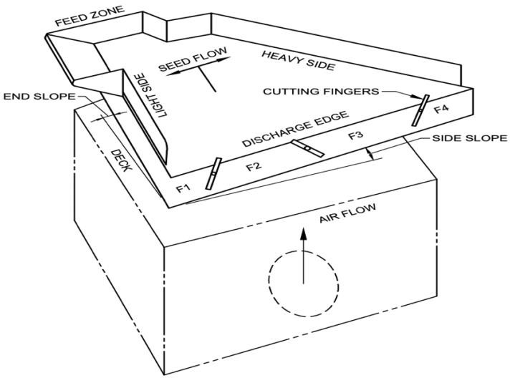

FIG. 1 SCHEMATIC DIAGRAM OF GRAVITY SEPARATORS (TRIANGULAR TYPE)

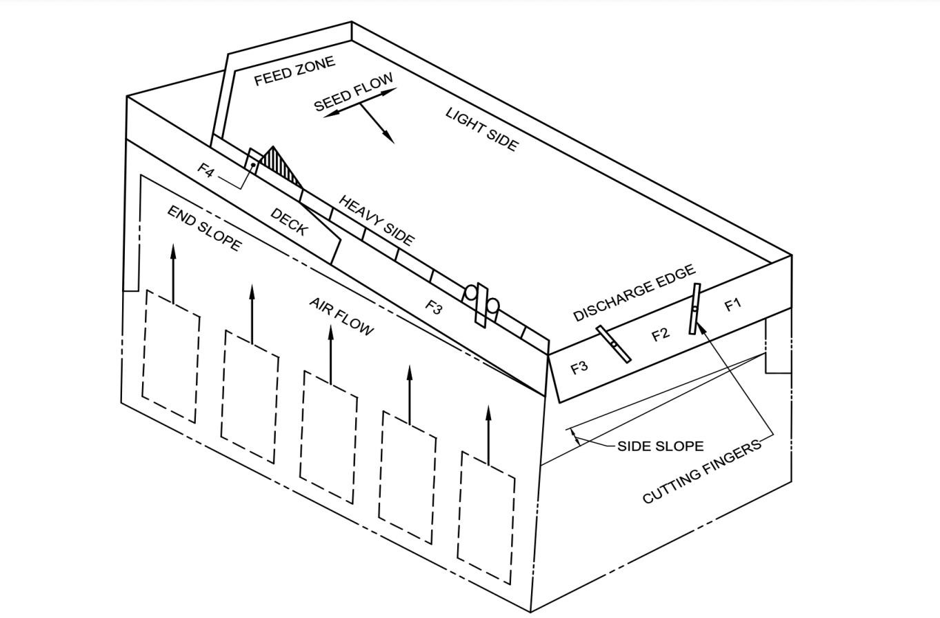

FIG. 2 SCHEMATIC DIAGRAM OF GRAVITY SEPARATORS (RECTANGULAR TYPE)

## Table 1 Material of Construction of Gravity Separators

(*Clause* 6)

|  |  |  |  |
| --- | --- | --- | --- |
| **Sl.**  **No.** | **Component** | **Material** | **Ref to Indian Standard** |
| (1) | (2) | (3) | (4) |
| i) | Feeding Hopper | Galvanized sheet | IS 277 |
|  |  | Stainless Steel (SS 304) | IS 6911 |
| ii) | Feed control mechanism | Galvanized sheet | IS 277 |
|  |  | Stainless Steel (SS 304) | IS 6911 |
| iii) | Vibrator (Optional) | Electromagnetic | - |
| iv) | Deck frame | Mild Steel | IS 2062 |
| v) | Deck surface - Wire/mesh  perforated Sheet (for bold seed) | Stainless Steel (SS 304) | IS 6911 |
| vi) | Deck surface - Cloth/wire  mesh (for small seed) | Stainless Steel (SS 304) | IS 6911 |
| vii) | Dams on deck | Wooden batten | IS 399 |
|  |  | Aluminum angle | - |
| viii) | Springs | Spring steel | IS 4454 (Part 4) |
| ix) | Body | Mild steel | IS 2062 |
| x) | Fan | Mild steel | IS 2062 |
|  |  | Cast iron | IS 210 |
| xi) | Fan housing | Galvanized sheet | IS 277 |
| xii) | Pulleys | Cast iron | IS 210 |
|  |  | Aluminum alloy | - |
|  |  | HDPE | - |
| xiii) | Eccentric | Cast iron | IS 210 |
| xiv) | Shaft | Mild steel | IS 2062 |
| xv) | Speed adjusting wheel | Mild steel | IS 2062 |
| xvi) | Discharge spout | Galvanized sheet | IS 277 |
|  |  | Stainless Steel (SS 304) | IS 6911 |
| xvii) | Air filter frame | Wood | IS 399 |
|  |  | Mild steel | IS 2062 |
|  |  | Fibre Glass | - |
| x) | Air control shutters | Galvanized sheet | IS 277 |
|  |  | Stainless Steel (SS 304) | IS 6911 |

# CONSTRUCTIONAL REQUIREMENTS

* 1. The sheets and plates used in construction of various parts shall be of minimum 1 mm and 3 mm thickness respectively.
  2. The dames on deck shall be of minimum 10 mm thickness if made of wood and of minimum 10 mm ×

10 mm if made of aluminum angle.

* 1. All other wooden components of the gravity separator shall be of minimum 20 mm thickness.

# OTHER REQUIREMENTS

* 1. The necessary bearings, eccentric, variable pulley and proper drive system shall be provided.
  2. The necessary provision of greasing/oiling for bearing shall be provided for the moving parts of the gravity separator. They shall be dust proof.
  3. The construction shall be such as to help easy and immediate repairs and maintenance.
  4. The machine shall be provided with easy facilities for adjustments (*see* **3.1**).

# WORKMANSHIP AND FINISH

* 1. The components of gravity separators shall be free from cracks, pits and other visual defects which may be detrimental for their use.
  2. The welding and joints, if any, shall not be porous and shall be smooth.
  3. The rust preventive coating shall be provided to the steel components and varnish to be provided to the wooden components.
  4. The control and adjustment provided shall be easy and operating smoothly.

# MARKING AND PACKING

* 1. **Marking —** Each gravity separator shall be marked with the following particulars:

1. Manufacturers’ name and address, if any;
2. Type and model number;
3. Power rating;
4. Drive details like number of oscillations of deck/min. rev/min of main shaft, air velocity of fan etc;
5. Batch or code number, if any; and
6. Year of manufacture.
   * 1. Each gravity separator may also be marked with the overall size and approximately weight of the machine or this information may be given in the cataloged supplied by the manufacturer.
   1. **Packing —** The packing of the gravity separator shall be done as agreed to between the purchaser and the supplier.

## BIS Certification Marking

The product(s) conforming to the requirements of this standard may be certified as per the conformity assessment schemes under the provisions of the *Bureau of Indian Standards Act*, 2016 and the Rules and Regulations framed there under, and the products may be marked with the Standard Mark.

# TESTING

## Test Material

Sufficient quantity of cleaned seeds obtained from an air-screen cleaner of specified crop and variety shall be taken for the test. The moisture contents of the throughput cleaned seed shall be determined in accordance with the method given in IS 4333 (Part 2). The seed lot selected for testing gravity separator shall have purity in the range of 70 to 80 percent.

## Running in and Preliminary Adjustments

* + 1. The gravity separator shall be installed on leveled preferably on hard surface.
    2. The gravity separator shall be run-in for about 30 minutes before commencing the test. All the adjustments shall be carried out in accordance with the recommendations of the manufacturers.

## General Tests

* + 1. *Checking of Specifications*

The specifications given by the manufacturer shall be checked and reported in the proforma given in Annex A.

* + 1. *Checking of Material*

The material of construction of various components of the machine shall be reported in the datasheet given in Annex B.

* + 1. *Visual Observations and Checking of Provision for Adjustments*

The observations and adjustments given in the data sheet in Annex C shall be made and reported.

## Test at No Load

* + 1. After running-in is over, the gravity separator shall be run at no load for 10 minutes at the specified speed. During and after the no load run, the visual observation at the specific gravity separator shall not show the following:

1. Presence of any marked vibration during operation;
2. Presence of undue knocking or rattling sound,
3. Any marked rise in bearing temperature;
4. Any marked unusual wear or slackness in any component; and e Any marked change in oscillation or slopes.
   * 1. Data shall be recorded in accordance with the proforma given in Annex D.

## Test at Load

* + 1. *Short Run Test*

The gravity separator shall be installed and the test material will be made ready for test (*see* **12.1** and **12.2**).

* + 1. *Operation and Collection of data*

The gravity separator shall be operated at its input capacity specified by the manufacturer for the particular crop seed and variety, incorporating best combination of adjustments for a period of 30 minutes. During the running periods speed of shaft, speed of oscillation, end slope, side slope, air control lever position, *etc.* shall be noted and recorded in Annex E.

Three sets of sample at the outlet of all (four) fractions/outlets either manually after each 10 minutes or continuously by automatic flow samplers for the entire period shall be collected. No sample shall be collected at the discharge edge of the deck which will give deceptive result.

* + 1. *Preparation and Analysis of Samples*
       1. The samples drawn from each fraction/outlet shall be bulked and thoroughly mixed to form a composite sample.
       2. Each sample shall be further divided using a sample divider to get 100 g of representative sample.
       3. Each 100 g sample shall be analyzed for physical purity-to find the percentage availability of the following different graded fractions and recorded in Annex F:

|  |  |  |
| --- | --- | --- |
| Fraction 1 | Light seed | To be analyzed for good seed content |
| Fraction 2 | Middling | To be analyzed for good seed content |
| Fraction 3 | Good seed | To be analyzed for mud balls/stones and insect damaged and weed seed |
| Fraction 4 | Heavy | To be analyzed for good seed content. {seed to blend in  Fraction} |

* + - 1. *Determination of separation efficiency*

The grading efficiency shall be calculated by the following formula:

*E*  (*F-G*)  (*E-F*)  (1-*G*)

*D* =  100

*F*  (*E-G*)2  (1-*F*)

where,

*D* = separation efficiency in percent,

*E* = mean of fraction of whole seed/good seeds at main grain outlet,

*F* = fraction of whole seed/good seeds in feed, and

*G* = mean of fraction of whole seed/good seeds at rejection outlet.

Record the data in the data sheet as given in Annex G.

* + - 1. *Determination of power consumption*

The power requirement during the test run shall be calculated/measured in accordance with the following methods and record the data in accordance with Annex G.

* + - * 1. In case of prime mover fitted with an energy meter, the readings taken shall be the power consumption for 10 minutes. The power consumption per hour giving due allowance to the type of drive shall be calculated and reported.
        2. In case of prime mover fitted with the dynamometer, the reading taken shall indicate the torque required. The power consumption per hour, giving due allowance to the type of drive, shall be calculated by theft following formula:

where,

*T*  *S*

*P* =

9549.30

*P* = power, kW;

*T* = torque, Nm; and

*S* = speed, rev/min.

NOTE — For the Purpose of certification, the power consumption at the declared feed rate shall only be calculated.

* + - 1. *Determination of the rated input capacity*

From the quantity of feed (q) taken for the test and the time taken (min.) to clean, capacity is calculated and expressed as q/h. The capacity in terms of the energy consumed shall be calculated by dividing the capacity by power consumed and shall be expressed in q/kWh. Record the data in Annex G.

NOTE — For the purpose of certification, since the separator has been operated only at declared capacity. It shall be seen whether the grading efficiency is met at the declared capacity or not.

## Long Run Test

The gravity separator shall be operated for a minimum duration of 20 hours at no load which could be covered by continuous run of at least 5 hours. During and after the operation no breakdown or defects shall develop in the separator. Record the major break-downs, defects developed and repairs made into the data sheet given in Annex H.

# 13 SUMMARY REPORT

For the guidance of the user, a summary report on the proforma as given in Annex J shall be compiled.

# ANNEX A

(*Clause* 12.3.1)

# SPECIFICATION SHEET FOR GRAVITY SEPARATOR

## A-l GENERAL

1. Make
2. Model
3. Type
4. Year of manufacture
5. Recommended grains for grading

# POWER UNIT

* + 1. Type of prime mover
    2. Recommended power, kW
    3. Type of drive

# FEEDING

* + 1. Method of feeding
    2. Location of inlet
    3. Type of feed regulation mechanism (baffle/shutter, *etc.)*
    4. Height of feeding hopper from ground level in installed condition
    5. Volume of hopper, m3

# DECK

* + 1. Size (length and width, mm)
    2. Construction of deck
    3. Type of perforation/dimple/surface nature
    4. Thickness of deck
    5. Size of perforation, mm
    6. Number of perforations/100 cm2
    7. Pitch of perforations, mm
    8. Provision to adjust end slope

1. Provision to adjust side slope
2. Provision to vary the vibration/oscillation of deck

# BLOWER

* + 1. Number of blowers
    2. Type of blower
    3. Type of drive
    4. Speed of impeller, m/min. (rpm)
    5. Provision to adjust velocity/flow rate
    6. Protection against entry of insects/dust along air
    7. Protection against dress/arm getting in
    8. Provision for easy cleaning

# OUTLETS

* + 1. Number of outlets
    2. Height of outlets from ground level in installed condition, m
    3. Projection of outlets from frame, m
    4. Type
    5. Construction details

# FRAME DETAILS

* + 1. Construction
    2. Easy of dismantling and assembling
    3. Overall dimension of the unit (L  B  H, mm)

# TRANSPORT ARRANGEMENT

* + 1. Type
    2. Number of wheels (in case wheels are not provided, details of an alternative provision shall be given)
    3. Size of wheels
    4. Wheel bearing
    5. Type of towing
    6. Wheel tread, m
    7. Wheel base, m

# TOOLS, ACCESSORIES AND MANUALS PROVIDED

NOTES

1. The items which are not applicable in a particular grader should be crossed while filling.
2. If other items are provided, their details should be filled-in.

# ANNEX B

(*Clause* 12.3.2)

**DATA SHEET FOR MATERIAL OF CONSTRUCTION**

* 1. **DATE OF TEST**
  2. **MATERIAL OF CONSTRUCTION**

|  |  |  |
| --- | --- | --- |
| **Sl.**  **No.** | **Component** | **Material and Size** |
| i) | Frame |  |
| ii) | Deck |  |
| iii) | Blower impeller |  |
| iv) | Reject trough |  |
| v) | Feed hopper |  |
| vi) | Main shaft |  |
| vii) | Transmission system |  |
| viii) | Pullies, gears, sprockets, *etc.* |  |
| ix) | Cam, eccentric, crank, *etc.* |  |
| x) | Spring |  |

Testing Engineer

(*Clause* 12.3.3)

# DATA SHEET FOR VISUAL OBSERVATIONS AND ADJUSTMENTS C-1 OBSERVATIONS

* + 1. Adequacy of marking inlet and outlets
    2. Adequacy of marking of direction of rotation of drives
    3. Adequacy of protection of bearings against ingress of dust
    4. Adequacy of safety arrangements, specially at moving points
    5. Provision for lubrication of moving parts
    6. Provision for belt tightening
    7. Provision for transportation
    8. Provision for easy changing of components requiring frequent replacement

1. Provision for anti-corrosive coatings
2. Tightness of bolts and nuts and other fasteners

m) Other observations

# C-2 PROVISION FOR ADJUSTMENT OF

1. Feed rate
2. Deck oscillation speed
3. Blower impeller speed
4. Deck slopes

Testing Engineer

# ANNEX D

(*Clause* 12.4.2)

# DATA SHEET FOR TEST AT NO LOAD

**D-l SOURCE OF POWER D-2 TYPE OF DRIVE**

# D-3 OBSERVATIONS

1. Presence of any marked vibration during operation
2. Presence of undue knocking or rattling sound
3. Frequent slippage of drive belt
4. Any marked unusual wear or slackness in any component
5. Any marked rise in bearing temperature
6. Any marked scene of failure or breakage or damage to any parts or components of gravity separator.
7. Other Observations.

Testing Engineer

# ANNEX E

(*Clause* 12.5.2)

**DATA SHEET FOR TEST AT LOAD**

**E-1 SOURCE OF POWER E-2 POWER RATING**

* 1. **MACHINE DETAIL**
     1. Stroke length of deck
     2. Oscillation of deck (number of strokes/min.)
     3. Side slope of deck, %
     4. End slope of deck, % load

# SEED/GRAIN

* + 1. Type of seed/grain
    2. Variety of seed/grain
    3. Size of seed/grain
    4. Moisture content, % d.b.
    5. Fraction of foreign matter before feeding

# TEST DATA

|  |  |  |  |  |  |  |  |  |  |  |  |  |  |
| --- | --- | --- | --- | --- | --- | --- | --- | --- | --- | --- | --- | --- | --- |
| **Sl. No**  **.** | **Dat e** | **Startin g Time** | **Stoppin g Time** | **Duration of Operatio n** | **Speed m/min. (rev/mi n)** | **Fee d Rat e (q/h**  **)** | **Power Require d (kW)** | **Fuel Consumpti on**  **(1/h)** | **Total Quantit y of**  **Grain at Main Grain Outlet (Kg)** | **Sample collecte d from** | **Quantit y (Kg) of Samples from** | | |
|  |  |  |  |  |  |  |  |  | **Sample No.** | | |
|  |  |  |  |  |  |  |  |  |  | **i** | **i i** | **ii i** |
|  |  |  |  |  |  |  |  |  |  | Feed | |  |  |
|  |  |  |  |  |  |  |  |  |  | Outlet/  chute -1 | |  |  |
|  |  |  |  |  |  |  |  |  |  | Outlet/  chute -2 | |  |  |
|  |  |  |  |  |  |  |  |  |  | Outlet/  chute -3 | |  |  |
|  |  |  |  |  |  |  |  |  |  | Outlet/  chute -4 | |  |  |
|  |  |  |  |  |  |  |  |  |  | Outlet/  chute -5 | |  |  |

The data should be collected for every test conducted on different feed rates if necessary.

# OBSERVATIONS

* + 1. Presence of any marked vibration during operation
    2. Presence of undue knocking or rattling sound
    3. Frequent slippage of belts
    4. Smooth running of shafts in their respective bearings
    5. Frequent clogging
    6. Smooth flowing of material through different components
    7. Any marked rise in bearing temperature
    8. Any marked wear, deformation and breakdown

1. Frequent loosening of fasteners
2. Other observations, if any

Testing Engineer

# ANNEX F

(*Clause* 12.5.3.3)

# DATA SHEET FOR ANALYSIS OF SAMPLES

|  |  |  |  |  |  |  |  |  |  |  |  |  |
| --- | --- | --- | --- | --- | --- | --- | --- | --- | --- | --- | --- | --- |
| **Sl.**  **No.** | **Feed rate (kg/h)** | **Sample Source** | **Sample mass (g)** | **Mass of (g)**  **Good seeds/grain Impurities**  **Sample No. Sample No.** | | | | | | | **E/F/G** | |
|  |  |  |  | i | ii | iii | Mean | i | ii | iii | Mean |  |
| (1) | (2) | (3) | (4) | (5) | (6) | (7) | (8) | (9) | (10) | (11) | (12) | (13) |
|  |  | Feed | 100 |  |  |  |  |  |  |  |  | F = (8)/ (4) |
|  |  | Outlet/chute -1 (light weight/ impurities) | 100 |  |  |  |  |  |  |  |  |  |
|  |  | Outlet/chute - 2 (middling/impurities) | 100 |  |  |  |  |  |  |  |  |  |
|  |  | Outlet/chute -3 Good seeds/grains | 100 |  |  |  |  |  |  |  |  | E = (8)/(4) |
|  |  | Outlet/chute -4 (Stones/heavier impurities) | 100 |  |  |  |  |  |  |  |  | G = (8)/(4)  of and  mean of |

Outlet/chute -5

(any other as per the

100

outlet/chute – 1, 2, 4 and any other outlets for rejects.

case)

Testing Engineer

# ANNEX G

(*Clauses* 12.5.3.4 and 12.5.3.6)

# DATA SHEET FOR EFFICIENCY, POWER REQUIREMENT AND CAPACITIES

|  |  |  |
| --- | --- | --- |
| **Sl.**  **No.** | **Item** | **Test No**.  **1 2 3 4 etc** |
| i) | Cylinder speed, m/min. (rev/min.) |  |
| ii) | Feed rate, q/h |  |
| iii) | Power required, kW |  |
| iv) | Separation efficiency, percent |  |
| v) | Rated input capacity, q/kWh |  |

Testing Engineer

**ANNEX H**

(*Clause* 12.6)

# DATA SHEET FOR LONG-RUN TEST

1. Total running time, h
2. Continuous running time
3. Breakdowns in separation unit (deck)
4. Breakdowns in outlets/chutes/elevation unit
5. Breakdowns in the main frame
6. Any major repairs conducted
7. Any other observations affecting the performance

Testing Engineer

# ANNEX J

(*Clause* 13)

**SUMMARY REPORT**

* 1. **NAME OF MANUFACTURER**
  2. **TYPE, MAKE AND MODEL NUMBER J-3 NAME OF TESTING STATION**

**J-4 BRIEF DESCRIPTION OF THE CLEANER J-5 NAME AND VARIETY OF SEEDS USED**

**J-6 PERCENTAGE FOREIGN MATTER BEFORE FEEDING**

**J-7 MOISTURE CONTENT BEFORE FEEDING**

* 1. **PROVISIONS FOR ADJUSTMENT**

## POWER REQUIREMENT, kW

* + 1. Recommended power
    2. Observed power at no-load
    3. Observed power at load at rated input capacity
  1. **SAPERATION EFFICIENCY %**
  2. **RATED INPUT CAPACITY, kg/h**

**J-13 ANY OTHER**

Testing Engineer