*Indian Standard*

**SPECIFICATION FOR**

**DOUBLE ROW CYLINDRICAL ROLLER BEARINGS**

**1 SCOPE**

This standard specifies the requirements for double row cylindrical roller bearings and their components including through hardened, induction hardened and cased hardened bearings. This standard does not cover the requirements of special application like super precision bearing or aerospace application.

**2 REFERENCES**

The following Indian Standards contain provisions which through reference in this text, constitute provision of this standard. At the time of publication, the editions indicated were valid. All standards are subject to revision and parties to agreements based on this standard are encouraged to investigate the possibility of applying the most recent editions of the standards indicated below:

IS No: Title

* 2398 : 1967: Identification code for rolling bearings
* 5669 : 1987 : General plan of boundary dimensions for radial rolling bearings
* 6453 -1984: Technical supply conditions for roller bearing (reaffirmed in 2011)
* 2399: 2019 : Rolling bearings — Vocabulary (second revision)
* 3073: 1967 : Assessment of surface roughness
* 3823: 2014 : Rolling bearings — Static load ratings (third revision)
* 3824: 2014 : Rolling bearings — Dynamic load ratings and rating life (third revision)
* 4397: 1999 : Cold-rolled carbon steel strips for ball and roller bearing cages/retainers
* 4398: 1994 : Carbon-chromium steel for the manufacture of balls, rollers and bearing races (second revision)
* 4905: 2015 : Random sampling and randomization procedures (first revision)
* 5489: 1975 : Specification for carburizing steels for use in bearing industry (first revision)
* 5692: 2019 : Rolling bearings — Radial bearings — Geometrical product specifications (GPS) and tolerance values (second revision)
* 13406: 2018 : Rolling bearings — Radial ball bearings with flanged outer ring — Flange dimensions
* 17111: 2019 : Heat-treated steels, alloy steels and free-cutting steels — Ball and roller bearing steels

**3 TERMINOLOGY**

For this standard the terms and definitions given in IS 2399: 1964’ and the following ‘, shall apply.

Supplier – The party producing the bearing and its components.

Purchaser – The party purchasing the bearings. This term also applies authorised person to act on behalf for the purpose of inspection.

**3 BEARING TYPES AND SYMBOLS**

This types of double row non locating and double row two direction locating shall conform to the IS 2398 : 1967 ‘Identification code for rolling bearings’

**Design of double row cylindrical roller bearings**

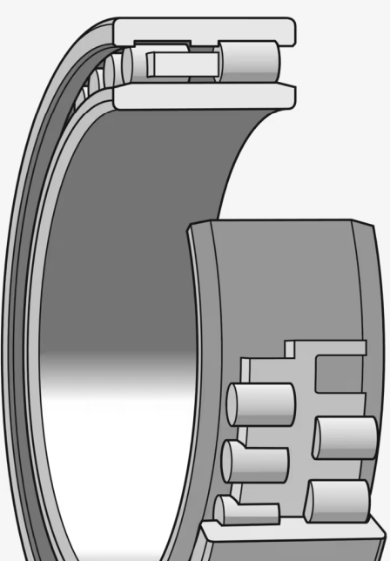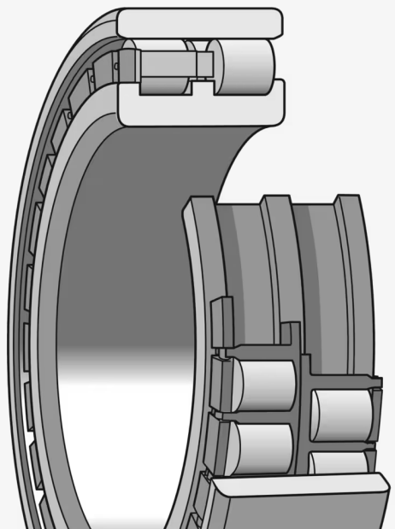 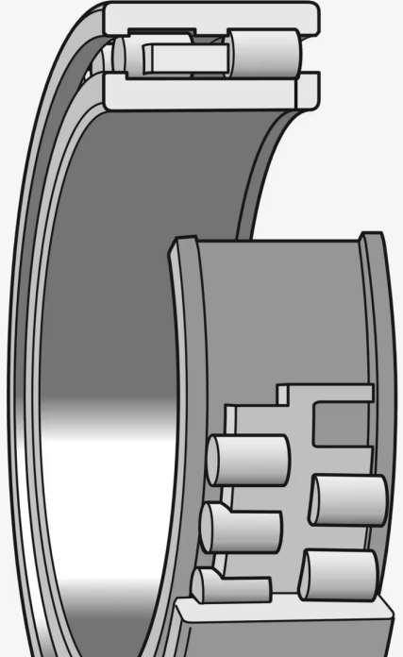

**NNU NN NNUP**

**Variants / Features**

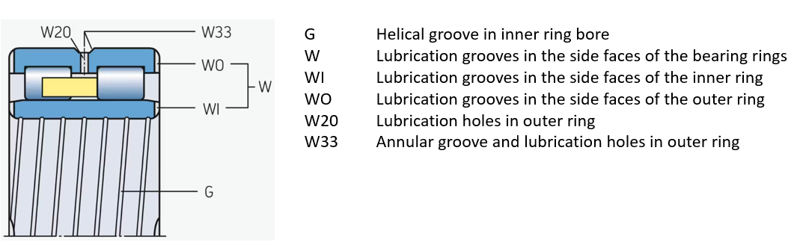

**Design of double row full complement cylindrical roller bearings**

**NNCL NNCF NNC NNF**

**Design and variants**

|  |  |  |
| --- | --- | --- |
| **Bearing design** | **Flange configurations** | **Cage design** |
|  **| * outer ring: three integrals * inner ring: none | * one cage * machined brass or steel * double prong-type * roller centered |
|  **| * outer ring: three integrals * inner ring: none | * two cages * machined brass * window-type * roller centered |
|  **| * outer ring: one integral central and two loose * inner ring: none | * one cage * machined brass or steel * double prong-type * roller centred |
|  **| * outer ring: three integrals * inner ring: none | * two cages * machined steel * pin-type * pierced rollers |
|  **| * outer ring: one integral central and two loose * inner ring: none | * two cages * machined steel * pin-type * pierced rollers |
|  **| * outer ring: two integrals * inner ring: none | * one cage * machined brass * window-type * roller centred |
|  **| * outer ring: two integrals * inner ring: none | * one cage * machined steel * pin-type * pierced rollers |
|  **| * outer ring: three integrals * inner ring: one integral and two loose | * one cage * machined brass or steel * double prong-type * roller centred |
|  **| * outer ring: two integral and one loose * inner ring: one integral and one loose | * two cages * machined steel * pin-type * pierced rollers |
|  **| * outer ring: none * inner ring: three integrals | * one cage * machined brass or steel * double prong-type * roller centred |
|  **| * outer ring: none * inner ring: three integrals | * two cages * either PA66 or stamped steel * window-type * roller centred |
|  **| * outer ring: none * inner ring: three integrals | * two cages * machined steel * pin-type * pierced rollers |
|  **| * outer ring: none * inner ring: one integral and two loose | * two cages * machined steel * pin-type * pierced rollers |

**4 GENERAL REQUIREMENTS**

For requirements that are common to bearing application are covered in, IS 6453: 1984. For a cylindrical roller bearing these requirements shall be confirmed as well to assure an optimum performance in application.

**5 BOUNDARY DIMENSIONS**

Geometrical characteristics of the boundary dimensions shall be as specified in the dimension series 49 and 30 of IS 5669 : 1970 ‘General plan of boundary dimensions for radial rolling bearings’

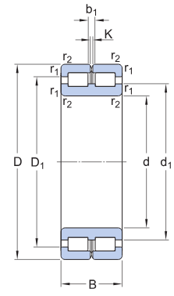 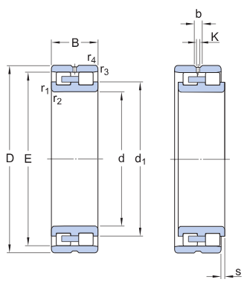

|  |  |  |  |
| --- | --- | --- | --- |
| d | Bore diameter | d | Bore diameter |
| D | Outside diameter | D | Outside diameter |
| B | Width | B | Overall bearing width |
| d1 | Shoulder diameter inner ring | d1 | Shoulder diameter inner ring |
| D1 | Shoulder diameter outer ring | E | Raceway diameter outer ring |
| b1 | Width annular lubrication groove outer ring | b | Width of annular groove |
| K | Diameter lubrication hole (outer ring) | K | Diameter lubrication hole |
| r1,2 | Chamfer dimension (open bearings) | r1,2 | Chamfer dimension inner ring |
|  |  | r3,4 | Chamfer dimension outer ring |
|  |  | s | Permissible axial displacement from the normal  position of one bearing ring relative to the other |

Table 1 Dimension and Designation

|  |  |  |  |  |  |  |  |  |  |  |  |
| --- | --- | --- | --- | --- | --- | --- | --- | --- | --- | --- | --- |
| **d** | **D** | **B** | **d1** | **D1** | **E** | **b1** | **K** | **r1,2** | **r3,4** | **s** | **Designation** |
| mm | | | | | | | | min. | min. | max. |  |
| 20 | 42 | 30 | 28,4 | 33,2 | – | 4,5 | 3 | 0,6 | 0,3 | 1 | NNCF5004CV |
| 25 | 47 | 30 | 34,5 | 38,5 | – | 4,5 | 3 | 0,6 | 0,3 | 1 | NNCF5005CV |
| 30 | 55 | 34 | 40 | 45,5 | – | 4,5 | 3 | 1 | 0,3 | 1,5 | NNCF5006CV |
| 35 | 62 | 36 | 45 | 51,5 | – | 4,5 | 3 | 1 | 0,3 | 1,5 | NNCF5007CV |
| 40 | 68 | 38 | 50,5 | 57,2 | – | 4,5 | 3 | 1 | 0,3 | 1,5 | NNCF5008CV |
| 45 | 75 | 40 | 55,3 | 62,5 | – | 4,5 | 3 | 1 | 0,3 | 1,5 | NNCF5009CV |
| 50 | 80 | 40 | 59 | 67,5 | – | 4,5 | 3 | 1 | 0,3 | 1,5 | NNCF5010CV |
| 55 | 90 | 46 | 68,5 | 78,7 | – | 4,5 | 3,5 | 1,1 | 0,6 | 1,5 | NNCF5011CV |
| 60 | 85 | 25 | 70,5 | 73,5 | – | 4,5 | 3,5 | 1 | 1 | 1 | NNCF4912CV |
| 85 | 25 | 70,5 | – | 77,51 | 4,5 | 3,5 | 1 | – | 1 | NNCL4912CV |
| 85 | 25 | 70,5 | 73,5 | – | 4,5 | 3,5 | 1 | – | – | NNC4912CV |
| 95 | 46 | 71,5 | 82 | – | 4,5 | 3,5 | 1,1 | 0,6 | 1,5 | NNCF5012CV |
| 65 | 100 | 46 | 78 | 88,3 | – | 4,5 | 3,5 | 1,1 | 0,6 | 1,5 | NNCF5013CV |
| 70 | 100 | 30 | 70 | 83 | 87 | – | 4,5 | 3,5 | 1 | 1 | NNCF4914CV |
| 100 | 30 | 83 | – | 91,87 | 4,5 | 3,5 | 1 | – | 1 | NNCL4914CV |
| 100 | 30 | 83 | 87 | – | 4,5 | 3,5 | 1 | – | – | NNC4914CV |
| 110 | 54 | 81,5 | 95 | – | 5 | 3,5 | 1,1 | 0,6 | 3 | NNCF5014CV |
| 75 | 115 | 54 | 89 | 103 | – | 5 | 3,5 | 1,1 | 0,6 | 3 | NNCF5015CV |
| 80 | 110 | 30 | 92 | 96 | – | 5 | 3,5 | 1 | 1 | 1 | NNCF4916CV |
| 110 | 30 | 92 | – | 100,78 | 5 | 3,5 | 1 | – | 1 | NNCL4916CV |
| 110 | 30 | 92 | 96 | – | 5 | 3,5 | 1 | – | – | NNC4916CV |
| 125 | 60 | 95 | 111 | – | 5 | 3,5 | 1,1 | 0,6 | 3,5 | NNCF5016CV |
| 85 | 130 | 60 | 99,5 | 116 | – | 5 | 3,5 | 1,1 | 0,6 | 3,5 | NNCF5017CV |
| 90 | 125 | 35 | 103 | 110 | – | 5 | 3,5 | 1,1 | 1,1 | 1,5 | NNCF4918CV |
| 125 | 35 | 103 | – | 115,2 | 5 | 3,5 | 1,1 | – | 1,5 | NNCL4918CV |
| 125 | 35 | 103 | 110 | – | 5 | 3,5 | 1,1 | – | – | NNC4918CV |
| 140 | 67 | 106 | 124 | – | 5 | 3,5 | 1,5 | 1 | 4 | NNCF5018C |
| 100 | 140 | 40 | 116 | 125 | – | 5 | 3,5 | 1,1 | 1,1 | 2 | NNCF4920CV |
| 140 | 40 | 116 | – | 129,6 | 5 | 3,5 | 1,1 | – | 2 | NNCL4920CV |
| 140 | 40 | 116 | 125 | – | 5 | 3,5 | 1,1 | – | – | NNC4920CV |
| 150 | 67 | 116 | 134 | – | 6 | 3,5 | 1,5 | 1 | 4 | NNCF5020CV |
| 110 | 150 | 40 | 125 | 134 | – | 6 | 3,5 | 1,1 | 1,1 | 2 | NNCF4922CV |
| 150 | 40 | 125 | – | 138,2 | 6 | 3,5 | 1,1 | – | 2 | NNCL4922CV |
| 150 | 40 | 125 | 134 | – | 6 | 3,5 | 1,1 | – | – | NNC4922CV |
| 170 | 80 | 127 | 149 | – | 6 | 3,5 | 2 | 1 | 5 | NNCF5022CV |
| 120 | 165 | 45 | 139 | 148 | – | 6 | 3,5 | 1,1 | 1,1 | 3 | NNCF4924CV |
| 165 | 45 | 139 | – | 153,55 | 6 | 3,5 | 1,1 | – | 3 | NNCL4924CV |
| 165 | 45 | 139 | 148 | – | 6 | 3,5 | 1,1 | – | – | NNC4924CV |
| 180 | 80 | 139 | 160 | – | 6 | 3,5 | 2 | 1 | 5 | NNCF5024CV |
| 130 | 180 | 50 | 149 | 160 | – | 6 | 3,5 | 1,5 | 1,5 | 4 | NNCF4926CV |
| 180 | 50 | 149 | – | 165,4 | 6 | 3,5 | 1,5 | – | 4 | NNCL4926CV |
| 180 | 50 | 149 | 160 | – | 6 | 3,5 | 1,5 | – | – | NNC4926CV |
| 200 | 95 | 149 | 175 | – | 7 | 4 | 2 | 1 | 5 | NNCF5026CV |
|  | | | | | | | | | | | |
| Table 1 (Continued) | | | | | | | | | | | |
| **d** | **D** | **B** | **d1** | **D1** | **E** | **b1** | **K** | **r1,2** | **r3,4** | **s** | **Designation** |
| 140 | 190 | 50 | 160 | 170 | – | 6 | 3,5 | 1,5 | 1,5 | 4 | NNCF4928CV |
| 190 | 50 | 160 | – | 175,9 | 6 | 3,5 | 1,5 | – | 4 | NNCL4928CV |
| 190 | 50 | 160 | 170 | – | 6 | 3,5 | 1,5 | – | – | NNC4928CV |
| 210 | 95 | 163 | 189 | – | 7 | 4 | 2 | 1 | 5 | NNCF5028CV |
| 150 | 190 | 40 | 166 | 173 | – | 7 | 4 | 1,1 | 1,1 | 2 | NNCF4830CV |
| 190 | 40 | 166 | – | 178,3 | 7 | 4 | 1,1 | – | 2 | NNCL4830CV |
| 190 | 40 | 166 | 173 | – | 7 | 4 | 1,1 | – | – | NNC4830CV |
| 210 | 60 | 171 | 187 | – | 7 | 4 | 2 | 2 | 4 | NNCF4930CV |
| 210 | 60 | 171 | – | 192,77 | 7 | 4 | 2 | – | 4 | NNCL4930CV |
| 210 | 60 | 171 | 187 | – | 7 | 4 | 2 | – | – | NNC4930CV |
| 225 | 100 | 170 | 198 | – | 7 | 4 | 2 | 1,1 | 6 | NNCF5030CV |
| 160 | 200 | 40 | 174 | 182 | – | 7 | 4 | 1,1 | 1,1 | 2 | NNCF4832CV |
| 200 | 40 | 174 | – | 186,9 | 7 | 4 | 1,1 | – | 2 | NNCL4832CV |
| 160 | 200 | 40 | 174 | 182 | – | 7 | 4 | 1,1 | – | – | NNC4832CV |
| 220 | 60 | 185 | 200 | – | 7 | 4 | 2 | 2 | 4 | NNCF4932CV |
| 220 | 60 | 185 | – | 206,16 | 7 | 4 | 2 | – | 4 | NNCL4932CV |
| 220 | 60 | 185 | 200 | – | 7 | 4 | 2 | – | – | NNC4932CV |
| 240 | 109 | 185 | 216 | – | 7 | 4 | 2,1 | 1,1 | 6 | NNCF5032CV |
| 170 | 215 | 45 | 187 | 196 | – | 7 | 4 | 1,1 | 1,1 | 3 | NNCF4834CV |
| 215 | 45 | 187 | – | 201,3 | 7 | 4 | 1,1 | – | 3 | NNCL4834CV |
| 215 | 45 | 187 | 196 | – | 7 | 4 | 1,1 | – | – | NNC4834CV |
| 230 | 60 | 194 | 209 | – | 7 | 4 | 2 | 2 | 4 | NNCF4934CV |
| 230 | 60 | 194 | – | 215,08 | 7 | 4 | 2 | – | 4 | NNCL4934CV |
| 230 | 60 | 194 | 209 | – | 7 | 4 | 2 | – | – | NNC4934CV |
| 260 | 122 | 198 | 232 | – | 7 | 4 | 2,1 | 1,1 | 6 | NNCF5034CV |
| 180 | 225 | 45 | 200 | 209 | – | 7 | 4 | 1,1 | 1,1 | 3 | NNCF4836CV |
| 225 | 45 | 200 | – | 214,1 | 7 | 4 | 1,1 | – | 3 | NNCL4836CV |
| 225 | 45 | 200 | 209 | – | 7 | 4 | 1,1 | – | – | NNC4836CV |
| 250 | 69 | 206 | 224 | – | 7 | 4 | 2 | 2 | 4 | NNCF4936CV |
| 250 | 69 | 206 | – | 230,5 | 7 | 4 | 2 | – | 4 | NNCL4936CV |
| 250 | 69 | 206 | 224 | – | 7 | 4 | 2 | – | – | NNC4936CV |
| 280 | 136 | 212 | 248 | – | 8 | 4 | 2,1 | 2,1 | 8 | NNCF5036CV |
| 190 | 240 | 50 | 209 | 219 | – | 7 | 4 | 1,5 | 1,5 | 4 | NNCF4838CV |
| 240 | 50 | 209 | – | 225 | 7 | 4 | 1,5 | – | 4 | NNCL4838CV |
| 240 | 50 | 209 | 219 | – | 7 | 4 | 1,5 | – | – | NNC4838CV |
| 260 | 69 | 216 | 233 | – | 7 | 4 | 2 | 2 | 4 | NNCF4938CV |
| 260 | 69 | 216 | – | 240,7 | 7 | 4 | 2 | – | 4 | NNCL4938CV |
| 260 | 69 | 216 | 233 | – | 7 | 4 | 2 | – | – | NNC4938CV |
| 290 | 136 | 222 | 258 | – | 8 | 4 | 2,1 | 2,1 | 8 | NNCF5038CV |
| 200 | 250 | 50 | 220 | 230 | – | 7 | 4 | 1,5 | 1,5 | 4 | NNCF4840CV |
| 250 | 50 | 220 | – | 235,5 | 7 | 4 | 1,5 | – | 4 | NNCL4840CV |
| 250 | 50 | 220 | 230 | – | 7 | 4 | 1,5 | – | – | NNC4840CV |
| 280 | 80 | 233 | 252 | – | 8 | 4 | 2,1 | 2,1 | 5 | NNCF4940CV |
| 280 | 80 | 233 | – | 259,34 | 8 | 4 | 2,1 | – | 5 | NNCL4940CV |
| 280 | 80 | 233 | 252 | – | 8 | 4 | 2,1 | – | – | NNC4940CV |
| 310 | 150 | 237 | 275 | – | 8 | 4 | 2,1 | 2,1 | 9 | NNCF5040CV |
|  | | | | | | | | | | | |
| Table 1 (Continued) | | | | | | | | | | | |
| **d** | **D** | **B** | **d1** | **D1** | **E** | **b1** | **K** | **r1,2** | **r3,4** | **s** | **Designation** |
| 220 | 270 | 50 | 241 | 251 | – | 7 | 4 | 1,5 | 1,5 | 4 | NNCF4844CV |
| 270 | 50 | 241 | – | 256,5 | 7 | 4 | 1,5 | – | 4 | NNCL4844CV |
| 270 | 50 | 241 | 251 | – | 7 | 4 | 1,5 | – | – | NNC4844CV |
| 300 | 80 | 248 | 269 | – | 8 | 4 | 2,1 | 2,1 | 5 | NNCF4944CV |
| 300 | 80 | 248 | – | 276,52 | 8 | 4 | 2,1 | – | 5 | NNCL4944CV |
| 300 | 80 | 248 | 269 | – | 8 | 4 | 2,1 | – | – | NNC4944CV |
| 340 | 160 | 255 | 302 | – | 8 | 6 | 3 | 3 | 9 | NNCF5044CV |
| 240 | 300 | 60 | 261 | 275 | – | 8 | 4 | 2 | 2 | 4 | NNCF4848CV |
| 300 | 60 | 261 | – | 281,9 | 8 | 4 | 2 | – | 4 | NNCL4848CV |
| 300 | 60 | 261 | 275 | – | 8 | 4 | 2 | – | – | NNC4848CV |
| 320 | 80 | 271 | 291 | – | 8 | 4 | 2,1 | 2,1 | 5 | NNCF4948CV |
| 320 | 80 | 271 | – | 299,46 | 8 | 4 | 2,1 | – | 5 | NNCL4948CV |
| 320 | 80 | 271 | 291 | – | 8 | 4 | 2,1 | – | – | NNC4948CV |
| 360 | 160 | 276 | 324 | – | 9,4 | 5 | 3 | 3 | 9 | NNCF5048CV |
| 260 | 320 | 60 | 283 | 297 | – | 8 | 4 | 2 | 2 | 4 | NNCF4852CV |
| 320 | 60 | 283 | – | 304,2 | 8 | 4 | 2 | – | 4 | NNCL4852CV |
| 320 | 60 | 283 | 297 | – | 8 | 4 | 2 | – | – | NNC4852CV |
| 360 | 100 | 295 | 321 | – | 9,4 | 5 | 2,1 | 2,1 | 6 | NNCF4952CV |
| 360 | 100 | 295 | – | 331,33 | 9,4 | 5 | 2,1 | – | 6 | NNCL4952CV |
| 360 | 100 | 295 | 321 | – | 9,4 | 5 | 2,1 | – | – | NNC4952CV |
| 400 | 190 | 302 | 362 | – | 9,4 | 5 | 4 | 4 | 10 | NNCF5052CV |
| 280 | 350 | 69 | 308 | 326 | – | 8 | 4 | 2 | 2 | 4 | NNCF4856CV |
| 350 | 69 | 308 | – | 332,4 | 8 | 4 | 2 | – | 4 | NNCL4856CV |
| 350 | 69 | 308 | 326 | – | 8 | 4 | 2 | – | – | NNC4856CV |
| 380 | 100 | 317 | 343 | – | 9,4 | 5 | 2,1 | 2,1 | 6 | NNCF4956CV |
| 380 | 100 | 317 | – | 353,34 | 9,4 | 5 | 2,1 | – | 6 | NNCL4956CV |
| 380 | 100 | 317 | 343 | – | 9,4 | 5 | 2,1 | – | – | NNC4956CV |
| 420 | 190 | 318 | 372 | – | 9,4 | 5 | 4 | 4 | 10 | NNCF5056CV |
| 300 | 380 | 80 | 330 | 349 | – | 9,4 | 5 | 2,1 | 2,1 | 6 | NNCF4860CV |
| 380 | 80 | 330 | – | 356,7 | 9,4 | 5 | 2,1 | – | 6 | NNCL4860CV |
| 380 | 80 | 330 | 349 | – | 9,4 | 5 | 2,1 | – | – | NNC4860CV |
| 420 | 118 | 340 | 374 | – | 9,4 | 5 | 3 | 3 | 6 | NNCF4960CV |
| 420 | 118 | 340 | – | 385,51 | 9,4 | 5 | 3 | – | 6 | NNCL4960CV |
| 420 | 118 | 341 | 374 | – | 9,4 | 5 | 3 | – | – | NNC4960CV |
| 460 | 218 | 352 | 418 | – | 9,4 | 5 | 4 | 4 | 9 | NNCF5060CV |
| 320 | 400 | 80 | 352 | 372 | – | 9,4 | 5 | 2,1 | 2,1 | 6 | NNCF4864CV |
| 400 | 80 | 352 | – | 379,7 | 9,4 | 5 | 2,1 | – | 6 | NNCL4864CV |
| 400 | 80 | 352 | 372 | – | 9,4 | 5 | 2,1 | – | – | NNC4864CV |
| 440 | 118 | 368 | 401 | – | 9,4 | 5 | 3 | 3 | 6 | NNCF4964CV |
| 440 | 118 | 368 | – | 412,27 | 9,4 | 5 | 3 | – | 6 | NNCL4964CV |
| 440 | 118 | 368 | 401 | – | 9,4 | 5 | 3 | – | – | NNC4964CV |
| 480 | 218 | 370 | 434 | – | 9,4 | 5 | 4 | 4 | 9 | NNCF5064CV |
|  | | | | | | | | | | | |
| Table 1 (Continued) | | | | | | | | | | | |
| **d** | **D** | **B** | **d1** | **D1** | **E** | **b1** | **K** | **r1,2** | **r3,4** | **s** | **Designation** |
| 340 | 420 | 80 | 368 | 390 | – | 9,4 | 5 | 2,1 | 2,1 | 6 | NNCF4868CV |
| 420 | 80 | 368 | – | 396,9 | 9,4 | 5 | 2,1 | – | 6 | NNCL4868CV |
| 420 | 80 | 369 | 369 | – | 9,4 | 5 | 2,1 | – | – | NNC4868CV |
| 460 | 118 | 385 | 419 | – | 9,4 | 5 | 3 | 3 | 6 | NNCF4968CV |
| 460 | 118 | 385 | – | 430,11 | 9,4 | 5 | 3 | – | 6 | NNCL4968CV |
| 460 | 118 | 385 | 419 | – | 9,4 | 5 | 3 | – | – | NNC4968CV |
| 520 | 243 | 395 | 468 | – | 9,4 | 5 | 5 | 5 | 11 | NNCF5068CV |
| 360 | 440 | 80 | 391 | 413 | – | 9,4 | 5 | 2,1 | 2,1 | 6 | NNCF4872CV |
| 440 | 80 | 391 | – | 419,8 | 9,4 | 5 | 2,1 | – | 6 | NNCL4872CV |
| 440 | 80 | 391 | 413 | – | 9,4 | 5 | 2,1 | – | – | NNC4872CV |
| 480 | 118 | 404 | 437 | – | 9,4 | 5 | 3 | 3 | 6 | NNCF4972CV |
| 480 | 118 | 404 | – | 447,95 | 9,4 | 5 | 3 | – | 6 | NNCL4972CV |
| 480 | 118 | 404 | 437 | – | 9,4 | 5 | 3 | – | – | NNC4972CV |
| 540 | 243 | 412 | 486 | – | 9,4 | 5 | 5 | 5 | 11 | NNCF5072CV |
| 380 | 480 | 100 | 419 | 447 | – | 9,4 | 5 | 2,1 | 2,1 | 6 | NNCF4876CV |
| 480 | 100 | 419 | – | 455,8 | 9,4 | 5 | 2,1 | – | 6 | NNCL4876CV |
| 480 | 100 | 419 | 447 | – | 9,4 | 5 | 2,1 | – | – | NNC4876CV |
| 520 | 140 | 430 | 469 | – | 9,4 | 5 | 4 | 4 | 7 | NNCF4976CV |
| 520 | 140 | 430 | – | 481,35 | 9,4 | 5 | 4 | – | 7 | NNCL4976CV |
| 520 | 140 | 430 | 469 | – | 9,4 | 5 | 4 | – | – | NNC4976CV |
| 400 | 500 | 100 | 434 | 462 | – | 9,4 | 5 | 2,1 | 2,1 | 6 | NNCF4880CV |
| 500 | 100 | 434 | – | 470,59 | 9,4 | 5 | 2,1 | – | 6 | NNCL4880CV |
| 500 | 100 | 434 | 462 | – | 9,4 | 5 | 2,1 | – | – | NNC4880CV |
| 540 | 140 | 451 | 489 | – | 9,4 | 5 | 4 | 4 | 7 | NNCF4980CV |
| 540 | 140 | 451 | – | 501,74 | 9,4 | 5 | 4 | – | 7 | NNCL4980CV |
| 540 | 140 | 451 | 489 | – | 9,4 | 5 | 4 | – | – | NNC4980CV |
| 600 | 272 | 460 | 540 | – | 9,4 | 5 | 5 | 5 | 11 | NNCF5080CV |

Designation given is informative and may vary for different manufacturers

**6 TOLERANCES AND GEOMETRICAL CHARACTRISTICS**

Tolerances and geometrical characteristics of the boundary dimensions shall be as specified in IS 5692 : 1970 ‘Tolerances for radial rolling bearings’

Tolerance classes and the corresponding values for certain tolerance characteristics are specified in ISO 492 (for radial bearings)

Three common tolerance classes for roller bearings:

|  |  |  |
| --- | --- | --- |
| Tolerance class | Designation suffix | Description |
| Normal | – | Minimum standard for all SKF ball and roller bearings. |
| Class 6 | P6 | Tighter tolerances than Normal. |
| Class 5 | P5 | Tighter tolerances than class 6. |

**7 ROLLING ELEMENTS**

Requirements for the cylindrical roller bearing shall be as specified in IS 9202 : 1979

**8 MATERIAL OF RACES AND ROLLERS**

The material used, must fulfil the requirements for the fatigue strength, wear resistance, hardness, toughness, and structural stability. Generally, a low alloy, through hardening bearing steel is consider sufficient for general use. If there are considerable shock load in the application, then the use of case hardening steel is recommended based on the agreement between supplier and purchaser.

Shall be as specified in IS 17111 IS 5489 or IS 4398

**9 CAGE**

The pressed sheet cages are widely used. Material specified in IS 4397 or IS 513. In some cases, alternate material could be used such as brass and polyamide in case cases there be agreement between the supplier and purchaser is required.

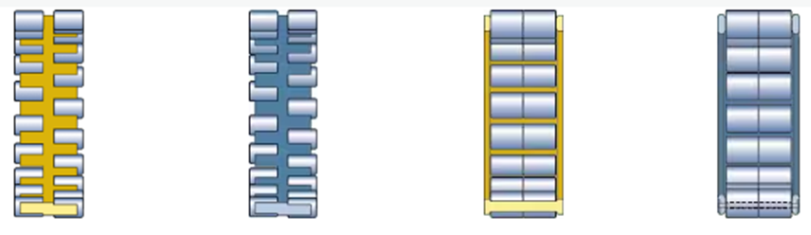

|  |  |  |  |  |
| --- | --- | --- | --- | --- |
| **Cage type** | Double prong-type, roller centred | Double prong-type, roller centred | Window-type, roller centred | Pin-type, pierced rollers |
| **Material** | Machined brass (standard??) | Machined steel | Machined brass | Machined steel |
| **No. per bearing** | 1 | 1 | 1 | 1 |

**10 RADIAL CLEARANCE**

Radial internal clearance is arithmetical mean of the radial distances through which one of the rings may be displaced relative to the other, from one eccentric extreme position to the diametrically opposite extreme position, in different angular directions and without being subjected to any external load.

Radial clearance shall be as specified in IS 5935 : 1970 ‘Radial internal clearances in unloaded radial rolling bearings’

**Radial internal clearance of cylindrical roller bearings with a cylindrical bore**

|  |  |  |  |  |  |  |  |  |  |  |  |  |
| --- | --- | --- | --- | --- | --- | --- | --- | --- | --- | --- | --- | --- |
| Bore diameter | | Radial internal clearance | | | | | | | | | | |
| d |  | C2 | | Normal | | C3 | | C4 | | C5 | |
| > | ≤ | min. | max. | min. | max. | min. | max. | min. | max. | min. | max. |
| mm |  | µm |  |  |  |  |  |  |  |  |  |
| – | 24 | 0 | 25 | 20 | 45 | 35 | 60 | 50 | 75 | 65 | 90 |
| 24 | 30 | 0 | 25 | 20 | 45 | 35 | 60 | 50 | 75 | 70 | 95 |
| 30 | 40 | 5 | 30 | 25 | 50 | 45 | 70 | 60 | 85 | 80 | 105 |
| 40 | 50 | 5 | 35 | 30 | 60 | 50 | 80 | 70 | 100 | 95 | 125 |
| 50 | 65 | 10 | 40 | 40 | 70 | 60 | 90 | 80 | 110 | 110 | 140 |
| 65 | 80 | 10 | 45 | 40 | 75 | 65 | 100 | 90 | 125 | 130 | 165 |
| 80 | 100 | 15 | 50 | 50 | 85 | 75 | 110 | 105 | 140 | 155 | 190 |
| 100 | 120 | 15 | 55 | 50 | 90 | 85 | 125 | 125 | 165 | 180 | 220 |
| 120 | 140 | 15 | 60 | 60 | 105 | 100 | 145 | 145 | 190 | 200 | 245 |
| 140 | 160 | 20 | 70 | 70 | 120 | 115 | 165 | 165 | 215 | 225 | 275 |
| 160 | 180 | 25 | 75 | 75 | 125 | 120 | 170 | 170 | 220 | 250 | 300 |
| 180 | 200 | 35 | 90 | 90 | 145 | 140 | 195 | 195 | 250 | 275 | 330 |
| 200 | 225 | 45 | 105 | 105 | 165 | 160 | 220 | 220 | 280 | 305 | 365 |
| 225 | 250 | 45 | 110 | 110 | 175 | 170 | 235 | 235 | 300 | 330 | 395 |
| 250 | 280 | 55 | 125 | 125 | 195 | 190 | 260 | 260 | 330 | 370 | 440 |
| 280 | 315 | 55 | 130 | 130 | 205 | 200 | 275 | 275 | 350 | 410 | 485 |
| 315 | 355 | 65 | 145 | 145 | 225 | 225 | 305 | 305 | 385 | 455 | 535 |
| 355 | 400 | 100 | 190 | 190 | 280 | 280 | 370 | 370 | 460 | 510 | 600 |
| 400 | 450 | 110 | 210 | 210 | 310 | 310 | 410 | 410 | 510 | 565 | 665 |
| 450 | 500 | 110 | 220 | 220 | 330 | 330 | 440 | 440 | 550 | 625 | 735 |
| 500 | 560 | 120 | 240 | 240 | 360 | 360 | 480 | 480 | 600 | 690 | 810 |
| 560 | 630 | 140 | 260 | 260 | 380 | 380 | 500 | 500 | 620 | 780 | 900 |
| 630 | 710 | 145 | 285 | 285 | 425 | 425 | 565 | 565 | 705 | 865 | 1 005 |
| 710 | 800 | 150 | 310 | 310 | 470 | 470 | 630 | 630 | 790 | 975 | 1 135 |
| 800 | 900 | 180 | 350 | 350 | 520 | 520 | 690 | 690 | 860 | 1 095 | 1 265 |
| 900 | 1 000 | 200 | 390 | 390 | 580 | 580 | 770 | 770 | 960 | 1 215 | 1 405 |
| 1 000 | 1 120 | 220 | 430 | 430 | 640 | 640 | 850 | 850 | 1 060 | 1 355 | 1 565 |
| 1 120 | 1 250 | 230 | 470 | 470 | 710 | 710 | 950 | 950 | 1 190 | 1 510 | 1 750 |
| 1 250 | 1 400 | 270 | 530 | 530 | 790 | 790 | 1 050 | 1 050 | 1 310 | 1 680 | 1 940 |
| 1 400 | 1 600 | 330 | 610 | 610 | 890 | 890 | 1 170 | 1 170 | 1 450 | 1 920 | 2 200 |
| 1 600 | 1 800 | 380 | 700 | 700 | 1 020 | 1 020 | 1 340 | 1 340 | 1 660 | 2 160 | 2 480 |
| 1 800 | 2 000 | 400 | 760 | 760 | 1 120 | 1 120 | 1 480 | 1 480 | 1 840 | 2 390 | 2 760 |

**11 DESIGNATION**

**Basic designation system for standard metric ball and roller bearings**

The designations of most rolling bearings follow a system that may consist of a basic designation with or without one or more prefixes and/or suffixes

An example and the applicable options for double row cylindrical roller bearings are given below.

**Typical examples**



|  |  |  |  |
| --- | --- | --- | --- |
| **NNU 41/1000 K30M/W33** | where | **NNU 41/1000** = |  |
| **K30** = |  |
| **M** = |  |
| **W33** = |  |

Applicable options

|  |  |
| --- | --- |
|  | **Prefixes** (n.a.) |
|  | **Basic designation** |
|  | |
|  | **Suffixes - Internal design** |
| **A** , **B** , **C** | Deviating or modified internal design |
|  | **Suffixes - External design (seals, snap ring groove** **, etc.)** |
| **G** | Helical groove in inner ring bore |
| **K** | Tapered bore, taper 1:12 |
| **K30** | Tapered bore, taper 1:30 |
|  | **Suffixes - Cage design** |
| **F** | Machined steel cage, roller centred |
| **M** | Machined brass cage, roller centred |
|  | **Suffixes - Materials, heat treatment** |
| **HA1** | Case-hardened inner and outer rings |
| **HA4** | Case-hardened inner and outer rings and rollers |
| **HA5** | Case-hardened rollers |
| **HB1** | Bainite-hardened inner and outer rings |

|  |  |
| --- | --- |
|  | **Suffixes - Accuracy, clearance, preload, quiet running** |
| **CN** | Normal radial internal clearance; only used together with an additional letter that identifies a reduced or displaced clearance range   * H = Reduced clearance range corresponding to the upper half of the actual clearance range * L = Reduced clearance range corresponding to the lower half of the actual clearance range * M = Reduced clearance range corresponding to the middle half of the actual clearance range * P = Displaced clearance range comprising the upper half of the actual clearance range plus the lower half of the next larger clearance range   The above letters are also used together with the clearance classes C2, C3, C4 and C5, e.g. C2H |
| **C2** | Radial internal clearance smaller than Normal |
| **C3** | Radial internal clearance greater than Normal |
| **C4** | Radial internal clearance greater than C3 |
| **C5** | Radial internal clearance greater than C4 |
|  | **Suffixes - Bearing sets, matched bearings** |
| **DR** | Set of two matched bearings |
| **TR** | Set of three matched bearings |
| **QR** | Set of four matched bearings |
|  | **Suffixes - Stabilization** |
| **S1** | Bearing rings heat stabilized for operating temperatures ≤ 200 °C *(390 °F)* |
| **S2** | Bearing rings heat stabilized for operating temperatures ≤ 250 °C *(480 °F)* |
|  | **Suffixes - Lubrication** |
| **W20** | Lubrication holes in the outer ring |
| **W33(X)** | Annular groove and lubrication holes in the outer ring |
|  | **Suffixes - Other variants** (n.a.) |