BUREAU OF INDIAN STANDARDS

DRAFT FOR COMMENTS ONLY
(Not to be reproduced without the permission of BIS or used as an Indian Standards)
भारतीय मानक मसौदा

एक औसत किसान के लिए मवेशी आवास के लिए सिफारिशें
(आई एस 11786 का पहला पुनरीक्षण)

Draft Indian Standard

RECOMMENDATIONS FOR CATTLE HOUSING FOR AN AVERAGE FARMER
(First Revision of IS 11786)

ICS 65.020.30

Animal Husbandry and Equipment Last date of comment:
Sectional Committee, FAD 32

FOREWORD
Proper housing is essential to improve the production capabilities of animals, in addition to selection, breeding, feeding and disease control. It is conducive to good health, comfort and protection from inclement weather and the animals are capable of utilizing their genetic abilities and feed for optimum production.

This Standard was originally published in1986 to consider changes in practices of animal management and knowledge of animal welfare. In this revision, following modifications have been incorporated keeping in view the technological advancements and updated housing practices in the field and the standard has been brought out in the latest style and format of the Indian Standards:

a) Requirement for soil conditions has been incorporated in site selection.
b) In space norms for cattle, it is recommended that the width of space may be increased about 0.6 m for all areas except in high altitude areas for more comfort.
c) The recommendation for using asbestos sheet in roofing has been deleted.
d) In details of laying different types of flooring of standings, additional methods for laying concrete, synthetic and, rubber flooring has been incorported.
e) Provision for laying drainage system has also been incorporated.

For the purpose of deciding whether a particular requirement of this standard is complied with, the final value observed or calculated, expressing the result of a test or analysis, shall be rounded off in accordance with IS 2: 2022 ‘Rules for rounding off numerical values (second revision)’. The number of significant places retained in the rounded off value should be the same as that of the specified value in this standard.

SCOPE
This standard recommends a layout and constructional details of a cattle shed meant for an average farmer normally having three milch (adult) animals with their calves and a pair of bullocks.

2 TERMINOLOGY

2.0 For the purpose of this standard, the following definition shall apply.

2.1 Standing (Stall) ⎯ The floor space provided within a shed (covered area) for an individual animal to stand or lie.

3. SELECTION OF SITE
Since India’s climatic condition, unlike most of the principal dairy countries of the world, are very varied, hence shed of cattle would also vary according to the climatic conditions prevailing in a particular region.
(a) Plain areas with dry climate, [ Plain regions with annual rainfall of 100 – 750 cm]
(b) Arid and semi-arid areas,[Areas receive less than 25 - 100 cm annually]
(c) High altitude / medium rainfall areas [lands above 2,400 meters MSL (8,000 feet) into the atmosphere / 750 – 2000mm annual rain fall ] ) and
(d) Heavy rainfall areas [ above 2000mm rain fall annually].
In order to resolve this problem, following guidelines have been may which may be applicable to all the agro-climatic zones as.
3.1 The shed shall be located on dry, elevated and well-drained area with consideration for future expansion and reasonably away from human dwellings.
3.2 The soil of the site must be suitable for strong foundation of the shed and preferably loamy and gravely soils are best suited for building construction
3.3 The shed shall preferably be located at a place where there are enough suitably placed trees to serve as windbreaks and to provide shade. In order to break the wind, it is recommended that a row of trees be also planted across the direction of wind at the boundary of the farm.
NOTE ⎯ In case there are no shaded trees on the site, these should be planted immediately keeping a minimum distance of 4 m from the shed with fast growing multi- purpose trees.
3.4 The site shall be away from public road but easily accessible throughout the year.
3.5 The site shall be such that arrangement could be made for adequate and good water supply.
3.6 The site shall be such that the long axis of the shed could be oriented east to west in all areas except in high altitude areas. In arid and semi-arid areas, the shed shall be oriented across the prevailing direction of the wind in order to protect the roof from being blown off by high wind.
3.6.1 In coastal areas the shed shall be oriented along the prevailing wind direction in order to protect the roof from being blown off by high wind [tropical cyclone]and at the same time to provide sufficient air movement in the shed. In sub-mountainous region, the buildings should be constructed to avail the natural aeration for drying.

4 LAYOUTS OF THE SHED

4.1 In view to prevent zoonotic diseases suitable plan is important to lay cattle shed away from human dwellings. An average farmer having not more than three milch animals with calves and a pair of bullocks generally makes use of an existing wall which might be not attached with homestead for constructing the cattle shed. The construction of shed under this holding is suggested to have a single row and a lean-to type roof against an existing wall. If the construction of shed to be planned separately, make a design and fix either a lean-to type roof or gable type roof. Arrangement of adequate water supply and light shall be made in the shed and ensure significant natural ventilation. The typical layout of such a shed to accommodate five animals is shown in Fig. 1. The two side walls would be a height of not more than 1.2 m. The height of main wall (see A in Fig. I) shall be minimum of 2.5 m.

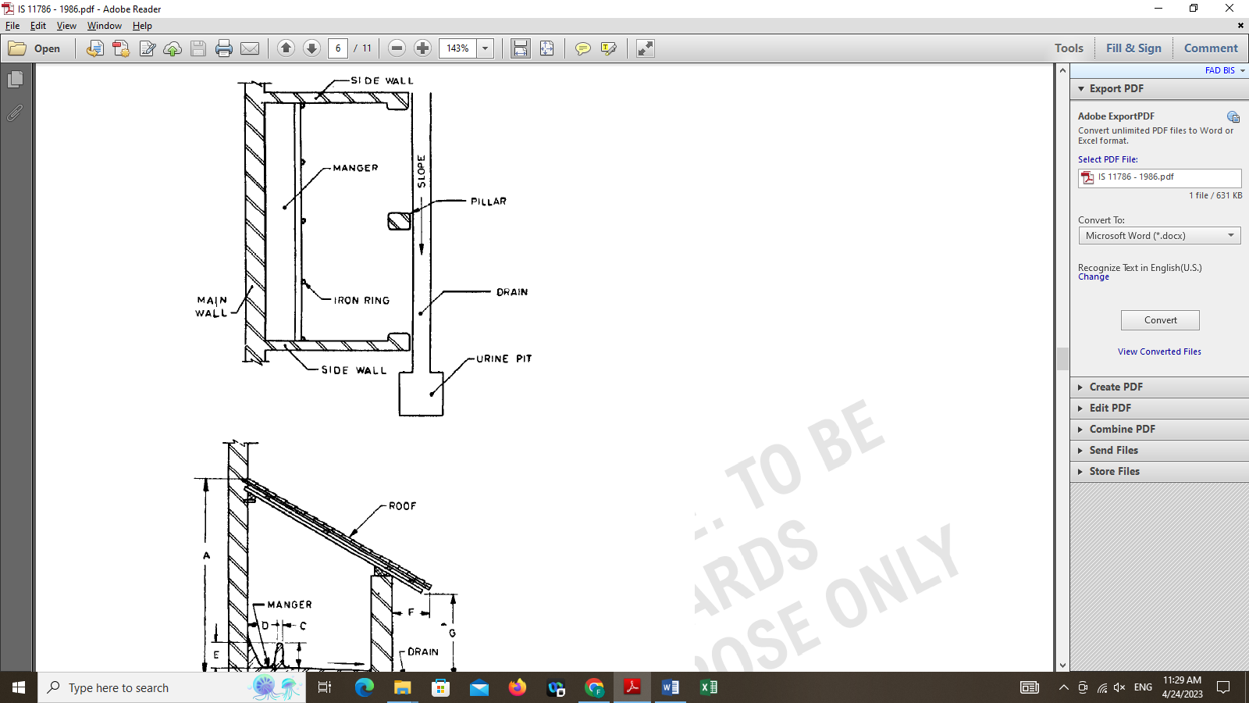

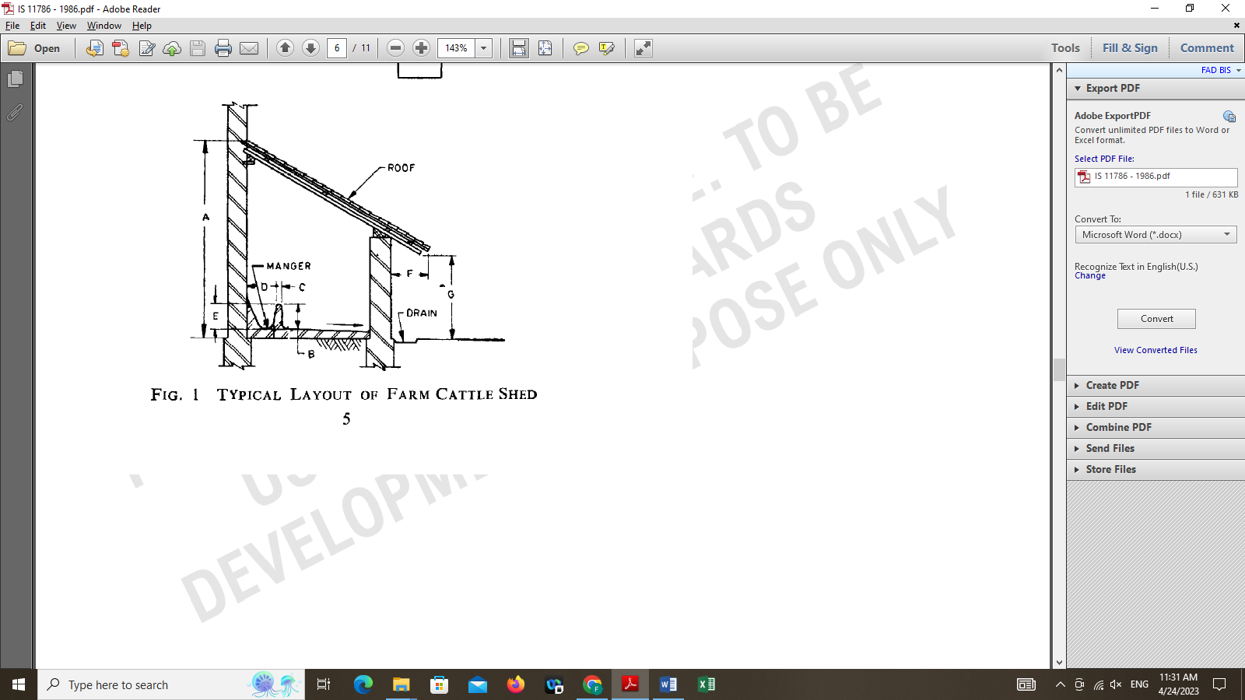

FIG. 1 TYPICAL LAYOUT OF FARM CATTLE SHED

5 CONSTRUCTION

5.1 Standings ⎯ In the selected site the construction of shed should be planned with single row and a lean-to type roof could be built against an existing wall. If the construction of shed is planned separately, make a design and fix either a lean-to type roof or gable type roof. Under the roof of covered area, the standings shall be constructed in such a way that the animals are kept facing towards the wall or. The manger shall be adjacent to the wall or lateral end in separate shed. The length and width and area of cow shed and buffalo shed capable of accommodating one to four cattle is given in Table 1. The width may be increased about 0.6 m for all areas except in high altitude areas for more comfort.

TABLE 1 SPACE NORMS FOR CATTLE SHED
 | All dimensions in metres.
NO. OF CATTLE | COW SHED  Length Width |  | BUFFALO SHED  Length Width |  | REMARKS
 | 2.5 | 3.0 | 2.7 | 3.4 | Along with calf
 | 4.2 | 3.0 | 5.2 | 3.4 | Along with calves
 | 5.7 | 3.0 | 7.3 | 3.4 | Along with calves
 | 5.6 | 3.0 | 6.8 | 3.4 | For cattle
 | 2.0 | 1.5 | 2.4 | 1.9 | For cattle

5.1.1 Flooring of Standings ⎯ The flooring of the standing may be of moorum or kankar or sand or stone slabs or brick-on-edge or concreate or wooden planks or rubber or specially manufactured material for cattle shed flooring. The wooden planks or rubber or specially manufactured material for cattle shed flooring should be used for high altitude cold climatic areas and for heavy milk yielders. The details of laying these types of floorings are given in Annex A. A plinth of at least 150 mm or (150- 300mm) in height shall be provided for the floor. The floor shall be sloped 1 in 40 (inches) towards drainage for moorum, sand and kankar and 1 in 60 (inches) towards drainage for brick-on-edge or stone-slab flooring.

5.1.2 Manger ⎯ The manger shall be of continuous type. The manger wall shall be made either of stone slabs, wooden planks or brick-in-lime or cement mortar or cement concreate. The flooring material of the manger shall be the same as for the floor, but the surface shall be finished smooth and impervious. All the corners of the manger shall be rounded off and finished smooth. The dimensions of the manger shall be as given in Table 2. Iron rings may be provided for tying the rope of the animals.

TABLE 2 DIMENSIONS OF MANGER

 | All dimensions in centimeters.
SL. NO | DIMENSION | STONE SLAB | WOODEN PLANK | BRICKS | REF TO FIG. 1
(1) | (2) | (3) | (4) | (5) | (6)
 | Height of fore curb, Max | 30 | 30 | 30 | B
 | Thickness of fore curb, Min | 4 | 3 | 10 | C
 | Inner width of manger, Min | 75 | 75 | 75 | D
 | Depth of manger, Min | 30 | 30 | 30 | E

5.2 Roof ⎯ The roof shall be lean-to type or gable type suitably sloped according to local conditions. The roof material may either be galvanized steel sheets, tiles or asphaltic roofing sheets, reinforced concreate or locally available materials. In hot climate, galvanized steel roofs may be overlaid with a an 8 to 10 cm thick thatch to lessen the stress of extreme climate. In sheds where locally available materials are used, gunny sacks treated with cement lime mixture (see 5.2.1) may be used. Generally, the eaves of the roof (see F in Fig. 1) shall project out at least 50 cm away from the pillars and in the regions where extreme climatic conditions prevail, the eaves may project up to 75 cm from the pillars to afford protection to the animals from direct sun and rain.
5.2.1 Preparation of Cement-Lime Mixture ⎯ Stir thoroughly 12 parts by volume of cement and three parts by volume of lime (see IS 712: 1973*) in 20 parts by volume of water. Add one part by volume of common salt (see IS 797: 1976†) and one-half part by volume of alum (see IS 258: 19671‡) and stir until all ingredients are well mixed. Apply the mixture evenly with the help of a brush on the inner surface of the gunny sack. Give two coats of the mixture on the outer surface of the gunny sack. Stretch the gunny sack and dry in the sun until it becomes stiff.

5.3 Pillars ⎯ The pillars may be made from any one of the following materials and their minimum dimensions shall be as indicated against each:

- Brick 45 $×$ 35 cm (see Note 1) or
40 $×$ 30 cm (see Note 2)

- Mild steel I section 10 $×$ 10 cm

- Stone masonry 30 $×$ 30 cm

- Iron pipes 10 cm diameter

- Timber

- Rectangular pillar 10 $×$ 10 cm

- Round poles 15 cm diameter

f) Reinforced concreate (RCC) 15 $×$ 10 cm (with 45 cm footing)

NOTE l ⎯ In case of 22.5 $×$ 11.25 cm brick, 2 lengths and 3 widths shall be used.

NOTE 2 ⎯ In case of 20 $×$ 10 cm (modular) brick, 2 lengths and 3 widths shall be used.

NOTE 3 ⎯ All iron structures shall be suitably painted for protection against corrtision.

*Specification for building lime (second revision).

†specification for common salt for chemical industries (second revision).

‡Specification for potash alum, technical (first revision).

5.3.1 All edges in rectangular pillars shall be rounded off and finished smooth, as far as possible. The height of pillar (see G in Fig. 1) shall be minimum of 2.1 m.

5.4 Drain ⎯ There shall be a drain laid just outside the shed. It shall be built out of brick and cement mortar and shall have rounded corners. Its lengthwise slope shall be 1 in 40 (inches). The width of drain may be of 23 cm but in any case, not more than 30 cm. The drain shall be of ‘U’ section with a depth of 6 cm at the bottom of the section. The drain shall be let to a urine pit having a depth not exceeding 40 cm. It may be circular or rectangular.
.

ANNEX A

(Clause 5.1.1)

DETAILS OF LAYING DIFFERENT TYPES OF
FLOORING OF STANDINGS

A-l MOORUM, KANKAR AND SAND FLOORING

A-l.1 The moorum, kankar and sand flooring shall be laid over a subgrade of rubble packing or broken bricks of 15 to 25cm thick wetted and well rammed. A 15-cm layer of hard moorum, kankar and sand (as the case may be) shall be laid over this subgrade with coarser pieces at the bottom and fine ones over at the top. A layer of powder moorum, kankar and sand about 3 to 5 cm shall be spread over the top of this layer. Water shall then be sprinkled, and the surface shall be well rammed. Water shall again be sprinkled until the floor is fully saturated. The surface shall be rammed, levelled and well consolidated. When the floor is dry, a thick paste of cow dung plaster shall be uniformly spread, and it shall be well rammed. A final thin coating of mixture of cow dung (four parts) and cement (one part) shall be applied after the floor has dried up and wiped clean to prevent cracking and panelling. The cow dung plaster shall be applied weekly or fortnightly to keep the floor in good condition.

A-2 BRICK-ON-EDGE FLOORING

A-2.1 The subgrade for this type of flooring shall be rubbler or brick aggregates which shall be hand-packed, watered and well rammed. A later of 10 cm of time concrete shall be spread over the sub-base, well rammed and shall be allowed to set for 7 days. The bricks shall be well burnt and of good quality (see IS 3583: 1975*) and shall be well

*Specification for burnt clay paving bricks (first revision).

soaked in water before laying. Bricks shall be laid on about 10mm thick cement or lime mortar bed and each brick shall be properly bedded on edge and set home by gentle tapping with the handle of trowel or a wooden mallet. Its inside faces shall be buttered with mortar before the next brick is laid and pressed against it. On Completion of a portion of flooring the vertical joints shall be fully filled from the top with the mortar.

A-2.2 The surface of the flooring during the laying shall be frequently checked with a straight edge at least 2 m long so as to obtain a true surface with the required slope. The surface of the flooring shall be kept constantly moist for a minimum period of 7 days. In the case of fat lime mortar, curing shall commence two days after the laying of the flooring and shall continue for 7 days. The bricks may be laid in rows having the joints parallel and at right angles to the walls or in ‘herringbone’ pattern.

A-3 STONE-SLAB FLOORING

A-3.1 The stone slabs shall be of good quality, hard, sound and dense (see IS 3622: 1977*). Apart from sandstone any other good quality stone slabs may be used according to the availability of the material. The subgrade shall be prepared as given in A-2.1 and the lime concrete bed shall be cleaned, wetted and mopped. The bedding for the slabs shall be made with cement mortar 1:4 (1 cement: 4 coarse sand) or with lime mortar (either 1 lime putty: 1 surkhi: 1 coarse sand or 1 lime putty: 2 coarse sand). The average thickness of the bedding mortar under the slab shall be 20 mm. The mortar shall be spread under the area of each slab to the specified thickness. The stone slab shall be washed clean before laying. It shall be laid on top, pressed, tapped with wooden mallet and brought to level with the adjoining slabs. It shall be lifted and laid aside. The top surface of the mortar shall then be corrected by adding fresh mortar at hollows. The edges of the slab already paved shall be buttered with cement slurry. The slab to be paved shall be lowered gently back in position and tapped with wooden mallet till it is properly bedded in level with and close to the adjoining slab with as fine a joint as possible. Subsequent slabs shall be laid in the same manner. After each slab has been laid, surplus cement on the surface of the slab shall be cleaned off. The flooring shall be cured for a minimum period of 7 days. The surface of the flooring as laid shall be true to a level and shall be of the desired slope. Slight unevenness at the meeting edges of slabs shall be removed by fine chiseling.

*Specification of sandstone (slabs and tiles) (first revision).

A – 4 DRAINAGE

The drain / manure gutter should be wide enough to hold all dung without getting blocked, and be easy to clean/ suitable dimensions are 2" width with a cross-fall of 1" away from standing. The gutter should have a gradient of 1" for every 10' length. This will permit a free flow of liquid excreta

A - 5 CONCRETE FLOORING
Concrete floor is the prevalent flooring surface in dairy barns and shelters. Concrete must be properly grooved or patterned to provide confident footing for cows. Ragged groove edges and rough finished surfaces are abrasive to cows' hooves and must be avoided. Cement concrete floor is a common material used in animal house. It is cheap and durable floor if properly constructed. Groove and rough surface are to be provided for making it non-slippery and to prevent accident.
A-6 SYNTHETIC AND RUBBER FLOORING
The surface textures of the rubber mats provide more grips for the hooves of the cows. Rubber mats not only minimize the risk of slipping, they also increase a cow’s stride and step length. It also protects the cows from any cuts or scrapes that may occur when they stand up or stretch their body. Cows prefer rubber mats as softer floors are similar to their natural habitat – grassy fields. Cows become more active as they take longer and more steps per day.

Note: The new diagram with Gable roof / Lean to type roof is necessary for separate shed rather than constructing with adjacent wall to be considered

