**BUREAU OF INDIAN STANDARDS**

**DRAFT FOR COMMENTS ONLY**

*(Not to be reproduced without the permission of BIS or used as an Indian Standards)*

|  |
| --- |
| *भारतीय मानक मसौदा*  **गोवंश के लिए कृत्रिम योनि — विशिष्टि**  *(आई एस 11800 का पहला पुनरीक्षण)*  *Draft Indian Standard*  **ARTIFICIAL VAGINA FOR BOVINES — SPECIFICATION**  *(First Revision of IS 11800)*  **ICS 65.020.30** |
| Animal Husbandry and Equipment Last date of comment: 10 October 2023  Sectional Committee, FAD 32 |

**FOREWORD**

*(Adoption clause will be added later)*

With increasing application of artificial insemination technique in the national livestock development plans, a sizeable number of artificial vagina are being used and will be required regularly for the collection of semen from the stud bulls. This standard is, therefore, being evolved to guide the manufacturers for production of quality artificial vagina.

This standard was originally published in 1986 to maintain the quality and establishing dimensional uniformity across the country. However, in order to make this standard in line with the current practices and requirements, the committee decided to revise it.

In this revision following major modifications have been made:

a) The length of cone is updated and individually specified for both buffalo bovine and cattle bovine.

b) The requirement for material of semen collection tube is updated.

For the purpose of deciding whether a particular requirement of this standard is complied with, the final value, observed or calculated, expressing the result of a test or analysis, shall be rounded off in accordance with IS 2: 2022 ‘Rules for rounding off numerical values (*second revision*)’. The number of significant places retained in the rounded off value should be the same as that of the specified value in this standard.

**1 SCOPE**

**1.1** This standard prescribes the material, dimensions, and other requirements for artificial vagina.

**2 REFERENCE**

The following standards contain provisions which through reference in this text, constitute provision of this standard. At the time of publication, the editions indicated were valid. All standards are subject to revision and parties to agreements based on this standard are encouraged to investigate the possibility of applying the most recent editions of the standards indicated below:

|  |  |
| --- | --- |
| ***IS No.*** | ***Tittle*** |
| IS 2088 : 2023 | Methods for determination of arsenic (*third revision*) |
| IS 2303 (Part 1/Sec 1) : 2021 / ISO 719 : 2020 | Grading glass for alkalinity  Part 1 Hydrolytic resistance of glass grains Section 1 Determination and classification of hydrolytic resistance at 98°C (*third revision*) |
| IS 3400 (Part 1) : 2021 / ISO 37 : 2017 | Methods of test for vulcanized  rubber Part 1 Tensile stress-strain properties (*fourth revision*) |
| IS 3400 (Part 4) : 2012 / ISO 188 : 2011 | Methods of test for vulcanized rubber Part 4 Accelerated ageing and heat resistance (*third revision*) |
| IS: 3708 (Part 1) : 2013 / ISO 126 : 2005 | Methods of test for natural rubber latex Part 1 Determination of dry rubber content [NRL : 1] (*second revision*) |
| IS 7523 : 1974 | Specification for rubber catheter (Urinary) |

**3 TYPES**

For the purpose of this standard, artificial vagina shall be of two types.

**a)** Hard Vagina

**b)** Flexible Vagina.

**4 MATERIALS**

The material for various parts of artificial vagina (*see* Fig. 1) shall be as given in **4.1** to **4.4.**

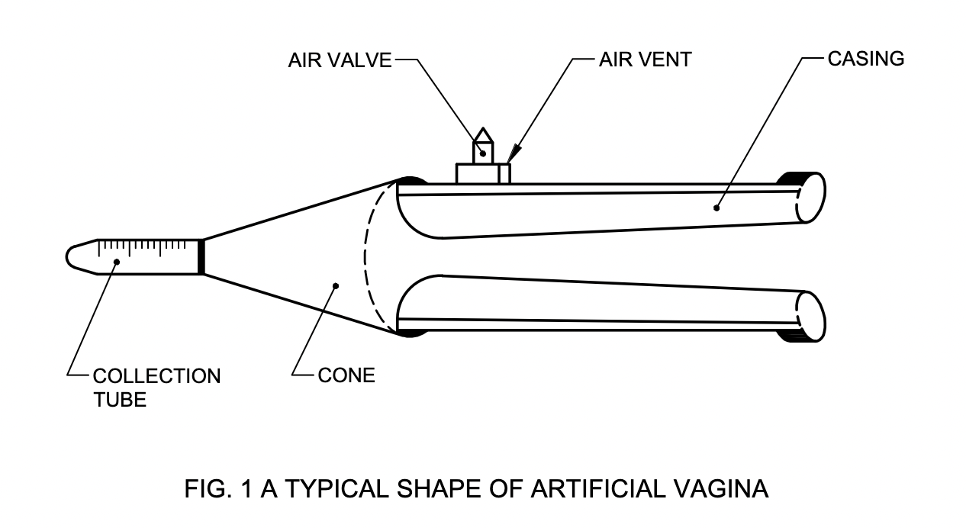

FIG. 1 A TYPICAL SHAPE OF ARTIFICIAL VAGINA

**4.1 Outer Case** ⎯ Natural or synthetic, hard or flexible rubber or thick canvas reinforced rubber free from longitudinal joints shall be used. It shall not contain any reclaimed rubber or vulcanized waste.

**4.2 Liner and Cone** ⎯Fully elastic latex rubber or neoprene rubber shall be used. No free colour shall be added in the rubber.

**4.3 Semen Collection Tube** ⎯ Chemically pure neutral glass and should not consume HCL more than 0.20 ml/gm when measure during boiling water test as mentioned in IS 2303 (Part 1/Sec 1).

**4.4 Insulation Bag** ⎯ Rexin with inside foam padding of minimum 2 mm thickness shall he used.

**5 DIMENSIONS**

**5.1 Outer Case** ⎯ The internal diameter of the case shall be 62.5 ± 2.5 mm. The length of the case shall be 290 ± 10 mm or 230 ± 10 mm.

**5.2 Liner** ⎯ The length and diameter of liner shall be 500 ± 20 mm and 54 ± 1 mm, respectively.

**5.3 Cone** ⎯ The length of the cone shall be 220 ± 30 mm for buffalo bulls and 325 ± 25 mm for cattle bulls. The proximal and distal diameter shall be 75.0 ± 2.5 mm and 15.0 ± 2.5 mm, respectively.

**5.4 Semen Collection Tube** ⎯ The tube shall be graduated up to 15 ml. Graduation up to 10 ml shall be at intervals of 0.1 ml each Land that up to 15 ml at intervals of one ml each. The length and diameter of tube shall be 120 ± 5 mm and 18 ± 1 mm, respectively.

**5.5 Insulation Bag** ⎯ The length of the bag shall be 360 ± 10 mm. The width at base and at point of attachment shall be 160 ± 5 mm and 110 ± 5 mm, respectively.

**6 PHYSICAL PROPERTIES OF RUBBER**

**6.1** The tensile strength and elongation at break of rubber when tested on dumb-bell test piece in accordance with the method given in IS 3400 (Part 1) shall be minimum of 1 MPa and 400 percent, respectively.

**6.2** When test pieces are subjected to ageing for 168 h at 70 ± 1°C in accordance with the method given in IS 3400 (Part 4), change from original value of tensile strength and elongation, tested in accordance with IS 3400 (Part 1) shall be $\begin{matrix}+10 \\ -25\end{matrix}$ and $\begin{matrix}+0 \\ -25\end{matrix}$ percent, respectively.

**6.3** The rubber used for outer case shall withstand boiling for two hours and latex rubber for liner and cone shall withstand 30 min at 100 kPa pressure.

**7 CHEMICAL PROPERTIES OF RUBBER**

**7.1** *p*H of water extract when tested in accordance with **7.1.1** shall be 7 ± 0.5.

**7.1.1** Rubber parts shall be cut into 2 mm pieces. Autoclave the pieces for 5 minutes at a pressure of 40 to 50 kPa with 200 ml of water. Discard the first extract and repeat the process with another 500 ml of water for 40 minutes. Decant the extract, cool and determine the *p*H with a *p*H meter.

**7.2** The concentration of each of the harmful contaminations of arsenic, copper, manganese and heavy metal shall not exceed 5 mg/kg. The contaminants shall be tested in accordance with the method given in Annex A.

**8 OTHER REQUIREMENTS**

**8.1** Both ends of the outer case shall be raised up to 3 mm and rounded outwards to secure the liner. The outer surface of the case shall be ribbed for better grip except for 20 mm length from both the edges.

**8.2** Both sides of the liner shall either be smooth or one side smooth and other side rough. The edges of the liners shall be rounded outwards at both ends.

**8.3** The surface of the cone shall be smooth, and both ends rounded outwards.

**8.4** Semen collection tube shall have the shape of a centrifuge tube with rounded edges, the other end having conical shape.

**8.5** The insulation bag shall have inside foam padding for the whole bag for protecting the collection tube. One end shall be circular to receive the vagina and the other end shall be provided with a good quality zip chain of 150 mm length for viewing the collection tube.

**8.6** The artificial vagina should have a metallic vent of non-ferrous material with a screw able air valve for adjustment of air pressure. The valve through which water is poured should be 60 ± 5 mm away from one end with a diameter of 110 ± 5 mm. The joint shall be leak-proof.

**9 WORKMANSHIP AND FINISH**

**9.1** The artificial vagina shall be homogenous in composition, evenly and smoothly finished, and free from pin holes, pits, cracks, grooves, and other defects.

**10 MARKING AND PACKING**

**10.1 Marking ⎯** Each artificial vagina shall be marked with the following particulars:

a) Manufacturer’s name or recognized trade-mark,

b) Type, and

c) Batch or code number.

**10.2 BIS Certification Marking**

The product(s) conforming to the requirements of this standard may be certified as per the conformity assessment schemes under the provisions of the *Bureau of Indian Standards Act*, 2016 and the Rules and Regulations framed there under, and the products may be marked with the Standard Mark.

**10.3 Packing** **⎯** The artificial vagina shall be packed in thick polythene bag for safe transit.

**11 SAMPLING FOR LOT ACCEPTANCE**

Unless otherwise agreed to between the purchaser and the supplier, the sampling of artificial vagina for lot acceptance shall be done in accordance with Annex B.

**ANNEX A**

(*Clause* **7.2**)

**METHOD OF TEST FOR CONTAMINANTS**

**A-l GENERAL**

**A-l.1 Preparation of Test Solution** ⎯ Pass 100 ml portion of sterile pyrogen free saline solution containing 9 g of sodium chloride per litre at room temperature through artificial vagina at a flow rate of approximately 10 ml/min and collect the effluent. Make up the solution to 250 ml.

**A-2 TEST FOR ARSENIC**

**A-2.1** Carry out the test for arsenic as prescribed in IS 2088 with 10 ml of the solution, using for comparison 0.005 mg of arsenic trioxide.

**A-3 TEST FOR COPPER AND MANGANESE**

**A-3.1** Carry out test from suitable test solution (*see* **A-l.1** ) for copper and manganese as prescribed in NRL : 13 and NRL : 15 respectively of IS: 3708 (Part 1).

**A-4 TEST FOR HEAVY METAL**

**A-4.1** From suitable test solution (*see* **A-l.1**), heavy metal contamination shall be tested in accordance with the method given in IS 7523

**ANNEX B**

(*Clause* **11.1**)

**SAMPLING OF ARTIFICIAL VAGINA FOR BOVINESS**

**B-l SCALE OF SAMPLING**

**B-l.1 Lot ⎯** All the artificial vagina of same size and type and belonging to the same batch of manufacture shall be grouped together to constitute a lot.

**B-l.2** For ascertaining the conformity of the material to the requirements of the specification, samples shall be tested from each lot separately.

**B-l.3** The number of artificial vagina to be selected from the lot shall depend on the size of the lot and shall be according to Table 1.

|  |  |  |  |  |
| --- | --- | --- | --- | --- |
| **TABLE 1 SCALE OF SAMPLING AND PERMISSIBLE NO. OF DEFECTIVES** | | | | |
| **NUMBER OF ARTIFICIAL VAQINA IN THE LOT** | **FOR VISUAL AND DIMENSIONAL** | | **SAMPLE SIZE** | |
| **Sample Size Acceptance**  **Number** | | **For Physical For Chemical**  **Properties Properties** | |
| (1) | (2) | (3) | (4) | (5) |
| Up to 8 | 2 | 0 | * | * |
| 9-25 | 3 | 0 | * | * |
| 26-50 | 5 | 0 | * | * |
| 51-100 | 8 | 0 | 1 | 1 |
| 101 and above | 13 | 1 | 2 |  |
| *As agreed to between the buyer and seller. | | | | |

**B-1.3.1** These artificial vagina shall be selected at random from the lot. In order to ensure randomness of selection, procedures given in IS: 4905 may be used.

**B-2 NUMBER OF TESTS AND CRITERIA FOR CONFORMITY**

**B-2.1** Each artificial vagina selected according to column 1 and 2 of Table 1 shall be first examined for visual and dimensional requirements given in 5, 8 and 9 of the specification. A vagina failing to satisfy one or more of these requirements shall be considered as defective. The lot shall be considered to have satisfied these requirements if the number of vagina found defective in the sample is less than or equal to the corresponding acceptance number given in column 3 of Table 1

**B-2.2** The lot having satisfied visual and dimensional requirements according to **B-2.1** shall be further tested for physical and chemical properties as given in 6 and 7 of the specification respectively. For this purpose, the number of vagina given in column 4 and 5 of Table 1 shall be tested. These may be taken from those already examined according to **B-2.1** and found satisfactory.

**B-2.2.1** The lot shall be declared as conforming to the requirements of this specification if none of the vagina tested according to **B-2.2** is found defective.