BUREAU OF INDIAN STANDARDS

DRAFT FOR COMMENTS ONLY
(Not to be reproduced without the permission of BIS or used as an Indian Standards)
भारतीय मानक मसौदा

पोल्ट्री के लिए लेग बैंड - विशिष्टि
(आई एस 6545 का पहला पुनरीक्षण)

Draft Indian Standard

LEG BAND FOR POULTRY - SPECIFICATION
(First Revision of IS 6545)

ICS 65.020.30

Animal Husbandry and Equipment Last date of comment:
Sectional Committee, FAD 32

FOREWORD

(Formal clause will be added later)

Leg bands are essential tools in poultry management, aiding in the identification and tracking of individual birds within a flock. These small, durable bands are typically made of materials like plastic or metal. Each band features a unique numbering system or color coding, allowing farmers, breeders, or researchers to monitor aspects such as age, breed, and health. This aids in record-keeping, disease control, and breeding programs.

To ensure the uniformity in the size and material of leg band, a need was felt to develop a national standards to help the poultry farmers, breeders or researcher selecting a better quality leg band and ensuring it’s durability. Accordingly, this standard was first published in 1972.

In this revision, following modifications have been incorporated keeping in view the technological advancement in the field so far and the standard have been brought out in the latest style and format of the Indian Standards.

- Material requirements have been updated as per the recent industrial practices.
- Additional clause has been added to include the precautions at the time of application and thereafter too.
- Marking clause has been modified by including correspondence address and phone number of manufacturer.
For the purpose of deciding whether a particular requirement of this standard is complied with, the final value observed or calculated, expressing the result of a test or analysis, shall be rounded off in accordance with IS 2: 2022 ‘Rules for rounding off numerical values (second revision)’. The number of significant places retained in the rounded off value should be the same as that of the specified value in this standard.

1 SCOPE

This standard specifies dimensional requirements, material requirements, and other requirements for leg bands for poultry.

2 DIMENSIONS

As shown in Fig. 1 and Fig. 2

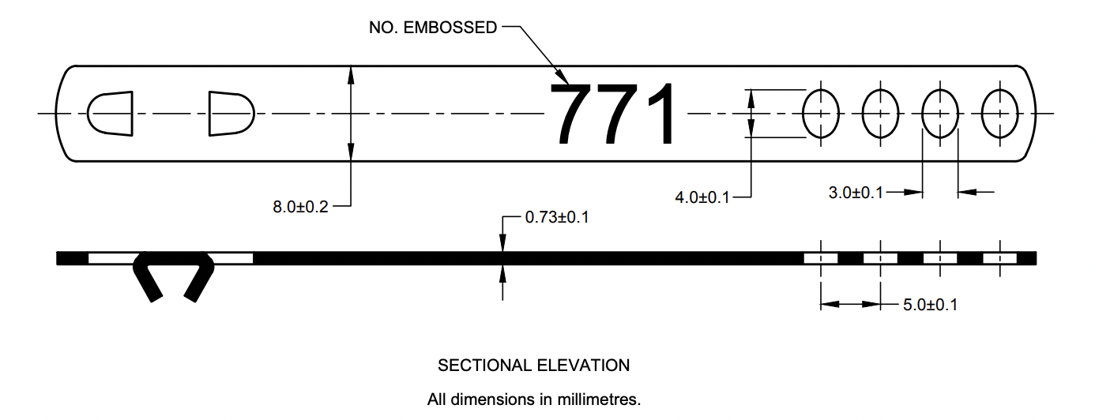

All dimensions in millimeters.

FIG. 1 ALUMINUM/ BRASS LEG BAND FOR POULTRY

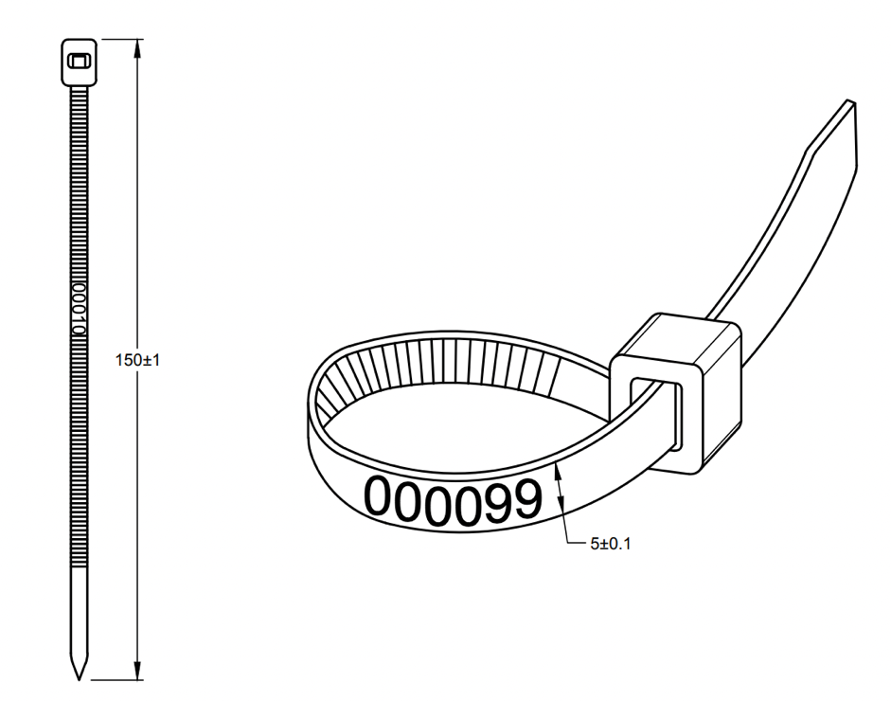

All dimensions in millimeters.

FIG. 2 PLASTIC/THERMOPLASTIC POLYURETHANE (TPU) LEG BAND FOR POULTRY

3 MATERIALS

3.1 Leg band shall be made of aluminum, brass, or plastic.

3.2 Thickness of aluminum leg band or brass leg band shall be in range of 0.63 to 0.83 mm.

3.2 Fully annealed aluminum leg band having thickness in the range of 0.015 mm to 0.017 mm shall be used for quails.

3.3 Minimum thickness of plastic leg band or Thermoplastic Polyurethane (TPU) leg band shall be 1 mm.

3.4 Material should be cold resistant, frost-resistant, heat-resistant, non-toxic, durable, and not easy to wear and can be reused.

4 OTHER REQUIREMENTS

4.1 Embossing – The numbers shall be embossed in the middle of the band (see Fig. 1) and shall be easily visible from a distance. The numbering pattern and color shall be as agreed to between the purchaser and the vendor.

4.2 Holes – There shall be maximum 4 holes at one end in the center of the sheet to adjust according to the size of the leg of birds and at the other end, there shall be projections to engage two adjacent holes. The projections shall be flat and shall not either drawn out or cupped. The bases of the projections shall be free from cracks and sharp turns. The distance between the centers of the two consecutive holes shall be not less than 5 mm. The distance between the end of the sheet and the first hole shall be not less than 3 mm.

5 PRECAUTIONS FOR SIZING OF LEG BANDS

5.1 Caution must be exercised to ensure that the right hole on the band is being used. The choice of hole used would determine how long the leg band would be when closed around the bird’s leg and therefore the hole to be used must be chosen carefully keeping in mind the size of the bird’s leg.

7.2 Over a period, the hole on the band, which is in use, must be changed to accommodate for the growing size of the bird’s leg as per need.

5 MARKING

5.1 The leg bands shall be clearly marked with the manufacturer’s name or brand, alongside the manufacturer’s phone number and correspondence address.

5.2 BIS Certification Marking

The product(s) conforming to the requirements of this standard may be certified as per the conformity assessment schemes under the provisions of the Bureau of Indian Standards Act, 2016 and the Rules and Regulations framed thereunder, and the products may be marked with the Standard Mark.

6 PACKING

The leg bands shall be packed in small cardboard boxes or wooden boxes, or the packing may be done as agreed to between the purchaser and the supplier.

