**BUREAU OF INDIAN STANDARDS**

**DRAFT FOR COMMENTS ONLY**

(Not to be reproduced without the permission of BIS or used as an Indian Standards)

|  |
| --- |
| *भारतीय मानक मसौदा*  **GOBLETS ⎯ SPECIFICATION**  *(आई एस 13125 का पहला पुनरीक्षण)*  ***Draft Indian Standard***  **GOBLETS ⎯ SPECIFICATION**  *(First Revision of IS 13125)*  **ICS** **65.020.30** |
| Animal Husbandry and Equipment Last date of comment:  Sectional Committee, FAD 32 |

**FOREWORD**

Goblets are used for storing frozen semen straws in cryocan filled with liquid nitrogen .

For the purpose of deciding whether a particular requirement of this standard is complied with, the final value, observed or calculated, expressing the result of a test or analysis, shall be rounded off in accordance with IS 2: 1960 ‘Rules for rounding off numerical values (revised)‘. The number of significant places retained in the rounded off value should be the same as that of the specified value in this standard.

In this revision, an additional requirement has been incorporated where the goblet shall be of white color only for establishing uniformity and easy identification of stored semen. The standard has been brought out in the latest style and format of the Indian Standards:

For the purpose of deciding whether a particular requirement of this standard is complied with, the final value observed or calculated, expressing the result of a test or analysis, shall be rounded off in accordance with IS 2: 2022 ‘Rules for rounding off numerical values *(second revision)*’. The number of significant places retained in the rounded off value should be the same as that of the specified value in this standard.

**1 SCOPE**

This standard prescribes the material, dimensions and other requirements for goblets (*see* Fig. 1).

**2 REFERENCES**

The following Indian Standards are necessary adjuncts to this standard:

|  |  |
| --- | --- |
| *IS No.* | *Title* |
| IS 733: 1983 | Specification for wrought aluminium and aluminium alloy bars, rods and sections (For General Engineering Purposes) (*third revision*) |
| IS 7328: 2020 | Specification for Polyethylene Material for Moulding and Extrusion (*third revision*) |

**3 TYPES**

For the purpose of this standard, the goblet shall be of the following types:

Type I Small

Type II Medium

Type III Large

NOTE **⎯** Each type shall again be classified in medium, mini and open end.

**4 MATERIALS**

The goblet shall be made of aluminium (*see* IS 733: 1983) or high-density polyethylene (*see* IS 7328: 2020).

**5 DIMENSIONS**

**5.1** The height and outer diameter of various type of the goblets shall be as given below (*see* also Fig. 1):

;

|  |  |  |  |  |  |  |  |  |  |
| --- | --- | --- | --- | --- | --- | --- | --- | --- | --- |
| Characteristics | Dimensions, mm | | | | | | | | |
|  |  | Small |  |  | Medium |  |  | Large |  |
|  | Medium | Mini | Open  End | Medium | Mini | Open  End | Medium | Mini | Open  End |
| (1) | (2) | (3) | (4) | (5) | (6) | (7) | (8) | (9) | (10) |
| Height (H) | 120 | 120 | 60 | 120 | 120 | 60 | 120 | 120 | 60 |
| Outer diameter (D) | 13 | 13 | 13 | 35 | 35 | 35 | 65 | 65 | 65 |

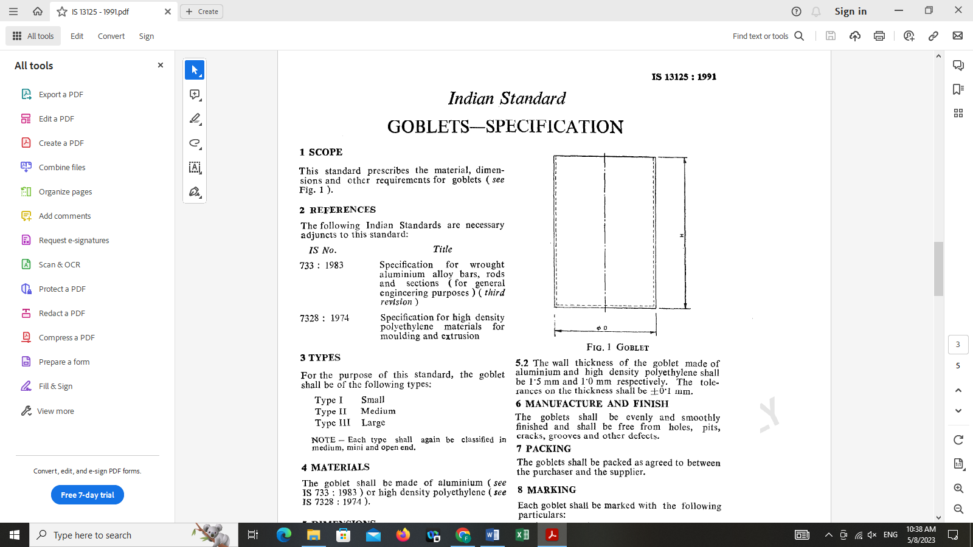

**FIG. 1 GOBLET**

**5.2** The wall thickness of the goblet made of aluminium and high density polyethylene shall

be 1.5 mm and 1.0 mm respectively. The tolerances on the thickness shall be ± 0.l mm.

**6 MANUFACTURE AND FINISH**

The goblets shall be evenly and smoothly finished and shall be free from holes, pits, cracks, grooves, other defects and shall be white colored for easy identification of stored semen.

**7 PACKING**

The goblets shall be packed as agreed to between the purchaser and the supplier.

**8 MARKING**

Each goblet shall be marked with the following particulars:

1. Name of the material,
2. Indication of the source of manufacture,
3. Type, and
4. Batch or code number.