**BUREAU OF INDIAN STANDARDS**

**DRAFT FOR COMMENTS ONLY**

(Not to be reproduced without the permission of BIS or used as an Indian Standards)

|  |
| --- |
| *भारतीय मानक मसौदा*  **सुअर आवास के लिए रीति संहिता**  *(आई एस 3916 का दूसरा पुनरीक्षण)*  ***Draft Indian Standard***  **CODE OF PRACTICE FOR PIG HOUSING**  *(Second Revision of IS 3916)*  **ICS** **65.020.30** |
| Animal Husbandry and Equipment Last date of comment:  Sectional Committee, FAD 32 |

**FOREWORD**

Pig is widely distributed in all the eco-regions of the country and is an important occupation of the rural society especially the tribal masses. People of certain ethnic groups in the country prefer to keep pigs, especially the black colored ones, for festivals and ceremonial purposes. The highest pig population is observed in eastern and northeastern (NE) states, followed by the northern, southern, central and western India.

In general, there are three types of pig farms in India based on the numbers of pigs produced on the farm; small (including backyard farms, <10 head), medium (50-200 head), and large (> 200 head). With urbanization and production efficiency, Indian pig and pork production is slowly shifting from backyard and small farms to specialized household (or local community) farms as well as modern intensive farms, especially in the urban areas close to cities.

In view of the extremely variable climatic conditions prevailing in different parts of the country, provision of suitable standards for housing of pigs is of great importance. The housing should also provide proper hygienic conditions required to maintain the healthy growth of these animals.Housing of pigs is dependent upon the system of farming, which may vary according to the prevailing conditions of the locality and also on the financial resources of the farmer.

An attempt was made in this code to specify dimensions of various structures of pig housing so as to serve general purpose in different regions of the country. However, it may be necessary to modify the structural designs under an available expert opinion suiting local conditions, especially in those places, where extreme climatic conditions prevail. This standard was originally published in 1966, In this revision, following other modifications have been incorporated keeping in view the technological advancements in the field and the standard has been brought out in the latest style and format of the Indian Standards:

For the purpose of deciding whether a particular requirement of this standard is complied with, the final value, observed or calculated, expressing the result of a test, shall be rounded off in accordance with IS 2: 1960*. The number of significant places retained in the rounded off value should be the same as that of the specified value in this standard.

**1 SCOPE**

This standard provides a guidance on the constructional details of structures required for housing of pigs.

**2 TERMINOLOGY**

**2.0** For the purpose of this code, the following definitions shall apply.

**2.1 Boar** ⎯ An uncastrated male pig.

**2.2 Sow** ⎯ A female pig that has farrowed at least once.

**2.3 Gilt** ⎯ A female pig which has not farrowed.

**2.4 Litter** ⎯ A group of piglets born to a sow.

**2.5 Piglet** ⎯ A young pig before weaning.

**2.6 Weaners** ⎯ Piglets which have been separated from the mother for the purpose of independent rearing.

**2.7 Sty** ⎯ A dwelling place consisting of one or more of pens (*see* 2.7.1) for pigs.

**2.7.1** *Pen* ⎯ A part of the sty for housing a single or group of pigs having a covered place and an adjoining open yard; the covered place providing feeding and watering troughs and dunging spaces.

**2.8 Dry Sow and Gilt Sty** ⎯ A dwelling place for dry sows and gilts.

**2.9 Farrowing Sty** ⎯ A dwelling place for nursing sows and their litters.

**2.10 Fattening Sty** ⎯ A dwelling place for young pigs kept for fattening purpose.

**2.11 Sick Sty** ⎯ A dwelling place for sick pigs particularly meant to be segregated from healthy stock.

**2.12 Boar Sty** ⎯ A dwelling place for breeding boars.

**3 LAYOUT**

**3.1** The general layout of the piggery having its different units may be as given in Fig. 1.

**4 LOCATION**

**4.1** The structures shall be located on a fairly raised and well-drained site, not liable to flooding. The ground shall not be clayey or slushy.

**4.2** The structures shall be at least 15 m away from dwelling and factories, 30 m away from dairies, animal and poultry houses and food grains storage structures, 45 m away from fire sources and 1 km away from garbage dumping grounds, slaughter houses, hide curing centres and tanneries.

**4.3** The boundaries of the site shall be at least 50 m away from the nearest transit roads and shall be surrounded by a fence. In locating buildings and structures on the site, suitable space shall be left for sanitary purpose.

**4.4** The site shall be so selected where adequate water supply is assured.

**4.5** The structures shall be so located and oriented as to avoid heavy draughts but at the same time it shall have plenty of sunlight and circulation of fresh air.

**5 SPACE REQUIREMENTS**

**5.1 Covered Floor Area Requirement** ⎯ The covered floor area recommended, and typical dimensions adopted in general for each animal shall be as given in Table 1.

|  |  |  |  |
| --- | --- | --- | --- |
| **TABLE 1 COVERED FLOOR AREA REQUIREMENT PER ANIMAL** | | | |
| **SL NO.** | **TYPE OF ANIMAL** | **COVERED FLOOR**  **AREA PER**  **ANIMAL**  m2 | **TYPICAL DIMENSIONS**  m |
| (1) | (2) | (3) | (4) |
| i) | Boar | 6.25 to 7.50 | 2.5 × 2.5 to 2.5 × 3.0 |
| ii) | Farrowing sow | 7.50 ,, 9.00 | 2.5 × 3.0 ,, 3.0 × 3.0 |
| iii) | Weaner /fattening pig | 0.96 ,, 1.80 | 0.8 × 1.2 ,, 1.2 × 1.5 |
| iv) | Dry sow or gilt | 1.80 ,, 2.70 | 1.2 × 1.5 ,, 1.8 × 1.5 |

**5.2 Open Yard Area Requirement** ⎯ The open yard area recommended for each animal shall be as given in Table 2. The open yard area for the particular type of animal shall be adjacent to its sty.

|  |  |  |
| --- | --- | --- |
| **TABLE 2 OPEN YARD AREA REQUIREMENT PER ANIMAL** | | |
| **SL NO.** | **TYPE OF ANIMAL** | **OPEN YARD AREA PER**  **ANIMAL**  m2 |
| (1) | (2) | (3) |
| i) | Boar | 8.8 to 12.0 |
| ii) | Farrowing sow | ,, ,, ,, |
| iii) | Weaner/fattening pig | ,, ,, ,, |
| iv) | Dry sow or gilt | 1.4 to 1.8 |

**5.3 Feeding and Watering Trough Area Requirement** ⎯ The trough length required per animal for feeding and watering purposes shall be as given in Table 3. In all cases the width of the trough shall not be less than 50 cm.

NOTE ⎯ The requirement of water for the animals would vary according to the prevailing climatic conditions, type of feed used and the age of the animals. According to the existing practical experience, the quantity of water required per animal per day is about 22 litres.

|  |  |  |
| --- | --- | --- |
| **TABLE 3 FEEDING AND WATERING TROUGH LENGTH REQUIRED PER ANIMAL** | | |
| **SL NO.** | **TYPE OF ANIMAL** | **LENGTH**  Cm |
| (1) | (2) | (3) |
| i) | Boar | 60 to 75 |
| ii) | Sow and litter | 75 ,, 100 |
| iii) | Fattening pig | 30 ,, 40 |
| iv) | Weaner | 20 ,, 30 |

**6 STIES**

**6.0** The animals shall be kept in sties (*see* 2.7) which shall be divided into one or more pens (2.7.1). Each pen may have a single animal or a group of animals depending upon the age, sex and purpose. The number and dimensions of pens shall depend upon the number of animals to be kept and the floor area (*see* 5.1) specified per animal, In the case of extensive system of pig-keeping, where the pigs are in pasture, the pens and sties shall be constructed separately to provide them shelter.

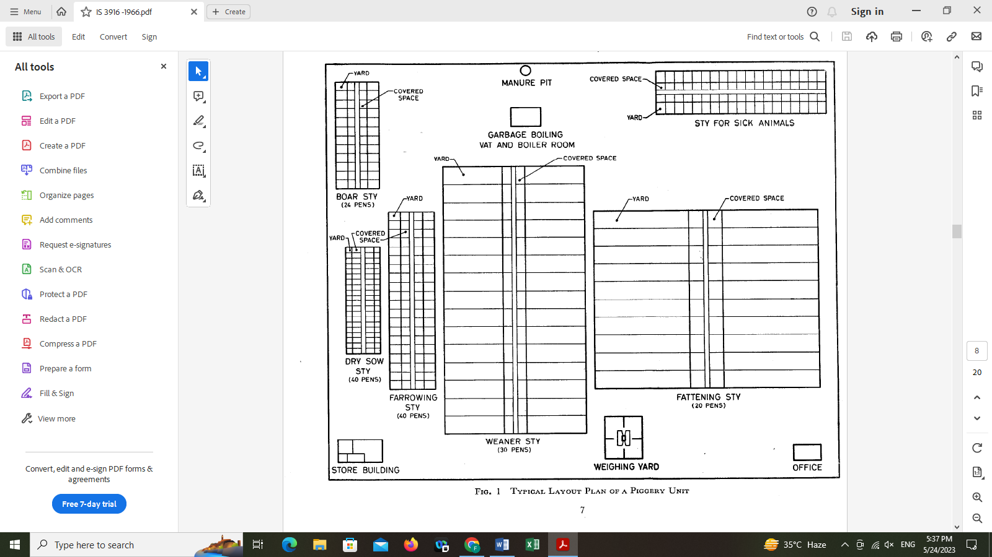

**FIG. 1 TYPICAL LAYOUT PLAN OF A PIGGERY UNIT**

**6.1** In large scale commercial piggeries having large number of animals for the convenience of better management there may be different types of sties as indicated below for housing different types of animals. For small scale operations instead of providing different sties the animals may be housed under the same roof with provision of separate pens for the purpose. Such sites are:

a) Boar sty,

b) Dry sow and gilt sty,

c) Farrowing sty,

d) Grower sty

e) Pregnant pig sty

f) Fattening sty, and

g) Sick, sty.

**6.1.1** *Boar Sty* ⎯ Each boar sty shall normally have not more than 24 pens under one roof and each pen shall accommodate not more than one animal.

**6.1.2** *Dry Sow and Gilt Sty* ⎯ Each sty shall normally have not more than 40 pens under one roof and these pens shall be arranged in two rows. Each pen shall accommodate two, five or ten animals depending upon the stage of pregnancy.

**6.1.3** *Farrowing or Nursing Sow Sty* ⎯ Each farrowing sty shall normally contain not more than 40 pens under one roof and each pen shall accommodate not more than one animal with the litter.

6.1.4 *Grower sty* - Each grower sty shall normally have not more than 15 pens under one roof and each pen may have 20 to 35 animals kept for fattening, purpose.

6.1.5 *Pregnant pig sty* - Each pregnant pig sty shall normally have not more than 20 pens under one roof and each pen shall accommodate not more than one animal.

**6.1.6** *Fattening Sty* ⎯ Each fattening sty shall normally have not more than 20 pens under one roof and each pen may have 16 to 32 animals kept for fattening, purpose.

**6.1.7** *Sty for Weaner Piglets* ⎯ Each sty shall normally have not more than 30 pens under one roof. Each pen may accommodate 10 to 20 animals of age ranging between two and six months.

**6.1.8** *Sty for Sick Animals* ⎯ The number of pens under this sty shall depend upon the number of animals kept in farm. Normally a minimum accommodation for 5 percent of the stock shall be provided for housing the sick animals. This sty shall be situated at a reasonable distance from the other sties to have an effective segregation from healthy animals. The construction and internal planning (*see* 6.2) of the sty shall be the same as for the other sties. Provisions for feeding and watering shall be made in the sty itself.

**6.2** The internal details, such as for sleeping quarter, dunging area, feeding passage, feeding and watering troughs in the sties meant for keeping boars, dry sows, weaners and fatteners are given in Fig. 2.

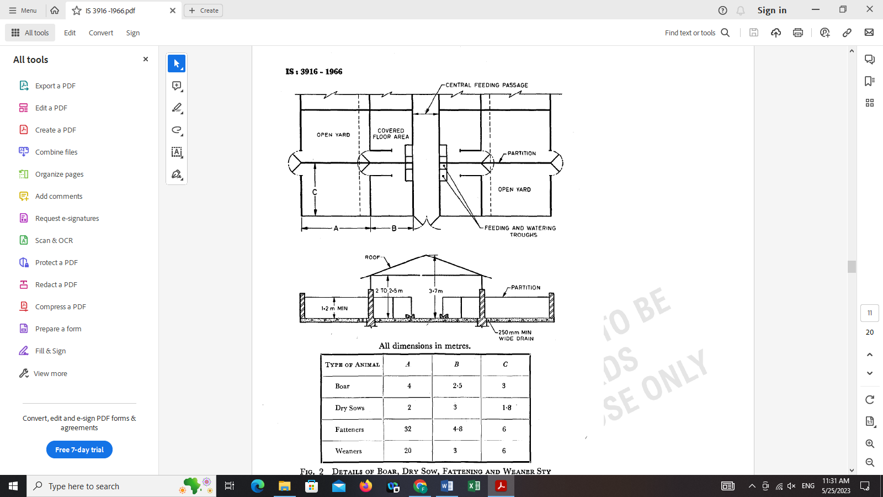

All dimensions in metres.

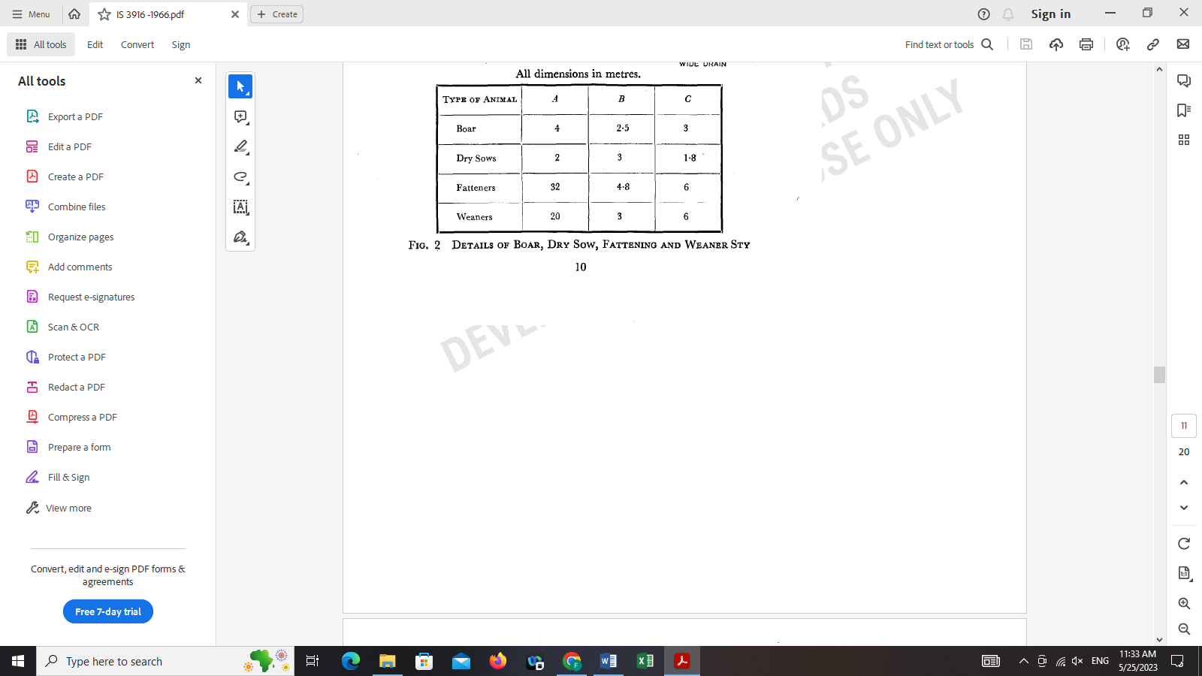

**FIG. 2 DETAILS OF BOAR, DRY SOW, FATTENING AND WEANER STY**

**6.2.1** *Internal Details of Furrowing Sty* ⎯ The farrowing sty shall be so designed as to provide sufficient room for the nursing sow to sleep and for the piglets to move. Along the walls, compartments for piglets shall be provided in one or two rows. Each such compartment shall measure 2.5 $×$ 0.75 $×$ 1.2 m high (*see* Fig. 3). An opening of 300 $×$ 225 mm shall be provided in each compartment facing the nursing sow. Watering and feeding troughs shall be provided in each compartment. Guard rails shall be provided 25 cm above the floor level.

NOTE ⎯ The idea to have these compartments is to keep the piglets as far as possible away from the nursing

sow so as to avoid the possible crushing of the young ones by the movement of the mother.

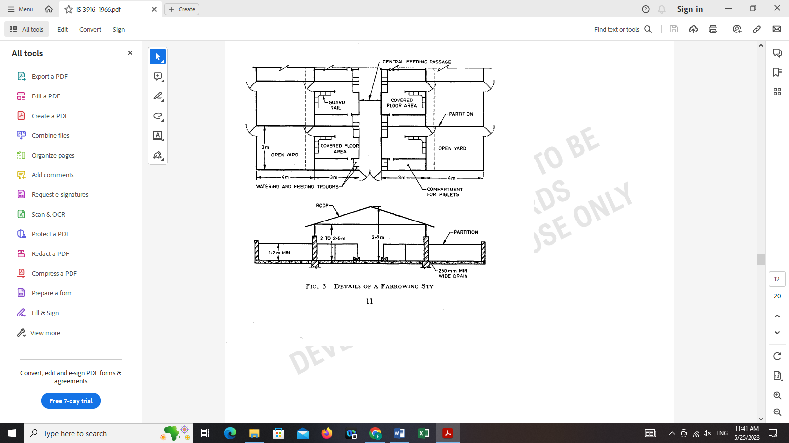

**FIG. 3 DETAILS OF A FARROWING STY**

**7 CONSTRUCTIONAL DETAILS OF STIES**

**7.1 Floor** ⎯ The floor shall be hard, non-slippery, non-abrasive, impervious to water and easy to clean. The floor may be of cement concrete (*see* IS 2571: 1963*) or paved with cement concrete flooring tiles (*see* IS 1443: 1959†), stone slabs or bricks (*see* IS 1077: 1957‡) and set in cement mortar (*see* IS 2250: 1965§) or lime mortar (*see* IS 1625: 1962‖). Wherever necessary the flooring may be suitably insulated. If the floor is made of stone slabs or bricks, the joints shall be filled in properly with the binding material. The surface of the floor shall be suitably patterned to give a rough surface. This floor shall slope towards the drains (*see* 7.6). The details of construction shall vary from place to place depending on the climatic conditions and shall be constructed on the recommendation of the

local housing experts.

**7.2** The height of walls shall be 2 to 2.5 m from the floor level. Ventilators (*see* 7.5) at suitable intervals shall be provided on the long sides of the walls. Alternatively, the walls up to two-thirds of the height may be built of bricks with cement mortar or lime mortar and the remaining portion of the wall may be made with the help of series of wooden rafters; each such rafter measuring at least 25 $×$ 40 mm. The clearance between two adjacent rafters shall be not more than 350 mm. These rafters shall be supported by 40 $×$ 40 mm angle iron placed at the intervals of 3 m. The open space may be covered with wire netting.

**7.3 Roof** ⎯ The roof may be of RCC flat type or gabled. In the case of the gabled roof, materials for roofing may be asbestos cement sheets (*see* IS 459: 1962¶), corrugated galvanized steel sheets (*see* IS 277: 1962**) or clay tiles (*see* IS 654: 1962††). The roofing shall be laid in accordance with the recommendations given in the relevant Indian Standards [*see* IS 3007 (Part I): 1964‡‡ and IS 2858: 1964§§ 1. In the regions of extreme climatic conditions the roof may be insulated either by providing a layer of thatching or ceiling in order to reduce the severity of heat inside the sty.

*Code of practice for laying in situ cement concrete flooring.

†Code of practice for laying and finishing of cement concrete flooring tiles.

‡Common burnt clay building brick.

§Code of practice for preparation and use of masonry mortars.

‖Code of practice for preparation and use of lime mortar in buildings.

¶Specification for unreinforced corrugated asbestos cement sheets (*revised*).

**Specification for galvanized steel sheets (plain and corrugated) (*revised*).

††Specification for clay roofing tiles, Mangalore pattern (*revised*).

‡‡Code of practice for laying of asbestos cement sheets: Part I Corrugated sheet.

§§Code of practice for roofing with Mangalore tiles.

**7.4 Doors** ⎯ The number of doors provided in each sty shall depend upon its dimensions. The doors shall be strong and so fitted that it is close to the floor level. The door leaves may be made of either galvanized steel sheets or wood. The door frame may be made of angle irons. The width of the door of individual pen may range between 0.75 to 1 m while the doors of a sty may range between 1.2 to 1.5 m and the height 1.2 to 2 m.

**7.5 Ventilators** ⎯ The ventilators shall be provided if the sties are closed on the sides. The number of ventilators to be provided shall depend upon the dimensions of the sty. Each ventilator shall be 0.6 m high and 1 m long. The top of each ventilator shall be 0.5 m from the highest point of the wall. Each ventilator shall be covered from outside by wire netting.

**7.6 Drainage** ⎯ Each sty shall be provided with at least one drain on one side of the sty for proper drainage. The drain shall have a minimum width of 250 mm and a slope of 25 mm in every 10 metres.

**8 SUBSIDIARY ITEMS**

**8.1** Over and above the general means of housing the pigs described above a big commercial or research piggery may require few subsidiary buildings like weighing yard, store building, loading and unloading ramp, skim milk tanks, manure pit, feed stuff boiling vat, boiler room and wallowing tank.

**8.1.1** *Weighing Yard* ⎯ The specification for the weighing yard may vary from one place to the other. A weighing shed shall be provided wherein a weighing scale shall be fitted to record the weights of the animals regularly. The details of the weighing yard are given in Fig. 4.

**8.1.2** *Store Building* ⎯ The store building may have a store-keeper’s office, a mixing room to mix the feed of the animals, a room for keeping miscellaneous items, such as farm equipment and tools and a feed store (*see* 8.1.2.1) meant for bulk storage of feed in bags. The general plan of the store-building is shown in Fig. 5 (*see* P 15).

**8.1.2.1** *Feed store* ⎯ The size of the feed room shall vary according to the number of animals kept. The space required for the feed room in a farm may be calculated as given below but at the same time some provision shall be made for some scope for increased storage and the passage to move about in the store:

Space required = $\frac{X ×Y × Z}{B}$ $×$ $\frac{1}{N}$

where

*X* = Number of bags in stack,

*Y* = Average feed consumption per day in kg,

*Z* = Number of days the feed has to be stored,

*B* = Capacity of each bag in kg, and

*N* = Number of bags to be stacked one over the other.

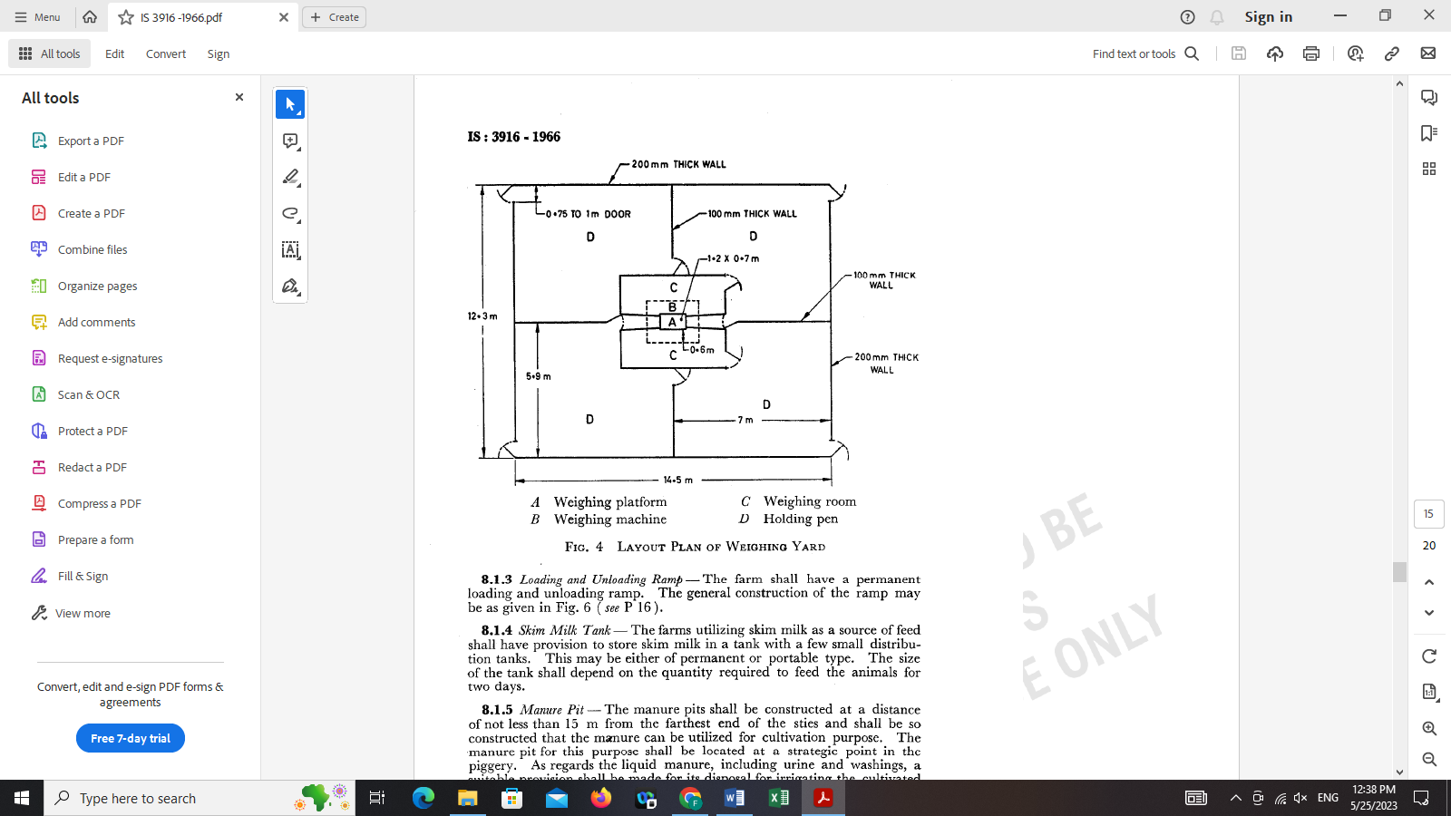

A Weighing platform C Weighing room

B Weighing machine D Holding pen

**FIG. 4 LAYOUT PLAN OF WEIGHING YARD**

**8.1.3** *Loading and Unloading Ramp* ⎯ The farm shall have a permanent loading and unloading ramp. The general construction of the ramp may beasgiveninFig.6 (*see* P 16).

**8.1.4** *Skim Milk Tank*  ⎯ The farms utilizing skim milk as a source of feed shall have provision to store skim milk in a tank with a few small distribution tanks. This may be either of permanent or portable type. The size of the tank shall depend on the quantity required to feed the animals for two days.

**8.1.5** *Manure Pit*  ⎯ The manure pits shall be constructed at a distance of not less than 15 m from the farthest end of the sties and shall be so constructed that the manure can be utilized for cultivation purpose. The ‘manure pit for this purpose shall be located at a strategic point in the piggery. As regards the liquid manure, including urine and washings, a suitable provision shall be made for its disposal for irrigating the cultivated areas through gravitation.

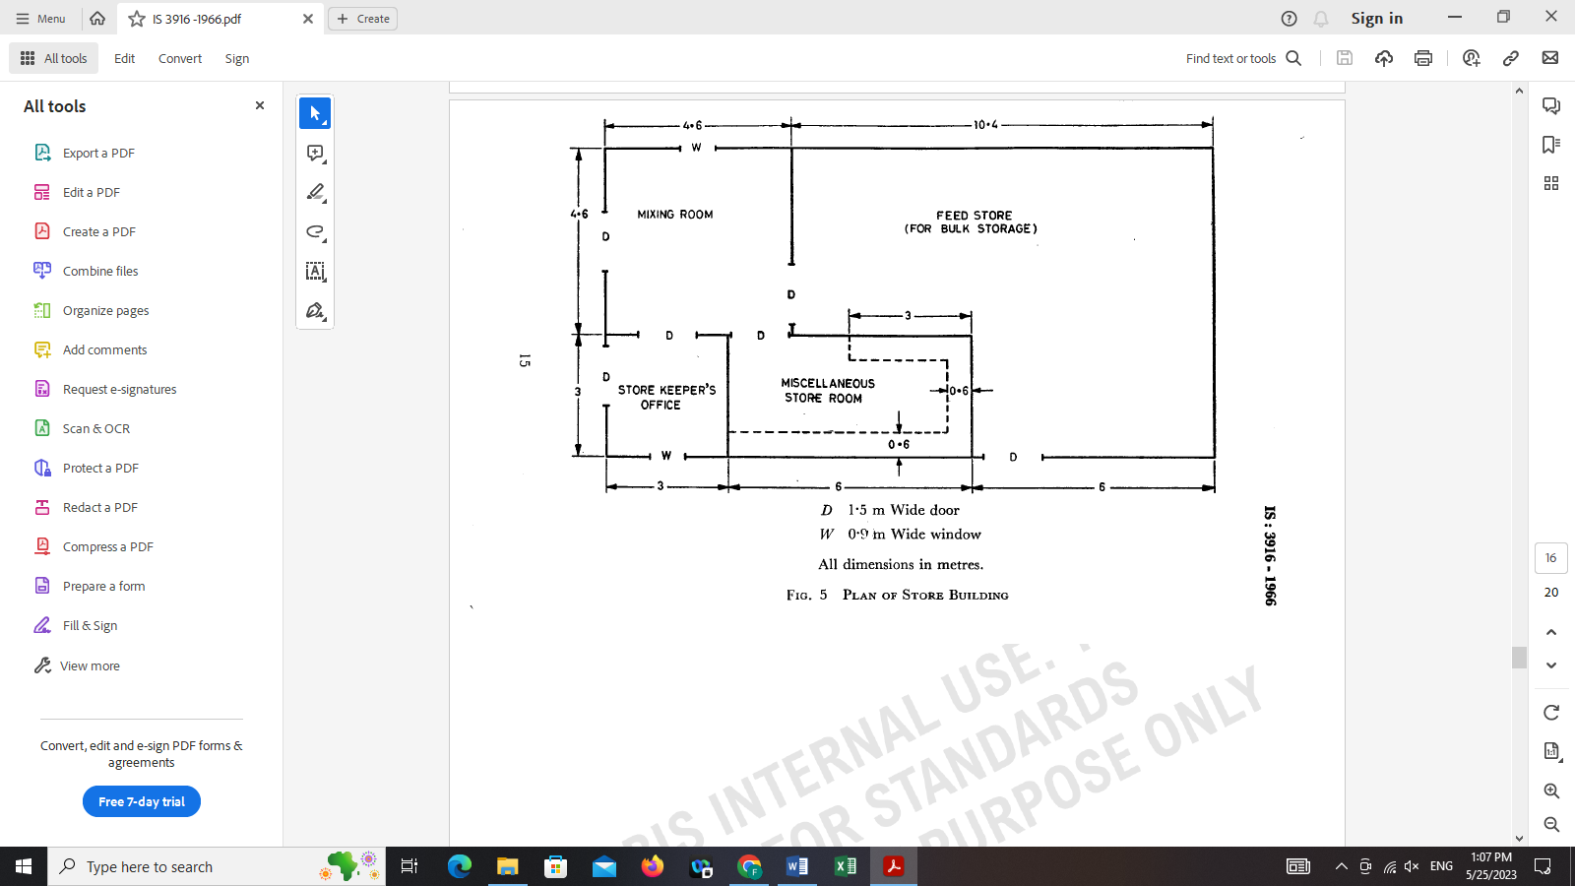

D 1.5 m Wide door

W 0.9 m Wide window

All dimension in metres.

**FIG. 5 PLAN OF STORE BUILDING**

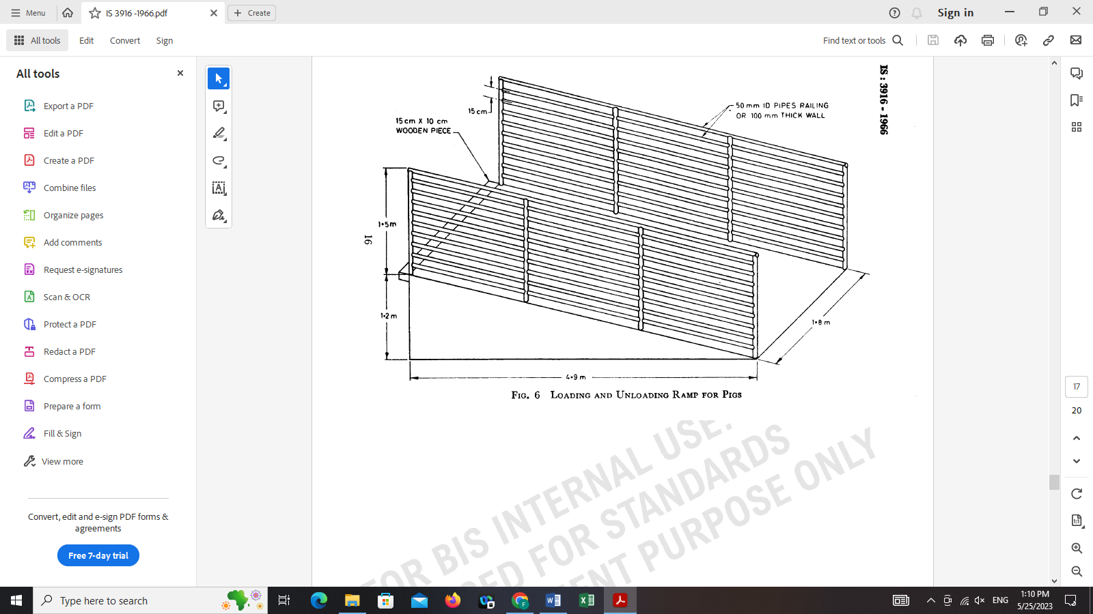

**FIG. 6 LOADING AND UNLOADING RAMP FOR PIGS**

**8.1.6** *Feed Stuff Boiling Vat and Boiler Room* ⎯ A shed or room shall be constructed for boiling the feed stuff either in big vessels or in jacketed vats. The boiling may be done with fire or with steam generator from a boiler.

**8.1.7** *Wallowing Tank*  ⎯ Wallowing tanks may be provided in pig breeding farms situated in hot zones. The wallowing tank may be made of cement concrete the dimensions of which shall not be less than 2.5 × l.2 × 0.15 m. Alternatively, overhead sprinkles or showers may be provided in order to keep the animals cool during summer.