**BUREAU OF INDIAN STANDARDS**

**DRAFT FOR COMMENTS ONLY**

(*Not to be reproduced without the permission of BIS or used as an Indian Standard*)

|  |
| --- |
| *भारतीय मानक मसौदा*  ***बाजरा के प्राथमिक प्रसंस्करण के लिए प्रतीक और प्रवाह आरेख***  *Draft Indian Standard*  **SYMBOLS AND FLOW DIAGRAM FOR PRIMARY**  **PROCESSING OF MILLETS**  **ICS No. 65.060** |
| Agriculture and Food Processing Equipment Last date of comments: **26 November 2023**  Sectional Committee, FAD 20 |

**FOREWORD**

*(Adoption clause will be added later)*

Equipment for primary processing for millet are now being extensively used in the country. It has, therefore, become necessary to have proper symbols for different components as well as flow diagrams for the entire process of milling. The adoption of these symbols would help in proper understanding and drawing of the system.

For the same purpose, a need was felt to develop an Indian Standard for Symbols and flow diagrams for equipment used in primary processing of millets which will help in ensuring product quality, safety, and industry competitiveness. This standard will also facilitate consistency, innovation, and adherence to best practices in the milling industry, ultimately benefiting both manufacturer and millers.

For the purpose of deciding whether a particular requirement of this standard is complied with, the final value observed or calculated, expressing the result of a test or analysis, shall be rounded off in accordance with IS 2: 2022 ‘Rules for rounding off numerical values (*second revision*)’. The number of significant places retained in the rounded off value should be the same as that of the specified value in this standard.

**1 SCOPE**

This standard prescribes the symbols and flow diagram used in the primary processing of millets.

**2 GENERAL FLOW CHART**

A general millet milling flow chart is given in Fig. 1.

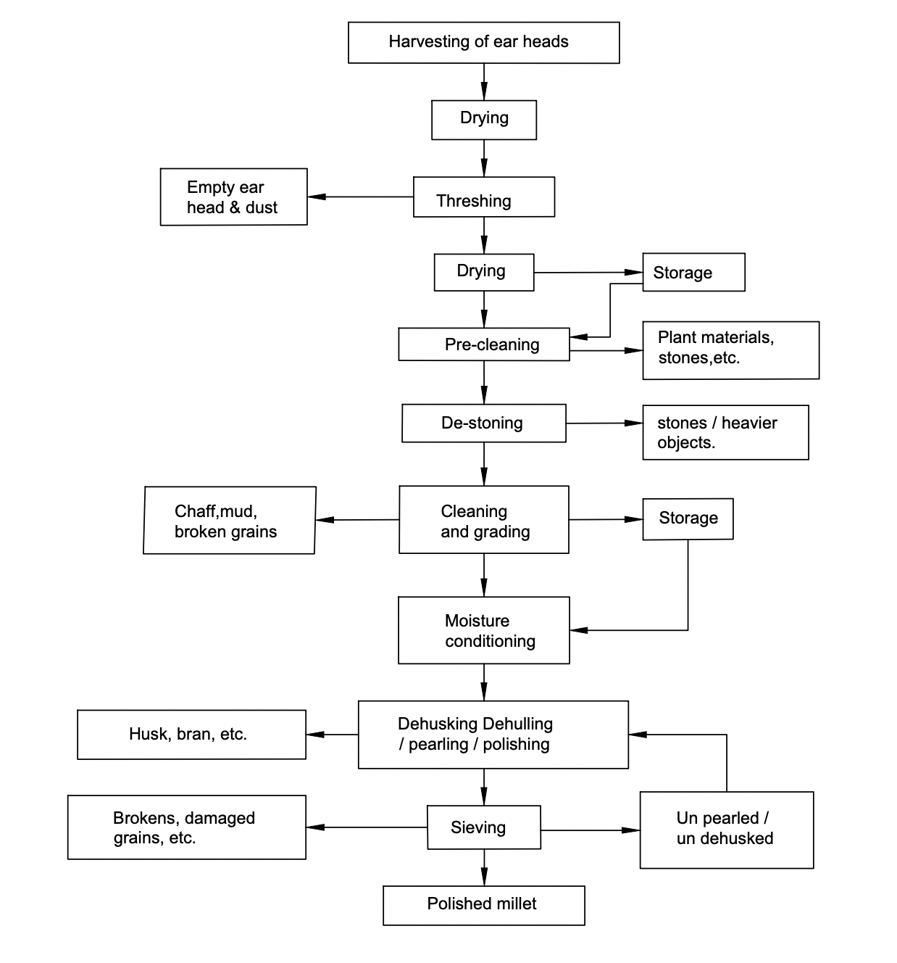

FIG. 1 GENERAL MILLET MILLING FLOW CHART

**3 SYMBOLS**

**3.1** The symbols for various components of equipment used in primary processing of millets viz., pre-cleaning, cleaning and dehusking are given in Table 1.

**Table 1 Symbols Relating to Primary Processing of Milets *Viz.,* Pre-Cleaning,**

**Cleaning and Dehusking**

(*Clause* 3.1)

|  |  |  |
| --- | --- | --- |
| **Sl. No.** | **Equipment / Process** | **Symbol** |
| (1) | (2) | (3) |
|  | Air screen cleaner cum grader |  |
|  | Centrifugal sheller |  |
|  | Disc sheller |  |
|  | Magnetic separator |  |
|  | Rubber and disc sheller |  |
|  | Rubber belt sheller | ↻ ↻ |
|  | Rubber roll sheller | ↻ ↺ |
|  | Scalper |  |
|  | Screen/sieve |  |

**3.2** The symbols for various components of equipment used in primary processing of millets including separation and grading are given in Table 2.

**Table 2 Symbols Relating to Separation and Grading**

(*Clause* 3.2)

|  |  |  |
| --- | --- | --- |
| **Sl. No.** | **Equipment/Process** | **Symbol** |
| (1) | (2) | (3) |
|  | Centrifuge |  |
|  | Cyclone separator |  |
|  | Destoner |  |
|  | Hexagonal reel |  |
|  | Husk depression separator |  |
|  | Husk pressure separator |  |
|  | Husk suction separator | ⭯ |
|  | Husk suction separator with riddle |  |
|  | Husk suction separator with superior riddle |  |
|  | Indented disc separator |  |
|  | Indented cylinder |  |
|  | Millet separator |  |
|  | Optical colour sorter |  |
|  | Riddle |  |
|  | Rotary sieve classifier (plan sifter) for floury products |  |
|  | Rotary sieve classifier (plan sifter) for milled millet |  |
|  | Slot perforated grading cylinder |  |
|  | Specific gravity separator |  |
|  | Static screen Millet separator |  |
|  | Super cyclone separator |  |
|  | Wire spiral grading cylinder |  |

**3.3** The symbols for various components of equipment used for polishing and glazing of millet are given in Table 3.

**Table 3 Symbols Relating to Polishing, Glazing, Crushing and Mixing**

(*Clause* 3.3)

|  |  |  |
| --- | --- | --- |
| **Sl. No.** | **Equipment / Process** | **Symbol** |
| (1) | (2) | (3) |
|  | Ball Mill | ↻ |
|  | Crusher |  |
|  | Friction Polisher | ↻ |
|  | Horizontal emery polisher |  |
|  | Mixers |  |
|  | Ribbon blender |  |
|  | Roller crusher |  |
|  | Whitening or pearling cone |  |

**3.4** The symbols for various accessories are given in Table 4.

**Table 4 Symbols for Accessories**

(*Clause* 3.4)

|  |  |  |
| --- | --- | --- |
| **Sl. No.** | **Equipment / Process** | **Symbol** |
| (1) | (2) | (3) |
|  | Air cleaner |  |
|  | Automatic scale |  |
|  | Bag filling machine |  |
|  | Bag loading machine |  |
|  | Bag sealing / stitching machine |  |
|  | Beam scale |  |
|  | Belt conveyor | ↻ ↻ |
|  | Bin |  |
|  | Blower / centrifugal pump | ↺ |
|  | Bran sacking machine |  |
|  | Bucket elevator |  |
|  | Chain conveyor | ↻ ↻ |
|  | Conveyor |  |
|  | Delay |  |
|  | Depression chest with screw conveyor |  |
|  | Electric motor – AC |  |
|  | Electric motor – AC 3 Phase |  |
|  | Electric motor – DC |  |
|  | Gate valve |  |
|  | Hopper |  |
|  | Hydraulic valve |  |
|  | Indented discs |  |
|  | Inspection |  |
|  | Manually operated valve |  |
|  | Mixer |  |
|  | Needle valve |  |
|  | Operation |  |
|  | Packer discs |  |
|  | Pneumatic Conveyor |  |
|  | Pressure filter |  |
|  | Rotary dryer |  |
|  | Round hole perforated plate |  |
|  | Sacking bin |  |
|  | Sacking scale |  |
|  | Sacking spout |  |
|  | Sacking tube conveyor |  |
|  | Screw conveyor |  |
|  | Slot perforated grading sieve |  |
|  | Slot perforated plate |  |
|  | Solenoid valve |  |
|  | Spiral sack slid |  |
|  | Storage |  |
|  | Suction fan | ↺ |
|  | Suction filter |  |
|  | Transportation |  |
|  | Tray dryer |  |
|  | Turbine |  |
|  | Wire mesh |  |
|  | Volumetric measure |  |
|  | Wire spiral grading sieve |  |