**BUREAU OF INDIAN STANDARDS**

**DRAFT FOR COMMENTS ONLY**

(*Not to be reproduced without the permission of BIS or used as an Indian Standard*)

|  |
| --- |
| भारतीय मानक मसौदा  ***केन्द्रापसारक प्रकार बाजरा डिहस्कर* ⎯ *विशिष्टि***  *Draft Indian Standard*  **CENTRIFUGAL TYPE MILLET DEHUSKER ⎯ SPECIFICATION**  **ICS No. 65.060** |
| Agriculture and Food Processing Equipment Last date of comments: **26 November 2023**  Sectional Committee, FAD 20 |

**FOREWORD**

(*Adoption clause will be added later*)

With the increase in millet production and rapid modernization of millet processing at industry level, centrifugal type millet dehusker is extensively used throughout the country for dehusking minor millet. Thus it becomes important to guide the manufacturers and end users through a standard / test code on producing quality machines and usage. Millet dehusker is expected to have a simple and sturdy construction, suitable for various types of millets, requiring minimum pre-treatments, operated with less skills, *etc.*

Therefore, it is felt to develop a standard to maintain the overall quality and promote the consumption of this valuable and nutritious grain, benefiting both industry and costumer. Therefore, a need was felt to develop a standard to ensure the quality of the process and the produce as well as for third party testing and certification purpose. This standard will also serve as guidance to the manufacturers of these equipment.

In the formulation of this standard considerable assistance was provided by ICAR-Central Institute of Agricultural Engineering Regional Centre, Coimbatore.

For the purpose of deciding whether a particular requirement of this standard is complied with, the final value observed or calculated, expressing the result of a test or analysis, shall be rounded off in accordance with IS 2: 2022 ‘Rules for rounding off numerical values (*second revision*)’. The number of significant places retained in the rounded off value should be the same as that of the specified value in this standard.

**1 SCOPE**

This standard specifies material, performance, constructional and other requirements for millet dehusker of centrifugal type. It also prescribes method of testing to evaluate the performance and durability of this equipment.

**2 REFERENCES**

The following standards contain provisions which through reference in this text, constitute provision of this standard. At the time of publication, the editions indicated were valid. All standards are subject to revision and parties to agreements based on this standard are encouraged to investigate the possibility of applying the most recent editions of the standards indicated below:

|  |  |
| --- | --- |
| ***IS No.*** | ***Title*** |
| IS 210: 2009 | Grey iron castings — Specification (*fifth revision*) |
| IS 816: 1969 | Code of practice for use of metal arc welding for general construction in mild steel (*first revision*) |
| IS 2062: 2011 | Hot rolled medium and high tensile structural steel — Specification (*seventh revision*) |
| IS 6911: 2017 | Stainless steel plate, sheet and strip — Specification  (*second revision*) |
| IS 8132: 2023/  ISO 3600:2022 | Tractors and machinery for agriculture and forestry, powered lawn and garden equipment — Operator’s manuals — Content and Format (*third revision*) |
| IS 8427: 2023 | Agricultural produce milling machinery — Rubber roll for paddy dehusker — Specification (*second revision*) |

**3 TERMINOLOGY**

For this standard, the following definitions shall apply.

**3.1 Aspirator** — The husk after dehusking is collected by suction, called aspirator.

**3.2 Commercial Test** — The tests conducted for establishing performance characteristics of millet dehusker-centrifugal type, that are ready for commercial production or already in production.

**3.2.1** *Initial Commercial Test* — The tests conducted on indigenous or imported prototype of millet dehusker-centrifugal type is ready for commercial production.

**3.2.2** *Batch Test* (*Conformity of Production*) — The tests conducted on millet dehusker- centrifugal type which have already undergone initial commercial test and are being manufactured/sold commercially in the country.

**3.2.3** *Repeat Test* — The tests conducted on centrifugal type millet dehusker, to validate the performance in case of not meeting the evaluative requirements of this standard or to ascertain the re-occurrence of breakdown/defects observed in earlier tests, for the same parameter and on the same sample under the test after rectifying the defects or after replacing the defected part/sub-assembly by new part of the same specifications.

**3.2.4** *Evaluative Requirements* — Requirements under this category are the ones which are mandatory for acceptance of the centrifugal type millet dehusker for the purpose of commercial production/availing subsidies/availing loans from financial institutions. The testing agency will assess the performance of the centrifugal type millet dehusker under test and release the report.

**3.3 Confidential Test** — The test conducted for providing confidential information on the performance of millet dehusker - centrifugal type, whether ready for commercial production or not, or to provide any special data that may be required by the manufacturer/processor.

**3.4 Cyclone** — A separator used to collect/separate the finer/chaffy/husk from the millets during processing.

**3.5 Dehusking Efficiency ⎯** Indicates the efficiency of the dehusker in removing the husk of the millets. It is the percentage of the dehusked grains over the millets fed.

**3.6 Impeller** — The major component of the centrifugal dehusker which rotates inside the dehusking chamber at speed around 2000 to 2800 rpm and receives the mass of the millet grains at the centre and delivers at periphery through the vanes at higher impact velocity/force.

**3.7 Millet Dehusker-Centrifugal Type** — Dehusking unit suitable to remove the husk from the millets with impact force due to centrifugal force when delivered at higher velocity from an impeller. Following terminologies related to this machine shall apply:

**3.7.1** *Dehusked Millet Kernel/Rice* — Millet grains from which the outer husk has been removed

**3.7.2** *Whole Millet Rice* — Dehusked millet grains either whole or broken and its major size is more than three-fourth of the original size

**3.7.3** *Broken Millet Rice* — Dehusked millet grains which are broken and its major size is less than three-fourth of the original size.

**3.7.4** *Cleaned Millet* — Mass of millet grains, physically clean and having foreign matter not exceeding 0.5 percent by mass.

**3.7.5** *Feed Mechanism* — A device to regulate the flow of millet into the dehusker to match with its capacity.

**3.7.6** *Feed Rate* — Mass of cleaned millet fed into the dehusker per unit time.

**3.7.7** *Foreign Matter* — The impurities present in the mass of millets. They include organic and inorganic matter. Inorganic matter shall include sand, gravel, dirt, pebbles stones, lumps of earth, mud, iron chips, *etc.* Organic matter includes, plant parts such as leaves, stems, *etc.*, seeds/grains of other crops, *etc.*

**3.8 Non Evaluative Requirements** — Requirements under this category are the ones which are not mandatory for acceptance of the millet dehusker- centrifugal type for the purpose of commercial production/availing subsidies/availing loans from financial institutions. However, the authorized testing agency may observe the performance for these requirements and record in the test report.

**3.9 Percent Broken** — Breakage of millet grains during dehusking and expressed as percentage over the total dehusked grains (whole and broken grains).

**3.10 Power Source** — The power required to operate the centrifugal type millet dehusker.

**3.11 Sample** — The quantity of millet taken from the feed/different outlets at a particular time period.

**4 TYPES OF MILLETS AND CENTRIFUGAL DEHUSKER**

**4.1 Millet Grains**

Millets are the group of small grains and following are the crops classified under millets (Table 1). Though they look similar in shape and size, they differ in the formation and hardness of the outer layer (husk) resulting varying levels of forces required for dehusking.

**Table 1 Common Names and Botanical Names of Millet Crops**

(*Clause* 4.1)

|  |  |  |
| --- | --- | --- |
| **Sl. No.** | **Common Name Of Millets** | **Botanical Name** |
| (1) | (2) | (3) |
| i) | Sorghum/Jowar/ Great Millet | *Sorghum bicolor* |
| ii) | Bajra/Pearl millet | *Pennisetum glaucum* |
| iii) | Finger/Ragi millet | *Eleusine coracana* |
| iv) | Kodo millet | *Paspalum scrobiculatum* |
| v) | Foxtail/Italian millet | *Setaria italic* |
| vi) | Little millet | *Panicum miliare* |
| vii) | Proso/Common millet | *Panicum miliaceum* |
| viii) | Barnyard millet | *Echinochloa esculenta* |
| ix) | Browntop millet | *Urochloa ramose* |

**4.2 Centrifugal Dehusker — Construction and Operation**

The grain to be dehusked is subjected to the impact force against a hard rubber surface. Thus the husk gets split and the dehusked grain/kernel is obtained. The centrifugal dehusker shall consists of a hopper, impeller, dehusking chamber, aspirator, husk outlet and grain / kernel outlet (*see* Fig.1 and Fig. 2). The impeller is rotated at about 2000 to 2800 rpm speed and receives grain to be dehusked from the feed regulated hopper and a feeding screw. From the centre of the impeller, the grain mass will be delivered radially with a higher centrifugal force. The discharged grains shall strike against a hard rubber surface with impact force and dehusking take place. The husk and the dehusked kernel will pass through the aspirator for separation of husk and delivered through the outlet. The dehusked kernel free from husk will be collected through its outlet. The dehusking capacity of such machine will be about 300 – 500 kg/h.

**5 MATERIAL**

**5.1** The material for the components (*see* also Fig. 1 and 2) shall be as given in *column* **3** and the material shall conform to the relevant Indian Standard given in *column* **4** of Table **2**.

**Table 2 Material of Construction**

(*Clause* 5.1)

|  |  |  |  |
| --- | --- | --- | --- |
| **Sl. No.** | **Component** | **Material** | **Relevant Indian Standard** |
| (1) | (2) | (3) | (4) |
| i) | Belt guard | Mild steel | IS 2062 |
| ii) | Blower/aspirator | Mild Steel | IS 2062 |
| iii) | Crank gear | Cast Iron | IS 6603 |
| iv) | Husk outlet/aspirator | Mild steel | IS 2062 |
| v) | Impeller shaft | Mild steel | IS 2062 |
| vi) | Dehusking chamber | Cast Iron | IS6603 |
| vii) | Dehusker frame | Mild steel | IS 2062 |
| viii) | Dehusker impeller | Stainless Steel | IS 6911 |
| Mild Steel | IS 2062 |
| ix) | Dehusked millet outlet | Stainless Steel | IS 6911 |
| x) | Feed screw | Cast Iron /mild steel | IS 210/IS 2062 |
| xi) | Feed hopper | Mild steel | IS 2062 |
| Stainless steel | Grade 204/304 of IS 6911 |
| xii) | Lid | Mild steel | IS 2062 |
| xiii) | Plummer block | Cast Iron | IS 210 |
| xiv) | Rubber ring/lining | Rubber sheet and moulded rubber | - |

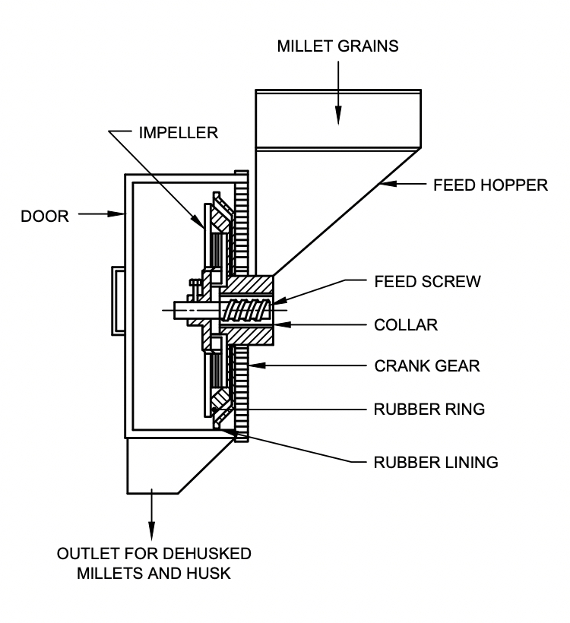

FIG. 1 SCHEMATIC DIAGRAM OF CENTRIFUGAL DEHUSKER SOWING PRINCIPLES OF OPERATION

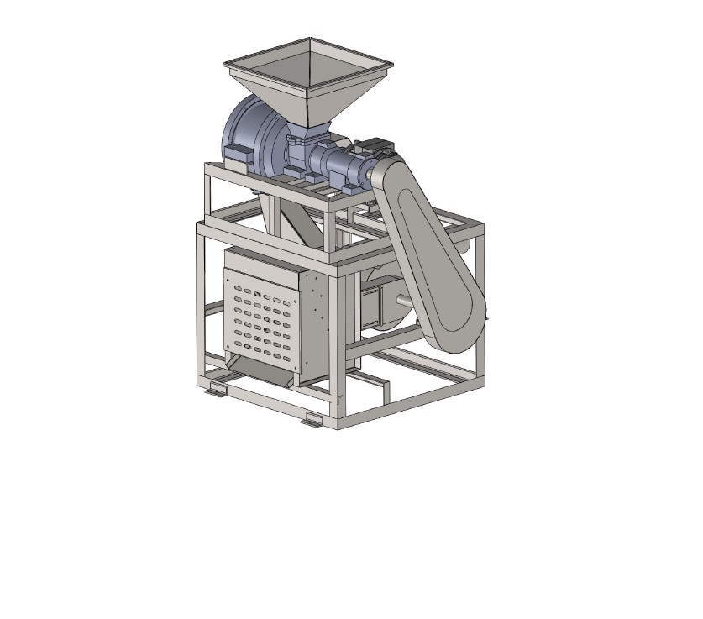

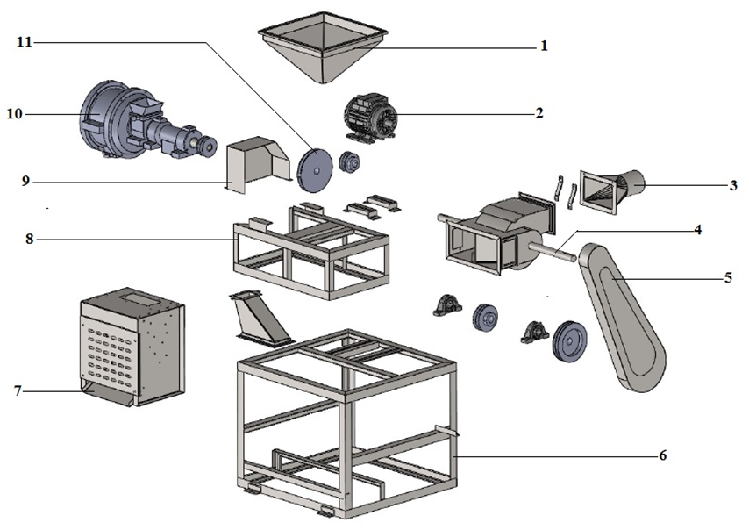

|  |  |
| --- | --- |
| 1) Feed hopper | 2) Electric motor; |
| 3) Husk outlet | 4) Machine/Aspirator shaft |
| 5) Dehusker belt guard | 6) Machine frame |
| 7) Dehusked millet outlet | 8) Dehusker frame |
| 9) Belt guard | 10) Dehusker chamber |
| 11) Dehusker impeller |  |

FIG. 2 EXPLODED VIEW OF MILLET DEHUSKER ⎯ CENTRIFUGAL TYPE

**6 CONSTRUCTIONAL REQUIREMENTS**

**6.1 Aspirator/Blower** — Aspirator/blower shall be of adequate size and the impeller is balanced and mounted on self-aligned bearings to run without vibration and the casing will be strong enough. The shutter to adjust the air flow rate will be provided with a locking arrangement to hold the position and ensures noise/vibration free running.

**6.2 Dehusking Chamber** —The dehusking chamber shall be made of cast iron to the size as per the capacity. The chamber will be also provided with crank gear and provision to rotate the chamber to facilitate uniform wear of the rubber lining and to fix rigid after rotation. The dehusker may be provided with two numbers of dehusking chambers to facilitate passing the millets for second time to increase the dehusking efficiency.

**6.3 Feed Screw** — A feed screw will be placed appropriately to feed the millets uniformly into the impeller for dehusking.

**6.4 Frame** — The main frame shall be made of suitable size using mild steel with channels/angle sections and shall be covered wherever required with mild steel sheet/galvanised sheet/stainless steel sheet of adequate thickness depending on the requirements and with provision to open the covers for any adjustments/maintenance.

**6.5 Feed Hopper** — Hopper shall be made of mild steel/stainless steel sheet and provided with a feed regulating device. The hopper should be provided with side slope (30-35°) for easy flow of the grains. The feed hopper will be located at appropriate height from ground level for easy filling manually. Alternatively the unit may be provided with a bucket elevator for filling the hopper.

**6.6 Impeller** — Impeller shall be made of appropriate size and vanes as per the capacity of the dehusker. The impeller shall be made of mild steel or stainless steel. The construction will be sturdy to withstand the rotation at 2000 – 2800 rpm.

**6.7 Outlet/Chute for the Grains/Kernels and Husk** —The outlet for the dehusked millet kernel will be placed at the suitable height from ground for easy collection/filling in gunny bags. The husk should be collected by the aspirator and delivered.

**6.8 Rubber Lining And Ring** — The rubber ring is provided on the crank gear and rubber lining on the inner side of the dehusking chamber. The lining and ring are made of natural/synthetic rubber using appropriate production technique with hardness of 85 to 97 A and pasted using adhesive to fix in place.

**6.9 Shafts** —The shafts shall be made of mild steel as per the required/calculated size and shall be supported with suitable bearings and housings on the stable part of machine.

**6.10 Surface Finish** — All the joints and surfaces will be made smooth and protected from weather conditions.

**6.11 Transmission Drive** — The suitable drive system using V-belt pulley system for transmitting the power shall be provided in the dehusker. The drive will be provided with suitable guard/cover.

**7 PERFORMANCE REQUIREMENTS**

**7.1** The dehusker, after installation and running-in shall be operated for half-an-hour at no-load. During the no-load run, the visual observations shall not indicate the following:

a) Presence of any marked vibration during operation;

b) Presence of any undue noise in the dehusker;

c) Unusual heating of any component;

d) Any slippage of belts;

e) Vibration in running of fan;

f) Non-smooth running of shafts in their respective bearings; and

g) Any marked unusual wear or slackness in any components.

**7.2** When tested in accordance with the method given in **11.4.1.3**, the rated capacity per kWh energy consumed shall be recorded. Various adjustments, clearances and speeds for the rated capacity shall be declared by the manufacturer.

**7.3** The dehusked millet shall not get any visible stain.

**7.4** During and after the capacity test, the visual observation shall not indicate the following:

a) Observations given in **7.1 (a)** to **(g)**; and

b) Spillage of grain / kernel from the dehusker.

**7.5** Dehusking unit shall be capable of dehusking atleast 50 percent of grains in case of raw millet and atleast 60 percent of the grains in case of parboiled millet, in the first pass and in the subsequent passes the efficiencies will be 70 and 80 percent, respectively. The maximum percent breakage will be 10 percent in raw millet and 5 percent in parboiled millet in one pass.

**7.6** Husk aspiration unit shall remove minimum of 95% husk present. Not more than 5% of brokens/kernels/grains should go along with husk.

**8 OTHER REQUIREMENTS**

**8.1** The sheet metal used in construction of various parts shall be of minimum 1 mm thickness.

**8.2** The shafts shall be finished to close tolerances at the bearings and shall be properly aligned.

**8.3** Provision shall be made for lubrication of bearings and they shall be dust-proof.

**8.4** A feed regulating system shall be provided

**8.5** Various controls shall be easily accessible and capable of being locked in a chosen position.

**8.6** In case of belt drive, provision shall be made for belt tightening.

**8.7** Transmission guards shall be provided to prevent accidental contact of persons on parts or clothing being caught in the transmission system unless the system is so constructed or placed as to be safe without guards.

**8.7.1** The guards shall be so designed as not to hinder in easy adjustment, servicing and operation of dehusker.

**8.7.2** It is preferable that all guards shall be either permanently attached or firmly secured to prevent their removal without the aid of the tools. The servicing and adjustments should be possible without complete removal of the guards.

**8.8** The Impeller shall be statically and dynamically balanced.

**8.9** The rubber ring and lining shall be firmly fixed using appropriate adhesive / glue.

**8.10** The hardness of rubber ring and lining shall conform to the requirements given in **6.3** of IS 8427. Type and size shall be declared by the manufacture. Arrangement shall be made for easy replacement as well as locking of the impeller.

**8.11** The dehusker shall be provided with the operator's manual. (*see* IS 8132)

**9 WORKMANSHIP AND FINISH**

**9.1** Welding used for joining different components shall not be porous and shall be smooth (*see* IS 816).

**9.2** Any sharp corners and protruding fasteners shall be avoided.

**9.3** Components of the dehusker shall be finished smooth and properly painted.

**10 MARKING AND PACKING**

**10.1 Marking** — Each dehusker shall be marked with the following particulars:

a) Manufacturer's name, address and recognized trademark, if any;

b) Model number;

c) Batch, code or serial number;

d) Power rating, kW;

e) Rated input capacity; and

f) Direction of rotation of impeller.

**10.1.1** A minimum cautionary notice worded as follows shall be written in vernacular language legibly and prominently on the main body of the dehusker:

a) Do not wear loose dress, bangles, watch, etc, while working with dehusker.

b) Do not work under the influence of intoxicants like liquor, opium, *etc*.

c) Children and aged persons should be discouraged for working on deshusker.

d) Do not cross over moving belts.

e) Do not operate without guards and safety devices.

f) Do not make adjustment when deshusker is working.

g) Do not put or take-off belt while pulley is running.

**10.2 Packing** — The dehusker or its components shall be packed as agreed to between the purchaser and the supplier for safe handling in transit and storage.

**10.3 BIS Certification Marking**

The product(s) conforming to the requirements of this standard may be certified as per the conformity assessment schemes under the provisions of the *Bureau of Indian Standards Act*, 2016 and the Rules and Regulations framed there under, and the products may be marked with the Standard Mark.

**11 METHODS OF TEST FOR MILLET DEHUSKER**

**11.1 Selection and Specification of Centrifugal Dehusker for Type Tests**

**11.1.1** *Selection* — The centrifugal dehusker shall be taken from the series production by the testing authority with the agreement of the manufacturer.

**11.1.2** *Specification* — The manufacturer shall supply specification sheet duly filled in as given in Appendix A as well as any further information required to carry out the tests. The manufacturer shall also supply all literature, operational manual and schematic diagram of grain flow in the destoner. The manufacturer shall also indicate the maximum input capacity and rated input capacity with the foreign matter at 5 percent and 10 percent.

**11**.**2 Test Material**

**11.2.1** Sufficient quantity of the raw material (millet grains, *viz.,* sorghum, bajra, finger millet, barnyard millet, proso millet, little millet, fox tail millet, kodo millet, brown top millet, *etc.*), preferably the same variety shall be taken. The grain lot selected for testing the dehusker shall have purity of minimum 90 percent and will be completely free from stones, metals, *etc*. to avoid damage to the rubber ring and rubber lining.

**11.2.2** The moisture content of test material shall be measured according to IS 4333 (Part 2) and shall be not more than 14 percent (w.b.) and the moisture content will be adjusted according to the type of millets.

**11.3. Running in and Preliminary Adjustments**

**11.3.1** The dehusker shall be installed on a level and preferably on a hard surface with anti-vibration mount / concrete foundation. All the adjustments shall be made in accordance with the manufacturer’s recommendation.

**11.3.2** The dehusker shall be attached with a suitable prime mover, preferably with an electric motor and auto-voltage stabilizer. An energy meter or some form of transmission dynamometer shall be fitted. The power delivered to the dehusker may be supplied in the following ways:

a) Direct coupling the prime mover with the main shaft of the destoner, and

b) Connecting the prime mover with the help of a flat or V-belt and pulleys with the dehusker’s main shaft.

**11.3.2.1** In the case of (a), the power delivered to the dehusker would be the power output of the prime mover, whereas, in the case of (b), the allowances for flat and V-belt drive losses may be taken at 6 percent and 3 percent, respectively.

**11.3.3** The dehusker shall be run-in without load before commencing the tests. The running-in shall be carried out in accordance with the manufacturer’s recommendation. In the absence of any recommendation by the manufacturer, the dehusker shall be run-in for 30 minutes. During the period of the run-in, adjustments for various functional components may be done. All the adjustments done shall be in accordance with the instructions contained in the manual supplied by the manufacturer.

**11.4 Tests**

Tests as indicated in **11.4.1** and **11.4.2** shall be carried out on millet dehusker.

**11.4.1** *Type Tests*

**11.4.1.1** *General*

a) Checking of specifications (Annex A);

b) Checking of material (Annex B); and

c) Visual observations and checking of provisions for adjustments (Annex C).

**11.4.1.2** *Test at no load*

**a)**  Power consumption (Annex D) shall be recorded from the start and closing reading of energy meter.

**b)**  After running-in is over, the dehusker shall be run at no load for 10 minutes at the specified speed. During and after the no load run, the visual observation at the dehusker shall not show the following:

i) Presence of any marked vibration during operation;

ii) Presence of undue knocking or rattling sound;

iii) Any marked rise in bearing temperature;

iv) Any marked unusual wear or slackness in any component; and

v) Any marked change in oscillation or slopes.

**c)** Data shall be recorded in accordance with the proforma given in Annex D.

**11.4.1.3** *Test at load*

**a)** *Operation and collection of data*

The dehusker shall be operated for a period of 30 minutes at its input capacity specified by the manufacturer for the particular millet grain and variety, incorporating best combination of adjustments. During the running period speed of impeller and blower, velocity of air, *etc.* shall be noted and recorded in Annex E.

Three sets of samples at the dehusked grain/kernel outlet and husk outlet either manually after each 10 minutes or continuously by automatic flow samplers for the entire period shall be collected. If the dehusker is provided with more number of dehusking chambers in series, samples from all the chambers will be collected.

**b)** *Preparation and analysis of samples*

i)The samples drawn from each outlet shall be bulked and thoroughly mixed to form a composite sample.

ii) Each sample shall be further divided using a sample divider to get 100 g of representative sample.

iii) Each 100 g sample from dehusked kernel outlet shall be manually analyzed for dehusked millet kernel, un-dehusked millet grains, brokens and husk. Similarly, 100 g of the sample collected at the husk outlet shall be manually analyzed for husk and grains (including un-dehusked, dehusked and brokens) and recorded in Annex. F.

iv) If the dehusker is provided with more number of chambers or dehusking is done through more number of passes, the results will be reported along with the number of passes.

**c)***Determination of dehusking efficiency*

The dehusking efficiency of centrifugal dehusker shall be calculated by the following formula:

*1 − u*

*D =* *× 100*

*f − s*

Where,

*D* = efficiency of dehusking, percent,

*f* = total mass of sample taken from dehusked kernel outlet (u + b + s), g,

*u* = mass of un-dehusked millet grain/kernel in the sample taken from dehusked kernel

outlet, g,

*s* = mass of husk in the sample taken from dehusked kernel outlet, g.

**d)** *Determination of percent breakage*

The percent breakage in the centrifugal dehusker shall be calculated by the following formula:

*b*

*B = × 100*

*f – u − s*

Where,

*B* = percent breakage of millet kernels, percent,

*f* = total mass of sample taken from dehusked kernel outlet (u + b + s), g,

*u* = mass of un-dehusked millet grain / kernel in the sample taken from dehusked kernel outlet,

g.

*b* = mass of broken millet grain / kernel in the sample taken from dehusked kernel outlet, g.

*s* = mass of husk in the sample taken from dehusked kernel outlet, g.

**e)** *Percent husk in the dehusked millet kernel*

The percent husk in the dehusked millet kernel shall be calculated by the following formula:

*s*

*H = × 100*

*F*

Where,

*H* = percent husk present in the dehusked millet kernel, percent,

*f* = total mass of sample taken from dehusked kernel outlet (d + u + b + s), g,

*s* = mass of husk in the sample taken from dehusked kernel outlet, g.

**f)** *Determination of cleaning efficiency of the aspirator*

The cleaning efficiency of aspirator in the centrifugal dehusker shall be calculated by the following formula:

*1− k*

*C = × 100*

*h*

Where,

*C* = cleaning efficiency of the aspirator in the centrifugal dehusker, percent,

*h* = total mass of sample taken from husk outlet, g,

*k* = mass of millet kernel/grains in the sample taken from husk outlet, g

**g)** *Power consumption*

The power requirement during the test run shall be calculated/measured in accordance with the following methods and record the data in accordance with *Annex G.*

i)In case of prime mover fitted with an energy meter, the readings taken shall be the power consumption for 10 minutes. The power consumption per hour giving due allowance to the type of drive shall be calculated and reported.

ii)In case of prime mover fitted with the dynamometer, the reading taken shall indicate the torque required. The power consumption per hour, giving due allowance to the type of drive, shall be calculated by the following formula:

*T × S*

*P = × 100*

*9549.30*

Where,

*P* = power, kW;

*T* = torque, Nm; and

*S* = speed, rev/min.

NOTE ⎯ For the Purpose of certification, the power consumption at the declared feed rate shall only be calculated.

**h)** *Determination of the rated input capacity*

From the quantity of millet (q, kg) taken for the test and the time taken (min.) to dehusk this quantity, capacity is calculated and expressed as q*60/h, kg/h. The capacity in terms of the energy consumed shall be calculated by dividing the capacity by power consumed and shall be expressed in q/kWh. Record the data in *Annex G.*

NOTE ⎯ For the purpose of certification, since the dehusker has been operated only at declared capacity, it shall be seen whether the dehusking efficiency is met at the declared capacity or not.

**11.4.1.4** *Routine tests*

a) Visual observations and checking of provision for adjustments (*see* **11.4.1.1**); and

b) Test at no-load (*see* **11.4.1.2**).

**11.4.1.5** *Long run test*

The dehusker shall be operated for a minimum duration of 20 hours at no load which could be covered by continuous run of at least 5 hours. During and after the operation no breakdown or defects shall develop in the destoner. Record the major break-downs, defects developed and repairs made into the data sheet given in *Annex H.*

**11.5 Summary Report**

For the guidance of the user, compile a summary report on the proforma as given in Annex J.

**ANNEX A**

(*Clause* 10.1.2)

**SPECIFICATION SHEET**

**1 General**

a) Name and address of manufacturer

b) Make

c) Model

d) Serial number

e) Year of manufacture

f) Rated capacity

g) Maximum capacity

**2 Power Unit**

a) Type of recommended prime mover

b) Type of drive

c) Recommended power rating, kW

**3 Main Drive**

a) Type and number of bearings

b) Size and number of belts

c) Size of pulley on prime mover

d) Size of pulley on dehusker, mm

e) Type of belt tightening arrangement

f) Details of gear system, if used

g) Recommended speed of impeller, rpm

h) Size of pulley (mm) and speed of blower/aspirator (rpm)

**4 Feeding Arrangement**

a) Type of feed mechanism

b) Storage capacity of feed hopper, kg

c) Type of drive for feed mechanism

d) Arrangement for controlling feed

e) Arrangement for uniform feeding of paddy

f) Location of feed hopper from ground level, m

g) Provision of elevator

**5 Dehusking Chamber**

a) Diameter of the chamber, mm

b) Width of the chamber, mm

c) Diameter of the impeller, mm

d) Width of the impeller, mm

e) Number of vanes in the impeller

f) Speed of impeller, rpm

g) Type and number of bearings

h) Provision of crank gear

j) Diameter of the rubber ring, mm

k) Hardness of rubber ring, Shore A

m) Thickness of the rubber lining, mm

n) Hardness of rubber lining, Shore A

**6 Aspirator/Blower**

a) Type of blower/aspirator

b) Diameter of the impeller, mm

c) Width of the blower, mm

d) Type and number of bearings

e) Provision for adjusting airflow

f) Speed of impeller/blade, rpm

g) Provision of husk outlet

**8 Overall Dimensions**

a) Length, m

b) Width, m

c) Height, m

d) Ground clearance for discharge, mm

e) Total mass, kg

**9 Tools, Accessories, Operation Manual and Spare Parts List Provided**

NOTES:

1 The item which is not applicable in a particular dehusker should be crossed while filling.

2 If any other items are provided, their details should be given.

Test Engineer

**ANNEX B**

(*Clause* 10.1.2)

**DATA SHEET FOR MATERIAL OF CONSTRUCTION**

|  |  |  |
| --- | --- | --- |
| **Sl. No.** | **Component** | **Material** |
| (1) | (2) | (3) |
| i) | Belt guard |  |
| ii) | Blower/aspirator |  |
| iii) | Blower Impeller |  |
| iv) | Blower shaft |  |
| v) | Crank gear |  |
| vi) | Dehusked millet outlet |  |
| vii) | Dehusker impeller |  |
| viii) | Dehusker frame |  |
| ix) | Dehusking chamber |  |
| x) | Discharge hopper |  |
| xi) | Feed hopper |  |
| xii) | Feed screw |  |
| xiii) | Husk outlet/aspirator |  |
| xiv) | Impeller shaft |  |
| xv) | Inspection doors |  |
| xvi) | Plummer block |  |
| xvii) | Pulleys |  |
| xviii)  xix) | Rubber ring/lining  Any other |  |

Test Engineer

**ANNEX C**

(*Clause* 11.4.1.1)

**DATA SHEET FOR VISUAL OBSERVATIONS AND PROVISIONS FOR**

**ADJUSTMENTS**

**1** Observations:

a) Provision for inspection window/cover

b) Provision for rotating the dehusking chamber

c) Adequacy of safety guards on moving parts

d) Provision for belt tightening

e) Provision for lubrication of moving parts

f) Provision for lifting and transport

g) Provision for easy changing of components requiring frequent replacement

h) Adequacy of protection of bearings from dust

j) Tightness of fasteners

k) Welding of seams

m) Provision for feed regulating and spreading system

n) Other observations

**2** Provision for Adjustment of:

a) Feed rate

b) Speed of dehusking impeller

c) Speed of blower/aspirator impeller

d) Air displacement

e) Air pressure in pneumatic system, if any

Test Engineer

**ANNEX D**

(*Clause* 10.4.1.2)

**DATA SHEET FOR TEST AT NO-LOAD**

**1 Observations:**

a) Presence of any marked vibration during operation

b) Presence of any undue noise in the dehusker

c) Any unusual heating of any component

d) Any slippage of belts

e) Vibration in blower running

f) Non smooth running of shafts in the irrespective bearings, and

g) Any marked unusual wear or slackness in any components

Test Engineer

**ANNEX E**

(*Clause* 10.4.1.3)

**DATA SHEET FOR TEST AT LOAD**

**1** Details of power supply

**2** Power rating, kW

**3** Type of drive

**4** Type of millet

**5** Variety of millet

**6** Moisture content of millet, percent (w.b)

**7** Air flow from the blower, m/min.

**8** Atmospheric conditions:

a) Temperature, °C

b) Pressure, kPa

c) Relative humidity, %

**9** Test Data*

**10** Observations:

a) Presence of any marked vibration during operation

b) Presence of any undue noise in the dehusker

c) Smooth running of shafts in their respective bearings

d) Undue heating of any component

e) Vibration free running of blower/aspirator

f) Any marked rise in bearing temperature

g) Frequent slippage of belts

h) Rise in temperature in the dehusking chamber

j) Any marked deformation, wear or breakdown

k) Frequent loosening of fasteners

m) Any other observations

Test Engineer

|  |  |  |  |  |  |  |  |  |  |  |  |  |
| --- | --- | --- | --- | --- | --- | --- | --- | --- | --- | --- | --- | --- |
|  | | | | | | | | | | | | |
| **Sl. No.** | **Date** | **STARTING TIME** | **STOPPING TIME** | **DURATION OF OPERATION** | **SPEED OF DEHUSKING IMPELLER (rev/min)** | **FEED RATE (kg/h)** | **ENERGY METER READING IN RELATION TO TIME** | | **NO. AND QUANTITY OF SAMPLES** | | | **DEHUSKED MILLET KERNEL OUT PUT, kg** |
| **Time** | **Energy**  **meter**  **Reading** | **No.** | **Quantity, g** | |
| **Dehusked kernel outlet** | **Husk outlet** |
| (1) | (2) | (3) | (4) | (5) | (6) | (7) | (8) | (9) | (10) | (11) |  | (12) |
|  | | | | | | | 5  10  15  20  25  30 |  | i)  ii)  iii)  iv)  v)  vi) |  |  |  |

Test Engineer

**ANNEX F**

[*Clause* 11.4.1.3 (a)]

**DATA SHEET FOR ANALYSIS OF SAMPLES**

|  |  |  |  |  |  |  |  |  |  |  |
| --- | --- | --- | --- | --- | --- | --- | --- | --- | --- | --- |
| **SL No.** | **Feed rate, kg/h** | **Mass of different fractions, g** | | | | | | | | **Remarks** |
| **Dehusked kernel outlet** | | | | | **Husk outlet** | | |
| **Dehusked kernel (*d*)** | **Un-dehusked millet (*u*)** | **Brokens (*b*)** | **Husk**  **(*s*)** | **Total**  **(*f*)** | **Husk**  **(*h*)** | **Millet grains**  **(*k*)** | **Total** |
| (1) | (2) | (4) | (5) | (6) | (7) | (8) | (9) | (10) | (11) | (12) |
|  |  |  |  |  |  |  |  |  |  |  |
|  |  |  |  |  |  |  |  |  |  |  |
|  |  |  |  |  |  |  |  |  |  |  |
|  |  |  |  |  |  |  |  |  |  |  |
|  |  |  |  |  |  |  |  |  |  |  |
|  |  |  |  |  |  |  |  |  |  |  |
|  |  |  |  |  |  |  |  |  |  |  |
|  |  |  |  |  |  |  |  |  |  |  |

Test Engineer

**ANNEX G**

(*Clause* 11.4.1.3)

**DATA SHEET FOR EFFICIENCY, CAPACITY AND POWER REQUIREMENT**

|  |  |  |  |  |  |  |  |
| --- | --- | --- | --- | --- | --- | --- | --- |
| **Sl. No.** | **Details** | **Test No.** | | | | | |
| **1** | **2** | **3** | **4** | **5** | **6** |
| 1 | Speed of impeller, rpm |  |  |  |  |  |  |
| 2 | Feed rate, kg/h |  |  |  |  |  |  |
| 3 | Dehusking efficiency, % |  |  |  |  |  |  |
| 4 | Percentage of brokens, % |  |  |  |  |  |  |
| 5 | Percentage of husk in dehusked millet kernel, % |  |  |  |  |  |  |
| 6 | Percentage of millet grain/kernel in husk,% |  |  |  |  |  |  |
| 7 | Power required, kW |  |  |  |  |  |  |
| 8 | Rated capacity, kg/h |  |  |  |  |  |  |
| 9 | Specific power, kWh / tonne |  |  |  |  |  |  |

Test Engineer

**ANNEX H**

(*Clause* 11.4.1.5)

**DATA SHEET FOR LONG-RUN REST**

**1** Total running time, h

**2** Continuous running time, h

**3** Any major breakdown

**4** Any repairs conducted

**5** Any other observations

Test Engineer

**ANNEX J**

(*Clause* 11.5)

**SUMMARY REPORT**

**1** Name of testing station

**2** Name and Address of manufacturer

**3** Model number

**4** Brief description of the dehusker

**5** Type of millet used

**6** Variety of millet used for test

**7** Nature of millet (raw/parboiled)

**8** Moisture content of millet, dry basis %

**9** Adjustments:

a) Feed rate, kg/h

b) Speed of dehusking impeller, rpm

c) Speed of blower/aspirator impeller, rpm

d) Air displacement, m/min.

**10** Power requirements:

a) At no load, kW

b) At load on rated capacity, kW

**11** Dehusking efficiency, %

**12** Percentage of brokens, %

**13** Percentage of husk in dehusked millet kernel, %

**14** Percentage of millet grain / kernel in husk outlet, %

**15** Power required, kW

**16** Rated capacity, kg/h

**17** Specific power, kWh /tonne

**18** Any marked observation affecting performance

**19** Any major breakdowns during test

**20** Other observations, if any

Test Engineer