**BUREAU OF INDIAN STANDARDS**

**DRAFT FOR COMMENTS ONLY**

*(Not to be reproduced without the permission of BIS or used as an Indian Standard)*

|  |
| --- |
| *भारतीय मानक मसौदा*  **सर्पिल ग्रेडर ⎯ परीक्षण संहिता**  *Draft Indian Standard*  **SPIRAL GRADER — TEST CODE**  **ICS 65.060** |
| Agriculture and Food Processing Equipment Last date of comments: **24 October 2023**  Sectional Committee, FAD 20 |

**FOREWORD**

*(Adoption clause will be added later)*

The freshly harvested round-seeded crops like soybean, pigeon pea, mustard, etc., often contain chaff, stems, stones, weed seeds, brokens, etc., which may be of the same size and hence cannot be separated by sieving. The presence of such impurities causes storage losses and poses problems in the processing of the crop.

A spiral grader is a machine that separates spherical granular material from non-spherical granular materials, based on the sphericity of food grains. The equipment works on gravity feed and does not require any external mechanical power to operate. The capacity of such a machine depends on the feed rate and affects the efficiency of grading. The other factors affecting grading efficiency are the shape, size, and number of the spiral ribbons, as well as the material of construction for the ribbons.

To facilitate the objective evaluation of the performance of the spiral grader, there was a need to develop this standard. This standard would establish uniformity in testing methods and would help in promoting the use of appropriately manufactured spiral graders by farmers or other stakeholders.

For the purpose of deciding whether a particular requirement of this standard is complied with, the final value observed or calculated, expressing the result of a test or analysis, shall be rounded off in accordance with IS 2 : 2022 ‘Rules for rounding off numerical values (*second revision*)’. The number of significant places retained in the rounded off value should be the same as that of the specified value in this standard.

**1 SCOPE**

This standard prescribes the method of testing of spiral grader to evaluate its performance (*see* Fig 1).

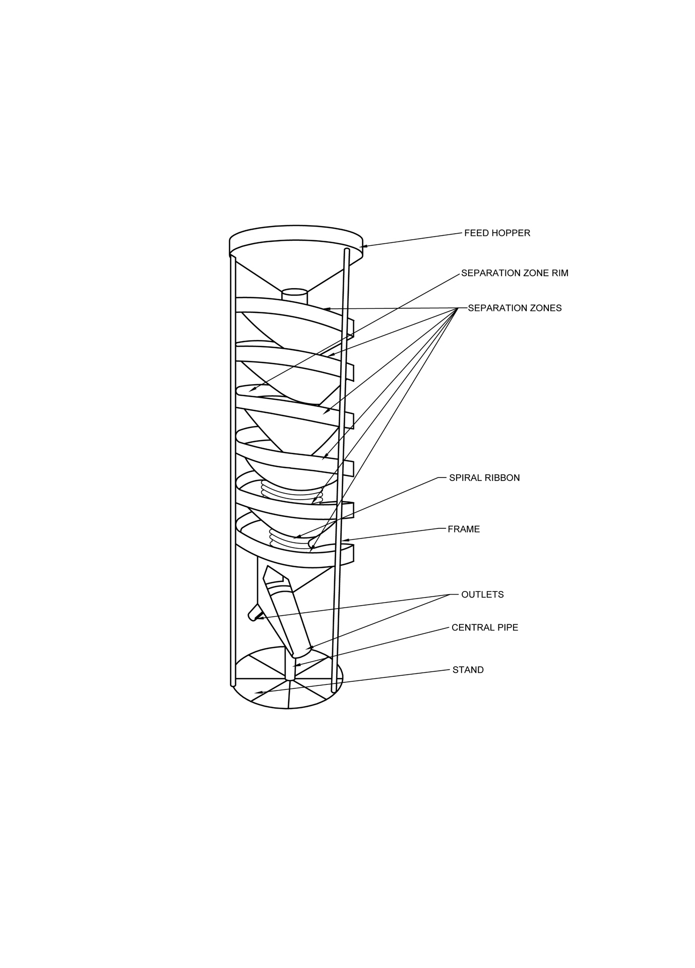

FIG. 1 TYPICAL SPIRAL GRADER

**2 TERMINOLOGY**

For the purpose of this standard, following definitions shall apply.

**2.1 Food Grains** — Food grains include cereals, millets, oilseeds and pulses meant for human consumption.

**2.2 Other Food Grains** — Food grains other than the grains being graded.

**2.3 Immature Kernels** — Kernels or pieces of grain kernels that are not fully developed.

**2.4 Brokens** — Pieces of sound kernels that are less than three-fourth of the size of the full kernels.

**2.5 Damaged / Shriveled** — Kernels or pieces of kernels that are sprouted or internally damaged or shrunk as a result of exposure to heat, moisture, weather and/or microbes.

**2.6 Spiral Grader** — It is stationary equipment vertical in shape and provided with spiral ribbons which separates the food grains on the basis of roundness/ sphericity.

**2.7 Outer Spiral/Helix** — It is an outer side separating trough which carries round grains.

**2.8 Inner Spiral/Helix** — It is an inner side trough which carries flat seeds/impurities.

**2.9 Feed Regulating Mechanism** — The mechanism which regulates the feed.

**2.10 Feed Rate** — Mass of uncleaned grains fed from the hopper of spiral grader per unit time.

**2.11 Foreign Matter** — It includes inorganic and organic matters. The inorganic matter shall include sand, gravel, dirt, pebbles, and stones, lumps of earth, mud and iron chips. The organic matter shall include chaff, straw, weed seeds, dead insects, worms and other inedible grains. It also includes off size and different shape grains.

**2.12 Maximum Input Capacity** — The maximum feed rate at which no choking or spillage of grains occurs in the grader.

**2.13 Rated Input Capacity** — The feed rate at which cleaning or grading efficiency is within the specified limits.

**2.14 Sphericity** — The geometric foundation of the concept of sphericity rests upon the isoperimetric property of a sphere. Sphericity shows the shape characteristics of the particle relative to the sphere having the same volume. It is dimensionless in nature.

**3 SELECTION AND SPECIFICATION OF CLEANER FOR TYPE TESTS**

**3.1 Selection** — The cleaner shall be taken from the series production by the testing authority with the agreement of the manufacturer. The selection procedure should be clearly indicated in the test report.

**3.2 Specification** — The manufacturer shall supply specification sheet duly filled-in as given in Annex A as well as any further information required to carry out the tests. The manufacturer shall also supply all literature, operational manual and schematic diagram of grain flow in the

equipment. The manufacturer shall also indicate the maximum input capacity and rated input capacity with the foreign matter at 5 percent and 10 percent.

**4 TEST**

Tests as indicated in 4.1 and 4.2 shall be carried out on spiral grader.

**4.1 Type Tests**

**4.1.1** *General*

a) Checking of specifications (*see* **6.1**)

b) Checking of material (*see* **6.2**), and

c) Visual observations and checking of provisions for adjustments (*see* **6.3**)

**4.1.2** *Test at Load*

a) Short-run tests (*see* **8.1**); and

i) Visual observations (*see* **8.1.4.5**)

ii) Determination of grading efficiency (*see* **8.1.6**)

iii) Determination of rated input capacity (*see* **8.1.7**)

**4.2 Routine Tests**

a) Visual observations and checking of provision for adjustments (*see* **6.3**) and

b) Test at no-load (***see* 7**)

**5 PRE-TEST OBSERVATIONS**

**5.1 Determination of Foreign Matter** — The foreign matter present in the grain lot to be graded shall be determined in accordance with IS 4333 (Part 1).

**5.2 Determination of Moisture** — The moisture content of the grain shall be determined in accordance with IS 4333 (Part 2).

**5.3 Running-In and Preliminary Adjustment** — The spiral grader shall be installed on level and preferably on hard surface. All the adjustments shall be made in accordance with manufacturer’s recommendations. The helix of spiral grader shall be checked for defects, bending or sticking of any foreign matter on helix surface.

**6 GENERAL TESTS**

**6.1 Checking of Specifications** — The specifications given by the manufacturer (*see* **3.2**) shall be checked and reported in the proforma as given in Annex A.

**6.2 Checking of Material** — The material of construction of all the components of the spiral grader shall be reported in the data sheet given in Annex B.

**6.3 Visual Observations and Checking of Provision for Adjustments** — The observations and adjustments given in data sheet in Annex C shall be made and reported.

**7 TEST AT NO LOAD**

Not applicable since no moving parts in the machine.

**8 TEST AT LOAD**

**8.1 Short Run Test**

**8.1.1** The spiral grader shall be installed on level platform and the adjustment of feed rate shall

be made as per the manufacturer’s recommendations.

**8.1.2** Sufficient quantity of grain material of the same variety shall be used. The foreign matter (*see* **5.1**) of the grain shall normally not exceed 10 per cent and the moisture content (*see* **5.2**) shall not be more than 20 per cent (*wb*).

**8.1.3** *Determination of Maximum Input Capacity* — The spiral grader shall be initially run for 3 times with full hopper using the feed plate recommended for the particular crop at 90 percent opening of the feed plate. If there is no choking, the feed rate should be increased to 100 percent by full opening of the feed plate. The feed rate should be gradually increased until choking of the helix of spiral grader occurs. In case the there is no choking with 100% opening, the experiment will be carried out again using larger feed plate at bottom of hopper and thus experiment can be carried out till choking occurs. The feed rate thus obtained shall be the maximum input capacity for the spiral grader. Record the data in the proforma given in Annex D.

**8.1.4** *Operation and Collection of Data* — The grader shall be operated for three times refilling the hopper at a feed rate slightly below the maximum input capacity.

**8.1.4.1** During the run collect the following sample and data;

a) Three sets of samples during each hopper filling at following outlets for quantities

indicated against each;

i) Clean grain outlet/Outlet -1: 2 kg

ii) Foreign matter outlet/Outlet-2: Least of 1 kg or total collected material

b) The noise level in decibel (dB) using a calibrated sound level meter placed at height

of 1.5 m from ground and at distance of 0.5 m from periphery of the spiral grader shall

be recorded during the test at load.

NOTE ⎯ The test mentioned in point 8.1.4.1(b) is optional and may also be decided by the testing authority.

**8.1.4.2** At the end of feeding, wait for some time, so that practically no more material already fed comes out. At the end of the test, collect and weigh the material dropped through helix and the grain received at clean grain outlet. The mass of the sample collected at clean grain outlet [*see* **8.1.4.1 (a)**] shall be added to the mass of grain collected after the run.

**8.1.4.3** Repeat the test given at **8.1.4, 8.1.4.1** and **8.1.4.2** for minimum of three times at various feed rates covering approximately 50, 70 and 90 percent of maximum input capacity.

**8.1.4.4** Record the data in the data sheet as given in Annex D.

**8.1.4.5** *Visual observations* — During and after the run tests, inspect the cleaner visually and record the observations in data sheet given in Annex D.

**8.1.5** *Preparation and Analysis of Samples* — The three sets of samples obtained at the clean grain outlet (outlet-1) and the foreign matter outlet (outlet-2) [*see* **8.1.4.1 (a)**] for various feed rates shall be thoroughly mixed separately to form a composite sample. Out of these composite samples, 100 g of sample shall be taken and analysed for the following:

a) Outlet-1: To be analysed for foreign matter (flat/ non-round seeds, broken seeds, other impurities).

b) Outlet-2: To be analysed for good seeds.

**8.1.5.1** Record the data in the data sheet given in Annex G.

**8.1.6** *Determination of Grading Efficiency* — The grading efficiency of various feed rates for different crop was calculated by the following formula:

100 × (𝐹 − 𝐺) (𝐸 − 𝐹) (1 − 𝐺)

D =

𝐹 × (E − G)2 (1 − F)

where,

*D* = grading efficiency in percent;

*E* = fraction of round seed at seed outlet 1;

*F* = fraction of round seed in feed; and

*G* = fraction of round seed at seed outlet 2.

**8.1.6.1** Record the data in the data sheet as given in Annex H.

**8.1.7** *Determination of Rated Input Capacity*— Select the feed rate at which the grading efficiency shall not be less than 85 percent.

**8.1.7.1** Record the data in the data sheet as given in Annex H.

**8.2 Long-Run Test** — Operate the spiral grader for at least 20 hours at the rated input capacity which should be covered by continuous run of at least 5 hours. Record the major break-downs, defects developed and repairs made into the data sheet given in Annex I. It is recommended to conduct the long-run test in open field and providing adequate protection to operator’s ears.

**8.3 Labour Requirement** — Total number of labours required to carry out operations shall be mentioned.

**9 SUMMARY REPORT**

For the guidance of the user, compile a summary report on the proforma as given in Annex J.

**10 EASE OF OPERATION AND ADJUSTMENT**

Overall easiness in operation and adjustment of the machine shall be mentioned.

**11 ADEQUACY OF LITERATURE**

**11.1** Adequacy of literature provided by the manufacturer in the form of operation manual, complete drawings of machine, information bulletin in English as well as local languages shall be checked and mentioned in the report.

**ANNEX A**

(*Clauses* 3.2 and 6.1)

**SPECIFICATION SHEET**

**A-1 GENERAL**

|  |  |  |
| --- | --- | --- |
| a) | Make |  |
| b) | Model |  |
| c) | Type |  |
| d) | Year of manufacturer |  |
| e) | Foundation |  |
| f) | Packing dimensions (cm × cm × cm) |  |
| g) | Total mass, kg |  |

**A-2 FEEDING HOPPER**

|  |  |  |
| --- | --- | --- |
| a) | Method of feeding |  |
| b) | Capacity of hopper (with crop name), Kg |  |
| c) | Hopper type |  |
| d) | Height and location of feeding hopper, cm from ground |  |
| e) | Feed rate adjustment |  |
| f) | Material of construction |  |

**A-3 SEPARATION ZONE**

|  |  |  |
| --- | --- | --- |
| a) | Number of spiral  Compartments |  |
| b) | Number of spiral ribbons in each compartment |  |
| c) | Slope of spiral ribbon with  Horizontal |  |
| d) | Material of construction |  |
| e) | Height of compartment rim in cm |  |

**A-4 OUTLETS**

|  |  |  |
| --- | --- | --- |
| a) | Size and location of seed discharge outlet 1 | Section (cm × cm) and height in cm from base |
| b) | Size and location of seed discharge outlet 2 | Section (cm × cm) and height in cm from base |
| c) | Material of construction |  |

**A-5 TRANSPORT ARRANGEMENT**

|  |  |  |
| --- | --- | --- |
| a) | Type |  |
| b) | Mode of transport |  |

**A-6 OVERALL DIMENSIONS**

|  |  |  |
| --- | --- | --- |
| a) | Height, cm |  |
| b) | Diameter, cm |  |
| c) | Bottom diameter (Base ring), cm |  |
| d) | Top diameter (Hopper), cm |  |
| e) | Slope of spiral, in ° |  |
| f)) | Height of feeding hopper, cm |  |
| g) | Ground clearance, cm |  |
| h) | Spiral Pitch, cm |  |

**A-7 TOOLS, ACCESSORIES AND MANUALS PROVIDED**

NOTE:

1 The item which is not applicable in a particular spiral grader should be crossed while filling.

2 If any other items are provided, their details should also be filled in.

**ANNEX B**

(*Clauses* 6.2)

**DATA SHEET FOR MATERIAL OF CONSTRUCTION**

**B-1 DATE OF TEST**

**B-2 MATERIAL OF CONSTRUCTION**

|  |  |  |  |  |
| --- | --- | --- | --- | --- |
| **Sl No.** | **Component** | **Material** | **Size (mm)** | **Mass(Kg)** |
| (1) | (2) | (3) | (4) | (5) |
| 1 | Frame |  |  |  |
| 2 | Feed hopper |  |  |  |
| 3 | Spiral ribbons |  |  |  |
| 4 | Spiral Compartments for  collection of round particles |  |  |  |
| NOTE – Columns 4 and 5 should be recorded for individual component, wherever feasible. | | | | |

**B-3 WORKMANSHIP AND FINISH**

a) Welding Joints (if done, shall not be porous and shall be smooth)

b) Machine components (free from cracks, pits, holes and other visual defects which may be detrimental for their use)

**B-4 MARKING & CAUTIONARY NOTICE**

a) Manufacturers name and recognized trademark, if any

b) Model Number/Batch/Code number

c) Year of manufacturing

d) Separating effectiveness

e) A minimum cautionary notice written in vernacular language legibly and prominently on the main body of the grader

Testing Engineer

**ANNEX C**

(*Clauses* 6.3)

**DATA SHEET FOR VISUAL OBSERVATIONS AND PROVISION FOR ADJUSTMENTS**

**C-1 OBSERVATIONS**

a) Adequacy of marking of inlet and outlets

b) Provision for transportation, if any

c) Surface and finish of spiral ribbons

d) Provision for anti-corrosive coatings

e) Tightness of bolts, nuts and other fasteners

f) Welding of seams

g) Other observations

**C-2 PROVISION FOR ADJUSTMENT**

a) Feed rate

b) Slope of spiral ribbons

Testing Engineer

**ANNEX D**

(*Clauses* 8.1.3, 8.1.4.4 and 8.1.4.5)

**DATA SHEET FOR TEST AT LOAD**

**D-1 NAME OF FOOD GRAINS WITH VARIETY**

**D-2 MOISTURE CONTENT**

**D-3 PERCENTAGE OF FOREIGN MATTER IN FOOD GRAINS BEFORE FEEDING**

**D-4 EQUIVALENT DIAMETER AND SPHERICITY OF FOOD GRAINS –** *See* **Annex E** for method of determination.

**D-5 SPHERICITY OF FOOD GRAIN** – *See* **Annex F** for method of determination.

**D-6 MAXIMUM INPUT CAPACITY (AS CLAIMED BY THE MANUFACTURER):**

**_____ kg/h**

**D-7 DATA SHEET**

|  |  |  |  |  |  |  |  |  |  |  |  |  |  |  |
| --- | --- | --- | --- | --- | --- | --- | --- | --- | --- | --- | --- | --- | --- | --- |
|  | **Crop name** | | | | | | | | | | | | | |
| Replication | 1 | | | |  | 2 | | | |  | 3 | | | |
| Plate used (Name or hole diameter, cm) | A | B | C | D |  | A | B | C | D |  | A | B | C | D |
| Feed quantity, kg |  |  |  |  |  |  |  |  |  |  |  |  |  |  |
| Throughput time, s |  |  |  |  |  |  |  |  |  |  |  |  |  |  |
| **Observation (No flow/ Choking/ Overflow/ Free flow)\*** |  |  |  |  |  |  |  |  |  |  |  |  |  |  |
| **Feed rate, kg/h** |  |  |  |  |  |  |  |  |  |  |  |  |  |  |
| Quantity in Outlet 1, kg |  |  |  |  |  |  |  |  |  |  |  |  |  |  |
| Quantity in Outlet 2, kg |  |  |  |  |  |  |  |  |  |  |  |  |  |  |
| Round seed in Outlet 1, g/100 g (1) |  |  |  |  |  |  |  |  |  |  |  |  |  |  |
| Round seed in Outlet 2, g/100 g (1) |  |  |  |  |  |  |  |  |  |  |  |  |  |  |
| Round seed in Outlet 1, g/100 g (2) |  |  |  |  |  |  |  |  |  |  |  |  |  |  |
| Round seed in Outlet 2, g/100 g (2) |  |  |  |  |  |  |  |  |  |  |  |  |  |  |
| Round seed in Outlet 1, g/100 g (3) |  |  |  |  |  |  |  |  |  |  |  |  |  |  |
| Round seed in Outlet 2, g/100 g (3) |  |  |  |  |  |  |  |  |  |  |  |  |  |  |
| **Efficiency (1)** |  |  |  |  |  |  |  |  |  |  |  |  |  |  |
| **Efficiency (2)** |  |  |  |  |  |  |  |  |  |  |  |  |  |  |
| **Efficiency (3)** |  |  |  |  |  |  |  |  |  |  |  |  |  |  |

* In case of No flow/ choking/ overflow – No further data would be recorded

**D-8 OBSERVATIONS**

a) Presence of any marked vibration during operation

b) Level of sound [*see* **8.1.4.1(b)**] (Optional)

c) Presence of undue knocking or rattling sound

d) Frequent clogging of spiral ribbons

e) Smooth flowing of material through different helix

f) Spillage of grains outside the ribbons

g) Frequent clogging of grain in hopper bottom

h) Any marked wear, deformation and breakdown

j) Frequent loosening of fasteners

k) Other observations (if any)

Testing Engineer

**ANNEX E**

(*Clause* D-4)

**Direct Method for Determination of Size**

**E-1** Principal component dimensions of biological material are measured by using instruments.

**E-2 Material/Apparatus Required**

a) Grains/fruits/vegetables/spice

b) Micrometre screw gauge/vernier callipers/travelling microscope/vertical height gauge.

**E-3 Experimental Procedure**

a) Biological objects are irregular in shape and have intrinsic variability. Hence it is always better to have a large sample size for measurement. Randomly select 50-100 grains/fruits/vegetables from given sample.

b) By using micrometer screw gauge/Vernier callipers/travelling microscope/height gauge, measure maximum, intermediate and minimum intercept.

**E-4** **How to use travelling microscope:**

a) Place a sample below the microscope and focus it at one of the extreme points of the

object, make the cross-wire perpendicular to the apex point by rotating eyepiece. Now

note down the Vernier scale reading.

b) Move the microscope in the direction of the line joining the two points. Focus on the

point where the extreme point of the object coincides with the point of intersection of

the cross-wires of the microscope. Now read the Vernier scale and note down the

reading.

c) The difference between the two readings is the size of the object.

**E-5** **How to use height gauge:**

a) Place the Vertical height gauge on a perfectly horizontal surface plate. Bring the

scriber to bottom and adjust the measuring face so that it is touching the surface plate

and the scale shows zero.

b) Move the scriber up.

c) Now place the object of measurement in its naturally stable position over the surface

plate and under the scriber measuring surface.

d) Move the scriber down so that the scriber measuring surface touches the object

surface.

e) Note down the reading on measuring scale. This denotes height of the object in its

naturally resting position.

**E-6 Equations/ Formulas Used**

1

𝐷𝑒 = (𝐿 × 𝐵 × 𝑇)3

where,

*De* - Equivalent diameter/geometric mean diameter, mm (*see* fig. 2)

*L* - Largest intercept (maximum intercept), mm (*see* fig. 2)

*B* - Largest intercept (intermediate intercept) perpendicular to L, mm (*see* fig. 2)

*T* - Largest intercept (minimum intercept) perpendicular to L and B, mm (*see* fig. 2)

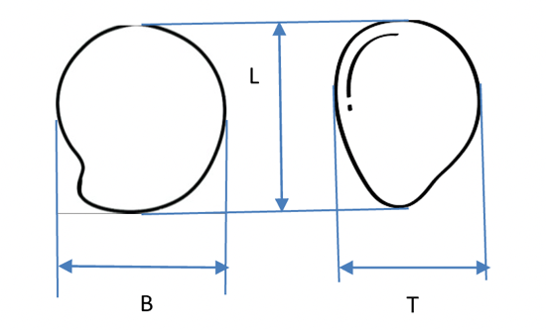

FIG. 2 DIMENSIONS OF GRAIN

**E-7 Observation Table**

Commodity name: ………………….

|  |  |  |  |  |
| --- | --- | --- | --- | --- |
| **Sr. No.** | **L (mm)** | **B (mm)** | **T (mm)** | **De (mm)** |
|  |  |  |  |  |
|  |  |  |  |  |
|  |  |  |  |  |
|  |  |  |  |  |
|  |  |  |  |  |

**ANNEX F**

(*Clause* D-4)

**Determination of Sphericity of Grains**

**F-1 Material Required**

a) Grains

b) Pen/pencil

c) White paper

d) Vernier callipers

**F-2 Experimental Procedure —** Place the object (Grains) on the paper and draw its projected outline by using pen/pencil.

**F-3 Method —** Using compass draw the two circles which is circumscribing and inscribing to the object shape.

1) Use scale to measure the diameter of that circumscribing (Dc) and inscribing (Di)

circles.

**F-4 Formula**

The sphericity of grain can be determined using following formula:

𝐷𝑖

𝑆 =

𝐷𝑐

where,

S - Sphericity, dimensionless

Dc - Diameter of smallest circumscribing circle, mm (see Fig.3)

Di - Diameter of largest inscribing circle, mm (see Fig.3)

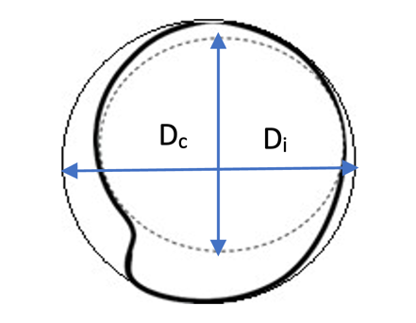

FIG. 3 DIAMETERS OF GRAIN

**F-5 Observation Table**

Commodity name: ………………….

|  |  |  |  |
| --- | --- | --- | --- |
| **Sr. No.** | **Di (mm)** | **Dc (mm)** | **S** |
|  |  |  |  |
|  |  |  |  |
|  |  |  |  |
|  |  |  |  |

**ANNEX G**

(*Clauses* 8.1.5.1)

**DATA SHEET FOR ANALYSIS OF SAMPLES**

**G-1** The data shall be recorded as per Table 1 and based on the same Table 2 shall be filled.

**Table 1 Mass of Clean grain and Foreign Matter in the Sample**

(Annex G-1)

|  |  |  |  |  |  |  |
| --- | --- | --- | --- | --- | --- | --- |
| **Sl No.** | **Feed rate (q/h) & Feed plate (name or hole**  **diameter)** | **Source of sample** | **Sample mass (kg)** | **Mass of** | | **Remark** |
| **Clean grain, kg** | **Foreign matter, kg** |
| (1) | (2) | (3) | (4) | (5) | (6) | (7) |
|  |  | i) From clean grain outlet  (outlet-1) |  |  |  |  |
| ii) From foreign matter outlet  (outlet-2) |  |  |  |  |

**Table 2 Percentage of round grains in the Sample**

(Annex G-1)

|  |  |  |  |  |  |  |  |
| --- | --- | --- | --- | --- | --- | --- | --- |
| **Crop** | **Feed plate (Name of hole size, mm)** | **Sample (kg)** | **Time (s)** | **Feed rate (q/h)** | **Inlet** | **Outlets** | |
| **1** | **2** |
| **Round grains (%)** | **Round grains (%)** | **Round grains (%)** |
|  | A |  |  |  |  |  |  |
| B |  |  |  |  |
| C |  |  |  |  |
| D |  |  |  |  |
|  | A |  |  |  |  |  |  |
| B |  |  |  |  |
| C |  |  |  |  |
| D |  |  |  |  |
|  | A |  |  |  |  |  |  |
| B |  |  |  |  |
| C |  |  |  |  |
| D |  |  |  |  |

Testing Engineer

**ANNEX H**

(*Clauses* 8.1.6.1 and 8.1.7.1)

**DATA SHEET FOR EFFICIENCY AND CAPACITIES**

**H-1** The data shall be recorded as per Table 3 and based on the same Table 4 shall be filled.

**Table 3 Percentage of round grains in the Sample**

(Annex H-1)

|  |  |  |  |  |  |  |
| --- | --- | --- | --- | --- | --- | --- |
| **Sl No.** | **Item** | **Test No.** | | | | |
| **1** | **2** | **3** | **4** | **etc.** |
| i) | Feed rate, q/h |  |  |  |  |  |
| ii) | Total grain received at  outlet -1, q |  |  |  |  |  |
| iii) | Total grain received at  outlet – 2, q |  |  |  |  |  |
| iv) | Grading  efficiency, % |  |  |  |  |  |
| v) | Rated input  capacity, q/h |  |  |  |  |  |

**Table 4 Percentage of round grains in the Sample**

(Annex H-1)

|  |  |  |
| --- | --- | --- |
| **Crop** | **Feed rate (q/h)** | **Grading Efficiency (%)** |
|  |  |  |
|  |  |
|  |  |
|  |  |  |
|  |  |
|  |  |
|  |  |  |
|  |  |
|  |  |
|  |  |

Testing Engineer

**ANNEX I**

(*Clause* 8.2)

**DATA SHEET FOR LONG-RUN TEST**

**I-1** During long run test following data shall be recorded

a) Total running time

b) Continuous running time

c) Breakdown in body part

d) Any knocking sound during operation

e) Any major repairs conducted

f) Any other observations

Testing Engineer

**ANNEX J**

(*Clause* 9.1)

**SUMMARY REPORT**

**J-1 The following information shall be given in the summary report**

1. Name of manufacturer;
2. Make and model number;
3. Name of testing centre;
4. Brief description of the spiral grader;
5. Name and variety of food grain tested;
6. Percentage of foreign matter in grains befor feeding;
7. Moisture content of grains before feeding;
8. Mean size and sphericity of tested sample ;

j) Mean roundness of tested sample;

k) Provisions for adjustment of feed rate;

m) Noise level at no load and load conditions;

n) Grading efficiency;

o) Rated input capacity;

p) Any marked observation affecting performance;

q) Any marked breakdowns, and

r) Other observations

Testing Engineer