**BUREAU OF INDIAN STANDARDS**

**DRAFT FOR COMMENTS ONLY**

(*Not to be reproduced without the permission of BIS or used as an Indian Standard*)

|  |  |
| --- | --- |
| *भारतीय मानक मसौदा* **मानव चलित भूसा कटर — विशिष्टि**  (*आइ एस 7898 का* तीसरा पुनरी*क्षण*)    *Draft* **Indian Standard**  **MANUALLY-OPERATED CHAFF CUTTER — SPECIFICATION**  (*Third Revision of IS 7898*)  **ICS 65.060** | |
| Agricultural and Food Processing Equipment  Sectional Committee, FAD 20 | Last date for Comments:  **6 September 2023** |

**FOREWORD**

(*Adoption clause will be added later*)

Manually-operated chaff cutters are very commonly used by farmers for cutting the chaff. The chaff cutters vary in dimensions, material of construction and other quality characteristics considerably from manufacturer to manufacturer which causes great inconvenience to the user specially replacement of the components. A need was, therefore, felt for preparation of an Indian Standard to guide the manufacturers to produce quality product and to help the users in selection of good quality chaff cutters.

This standard was first published in 1975 and was first revised in 1981. In the second revision in 2001, certain provisions for operator’s safety and test for judging the variation in length of cut and idle-run test were incorporated.

In this revision, following modifications have been incorporated keeping in view the technological advancements in the field and the standard has been brought out in the latest style and format of the Indian Standards:

a) The specifications for the blade which were earlier published in IS 1511 : 1979 have been incorporated in this revision.

b) The material specifications for various components have been incorporated/updated and bush bearing is removed while pedestal bearing, discharge box and flywheel cover have been added in the list of components.

Figures given in this standard are meant for illustration of various components and dimensions of chaff cutters and they should not be treated as suggestive of any standard design.

For the purpose of deciding whether a particular requirement of this standard is complied with the final value, observed or calculated, expressing the result of a test or analysis, shall be rounded off in accordance with IS 2 : 2022. ‘Rules for rounding off numerical values (*second revision*)’. The number of significant places retained in the rounded off value should be the same as that of the specified value in this standard.

|  |
| --- |
| ***The draft revision of this standard was earlier issued in wide circulation on 15 December 2022 for comments for 60 days. Based on comment received from stakeholders, the document is being issued into second wide circulation incorporating the test methods, blade specifications and the updated material for individual components of the manually operated chaff cutter.*** |

**1 SCOPE**

This standard specifies material, construction, safety requirements and method of testing for manually-operated chaff cutter (*see* Fig. 1).

**2 REFERENCES**

The standards given below contain provisions which, through reference in this text, constitute provisions of this standard. At the time of publication, the editions indicated were valid. All standards are subject to revision and parties to agreements based on this standard are encouraged to investigate the possibility of applying the most recent editions of these standards.

|  |  |
| --- | --- |
| *IS No.* | *Title* |
| IS 210 : 2009 | Grey iron castings — Specification (*first revision*) |
| IS 399 : 1963 | Classification of Commercial Timbers and Their Zonal Distribution |
| IS 513 : 2016 | Cold reduced low carbon steel sheets and strips (*sixth revision*) |
| IS 1153: 2021 | Temporary Corrosion Preventives Hard Film Solvent Deposited — Specification (*third revision*) |
| IS 1500 (Part 1) : 2019 / ISO 6506-1 : 2014 | Metallic materials – Brinell hardness test: Part 1 Test method (*fifth revision*) |
| IS 1570 (Part 2) : 1979 | Schedules for wrought steels: Part 2 Carbon steels (Unalloyed Steels) (*first revision*) |
| IS 1586 (Part 1): 2018 / ISO 6508-1: 2016 | Metallic materials – Rockwell hardness test: Part 1 Test method (*fifth revision*) |
| IS 2062 : 2011 | Hot rolled medium and high tensile structural steel — Specification (*seventh revision*) |
| IS 2102 (Part 1) / ISO 2768-1 | General tolerances: Part 1 Tolerances for linear and angular dimensions without individual tolerance indications (*third revision*) |
| IS 4454 (Part 1) : 2001 | Steel wire for mechanical springs — Specification: Part 1 Cold drawn unalloyed steel wire (Third Revision) |
| IS 4711 : 2008 | Methods for sampling of steel pipes, tubes and fittings (*second revision*) |
| IS 7201 (Part 1) : 1987 | Methods of Sampling for Agricultural Machinery and Equipment: Part 1 Hand – Tools and Hand – Operated / Animal Drawn Equipment (*first revision*) |

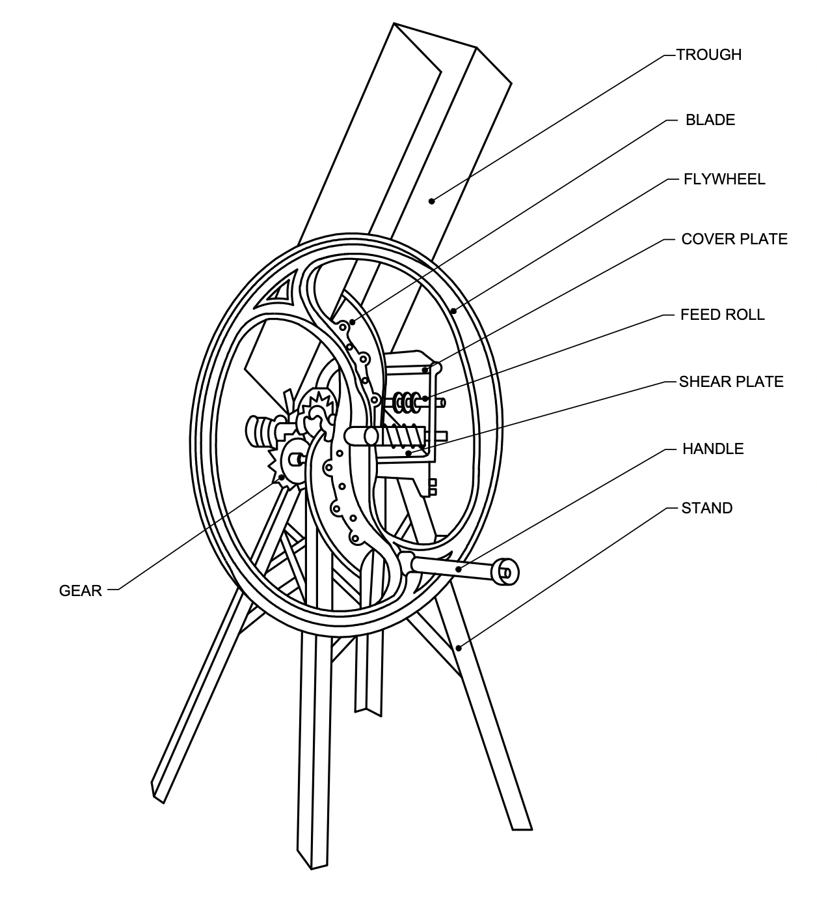

FIG. 1 TYPICAL DRAWING OF MANUALLY-OPERATED CHAFF CUTTER

**3 MATERIALS**

**3.1** The material for construction of various components of the chaff cutter, other than blade, shall be as given in *col* 3 of Table 1. The material shall conform to Indian Standards given in *col* 4 of Table 1.

**3.2** The chemical composition of the steels to be used for the manufacture of blades shall be as follows:

1. **Carbon steel**

Carbon 0.60 to 0.90 percent

Silicon 0.10 to 0.40 percent

Manganese 0.50 to 1.0 percent

Sulphur 0.05 percent, *Max*

Phosphorous 0.05 percent, *Max*.

1. **Alloy steel**

Carbon 0.55 to 0.90 percent

Silicon 0.10 to 0.40 percent

Manganese 0.50 to 0.80 percent

Sulphur 0.05 percent, *Max*

Phosphorous 0.05 percent, *Max*

Aluminium 0.1 percent, *Max*

Chromium 0.1 to 0.2 percent.

**3.2.1** Some of the typical steels that may be used are T 65, T 70 Mn 65, T 75, T 60 Mn 65, T 85 and 40Cr1 [*see* IS 1570 (Part 2)].

**Table 1 Material of construction**

(*Clause* 3.1)

|  |  |  |  |
| --- | --- | --- | --- |
| **S. No** | **Parts** | **Material** | **Relevant Standard** |
| (1) | (2) | (3) | (4) |
| i) | Flywheel | Cast iron  Mild steel | IS 210  IS 2062 |
| Flywheel cover | Mild steel | IS 2062 |
| ii) | Cylinder | Mild steel | IS 2062 |
| iii) | Handle grip | Hard or Medium hard wood | IS 399 |
| iv) | Handle Support | Mild Steel | IS 2062 |
| v) | Frame | Cast iron  Mild Steel | IS 210  IS 2062 |
| vi) | Cover Plate | Cast iron  Mild steel | IS 210  IS 2062 |
| vii) | Shear Plate | Cast iron  Mild steel  Alloy steel | IS 210  IS 2062  IS 4711 |
| viii) | Feed Rolls | Cast iron  Mild steel | IS 210  IS 2062 |
| ix) | Feed Roll Shafts | Cast iron  Mild steel | IS 210  IS 2062 |
| x) | Spring | Spring Steel | IS 4454 (Part 1) |
| xi) | Tie rod | Cast iron  Mild steel | IS 210  IS 2062 |
| xii) | Worm and worm gear | Cast iron | IS 210 |
| xiii) | Legs | Mild steel | IS 2062 |
| xiv) | Leg support | Mild steel | IS 2062 |
| xv) | Shaft and Axles | Mild steel | IS 2062 |
| xvi) | Pedestal bearing | Alloy steel | IS 4711 |
| xvii) | Feeding Chute | Mild steel  CRCA sheet | IS 2062  IS 513 |
| xviii) | Fingers, If separate | Cast Iron | IS 210 |
| xix) | Blade Cover | Mild steel  Plastic | IS 2062  - |
| xx) | Discharge box | Mild steel  CRCA sheet | IS 2062  IS 513 |

**4 CONSTRUCTIONAL REQUIREMENTS**

**4.1 Blade**

**4.1.1** *Hardness of Blade*

a)All cast iron components shall have a hardness of 160 to 220 HB [*see* IS 1500 (Part 1)].

b)The blade shall be either fully or partially hardened. The fully hardened blade shall be properly and uniformly heat treated to have a hardness of 40 to 45 HRC or 370 to 422 HB [*see* IS 1586 (Part 1)]. The partially hardened blades shall be properly heat treated to have a hardness of 40 to 45 HRC [*see* IS 1586 (Part 1)] up to two-thirds portion of the blade from the tip of the bevelled edge.

**4.1.2** *Shape of Blade*

A typical shape of the blade is given in Fig. 2.

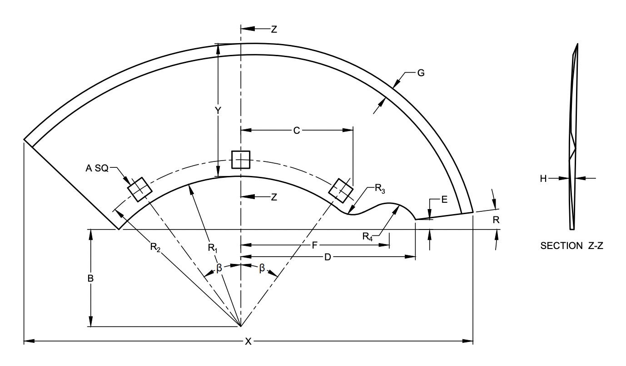

FIG. 2 TYPICAL SHAPE OF THE BLADE

**4.1.3** *Dimensions of Blade*

a) The essential dimensions of blade when read in conjunction with Fig. 2 shall be as given in Table 2.

b) The nominal thickness of steel sheet shall be between 1.50 to 2.50 mm. The tolerance on the declared thickness shall be ± 10 percent.

c) The length of the blade (*see* X in Fig. 2) shall be declared by the manufacturer. The width of the blade (*see* Yin Fig. 2) shall be between 100 to 150 mm. The tolerance on declared width and length shall be ± 1 mm.

**Table 2 Dimensions of Blade**

[*Clause* 4.1.3 (a)]

|  |  |  |  |  |  |  |  |  |  |  |  |  |
| --- | --- | --- | --- | --- | --- | --- | --- | --- | --- | --- | --- | --- |
| **Sl No.** | **A** | **B** | **C** | **D** | **E** | **F** | **R1** | **R2** | **R3** | **R4** |  |  |
| **(1)** | **(2)** | **(3)** | **(4)** | **(5)** | **(6)** | **(7)** | **(8)** | **(9)** | **(10)** | **(11)** | **(12)** | **(13)** |
|  | +1  -0  mm | ± 3  mm | ± 5  mm | ± 3  mm | mm | ± 3  mm | ± 1  mm | ± 1  mm | ± 1  mm | ± 1  mm | ± 2  degrees | ± 2  degrees |
| i) | 12 | 85 | 85 | 135 | 5 to 10 | 115 | 125 | 140 | 15 | 20 | 8 | 34 |
| ii) | 12 | 90 | 100 | 155 | 5 to 10 | 130 | 140 | 155 | 20 | 25 | 8 | 34 |
| iii) | 12 | 100 | 100 | 160 | 5 to 10 | 135 | 150 | 165 | 20 | 25 | 8 | 37 |

**4.2 Handle**

Handle shall consist of handle support of mild steel rod and a wooden grip placed over the rod. The diameter of the handle support (*see* Fig. 3) shall be minimum of 15 mm. The total length of the handle (*see* B in Fig. 3) shall be at least 500 mm and the length of wooden grip (*see* C in Fig. 3) shall be 430 mm to 450 mm. The diameter of the grip (*see* D in Fig. 3) shall be 37 mm to 42 mm. The grip shall be properly attached with the support. The one end of the support shall be threaded. The handle shall be attached with fly wheel by a hexagonal nut with washers.

**4.3 Flywheel**

A flywheel of 900 mm to 1350 mm diameter (*see* A in Fig. 4) shall be provided. The flywheel shall have two arms. Each arm shall be provided with one square hole for fixing the handle; three holes for fixing the blade and six tapped holes for fixing the bolts for blade setting adjustment. At the centre of the flywheel a circular hole shall be provided for connecting it to the main shaft. A hole of 10 mm diameter shall be made in the rim of the flywheel parallel to direction of the hub hole. The weight of the fly-wheel shall not be less than 24 kg.

FIG. 3 HANDLE

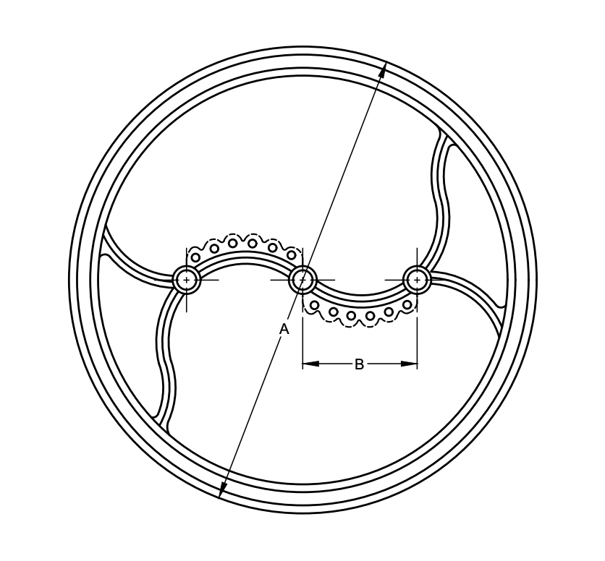

FIG. 4 FLYWHEEL

**4.4 Main Shaft**

The one end of the main shaft shall be rigidly attached at the centre hole of flywheel and other end may be supported on a plumber block. The length and diameter of the shaft (*see* A and B in Fig. 5) shall be 400 mm and 30 mm respectively. Plummer block shall be provided with ball bearing.

**4.5 Worm**

The worm shall be fitted on the main shaft. The hole size of the worm (*see* A in Fig. 6) shall be such that it should push fit on the main shaft. the outer diameter and length of the worm (*see* B and C in Fig. 6) shall be 75 mm or 80 mm and 155 mm respectively. The pitch of the worm (*see* D in Fig. 6) shall be 25 mm. It shall be provided with two holes for proper fixing to the shaft. The distance of centre of hole from the end of the worm (*see* E in Fig. 6) shall be 50 mm or 13 mm.

NOTE — The pitch of the worm at both ends shall be 25 mm but teeth at one end may be double start to enable to have two chopping length by reversing the worm.

**4.6 Worm Gears**

There shall be two gears; one located at upper side and other at the lower side of the worm. The outer diameter of the gears (see A in Fig. 7) shall be 125 mm or 133 mm and there shall be 15 teeth in each gear. At the option of the purchaser the gears may have 11 or 13 teeth. The gear shall be attached with axles by hexagonal bolts.

FIG. 5 MAIN SHAFT

FIG. 6 WORM

|  |  |
| --- | --- |
|  |  |
| 7A LOWER WORM GEAR | 7B UPPER WORM GEAR |

FIG. 7 WORM GEAR

**4.7 Feed Rolls**

There shall be two feed rolls. The length and outer diameter of the rolls (*see* A and B in Fig. 8) shall be 207 mm and 75 mm or 85 mm respectively. Each roll shall have eight projections on circumferential periphery. The lower roll shall have 11 fill teeth and upper roll 10 full and two half teeth on lengthwise fixing the axles (*see* C in Fig. 8).

**4.8 Springs**

Two tension springs shall be provided to keep the upper roll in tension. Total length of each spring (see A in Fig. 9) shall be minimum 95 mm. The outer diameter (*see* B in Fig. 9) shall be 20 mm, the wire diameter shall be 2.5 mm and the number of coils shall be 18.

**4.9 Cover Plates**

Two sides and one top cover plates shall be provided to protect the feed-rolls as well as for proper mounting of the worm and worm gears. Both the side plates shall be attached to a tie rod. The rod shall be of minimum 225 mm in length with both the ends threaded. The top cover plate shall have 11 full teeth.

**4.10 Shear Plate**

A rectangular plate with top open, shall be attached at the front of the feed rolls. The width and height of the plate (*see* A and B in Fig. 10) when measured internally shall be minimum 207 mm and 105 mm respectively. The shear plate shall have 12 fill teeth.

**4.11 Back Plate**

There shall be one back plate fitted in between two side plates at the rear. The length of the back plate (*see* A in Fig. 11) shall be 207 mm and width (*see* B in Fig. 11) including teeth shall be 145 mm. There shall be 12 teeth in the back plate.

**4.12 Feeding Trough**

A rectangular or trapezoidal trough shall be attached on the rear side of the shear plate. The trough shall be detachable. Provision for changing the angle of placement of trough shall be provided. At the rear side of the trough a support should be provided. The total length of the trough shall be minimum of 900 mm.

8A LOWER FEED ROLLER

8B UPPER FEED ROLLER

FIG. 8 FEED ROLLERS

FIG. 9 SPRING

FIG. 10 SHEAR PLATE

FIG. 11 BACK PLATE

**4.13 Stand**

Stand shall consist of four legs; leg supports and one finger in each leg. The leg shall be made of angle section of minimum 50 mm $×$ 50 mm $×$ 2 mm size. The leg support may be detachable or riveted with the leg. The fingers may be a separate component attached to the leg or may be made by taking out at the bottom of each leg. The total height, length and width of the stand (*see* A, B and C in Fig. 12) shall be minimum of 750 mm, 600 mm and 550 mm respectively. In one of the legs a hole of 10 mm shall be provided at a point coinciding with the hole made in the rim of the fly wheel.

**4.14** Allowable deviations for dimensions without specified tolerance shall be as given in IS 2102 (Part 1).

FIG. 12 STAND

**5 OTHER REQUIREMENTS**

**5.1** The worm gears should as far as possible, be enclosed and should preferably be run in an oil trough.

**5.2** The bearings shall be completely enclosed with provision for lubrication.

**5.3** Provision shall be provided to change the inclination of the plane of the cutting knives to the plane of rotation of fly wheel to avoid feed interference.

**5.4** Provision to change the direction of rotation of feed rolls should be provided.

**5.5** Hooks at suitable places may be provided for lifting the chaff cutter for easy movement.

**5.6** The maximum height of cranking from ground level shall be within 800 to 900 mm. The cranking radius shall be 250 to 350 mm (*see* B in Fig. 4).

**5.7** All the three sides of shear plate shall be in one plane.

**5.9** Operational manual giving operational, maintenance, assembly instructions and adjustments shall be supplied by the manufacturer with each chaff cutter. Instructions for safe operation of chaff cutter shall also be provided.

**5.10** The holes in blades shall be square/round and smooth. The corners of the square holes should be rounded. The square holes should be provided with 10 mm size square carriage bolts.

**5.11** The cutting edge of the blade shall be sharp and shall be bevelled on one side. The minimum length of bevelling (*see* *G* in Fig. 2) shall be 10 mm. The bevelling may have single angle or double (stepped) angle. The recommended bevel angle for single bevelling is 12° and for double bevelling 45°/12°.

**5.12** The blade shall be slightly curved towards the back. When it is laid on a flat surface, the curvature shall be such that the height of the back of the blade from the flat surface (*see* *H* in Fig. 2) shall be 3 to 9 mm.

**6 TESTS**

**6.1 Idle Run Test**

Fix the chaff cutter on level and preferably on hard surface. Operate it for 30 minutes. The speed of the cutter head should be 50 rpm (rev/min). During the operation, observation shall not show the following:

1. Presence of any marked oscillation;
2. Presence of knocking or rattling sound;
3. Obstructions in running of shafts in bearings; and
4. Any marked unusual wear or slackness in any component.

**6.2 Test for Variation in Cut Length**

**6.2.1** *Installation*

Fix the chaff cutter firmly on the level and preferably hard surface. Set the clearance between blade and shear plate and make other adjustments in accordance with the manufacturer’s recommendations for cutting a particular length of the chaff.

**6.2.2** *Fodder*

Take sufficient quantity of fodder . The fodder should be of same variety and free from roots. The length of the fodder should, as far as possible, be the same.

**6.2.3** *Theoretical Length*

The theoretical length of the fodder to be cut shall be obtained by the following formula:

$$x= \frac{n}{N}×\frac{22×D}{7×R}$$

Where,

*x* = Length of cut, mm;

*n* = rpm of feed roll;

*N* = rpm of fly wheel;

*D* = Diameter of the feed roll in mm; and

*R* = Number of blades.

**6.2.4** *Operation*

Operate the fly wheel of the chaff cutter at 50 rev/min and feed the fodder manually. Ensure that the feeding is done continuously and covers full width and height of the throat. The feeding should be done from root side of the fodder. While feeding, a rigid plastic pipe of diameter of 12 mm to 15 mm and 2 m in length shall be fed along with the fodder. Duration of the operation shall be such that at least 25 pieces of plastic pipes are cut.

**6.2.5** *Measurement*

Select 25 pieces of plastic pipe and measure the length of each piece in mm. Obtain the average length of cut.

**6.2.6** *Observation*

Compare the average measured length of cut with the theoretical length (*see* **6.2.3**). The variation in length shall be not more than 5 percent.

**7 SAFETY REQUIREMENTS**

**7.1** Each manually-operated chaff cutter shall be provided with safety provision as given in **7.1.1** to **7.1.7** (*see* Fig. 13).

**7.1.1** *Flywheel Locking Device*

A suitable hole shall be provided in the flywheel shaft for fixing a locking pin for fixing the flywheel in a position when the machine is not in use or alternatively a bolt shall be fitted in both the holes (hole of leg and hole of flywheel rim) and tightened with nut so that the fly wheel shall not move when not in work (*see* Fig. 14).

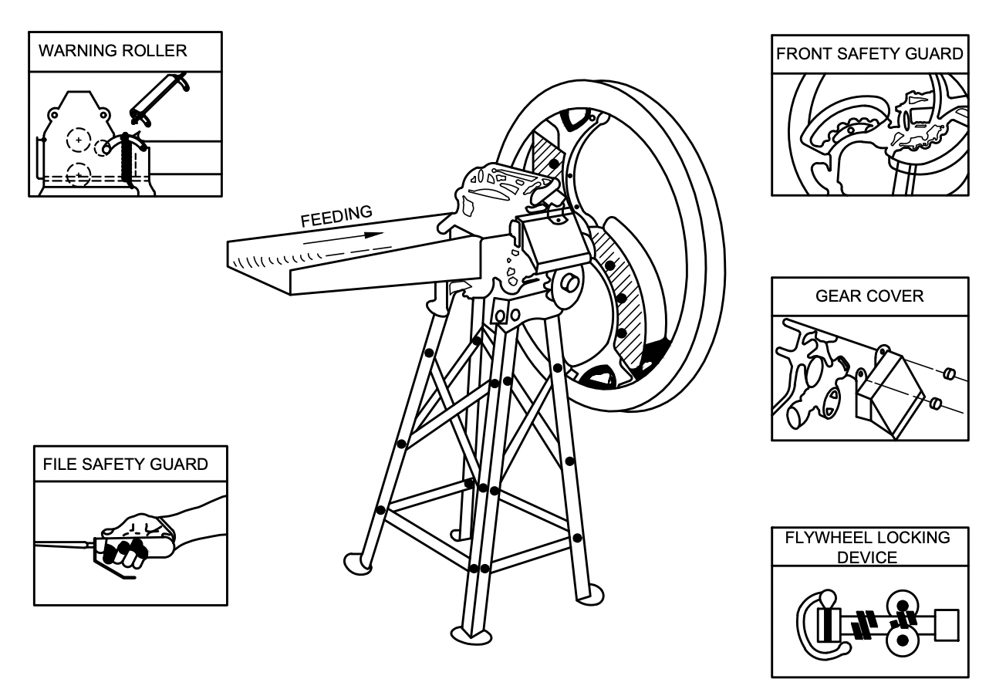

FIG. 13 SAFETY MEASURES ON EXISTING FODDER CUTTER

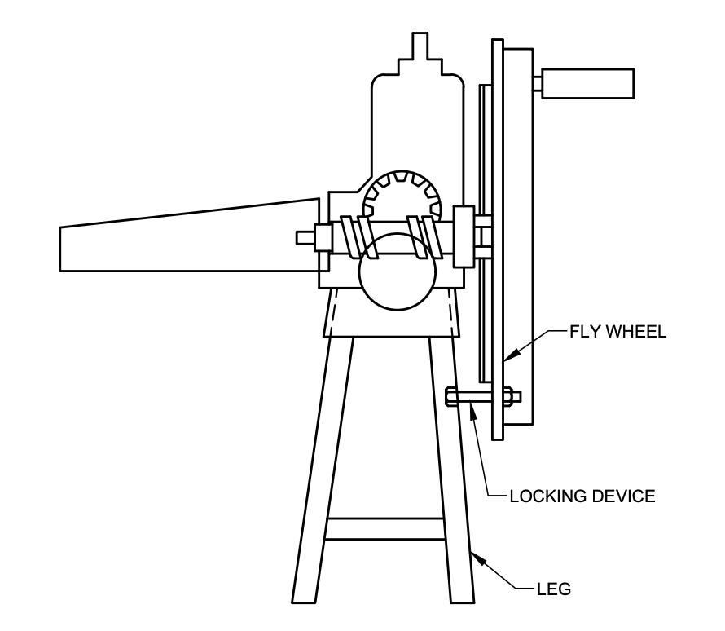

FIG. 14 TYPICAL LOCKING ARRANGEMENT FOR CHAFF CUTTER

**7.1.2** *Front Safety Guard*

A front safety guard shall be fitted on each knife blade tightly as a safety device (*see* Fig. 15).

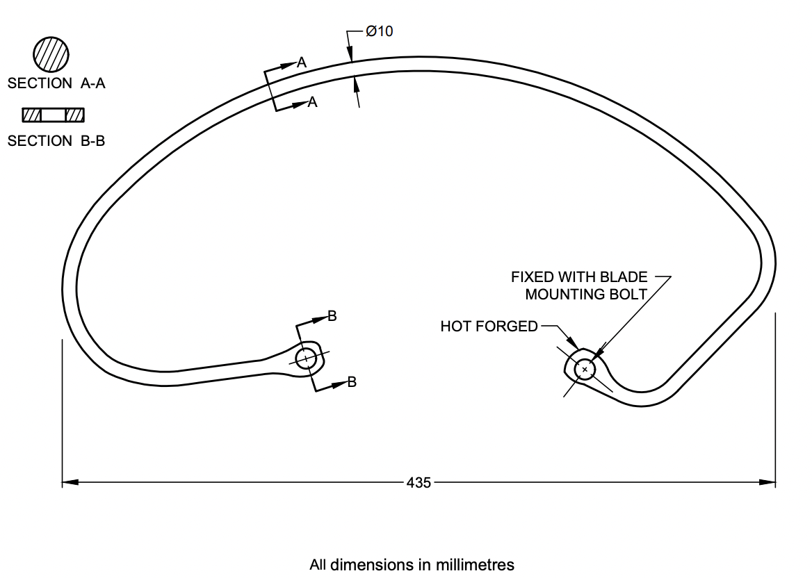

FIG. 15 FRONT SAFETY GUARD

**7.1.3** *Gear Cover*

Warm and pinion assembly shall be covered from all the sides by a metal sheet as shown in Fig. 13.

**7.1.4** *Warning Roller*

A warning roller which is a sort of idler roller with spring (see Fig. 16) shall be fitted just before the feeding rollers as an alternate to cover chute (*see* **7.1.5**).

**7.1.5** *Covered Chute*

The trough on the shear plate side shall be covered upto a length of 450 mm minimum.

**7.1.6** *Blade Cover*

Each blade shall be covered with a cover. A typical shape and dimension of the blade cover is given in Fig. 17.

**7.1.7** A minimum cautionary notice worded as follows shall be written in vernacular language legibly on a label preferably fixed on the main body of the chaff cutter:

1. Do not wear loose dress, bangles, watch, etc., while feeding the fodder;
2. Do not smoke and light fire near dry fodder being cut;
3. Do not work under the influence of intoxicants like liquor, opium, etc.;
4. Children and aged persons should be discouraged for working;
5. Do not push small fodder by hand, use pushing device;
6. Put the cover on blade after completing the work;
7. Lock the flywheel with the locking pin after work; and
8. Never bring hand near feed rolls and open blade.

**8 WORKMANSHIP AND FINISH**

**8.1** All the components of the chaff cutter shall be free from cracks and such other defects that may be detrimental for their use.

**8.2** The cast iron components shall not be porous. Welding, if done, shall also not be porous.

**8.3** All exposed metallic surfaces shall be free from rust and may be painted, if required.

**8.4** The blade shall be ground on its non-bevelled side.

**8.5** The blade shall be free from flaws, seams, scratches, cracks, pits and other defects. All fins, burrs and sharp edges, other than the cutting edges shall be removed. The cutting edge shall be sharpened ready for use.

**8.6** The finished blade shall be given a coat of any suitable mineral jelly or any other corrosion preventives (*see* IS 1153).

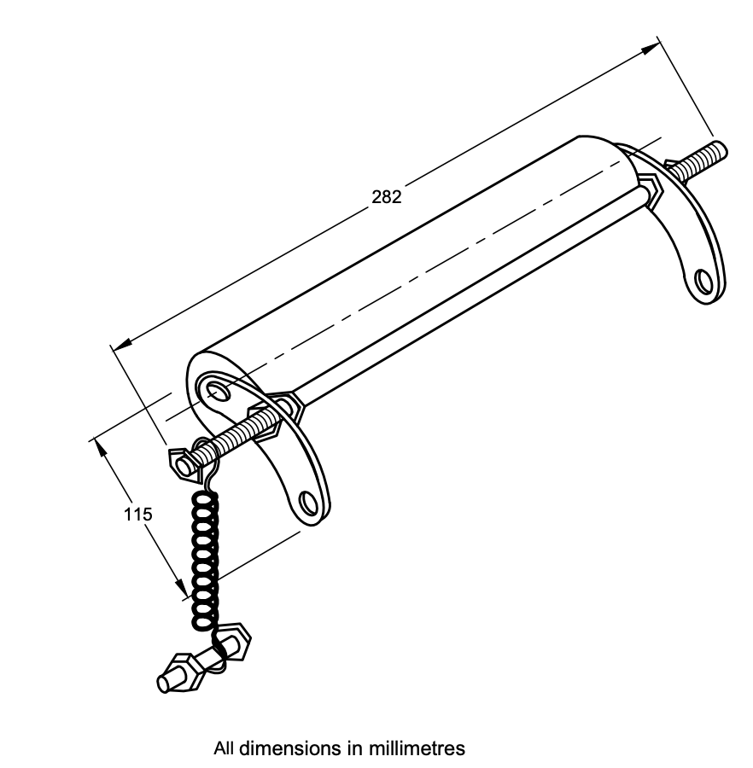

FIG. 16 WARNING ROLLER

FIG. 17 BLADE COVER

**9 MARKING AND PACKING**

**9.1 Marking** — Each product shall be marked with the following particulars:

1. Manufacturer’s name and/or recognized trademark, if any;
2. Code and batch number;
3. Thickness of blade;

**9.1.1** *BIS Certification Marking*

The product(s) conforming to the requirements of this standard may be certified as per the conformity assessment schemes under the provisions of the Bureau of Indian Standards Act, 2016 and the Rules and Regulations framed thereunder, and the products may be marked with the Standard Mark.

**9.2 Packing**

**9.2.1** The blades of the same size and thickness shall be packed in bundles of two or multiples of two, as agreed to between the purchaser and the supplier for safe handling in transit and storage.

**9.2.2** For ease in packing for transportation, the chaff cutter may be dismantled in suitable sub-assemblies. The packing shall be done as agreed to between the purchaser and the supplier.

**10 SAMPLING FOR LOT ACCEPTANCE**

Unless otherwise agreed to between the purchaser and the supplier, the criteria for sampling for lot acceptance shall be in accordance with as per IS 7201 (Part 1).