**July 15th, 2023**

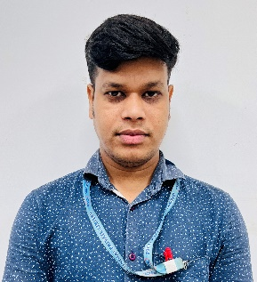

**To whom so ever it may Concern**

Dear Sir,

This is to certify that Mr. Rabindra Sahoo is working in PICL as technical support in Lab department since 06th July 2022.

He is having total work experience of 8 years.

**For PICL India Pvt Ltd**

**Shiv Deshwal**

**Manager – Human Resource**