**BUREAU OF INDIAN STANDARDS**

DRAFT FOR COMMENTS ONLY

(Not to be reproduced without permission of BIS or used as an Indian Standard)

***भारतीय मानक मसौदा***

विस्फोटक और आतिशबाज़ी उद्योग के लिए सोडियम नाइट्रेट —विशिष्टि

(*पहला पुनरीक्षण*)

***Draft Indian Standard***

SODIUM NITRATE FOR EXPLOSIVES AND PYROTECHNIC INDUSTRY— SPECIFICATION

(*First Revision*)

ICS 71.100.30

Explosives and Pyrotechnics Sectional Committee, CHD 26

**Last date for Comments: 16th Dec, 2023**

**FOREWORD**

**(***Formal clause to be added later*)

Sodium nitrate has a molecular formula of NaNO3 and a molecular weight of 85. Sodium nitrate is one of the important raw materials in the manufacture of explosives and pyrotechnics. It is mainly used as an oxidizing agent in the manufacture of both NG-based as well as slurry-based explosives. Sodium nitrate is also used in glass manufacture and there is a separate standard for the specifications of sodium nitrate for glass compositions (IS 9157 Specification for sodium nitrate and potassium nitrate for glass compositions).

This Indian Standard was originally published in 1989. This first revision of the standard has been taken up to update the ICS No and several other editorial changes in order to bring out the standard in the latest style and format of the Indian Standards.

For the purpose of deciding whether a particular requirement of this standard is complied with, the final value, observed or calculated, expressing the result of a test or analysis, shall be rounded off in accordance with IS 2 : 2022 ‘Rules for rounding off numerical values (*second revision*)’. The number of significant places retained in the rounded off value should be the same as that of the specified value in this standard.

*Draft Indian Standard*

SODIUM NITRATE FOR EXPLOSIVES AND PYROTECHNIC INDUSTRY — SPECIFICATION

(*First Revision*)

**1 SCOPE**

This standard prescribed requirements and method of sampling and the test for sodium nitrate for explosives and pyrotechnic industry.

**2 REFERENCE**

The standards listed below contain provisions which through reference in this text, constitute provisions of this standard. At the time of publication, the editions indicated were valid. All standards are subject to revision and parties to agreements based on this standard are encouraged to investigate the possibility of applying the most recent editions of the standards indicated below:

|  |  |
| --- | --- |
| *IS No* | *Title* |
| IS 9157:1979 | Specification for sodium nitrate and potassium nitrate for glass compositions |

**3 REQUIREMENTS**

**3.1 Description**

The material shall be in the form of free-flowing fine colourless crystals, free from grit and other foreign matter.

**3.1.1** The material shall have particle size as agreed to between the purchaser and supplier.

**3.2** The material shall also comply with the requirements given in Table 1 when tested according to methods given in **Annex A**. Reference to relevant clauses of **Annex A** is given in col 4 of Table 1.

**4 PACKING AND MARKING**

**4.1 Packing**

The material shall be packed in clean, dry, airtight packages as agreed to between the purchaser and the supplier.

**4.2 Marking**

The packages shall be legibly and indelibly marked with the following information:

a) Name of the material;

b) Net mass of the material;

c) Manufacturer’s name and/or his trade mark, if any; and

d) Lot number and date of manufacture.

**4.2.1** BIS *Certification Marking*

The packages may also be marked with Standard Mark. The use of the Standard Mark is governed by the provisions of The Bureau of Indian Standards Act, 2016 and the Rules and Regulations made thereunder. The details of the conditions under which the licence for use of the Standard Mark may be granted to manufacturers or producers, may be obtained from the Bureau of Indian Standards.

**5 SAMPLING**

**5.1** The method of preparing representative samples of the material and the criteria for its conformity to this specification shall be as prescribed in **Annex B**.

**Table 1 Requirements for Sodium Nitrate for Explosives and Pyrotechnic Industry**

(*Clauses* 3.2 and**B-4.2**)

|  |  |  |  |
| --- | --- | --- | --- |
| **SL No.** | **Characteristic** | **Requirements** | **Methods of Test (Ref to Annex A)** |
| **(1)** | **(2)** | **(3)** | **(4)** |
|  | Assay, percent by mass, *Min* | 99 | A-2 |
|  | Moisture and volatile matter, percent by mass, *Max* | 0.5 | A-3 |
|  | Matter insoluble in water, percent by mass, *Max* | 0.03 | A-4 |
|  | Nitrites (as NaNO2),percent by mass, *Max* | 0.05 | A-5 |
|  | Chlorides ( as NaCl), percent by mass, *Max* | 0.1 | A-6 |
|  | Sulphates (as Na2SO4), percent by mass, *Max* | 0.25 | A-7 |
|  | Chlorates | Nil | A-8 |
|  | Perchlorates (as NaClO4), percent by mass, *Max* | 0.05 | A-9 |
|  | Iodates ( as NalO3),percent by mass, *Max* | 0.02 | A-10 |
|  | Total calcium and magnesium or compounds of these metals calculated as oxides, percent by mass, *Max* | 0.05 | A-11 |
|  | Ammonium compounds (as NH4NO3), percent by mass, *Max* | 0.05 | A-12 |
|  | pH of 10 percent solution | 5.5 to 7.0 | A-13 |

**ANNEX A**

**METHODS OF TEST FOR SODIUM NITRATE FOR EXPLOSIVES AND PYROTECHNIC INDUSTRY**

(*Clause* 3.2)

**A-1 QUALITY OF REAGENTS**

Unless specified otherwise, pure chemicals and distilled water shall be employed in tests.

NOTE — ‘Pure chemicals’ shall mean chemicals that do not contain impurities which affect the results of analysis.

**A-2 DETERMINATION OF ASSAY**

**A-2.1 General**

Three methods, namely, ferrous ammonium sulphate method, ion-exchange method and ultraviolet spectrophotometric method have been given. However, in case of dispute, UV spectrophotometric method shall be the referee method.

**A-2.2 Ferrous Ammonium Sulphate Method**

**A.2.2.1** *Reagents*

**A-2.2.1.1** *Ferrous ammonium sulphate,* 0.2 **N.**

**A-2.2.1.2** *Potassium permanganate,* 0.1 N*.*

**A-2.2.1.3** *Ammonium molybdate,* 10 percent aqueous solution.

**A-2.2.1.4** *Sulphuric acid***,**28 N.

**A-2.2.2** *Procedure*

Weigh about 0.2 g of the material in a 500 ml flask and dissolve in water. Add 25 ml of 0.2 N ferrous ammonium sulphate solution and 5 ml of 10 percent aqueous solution of ammonium molybdate followed by gradual addition of 50 ml of 28 N sulphuric acid. Mix the contents of the flask and boil briskly for about 3-4 minutes. Cool the flask rapidly, dilute with water and again cool. Titrate the solution with 0.1 N potassium permanganate until the pink colour produced at the end point remains stable for about 5 minutes.

**A-2.2.3** *Calculation*

Calculate the excess of ferrous ammonium sulphate reacted with potassium permanganate (1 ml of 0.1 N KMnO­4 = 0.005585 g Fe). From this, find out the amount of ferrous ion converted to ferric ion by subtracting from total amount of ferrous salt taken (1 ml of ~~in~~ 1N FeSO4 = 0.02834 g of NaNO3).

**A-2.3 Ultraviolet Spectrophotometric Method**

**A-2.3.1** *Reagents*

**A-2.3.1.1** *Demineralized water*

**A-2.3.1.2** *Sodium nitrate GR*

**A-2.3.2** *Equipment*

**A-2.3.2.1** *UV Spectrophotometer* with 1 cm cells

**A-2.3.3** *Procedure*

Weigh accurately about 1.5 g of the sample and transfer into a 100 ml volumetric flask. Dissolve by demineralized water and dilute to mark. Filter the solution if found hazy. Prepare a reference solution of sodium nitrate (NaNO3 GR) in the same manner. Take the absorbance measurement of both the solutions at 354 and 302 nm. Take absorbance readings of solvent (water) blank also.

**A-2.3.4** *Calculation*

Corrected absorbance of reference ~~NaNO~~~~2~~ NaNO3 at 302 nm, $A_{R}=B-\frac{A}{2.57}$

Corrected absorbance of sample at 302 nm, $A_{s}=D- \frac{C}{2.57}$

$$Percent sodium nitrate= \frac{A_{S}×100}{A_{R}}$$

where

*A =* absorbance of reference sodium nitrate solution at 354 nm,

*B* = absorbance of reference sodium nitrate solution at 302 nm,

*C* = absorbance of sample solution at 354 nm, and

*D* = absorbance of sample solution at 302 nm.

**A-2.4 Ion Exchange Method**

**A-2.4.1** *Principle*

When a dilute solution of known quantity of sodium nitrate is passed through a suitable column containing strong cation exchanger in H+ form, the salt is converted to corresponding acid which is titrated against standard sodium hydroxide solution to determine the purity of sodium nitrate.

**A-2.4.2** *Apparatus*

The cation exchange column consists of a vertical glass tube about 2 cm bore, fitted at the lower end with a ~~stop-cock~~ glass wool plug and containing a height of about 25 cm of cation exchange resin. The total length of the tube may be 60 cm or it may be widened into a funnel above the level of the resin. The resin is introduced into the column by mixing it with water and pouring the slurry into the tube so that no air bubbles are trapped between the particles. During use, the liquid level is not allowed to fall below the surface level of the resin.

**A-2.4.3** *Preparation of the Column*

The resin is washed by passing carbon dioxide free water down the column until 50 ml of elute requires not more than 0.05 ml of N/10 sodium hydroxide using phenolphthalein as the indicator.

**A-2.4.3.1** Up to four assays can normally be carried out by the column before regeneration. If a doubt exists as to the effectiveness of the column, the elute should be tested for the cation that should have been removed.

**A-2.4.4** *Procedure*

Dissolve 0.3 g of the material in 50 ml carbon dioxide free water and pass the solution through the cation exchange column at a rate of 3 to 4 ml per minute, collecting the elute in a titration flask. Wash the resin with carbon dioxide free water and titrate the elute with standard N/10 sodium hydroxide using bromothymol blue indicator as the washing proceeds until 50 ml of elute requires no further titration to the green end point.

**A-2.4.5** *Calculation*

$$Percentage of sodium nitrate= \frac{0.8499×v×f}{m}$$

where

*v* = volume in ml of standard sodium hydroxide required for the titration.

*f* = factor of standard sodium hydroxide used, and

*m* = mass of the sample taken for the test.

**A-2.4.6** *Regeneration of Resin*

The resin can be regenerated by leaving 4 N hydrochloric acid in the column overnight and passing a further 50 ml of hydrochloric acid through the column before the usual washing.

**A-3 DETERMINATION OF MOISTURE AND VOLATILE MATTER**

**A-3.1 Procedure**

Weigh accurately about 10 g of the material in a petri-dish. Keep the petri-dish in an air-oven maintained at (110 ± 2) ˚C for 2 hours. Cool the petri-dish in a desiccator and weigh. Repeat the process of heating and cooling till constant mass is obtained.

**A-3.2 Calculation**

$$Moisture and volatile content, percent by mass= \frac{\left(M_{1}-M_{2}\right)×100}{M_{1}}$$

where

*M*1 = mass in g of the material taken for the test, and

*M*2 = mass in g of the material after drying.

**A-4 DETERMINATION OF MATTER INSOLUBLE IN WATER**

**A-4.1 Procedure**

Weigh accurately 20 g of the material and dissolve in about 250 ml of water. Filter through a tared sintered glass crucible (G. .No. 4) and wash the residue thoroughly with water several times using small quantities of water to ensure removal of all soluble matter into the filtrate. Dry the residue at (105 ± 2) °C for 30 minutes, cool in a desiccator and weigh.

**A-4.2 Calculation**

$$Matter insoluble in water, percent by mass= \frac{100 M_{1}}{M}$$

where

*M*1 = mass in g of the residue, and

*M* = mass in g of the material taken for the test.

**A-5 DETERMINATION OF NITRITES**

**A-5.1 Reagents**

**A-5.1.1** *Potassium Permanganate,* 0.02 N.

**A-5.1.2** *Sulphuric Acid,* 1:1 (*v/v*).

**A-5.2 Procedure**

Weigh accurately 25 g of the material, dissolve in water and dilute to 100 ml in a measuring flask. Pipette out 20 ml of 0.02 N potassium permanganate in 250 ml conical flask. Add 20 ml of water and 5 ml of 1:1 (*v/v*) sulphuric acid. Heat to 40 ˚C and titrate against sodium nitrate solution till the pink colour disappears.

**A-5.3 Calculation**

$$Nitrite \left(as Sodium nitrite\right), percent by mass=\frac{0.0345×N×100}{M×V}×100$$

where

*N* = normality of potassium permanganate,

*M* = mass in g of sodium nitrate taken for estimation,

*V* = volume in ml of sodium nitrate used in titration.

**6 DETERMINATION OF CHLORIDES**

**A-6.1 Reagents**

**A-6.1.1** *Standard Silver Nitrate Solution****,*** 0.1 N approx.

**A-6.1.2** *Concentrated Nitric Acid*

**A-6.1.3** *Ferric Ammonium Sulphate Indicator,* 10 percent (*m/v).*

**A-6.1.4** *Standard Ammonium Thiocyanate Solution****,*** 0.1 N approximately.

**A-6.1.5** *Nitrobenzene*

**A-6.2 Procedure**

Weigh accurately 2 g of the material and dissolve in about 50 ml of water. Add 10 ml of standard silver nitrate solution, 2 ml of concentrated nitric acid and 5 ml of nitrobenzene. Shake vigorously for one minute. Add 2 ml of ferric ammonium sulphate indicator solution and titrate excess silver nitrate with standard ammonium thiocyanate solution shaking well between successive additions to the first persistent colour change.

**A-6.3 Calculation**

*N*1 = normality of standard silver nitrate solution,

*V*= volume in ml of standard ammonium thiocyanate solution used in titration,

*N*2 = normality of standard ammonium thiocyanate solution, and

*M* = mass in g of the material taken for the test.

**A-7 DETERMINATION OF SULPHATES**

**A-7.1 Reagents**

**A-7.1.1***Concentrated Hydrochloric Acid*

**A-7.1.2** *Barium Chloride Solution,* approximately 10 percent (*m/v).*

**A-7.2 *Procedure***

Weigh accurately about 2 g of the sample and dissolve in 50 ml of water. Add 15 ml of concentrated hydrochloric acid and dilute to 200 ml with water. Filter, if necessary. Heat to boiling, add drop by drop, with constant stirring, 10 ml of barium chloride solution and allow to stand for about 2 hours. Filter through a tared sintered glass crucible (G. No. 4), wash the precipitate thoroughly with hot water till free from chlorides and dry between 105 °C to 110 °C to constant mass.

**A-7.3 Calculation**

$$Sulphates \left(as Na_{2}SO_{4}\right), = \frac{60.92M_{1}}{M}$$

where

*M*1 = mass in g of the barium sulphate precipitate, and

*M* = mass in g of the material in the aliquot taken for the test.

**A-8 DETERMINATION OF CHLORATES**

**A-8.1 Reagents**

**A-8.1.1** *Aniline Hydrochloride*

Dissolve 18 g of redistilled aniline in 375 ml of concentrated hydrochloric acid and make up the volume to 500 ml with distilled water. Add 2 drops of saturated potassium chlorate solution, shake and allow to stand overnight. Filter off the blue sediment, store the reagent in a glass stoppered bottle in the dark.

**A-8.2 Procedure**

Dissolve 5 g of the material in 40 ml of water, filter if necessary, and make up to 100 ml with aniline hydrochloride reagent.

**A-8.2.1** The material shall be considered to have passed the test if no blue colouration is developed in 10 minutes.

**A-9 DETERMINATION OF PERCHLORATES**

**A-9.1 Apparatus**

The apparatus consists of a wide-necked flask (about 300 ml) fitted with a cork carrying a reflux condenser, an inlet tube (6 mm bore) reaching the bottom of the flask, and a short tube (at least 12 mm bore) fitted with a cork.

**A-9.2 Reagents**

**A-9.2.1** *Concentrated Hydrochloric Acid*

**A-9.2.2** *Sulphur Dioxide* gas.

**A-9.2.3** *Dilute Sulphuric Acid,* approximately 12 N.

**A-9.2.4** *Titanous Chloride Solution,* approximately 3 percent, prepared by diluting 10 ml of 15 percent (*m/v*) of titanous chloride solution to 50 ml with concentrated hydrochloric acid.

**A-9.2.5** *Ammonium Thiocyanate Solution,* approximately 10 percent (*m/v*).

**A-9.2.6** *Standard Ferric Ammonium Sulphate Solution ,*approximately 0.1 N prepared by dissolving 48.22 g of ferric ammonium sulphate in 500 ml of freshly boiled water that has been acidified with 10 ml of dilute sulphuric acid (40 percent by mass). Make up the volume to 1 000 ml with freshly boiled water (Solution *A*).

1. Measure into a 200 ml conical flask 25 ml of freshly boiled water, 25 ml of 0.1 potassium dichromate solution and 15 ml of dilute sulphuric acid (40 percent by mass). Fit the conical flask with a rubber bung bored with two holes, through one of which passes a leading tube reaching, about 50 mm into the flask. Pass a rapid stream of carbon dioxide into the flask for several minutes in order to displace the air. Place the jet of the burette containing the titanous chloride solution in the second hole of the rubber bung, and whilst continuing to pass carbon dioxide, run 20 ml of the titanous chloride solution. Mix the liquid by swirling the flask gently and titrate the excess of titanous salt with Solution *A* added from a 25 ml burette, the jet of which is placed inside the second hole in the rubber bung. Towards the end of the titration, that is, when the dark colour due to the titanous salt has nearly disappeared, add 10 ml of ammonium thiocyanate solution and continue the addition of Solution *A* until a pink colour is obtained that is permanent for one minute. Maintain a slow stream of carbon dioxide throughout the titration.
2. In the same way, titrate 20 ml of titanous chloride solution with Solution *A* from a 50 ml burette but omitting 0.1 N potassium dichromate solution. From the volume of Solution *A* used in this titration, deduct the volume of ferric ammonium sulphate solution used in the first titration (this difference corresponds to 25 ml of 0.1 N potassium bichromate solution), and calculate the exact normality of ferric ammonium sulphate solution.

**A-9.3 Procedure**

Weigh accurately about 5 g of the material and transfer it completely into the wide necked flask. Dissolve it in water and pass sulphur dioxide through the solution. Note the progress of the reduction by the evolution of heat and the completion of reduction by the solution becoming cold (the time taken is generally $1_{2}^{1}$ to 2 hours). Remove the excess of sulphur dioxide completely with boiling and by the aid of a current of carbon dioxide passing through the liquid. Complete removal is indicated by the absence of odour of sulphur dioxide but as a precaution, continue the boiling gently for 30 minutes after the odour has disappeared. After cooling, add 20 ml of dilute sulphuric acid and dilute the solution with water to 150 ml.

Fit the flask to a reflux condenser and pass carbon dioxide through the liquid continuously until the end of the titration. Boil the solution for a few minutes to remove dissolved air. Add an, exact volume (say, 10 ml) of titanous chloride solution by means of a pipette through the wide glass tube which is immediately closed with a small cork. Continue refluxing for one hour, after which remove the flask from the condenser and cool in water. Add 5 ml of ammonium thiocyanate solution, and then titrate with solution A through the glass-lined hole in the cork.

**A-9.3.1** Carry out a blank determination using potassium chlorate (perchlorate-free) and other reagents used in the test under **A-9.3.**

**A-9.4 Calculation**

$$Perchlorate \left(as NaClO_{4}\right)= \frac{1.53 \left(V_{1}-V_{2}\right) N}{M}$$

where

*V*1 = volume in ml of standard ferric ammonium sulphate solution required for the blank determination (*see* **A-9.3.1**),

*V*2 = volume in ml of standard ferric ammonium sulphate solution (*see* **A-9.3**) required for test with the material,

*N* = normality of standard ferric ammonium sulphate solution, and

*M* = mass in g of the material test for the test.

**A-10 DETERMINATION OF IODATES**

**A-10.1 Reagents**

**A-10.1.1** *Standard Potassium Iodide Solution*

Dissolve 0.65 g of potassium iodide in water and make up to one litre.

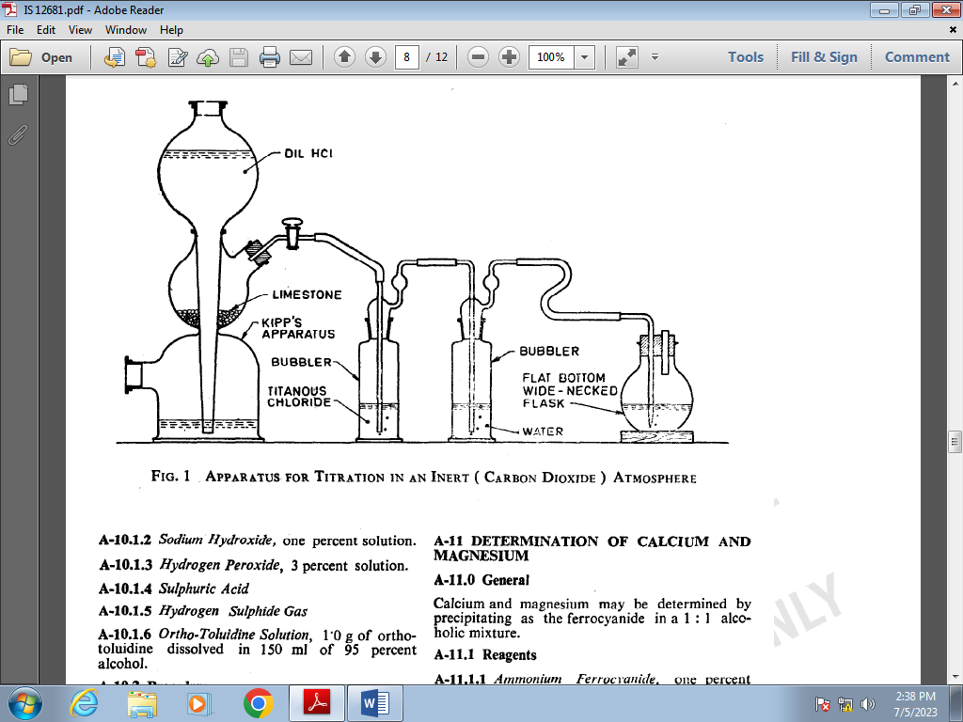

FIG. 1 APPARATUS FOR TITRATION IN AN INERT (CARBON DIOXIDE) ATMOSPHERE

**A-10.1.2** *Sodium Hydroxide,* one percent solution.

**A-10.1.3** *Hydrogen Peroxide,* 3 percent solution.

**A-10.1.4** *Sulphuric Acid*

**A-10.1.5** *Hydrogen Sulphide Gas*

**A-10.1.6** *Ortho-Toluidine Solution,* 1.0 g of ortho-toluidine dissolve in 150 ml of 95 percent alcohol.

**A-10.2 Procedure**

Take 10 g of sample separately in two beakers and dissolve in minimum quantity of water. Make it alkaline by using 1 percent sodium hydroxide. Add 10 ml of 3 percent hydrogen peroxide to oxidize nitrites. Reduce the bulk to about 20 ml by boiling. Neutralize by adding dilute sulphuric acid drop by drop using litmus paper as the indicator. In one beaker, pass hydrogen sulphide gas till it is saturated. Boil off excess of hydrogen sulphide and cool. To both beakers, add 0.5 ml of ortho-toluidine solution.

**A-10.2.1** Take the contents of the two beakers in two separate Nessler’s cylinders and make the volume to 50 ml. Compare the turbidities with a series of standards using 1to 10 ml of standard potassium iodide solution. The difference in turbidities between the two Nessler’s cylinders is due to iodates and shall not exceed 2.5 ml of standard potassium iodide solution.

**A-11 DETERMINATION OF CALCIUM AND MAGNESIUM**

**A-l 1.1 General**

Calcium and magnesium may be determined by precipitating as the ferrocyanide in a 1:1 alcoholic mixture.

**A-11.2 Reagents**

**A-11.2.1** *Ammonium Ferrocyanid****e***, one percent solution.

**A-11.2.2** Ethyl Alcohol

**A-11.2.3** *Standard Calcium Carbonate Solution*

Dissolve 1.778 g of calcium carbonate in 50 ml of 1 N hydrochloric acid and dilute to 1 litre with water. 1.0 ml of this solution is equivalent to 1 mg of calcium oxide.

**A-11.3 Procedure**

Take 10 g of sample and dissolve in 40 ml of water, add 50 ml of ethyl alcohol, 5 ml of one percent ammonium ferrocyanide and stir. Take it in a Nessler’s cylinder and make up the volume.

**A-11.3.1** Compare the turbidity with a series of standards using 1 ml to 5 ml of standard calcium carbonate solution. Turbidity of sample solution shall not be more than that of the standard using 5 ml standard solution.

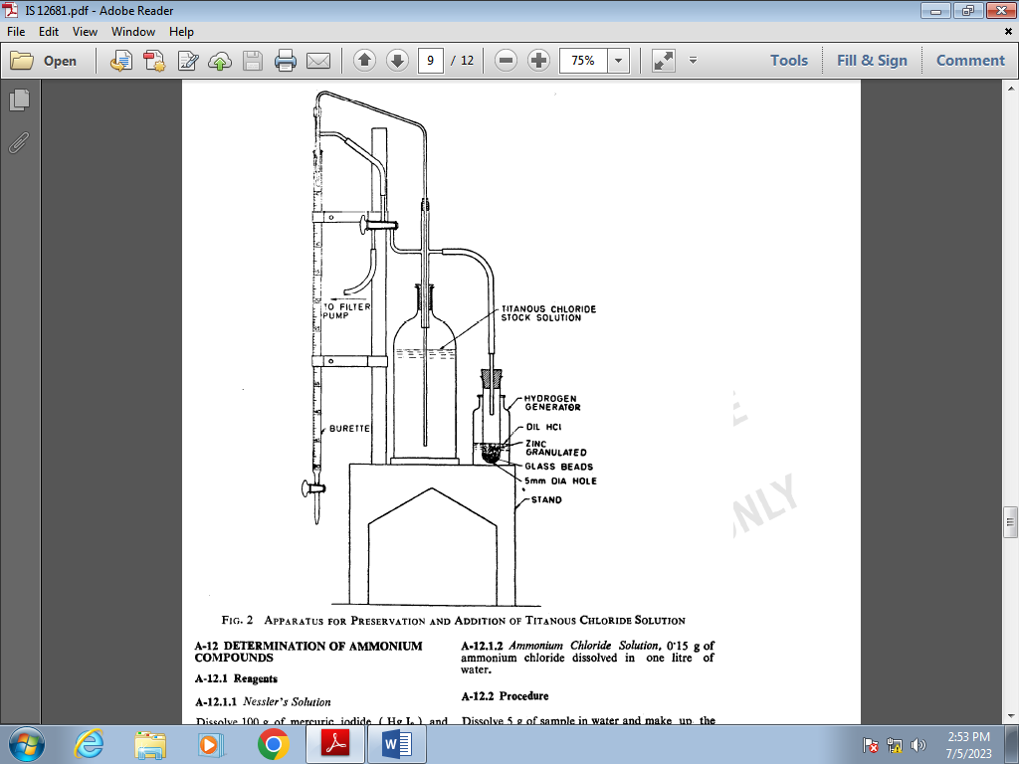

FIG. 2 APPARATUS FOR PRESERVATION AND ADDITION OF TITANOUS CHLORIDE SOLUTION

**A-12 DETERMINATION OF AMMONIUM COMPOUNDS**

**A-12.1 Reagents**

**A-12.1.1** *Nessler’s Solution*

Dissolve 100 g of mercuric iodide (HgI2) and 70 g of potassium iodide (KI) in a small quantity of water. Add this mixture slowly, with stirring, to a cool solution of 160 g sodium hydroxide dissolve in 500 ml of water. Dilute to one litre. Store in rubber stoppered borosilicate glassware and away from sunlight.

**A-12.2** *Ammonium Chloride Solution,* 0.15 g of ammonium chloride dissolve in one litre of water*.*

**A-12.2 Procedure**

Dissolve 5 g of the sample in water and make up the volume to 100 ml in a Nessler cylinder. Add 2 ml of Nessler’s solution and after 3 minutes, compare the colour developed with that of other Nessler cylinders containing known volumes of the standard ammonium chloride solution treated in a similar manner.

1 ml NH4 Cl (0.15 g per litre) = 0.001 percent NH3  (on 5 g sample )

**A-12.3 Calculation**

Ammonium compounds (as NH4 NO3) percent by mass = 0.001 percent NH3 × 4.71

**A-13 DETERMINATION OF *pH***

**A-13.1 Procedure**

Dissolve 10.0 g of the material in 100 ml of water and measure the pH of the solution by means of a suitable pH meter using glass electrodes.

**ANNEX B**

**SAMPLING OF SODIUM NITRATE FOR EXPLOSIVES AND PYROTECHNICS INDUSTRY**

(*Clause* 5.1)

**B-l GENERAL REQUIREMENTS**

**B**-**1.1** In drawing, preparing, storing and handling test samples, the following precautions and directions shall be observed.

**B-1.2** Samples shall not be drawn in an exposed place. It shall be drawn at room temperature & relative humidity of not more than ~~(60±5)~~ 50%.

**B-1.3** Precautions shall be taken to protect the samples, the material being sampled, the sampling instruments and the containers for samples from adventitious contamination.

**B-l.4** To draw a representative sample, the contents of each container selected for sampling shall be mixed thoroughly by suitable means.

**B-l.5** The samples shall be placed in clean, dry, air-tight glass or other suitable containers which have no action on the material.

**B-1.6** The sample containers shall be of such a size that they are almost completely filled by the sample.

**B-1.7** Each sample container shall be sealed airtight with a stopper after filling and marked with all particulars of the material (***se*e 3.2**) and the date of sampling.

**B-1.8** Samples shall be stored in such a manner that the temperature of the material does not vary unduly from the ambient temperature.

**B-2 SCALE OF SAMPLING**

**B-2.1 Lot**

In a single consignment of the material, all the containers of the same type and size and drawn from the same batch of manufacture shall constitute a lot. If a consignment is known to consist of different batches of manufacture or of different types and sizes of containers, the containers belonging to the same batch, type and sizes shall be grouped together and each such group shall constitute a separate lot.

**B-2.1.1** For ascertaining the conformity of the material in a lot to the requirements of the specification, tests shall be carried out for each lot separately. The number of containers to be selected at random from lots of different sizes shall be in accordance with Table 2.

**TABLE 2 SCALE OF SAMPLING**

(*Clause* B-2.1.1)

|  |  |  |
| --- | --- | --- |
| **Sl No.** | **Lot Size** | **Sampling Size** |
|  | ***N*** | ***n*** |
| **( 1 )** | **( 2 )** | **( 3 )** |
|  | Up to 15 | 3 |
|  | 16 to 25 | 4 |
|  | 26 to 50 | 5 |
|  | 51 to 100 | 7 |
|  | 101 and above | 10 |

**B-2.1.2** In order to ensure randomness of selection, random number tables shall be used. In case such tables are not available, the following procedure is recommended for use: Arrange the containers in the Jot in a systematic order and starting from any one, count them as 1, 2, 3 …….., etc., up to ***r*** and so on, where ***r*** is the integral part of *N*/n (*N* and n being the lot size and sample size, respectively). Every *r*th container thus counted shall be withdrawn to constitute the sample.

**B-3 PREPARATION OF TEST SAMPLES**

**B-3.1** From each of the containers selected, draw a small representative portion of the material not less than 100 g in mass.

**B-3.2** Out of these portions, small but equal quantity of the material shall be taken and mixed thoroughly, to form a composite sample of mass not less than 150 g. The composite sample shall be divided into 3 equal parts, one for the purchaser, one for the supplier and the third to be used as a referee sample.

**B-3.3** The remaining portion of the material from each container shall be divided into 3 equal parts and transferred to separate bottles, giving full identification particulars of the samples on the bottles. The material in each bottle constitutes an individual sample. One of these three sets (each containing one bottle representing each containers sample) shall be marked for the purchaser, another for the supplier and the third for the referee.

**B-3.4** The referee test samples consisting of a composite sample and a test of individual samples shall bear the seal of both the purchaser and the supplier. The referee sample shall be kept at a place agreed to between the purchaser and the supplier and shall be used in case of a dispute between the two.

**B-4 NUMBER OF TESTS**

**B-4.1** Tests for determination of assay, moisture and matter insoluble in water shall be performed on each of the individual samples.

**B-4.2** Tests for determination of all remaining given in col 2 of Table 1 shall be carried out on the composite sample.

**B-5 CRITERIA FOR CONFORMITY**

**B-5.1 For Individual Samples**

For declaring the conformity of lot:

1. $\overline{X}+0.6R$ shall be less than or equal to the maximum specified requirements, and
2. $\overline{X}-0.6R$ shall be greater than or equal to the minimum specified requirements.

where

$X$ = mean value of test results, and

*R =* range of results

**B-5.2 For Composite Sample**

For declaring the conformity of the lot to the requirements of al characteristics tested on the composite sample, the test results shall satisfy the corresponding specified requirements.