***भारतीय मानक***

***Indian Standard***

**IS 1091 : 20XX**

**Doc No. CHD 26/23634 F**

नाइट्रोसेल्युलोज़ —विशिष्टि

*( चौथा* पुनरीक्षण )

NITROCELLULOSE — SPECIFICATION

( *Fourth Revision )*

ICS 71.100.30

© BIS 2024



भारतीय मानक ब्यूरो

BUREAU OF INDIAN STANDARDS

मानक भवन, 9 बहादुर शाह ज़फर मार्ग, नई दिल्ली - 110002

MANAK BHAVAN, 9 BAHADUR SHAH ZAFAR MARG

NEW DELHI - 110002

[www.bis.gov.in](http://www.bis.org.in) [www.standardsbis.in](http://www.standardsbis.in)

**January 2024 Price Group X**

Explosives and Pyrotechnics Sectional Committee, CHD 26

FOREWORD

This Indian Standard (Fourth Revision) was adopted by the Bureau of Indian Standards, after the draft finalized by the Explosives and Pyrotechnics Sectional Committee had been approved by the Chemical Division Council.

The nitrocellulose covered in the standard is used in the manufacture of lacquers for finishing of items like automobiles, wood, and leather; coatings for paper, fabric, tube light, stencil paper, and surgical films and in the manufacture of printing inks, adhesives, etc.

This standard was originally published in 1958. It was revised in 1968 and subsequently in 1976. The third revision was published in 1985. In the third revision, the nitrogen content and mineral matter were reduced and sulphate content was increased. Pulping fineness was deleted as this requirement is applicable in the case of explosive grade of nitrocellulose which is being covered by a separate standard.

This fourth revision has been taken up to incorporate the ICS No. and several other editorial changes in order to bring out the standard in the latest style and format of the Indian Standards. In this revision, the requirements for dampening medium has been modified and editorial corrections in table 1 has also been incorporated.

This standard contains clauses **4.2, 4.2.1, 4.3, 4.4, 4.6** and **5.1** which call for agreement between the purchaser and the manufacturer.

The composition of the Committee responsible for development of this standard is given in Annex T.

For the purpose of deciding whether a particular requirement of this standard is complied with, the final value, observed or calculated, expressing the result of a test or analysis, shall be rounded off in accordance with IS 2:2022 ‘Rules for rounding off numerical values (*second revision*)’. The number of significant places retained in the rounded off value should be the same as that of the specified value in this standard.

*Indian Standard*

NITROCELLULOSE — SPECIFICATION

(*Fourth Revision*)

**1 SCOPE**

**1.1** This standard prescribes the requirements and the methods of sampling and test for nitrocellulose (also known as cellulose nitrate or gun cotton) for general industrial use.

**1.2** This standard does not cover nitrocellulose used in the manufacture of explosives.

**2 REFERENCE**

The standards listed in Annex A contain provisions which through reference in the text, constitute provisions of and necessary adjuncts to this standard. At the time of publication, the editions indicated were valid. All standards are subject to revision and parties to agreements based on this standard are encouraged to investigate the possibility of applying the most recent editions of the standards indicated in Annex A.

**3 TERMINOLOGY**

For the purpose of this standard, the following definitions shall apply.

**3.1 Nitrocellulose**

Product obtained by nitration of a suitable form of bleached cellulose.

**3.2 Dampening Medium**

Organic liquid or water which is used for keeping nitrocellulose in wet condition to minimize the risk of self-ignition of the material.

**4 REQUIREMENTS**

**4.1 Appearance**

The material shall be uniformly of a good white colour and shall be free from lumps, mechanical impurities and foreign material, such as charred particles, and un-nitrated cellulose.

**4.2 Form and Condition**

The material shall be supplied in the form of fibres and granules dampened with one of the media prescribed in **4.2.1** as may be agreed between the purchaser and the manufacturer.

**4.2.1** *Dampening Medium*

The dampening medium shall be either rectified spirit (*see* IS 323), butyl alcohol (*see* IS 361), isopropyl alcohol (*see* IS 2631), double distilled water or as agreed between the purchaser and the manufacturer, and shall be present to the extent of not less than 30 percent and not more than 35 percent by mass of wet material when determined by the method prescribed in Annex B.

**4.3 Nitrogen Content**

The nitrogen content of the material calculated on dry basis shall be from 10.7 percent to 12.2 percent unless otherwise agreed between the purchaser and the manufacturer when determined by the method prescribed in Annex C.

**4.4 Viscosity**

The viscosity of the material as determined by the method prescribed in Annex D, shall be as agreed between the purchaser and the manufacturer.

**4.5 Solubility in Butyl Acetate and Clarity of Solution**

The solution when made in accordance with Annex E shall be clear and appreciably free from insoluble matter or haze, the colour of the solution shall he not deeper than pale straw.

**4.6 Toluene Dilution Value**

This value shall be as agreed between the purchaser and the manufacturer and shall be determined by the method prescribed in Annex F.

**4.7** The material shall also satisfy the requirements given in Table 1, when tested according to the methods referred to in col 4 of the table.

**Table 1 Requirements for Nitrocellulose**

|  |  |  |  |
| --- | --- | --- | --- |
| **Sl No.** | **Characteristic** | **Requirement**  **(on dry basis)** | **Method of Test, Ref To Annex** |
| (1) | (2) | (3) | (4) |
| i) | Acidity (as HNO3), percent by mass, *Max* | 0.01 | G |
| ii) | Mineral matter, percent by mass, *Max* | 0.20 | H |
| iii) | Stability at (132 ± 0.2) °C, mg nitrogen/g of the dried material, *Max* | 1.5 | J |
| iv) | Heat test at (77 ± 0.2) °C, minutes, *Min* | 10 | K |
| v) | Organic matter insoluble in acetone, percent by mass, *Max* | 0.5 | L |
| vi) | Solubility in ether-alcohol, percent by mass, *Min* | 95 | M |
| vii) | Alkalinity (as CaCO3), percent by mass | Nil | N |
| viii) | Sulphate (as H2SO4), percent by mass, *Max* | 0.20 | P |
| ix) | Magnetic ferruginous matter (as Fe), percent by mass, *Max* | 0.005 | Q |

**5 PACKING AND MARKING**

**5.1 Packing**

The material shall be packed dampened in suitable well-closed containers as agreed between the purchaser and the manufacturer; the containers shall not have any action on the material.

**5.2 Marking**

Each container shall be securely closed and shall bear legibly and indelibly the following information:

a) Name of the material;

b) Name of the dampening medium;

c) Name of the manufacturer or his recognised trade-mark, if any;

d) Gross, net and tare mass;

e) Date of manufacture; and

f) Batch number.

**5.2.1** The marking shall indicate caution in handling and opening the containers (*see* Annex R) and also display prominently the words 'Highly Flammable'. The containers shall also be marked with the symbol for explosion [*see* IS 1260 (Part 1)].

**5.2.2** *BIS Certification Marking*

The product(s) conforming to the requirements of this standard may be certified as per the conformity assessment schemes under the provisions of the *Bureau of Indian Standards Act*, 2016 and the Rules and Regulations framed thereunder, and the products may be marked with the standard mark.

**6 HANDLING AND STORAGE**

In handling and storage of the material, the precautions prescribed in Annex R shall be observed.

**7 SAMPLING**

Representative samples of the material shall be drawn and their criteria for conformity shall be determined as prescribed in Annex S.

**8 TESTS**

**8.1 Drying of Samples**

For the determination of the requirements given in **4.3** to **4.6** and in Table 1, the material shall be dried as described in **8.1.1**.

**8.1.1** Place the sample of nitrocellulose between three or four sheets of thick filter paper, pure and free from chemical impurities, and put it under a hand screw-press. Subject it to a severe pressure for about 3 minutes. Separate out the pressed material loosely with fingers and spread out in a thin layer upon a tray made from two or three layers of filter paper. When suitably air-dried, mix and dry in a stream or electrically heated water oven at (50 ± 0.2) °C to constant mass. Keep the door of the oven slightly open during drying. Remove the tray from the oven and expose the material for 4 hours at room temperature to dry air, free from acid fumes.

NOTE — The oven used for drying nitrocellulose shall be effectively earthed in view of the risk due to electrostatic charges associated with the handling of dry nitrocellulose.

**8.2** Unless specified otherwise, pure chemicals and distilled water (*see* IS 1070) shall be employed in tests.

NOTE — 'Pure chemicals' shall mean chemicals that do not contain impurities which affect the results of analysis.

**ANNEX A**

**LIST OF REFERRED INDIAN STANDARDS**

(*Clause* 2)

|  |  |
| --- | --- |
| *IS No* | *Title* |
| IS 170 : 2020 | Acetone — Specification (*fifth revision*) |
| IS 230 : 1972 | Specification for Normal Butyl Acetate (*second revision*) |
| IS 264 : 2005 | Nitric acid — Specification (*third revision*) |
| IS 265 : 2021 | Hydrochloric Acid Specification (*fifth revision*) |
| IS 266 : 1993 | Sulphuric acid — Specification (*third revision*) |
| IS 323 : 2009 | Rectified Spirit for Industrial Use — Specification (*second revision*) |
| IS 336 : 2021 | Ether — Specification (*third revision*) |
| IS 361 : 2009 | Normal Butyl Alcohol, Technical — Specification (*third revision*) |
| IS 435 : 1973 | Specification for castor oil (*second revision*) |
| IS 460 (Part 1) : 2020 | Test Sieves — Specification Part 1 Wire Cloth Test Sieves (*fourth revision* ) |
| IS 537 : 2011 | Toluene — Specification (*second revision*) |
| IS 1070 : 2023 | Reagent Grade Water Specification (*fourth revision*) |
| IS 1260 (Part 1) : 1973 | Pictorial Marking for Handling and Labelling of Goods: Part 1 Dangerous Goods (*first revision*) |
| IS 2303 (Part 1/Sec 1) : 2021/  ISO 719:2020 | Grading Glass For Alkalinity Part 1 Hydrolytic Resistance of Glass Grains Section 1 Determination And Classification of Hydrolytic Resistance At 98 °C (*third revision*) |
| IS 2631 : 2020 | Iso Propyl Alcohol — Specification (*second revision*) |
| IS 4161 : 2023 | Nessler Cylinder — Specification (*first revision*) |
| IS 4905 : 2015/  ISO 24153:2009 | Random sampling and randomization procedures (*first revision*) |
| IS 12615 : 2018 | Line operated three phase AC motors (IE Code) "Efficiency classes and performance specification" (*third revision*) |

**ANNEX B**

**DETERMINATION OF DAMPLING MEDIUM CONTENT**

(*Clause* 4.2.1)

**B-1 PROCEDURE**

**B-1.1** Weigh accurately about 2 g of the material into an aluminium dish with an outside lid or in a glass weighing bottle with tight fitting outside cover. Dry to constant mass in a well-ventilated water oven at a temperature of (65 ± 2) °C. After drying, cool in a desiccator and weigh again.

**B-1.2** **Precaution**

Do not use a naked flame at any time for heating. Wet with water the dry nitrocellulose obtained at the conclusion of the determination and destroy it (*see* **R-5**). Do not allow it to remain in the laboratory in the dry state for any length of time.

**B-2 CACULATION**

$$Dampening medium content, percent by mass =\left(\frac{M-m}{M}\right)×100$$

where

*M* = mass in g of the material taken, and

*m* = mass in g of the residue.

**ANNEX C**

**DETERMINATION OF NITROGEN CONTENT**

(*Clause* 4.3)

**C-1 GENERAL**

**C-1.1 Outline of the Methods**

The two methods prescribed herein are based on decomposing nitrocellulose with sulphuric acid in the presence of mercury and in the absence of air. This results in the liberation of nitric oxide, which is measured quantitatively and converted into percent of nitrogen. In the case of dispute, the first method shall be used.

**C-2 METHOD 1**

**C-2.1 Apparatus**

**C-2.1.1** *Nitrometer* — use the nitrometer as shown in Fig. 1 to 4.

**C-2.2 Reagents**

**C-2.2.1** *Concentrated Sulphuric Acid* of strength (94 ± 0.2) percent (m/m), prepared by diluting the concentrated acid conforming to analytical reagent grade of IS 266.

**C-2.2.2** *Potassium Nitrate* crystals, recrystallized twice from distilled water and ground to pass 150 micron IS Sieve [*see* IS 460 (Part 1)].

**C-2.2.3***Mercury* — pure and dry.

**C-2.3 Procedure**

**C-2.3.1** *Precaution*

As a precaution against explosion, a face mask, so constructed that a thick piece of cellulose acetate sheet or other transparent plastic sheeting protects the face, shall be worn during the generation and measurements of the gas.

**C-2.3.2** *Standardization of Apparatus*

**C-2.3.2.1** Fill the compensating and measuring tubes and the reaction bulb along with rubber connections with mercury. Run 20 ml to 30 ml of concentrated sulphuric acid into the reaction bulb through the cup at the top and admit about 210 ml of air. Close the stopcocks, shake the bulb well and allow to stand overnight to desiccate the air. Admit the air into the compensating tube after making appropriate connections with the reaction bulb (not shown in Fig. 3) until the mercury is about on a level with the 12.50 percent mark on the measuring tube, the two tubes being held at the same height. Then seal the compensating tube using a small blowpipe flame.

NOTE — As a preferred alternative, nitrogen may be used in place of air. Also, the use of sulphuric acid as a desiccant may be eliminated and the air or nitrogen may be dried by passing through a solid desiccant like anhydrous calcium sulphate.

**C-2.3.2.2** Place 0.9 g to 1.0 g of potassium nitrate in a weighing bottle and weigh. Dry the material for 2 h to 3 h at 135 °C to 150 °C. Stopper the bottle, cool in a desiccator and weigh accurately. Then transfer potassium nitrate to the cup of the reaction bulb and re-weigh the weighing bottle to obtain the mass of potassium nitrate transferred. Add 1 ml of water and stir the mixture in the cup with a small glass rod to liberate entrapped bubbles of air; work the undissolved crystals into the lower part of the cup keeping them below the surface of the solution.

NOTE — It is not necessary that potassium nitrate should dissolve before it is drawn into the reaction bulb.

**C-2.3.2.3** Make sure the lower stopcock is open, then admit the mixture into the bulb by a series of quick openings of the upper stopcock, keeping the crystals in the meantime below the surface of the liquid. In this way, all but a small amount of potassium nitrate may be run into the bulb. Rinse the cup with a second 1 ml portion of water: then repeat with a third 1 ml portion (3 ml in all). This volume should be sufficient to dissolve all the remaining particles of potassium nitrate in the cup.

**C-2.3.2.4** Transfer 25 ml of concentrated sulphuric acid, in several portions, to the cup and subsequently into the bulb by lowering the reservoir slightly and opening and closing the upper stopcock. When taken that no air enters even the bore in the stopcock. When introducing potassium nitrate, the washed water and the acid, always apply a slight suction but never so much as to cause air to be sucked into the reaction bulb. Keep the quantities of water and concentrated sulphuric acid used constant. Then with the bottom stopcock still open, lower the reservoir bulb to give reduced pressure in the reaction bulb and gently shake the reaction bulb to start the decomposition.

NOTE — It is extremely important that the bottom stopcock be left open until the major part of the decomposition has occurred; otherwise sudden evolution of gas will burst the bulb, scattering acid and glass.

**C-2.3.2.5** After the evolution of nitric oxide has slowed down, lower the reservoir bulb until all but 25 ml of mercury in the reaction bulb is withdrawn. Close the bottom stopcock and shake the reaction bulb vigorously for 5 minutes. When the reaction is complete, allow the gas to cool for 30 minutes; then transfer the gas to the measuring tube. By means of the levelling device, make careful adjustment of the mercury levels so that mercury in the measuring tube is at the 13.85 percent mark ( the theoretical percentage of nitrogen is potassium nitrate) if an exactly 1 g sample was used, or a proportional reading if a different amount was used. Paste a strip of paper on the compensating tube at the level of the mercury and complete the standardization. Make several check determinations, preferably on different days, to ensure accurate standardization. Determinations should check within ± 0.01 percent.

**C-2.3.3** *Determination of Nitrogen Content in the Material*

Dry the material (*see* **8.1.1**) Place the dried material 1 g to l.2 g in a weighing bottle which has been previously dried and weighed. Wipe off any particles of material adhering to the upper part of the weighing bottle. Dry at (100 ± 2) °C for one hour. Stopper the weighing bottle, cool in a desiccator and weigh accurately. The difference gives the mass of the material. Add carefully 5 ml to 8 ml of concentrated sulphuric acid into the weighing bottle. Allow the acid to wet the material for a few minutes and then gently swirl the weighing bottle till the material is well dispersed. With the help of a small glass rod, pour the mixture into the cup of the reaction bulb. Lower the mercury reservoir and then, with the lower stopcock open, draw the mixture in by opening the upper stopcock. Take care that no air is drawn in. Rinse the weighing bottle and the cup of the reaction vessel several times with concentrated sulphuric acid using a total of 25 ml for dissolving and rinsing. Complete the determination as described in **C-2.3.2.4** and **C-2.3.2.5** and take the reading after adjusting the level of mercury in the two tubes at the mark on the compensating tube.

**C-2.4 Calculation**

$$Nitrogen content, percent by mass of the dried material=\frac{B}{M}$$

where

*B* = Reading of the level in the measuring tubes, and

*M* = mass in g of the dried material taken for the test.

**C-3 METHOD 2**

**C-3.1 Apparatus —** lunge nitrogen 150 ml capacity (*see* Fig. 5)

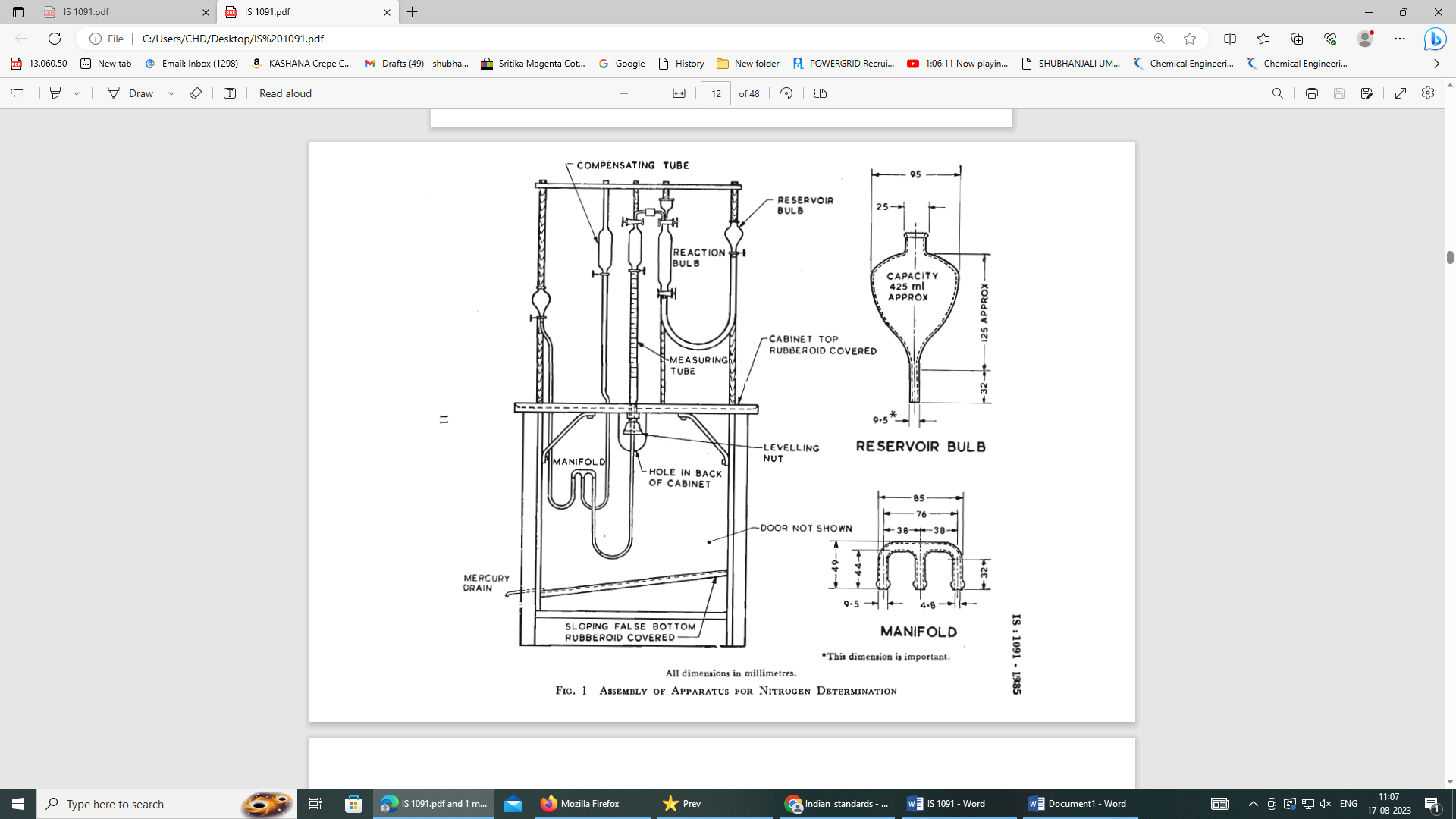

All dimensions in millimetres

FIG. 1 ASSEMBLY OF APPARATUS FOR NITROGEN DETERMINATION

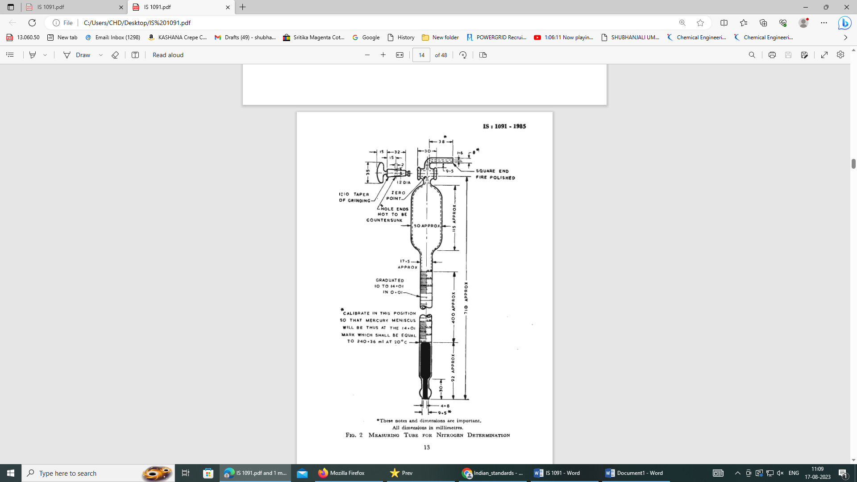

*These notes and dimensions are important

All dimensions in millimetres.

FIG. 2 MEASURING TUBE FOR NITROGEN DETERMINATION

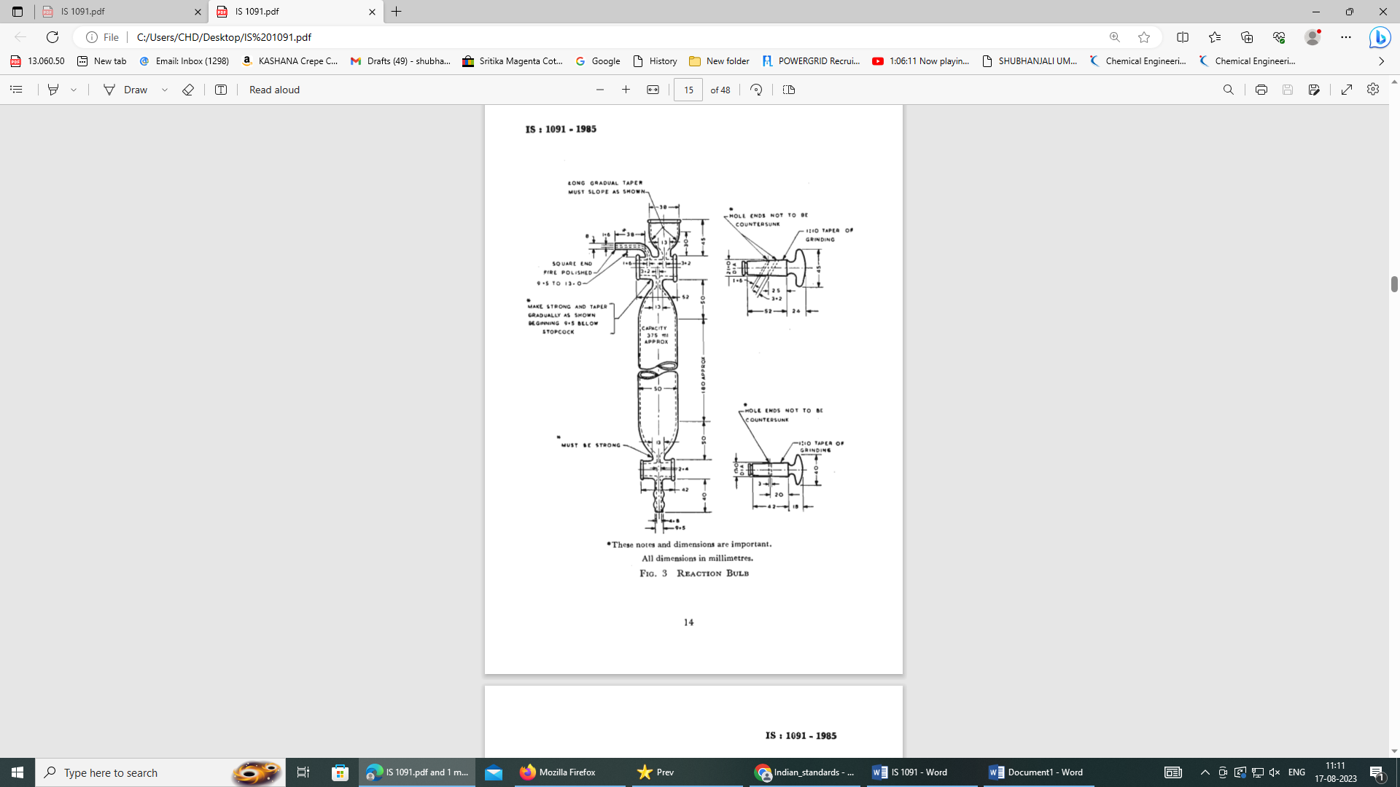

*These notes and dimensions are important

All dimensions in millimetres.

FIG. 3 REACTION BULB

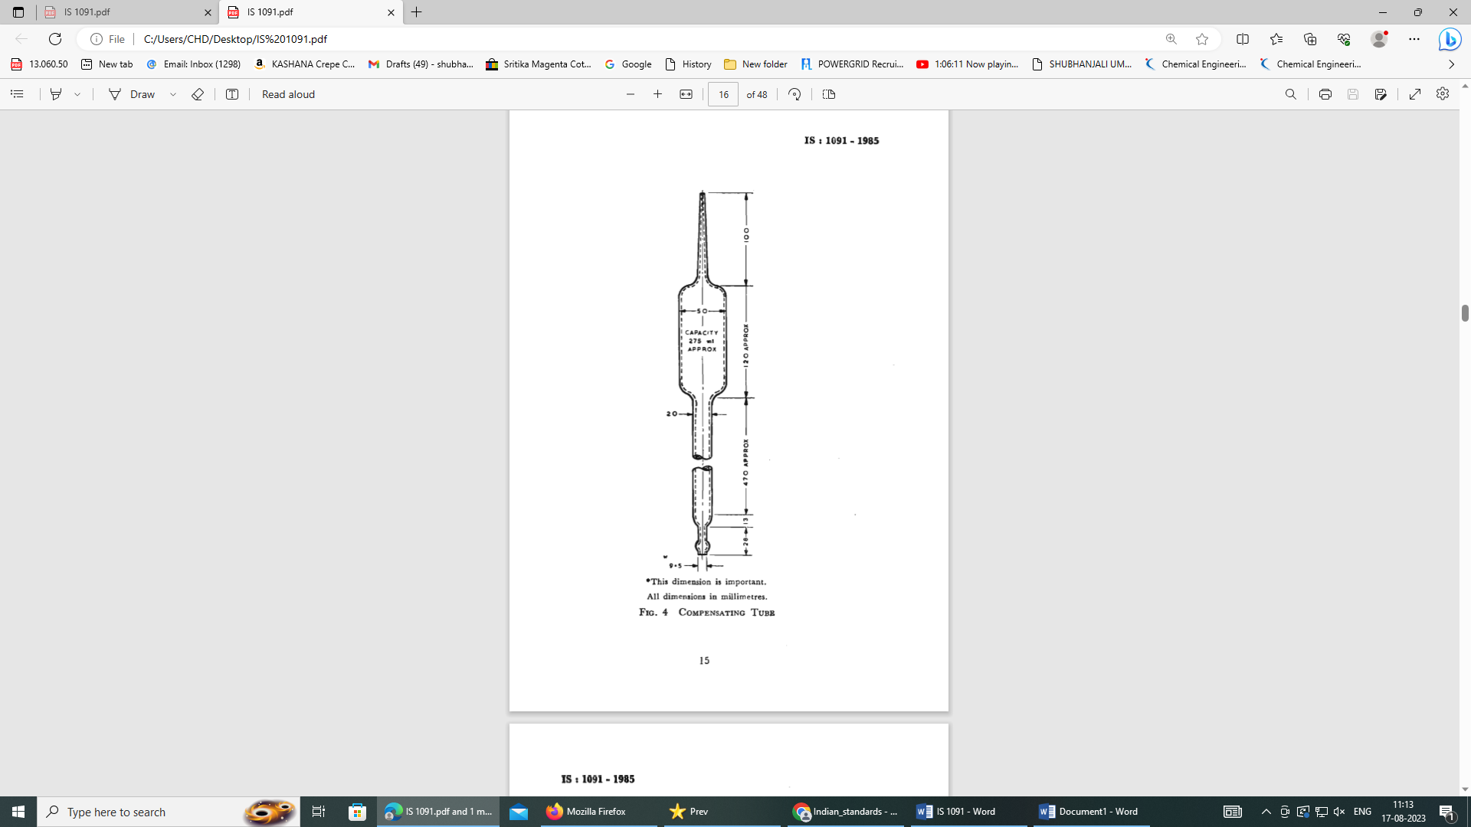

**\***This dimension is important

All dimensions in millimetres

FIG. 4 COMPENSTION TUBE

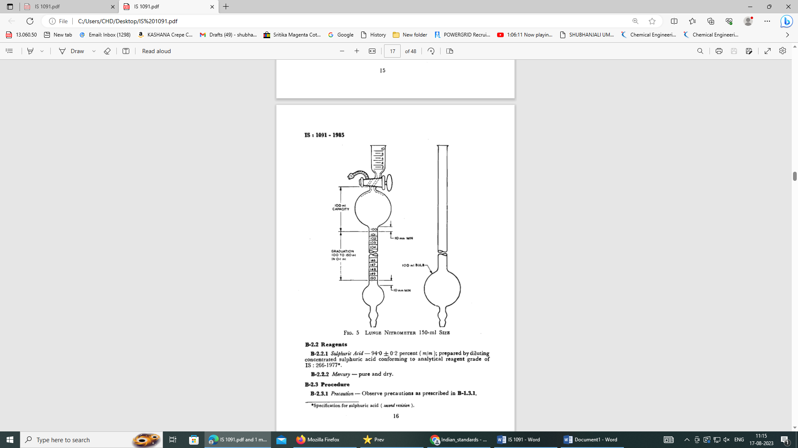

FIG. 5 LUNGE NITROMETER 150 ml SIZE

**C-3.2 Reagents**

**C-3.2.1** *Sulphuric Acid* — (94 ± 0.2) percent (*m/m*); prepared by diluting concentrated sulphuric acid conforming to analytical reagent grade of IS 266.

**C-3.2.2***Mercury*— Pure and dry.

**C-3.3 Procedure**

**C-3.3.1***Precaution* — observe precautions as prescribed in **C-2.3.1**.

**C-3.3.2** Fill the levelling tube along with the rubber tube connecting the nitrometer with mercury and displace all the air from the nitrometer by operating the stopcock and raising the levelling tube. Close the stopcock.

**C-3.3.2.1** Place 0.51 g to 0.52 g of the material, dried as in **8.1.1** in a tared weighing bottle. Wipe off any particles of material adhering to the upper part of the weighing bottle. Dry at (100 ± 2) °C for one hour. Stopper the weighing bottle, cool in a desiccator and weigh accurately. The difference gives the mass of the material. Add carefully 5 ml of sulphuric acid into the weighing bottle. Allow the acid to wet the material for a few minutes and then gently swirl the weighing bottle till the material is well-dispersed. Pour the mixture with the help of a glass rod into the cup of the nitrometer. Lower the levelling tube and draw the mix mixture into the nitrometer by operating the stopcock and taking care that no air is drawn in. Rinse the weighing bottle and the cup of the nitrometer several times with sulphuric acid using a total of 15 ml for dissolving and rinsing. After an interval of 15 minutes, shake the nitrometer vigorously for 2 minutes to complete the liberation of nitric oxide. Allow the gas to cool to room temperature and then measure its volume under atmospheric pressure by lowering or raising the levelling tube.

**C-3.4 Calculation**

$$Nitrogen content, percent by mass 0.022 46 =\frac{V \left(P-B\right)}{\left(273+t\right)G}$$

where

*V* = observed volume of gas in ml,

*P* = observed barometric pressure in mm of mercury,

*B* = barometric correction for expansion of brass in mm mercury,

*t* = observed temperature in °C, and

*G* = mass in g of the dried material taken for the test.

**ANNEX D**

**DETETMINATION OF VISCOSITIY**

(*Clause* 4.4)

**D-1 GENERAL**

**D-1.1 Outline of the Method**

The viscosity of nitrocellulose is determined by the falling-sphere method using a solution of specified concentration and noting the time of fall of a (1.58 ± 0.01) mm diameter steel ball through a known height of the solution.

**D-2 TEST TEMPERATURE**

The viscosity determination shall be carried out at (27 ± 2) °C.

**D-3 APPARATUS**

**D-3.1 Viscometer**

This consists of a glass tube 28.5 cm long with 2 cm internal diameter as shown in Fig. 6. It is fitted with a stopper bored with a single hole and carrying a glass tube 7 cm long with 3 mm internal diameter, called the releasing tube, which has a small hole blown in the side 4.5 cm from its lower end. The wide glass tube is etched all round its circumference at the points *a, b, c, d, e* and *f*, the distance between adjacent marks being 5 cm except in *a-b* where it is 3 cm.

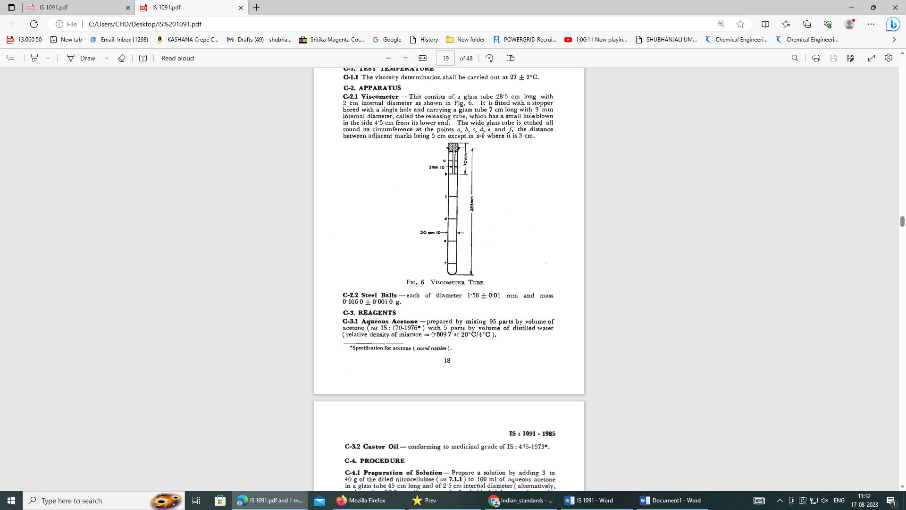

FIG. 6 VISCOMETER TUBE

**D-3.2 Steel Balls**

Each of diameter (1.58 ± 0.01) mm and mass (0.016 0 ± 0.001 0) g.

**D-4 REAGENTS**

**D-4.1 Aqueous Acetone**

Prepared by mixing 95 parts by volume of acetone (*see* IS 170) with 5 parts by volume of distilled water (relative density of mixture = 0.809 7 at 20°C/4°C).

**D-4.2 Castor Oil**

Conforming to medicinal grade of IS 435.

**D-5 PROCEDURE**

**D-5.1 Preparation of Solution**

Prepare a solution by adding 3 g to 40 g of the dried nitrocellulose (*see* **8.1.1**) to 100 ml of aqueous acetone in a glass tube 45 cm long and of 2.5 cm internal diameter (alternatively, a glass tube of 2.5 cm diameter and of suitable height, may be used). Stopper the tube securely, shake by hand to prevent the caking of the nitrocellulose into a hard mass, and then rotate on a wheel until the mixture is quite homogeneous. Carry out the actual viscosity determination within 48 hours of making the solution.

**D-5.2 Determination of Density of Steel Balls**

**D-5.2.1** For routine work, it is not necessary to determine the density of the balls as steel may always be taken to have a density of 7.65 cm3 without introducing any significant error. However, in case it is desired to carry out the density determination, the following method may be adopted.

**D-5.2.2** Thoroughly clean a 50 ml density bottle, rinse with some acetone and allow to dry in a warm place. Fill the bottle carefully with distilled water and place it in a thermostat maintained at the test temperature (*see* **D-2**) for IS minutes. Close the bottle with a stopper, make sure there are no air bubbles, wipe the outside dry and weigh.

**D-5.2.3** Introduce a convenient number (say, six) of steel balls to the pan of the balance in which the relative density bottle has been placed and weigh again. Now carefully drop the steel balls into the relative density bottle. Place the bottle again in the thermostat for 15 minutes and put the stopper on. Make sure there are no air bubbles, wipe the outside, dry and weigh again.

**D-5.3 Determination of Density of Nitrocellulose Solution**

Clean a 50 ml stoppered graduated cylinder, dry it and weigh. Fill the cylinder to about 1 cm below the 50 ml mark with the solution (*see* **C-5.1**). While filling, care shall be taken not to wet the portion of the cylinder above the 50 ml mark with the solution. Close the stopper and set aside till the air bubbles have escaped. Fill almost to the mark, allow to stand in the thermostat maintained at (27 ± 0.5) °C. When the solution in the cylinder is completely free from air bubbles, adjust the height of the solution accurately to the 50 ml mark with more solution and weigh again.

**D-5.4 Determination of Density of Castor Oil**

Carry out the determination, using castor oil in place of nitrocellulose solution, exactly as described in **C-5.3.**

**D-5.5 Determination of Time of Fall**

As temperature affects viscosity results very markedly, after transferring a portion of the solution to the viscometer, stopper the viscometer and clamp it in a vertical position in a thermostat and allow it to stand in the thermostat until quite free from air bubbles and until it has attained the temperature (27 ± 0.5) °C. Then replace the stopper by the one carrying the release tube and introduce the steel ball into the liquid by this means. Note the time of fall of the ball through 15 cm from the mark *c* to the mark *f*.

**D-5.5.1** Carry out the test under similar conditions using castor oil of known viscosity in place of nitrocellulose solution and note the time of fall.

**D-6 CALCULATION**

**D-6.1 Density of Steel Balls**

$$Density of steel balls, g/ml=\frac{M_{2}-M_{1}}{M_{2}-M_{3}}×a$$

where

*M1* = mass in g of the relative density bottle with water alone,

*M2* = total mass in g of the relative density bottle filled with water alone and the steel balls,

*M3* = mass in g of the relative density bottle containing the steel balls and then filled up with water, and

*a* = having a value 0.996 5 for test temperature 27 °C.

**D-6.2 Density of Nitrocellulose solution**

$$Density of nitrocellulose ,\frac{g}{ml}=\frac{M_{5}-M_{4}}{50}$$

where

*M5* = mass in g of the cylinder with the solution, and

*M4* = mass in g of the empty cylinder.

**D-6.3 Viscosity of Nitrocellulose Solution in Poises**

$$Viscosity, in poises=\frac{T\left(S-S_{1}\right)}{T_{1}\left(S-S_{2}\right)}×viscosity of castor oil on poises$$

where

*T* = time of fall in seconds in nitrocellulose solution,

*S* = density of steel balls (*see* **D-6.1**),

*S1* = density of nitrocellulose solution (*see* **D-6.2**),

*T1*= time of fall in seconds in castor oil, and

*S2* = density of castor oil (*see* **D-5.4**),

(Viscosity of castor oil at 27 °C is 5.61 poises)

**ANNEX E**

**TEST FOR SOLUBILITY IN BUTYL ACETATE AND CLARITY OF SOLUTION**

(*Clause* 4.5)

**E-1 REAGENT**

**E-1.1 Butyl Acetate** — *See* IS 230.

**E-2 PROCEDURE**

**E-2.1** Dissolve about 3 g to 10 g of the dried material (*see* **8.1.1**) in 100 ml of butyl acetate and note whether the solution is practically free from insoluble matter or haze. Compare the appearance with a similar solution of the approved sample.

**E-2.1.1**The material shall be taken to have satisfied the requirements of the test if the solubility and colour of the solution is not inferior to and darker than those of the approved sample of the material.

**ANNEX F**

**DETERMINATION OF TOLUENE DILUTION VALUE**

(*Clause* 4.6)

**F-1 REAGENTS**

**F-1.1 Butyl Acetate** —*See* IS 230.

**F-1.2 Toluene** — *See* IS 537.

**F-2 PROCEDURE**

In a stoppered bottle, dissolve 12.2 g of the material, dried at (65 ± 2) °C to constant mass in 87.8 g of butyl acetate. Take 50 ml of this solution in another stoppered bottle and to this add toluene in small quantities from a burette, the mixture being well shaken after each addition. Note the volume of toluene added when the first permanent separation of the material occurs. Express this volume as the toluene dilution value.

**ANNEX G**

**DETERMINATION OF ACIDITY**

[*Table* 1, *Item* (i)]

**G-1 GENERAL**

**G-1.1 Outline of the Method**

The dried material is dissolved in neutral acetone, water added to the solution and then titrated with sodium hydroxide solution.

**G-2 REAGENTS**

**G-2.1 Acetone** — Neutralized to methyl red indicator (*see* IS 170).

**G-2.2 Standard Sodium Hydroxide Solution** — 0.01 N approximately.

**G-2.3 Methyl Red Indicator** — Dissolve one g of methyl red (water soluble) in water and dilute the solution to 1 litre.

**G-3 PROCEDURE**

**G-3.1** Add about 2 g to 10 g of the dried material (*see* **8.1.1**), weighed accurately to 0.01 g to 100 ml of acetone. Shake the mixture vigorously for several minutes until solution is complete. Add 100 ml of freshly boiled and cooled water to solution with efficient stirring. Boil off the acetone on a water-bath, cool, filter through a filter paper (Whatman No. 1 or its equivalent), wash with two 10 ml portions of water titrate the filtrate with standard sodium hydroxide solution using methyl red as indicator.

**G-3.2** Run a blank determination using the same quantities of reagents.

**G-4 CALCULATION**

Calculate the acidity as follows:

$$Acidity \left(as HNO_{3}\right), percent by mass =\frac{6.3×\left(V-v\right)N}{M}$$

where

*V* = volume in ml of standard sodium hydroxide solution required by the material,

$v$ = volume in ml of standard sodium hydroxide solution required by the blank,

*N* = normality of standard sodium hydroxide solution, and

*M* = mass in g of the dried material taken for the test.

**ANNEX H**

**DETERMINATION OF MINERAL MATTER**

[*Table* 1, *Item* (ii)]

**H-1 REAGENTS**

**H-1.1 Paraffin Wall or Liquid Paraffin (Ash-Free**)

**H-1.2 Ammonium Carbonate Solution** — approximately 10 percent (*m/v*).

**H-2 PROCEDURE**

**H-2.1** Place about 2 g of dry nitrocellulose (*see* **8.1.1**) into a tared silica crucible, and cover with molten paraffin wax or liquid paraffin. Ignite the mixture gently and allow it to burn away. Moisten the residue with a few drops of ammonium carbonate solution in a slight excess, dry and heat at 105 °C to 110 °C to constant mass.

**H-2.1.1** Carry out a blank determination using paraffin wax or liquid paraffin as described under **H-2.1.**

**H-3 CALCULATION**

Calculate the percentage of mineral matter as follow:

$$Mineral matter, percent by mass =100×\frac{\left(M_{1}-M_{2}\right)}{M}$$

where

*M1* = mass in g of mineral matter in the material,

*M2*= mass in g of mineral matter in the blank, and

*M* = mass in g of the dried material taken for the test.

**ANNEX J**

**DETERMINATION OF STABILITY**

[*Table* 1, *Item* (iii)]

**J-1 GENERAL**

**J-1.1 Outline of the Method**

The method is based on Bergmann and Junk test. In this test nitrocellulose is heated for two hours at (132 ± 0.2) °C, the extent of the decomposition being measured by the absorption of the evolved gases in water and their determination in the solution so obtained.

**J-1.2 Precaution**

This test is of a hazardous nature. Therefore, it is necessary that the operator must wear a cellulose acetate face mask and heavy gloves and that the reaction tube assembly is handled with long forceps.

**J-2 APPARATUS**

**J-2.1 Bath**

The bath consists of a cylindrical copper vessel with a side outlet to adjust the level of the heating liquid. The cover is fitted with a condenser and six copper tubes each 190 mm long and 40 mm in diameter for holding the reaction tubes and thermometers (*see* Fig. 7). Alternately, the cover and the tubes may be in one piece or brass casting. The bath is covered on the sides and top with asbestos lagging about 15 mm in thickness and is surrounded with a screen to protect against draughts.

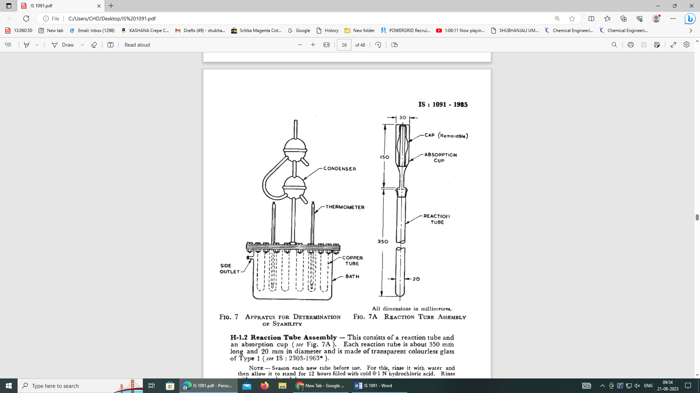

FIG. 7 APPARATUS FOR DETERMINATION OF STABILITY



All dimensions in millimetres

FIG 7A REACTION TUBE ASSEMBLY

**J-2.2 Reaction Tube Assembly**

This consists of a reaction tube and an absorption cup (*see* Fig. 7A). Each reaction tube is about 350 mm long and 20 mm in diameter and is made of transparent colourless glass of Type 1 (*see* IS 2303).

NOTE — Season each new tube before use. For this, rinse it with water and then allow it to stand for 12 hours filled with cold 0.1 N hydrochloric acid. Rinse with water again and dry.

**J-2.3 Heater** — preferably an electric hot-plate for heating the bath.

**J-2.4 Face Mask** — so constructed that a thick piece of cellulose acetate sheet protects the face.

**J-2.5 Gloves** — a pair of heavy rubber gloves.

**J-2.6 Forceps** — long forceps for handling the reaction tubes.

**J-2.7 Thermometers** — capable of reading a temperature of (132 ± 0.2) °C.

**J-3 REAGENTS**

**J-3.1 Glycerine-Water Mixture** — approximately 86.4 percent (*v/v*) adjusted to a boiling point of (132 ± 0.2) °C.

**J-3.2 Liquid Paraffin**

**J-3.3 Standard Hydrochloric Acid** — 0.1 N approximately.

**J-3.4 Standard Sodium Hydroxide Solution** — 0.1 N.

**J-3.5 Methyl Red and Methylene Blue Mixed Indicator**

Dissolve 1 g of methyl red (water soluble) and 0.6 g of methylene blue in water and dilute to 1 000 ml.

**J-4 PROCEDURE**

**J-4.1** Fill the bath with glycerine-water mixture to the level of the side outlet, and the sixth copper tubes with liquid paraffin 50 that the level in them rests at 50 mm below the top of the cover plate when reaction tubes are inserted to a depth of 150 mm. Heat the bath and maintain its temperature at (132 ± 0.2) ° C.

**J-4.2 Application of the Test**

Sieve 10 g of the dried material (*see* **8.1.1**) through 212-micron IS Sieve [*see* IS 460 (Part 1)]. Weigh out accurately portions, each of 2 g into weighed squat weighing bottles and re-weigh after re-drying at 50 °C for One and a half hours. Place the weighing bottles under bell jar containing a saturated solution of calcium nitrate and allow these to remain until the increase in mass is equivalent to an absorption of 0.8 percent to 1.0 percent of water. Transfer each portion to a reaction tube and settle by gently tapping the tube. Set apart a fourth reaction tube to be included as a bank. Fill four absorption cups with 8 ml to 10 ml of water in each and fit them to the four reaction tubes with using a non-reactive grease at the joints. Place the cap over each absorption cup in order to seal the apparatus. Place each of these four reaction tube assemblies in the copper tubes of the bath to a depth of 150 mm by means of a cork with a central hole. Leave the reaction tube in the bath for exactly two hours, taking care to see that the temperature is constant at (132 ± 0.2) °C. Remove the tubes, add a further quantity of 20 ml to 30 ml of water to the cups and allow to cool for not more than one hour to room temperature. Rinse each cup into a conical flask and add 20 ml of standard hydrochloric acid to each reaction tube and to the blank. Cork the tubes and shake for 15 minutes; filter the contents of each tube without delay into appropriate flasks and wash thoroughly. Add 25 ml of each flask to a uniform bulk of 300 ml and titrate with standard hydrochloric acid, adding a few drops of the mixed indicator immediately before titration. Take the average of the three titre values obtained with the sample.

**J-5 CALCULATION**

Stability at (132 ± 0.2) °C in terms of mg nitrogen per gram of the dried material = 7 × (*B – A*) × *N.*

where

*B* = volume in ml of standard hydrochloric acid used with the blank,

*A* = volume in ml of standard hydrochloric acid used with the material, and

*N* = normality of standard hydrochloric acid.

**ANNEX K**

**HEAT TEST**

[*Table* 1, *Item* (iv)]

**K-1 GENERAL**

**K-1.1 Outline of the Method**

This test consists in maintaining the material at (77 ± 0.2) °C in a test tube which is fitted with a special test paper. The length of time which elapses till the appearance of a standard tint on the test paper is a measure of the stability of the material.

**K-2 APPARATUS**

**K-2.1** The apparatus consists essentially of a water-bath and a special type lid, both made of copper as shown in Fig. 8. The copper sheet used for making the bath should not be less than 0.5 mm in thickness and that for the lid not less than 1.0 mm.

**K-2.2 Water-Bath**

The water-bath is spherical in shape and of 20 cm diameter with an opening of 14 cm diameter at the top. The upper and lower parts of the body are joined together firmly and soldered. The top edge is turned over all round. Three metal projections are provided equidistantly on the lower part.

**K-2.2.1** *Lid*

The lid has an overall diameter of 15 cm and is fitted loosely to the opening of the bath at the top. It is provided with three positioning studs at the rim and punched with seven holes, one to receive thermometer and the rest to accommodate test tubes containing the material to be tested. Brass clips or wire cages are soldered around all the holes on the lower surface of the lid to hold the test tubes and the thermometer. Metal discs of adjustable covers are used during testing to cover any holes which are not in use.

**K-2.3 Heating**

Heating may be achieved by suitable gas burner or spirit lamp with copper chimney. In the latter case, the bath is supported on a tripod stand surrounded by a sheet of copper to regulate the supply of heat by adjusting the burner or lamp flame.

**K-2.4 Thermometer**

Having a range of temperature of 40 °C and 100 °C and graduated to read to an accuracy of 0.2 °C.

NOTE — Standardize the heat test thermometer against a standard reference thermometer every three months and indicate the corrections to be applied.

**K-2.5 Test Tubes** — 135 to 140 mm in length, made of glass conforming to Type 1 of IS 2303 and without lip. Each test tube shall have a weight 10 g to 11.5 g and capacity 20 ml to 22 ml when filled to a height of about 127 mm.

**K-2.5.1** Each test tube shall have 3 marks etched on it at 75 mm, 95 mm and 125 mm from the bottom as shown in Fig. 8A. The lowest mark indicates the depth to which the tube shall be inserted in the bath, the middle one indicates the level of the lower moistened part of the test paper and the top line, the level of the lower side of the rubber stopper which is used for the tube.

NOTE — Wash test tubes thoroughly with hot water before each test. Rinse with water before each test. Rinse with water and acetone. Dry in an oven and cool to room temperature.

**K-2.6 Rubber Rings**

Rubber rings shall be placed round the test tubes to check the escape of water from the bath and to provide additional support for the tube.

**K-2.7 Ventilated Light-Tight Cap**

Ventilated light-tight caps, as shown in Fig. 8B, shall be provided to shield the portion of the test tube above the lid of the bath from exposure to direct light during the major part of the test.

**K-2.8 Gauge**

Suitable to measure distance between two lines.

**K-2.9 Glass Rod**

Terminating in a platinum wire hook for suspending the test paper in the test tube. The rod and the platinum wire shall conform to the dimensions given in Fig. 8C.

**K-2.10 Stop-Watch** — reading minutes and seconds.

**K-2.11 Rubber Stopper**

Rubber stoppers of good commercial quality only shall be used. All rubber stoppers shall be cleaned periodically by scouring in hot water with a piece of clean smooth pumice stone and rinsed finally with hot water and dried at about 50 °C.

**K-2.12 Weighing Bottle** — about 50 ml in capacity.

**K-2.13 Dropping Bottle** — about 39 ml in capacity and made of clear glass and provided with a dropping rod.

**K-2.14 Aluminium Scoop** — for handling the material.

**K-3 HEAT TEST PAPERS**

**K-3.1** These shall be obtained from the Chief Controller, Chief Controllerate of Military Explosives, Kirkee, Pune 411003.

**K-3.1.1** The papers shall be supplied in amber coloured glass tubes each containing 100 papers and every tube shall be marked with a number and the date of issue.

**J-3.1.2** When not in use, the tube shall be kept tightly corked and stored in a cool, dark place. Paper withdrawn from the tube and not used shall not be replaced but destroyed. The papers shall not be touched by hand but by forceps.

**K-3.1.3** Test papers which have been stored for more than a year shall be discarded if they do not pass the test (*see* **K-3.1.3.1**).

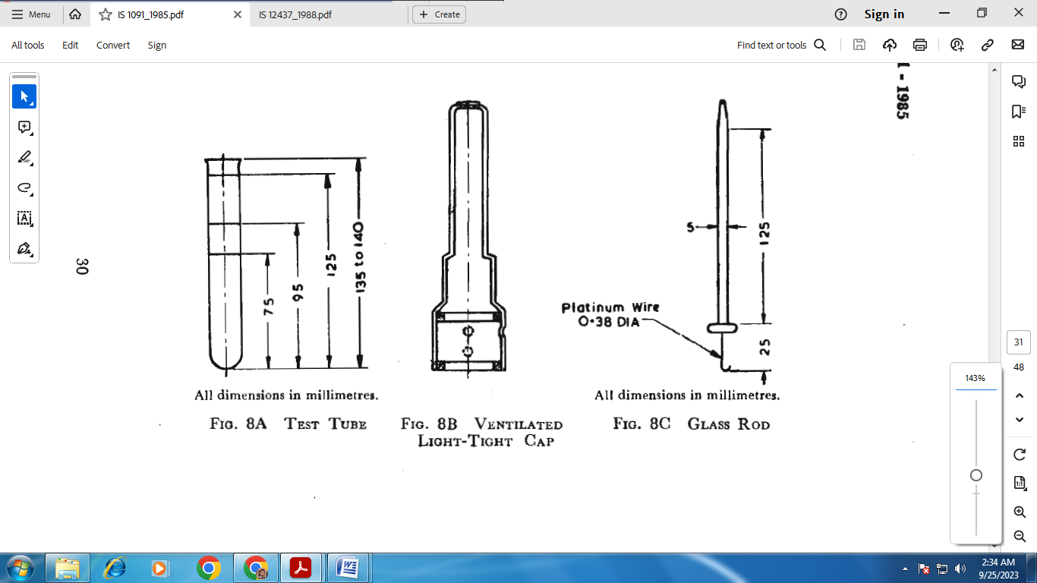

All dimension in millimetres

FIG. 8A TEST TUBE



FIG. 8B VENTILATED LIGHT-TIGHT CAP



All dimensions in millimetres

FIG. 8C GLASS ROD

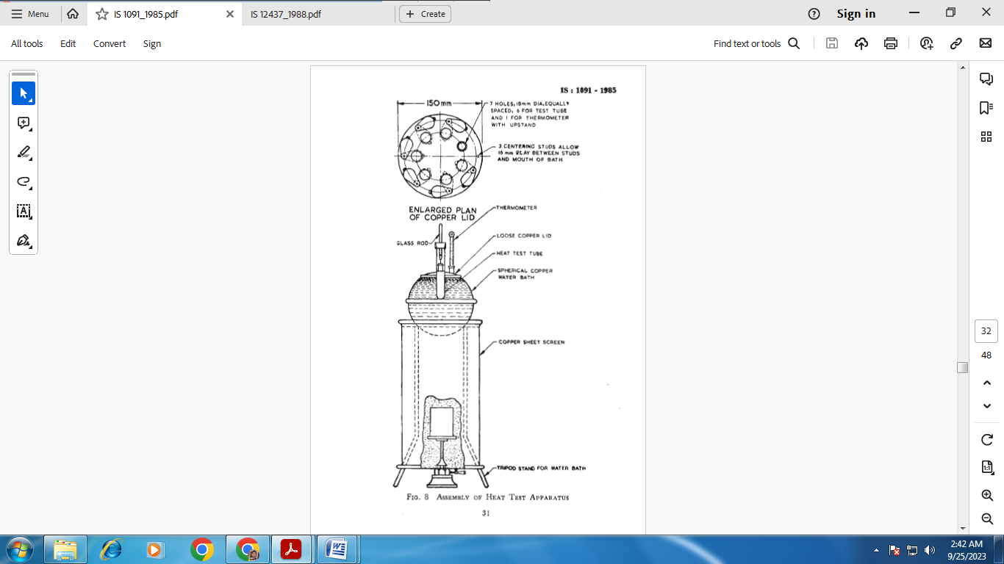

FIG. 8 ASSEMBLY OF HEAT TEST APPARATUS

**K-3.1.3.1** *Test for deterioration of heat test papers*

Place a drop of dilute acetic acid by means of a glass rod on a strip of the paper. No discoloration shall take place. If the paper is unserviceable, a brown or bluish discoloration appears at once; any discoloration appearing some time afterwards shall be disregarded.

NOTE — Since the test papers are very sensitive to nitrous fumes, acid vapour and other reactive impurities in the atmosphere, the room where the test is conducted shall be free from such fumes; preferably the test room shall be exclusively used for this purpose.

**K-4 STANDARD TINT PAPER**

**K-4.1** Each paper shall be stored in a colourless glass tube enclosed in a cylindrical carton. The standard tint paper shall never be removed from its tube and when not in use shall be kept in the carton.

**K-4.2** *Renewal of Stock*

Two new standard tint papers, one for use and one in reserve shall be renewed annually.

**K-5 REAGENTS**

**K-5.1 Glycerine-Water Mixture**

Mix equal volumes of glycerine and water. Take fresh mixture every 14 days and discard discoloured mixture.

**K-6 PROCEDURE**

**K-6.1** Carry out the test in duplicate.

**K-6.2 Preparation of the Water-Bath**

Place the assembled apparatus on a bench at right angles to a window facing north or away from direct sunlight, the background of the bath being free from yellow tint. Fill the water-bath up to 6 mm of the top with distilled water and insert the thermometer through the hole to a depth of 70 mm below the lid. Maintain the water in the bath at (77 ± 0.2) °C.

**K-6.3** When the correct temperature has been attained, weigh accurately on an aluminium scoop about 1.3 g of the dried sample (*see* **8.1.1** ) place in one of the test tubes, and gently press down until it occupies a height of not more than 30 mm in the tube.

**K-6.4** Immediately after the sample has been inserted in the tube, remove a test paper from the amber glass tube with forceps and place it on a perforated glass plate. Pierce the test paper with a clean needle in the centre, near the upper edge. Hold the paper in the forceps by the unperforated end in an inclined position with the ends horizontal. Withdraw a suitable amount of glycerine-water mixture on the glass rod of the dropping bottle by dipping it to a depth of 25 mm to 30 mm. Hold the rod parallel with the upper edge (perforated end) of the test paper, slightly inclining both so that any excess of liquid flows away from the extremity of the rod. Apply the end of the rod, a little rapidly and evenly down the surface of the paper to a distance of about 4 mm from the upper edge, the distance depending upon the amount of liquid on the rod. *It is essential that the liquid be applied to the paper in a single smoothly excess liquid operation*. Maintain the paper in its oblique position until the excess liquid on the surface has been absorbed.

**K-6.4.1** The amount of liquid applied shall be such that the dividing line between the wet and dry portions of the paper at the completion of the test is 9 mm to 12 mm from the upper edge and is parallel to it. A gauge shall be used for checking this distance.

**K-6.4.2** Pass the platinum wire hook of the glass rod, previously cleaned by passing it through a gas or spirit flame, through the perforation in the wetted paper and insert the rubber stopper into the test tube containing the sample under test, so that the paper hangs vertically in the tube. Place the tube in the test tube stand and allow it to remain for about one and a half minutes by which time it will be possible to judge whether the paper has been wetted satisfactorily. Discard any paper not used within three minutes of wetting and anyone which is clearly under wetted or over wetted.

**K-6.5** Press the rubber stopper carrying the glass rod and the test paper into the test tube so that the bottom of the stopper coincides with the top etch-line on the test tube and the centre etch-line on the test tube coincides exactly with the lower moistened part of the test paper. Fit the test tube with the rubber ring and insert into the bath so that the lower etch-line on the test tube coincides with the upper surface of the lid. Insert the tube in one of the holes in the lid of the bath so that the rubber ring rests on the lid.

**K-6.5.1** Place the test paper first near the top of the tube, but not touching the cork, until after the tube has been immersed for about five minutes. By this time, a ring of moisture will be deposited upon the sides of the test tube, slightly above the cover of the bath. When this appears, lower the glass rod until the lower margin of the moistened portion of the paper is on a level with the ring of moisture in the tube. Start a stop watch at the commencement of the test and cover the upper portion of the tube with the ventilated light-tight cap.

**K-6.6 Special Precautions**

Shield the portion of the test tube above the lid of the bath at once from light by covering it with ventilated light-tight cap during the test. Raise the cap from time to time for observations of the test paper and remove towards the conclusion of the test.

**K-6.6.1** Take special care to prevent unnecessary exposure of the test paper to light especially after it has been wetted. Discard a test in which the test tube is not inserted into the bath within about three minutes of the wetting of the test paper.

**K-6.7 Completion of Test**

Use reflected light for comparison. The test is completed when a faint brown tint, equal in intensity to the brown line drawn on the standard tint paper, makes its appearance at the line between the wet and dry portions of the test paper.

**K-6.7.1** The coloured lines produced in the test may differ a slightly as regards width, regularity and definiteness of outline and, occasionally, uniformity of colour.

**K-6.7.2** Consider the test as completed when the shade and intensity of any part of the colour line is equal to that of the standard tint. Stop the stop-watch and note the time to the nearest half second.

**K-6.8 Test Results**

Perform the test in duplicate and record both the results together with the temperature of testing and date. Consider the lower value of the test results for the purpose of accepting the sample to pass the test.

**K-6.8.1** The material shall be taken to have satisfied the requirements of the test if the time taken by it for the appearance of the standard tint is not less than 10 minutes.

NOTES

1 — It is customary to carry out six tests at a time, this being the number of tubes which the bath accommodates.

2 — If the distance, from the top edge of the paper, of the coloured line or of the margin between the dry and the wetted portion of the test paper, when no coloured line has been obtained, is not between 9 mm to 12 mm, reject the test.

3 — In case the time recorded in duplicate tests varies by more than 1 minute, repeat the test.

**K-6.9 Discarded Samples**

All discarded samples shall be placed in a pail of water, complete with lid. Tables and floors shall be kept free of the unused material, using the appropriate brush and a copper shovel. The contents of the pail shall be destroyed daily (*see* **R-5**).

**ANNEX L**

**DETERMINATION OF ORGANIC MATTER INSOLUBLE IN ACETONE**

[*Table* 1, *Item* (v)]

**L-1 REAGENT**

**L-1.1 Acetone** — conforming to IS 170

**L-2 PROCEDURE**

**L-2.1** Weigh accurately about 1 g of the dried nitrocellulose (*see* **8.1.1**) into a 300 ml stoppered cylinder and add 250 ml of acetone. Clamp the cylinder in a rotary type shaker and shake for 4 hours till the solution is complete. Remove the cylinder from the shaker and let stand for about 12 hours. Syphon off the clear supernatant solution until about 25 ml of solution is left in the cylinder. Add fresh acetone to make up the volume to 250 ml, and repeat the cycle 4 times more. Finally transfer the insoluble residue to a porcelain basin of 100 ml capacity. Rinse the cylinder with small quantities of acetone and transfer the washings to the porcelain basin. Evaporate the acetone on a water-bath; finally dry at 100 °C to 104 °C for one hour and weigh. Then heat strongly and ash the residue, cool and weigh again.

NOTE — A convenient method to ash the residue is to heat at 600 °C to 700 °C in an oxidizing atmosphere.

**L-3 CALCULATION**

$$Organic matter insoluble in acetone, percent by mass of the dried material = \frac{100 \left(A-B\right)}{M}$$

where

*A* = mass in g of residue on drying at 100 °C to 105 °C,

*B* = mass in g of residue on ashing, and

*M* = mass in g of the dried material taken for the test.

**ANNEX M**

**DETERMINATION OF MATTER SOLUBLE IN ETHER-ALCOHOL**

[*Table* 1, *Item* (vi)]

**M-1 REAGENTS**

**M-1.1 Ethyl Ether** — solvent grade (*see* IS 336).

**M-1.2 Alcohol** — rectified spirit, grade I (*see* IS 323).

**M-2 PROCEDURE**

**M-2.1** Transfer 4 g of the dried material (*see* **8.1.1**) to a graduated cylinder of 200 ml capacity containing 150 ml of ether-alcohol at (15 ± 0.5) °C [2 parts of ethyl ether and 1 part of alcohol (v/v)].

**M-2.2** Mix the contents of the cylinder by shaking and then place for 6 hours in a mechanical shaker consisting of a wheel submerged in water and revolving at the rate of 15 rev/min. Allow the mixture to settle without further disturbance until the liquid is clear. During the process of settling and standing maintain the mixture at (15.5 ± 0.5) °C. Withdraw a measured quantity, about 50 ml of the clear supernatant liquid, and after evaporation of the solvent, dry the residue with molten paraffin wax, gently ignite and allow to burn away. Moisten the ash with ammonium carbonate solution, dry and heat to constant mass at 105 °C to 110 °C. The content of soluble organic matter is calculated from the mass of the dried residue after deduction of the mass of carbonated ash.

**M-3 CALCULATION**

$$Solubility in ether-alcohol, percent by mass =\frac{M_{1}×3×100}{M}$$

where

*M1* = mass in g of the residue, and

*M* = mass in g of the material taken for the test.

**ANNEX N**

**DETERMINATION OF ALKALINITY (as CaCO3)**

[*Table* 1, *Item* (vii)]

**N-1 GENERAL**

**N-1.1 Outline of the Method**

The material is treated with hydrochloric acid and the equivalent acid neutralized by alkali is determined by titration with sodium carbonate.

**N-2 REAGENTS**

**N-2.1 Hydrochloric Acid** — 0.1 N approximately.

**N-2.2 Sodium Carbonate Solution** — 0.1 N approximately.

**N-3 PROCEDURE**

Place 10 g of the dried material (*see* **8.1.1**) in a stoppered cylinder with 100 ml of hydrochloric acid, dilute with 100 ml of water and shake the cylinder at intervals of one hour. After the mixture has been allowed to settle, titrate 100 ml of the clear liquid with sodium carbonate solution using methyl orange as indicator.

**N-4 CALCULATION**

**N-4.1 Alkalinity — (**as CaCO3) percent by mass = 50*N* – *VN1*

where

*N* = normality of hydrochloric acid,

*V* = volume in ml of sodium carbonate solution required for the test, and

*N1*= normality of sodium carbonate solution.

**ANNEX P**

**DETERMINATION OF SULPHATES (as H2SO4)**

[*Table* 1 *Item* (viii)]

**P-1 GENERAL**

**P-1.1 Outline of the Method**

Sulphates are determined by precipitation as barium sulphate from a solution prepared by using concentrated nitric acid and hydrochloric acid.

**P-2 REAGENTS**

**P-2.1Cencentrated Nitric Acid** — s*ee* IS 264.

**P-2.2 Sodium Chlorite**

**P-2.3 Concentrated Hydrochloric Acid** — *See* IS 265.

**P-2.4 Dilute Hydrochloric Acid** — 10 percent (*v/v*).

**P-2.5 Barium Chloride Solution** —10 percent (*m/v*).

**P-3 PROCEDURE**

Weigh accurately about 5 g of the dried material (*see* **8.1.1**) and heat on a water-bath with 50 ml of concentrated nitric acid until the solution is complete. Add about 1 g of sodium chlorate in successive small quantities and evaporate the solution to dryness. Treat the residue with 20 ml of concentrated hydrochloric acid, about 0.5 g of sodium chlorate and evaporate to dryness. Repeat treatment with concentrated hydrochloric acid and sodium chlorate. Dissolve the residue in 200 ml of water and 5 ml of dilute hydrochloric acid and boil. Add 10 ml of barium chloride solution to the boiling solution. Boil again for 2 minutes, let it stand for 4 hours and filter through a tared sintered glass crucible (G No. 4) or a tared Gooch crucible. Wash the precipitate free from chlorides and dry to constant mass at 105 °C to 110 °C.

NOTE — Excess of barium chloride is necessary to reduce the solubility of barium sulphate. Precipitation in hot solution by addition of barium chloride in a slow stream with stirring minimizes mechanical occlusion of barium chloride and gives a coarse precipitate which is less soluble in acids.

**P-4 CALCULATION**

$$Sulphates \left(as H_{2}{SO}_{4}\right), percent by mass=\frac{M_{1}}{M_{2}}×42$$

where

*N1* = mass in g of the precipitate, and

*N2* = mass in g of the material taken for the test.

**ANNEX Q**

**DETERMINATION OF MAGNETIC FERRUGINOUS MATTER**

[*Table* 1, *Item* (ix)]

**Q-1 GENERAL**

**Q-1.1 Outline of the Method**

The method is based on separating iron from the material using an electromagnetic separator and finally determining it colorimetrically.

**Q-2 APPARATUS**

**Q-2.1 Electromagnetic Separator**

The apparatus consists of a bath and a cover made of copper. An either bladed paddle wheel is fitted inside the bath and takes an ebonite pulley at the end of its shaft, for being connected to a motor by means of a belt. This is to maintain the circulation of the slurry in the bath. A baffle is soldered along the entire length of the paddle wheel to the bottom of the bath across the path of the slurry. The electromagnet is made of mild steel (carbon content less than 0.1 percent) and is capable of taking uniform and durable nickel plating. Each of the two brass reels is wound with about 305 metres of double cotton covered copper wire in 22 layers of 116 turns each. The general arrangement of the apparatus is shown in Fig. 9.

**Q-2.2 Nessler Cylinder** — 100 ml capacity (*see* IS 4161).

**Q-3 REAGENTS**

**O-3.1 Concentrated Hydrochloric Acid** — *see* IS 265.

**Q-3.2 Concentrated Nitric Acid** — *see* IS 264.

**Q-3.3 Ammonium Thiocyanate Solution** — Approximately 5 percent (*m/v*).

**Q-3.4 Standard Iron Solution**

Dissolve 0.702 g of ferrous ammonium sulphate [FeSO4 (NH4)2SO4.6H2O] in about 100 ml of water containing 10 ml of dilute sulphuric acid (10 percent v/v) and dilute to 1 000 ml. One millilitre of the solution is equivalent to 0.1 mg of iron (as Fe).

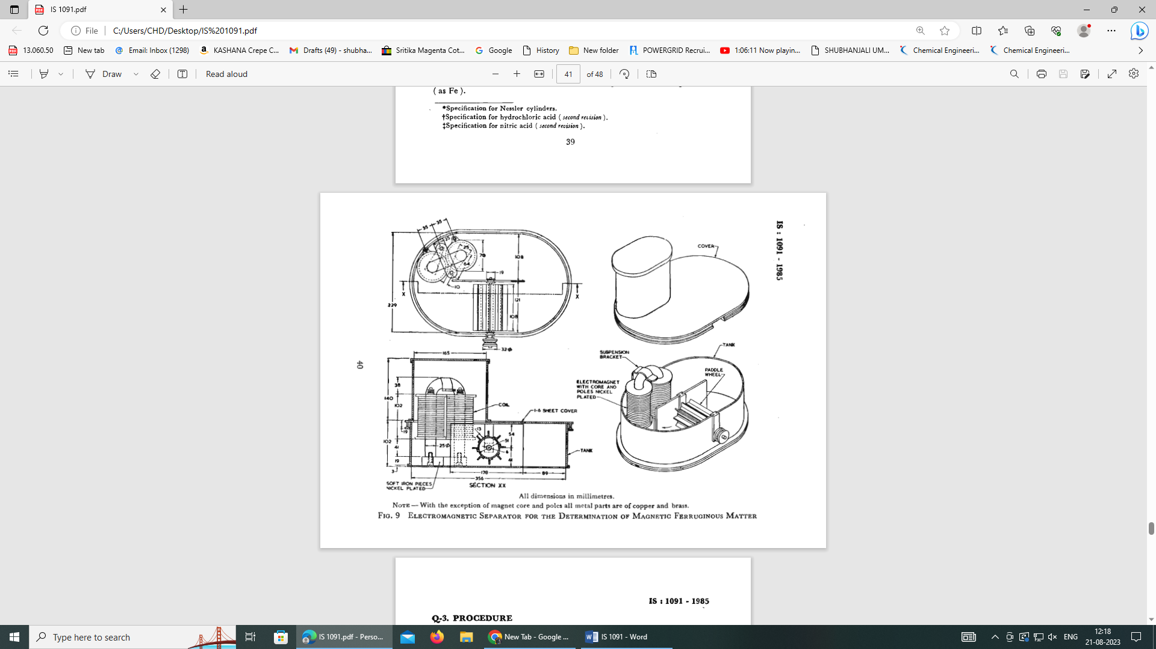

All dimensions in millimetres

NOTE **—** With the exception of magnet core and poles all metal parts are of copper and brass.

FIG. 9 ELECTROMAGNETIC SEPARATOR FOR THE DETERMINATION OF MAGNETIC FERRUGINOUS MATTER

**Q-4 PROCEDURE**

**Q-4.1** Estimate the moisture content of the wet nitrocellulose by drying about 5 g to a constant mass at 100 °C.

**Q-4.1.1** Weigh accurately wet nitrocellulose equivalent to 100 g of the dry material and mix with 1 300 ml of water and transfer the mixture to the bath of the electromagnetic separator. Switch on the electromagnet and the motor for rotating the paddle wheel so that the slurry flows in the direction of the electromagnets as shown in Fig. 9. Stop the paddle wheel after one hour and raise the electromagnet, above the bath, without switching it off. Wash the poles of the electromagnet gently with water, switch off the current and remove the ferruginous matter with moist ash less filter paper. Replace the electromagnet in the bath, rinse down any material sticking to the sides of the bath and repeat the operation for four further hourly periods.

**Q-4.1.2** Collect all the filter papers used for removing ferruginous matter and incinerate them. Add 25 ml of concentrated hydrochloric acid and a few drops of nitric acid and dissolve the residue by boiling. Cool and transfer the solution to a 500 ml volumetric flask and make up the volume up to the mark.

**Q-4.1.3** Transfer 50 ml of the solution obtained in **Q-4.1.2** to a Nessler cylinder, add 3 ml of ammonium thiocyanate solution and dilute up to the mark. Carry out a control test proceeding as with the incinerated residue in **Q-4.1.2** using 5 ml of standard iron solution.

**Q-4.2** The material shall be taken as having not exceeded the limits prescribed in Table 1 if the intensity of the colour obtained with the material is not greater than that obtained in the control test.

**ANNEX R**

**PRECAUTIONS FOR STORAGE AND HANDLING**

(*Clauses* 5.2.1 and 6)

**R-1 DRYING IN STORAGE**

**R-1.1** Care should be taken that the nitrocellulose does not dry in storage as in this condition it is very dusty and may settle and accumulate in niches and other places, and thus become liable to ignition by sparks friction, impact, flame or static electricity. Dry nitrocellulose is highly flammable. It burns with great speed producing intense heat with possibilities of explosion in confined space.

**R-1.2** The top layers of nitrocellulose in the containers, although these be securely closed, are liable to become dry on storage. It is recommended that the drums be opened periodically and a quantity of dampening medium added to them to maintain the contents suitably damp.

**R-1.3** As all damping media have a tendency to settle on standing, containers shall be inverted at regular intervals, say fortnightly, during storage in order to maintain even distribution of the dampening medium. This precaution is particularly desirable when the entire contents of a container are not intended to be used in one mixing.

**R-2 STORAGE BUILDING**

**R-2.1** Nitrocellulose shall be stored in a suitable, separate, well-ventilated building and at a distance of at least 10 metres from other buildings in which manufacturing processes are carried out. When nitrocellulose is stored in dry state the buildings should be separated from the adjacent buildings at least by the distance stipulated in the relevant Explosives Regulations.

**R-2.2** The storage building shall be constructed of fire-resisting material and used for no other purpose than for storing nitrocellulose only. It shall be provided with at least two exists and adequate means of extinguishing fire.

**R-2.2.1** The storage building for dry nitrocellulose should be constructed according to the relevant Explosives Regulations.

**R-2.3** The storage building shall be kept locked and no unauthorized person is allowed to enter it.

**R-2.4** No open light or fire shall be permitted near the storage building. Matches and other means of producing spark or flame, and articles liable to cause fire or explosion shall be prohibited in the storage building as also in the building in which nitrocellulose is processed.

**R-2.4.1** In addition, the following precautions should also be observed while entering storages holding dry nitrocellulose:

1. Before any container containing dry nitrocellulose is either put into or taken out of the storage house the floor is to be made damp with wet flannels.
2. Any person shall enter buildings containing dry nitrocellulose only after wearing rubber shoes or sewn leather shoes or sewn leather shoes barred or studded with rubber to prevent slipping. All such shoes are to be provided with four copper studs projecting slightly from the heel of the shoe and making contact with the heel of the wearer. Should it be necessary for any person wearing shoes to enter when the floor is not damp, he shall remove his shoes and enter in his socks only.
3. After work is completed the house is to be swept with wet flannels and all sweepings shall be washed with water.
4. Floor, ceilings, walls, etc., of the building, wherein dry nitrocellulose is handled naked would be rubbed down with damp flannel after the work is completed.

**R-2.5** Radiators shall be avoided, if possible. If their use is imperative, they shall be heated only by means of low pressure steam and be in such a position that nitrocellulose containers may not be placed against them.

**R-2.6** Containers shall not be stored in tiers.

**R-2.7** The walls and roofs of storage and processing buildings shall be washed down periodically to remove dry nitrocellulose dust.

**R-3 EXPOSURE**

**R-3.1** Nitrocellulose shall not be exposed to the direct rays of the sun.

**R-3.2** The material shall not be stored in a building into which direct rays of the sun enter.

**R-4 OPENING CONTAINERS**

**R-4.1 Tools**

The tools used for opening containers and handling nitrocellulose shall be of brass, bronze or of other non-sparking material.

**R-4.2** Containers shall be handled carefully to avoid sparks on contact with steel or concrete surfaces.

**R-4.3** No undue force shall be used in opening containers.

**R-4.4** The weighing of nitrocellulose shall be isolated so that ignition dangers consequent on the formation of dry nitrocellulose dust may be kept away from other operative work.

**R-4.5** The lids of nitrocellulose containers shall be replaced as soon as possible in order to prevent the evaporation of dampening medium.

**R-4.6** The packages shall be marked or labelled to indicate the explosive contents, their classification and maker or sender.

**R-5 DISPOSAL OF WASTE MATERIAL**

The amount of nitrocellulose in any manufacturing building shall be collected at once, deposited in a suitable receptacle, wetted with water and collected at the end of the day or in convenient periods for burning on a wood fire in an isolated and safe area. Such waste shall not be disposed off in a boiler fire.

**ANNEX S**

**SAMPLING OF NITROCELLULOSE**

(*Clause* 7)

**S-1 GENERAL REQU1REMENTS OF SAMPLING**

**S-1.1** In drawing, preparing, storing and handling samples, the following precautions shall be observed.

**S-1.2** As the material is highly explosive, precautions described in Annex P shall be strictly observed, when sampling operations are carried out.

**S-1.3** The sampling instrument shall be clean and dry when used.

**S-1.4** Precautions shall be taken to protect the samples, the material being sampled, the sampling instrument and the containers for samples from adventitious contamination.

**S-1.5** To draw a representative sample, the contents of each container selected for sampling shall be mixed as thoroughly as possible by suitable means.

**S-1.6** The sample shall be kept in suitable, clean, dry, airtight glass or other suitable containers on which the material has no action.

**S-1.7** The sample containers shall be of such a size that they are almost, but not completely, filled with the sample.

**S-1.8** Each sample container shall be sealed airtight after filling and marked with full details of sampling, the date of sampling, the year of manufacture and other important particulars of the consignment.

**S-1.9** Samples shall be stored in such a manner that the temperature of the material does not vary unduly from the normal temperature.

**S-2 SCALE OF SAMPLING**

**S-2.1 Lot**

All the containers in a single consignment of the material drawn from a single batch of manufacture shall constitute a lot. If a consignment is declared to consist of different batches of manufacture, the batches shall be marked separately, and the groups of containers in each batch shall constitute separate lots.

**S-2.2** For ascertaining the conformity of the lot to the requirements of the specification, samples shall be tested from each lot separately.

**S-2.3** The number of containers to be selected for this purpose shall depend on size of the lot and shall be in accordance with Table 2.

**Table 2 Number of Containers to be Selected**

|  |  |
| --- | --- |
| **No. of Containers in the Lot** | **Sampling Size** |
| (1) | (2) |
| Up to 15 | 2 |
| 16 to 25 | 3 |
| 26 to 50 | 5 |
| 51 to 100 | 8 |
| 101 to 300 | 13 |
| 301 to 500 | 20 |
| 501 and above | 32 |

**S-2.3.1** These containers shall be selected at random. In order to ensure the randomness of selection, procedures given in IS 4905 shall be followed.

**S-3 TEST SAMPLES AND REFEREE SAMPLE**

**S-3.1** Draw with an appropriate sampling instrument portions of material from two well separated points at least 30 cm beneath the surface of the material from each of the containers selected according to **S-2.3,** about 1 kg of material.

**S-3.2** Out of these portions equal quantity of material shall be taken and thoroughly mixed to form a composite sample of the quantity sufficient to make triplicate determinations for each of the characteristics tested on the composite sample. The composite sample shall be divided into three equal parts, one for purchaser, and another for the manufacturer and third to be used as referee sample.

**S-3.3** The remaining portion of the material from each of the containers shall be divided into three equal parts, each forming an individual sample. One set of the individual samples shall be marked for the purchaser, another for the manufacturer and the third to be used as referee sample.

**S-3.4** All individual and composite samples shall be transferred to thoroughly dried bottles which are sealed airtight with cork stoppers which are waxed or covered with foil or a sheet of polyethylene. These shall be labelled with all the particulars of sampling given in **S-1.8**.

**S-3.5** The referee samples consisting of composite sample and a set of individual samples shall bear the seals of the purchaser and the supplier. They shall be kept at a place agreed between the purchaser and the manufacturer to be used in case of a dispute between the two.

**S-4 NUMBER OF TESTS**

**S-4.1** Nitrogen content and solubility in ether-alcohol shall be tested on each of the individual samples.

**S-4.2** The remaining characteristics given In 3 shall be tested on the composite sample.

**S-5 CRITERIA FOR CONFORMITY**

**S-5.1 Individual Sample**

The lot shall be considered to have satisfied the requirements given in **S-4.1** if all the test results on each of the individual samples satisfy the corresponding requirements given in the specification.

**S-5.2 Composite Samples**

The lot shall be deemed to have met the requirements tested on the composite sample if all the test results meet the corresponding requirements given in the specification.

**S-5.3** The lot shall be declared as conforming to the requirements of this specification if conditions in **S-5.1** and **S-5.2** are satisfied.

**ANNEX T**

( *Foreword* )

**COMMITTEE COMPOSITION**

Explosives and Pyrotechnics Sectional Committee, CHD 26

|  |  |
| --- | --- |
| *Organization* | *Representative(s)* |
| DRDO-High Energy Materials Research Laboratory, Pune | DR A P DASH (***Chairperson***) |
| Arumugam Fireworks Pvt. Ltd., Sivakasi | SHRI K MARIAPPAN  SHRI ARUN M. LALITH KUMAR (*Alternate*) |
| CDET Explosives Industries Pvt. Ltd., Nagpur | SHRI RAGHAV RATHI |
| CSIR-Central Institute of Mining and Fuel Research, Dhanbad | DR C SAWMLIANA  DR FIROZ ALI (*Alternate*) |
| Central Mine Planning and Design Institute Ltd., Ranchi | SHRI SATYENDRA NARAYAN  SHRI BINAY KUMAR SINGH (*Alternate*) |
| Central Pollution Control Board, New Delhi | SHRI ABHIJIT PATHAK |
| Coal India Ltd., Kolkata | SHRI K SUDHAKAR  SHRI DEBDULAL SARKAR (*Alternate*) |
| Consumer Guidance Society of India, Mumbai | SHRI SITARAM DIXIT  DR M S KAMATH (*Alternate*) |
| Directorate General of Mines Safety, Dhanbad | SHRI SAIFULLAH ANSARI  SHRI A RAJESHWAR RAO (*Alternate*) |
| Directorate of Standardization, New Delhi | CAPT. M H KEKRE |
| Enif Paper Products Pvt. Ltd., Nagpur | SHRI MANAN DESAI |
| Fireworks Manufacturers Association (North India), Gwalior | SHRI HARISH MILWANI  SHRI RAJEEV JAIN (*Alternate*) |
| GOCL Corporation Ltd., Hyderabad | SHRI C SAINATH  SHRI S VIJAY KUMAR (*Alternate*) |
| Gudiya Fireworks, Delhi | SHRI KSHITIJ JAIN |
| High Energy Materials Research Laboratory, Pune | SHRI C GURURAJA RAO  DR R B PAWAR (*Alternate*) |
| IDL Explosives ltd., Hyderabad | SHRI AJIT ASHOKRAO TATWADI |
| Ministry of Defence (DGQA), New Delhi | SHRI P J CHAHNDE  SHRI S. DHILLIP (*Alternate*) |
| Munitions India Limited, Pune | SHRI D VIKAS  SHRI D K URKUDE (*Alternate*) |
| Neyveli Lignite Corporation Ltd., Chennai | SHRI M MUTHUKUMARAN |
| Petroleum and Explosives Safety Organization (PESO), Nagpur | SHRI P KUMAR  SHRI P SEENIRAJ (*Alternate*) |
| Shri Kaliswari Fireworks, Sivakasi | SHRI A P SELVARAJAN |
| Solar Industries India Ltd., Nagpur | SHRI A K JAIN  SHRI P P DEOTARE (*Alternate*) |
| Standard Fireworks, Sivakasi | SHRI M S SARAVANAN |
| The Coronation Fireworks Factory, Sivakasi | SHRI P KANAGAVEL  SHRI K JEYAKUMAR (*Alternate*) |
| The Indian Fireworks Manufacturers Association (TIFMA), Sivakasi | SHRI T KANNAN |
| The Metal Powder Co. Ltd., Madurai | SHRI P SUNDARAPANDIAN  SHRI N CHANDRASEKARAN (*Alternate*) |
| The Tamil Nadu Fireworks and Amorces Manufacturers Association (TANFAMA), Sivakasi | THE PRESIDENT  THE SECRETARY (*Alternate*) |
| BIS Directorate General | SHRI A. K. LAL, SCIENTIST ‘F’/SENIOR DIRECTOR AND HEAD CHEMICAL  [REPRESENTING DIRECTOR GENERAL (*EX—OFFICIO*)] |
| *Member Secretary*  SHRI MOHIT GARG  SCIENTIST ‘B’ / ASSISTANT DIRETOR  (CHEMICAL), BIS | |