***भारतीय मानक***

***Indian Standard***

**IS 7886 : 20XX**

**Doc. : CHD 26 (23675) F**

***विस्फोटक तथा आतिशबाज़ी उद्योग के लिए बेरियम क्रोमेट — विशिष्टि***

*( दूसरा* पुनरीक्षण )

**Barium Chromate for Explosives and Pyrotechnic Industry — Specification**

*( Second Revision )*

ICS 71.060.50; 71.100.30

© BIS 2024

भारतीय मानक ब्यूरो

BUREAU OF INDIAN STANDARDS

मानक भवन, 9 बहादुर शाह ज़फर मार्ग, नई दिल्ली - 110002

MANAK BHAVAN, 9 BAHADUR SHAH ZAFAR MARG

NEW DELHI - 110002

[www.bis.gov.in](http://www.bis.org.in) [www.standardsbis.in](http://www.standardsbis.in)

**November 2024 Price Group**

Explosives and Pyrotechnics Sectional Committee, CHD 26

FOREWORD

This Indian Standard (Second Revision) was adopted by the Bureau of Indian Standards, after the draft finalized by the Explosives and Pyrotechnics Sectional Committee had been approved by the Chemical Division Council.

This Indian Standard prescribes the barium chromate is a synthetic inorganic chemical, widely used in the manufacture of delay detonators and in pyrotechnic formulations.

This Indian Standard was originally published in 1975 and the first revision was published in 1997. The first revision of the standard, new requirements of apparent density and barium content (as BaSO4) of the material were incorporated and volatile matter content of the material was modified.

In this second revision, an alternative method for direct calculation of Barium Chromate content has been provided. Several editorial changes such as ICS No., Hindi Title, and Reference clause, etc. has also been incorporated to bring out the standard in the latest style and format of the Indian Standards.

The composition of the Committee responsible for development of this standard is given in Annex D.

For the purpose of deciding whether a particular requirement of this standard is complied with, the final value, observed or calculated, expressing the result of a test or analysis, shall be rounded off in accordance with IS 2 : 2022 ‘Rules for Rounding off Numerical Values (*second revision*)’. The number of significant places retained in the rounded off value should be the same as that of the specified value in this standard.

*Indian Standard*

BARIUM CHROMATE FOR EXPLOSIVES AND PYROTECHNIC INDUSTRY — SPECIFICATION

(*Second Revision*)

**1 SCOPE**

This standard prescribes requirements and methods of sampling and test for barium chromate intended for use in explosives and pyrotechnic compositions.

**2 REFERENCES**

The standards listed in **Annex A** contain provisions which through reference in text, constitute provisions of and necessary adjuncts to this standard. At the time of Publication, the editions indicated were valid. All standards are subject to revision and parties to agreements based on this standard are encouraged to investigation the possibility of applying the most recent editions of the standard indicated in **Annex A**.

**3 TERMINOLOGY**

For the purpose of this standard, the definitions given in IS 10081 shall apply.

**4 REQUIREMENTS**

**4.1 Description**

The material shall be in the form of light-yellow powder free from visible impurities and grit.

**4.2** The material, when tested by the method prescribed in **B-9,** shall consist, on dry basis, of not less than 59.62 percent of barium oxide and not less than 38.88 percent of chromic anhydride (CrO3), equivalent to not less than 98.50 percent by mass of barium chromate (BaCrO4).

**4.3** The material shall also comply with the requirements given in Table 1, when tested by the methods prescribed in **Annex B** of this standard. Reference to the relevant clauses of **Annex B** is given in co1 4 of Table 1.

**4.4 For Defence Purpose**

**4.4.1** *Practical Test*

The material shall also pass the practical test when carried out under actual filled condition, if required by defence authorities in accordance with the method prescribed by them.

**Table 1 Requirements for Barium Chromate for Explosives and Pyrotechnic Industry**

(*Clauses* 4.3, B-4.1, and B-5.1)

|  |  |  |  |
| --- | --- | --- | --- |
| **Sl No.** | **Characteristic** | **Requirement** | **Method of Test (Ref to Cl No.) in Annex B** |
| (1) | (2) | (3) | (4) |
| i) | Volatile matter, percent by mass, *Max* | 0.1 | **B-2** |
| ii) | Matter soluble in water, percent by mass, *Max* | 0.08 | **B-3** |
| iii) | Water soluble chlorides (as Cl), percent by mass, *Max* | 0.05 | **B-4** |
| iv) | Moisture reabsorption (at 90 percent RH for 24 h), percent by mass, *Max* | 0.20 | **B-5** |
| v) | Bulk density, g/ml, *Max* | 0.85* | **B-6** |
| vi) | Fineness material retained on 4 to 5 micron IS sieve | Nil | **B-7** |
| vii) | Average particle size (by air permeability method), microns | 1 to 4 | **B-8** |
| viii) | Barium (as BaCrO­4), percent by mass, *Min* | 98.5 | **B-9** |
| ix) | Apparent density, g/ml | 0.35 to 0.65 | **B-10** |
| *For special requirement, a higher bulk density as agreed to between the purchaser and the supplier may be specified | | | |

**5 PACKING AND MARKING**

**5.1 Packing**

The material shall be suitably packed as agreed to between the purchaser and the supplier.

**5.2 Marking**

The packages shall be legibly and indelibly marked with the following information:

a) Name and description of the material,

b) Indication of the source of manufacture,

c) Tare and net mass of the material, and

d) Identification mark in code or otherwise to enable the batch of manufacture to be traced from records.

**5.2.1** *BIS Certification Marking*

The product(s) conforming to the requirements of this standard may be certified as per the conformity assessment schemes under the provisions of the *Bureau of Indian Standards Act*, 2016 and the Rules and Regulations framed thereunder, and the products may be marked with the standard mark.

**6 SAMPLING**

**6.1** The method of drawing representative samples of the material, the number of tests to be performed and the criteria for conformity of the material to the requirements of this specification shall be as prescribed in **Annex C**.

**ANNEX A**

**LIST OF REFERRED INDIAN STANDARDS**

(*Clause* 2and *Table* 1)

|  |  |
| --- | --- |
| *IS No* | *Title* |
| IS 265 : 2021 | Hydrochloric acid Specification (*fifth revision)* |
| IS 878 : 2008 | Laboratory glassware - Graduated measuring cylinders (*second revision)* |
| IS 1070 : 2023 | Reagent Grade Water Specification (*fourth revision*) |
| IS 1796 : 2023 | Glycerine — Specification (*third revision*) |
| IS 4905 : 2015  ISO 24153 : 2009 | Random sampling and randomization procedures *(first revision)* |
| IS 5165 : 2017/  ISO 383 : 1976 | Laboratory glassware - Interchangeable conical ground joints (*First Revision*) |
| IS 10081 : 1981 | Glossary of terms relating to explosive pyrotechnic and blasting practices |

**ANNEX B**

(*Clause* 4.3 and *Table* 1)

**METHODS OF TEST FOR BARIUM CHROMATE FOR EXPLOSIVES AND PYROTECHNIC INDUSTRY**

**B.1 QUALITY OF REAGENTS**

**B-l. 1** Unless specified otherwise, pure chemicals and distilled water *see* IS 1070 shall be used in tests.

NOTE — ‘Pure chemicals’ shall mean chemicals that do not contain impurities which affect the results of the analysis.

**B-2 DETERMINATION OF VOLATILE MATTER**

**B-2.1 Procedure**

**B-2.1.1** Heat a flat-bottomed clean glass or aluminum dish with cover, about 6 cm in diameter and 3 cm in depth, in an oven at 100 ℃ ± 2°C for half an hour. Cool it in a desiccator and weigh. Place about 10 g of the material in the dish, replace the cover and weigh accurately.

**B-2.1.2** Uncover the dish and heat the sample and cover in an oven maintained at 100 ℃ ± 2 °C for 2 h. At the end of this period, replace the cover, cool the dish and cover in a desiccator to room temperature and weigh. Repeat this till constant mass is obtained. Preserve the dish with the residue for test in **B-5**.

**B-2.2 Calculation**

$$Volatile matter, percent by mass =100 × \frac{\left(M_{2}-M_{3}\right)}{\left(M_{2}-M_{1}\right)}$$

where

*M1* = mass in g of the empty dish and cover,

*M2* = mass in g of the dish and cover with the sample taken, and

*M3*= mass in g of the dish and cover with the sample after heating.

**B-3 DETERMINATION OF MATTER SOLUBLE IN WATER**

**B-3.1 Procedure**

Weigh accurately about 10 g of the material dried as prescribed under **B-2** and transfer it to a beaker. Wet it thoroughly with 95 percent (*v/v*) of ethyl alcohol or rectified spirit and then add 200 ml of water. Boil for 5 min. Cool the mixture to room temperature and transfer to a 250 ml volumetric flask. Make up to 250 ml with freshly boiled and cooled water. Shake and filter. Reject about 50 ml of the first portion of the filtrate. Take a 100 ml portion from the rest of the filtrate in a tared porcelain dish and evaporate to dryness on a water-bath. Dry the residue obtained to constant mass in an oven at 100 ℃ ± 2 °C.

**B-3.2 Calculation**

$$Matter soluble in water, percent by mass = \frac{\left(M_{2}-M_{1}\right)×2.5×100}{M}$$

where

*M* = mass in g of the material taken for test,

*M2 =*mass in g of the dish with the residue, and

*M*­1 =mass in g of the empty dish

**B-4 DETERMINATION OF WATER SOLUBLE CHLORIDES**

**B-4.1 Reagents**

**B-4.1.1** *Standard Silver Nitrate Solution —* 0.1 N.

**B-4.1.2** *Potassium Chromate Solution —* 5 percent.

**B-4.2 Procedure**

Weigh to the nearest milligram about 10 g of the material and transfer to a 500 ml conical flask. Add 200 ml of water and shake thoroughly. Add a small quantity of filter paper pulp and filter the mixture. Wash the residue with several portions of water and add the washings to the filtrate. Add 1 ml of potassium chromate solution to the filtrate and titrate with standard silver nitrate solution to a permanent faint blood-red tinge. Run a blank simultaneously.

**B-4.3 Calculation**

$$Chlorides (as Cl), percent by mass =\frac{3.55 ×\left(V-B \right)×N}{M}$$

where

*V* = volume in ml of standard silver nitrate solution used for the sample;

*B =* volume in ml of standard silver nitrate solution used for blank;

*N* = normality of silver nitrate solution; and

*M* = mass in g of the sample taken for the test.

**B-5 MOISTURE REABSORPTION**

**B-5.1 General**

The percentage increase in the mass of the dry material when kept in an atmosphere of 90 percent relative humidity and 27 ℃ ± 1 °C for 24 h is taken as the moisture reabsorption.

**B-5.2 Procedure**

Prepare a 35.7 percent solution of glycerol by diluting glycerine of chemically pure grade (*see* IS 1796). Place the dried sample obtained after the determination of volatile matter in **B-2** in a desiccator containing the glycerol solution for 24 h at 27 ℃ ± 1 °C. Weigh the material after this period.

**B-5.3 Calculation**

$$Moisture reabsorption, percent by mass = 100× \frac{M_{1}}{M}$$

*M =* mass in g of the material taken for the test, and

*M1*= increase in mass in a g of the material.

**B-6 DETERMINATION OF BULK DENSITY**

**B-6.1 Apparatus**

**B-6.1.1** Assemble the apparatus as shown in Fig. 1. The measuring cylinder *A* shall be of 250 ml capacity and shall conform to IS 878. The base of the measuring cylinder shall be ground flat. The distance between the flat-ground part of the base of the measuring cylinder A and the rubber base pad B when the measuring cylinder *A* is raised to the full height, shall be 25 mm ± 2 mm.

**B-6.1.2** The rubber base pad B shall have a Shore hardness of 42 to 50.

**B-6.1.3** Pans of the balance shall be at least 10 cm in diameter and the balance shall have accuracy of not less than 0.1 g.

**B-6.2 Procedure**

Dry sieve about 20 g of the material through 250 micron IS sieve by lightly brushing a 25 mm wide and 12.5 mm thick good quality paint brush on to a tared glazed paper and weigh it accurately. Slip the powder gently and smoothly into the measuring cylinder, which should be held at 45o to the vertical, without knocking or squeezing. Assemble the apparatus as shown in Fig. 1. With the thumb and fingers of one hand, gently grasp the upper part of the cylinder, and within one second lift it as far as 25 mm (*see* Fig. 1). Do not jerk the cylinder by knocking it against the upper stop. At the start of the next second, release the cylinder smoothly. Continue lifting and dropping at the rate of one drop per second until 50 complete drops have been given. Once every two seconds, a gentle twist of about 10 should be given to the cylinder. As soon as 50 drops have been completed, raise the cylinder to eye level and read the volume of the sieved material.

**B-6.3 Calculation**

$$Bulk density, g/ml^{3}=\frac{M}{V}$$

where

*M =* mass in g of the sieved material taken for the test, and

*V =* final volume in ml of the sieved material.

**B-7 TEST FOR FINENESS**

**B-7.1 Procedure**

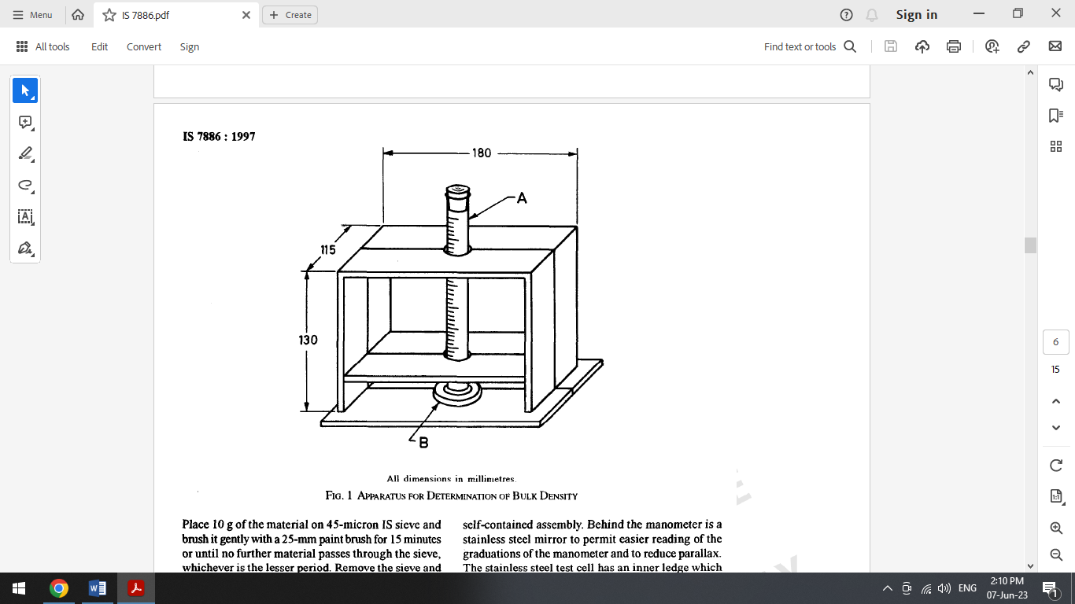

All dimensions in millimetres.

FIG. 1 APPARATUS FOR DETERMINATION OF BLUNK DENSITY

Place 10 g of the material on 45 micron IS sieve and brush it gently with a 25 mm paint brush for 15 min or until no further material passes through the sieve, whichever is the lesser period. Remove the sieve and weigh the portion of the sample retained on it.

**B-7.2** The material shall be considered to have passed the requirement of the test if there is no residue left on the sieve.

**B-8 DETEFUWINATION OF AVERAGE PARTICLE SIZE AND SPECIFIC SURFACE (AIR PERMEABILITY METHOD)**

**B-8.1 Outline of the Method**

The specific surface of the powder is first measured by the time of flow of a known volume of air through a compact bed of the material. The mathematical basis for the procedure is complex and to a certain extent empirical. The mean particle diameter is then calculated from its specific surface if the particle shape is known. For spherical particles the formula, *X* = 6/*S* is used, where, *X* is the mean particle diameter in cm, and S is the specific surface in cm2/cm3.

**B-8.2 Apparatus**

Assemble the apparatus as shown in Fig. 2 (*Blain air permeability fineness tester*)*.* It consists of a graduated glass U-tube manometer, a ground-glass joint supporting a stainless-steel test cell and a glass tube with stop cock leading to a rubber air aspirator bulb, all mounted on a wooden support stand forming one compact portable self-contained assembly. Behind the manometer is a stainless-steel mirror to permit easier reading of the graduations of the manometer and to reduce parallax. The stainless-steel test cell has an inner ledge which supports a stainless-steel perforated disc. The test cell can also hold a stainless-steel plunger used for compacting the sample bed. The manometer contains diesel oil of known density up to a height of 12 cm from the bottom of the U-tube. The dimensions of the apparatus, the cell and the plunger are shown in Fig. 3.

**B-8.2.1** Alternatively, Fischer sub-sieve sizes may also be used.

**B-8.3 Determination of Constants of the Test Cell**

**B-8.3.1** Determine the inside diameter of the cylindrical test cell by means of slide calipers and calculate the area of the bed of powder in cm2 (*A*).

**B-8.3.2** Determine depth of the cell with the perforated disc and the two filter paper discs (that will be used later in the experiment) placed on the metal perforated disc. Subtract from cell depth, the height of stainless steel plunger from bottom end to collar, to obtain depth of the bed of powder in cm (*L*).

**B-8.3.3** Determine the volume of manometer arm between marks *B* and C by filling from a burette. This volume (*V*) in ml will be equal to the volume of air passing through the bed in the experiment.

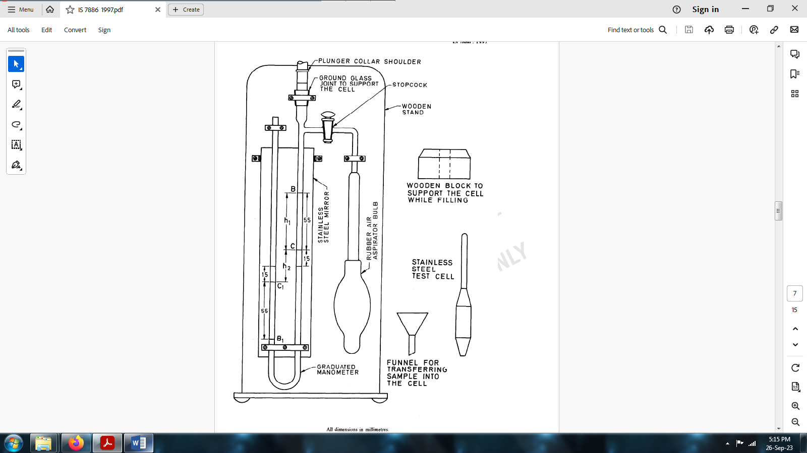

All dimensions in millimeters

FIG. 2 APPARATUS FOR THE DETEERMINATION OF AVERAGE PARTICLE SIZE — AIR PERMEABILITY FINENESS TESTER

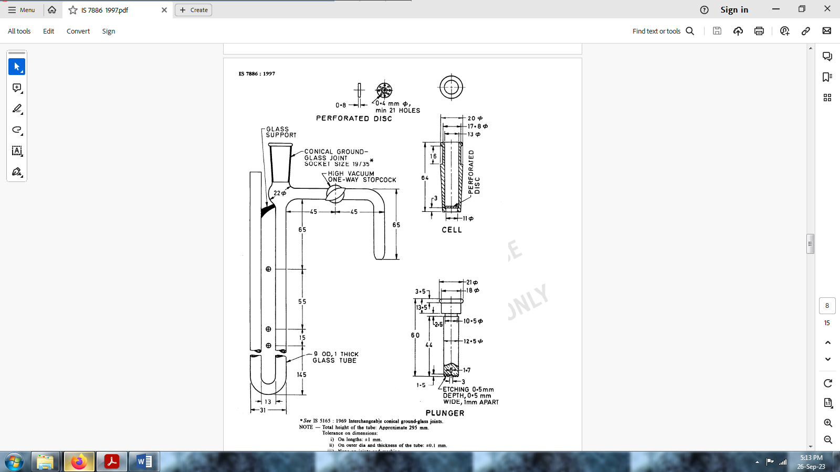

\**see* IS 5165 Interchangeable conical ground–glass joints.

NOTE — Total height of the tube: Approximate 295 mm.

Tolerance on dimensions:

|  |  |
| --- | --- |
| i) | On lengths: ± 1 mm. |
| ii) | On outer dia and thickness of the tube: ± 0.1 mm. |
| iii) | None on joints and marking. |

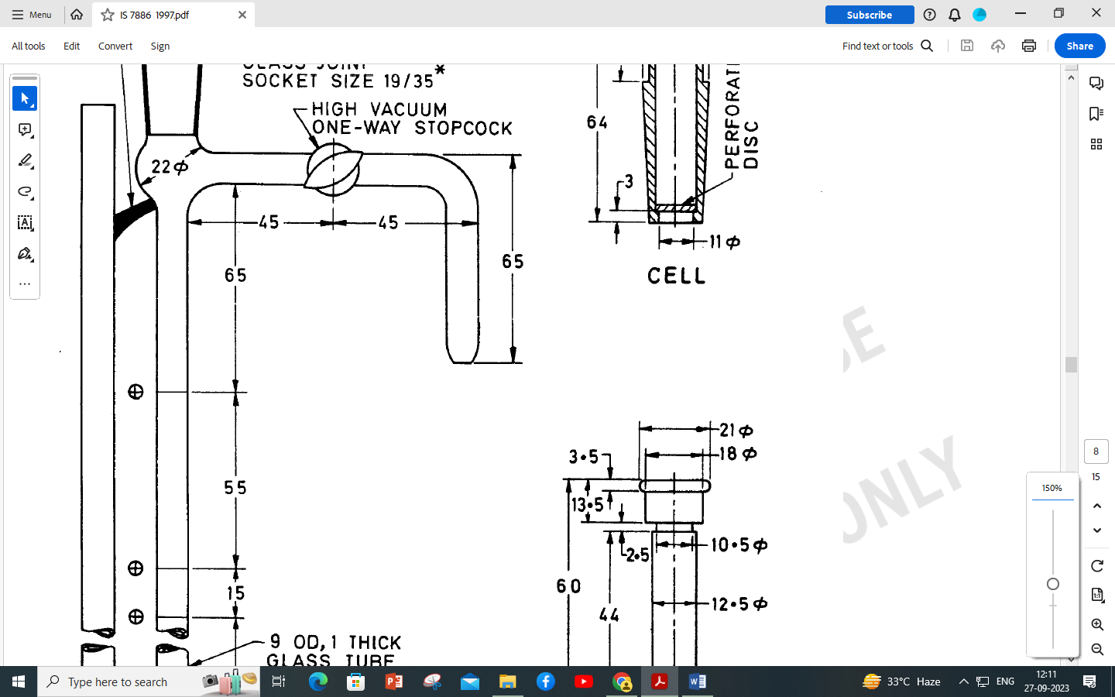Circular mark to be etched.

*Material:* Stainless steel for cell and plunger; brass for perforated disc.

All dimensions in millimeters.

FIG. 3 DIMENSIONS OF APPARATUS FOR DETERMINATION OF PARTICLE SIZE — AIR PERMEABILITY TESTER

**B-8.4 Procedure**

**B-8.4.1** Mix the whole sample well on a sheet of paper and make sure that its moisture content is within specification. Weigh out exactly 3.084 g of the sample of barium chromate on to a sheet of glazed paper. The quantity of the material taken is such that it gives a bed of standard porosity of 0.63 when pressed into the test cell (*see* **B-8.5.1** for calculation of porosity).

**B-8.4.2** Place the stainless-steel perforated disc in the clean dry stainless steel test cell and ensure that the disc sits properly on the inner ledge.

**B-8.4.3** Cut two discs of filter paper exactly of the same diameter as the inside of the test cell using the punch provided and place one disc on top of the perforated disc.

**B-8.4.4** Place the test cell in the wooden bloc usually provided with the apparatus and transfer the weighed barium chromate into the test cell using a funnel.

**B-8.4.5** Consolidate and level the powder by tapping the cell. Place the second filter paper disc on top of the powder, insert the stainless-steel plunger and push it down until the shoulder of the plunger rests on the lip of the test cell.

**B-8.4.6** withdraw the plunger from the test cell slowly in order to avoid formation of partial vacuum. Fix the test cell firmly into the ground-glass joint.

**B-8.4.7** Partially exhaust the air from the arm of the manometer through the glass stopcock and aspirator bulb until the level of the liquid in that arm comes well above the mark *B.*

**B-8.4.8** Close stopcock and note with a stopwatch, the time taken for the level of the liquid to fall from mark *B* to mark C.

**B-8.4.9** Repeat the timing operation to give a total of 3 or 5 readings, 3 if the readings are constant and 5 if there is a fair range in the readings.

**B-8.4.10** Calculate the average time in seconds required for the liquid to fall from *B* to C and determine the specific surface (surface area per unit volume of particle in cm2/cm3) and particle size in cm as given in **B-8.5.1** and **B-8.5.2**.

**B-8.5 Calculation**

**B-8.5.1** Specific surface (s),

$${cm}^{2}/{cm}^{3}=\frac{gAPT}{KVNL}×\frac{e^{3}}{{\left(l-e\right)}^{2}}$$

where

g = acceleration due to gravity in cm/s2,

*A* = cross –sectional area of the cell in cm2which is the area of bed of the powder in cm2,

*T* = time of flow of air in seconds,

*e =* porosity that is, volume of pore space per unit volume of bed, and is equal to:

$$1-\frac{(mass in g of the material)/density of powder}{volume in ml of the bed}$$

(density of barium chromate is 4.498 g/ml and shall be determined for each sample),

*K* = a constant which has a value of 5,

*V* = total volume of air passing through the powder in ml and is equal to volume of the manometer arm between marks *B* and *C*,

*N* = viscosity of air in poises. It varies from 0.000 182 7 poise at 18 ℃ to 0.000 195 8 poise at 40 ℃ and is usually taken as 0.000 18 5, unless stated otherwise,

*L* = depth of powder bed in cm, and

*P* = mean effective pressure difference across the bed of powder, in g/cm2, and is calculated from the commonly used equation:

$$H= \frac{H_{1}- H_{2}}{loge\left(H_{1}/H_{2}\right)}……………………………(I)$$

where

*H* = mean effective head,

*H1 =* initial head, and

*H2* = final head.

In terms of the apparatus shown in Fig. 2, the final pressure:

$$H_{2}d=\left(CC_{1}\right)d=h_{2}d$$

where

*d* = the density of the oil in the manometer.

Initial pressure,

(B, B1, *C*, *C*1and *h2* are the same as Fig. 2).

Substituting these values in equation (I),

$$Mean effective pressure, P =\frac{{ 2 h}_{1}d}{loge \left(1 +2h_{1}/h_{2}\right)}$$

$$or in terms of common logarithm, P=\frac{{ 0.8686× h}_{1}d}{loge \left(1 +2h_{1}/h_{2}\right)}$$

Using diesel oil of density 0.857 3 g/ml at 15 °C and a value of 55 mm for *h1*and 30 mm for *h2,*as shown in Fig. 2, *P*works out to be 6.12 g/cm2.

**B-8.5.2** *Particle Size* ***—*** Calculate mean particle size as follows:

$$Mean particle diameter, cm =\frac{6}{S}$$

where

*S* = specific surface in cm2/cm3 as obtained in **B-8.5.1.**

**B-9 DETERMINATION OF BARIUM (As BaCrO4)**

**B-9.1 Preparation of Sample**

Grind the material if it is lumpy or not finely powdered. If the sample is large, mix thoroughly and take a representative portion (*see* also **4.2**).

***B*-9.2Determination of Barium (as BaCrO4)**

**B-9.2.1** *Outline of the Method*

The material is dissolved in dilute hydrochloric acid and treated with ammonium sulphate solution. In the resulting filtrate, barium is precipitated as barium sulphate. The precipitate is then ignited and barium oxide (BaO) content is estimated. For estimation of chromic anhydride (CrO3) content, the material is dissolved in hydrochloric acid and reacted with potassium iodide. The liberated iodine, which is equivalent to the chromic anhydride content, is estimated by titration against standard sodium thiosulphate solution using starch solution as indicator. The sum total of the barium oxide content and the chromic anhydride content is equal to the barium chromate (BaCrO4) content.

**B-9.2.2** *Reagents*

**B-9.2.2.1***Dilute hydrochloric acid* ***—*** approximately 4 N.

**B-9.2.2.2** *4mmonium hydroxide**—* relative density 90 percent.

**B-9.2.2.3** *Concentrated hydrochloric Acid* ***—*** relative density 1.18 *see* IS 265.

**B-9.2.2.4** *Ammonium sulphate solution* ***—*** 10 percent *(m/v).*

**B-9.2.2.5** *Potassium iodide*

**B-9.2.2.6** *Standard sodium thiosulphate solution* ***—*** 0.1N.

**B-9.2.2.7** *Starch solution* ***—*** saturated.

**B-9.2.2.8** *Denatured spirit* ***—*** *see* IS 324.

**B-9.3Procedure**

**B-9.3.1** *For Determination of Barium Oxide (BaO) Content*

Weigh accurately 0.5 g of the material in a 400 ml beaker and dissolve in 50 ml of dilute hydrochloric acid by boiling and filter, if necessary. Add water to make the volume approximately 200 ml. Neutralize with ammonium hydroxide and add 2 ml of concentrated hydrochloric acid. Add denatured spirit and boil to reduce chromate to chromium. While stirring add slowly 20 ml of ammonium sulphate solution. Boil for 5 minutes and allow it to stand on the water-bath for at least 4 h or overnight. Filter the precipitate and wash it with water. Ignite and weigh as barium sulphate.

Alternatively, BaO content may also be determined using the calibrated ICP-OES method.

**B-9.3.2** *For Determination of Chromic Anhydride (CrO3) Content*

Weigh accurately 0.5 g of the material in a 500 ml conical flask. Add 25 ml of dilute hydrochloric acid and shake the flask for 2 min to 3 min. Then add 25 ml of water and 3 g of potassium iodide to the solution. Cover the flask with a watch-glass and keep in a dark place for 3 min to 5 min. Then titrate the liberated iodine with standard sodium thiosulphate solution using starch solution as indicator.

Balanced Chemical Reactions involved:

$$6KI+2BaCrO_{4}+16HCl →3I_{2}+2Ba{Cl}_{2}+2Cr{Cl}_{3}+6KCl+8H_{2}O$$

$$2{Na}_{2}S_{2}O_{3}+ I_{2} →2NaI+ {Na}_{2}S_{4}O_{6}$$

**B-9.4 Calculation**

**A-9.4.1** Calculate barium oxide (as BaO) content as follows:

$$Barium oxide (as BaO), percent by mass =\frac{65.72×M_{1}}{M_{2}}$$

where

*M1* = mass in g of the barium sulphate obtained, and

*M2* = mass in g of dried material taken.

**B-9.4.2** Calculate chromic anhydride (as CrO3) content as follows:

$$Chromic anhydride (as CrO_{3}), percent by mass, = \frac{V×0.003334 }{M}×100$$

where

*V* = volume in ml of 0.1 N sodium thiosulphate solution required for the titration, and

*M* = mass in g of the material taken for test.

**B-9.4.3** Calculate barium chromate (as BaCrO4) content either using 9.4.3.1 or 9.4.3.2:

**9.4.3.1** Barium (as BaCrO4), percent by mass = Barium oxide (BaO), percent by mass + Chromic anhydride (CrO3), percent by mass.

**9.4.3.2 $$Barium Chromate (BaCrO_{4}), percent by mass, = \frac{V×0.008446 }{M}×100$$**

Where,

*V* = volume in ml of 0.1 N sodium thiosulphate solution required for the titration, and

*M* = mass in g of the material taken for test.

**B-10 DETERMINATION OF APPARENT DENSITY**

**B-10.1 Apparatus**

**B-10.1.1** A glass funnel of approximate dimensions as follows: Stem 110 mm long, tapering, internally from 8 mm diameter at the top to 5 mm diameter at the orifice.

**B-10.1.2** A glass cylinder of 25 mm internal diameter and 50 ml total volume, the top edge of the cylinder being ground flat.

**B-10.2 Method**

Weigh the cylinder empty (*M*1). Assemble the apparatus so that the funnel is clamped vertically and centrally above the cylinder with the lowest point of the funnel at about 70mm above the top edge of the cylinder.

Pour the material (previously dried and sieved through 63 micron IS Sieve) gradually into the funnel and so, into the cylinder until the latter overflows. This should take about one minute. Then, without tapping or shaking the cylinder, draw a straight edge across its top and level off the material. Weigh the cylinder and its contents (*M*2):

**ANNEX C**

(*Clause* 6.1)

**SAMPLING OF BARIUM CHROMATE FOR EXPLOSIVE AND PYROTECHNIC INDUSTRY**

**C-1 GENERAL REQUIREMENTS OF SAMPLING**

**C-1.1** In drawing, preparing, storing and handling test samples, the following precautions and directions shall be observed.

**C-1.2** Samples shall not be taken in an exposed place.

**C-1.3** The sampling implement and the containers for samples shall be made of metal or opaque glass on which the material has no action. They shall be clean and dry.

**C-1.4** Precautions shall be taken to protect the samples, the material being sampled, the sampling instrument and the containers for sampling from adventitious contamination.

**C-1.5** The sample containers shall be of such a size that they are almost, but not completely, filled with the sample.

**C-1.6** The sample containers shall be sealed air-tight after-filling and marked with full identification particulars, such as date of sampling, month and year of manufacture of the material, the name of the sample and any other relevant particulars of the consignment.

**C-1.7** Samples shall be stored in such a manner as to avoid excessive variations of temperature.

**C-2 SCALE OF SAMPLING**

**C-2.1 Lot**

In a single consignment of the material all the containers of the same type and size and drawn from the same batch of manufacture shall constitute a lot. If a consignment is known to consist of different types and size of containers, the containers belonging to the same batch, type and size shall be grouped together and each such group shall constitute a separate lot.

**C-2.1.1** For ascertaining the conformity of the material in a lot to the requirements of the specification, tests shall be carried out for each lot separately. The number of containers to be selected at random from lots of different sizes shall be in accordance with Table 2.

**Table 2 Scale of Sampling**

(*Clauses* C-2.1.1andC-5.1)

|  |  |  |
| --- | --- | --- |
| **Sl. No.** | **Lot Size** | **Sample Size** |
|  | *N* | *n* |
| (1) | (2) | (3) |
|  | Up to 20 | 1 |
|  | 21 to 60 | 2 |
|  | 61 to 150 | 3 |
|  | 151 to 300 | 4 |
|  | 301 to 500 | 5 |
|  | 501 and above | 6 |

**C-2.1.2** The containers shall be selected at random. In order to ensure randomness of selection, random number tables given in IS 4905 may be used. In case such tables are not available, the following procedure may be adopted: Starting from any container, count them in one order as 1, 2, 3,........, up to *r* and so on, where *r* is the integral part of *N/n.* Every *r*th container thus counted shall be taken out until the sample of required size is obtained.

**C-3 PBEPABATION OF TEST SAMPLE**

**C-3.1** From each of the containers selected, draw with an appropriate sampling instrument a small representative portion of the material approximately 100 g in mass.

**C-3.2** Out of these portions, small but equal quantity of the material shall be taken and mixed thoroughly to form a composite sample of mass about 200 g. This composite sample shall be divided into three equal parts. One for the purchaser, another for the supplier and the third to be used as a referee sample.

**C-3.3** The composite reference sample shall bear the seal of both the purchaser and the supplier. It shall be kept at a place agreed to between the purchaser and the supplier and shall be used in case of dispute between the two.

**C-4 NUMBER OF TESTS**

**C-4.1** Tests for the determination of all the characteristics mentioned in Table 1 shall be carried out on the composite sample.

**C-5 CBITEBIA FOR CONFORMITY**

**C-5.1** For declaring the conformity of the lot to the requirements of this specification, the test results for each of the characteristics shall meet the corresponding values specified in Tables 1 and 2.

**ANNEX D**

( *Foreword* )

**COMMITTEE COMPOSITION**

Explosives and Pyrotechnics Sectional Committee, CHD 26

|  |  |
| --- | --- |
| *Organization* | *Representative(s)* |
| DRDO-High Energy Materials Research Laboratory, Pune | DR A P DASH (***Chairperson***) |
| Arumugam Fireworks Pvt. Ltd., Sivakasi | SHRI K MARIAPPAN  SHRI ARUN M. LALITH KUMAR (*Alternate*) |
| Ayyan Fireworks Manufacturers Association, Sivakasi | SHRI ABIRUBEN G |
| CDET Explosives Industries Pvt. Ltd., Nagpur | SHRI RAGHAV RATHI |
| CSIR-Central Institute of Mining and Fuel Research, Dhanbad | DR C SAWMLIANA  DR FIROZ ALI (*Alternate*) |
| Central Mine Planning and Design Institute Ltd., Ranchi | SHRI BINAY KUMAR SINGH  SHRI SATYENDRA NARAYAN (*Alternate*) |
| Central Pollution Control Board, New Delhi | SHRI ABHIJIT PATHAK |
| Centre for Fire and Explosive Environment Safety, Defence Institute of Fire Research, Delhi | SHRIMATI HEMLATA GAUTAM  SHRI GULSHAN KUMAR SINGLA (*Alternate*) |
| Coal India Ltd., Kolkata | SHRI K SUDHAKAR  SHRI DEBDULAL SARKAR (*Alternate*) |
| Consumer Guidance Society of India, Mumbai | SHRI SITARAM DIXIT  DR M S KAMATH (*Alternate*) |
| Directorate General of Mines Safety, Dhanbad | SHRI SAIFULLAH ANSARI  SHRI DEEPAK PRABHAKAR (*Alternate*) |
| Directorate General of Quality Assurance, New Delhi | DR T K VARADARAJAN  SHRI R RAGHUNATH (*Alternate*) |
| Fireworks Manufacturers Association (North India), Gwalior | SHRI HARISH MILWANI |
| GOCL Corporation Ltd., Hyderabad | SHRI C.N SAINATH  SHRI N Venkatesh (*Alternate*) |
| Gudiya Fireworks, Delhi | SHRI R K Jain  SHRI KSHITIJ JAIN (*Alternate*) |
| High Energy Materials Research Laboratory, Pune | SHRI C GURURAJA RAO  DR R B PAWAR (*Alternate*) |
| IDL Explosives ltd., Hyderabad | SHRI P SIVASANKAR RAO  SHRI S. VIJAY KUMAR (*Alternate*) |
| Keltech Energies Limited, Nagpur | SHRI ATUL P. DWIVEDI |
| NLC India Limited, Chennai | SHRI M MUTHUKUMARAN |
| Ordnance Factory Bhandara, Bhandara | SHRI D VIKAS  SHRI D. K. URKUDE (*Alternate*) |
| Petroleum and Explosives Safety Organization (PESO), Nagpur | SHRI P KUMAR  SHRI P SEENIRAJ (*Alternate*) |
| Solar Industries India Ltd., Nagpur | SHRI P P DEOTARE  SHRI A K JAIN (*Alternate*) |
| Sri Kaliswari Fireworks, Sivakasi | SHRI A. P. SELVARAJAN |
| Standard Fireworks, Sivakasi | SHRI M. S. SARAVANAN |
| Tamil Nadu Fireworks and Amorces Manufacturers Association (TANFAMA), Sivakasi | THE PRESIDENT |
| The Coronation Fireworks Factory, Sivakasi | SHRI K JEYAKUMAR (*Alternate*) |
| The Indian Fireworks Manufacturers Association (TIFMA), Sivakasi | SHRI T KANNAN |
| The Metal Powder Company Ltd., Madurai | SHRI P SUNDARAPANDIAN  SHRI N CHANDRASEKARAN (*Alternate*) |
| In Personal Capacity, (*Qtr. No. 51014, O. F. Badmal Estate, Badmal. Distt. Balangir. Odisha 767070)* | DR ONKAR MONDHE |
| BIS Directorate General | SHRI AJAY KUMAR LAL, SCIENTIST ‘F’/SENIOR DIRECTOR AND HEAD (CHD)  [REPRESENTING DIRECTOR GENERAL (*EX-OFFICIO*)] |
| *Member Secretary*  SHRI MOHIT GARG  SCIENTIST ‘C’ / DEPUTY DIRETOR  (CHEMICAL), BIS | |